# CommerceUNITED STATES DEPARTMENT OF COMMERCE

## National Oceanic and Atmospheric Administration

NATIONAL MARINE FISHERIES SERVICE

Northwest Fisheries Science Center

2725 Montlake Boulevard East

Seattle, WA 98112-2097

August 1, 2024

Dear Editor,

We are grateful for the opportunity to submit our revised manuscript “Variability in somatic growth over time and space determines optimal season-opening date in the Oregon ocean shrimp (*Pandalus jordani)* fishery” for publication in the Canadian Journal of Fisheries and Aquatic Sciences. We appreciate the thoughtful comments from you and the two reviewers and believe the manuscript has genuinely improved as a result of this very constructive feedback.

The most significant change we have made is adding a new section to the supplement providing more detail on how ages were assigned to individual shrimp, and why we believe the method was sufficiently robust for our purposes. As part of this, we have included sample histograms showing distinct modes, overlaid with the average length-at-age input into our models. We also paid particular attention to addressing reviewer comments on the management context, which has resulted in minor additions throughout. Beyond the ageing method, there were no major concerns with the methods, so our results remain unchanged.

This manuscript is posted as a preprint on OSF (DOI forthcoming). Thank you for your consideration and please let us know if you have any questions.

Sincerely,

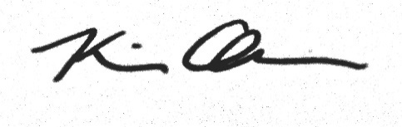

Kiva Oken, PhD

Fishery Resource Analysis and Monitoring Division

Northwest Fisheries Science Center

kiva.oken@noaa.gov