Research
Global April 2025
jll.com

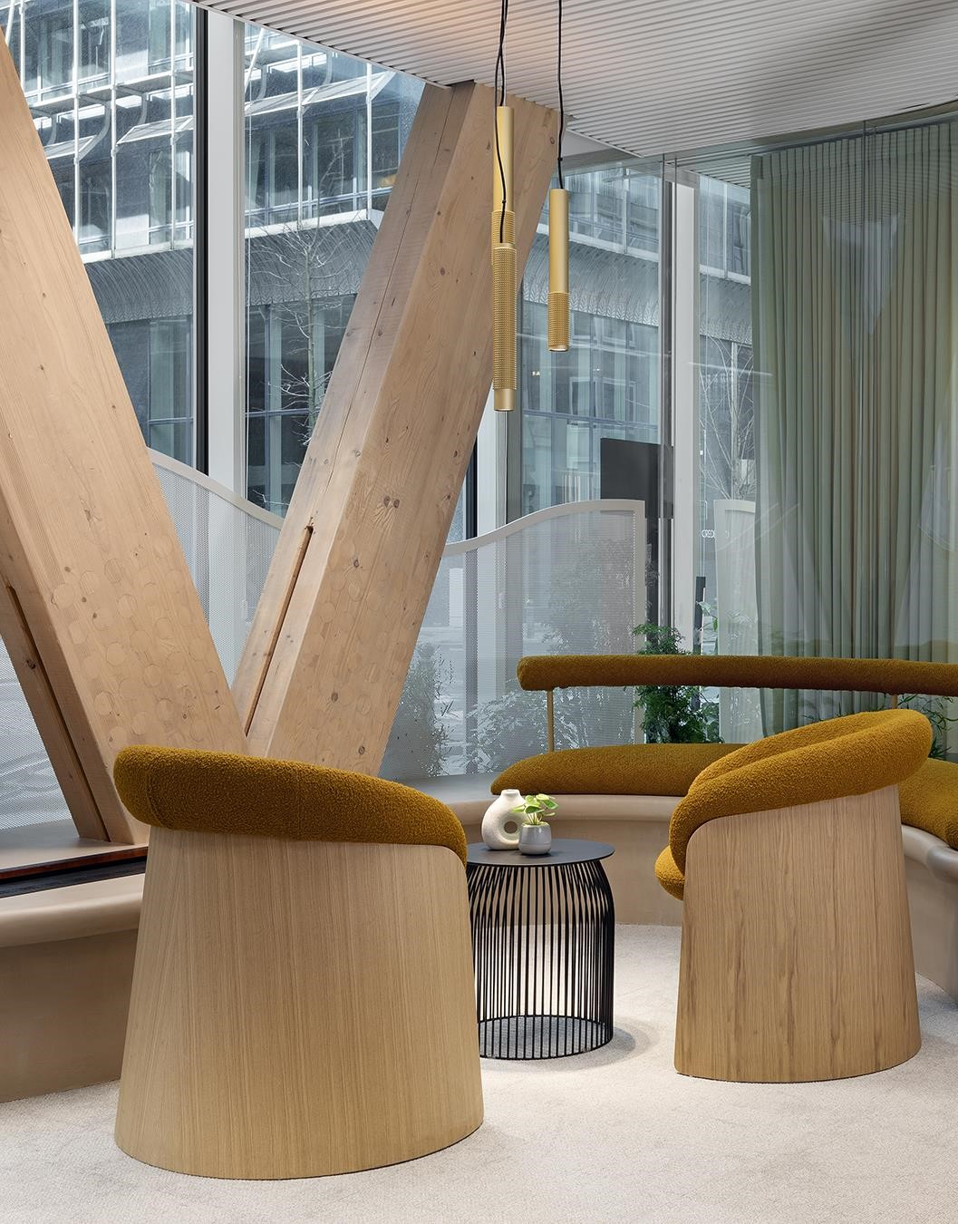
Global Office Fit-Out Cost Guide 2025


Introduction
The outlook for office fit-outs is broadly positive in 2025, as JLL Research shows optimism in corporate occupier sentiment for business growth, with associated increases in headcount, portfolio footprint and utilization. Many global corporates are shifting to workplace policies favoring higher in-office attendance, placing more importance on the role of the office once again.
59%
of organizations globally plan to increase investment in space design and fit-outs in the next five years.
Proportion of organizations in country planning to increase investment
59
%
58
%
72
%
74
%
73
%
Global
U.S.
Australia
India
Middle East
Source: JLL Research, Future of Work 2024
© 2025 Jones Lang LaSalle IP, Inc. All rights reserved.
Corporates are seeking high-quality, sustainable spaces to enhance employee wellbeing and productivity, and are investing in office fit-outs that support corporate goals. JLL’s Future of Work survey found 59% of organizations plan to boost investment in office fit-outs in the next five years. This sentiment is echoed across the majority of surveyed countries and even higher in some regions including Australia, India and the Middle East.
However, despite this optimism, early 2025 has brought economic and political uncertainty. As we progress through the coming year, the global construction industry faces a complex landscape of challenges and opportunities. Continuing developments in U.S. trade policy, particularly extensive tariff proposals and retaliatory measures from key trading partners, may significantly impact material costs and supply chains at a global scale.
While the current economic environment may prompt cautious decision-making, corporates focused on growth and expansion will continue to target investment in office fit-outs to support strategic goals, with long-term benefits from decisiveness over the next twelve months.
Our Global Office Fit-Out Cost Guide 2025 provides insights on market trends and cost drivers to inform capital planning and office fit-out strategies.

Key findings

01
Targeted investment in office fit-outs across global portfolios
Corporate Real Estate (CRE) leaders are looking to global benchmarks to understand cost drivers across geographies and develop capital plans that prioritize investment for maximum ROI across portfolio locations.
The average fit-out cost globally for an office is $1,950/sqm and ranging from $770/sqm to $3,790/sqm across geographies and typologies.

02
Increasing costs constraining decision-making
Rising costs and economic uncertainty are contributing to hesitancy in CRE investment decisions with potential long-term impacts on portfolio and workplace strategy realization.
Fit-out costs have increased across all regions in the last 12 months, with threequarters of markets reporting increases in raw material prices and half of markets reporting that labor shortages are increasing construction costs. A strengthening of the U.S. dollar in past year has also impacted on costs of importing materials and products in some regions.

03
‘Flight to quality’ influencing project cost profiles
Increased focus on in-office attendance, employee experience and sustainability performance is leading focus on investing in high quality workspaces, with increased spend on materials and finishes and shifting cost profiles on many projects.
In locations with short supply of Grade A office buildings, tenants and building owners are investing in refurbishments and fit-out of existing office space, often with higher costs associated with upgrading Mechanical & Electrical (M&E) services.

04
Increasing demand for sustainable fit-outs
Demand for sustainable office fit-outs is on the rise, with 60% of markets assessed reporting increases in the number of fit-out projects with high sustainable criteria in the past twelve months.
Corporates are seeking to demonstrate long term ROI through investment in sustainable offices, with greater focus on operational and embodied carbon savings throughout the life cycle of an office, from M&E Services upgrades to reinstatement requirements.

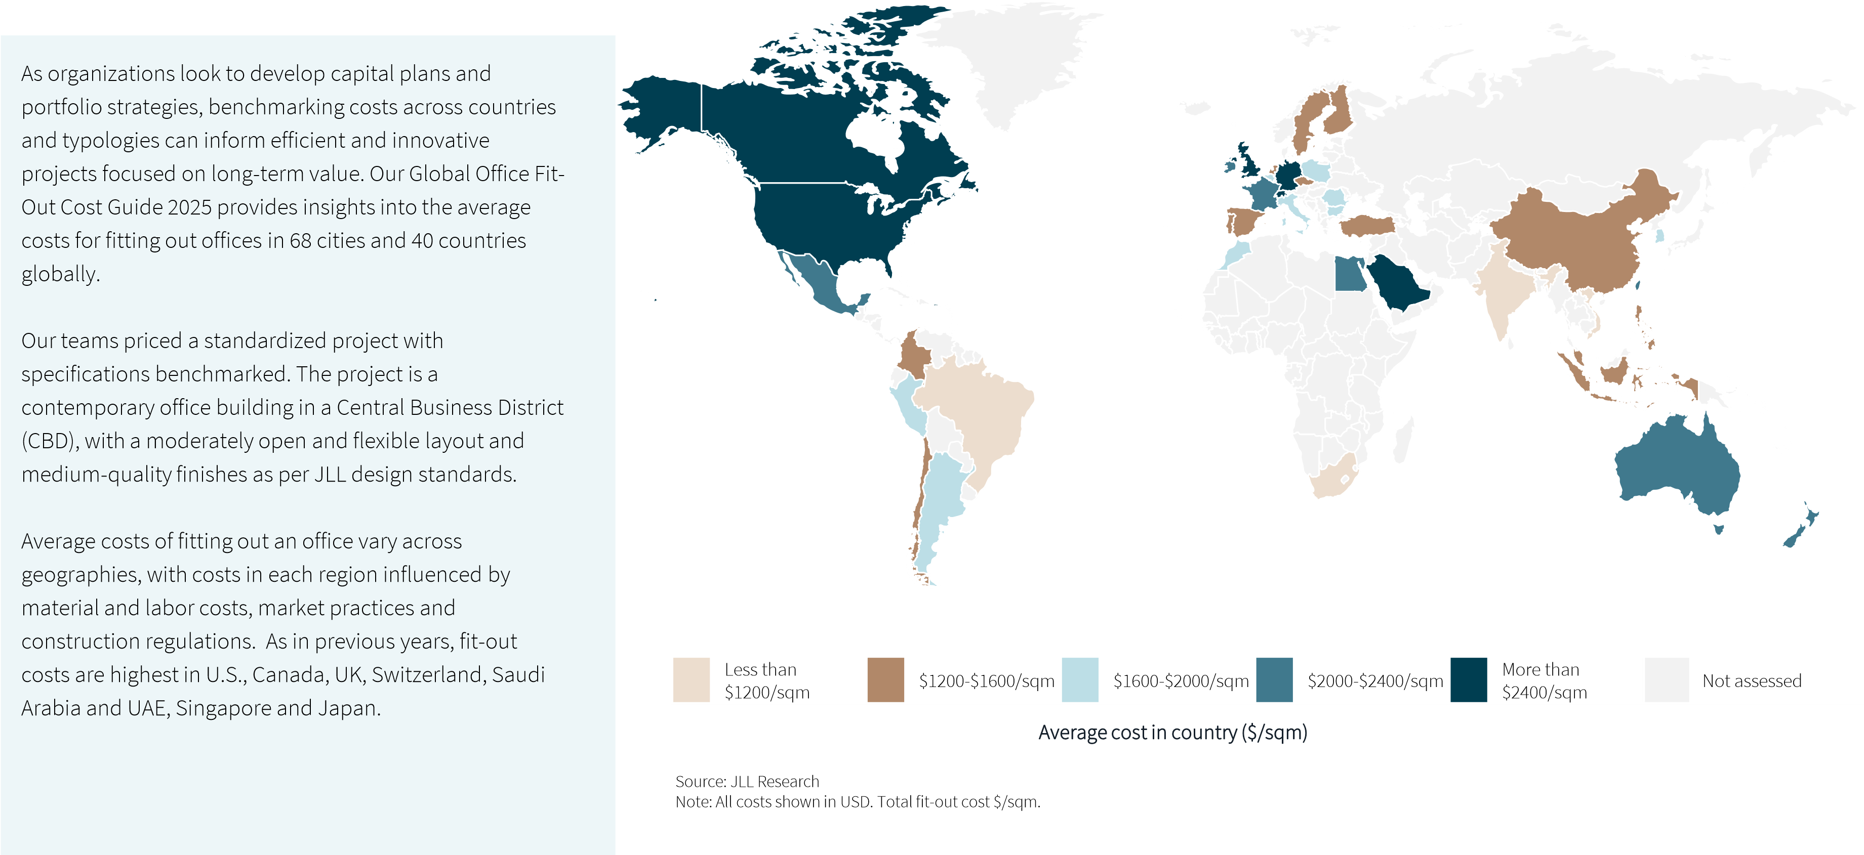
Range of average fit-out costs globally Global to local

Global and regional average fit-out costs for offices
Global | North  America  (14 cities) | Latin  America  (8 cities) | Europe, Middle  East, Africa  (25 cities) | Asia  Pacific  (21 cities)
$1,830 | $3,070 | $1,790 | $1,970 | $1,460

Range of costs in region (Moderate, Medium quality)
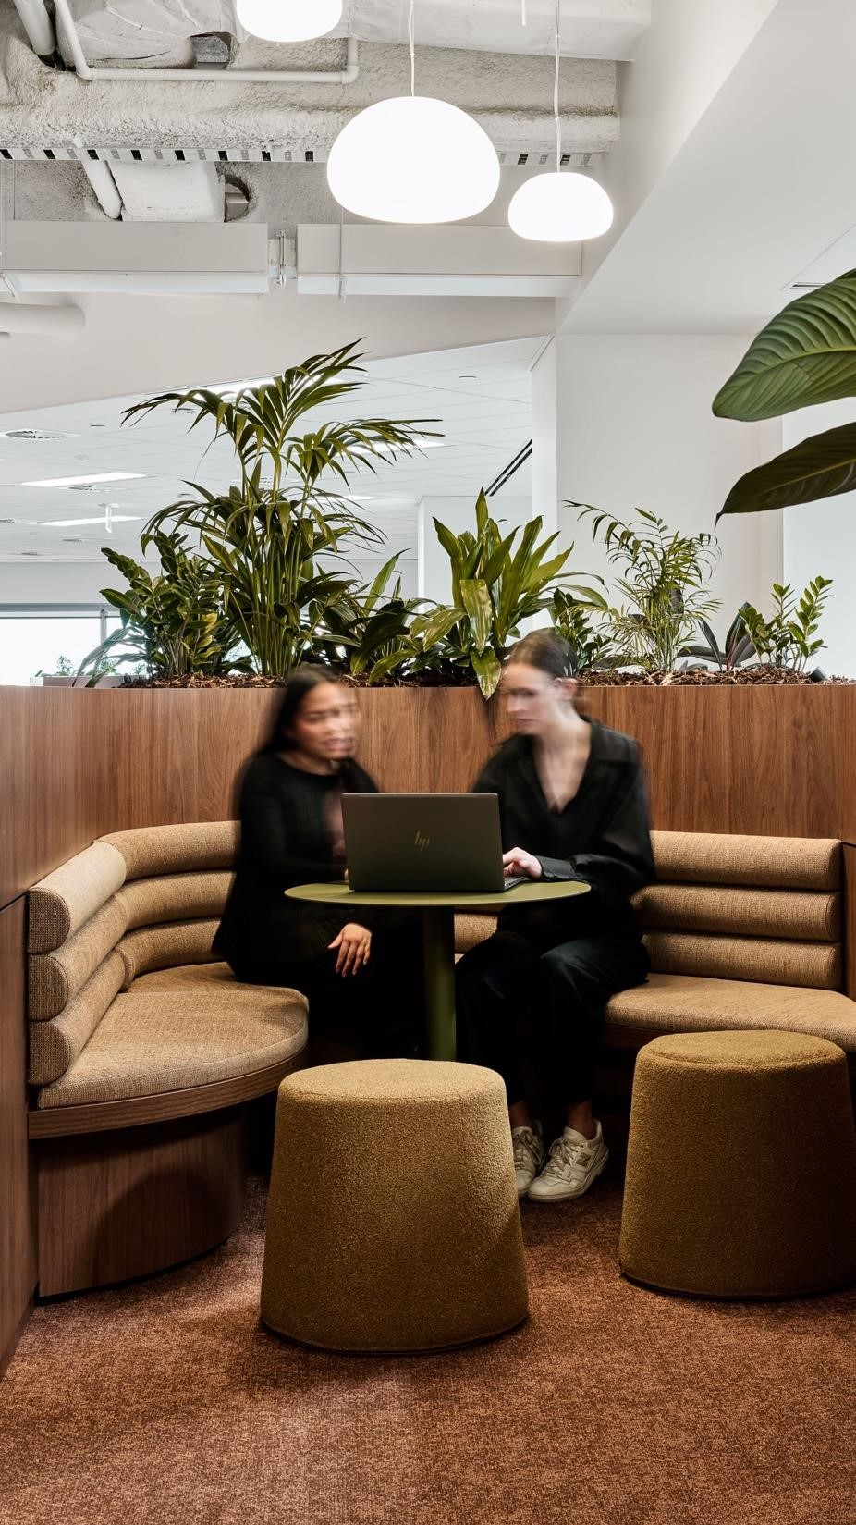
$/sqm
NAM
LATAM
EMEA
APAC
Global
$0
$500
$1,000
$1,500
$2,000
$2,500
$3,000
$3,500
$4,000
Average cost per city in region ($/sqm)
Source: JLL Research
Note: All costs shown in USD. Total fit-out cost $/sqm.

Global Office Fit-Out Cost Guide 2025

City cost index
Understanding costs in key cities can be critical to global portfolio CAPEX planning and the implementation of corporate design requirements across global locations. To understand the relative difference in costs between cities, comparable costs of office fit-outs in each city are assessed against a baseline to London.
The top 20 cities are dominated by U.S. cities alongside other major global cities including Vancouver, Tokyo, London and Dubai. These cities remain comparable in costs, with continued competition for Grade A space and in highly buoyant local economies.
Cities featuring on the lower end of the index include global cities across India, South Africa, Vietnam and China. Although costs in these locations are relatively lower, in many cases they are also experiencing high levels of construction cost growth and an evolving cost landscape. A strengthening of the U.S. dollar in past year also impacting on costs of importing materials and products in some regions.

City cost index
0 0.2 0.4 0.6 0.8 1 1.2 1.4 0 0.2 0.4 0.6 0.8 1 1.2 1.4
New York City^{Warsaw}
NAM
LATAM
EMEA
APAC
Index

London = 1
San Francisco^{Lima}
BostonTaipei
ChicagoBucharest
Los AngelesBuenos Aires
SeattleBratislava
Philadelphia^{Marrakech}
San JuanBrussels
Washington DCBudapest
DenverStockholm
ZurichHelsinki
LondonAmsterdam
MunichMadrid
VancouverPrague
DubaiLisbon
TokyoBogota
AtlantaKuala Lumpur
MiamiManila
PhoenixSantiago
DallasBangkok
RiaydhJakarta
Mexico CityBeijing
SingaporeIstanbul
DublinHo Chi Minh
LuxembourgTianjin
WellingtonJohannesburg
SydneySao Paulo
Hong KongMumbai
ParisDelhi
CairoKolkata
Tel AvivPune
MilanBangalore
SeoulHyderabad
San JoseChennaiIndex
London = 1
Macroeconomic context
While cost drivers will vary across geographies and local markets, there are common factors across many regions. Rising costs of material and labor remain key drivers, and although inflation has stabilized across most countries, it continues to be higher than in the years leading up to the pandemic.

Inflation
While most economies are not expected to see the kind of robust rates of GDP growth that would drive inflation higher, other factors threaten higher price growth. European gas prices have doubled over the last year and international shipping prices remain volatile and prone to upward swings.

Labor costs
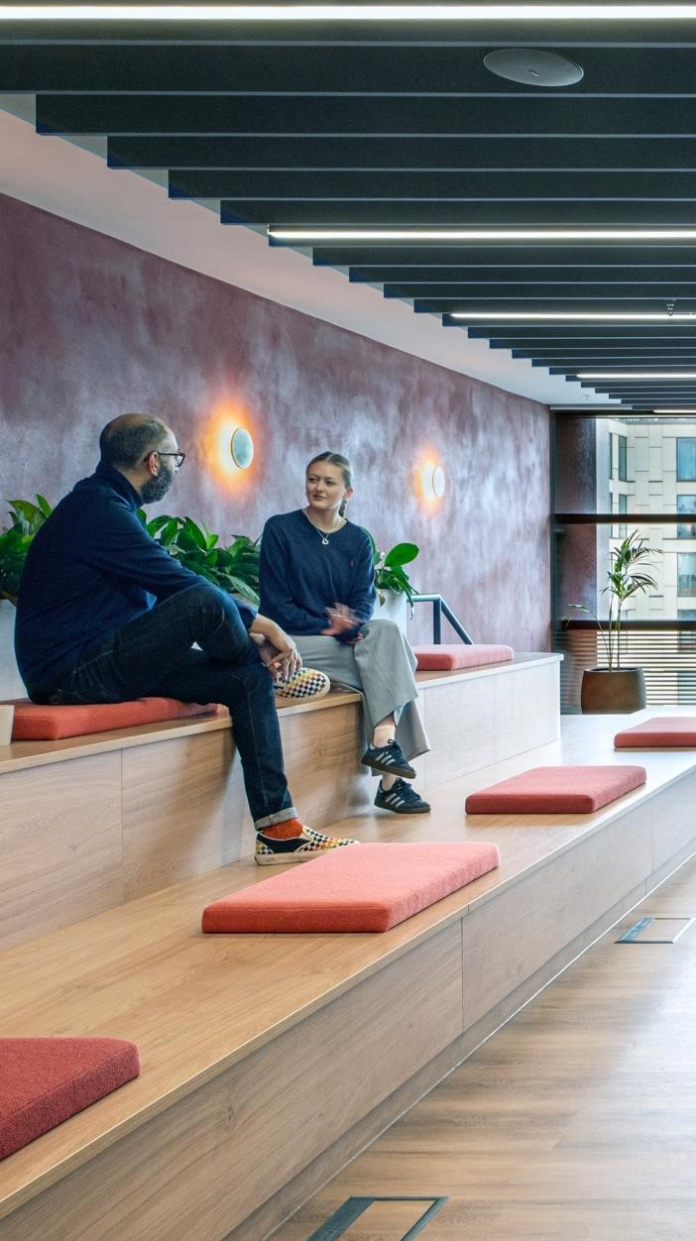
Labor costs are rising and will likely continue to increase at above inflation rates. Sectors seeing worker shortages, such as construction in many countries, will see higher wage growth still.

Raw material costs
Raw material prices rose sharply following the pandemic and have not significantly come down. Metals prices are elevated, with aluminum and copper prices close to multiyear if not multi-decade highs (excluding the pandemic period). In contrast, steel prices are in line with their prepandemic levels, though U.S. prices have shot up recently following the elevation of tariff rates on imports.

U.S. tariffs
The construction industry should anticipate potential supply chain disruptions and price volatility, especially for projects heavily reliant on imported materials. Uncertainty around U.S. foreign and domestic policy outcomes has forced the construction industry to engage change reactively, making the need to balance longer-term growth needs and short-term impacts increasingly difficult for CRE stakeholders.

Macroeconomic factors influencing construction costs across geographies

Canada
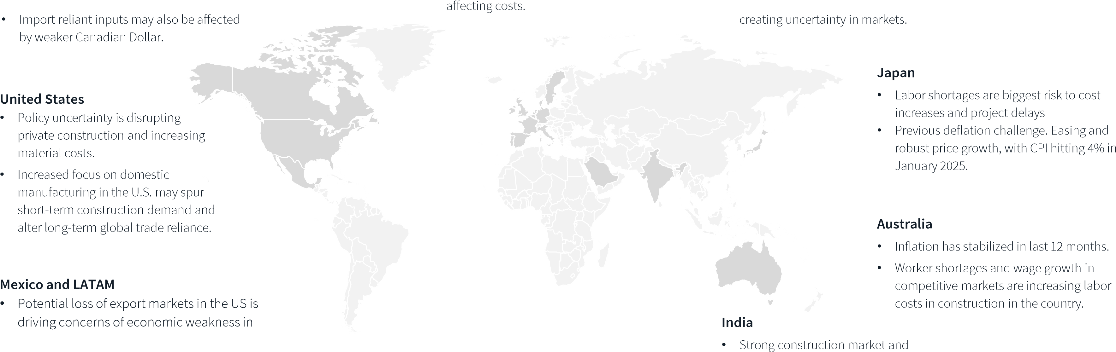
- Import tariffs with the U.S. anticipated to disproportionately impact Canadian firms and disrupt construction.
Mexico but less impactful in LATAM broadly.
- Regional inflation is expected to cool moderately but only modest growth is anticipated.
Source: JLL Research

UK
• Inflation stabilized from 2023-25. • Labor shortages increasing,

Saudi Arabia and UAE
- Imported material costs increases in 2024.
- Continued risk exposure to supply chain disruption, as shipping through Suez Canal down by more than half.

EU
- Inflation reducing in most countries, but still higher than pre-pandemic levels.
- Conflict in region and looming trade tariffs economic growth overall.
- Imported material costs increasing, with FX rates U.S. dollar a factor.

Evolving office typologies

The global office fit-out landscape exhibits significant variability, influenced by diverse factors including layout preferences, finish quality and local market dynamics.
Recent JLL research shows that space provision trends have seen continued increases and shifts towards open plan and shared desks in 2024, alongside increases in open and small enclosed meeting spaces.
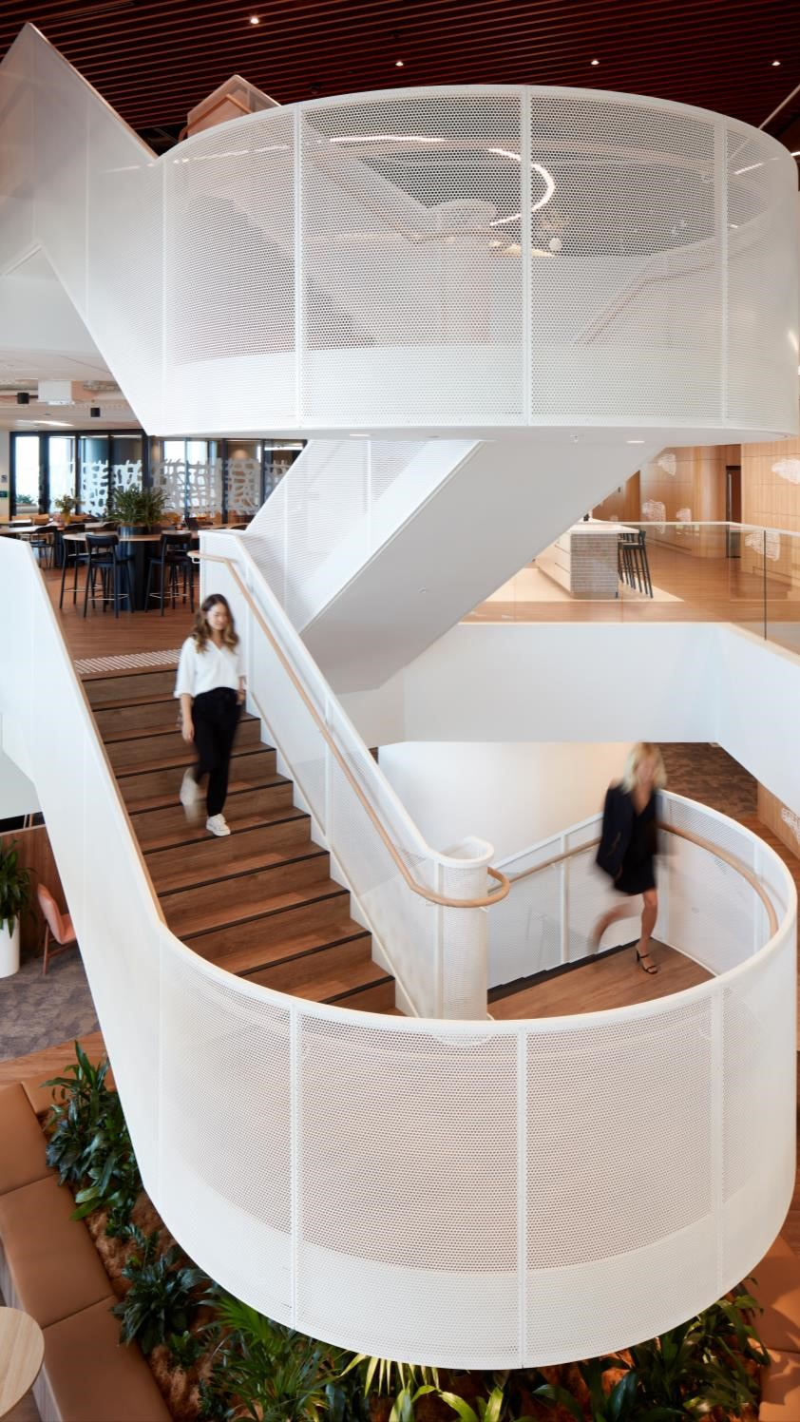
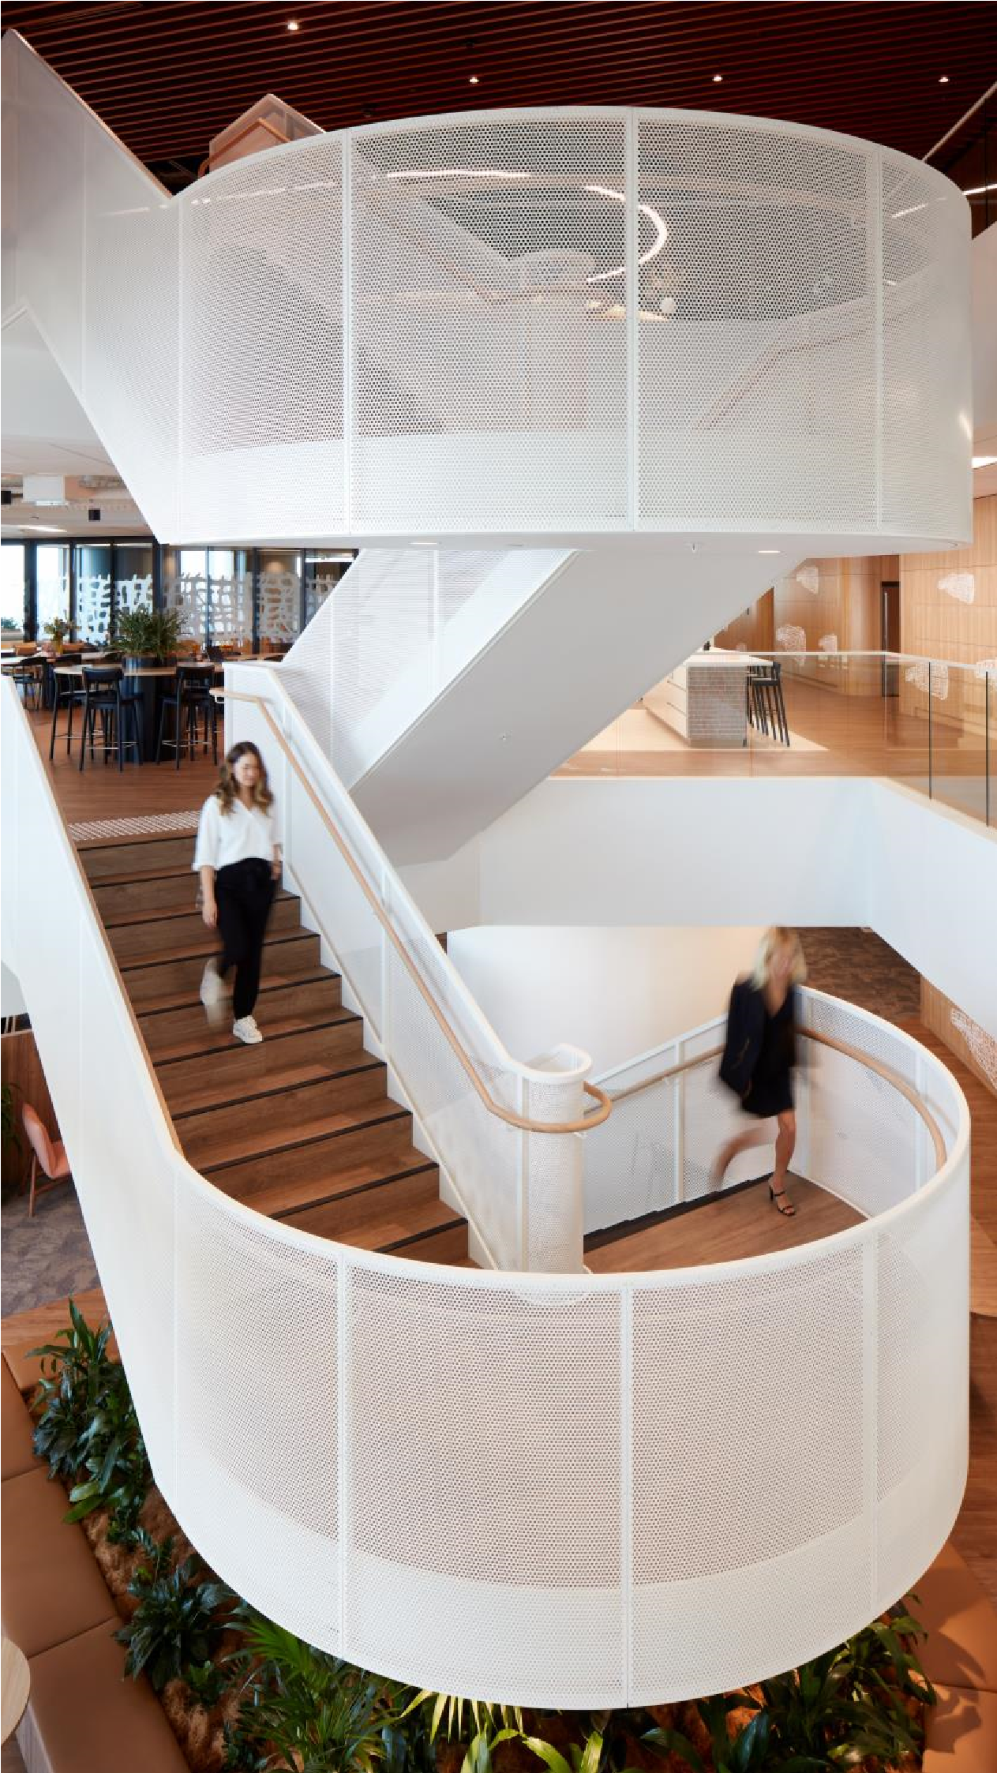
However, more recent shifts to increased in-office attendance requirements or even five day a week in office, is raising the need for more focused working. Adaptable and flexible workplace layouts are increasingly important for supporting varied collaboration activities and increases in the number of small meeting rooms in many projects are being designed to flex in function as meeting spaces and individual offices for periods of time.
As organizations focus on high-quality spaces for employee performance, experience and talent attraction, our clients are seeking to understand the costs for office design typologies and space types.
To address this complexity, a nine-point pricing matrix has been developed, adapting standardized layouts to various quality levels and office configurations. This approach enables more precise budgeting across different project goals.
While no single typology can provide the perfect solution, matching your workforce needs to space requirements is critical to inform strategic capital investment that supports corporate ambitions and workforce needs.

 | Office layout typology
Open & flexible (Progressive) | High spatial variety (Moderate) | Structured (Traditional)

Global average costs
Focus on dedicated desks single, private offices and
Open floor plan with no enclosed offices. Open floor plan with no enclosed offices. High mix of enclosed meeting rooms. Collaboration and social
Prioritization of open collaboration spaces and agile open and enclosed collaboration spaces, agile work spaces clustered in one area. work zones distributed across floor plan. zones and focus areas.
Space quality and  complexity |  | Baseline  Simple aesthetic with finishes focused on function. |  | $ 1,700 | $ 1,830 | $ 1,900
 |  | Medium  Standard project complexity with a few unique design features and average-quality materials finishes. |  | $ 1,830 | $ 1,970 | $ 2,050
 |  | High  Emphasizes top-quality finishes, with increased effort spent on aesthetics and detail design |  | $ 2,090 | $ 2,250 | $ 2,360
Regional average costs |  |  | Open & flexible |  | High spatial variety | Traditional focus
Space quality and  complexity | Asia Pacific (APAC) |  | $ 1,350 |  | $ 1,460 | $ 1,590
Space quality and  complexity | Europe, Middle East & Africa (EMEA) |  | $ 1,840 |  | $ 1,970 | $ 2,070
Space quality and  complexity | Latin America (LATAM) |  | $ 1,680 |  | $ 1,790 | $ 1,860
Space quality and  complexity | North America (NAM) |  | $ 2,840 |  | $ 3,070 | $ 3,190
Source: JLL Research
Note: All costs shown in USD. Total fit-out cost $/sqm.

Cost drivers
The global construction and fit-out industry is grappling with a complex array of cost pressures in 2025. With increased focus on the office and investment in workspaces, many organizations are seeking to understand the relative cost factors and potential associated outcomes can inform the design and delivery of office fit-outs.
While cost profiles vary regionally, Builders’ Works (from partitions and flooring, to finishes and joinery) accounts for the largest component of fit-out costs in all regions except LATAM.
With increased focus on the office, many organizations are seeking to invest in high-quality offices to boost office attendance and enhance talent attraction. Specifications of materials and finishes can have a significant impact on the quality of workplaces but can also be large variation in costs. The proportion of cost spent on Builders’ Works was found to range between 20% to 45% of costs within regions.
%
38
%
32
%
37
%
39
%
29
%
41
%
29
%
26
%
14
%
12
%
12
%
13
10
%
%
6
%
14
%
15
9
%
9
%
9
%
7
%
North America
Latin America
Europe,
Middle East, Africa
Asia Pacific
Source: JLL Research
37
%
29
%
%
13
12
%
8
%
Builders Works
M & E Services
Furniture, Fixtures, Equipment
Security, IT & AV works
Professional Services
Global
Typical fit out cost breakdown
The second largest cost is M&E services, which is also where there is most variation between regions. M&E can account for between 20% to 45% of costs, due to a combination of climatic demands and local tenant obligations within a building, which can vary extensively between countries.
Costs for Furniture, Fixtures, Equipment (FFE) range across regions from 13%-16% of total costs, comparing like-for-like specification from locally available products. Furniture costs can vary significantly depending on the availability of project specification products, with many organizations increasingly seeking to balance global design standards with greater focus on local sourcing and reducing embodied carbon footprints.
AV & Technology forms a larger component in APAC compared to other regions, reflecting the growing emphasis on technology to support greater efficiencies and hybrid working practices in the region.

Planning for sustainable fit-out

Demand for sustainable fit-outs is on the rise, with 60% of the markets surveyed reporting an increase in client enquiries for more sustainable fit-outs in the last 12 months. Corporate ambitions for sustainability remain strong, highlighted in JLL’s Future of Work survey which found 66% of organizations globally plan to increase investment in sustainability performance in the next five years.
Continued demand for Grade A office space, coupled with lack of supply, is also heightening focus on existing office buildings and what the long-term value of investing in fitouts can deliver for both occupiers and building owners.
66%
of organizations globally plan to increase investment in sustainability performance in the next five years.
66
%
71
%
73
%
74
%
77
%
78
%
Global
Canada
UK
Italy
India
KSA/UAE
Source: JLL Research, Future of Work 2024
© 2025 Jones Lang LaSalle IP, Inc. All rights reserved.
Investing in existing buildings can provide benefits in reducing both operational and embodied carbon and meeting corporate sustainability goals.
While costs for sustainable design specifications often fall within cost driver categories of material specifications, furniture and M&E Services, organizations are increasingly implementing innovative approaches, from AI enhanced building systems to upcycling furniture, to improve sustainability and manage costs.
However, one area that has received less attention, is the opportunity to consider whole-life sustainability and the impact of reinstatement on embodied carbon. Reinstatement approaches vary significantly depending on typical landlord/tenant responsibilities, in-region norms and lease requirements, but increased focus on embodied carbon, led by global city policies, is likely to drive greater collaboration on the impact of reinstatement at lease ends.

Mechanical & Electrical (M&E) Services is often an
area associated with higher costs related to higher
environmental standards or green certifications, often
comprising a high proportion of upfront costs but
with some of the most significant long
-
term benefits
for lowering operational costs. In the context of
continued rising energy prices, forward
-
looking
organizations will be focusing on targeted investment
in M&E solutions to future
-
proof.
Across all countries, M&E Services costs were found to
be on average 29% of total fit
-
out costs, with some
regions even higher reporting 35%
-
45
% of costs. The
costs of M&E services can vary significantly due to the
costs of importing mechanical systems in some
countries, high competition for specialized services in
smaller markets, and higher load requirements in
response to some climatic needs.
However, these upfront costs are often where the
greatest long
-
term cost efficiencies can be found, as
research has also shown that investing in M&E
upgrades can save between 10%
-
% on operational
40
energy costs depending on the level of investment or
upgrade (JLL Research, 2024).
%
29
41
%
%
29
26
%
29
%
%
0
20
%
40
%
%
60
North America
Latin America
Europe, Middle East,
Africa
Asia Pacific
Global
Top 15 cities with highest proportion of
overall costs allocated to M&E Services
%
0
%
10
20
%
%
30
40
%
50
%
%
60
San Juan
Bogota
Santiago
Dublin
Buenos Aires
Cairo
San Jose
Berlin
Warsaw
Lima
Milan
Mexico City
New York City
Chicago
Dubai
Boston
APAC
EMEA
LATAM
NAM
Source: JLL Research
Note: Total fit
-
out cost $/sqm
.
Average proportion of costs for M&E
Services by region

Reinstatement and whole life considerations
Reinstatement costs, also known as dilapidations or asset restoration obligations, is a term that generally describes a tenant’s liability at the end of their lease of how they must return the premises to the landlord.
Reinstatement requirements can have both positive or negative impacts on sustainability outcomes and metrics as an important but often overlooked aspect of whole-life impact of a fit-out.
With increasing costs for materials, furniture and finishes, forward-looking organizations will be considering how alternative reinstatement models could create both cost and carbon savings. Central to the success of these will be collaborative partnerships between landlords and tenants to identify opportunities for re-use and enhancement of existing fixtures and fittings.
Source: JLL Research
Note: All costs shown in USD. Total fit-out cost $/sqm.

Average regional costs for reinstatements*
Europe, Middle East, Africa | Asia Pacific | Americas (North and Latin)
$140 | $170 | $110
$
-
$100
$200
$300
$400
$500
$600
EMEA APAC AMER
*Required scope of work varies significantly from country to country. Most commonly, the work includes full reinstatement, repair and redecoration while alternative scopes include simple removal of Furniture, Fixtures and Equipment (FFE) or is rarely performed at all.

Outlook for the year ahead
1
2
3
Office market bouncing back Now is the time for decisive investment On watch – U.S. Policies
As trends in office leasing and expansion activity are seeing upturns in many countries, increased demand and limited supply for Grade A office space in prime locations is anticipated to continue throughout 2025 and in the long-term.  With office development and new construction at historic lows, there will be greater focus on lease renewals and upgrading existing buildings as an alternative. |  | Delays in decision-making and hesitancy around investment in the past few years have led to tighter timeframes for leasing and capital projects, with implications on material supply and labor channels.  Early planning for lease ends and decisive investment in existing buildings will benefit landlords and occupiers and help to plan for and manage associated costs. |  | U.S. policy shifts on trade, immigration and defense spending have broad implications for commercial real estate globally. Beyond direct cost impacts on core materials and U.S. construction labor availability, new trade and manufacturing patterns will have long-term effects on global demand for industrial, warehousing and the service sector and infrastructure to support changing economies. The final scope tariffs cover, immigration policy enforcement, and changes in federal spending will dictate how the next cycle proceeds in the U.S. and how acutely the impacts are felt internationally.

Research authors

Ruth Hynes
Director, Research & Strategy
Work Dynamics Research EMEA Ruth.hynes@jll.com

PDS Contacts

Martin Hinge
Executive Managing Director, PDS Asia Pacific martin.hinge@jll.com

Daniel Malacchini
Head of Cost Advisory and Cost Management, PDS, APAC daniel.malacchini@jll.com Andrew Volz
Construction Research Manager Work Dynamics Research AMER andrew.volz@jll.com

Louis Molinini
Americas Head of Variable Business,
PDS AMER
louis.molinini@jll.com

Daniel Pomfrett
Senior Vice President, Cost Management, PDS, AMER daniel.pomfrett@jll.com Shweta Choudhari Director, Research & Strategy Work Dynamics Research APAC shweta.choudhari@jll.com
Nick Winter Head PDS and Tetris, EMEA nick.winter@jll.com

Elaine O’Connor
Chief Operating Officer, PDS EMEA and Tetris elaine.oconnor@jll.com Research at JLL
JLL’s research team delivers intelligence, analysis and insight through marketleading reports and services that illuminate today’s commercial real estate dynamics and identify tomorrow’s challenges and opportunities. Our more than 550 global research professionals track and analyze economic and property trends and forecast future conditions in over 60 countries, producing unrivalled local and global perspectives. Our research and expertise, fueled by real-time information and innovative thinking around the world, creates a competitive advantage for our clients and drives successful strategies and optimal real estate decisions.

About JLL
For over 200 years, JLL (NYSE: JLL), a leading global commercial real estate and investment management company, has helped clients buy, build, occupy, manage and invest in a variety of commercial, industrial, hotel, residential and retail properties. A Fortune 500® company with annual revenue of $23.4 billion and operations in over 80 countries around the world, our more than 112,000 employees bring the power of a global platform combined with local expertise. Driven by our purpose to shape the future of real estate for a better world, we help our clients, people and communities SEE A BRIGHTER WAY℠. JLL is the brand name, and a registered trademark, of Jones Lang LaSalle Incorporated. For further information, visit jll.com.

© 2025 Jones Lang LaSalle IP, Inc. All rights reserved.
This report has been prepared solely for information purposes and does not necessarily purport to be a complete analysis of the topics discussed, which are inherently unpredictable. It has been based on sources we believe to be reliable, but we have not independently verified those sources and we do not guarantee that the information in the report is accurate or complete. Any views expressed in the report reflect our judgment at this date and are subject to change without notice. Statements that are forward-looking involve known and unknown risks and uncertainties that may cause future realities to be materially different from those implied by such forward-looking statements. Advice we give to clients in particular situations may differ from the views expressed in this report. No investment or other business decisions should be made based solely on the views expressed in this report.

