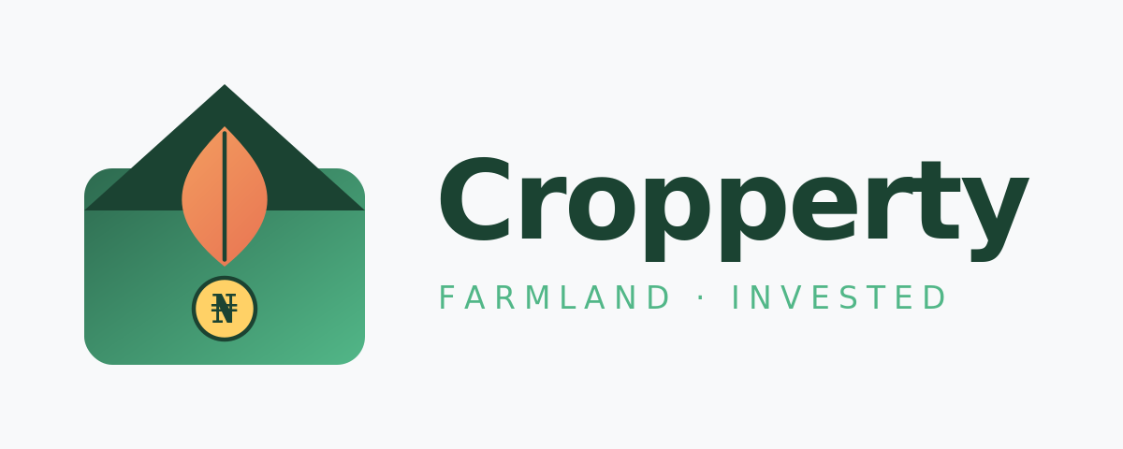
WEBSITE & MOBILE APP
DEVELOPMENT PROPOSAL
Premium fintech-grade build · Customer · Agent · Admin
PREPARED BY  Semester Integrated Limited  Digital product studio  admin@semestertech.ng | PREPARED FOR  Cropperty  Farmland investment platform  Founders & technical leadership
Date: 7 May 2026 · Validity: 30 days ·

1. Executive Summary
Cropperty is poised to do for Nigerian farmland what FarmTogether did forAfrica equities and what FarmCrowdy attempted for crop sponsorship — but with a sharper edge: real, titled land you actually own, paid for outright or in flexible monthly installments, with a referral-driven agent network and a transparent admin spine.
Semester Integrated Limited proposes to design and build the full Cropperty product: a marketing website, a customer-facing iOS and Android app, an Agent Portal with a commission engine, and an Admin Operations Console — all wired to a single secure backend. The build is engineered for trust (titled-land verification, escrow, KYC), for retention (live farm telemetry, dashboards, payouts), and for growth (referral attribution, viral sharing, smart matching).
WHY THIS IS A WINNING BET
- ₦150M+ poured into Nigerian agritech between 2023–2025 — the appetite is proven, the category leader is open.
- No incumbent in Nigeria currently combines titled-land ownership + installment pay + agent referrals in one product.
- Semester Integrated has shipped trust-heavy fintech and telco platforms (e.g., Derain services) — the same discipline applied to farmland.

2. Market & Competitive Landscape
We pressure-tested the opportunity against the actual platforms Nigerian and diaspora investors compare Cropperty to. The verdict: the structural gap is real, and Cropperty is positioned to take it.

2.1 The market
- Nigeria’s agritech sector raised over $150M between 2023 and 2025 — capital is flowing, exits are starting to materialise.
- Real estate investment apps (Risevest, Estate Intel, PropertyPro) are normalising mobile-first ownership of physical assets.
- A growing diaspora cohort actively seeks titled, productive land back home — but is repelled by paperwork, distance, and trust gaps.
- Nigeria has 70M+ hectares of arable land, of which only ~40% is cultivated — vast supply on the merchant side.

2.2 Where competitors fall short
PLATFORM | CORE MODEL | WHAT WORKS | CROPPERTY EDGE
FarmCrowdy | Crop sponsorship per cycle | Demand-led farmer network | Cropperty offers titled land, not seasonal crop slots — lasting equity, not a 6-month bet.
ThriveAgric | Leases land + contracts farmers | Strong field operations | No consumer-app polish, no installment ownership; Cropperty fronts a fintech-grade UX.
PropertyPro | Listings marketplace | Massive listing inventory | Not transactional or ROI-focused; Cropperty closes the loop end-to-end.
AcreTrader / FarmTogether | Fractional US farmland | Institutional-grade dashboards | No African footprint; Cropperty becomes the African analogue with installment innovation.

2.3 The Cropperty wedge
- Titled ownership (C of O / Governor’s Consent) — the asset is real, transferable and inheritable.
- Outright OR 6/12/24-month installment — financial inclusion at the centre, not the edge.
- Live farm telemetry (drone imagery, soil and crop data) — investors see what they own.
- Agent referral graph with multi-tier commission — every offline broker becomes a growth lever.

3. Personas & User Journeys
Three product surfaces, three loops. Each persona has a primary success state we instrument and optimise for from week one.

3.1 The Investor (Customer)
Profile  Adaeze, 32 — Lagos-based marketing director with ₦8M to deploy and a plan of 1–4 years. | Goals  • Inflation-resistant store of value  • Tangible, productive asset she can visit  • Predictable monthly outflow if paying installments
Frictions today  Title fraud, illiquid land deals, opaque ROI, brokers ghosting after payment. | Cropperty journey  1. Onboard with NIN + BVN in <90 seconds  4. Choose outright or 12-month plan; sign C of O digitally  6. Refer a friend → unlocks ₦5,000 credit each

3.2 The Agent (Referrer)
Profile  Tunde, 41 — independent property broker in Abeokuta with a WhatsApp Group of 600 prospects. | Goals  • Predictable, reportable commission  • Tools to convert WhatsApp leads  • Zero paperwork between him and his client
Frictions today  Commission disputes, lost paperwork, no way to track who is closing. | Cropperty journey  1. Apply to Agent Programme — vetted in 24 hrs  2. Get unique referral link + QR + branded share kit  3. Send to client; system attributes the lead automatically  4. Sees deal pipeline (lead → KYC → reservation → installment 1 → close)  5. Commission accrues on every cleared installment, withdrawn weekly/monthly

3.3 The Operator (Admin)
Profile  Cropperty internal team — Operations, Compliance, Finance, Land-acquisition, Customer Success. | Goals  • One console for everything: listings, KYC, payments, agents, support  • Audit-grade trail for every state change  • Dashboards that flag risk before it becomes a fire

4. Design Direction & Visual Concepts
Brand language: confident agricultural modernism. Deep forest greens (₦ trust), warm harvest gold (yield, return), generous whitespace, a typographic system anchored in Inter. Imagery skews aerial / drone — investors should feel the scale of what they own.

CONCEPT SCREENS
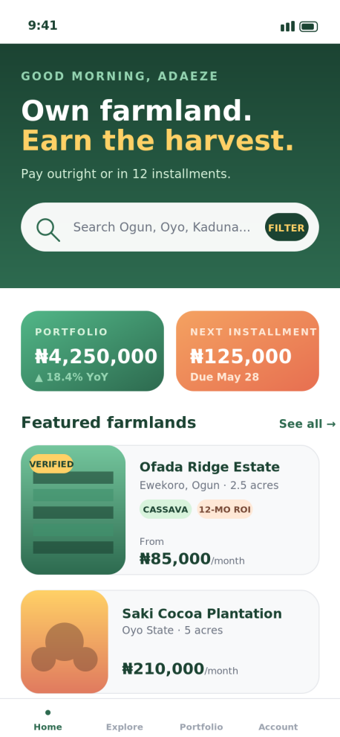  Investor Home  Daily-use surface: portfolio, next installment, featured plots. | 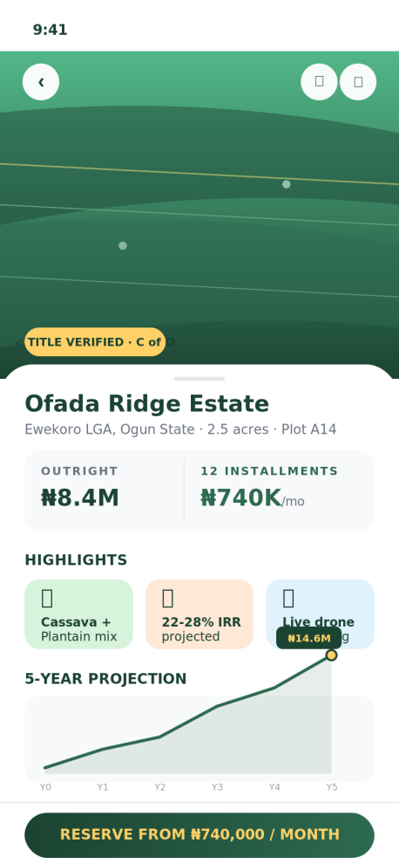  Plot Detail  Title verification, dual pricing, 5-yr ROI projection, sticky CTA. | 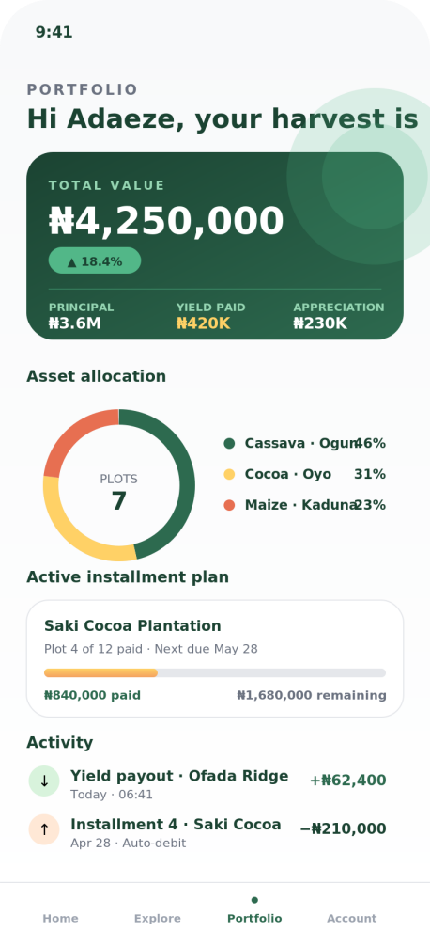  Portfolio  Total value, allocation, installment progress, activity stream.
These are concept directions, not final UI. Final fidelity is delivered in Figma during Phase 2 with a full design system (tokens, components, dark mode, accessibility).

5. Feature Specification
Premium tier — fully featured across the three surfaces. Every feature below is in scope for the all-in price.

5.1 Customer (Investor) — Web + iOS + Android
FEATURE | WHAT IT DOES
Onboarding & KYC | NIN / BVN verification,
Smart Listing Discovery | Map + list views, filters (state, crop, ROI band, lot size, payment plan), saved searches, alerts.
Plot Detail & Verification | Drone imagery, satellite overlay, soil & crop data, title verification badge, comparable returns.
Outright & Installment Checkout | 6/12/24-month plans, auto-debit mandate, escrow holding
Live Farm Telemetry | Monthly drone snapshots, weather alerts, harvest countdown, yield reports.
Portfolio Dashboard | Total value, principal vs yield vs appreciation, allocation donut, activity ledger, statement export.
E-Wallet | Wallet for yield payouts; withdraw to bank, reinvest into next plot, or hold in interest-bearing balance.
Referrals | Personal referral link, social share kit, ₦5,000 credit per qualifying signup, attribution tracking.
Notifications | Push, SMS, email — installment due, payout received, listing match, anomaly alert.
Help & Live Chat | In-app chat with humans, FAQ search, ticket history, WhatsApp deflect.

5.2 Agent Portal — Web + App
FEATURE | WHAT IT DOES
Vetted Onboarding | Application form, ID + address verification, agreement e-sign; Cropperty admin approves in <24 hrs.
Smart Referral Engine | Personal link + QR + branded image kit; UTM-coded; deep links into chosen plot.
Lead Pipeline (CRM-lite) | Kanban: New → KYC → Reservation → Installment 1 → Closed; notes, reminders, WhatsApp templates.
Multi-tier Commission | Configurable: % on outright sales, recurring % on each cleared installment, tier bonuses, override on sub-agents.
Earnings Wallet | Real-time balance, pending vs cleared, withdraw to bank, statement download for tax.
Targets & Leaderboard | Monthly target, progress, peer leaderboard (opt-in); fuels healthy competition.

5.3 Admin Operations Console — Web
FEATURE | WHAT IT DOES
RBAC & Audit | Role-based access (Ops, Compliance, Finance, Land, Support, Super-admin); every state change time-stamped & immutable.
Listing CMS | Upload plots, photos, drone, title docs; geo-fenced map; publish workflow with approver.
KYC Review Queue | Manual override, rejection reasons, document re-request; SLA timer; bulk actions.
Payments & Reconciliation | Paystack/Flutterwave/Monnify integration, escrow ledger, dunning, retry rules, refund flows.
Agent Management | Approve/suspend agents, set commission tiers, override individual deals, dispute resolution console.
Analytics & BI | Cohort retention, conversion funnel, ARR by state, agent productivity, anomaly alerts.
Customer Support Console | Unified inbox (in-app, email, WhatsApp), macro responses, ticket routing, customer 360 view.
Content & Notifications | Create campaigns, segment users, A/B subject lines, push/SMS/email orchestration.
Land Operations | Field officer module — drone scheduling, harvest tracking, yield reconciliation, agronomist notes.

6. Implementation Timeline
Fourteen weeks, parallelised. Design and back-end skeletons start in week 1; mobile and web feature work begins as soon as the design system stabilises in week 4.
PHASE | WEEK | WORK
Phase 0 · Discover | Week 1 | Stakeholder workshops, persona validation, success-metric definition, technical RFC.
Phase 1 · Design | Weeks 2–4 | Information architecture, wireframes, hi-fidelity Figma, design system, motion tokens, accessibility audit.
Phase 2 · Customer(Web + Mobile App) | Weeks 5–7 | Listings, plot detail, checkout, installments, dashboard, wallet, referrals, push.
Phase 3 · Agent(web + mobile) | Weeks 8–10 | Agent portal, commission engine, Agent dashboards,
Phase 4 ·Admin | Weeks 11–13 | admin console, BI dashboards, support inbox.
Phase 5 · Testing | Weeks 14–15 | Security audit, load test, accessibility, content polish, store submission.
Phase 6 · Launch | Week 16 | Web App Hosing, Andriod Playstore, Apple Store

7. Investment & Commercials
All figures in Nigerian Naira, exclusive of VAT. Third-party SaaS (Mapbox,Identity Verification, Payment Geteway) is billed at cost and re-billed transparently to Cropperty.

7.1 One-time build fee
WORKSTREAM | INCLUSIONS | AMOUNT (₦)
Company Full Branding | Full Brand Design(Logo, Typography,Marketing Marchandise) | 500,000
Product & UX design | Brand system, hi-fidelity Figma, prototype, accessibility audit. | 2,000,000
Front-End Web app | Responsive web app for investors,Agetn and Admin | 3,000,000
Mobile Application | iOS and Android | 3,000,000
Backend & integrations | Rest API, Postgres, Redis, queues, Payment Gateway, Map | 2,000,000
QA & security audit | Manual + automated QA, OWASP ASVS L2 review, third-party pen-test. | 1,000,000
DevOps & launch | CI/CD, observability, Apple and Google store submission, 30-day hypercare. | 1,000,000
TOTAL | ₦12,500,000

7.2 Payment milestones
MILESTONE | TRIGGER | AMOUNT
1. Mobilisation | Contract sign | ₦3,750,000 (30%)
2. Design sign-off | End of week 4 | ₦3,750,000 (30%)
3. Customer beta | TestFlight + APK live | ₦3,750,000 (30%)
4. Public launch | Stores live | ₦1,250,000 (10%)

8. Why Semester Integrated Limited
We have shipped trust-heavy digital platforms (telecom self-service, e-commerce, appointment systems) for clients who could not afford for the rails to wobble. The same operational discipline now bent toward farmland fintech.
- Senior team only — no rotating juniors, no offshored handoffs.
- Fixed scope, fixed price, milestone-based — the risk of overrun sits with us, not Cropperty.
- Source code, designs, infrastructure are 100% owned by Cropperty from day one.
- Three-month post-launch warranty included for any defect attributable to the build.
- Optional founders’ equity-flex: up to 20% of the build fee can be converted into a SAFE on agreed terms — we want to be on the same side of the table.

09. Next Steps
- Sign this proposal — kick-off in 3 working days.
- Mobilisation invoice issued; we lock the team and book the staging environment.
- Discovery workshop (full day, hybrid) within 3 days of sign.
- Design and engineering sprints begin; first demo in week 4.
Cropperty has the thesis. We have the build muscle. Together, this is the platform that takes Nigerian farmland mainstream.
Ready when you are,
The Semester Integrated Limited team

