**Nama Program :** Volume Bola

**Software :** MinGW Developer Studio

**Bahasa :** C++

**Script Program :**

#include <iostream.h>

int main()

{

float r1, r2, r3, volume_bola;

cout<<"masukan nilai r1: ";

cin>> r1;

cout<<"masukan nilai r2: ";

cin>> r2;

cout<<"masukan nilai r3: ";

cin>> r3;

volume_bola=4/3*3.14*r1*r2*r3;

cout<<"nilai volume_bola adalah: "<<volume_bola<<endl;

}

**Output Program :** 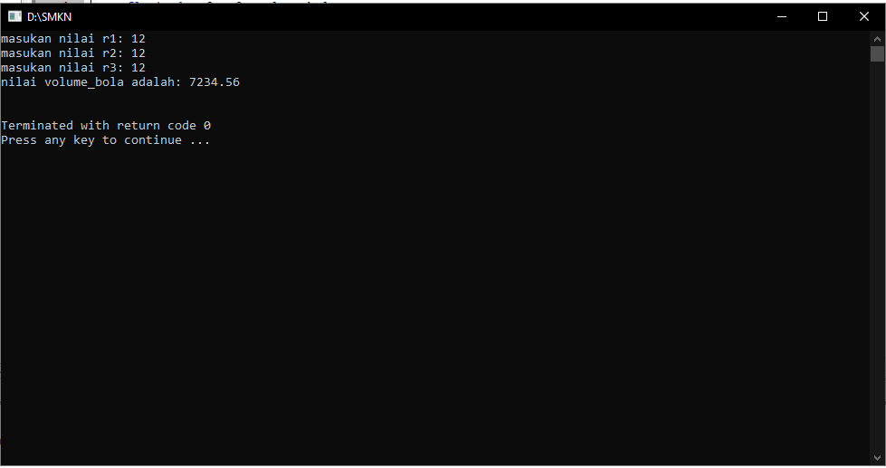

**Flowchart :**

Stop

Hasil Volume

V=4/3*3.14*

Masukan Jari-Jari: r

Start