nginx目录

/etc/nginx

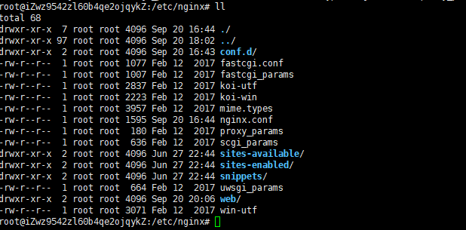

**vim nginx.conf**

user www-data;

worker_processes auto;

pid /run/nginx.pid;

events {

worker_connections 768;

# multi_accept on;

}

http {

##

# Basic Settings

##

sendfile on;

tcp_nopush on;

tcp_nodelay on;

keepalive_timeout 65;

types_hash_max_size 2048;

# server_tokens off;

# server_names_hash_bucket_size 64;

# server_name_in_redirect off;

include /etc/nginx/mime.types;

default_type application/octet-stream;

##

# SSL Settings

##

ssl_protocols TLSv1 TLSv1.1 TLSv1.2; # Dropping SSLv3, ref: POODLE

ssl_prefer_server_ciphers on;

##

# Logging Settings

##

access_log /var/log/nginx/access.log;

error_log /var/log/nginx/error.log;

##

# Gzip Settings

##

gzip on;

gzip_disable "msie6";

# gzip_vary on;

# gzip_proxied any;

# gzip_comp_level 6;

# gzip_buffers 16 8k;

# gzip_http_version 1.1;

# gzip_types text/plain text/css application/json application/javascript text/xml application/xml application/xml+rss text/javascript;

##

# Virtual Host Configs

##

include /etc/nginx/conf.d/*.conf;

include /etc/nginx/sites-enabled/*;

include /etc/nginx/web/todolist.conf;

include /etc/nginx/web/customer.conf;

#include /etc/nginx/web/customer2.conf;

}

#mail {

# # See sample authentication script at:

# # http://wiki.nginx.org/ImapAuthenticateWithApachePhpScript

#

# # auth_http localhost/auth.php;

# # pop3_capabilities "TOP" "USER";

# # imap_capabilities "IMAP4rev1" "UIDPLUS";

#

# server {

# listen localhost:110;

# protocol pop3;

# proxy on;

# }

#

# server {

# listen localhost:143;

# protocol imap;

# proxy on;

# }

#}

红色部分为对应项目的nginx配置文件，todolist项目的nginx配置文件路径为web目录下的todolist.conf

各项目的nginx配置文件集中放在web目录下

**cd web**

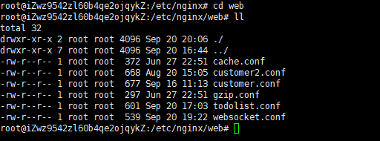

**vim todolist.conf**

server {

listen 8080;

root /home/liuyuanbing/todolist/frontend/build;

index index.html index.htm;

include /etc/nginx/web/gzip.conf;

include /etc/nginx/web/cache.conf;

location / {

try_files $uri $uri/ /index.html;

# /index.html;

}

location ^~ /user/ {

proxy_pass http://127.0.0.1:8082;

}

location ^~ /todolist/ {

proxy_pass http://127.0.0.1:8082;

}

include /etc/nginx/web/websocket.conf;

location ^~ /assets/ {

gzip_static on;

expires max;

add_header Cache-Control public;

}

error_page 500 502 503 504 /500.html;

client_max_body_size 20M;

keepalive_timeout 10;

}

服务器nginx配置文件夹目录见github