nginx目录

/etc/nginx

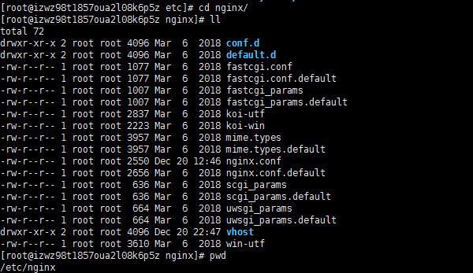

nginx配置

nginx/vhost目录下node_react.conf



nginx根目录下nginx.conf



nginx.conf 配置

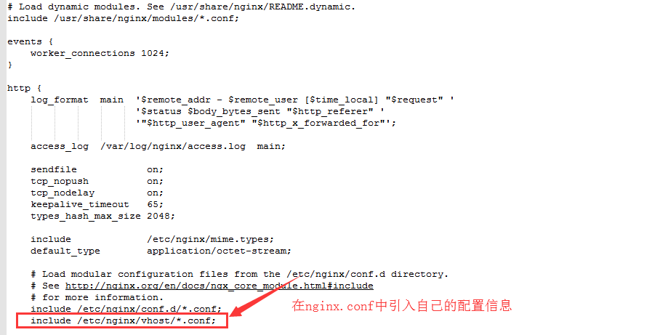

node_react.conf 配置

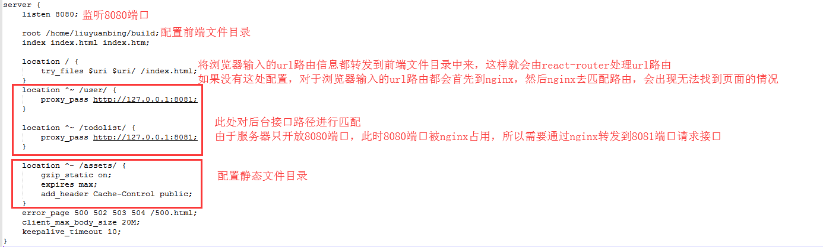

最新配置：对build文件夹的路径进行了调整

server {

listen 8080;

root /home/liuyuanbing/todolist/frontend/build;

index index.html index.htm;

location / {

try_files $uri $uri/ /index.html;

# /index.html;

}

location ^~ /user/ {

proxy_pass http://127.0.0.1:8081;

}

location ^~ /todolist/ {

proxy_pass http://127.0.0.1:8081;

}

location ^~ /assets/ {

gzip_static on;

expires max;

add_header Cache-Control public;

}

error_page 500 502 503 504 /500.html;

client_max_body_size 20M;

keepalive_timeout 10;

}