Exercise 1

1.IP address of the website [www.koala.com.au](http://www.koala.com.au) is

104.18.60.21,

104.18.61.21,

And 172.67.219.46. I think the answer of why have several IP addresses as an output is

1. It is easy to use, easy to change and cheap
2. As a mattress company, multiple IP addresses can separate customers to different address to collect the data.
3. Link customers to their closest address to accelerate access

2. name = localhost ,the different is 127.0.0.1 can use uslookup to get the host which is local host but localhost won’t use uslookup to get 127.0.0.1 because actually its not a real internet ip

Exercise 2

* [www.unsw.edu.au](http://www.unsw.edu.au/)  reachable
* [www.getfittest.com.au](http://www.getfittest.com.au/)  unreachable (host is not exist
* [www.mit.edu](http://www.mit.edu/) reachable
* [www.intel.com.au](http://www.intel.com.au/) reachable
* [www.tpg.com.au](http://www.tpg.com.au/) reachable
* [www.hola.hp](http://www.hola.hp/) unreachable (host is not exist
* [www.amazon.com](http://www.amazon.com/) reachable
* [www.tsinghua.edu.cn](http://www.tsinghua.edu.cn/) reachable
* [www.kremlin.ru](http://www.kremlin.ru/) unreachable but are reachable from the Web browser (pack lose, maybe because multi-path fading that make signal degradation)
* 8.8.8.8 reachable

Exercise 3:

1.traceroute to www.columbia.edu (128.59.105.24), 30 hops max, 60 byte packets

1 cserouter1-server.cse.unsw.EDU.AU (129.94.242.251) 0.101 ms 0.084 ms 0.076 ms

2 129.94.39.17 (129.94.39.17) 0.902 ms 0.932 ms 0.889 ms

3 libudnex1-vl-3154.gw.unsw.edu.au (149.171.253.34) 1.373 ms 1.596 ms 1.444 ms

4 ombcr1-po-5.gw.unsw.edu.au (149.171.255.197) 1.146 ms ombcr1-po-6.gw.unsw.edu.au (149.171.255.169) 1.143 ms libcr1-po-5.gw.unsw.edu.au (149.171.255.165) 1.117 ms

5 unswbr1-te-2-13.gw.unsw.edu.au (149.171.255.105) 1.222 ms unswbr1-te-1-9.gw.unsw.edu.au (149.171.255.101) 1.227 ms unswbr1-te-2-13.gw.unsw.edu.au (149.171.255.105) 1.228 ms

6 138.44.5.0 (138.44.5.0) 1.363 ms 2.048 ms 2.050 ms

7 et-1-3-0.pe1.sxt.bkvl.nsw.aarnet.net.au (113.197.15.149) 2.132 ms 2.322 ms 2.081 ms

8 et-0-0-0.pe1.a.hnl.aarnet.net.au (113.197.15.99) 95.276 ms 95.280 ms 95.271 ms

9 et-2-1-0.bdr1.a.sea.aarnet.net.au (113.197.15.201) 146.930 ms 146.933 ms 146.945 ms

10 abilene-1-lo-jmb-706.sttlwa.pacificwave.net (207.231.240.8) 159.973 ms 159.928 ms 159.966 ms

11 ae-1.4079.rtsw.minn.net.internet2.edu (162.252.70.173) 192.809 ms 192.814 ms 192.805 ms

12 ae-1.4079.rtsw.eqch.net.internet2.edu (162.252.70.106) 201.350 ms 201.452 ms 201.211 ms

13 ae-0.4079.rtsw3.eqch.net.internet2.edu (162.252.70.163) 227.008 ms 213.957 ms 213.907 ms

14 ae-1.4079.rtsw.clev.net.internet2.edu (162.252.70.130) 209.787 ms 209.857 ms 209.857 ms

15 buf-9208-I2-CLEV.nysernet.net (199.109.11.33) 213.375 ms 213.607 ms 213.500 ms

16 syr-9208-buf-9208.nysernet.net (199.109.7.193) 217.104 ms 217.403 ms 217.364 ms

17 nyc111-9204-syr-9208.nysernet.net (199.109.7.94) 226.522 ms 226.546 ms 226.525 ms

18 nyc-9208-nyc111-9204.nysernet.net (199.109.7.165) 225.639 ms 226.032 ms 225.809 ms

19 columbia.nyc-9208.nysernet.net (199.109.4.14) 225.710 ms 225.753 ms 225.739 ms

20 cc-core-1-x-nyser32-gw-1.net.columbia.edu (128.59.255.5) 226.764 ms 226.724 ms 226.751 ms

21 cc-conc-1-x-cc-core-1.net.columbia.edu (128.59.255.21) 226.315 ms 226.111 ms 226.061 ms

22 columbiauniversity.info (128.59.105.24) 225.879 ms 225.906 ms 225.945 ms

There are 22 routers are there between mine workstation and [www.columbia.edu](http://www.columbia.edu/)

There are 4 routers along the path are part of the UNSW network

Between 7 and 8 packets cross the Pacific Ocean

2.

traceroute to www.ucla.edu (164.67.228.152), 30 hops max, 60 byte packets

1 cserouter1-server.cse.unsw.EDU.AU (129.94.242.251) 0.093 ms 0.068 ms 0.052 ms

2 129.94.39.17 (129.94.39.17) 0.854 ms 0.812 ms 0.820 ms

3 ombudnex1-vl-3154.gw.unsw.edu.au (149.171.253.35) 1.176 ms libudnex1-vl-3154.gw.unsw.edu.au (149.171.253.34) 1.599 ms 1.603 ms

4 ombcr1-po-6.gw.unsw.edu.au (149.171.255.169) 1.088 ms 1.022 ms libcr1-po-6.gw.unsw.edu.au (149.171.255.201) 1.024 ms

5 unswbr1-te-1-9.gw.unsw.edu.au (149.171.255.101) 1.120 ms 1.076 ms 1.116 ms

6 138.44.5.0 (138.44.5.0) 1.217 ms 1.271 ms 1.258 ms

7 et-1-3-0.pe1.sxt.bkvl.nsw.aarnet.net.au (113.197.15.149) 2.153 ms 2.161 ms 2.178 ms

8 et-0-0-0.pe1.a.hnl.aarnet.net.au (113.197.15.99) 95.087 ms 95.113 ms 94.955 ms

9 et-2-1-0.bdr1.a.sea.aarnet.net.au (113.197.15.201) 146.911 ms 146.828 ms 146.888 ms

10 cenichpr-1-is-jmb-778.snvaca.pacificwave.net (207.231.245.129) 163.474 ms 164.142 ms 164.179 ms

11 hpr-lax-hpr3--svl-hpr3-100ge.cenic.net (137.164.25.73) 160.596 ms 159.961 ms 160.517 ms

traceroute to www.u-tokyo.ac.jp (210.152.243.234), 30 hops max, 60 byte packets

1 cserouter1-server.cse.unsw.EDU.AU (129.94.242.251) 0.090 ms 0.163 ms 0.161 ms

2 129.94.39.17 (129.94.39.17) 0.915 ms 0.864 ms 0.903 ms

3 ombudnex1-vl-3154.gw.unsw.edu.au (149.171.253.35) 1.734 ms 2.051 ms 1.695 ms

4 libcr1-po-6.gw.unsw.edu.au (149.171.255.201) 1.100 ms libcr1-po-5.gw.unsw.edu.au (149.171.255.165) 1.146 ms ombcr1-po-5.gw.unsw.edu.au (149.171.255.197) 1.088 ms

5 unswbr1-te-2-13.gw.unsw.edu.au (149.171.255.105) 1.055 ms 1.404 ms unswbr1-te-1-9.gw.unsw.edu.au (149.171.255.101) 1.319 ms

6 138.44.5.0 (138.44.5.0) 1.571 ms 1.413 ms 1.277 ms

7 et-0-3-0.pe1.bkvl.nsw.aarnet.net.au (113.197.15.147) 1.739 ms 1.699 ms 1.683 ms

8 ge-4_0_0.bb1.a.pao.aarnet.net.au (202.158.194.177) 155.021 ms 154.975 ms 155.010 ms

9 paloalto0.iij.net (198.32.176.24) 156.479 ms 156.506 ms 156.302 ms

10 osk004bb00.IIJ.Net (58.138.88.185) 287.058 ms 287.075 ms osk004bb01.IIJ.Net (58.138.88.189) 269.602 ms

11 osk004ip57.IIJ.Net (58.138.106.166) 269.198 ms 269.159 ms 269.125 ms

12 210.130.135.130 (210.130.135.130) 286.911 ms 278.075 ms 286.877 ms

13 124.83.228.58 (124.83.228.58) 278.303 ms 334.775 ms 334.715 ms

14 124.83.252.178 (124.83.252.178) 292.886 ms 284.123 ms 304.868 ms

15 158.205.134.26 (158.205.134.26) 275.283 ms 284.082 ms 284.144 ms

16 158.205.121.46 (158.205.121.46) 293.009 ms 284.152 ms 284.247 ms

17 * * *

18 * * *

19 * * *

20 * * *

21 * * *

22 * * *

23 * * *

24 * * *

25 * * *

26 * * *

27 * * *

28 * * *

29 * * *

30 * * *

traceroute to www.lancaster.ac.uk (148.88.65.80), 30 hops max, 60 byte packets

1 cserouter1-server.cse.unsw.EDU.AU (129.94.242.251) 0.144 ms 0.115 ms 0.130 ms

2 129.94.39.17 (129.94.39.17) 0.904 ms 0.882 ms 0.869 ms

3 ombudnex1-vl-3154.gw.unsw.edu.au (149.171.253.35) 1.501 ms 1.500 ms libudnex1-vl-3154.gw.unsw.edu.au (149.171.253.34) 7.353 ms

4 libcr1-po-5.gw.unsw.edu.au (149.171.255.165) 1.120 ms 1.137 ms ombcr1-po-6.gw.unsw.edu.au (149.171.255.169) 1.161 ms

5 unswbr1-te-1-9.gw.unsw.edu.au (149.171.255.101) 1.263 ms unswbr1-te-2-13.gw.unsw.edu.au (149.171.255.105) 1.242 ms unswbr1-te-1-9.gw.unsw.edu.au (149.171.255.101) 1.225 ms

6 138.44.5.0 (138.44.5.0) 1.347 ms 1.301 ms 1.240 ms

7 et-1-1-0.pe1.rsby.nsw.aarnet.net.au (113.197.15.12) 2.688 ms 4.178 ms 4.168 ms

8 xe-1-1-0.pe1.eskp.nsw.aarnet.net.au (113.197.15.199) 2.779 ms 2.714 ms 2.754 ms

9 et-0-3-0.pe1.prka.sa.aarnet.net.au (113.197.15.42) 19.617 ms 19.731 ms 19.751 ms

10 et-0-3-0.pe1.knsg.wa.aarnet.net.au (113.197.15.45) 47.303 ms 47.318 ms 47.344 ms

11 et-2-1-2.bdr2.sing.sin.aarnet.net.au (113.197.15.247) 91.611 ms 91.718 ms 91.690 ms

12 ae1.bdr1.sing.sin.aarnet.net.au (113.197.15.234) 91.584 ms 91.468 ms 91.399 ms

13 138.44.226.7 (138.44.226.7) 259.544 ms 259.487 ms 259.466 ms

14 janet-gw.mx1.lon.uk.geant.net (62.40.124.198) 265.135 ms 259.517 ms 259.460 ms

15 ae29.londpg-sbr2.ja.net (146.97.33.2) 259.524 ms 259.740 ms 259.721 ms

16 ae31.erdiss-sbr2.ja.net (146.97.33.22) 263.490 ms 263.470 ms 265.270 ms

17 ae29.manckh-sbr2.ja.net (146.97.33.42) 265.240 ms 265.388 ms 265.184 ms

18 ae24.lanclu-rbr1.ja.net (146.97.38.58) 267.580 ms 267.673 ms 267.614 ms

19 lancaster-university.ja.net (194.81.46.2) 282.744 ms 285.426 ms 288.722 ms

20 is-border01.bfw01.rtr.lancs.ac.uk (148.88.253.202) 268.452 ms 268.371 ms 268.354 ms

21 bfw01.iss-servers.is-core01.rtr.lancs.ac.uk (148.88.250.98) 273.464 ms 269.873 ms 270.222 ms

22 * * *

23 www.lancs.ac.uk (148.88.65.80) 268.202 ms !X 268.192 ms !X 268.150 ms !X

1. They diverge at route

2. Here are the details of the router

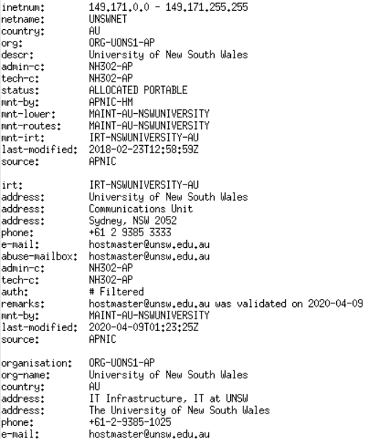 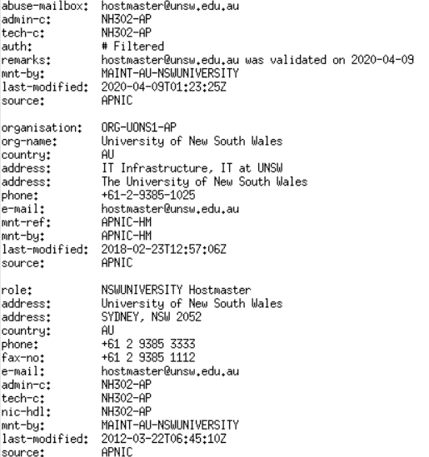

3.

www.ucla.edu (164.67.228.152) 11 routers, located at America

www.u-tokyo.ac.jp (210.152.243.234), 30 routers, located at Japan

www.lancaster.ac.uk (148.88.65.80),23 routers , located at United kingdom

So we find the number of hops on each path not proportional the physical distance

3.

1. 202.150.221.170and 203.50.5.178

2. 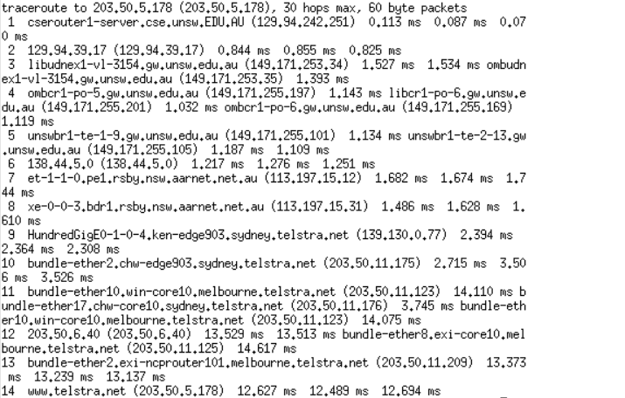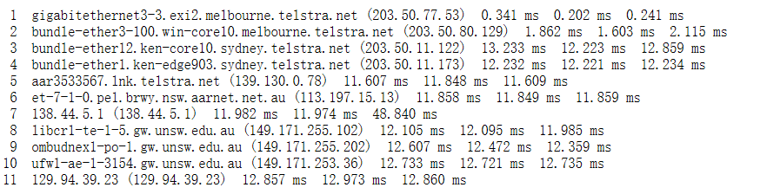I tested both of them and here is the route from my mechine to 203.50.5.178 and from 203.50.5.178 to my machine, and I find they are not going the same path.

3.No, All routers are different except for the starting and ending points

4.I think it is because from my machine to that IP is not an Asymmetric routing

Exercise 4:

1. [www.uq.edu.au](http://www.uq.edu.au/): **1905 km 6.35ms**

[www.dlsu.edu.ph](http://www.dlsu.edu.ph/) : 6266 km 20.88ms

[**www.tu-berlin.de:16114km53.7ms**](http://www.tu-berlin.de:16114km53.7ms)

Manila

Berlin

Brisbaneee

There are some transmission delay and queuing delay,

And the speed of packets wont be speed of light in any medium

1. It is vary over time, Due to the complexity of the Internet, the dynamic change of network traffic and the dynamic choice of network routing, the network delay is always changing
2. Yes it is
3. propagation delay, processing delay depend on the packet size and the other two not.