Exercise 3：

Q1.

HTTP/1.1 200 (text/html)

Q2.

last modified at Tue Sep 23, 2003 5:29:00 in GMT. Yes, server’s time is the DATA header.

Q3.

Persistent, because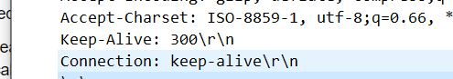

Q4.

73

Q5. 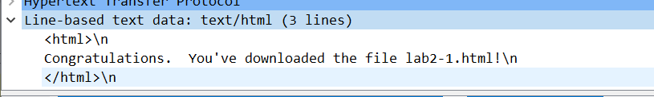

Exercise 4：

Q1.

No I haven’t.

Q2.

Yes. 

Q3. Yes.



Q4. 

NO,it did not return any contents,error message 304 means that the web did not modified since last request so there are not any contents could be return

Q5. 

The value didn’t change because the first request is success and the message was recived.

Etag USES the browser's cache to reduce the bandwidth pressure on our servers. This can improve the performance of the server because web server does not need to send a fulll response if the content has not changed

Exercise 5

