Exercise 3:

1. 23.185.0.1,A

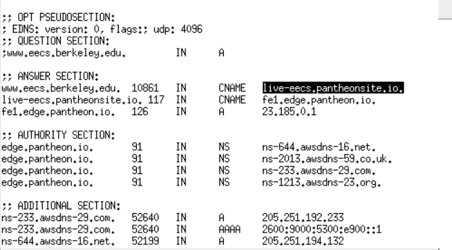

2. live-eecs.pantheonsite.io.After transferred the CNAME of domain name to the new address, the complexity of authoritative DNS configuration is reduced, the frequently changing configuration, function and business are cut and separated, and the troubleshooting is simple and clear

3. AUTHORITY SECTION got four records in type Ns and all of them from edge.pantheon.io.

ADDITIONAL SECTION has two types of server witch is A and AAAA

4. 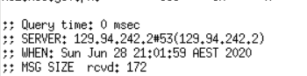

So local is 129.94.242.2

5.

Nameserver:

ADNS3.BERKELEY.EDU IP: 192.107.102.142  
ADNS2.BERKELEY.EDU IP: 128.32.136.14  
ADNS1.BERKELEY.EDU IP: 128.32.136.3

NS

6. webserver.seecs.nust.edu.pk, PTR

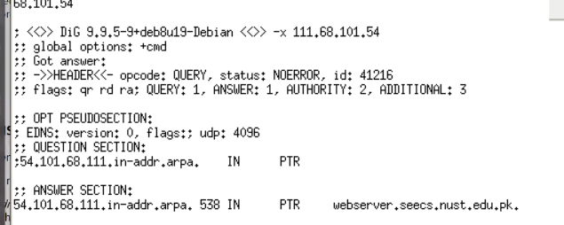

7.NO its not,because there isn’t aa (qr rd ra) in flags

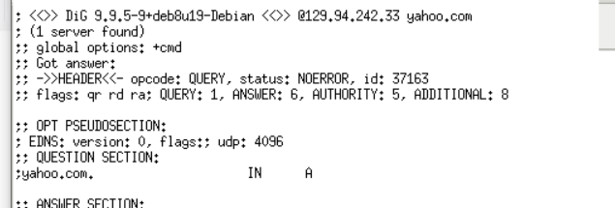

8. I used 192.107.102.142 and there isn’t any answer,

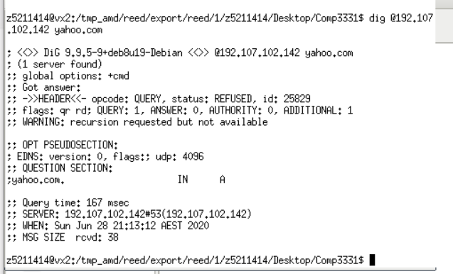

9.Mx and NS

10.Six times ,first run dig . NS

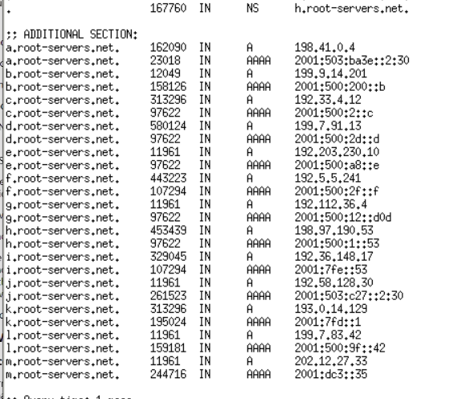

Now I choose one of the server.

Run dig @a.root-servers.net au. NS and I got

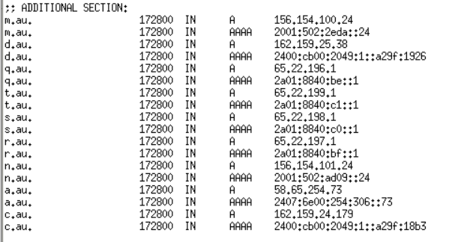

And keep choose one and run dig @c.au. edu.au. NS

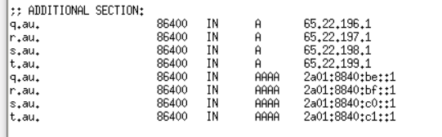

And keep run dig @t.au. unsw.edu.au. NS

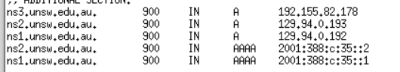

And run dig @ ns1.unsw.edu.au cse.unsw.edu.au. NS

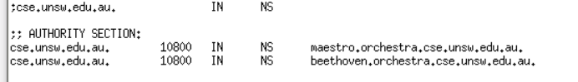

And run dig @maestro.orchestra.cse.unsw.edu.au. localhost

Will get the IP address of mine machine

11.Sure, Because the domain name binding, not only have the IP, but also the site files on the host directory to find a specific site, so can have more than one domain name

Exercise 4

1.