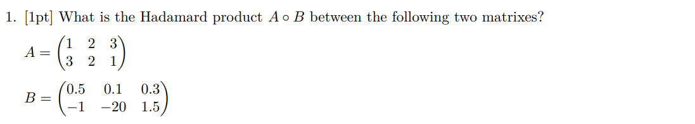





No. Because the shape does not match. A $2×3$ matrix cannot multiply with another $2×3$ matrix in this order.





