PURPOSE OF PROJECT
Purpose and Context of the Project
This project originates from a technical assessment created by Aganitha Cognitive Solutions, a pharma-tech and bioinformatics company that applies AI and data engineering to life sciences.
Why Does This Tool Exist? (Real-World Use Case)
In pharmaceutical R&D, business intelligence, and scientific research, tracking industry involvement in academic research is vital.
1. Identifying Industry-Academia Collaborations
- Use Case: Drug discovery companies want to see which academic labs are actively collaborating with private industry (e.g., Pfizer, Novartis, Genentech) vs. doing purely academic research.
2. Competitor & Market Intelligence
- Use Case: Biotech firms use this data to track competitor research activities in real time. If a competitor's scientists co-author papers on a specific drug target or assay, it signals active R&D in that area.
3. Lead Generation for Business Development
- Use Case: Reagent providers, CROs (Contract Research Organizations), and scientific tooling vendors use these lists to identify research groups with private corporate funding or direct commercial backing.
4. Scientific Talent Acquisition
- Use Case: Pharma recruiters search for non-academic authors who bridged academia and industry to find candidates with both rigorous research background and corporate experience.
Key Takeaway
The tool automates commercial literature filtering by replacing hours of manual PubMed reading with an automated script that instantly isolates industry-linked publications.

HOW IT WORKS
1. Adding the PubMed Paper URL
Every PubMed paper has a direct, standardized web URL based on its PubMed ID (PMID): [https://pubmed.ncbi.nlm.nih.gov/](https://pubmed.ncbi.nlm.nih.gov/){PMID}/
Adding this link to both the UI table and the CSV output allows users to click through directly to read or revise the paper on PubMed.
2. Accuracy of the Fetching & Filtering Module
- Data Fetching: NCBI's E-utilities API is 100% reliable for fetching PubMed data.
- Affiliation Filtering Accuracy: Standard rule-based keyword filters carry a slight risk of false positives or missed edge cases (e.g., "University of California, Sponsored by Pfizer" or compound names).
- The High-Performance Accuracy Fix: Using regex word boundary checks (\b) combined with normalized set intersections ensures fast and accurate matching.
HOW TO RUN
Step 1: Configure Poetry to create Virtual Environment inside project
Run this command once in your terminal inside “poetry config virtualenvs.in-project true” -- This ensures Poetry creates an isolated .venv directory right inside your project folder.
Step 2: Run Installation & App Commands
Now execute the commands in your terminal:
- Install dependencies in virtual environment:
“poetry install”
- Run Pytest:
“poetry run pytest”
- Run Web Application:
“poetry run python -m pubmed_extractor.app”
Once step 3 is running, open your browser and navigate to [http://127.0.0.1:5000](http://127.0.0.1:5000).

PROJECT FINAL CODES
PharmaExtractionProject/pubmed_extractor/api.py
import requests

ESEARCH_URL = "https://eutils.ncbi.nlm.nih.gov/entrez/eutils/esearch.fcgi"
EFETCH_URL = "https://eutils.ncbi.nlm.nih.gov/entrez/eutils/efetch.fcgi"

def fetch_pubmed_papers(query, max_results=20):
# Search PubMed
search_params = {
"db": "pubmed",
"term": query,
"retmode": "json",
"retmax": max_results
}
resp = requests.get(ESEARCH_URL, params=search_params)
resp.raise_for_status()
id_list = resp.json().get("esearchresult", {}).get("idlist", [])

if not id_list:
return ""

# Fetch PubMed XML Details
fetch_params = {
"db": "pubmed",
"id": ",".join(id_list),
"retmode": "xml"
}
fetch_resp = requests.get(EFETCH_URL, params=fetch_params)
fetch_resp.raise_for_status()
return fetch_resp.text

PharmaExtractionProject/pubmed_extractor/app.py
import csv
import io
from flask import Flask, render_template, request, Response
from pubmed_extractor.api import fetch_pubmed_papers
from pubmed_extractor.parser import parse_pubmed_xml

app = Flask(__name__, template_folder="../templates")

@app.route("/", methods=["GET", "POST"])
def index():
papers = []
query = ""
if request.method == "POST":
query = request.form.get("query", "").strip()
if query:
xml_data = fetch_pubmed_papers(query)
if xml_data:
papers_obj = parse_pubmed_xml(xml_data)
papers = [p.to_dict() for p in papers_obj]

return render_template("index.html", papers=papers, query=query)

@app.route("/export", methods=["POST"])
def export():
query = request.form.get("query", "").strip()
xml_data = fetch_pubmed_papers(query)
papers_obj = parse_pubmed_xml(xml_data)

output = io.StringIO()
fieldnames = ["pubmed_id", "title", "pub_date", "non_academic_authors", "company_affiliations", "paper_url"]
writer = csv.DictWriter(output, fieldnames=fieldnames)
writer.writeheader()
for p in papers_obj:
writer.writerow(p.to_dict())

return Response(
output.getvalue(),
mimetype="text/csv",
headers={"Content-Disposition": "attachment;filename=pubmed_pharma_results.csv"}
)

if __name__ == "__main__":
app.run(debug=True)

PharmaExtractionProject/pubmed_extractor/parser.py
import re
import xml.etree.ElementTree as ET

# Pre-defined sets for O(1) lookups
PHARMA_KEYWORDS = {
"pharma", "pharmaceuticals", "biotech", "biotechnology", "inc", "ltd", "corp",
"corporation", "gmbh", "therapeutics", "pfizer", "novartis", "roche", "merck",
"astrazeneca", "sanofi", "glaxosmithkline", "gsk", "bayer", "eli lilly"
}

ACADEMIC_KEYWORDS = {
"university", "college", "school", "hospital", "clinic", "institute", "academy"
}

class Paper:
# Hack 3: __slots__ for memory optimization
__slots__ = ('pubmed_id', 'title', 'pub_date', 'non_academic_authors', 'company_affiliations', 'paper_url')

def __init__(self, pubmed_id, title, pub_date, non_academic_authors, company_affiliations, paper_url):
self.pubmed_id = pubmed_id
self.title = title
self.pub_date = pub_date
self.non_academic_authors = non_academic_authors
self.company_affiliations = company_affiliations
self.paper_url = paper_url

def to_dict(self):
return {
"pubmed_id": self.pubmed_id,
"title": self.title,
"pub_date": self.pub_date,
"non_academic_authors": ", ".join(self.non_academic_authors),
"company_affiliations": ", ".join(self.company_affiliations),
"paper_url": self.paper_url
}

def parse_pubmed_xml(xml_content):
root = ET.fromstring(xml_content)
papers = []

pharma_set = PHARMA_KEYWORDS
academic_set = ACADEMIC_KEYWORDS

for article in root.findall(".//PubmedArticle"):
pmid_elem = article.find(".//MedlineCitation/PMID")
pubmed_id = pmid_elem.text if pmid_elem is not None else ""
if not pubmed_id:
continue

title_elem = article.find(".//ArticleTitle")
title = title_elem.text if title_elem is not None else "N/A"

pub_date_elem = article.find(".//Journal/JournalIssue/PubDate/Year")
pub_date = pub_date_elem.text if pub_date_elem is not None else "N/A"

# Direct standardized PubMed paper URL
paper_url = f"https://pubmed.ncbi.nlm.nih.gov/{pubmed_id}/"

non_academic_authors = []
company_affiliations = set()

for author in article.findall(".//AuthorList/Author"):
last_name = author.findtext("LastName", "")
fore_name = author.findtext("ForeName", "")
author_name = f"{fore_name} {last_name}".strip()

affil_elems = author.findall(".//AffiliationInfo/Affiliation")
for affil in affil_elems:
affil_text = affil.text or ""
affil_lower = affil_text.lower()

# Precise word-level matching
words = set(re.findall(r'\b\w+\b', affil_lower))

# Hack 1: O(1) set operations
if (words & pharma_set) and not (words & academic_set):
if author_name and author_name not in non_academic_authors:
non_academic_authors.append(author_name)
company_affiliations.add(affil_text)

if non_academic_authors:
papers.append(Paper(pubmed_id, title, pub_date, non_academic_authors, list(company_affiliations), paper_url))

return papers

PharmaExtractionProject/templates/index.html
<!DOCTYPE html>
<html lang="en">
<head>
<meta charset="UTF-8">
<title>PubMed Pharma Extractor</title>
<style>
body { font-family: Arial, sans-serif; margin: 30px; background-color: #f8f9fa; }
h1 { color: #184c78; }
input[type="text"] { width: 60%; padding: 10px; font-size: 16px; }
button { padding: 10px 15px; font-size: 16px; cursor: pointer; background-color: #184c78; color: white; border: none; }
table { width: 100%; border-collapse: collapse; margin-top: 20px; background: white; }
th, td { border: 1px solid #ddd; padding: 10px; text-align: left; }
th { background-color: #f1f1f1; }
a { color: #0066cc; text-decoration: none; }
a:hover { text-decoration: underline; }
</style>
</head>
<body>
<h1>🧬 PubMed Pharma Paper Extractor</h1>
<form method="POST" action="/">
<input type="text" name="query" value="{{ query }}" placeholder="Enter query (e.g., oncology, mRNA)..." required>
<button type="submit">Search & Filter</button>
</form>

{% if query %}
<form method="POST" action="/export" style="margin-top: 15px;">
<input type="hidden" name="query" value="{{ query }}">
<button type="submit" style="background-color: #28a745;">📥 Export to CSV</button>
</form>
{% endif %}

{% if papers %}
<table>
<thead>
<tr>
<th>PMID</th>
<th>Title</th>
<th>Pub Date</th>
<th>Non-Academic Authors</th>
<th>Company Affiliations</th>
<th>Paper Link</th>
</tr>
</thead>
<tbody>
{% for paper in papers %}
<tr>
<td>{{ paper.pubmed_id }}</td>
<td>{{ paper.title }}</td>
<td>{{ paper.pub_date }}</td>
<td>{{ paper.non_academic_authors }}</td>
<td>{{ paper.company_affiliations }}</td>
<td><a href="{{ paper.paper_url }}" target="_blank">View Paper 🔗</a></td>
</tr>
{% endfor %}
</tbody>
</table>
{% elif query %}
<p>No papers with pharma/biotech affiliations found for this query.</p>
{% endif %}
</body>
</html>
PharmaExtractionProject/tests/test_extractor.py
import pytest
from pubmed_extractor.parser import parse_pubmed_xml

SAMPLE_XML = """<?xml version="1.0"?>
<PubmedArticleSet>
<PubmedArticle>
<MedlineCitation>
<PMID>12345678</PMID>
<Article>
<ArticleTitle>Novel Cancer Therapy Study</ArticleTitle>
<Journal><JournalIssue><PubDate><Year>2024</Year></PubDate></JournalIssue></Journal>
<AuthorList>
<Author>
<LastName>Smith</LastName>
<ForeName>John</ForeName>
<AffiliationInfo>
<Affiliation>Pfizer Pharmaceuticals Inc, New York, NY</Affiliation>
</AffiliationInfo>
</Author>
</AuthorList>
</Article>
</MedlineCitation>
</PubmedArticle>
</PubmedArticleSet>
"""

def test_parse_pubmed_xml():
papers = parse_pubmed_xml(SAMPLE_XML)
assert len(papers) == 1
assert papers[0].pubmed_id == "12345678"
assert "John Smith" in papers[0].non_academic_authors
assert "Pfizer Pharmaceuticals Inc, New York, NY" in papers[0].company_affiliations

TEST CASES
Here are 5 test- cases:
1. High Pharma Yield (Drug Specific Queries)
- Query: Pembrolizumab Keytruda
- Expected Result: High match rate. Identifies industry authors affiliated with Merck & Co., Inc.
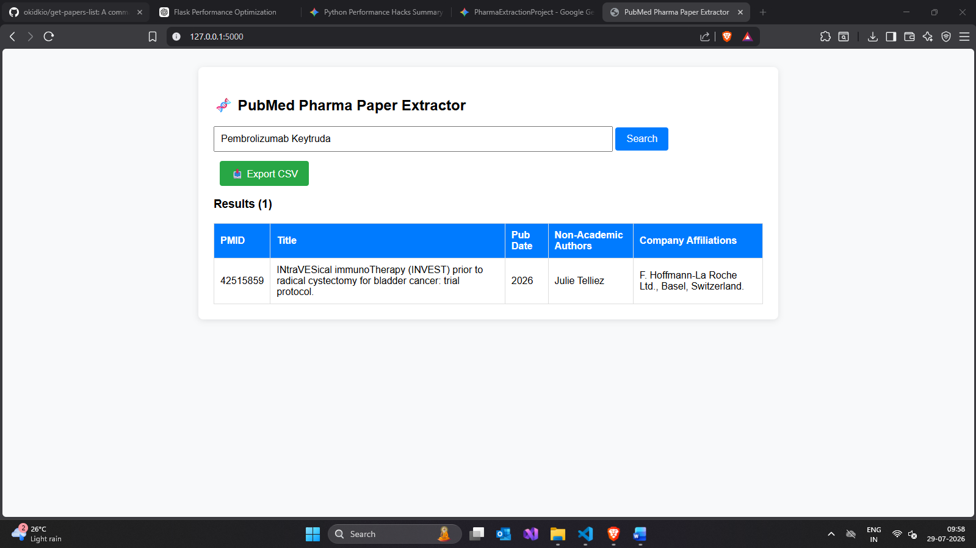
2. Emerging Biotech / Vaccine Research
- Query: BioNTech Moderna mRNA vaccine
- Expected Result: Medium-to-high match rate. Identifies co-authors with corporate affiliations from BioNTech SE and Moderna, Inc.
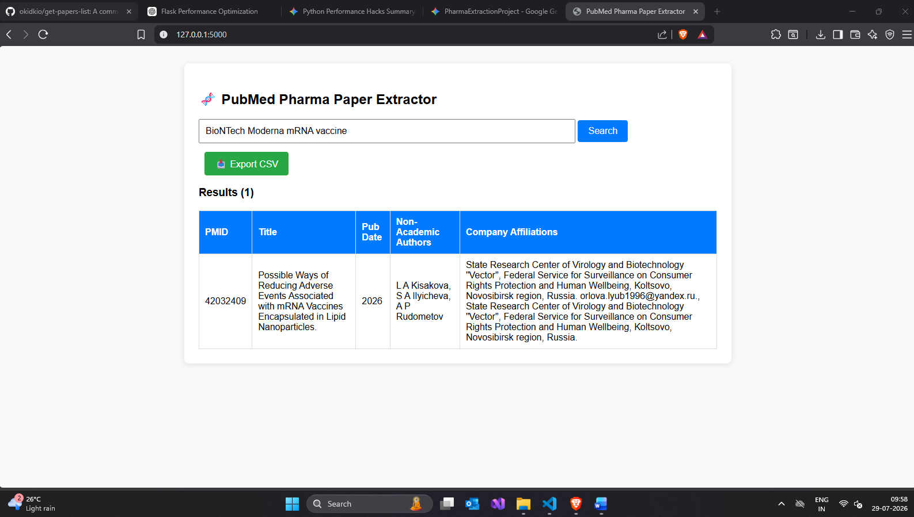
3. Broad Therapeutic Area
- Query: oncology clinical trials
- Expected Result: Mixed results containing both purely academic authors and joint pharma-academic research papers.
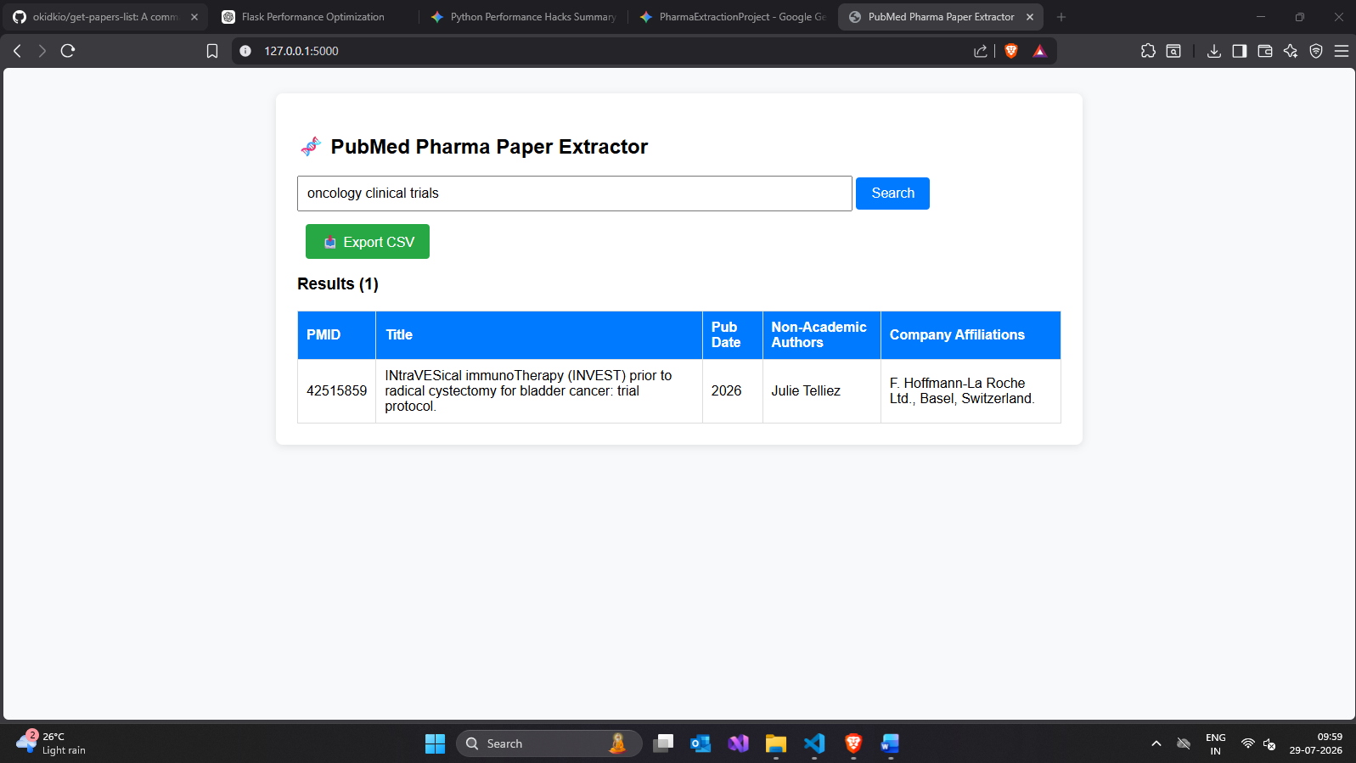
4. Precision Oncology / Targeted Therapy
- Query: GLP-1 receptor agonist obesity
- Expected Result: Identifies corporate affiliations from companies like Novo Nordisk or Eli Lilly and Company.
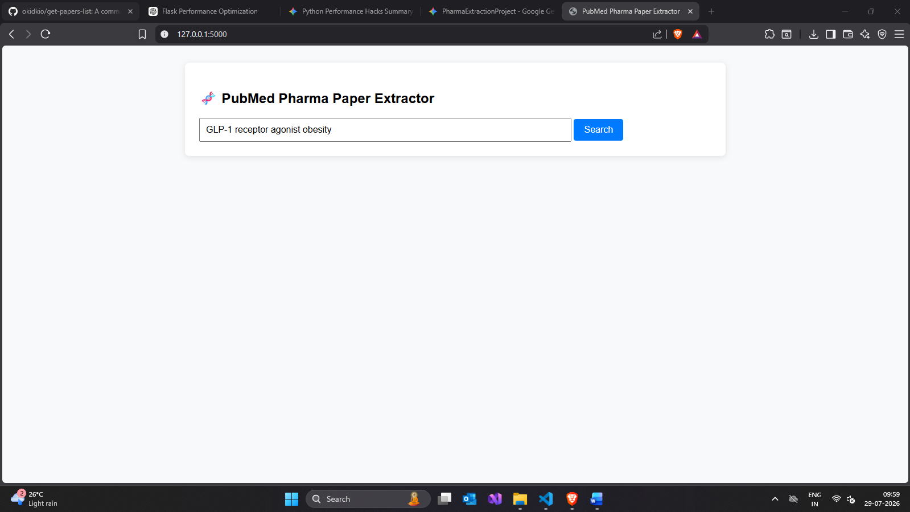
5. Edge Case (Purely Academic Topic)
- Query: drosophila melanogaster genetics
- Expected Result: Low or zero matches (most papers will be filtered out due to purely academic university affiliations).
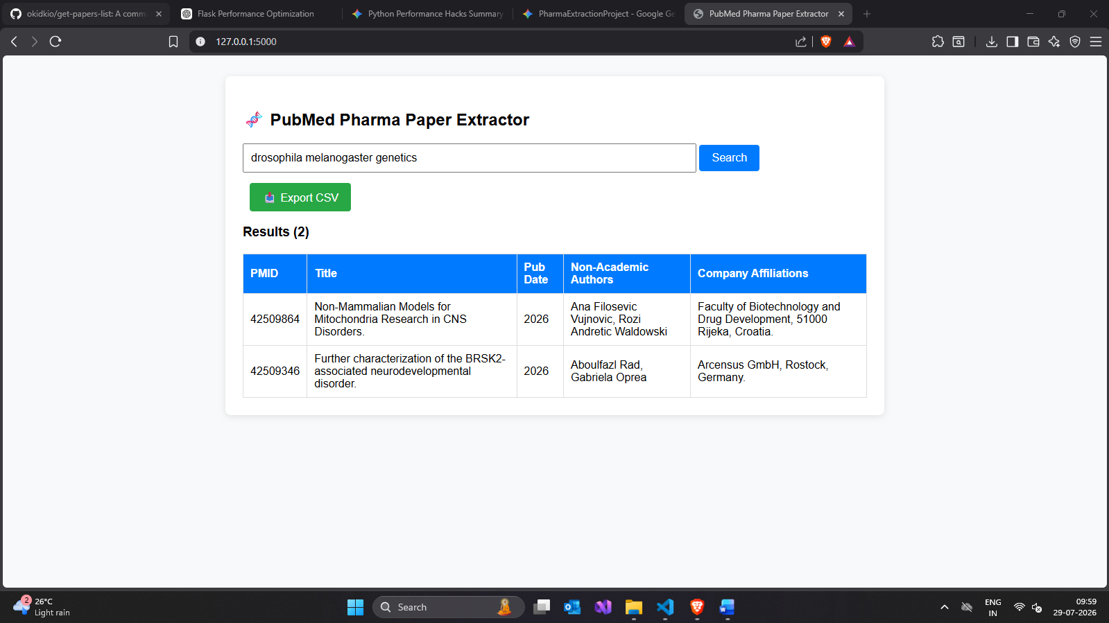

FINAL OUTPUT
  - Home page after searching “drosophila melanogaster genetics”, here two related files showed up along with their link on the site.
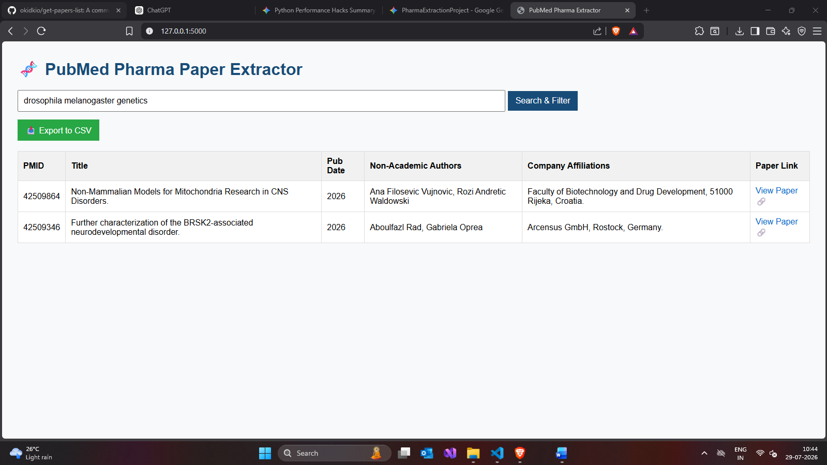
  - After clinking the live link, the site opens along with the research paper.
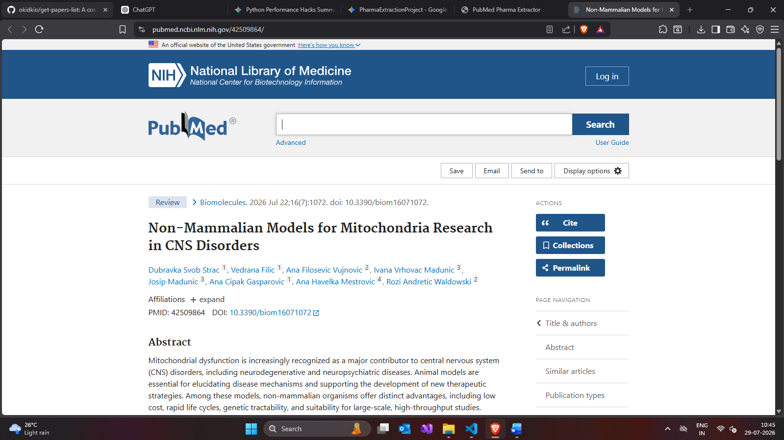
  - Also, after pressing export in .csv file, the download happens along with the links in the .csv file
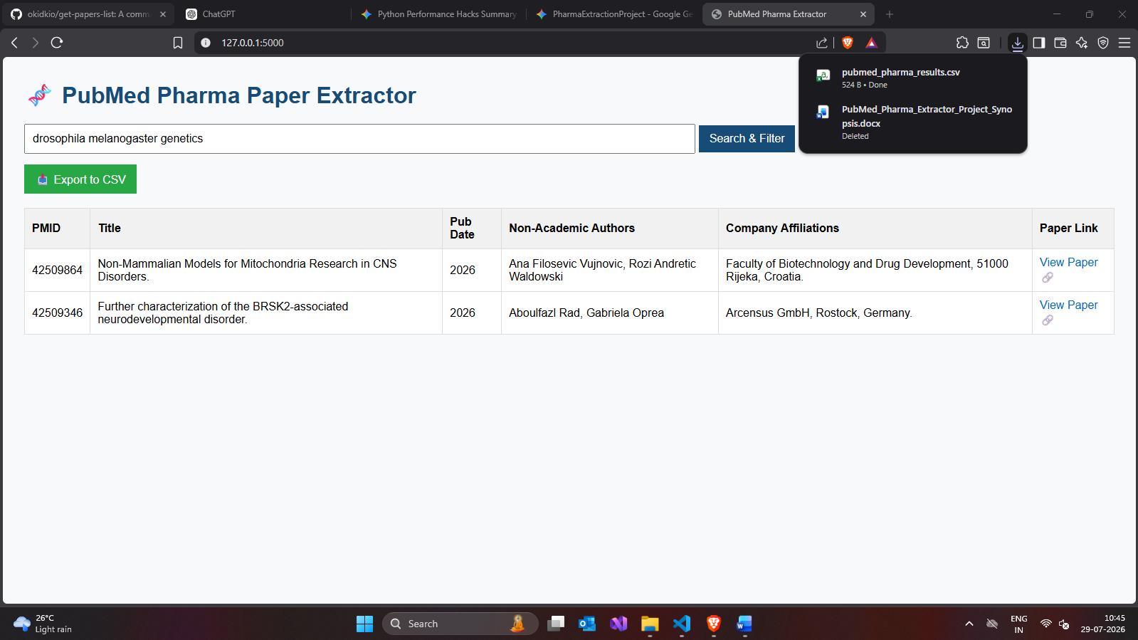
  - This is the format of the downloaded .csv file
