


INDIVIDUAL ASSIGNMENT

LANKA

COMP40004

WEB DEVELOPMENT AND OPERATING SYSTEMS-1
COM2421, COM2422, COM2423, COM2424

HAND OUT DATE: 18th March 2024

HAND IN DATE: ASSIGNMENT2: 24th May 2024

WEIGHTAGE: ASSIGNMENT 2: 30%

INSTRUCTION TO CANDIDATES:

- Students are advised to underpin their answers with the use of references (cited using the Harvard Name System of Referencing).

- Late submission will be awarded zero (0) unless Extenuating Circumstances (EC) are upheld.

- Cases of plagiarism will be penalized

- Assignment presentation should be submitted in the form of softcopy and hardcopy both; modeling work should be submitted in softcopy form

Learning outcome from the Assignment

As a person who has not got much of exposure to the IT world this assignment helped me a lot in learning new skills related to Web Designing. I learned key aspects of HTML and CSS, also how to use them effectively. Throughout the process of making the website I was able to see a gradual increase in my skills and knowledge related to Web Design. I was able to understand that Planning is a very critical aspect which plays a big role in this because without a good plan or a structure its very hard to navigate things easily, this where the use of Wireframes came into play. As a result of creating a website we had to host it, a platform was needed. I was able to learn about GitHub and host my website and make it accessible to others.

As a summary,
- I learnt two new languages, HTML and CSS
- Learnt how to use them effectively and efficiently
- Learnt about Wireframes which was very useful in the process of creating the website
- Finally, learned about hosting on GitHub

Challenges Faced

As a rookie for all of this, I did not find these languages that easy. Talking about HTML I only knew the basics of it, I didn’t know anything about <div>, <section>, <form>, tags and even to comment anything. All regards to them CSS was not even reachable because I didn’t know what to use, when to use these elements. With all these challenges, media queries seemed to be pretty much impossible.

Way of overcoming

The main reason that I was able to overcome these challenges were, my interest in learning new things. I started my assignment soon after the lecturer explained it to us. It was the small steps which eventually guided me to the right path. There were lot of failures in the beginning until the end but since I started early there was enough time to catch up. As I mentioned, since I started early just knowing the fundamentals, I had to gain extra knowledge, for that I sought help from colleagues, watched YouTube videos related to HTML and CSS and eventually started with the planning (Wire frames), step by step I was in the process of making the website. Finally, for hosting I had to self-study on that and as a source I used YouTube. As per the saying “nothing comes easy”, I had to put in the effort in self-learning and self-experiencing eventually which led me to finish this assignment successfully.

Home Page (Desktop view)

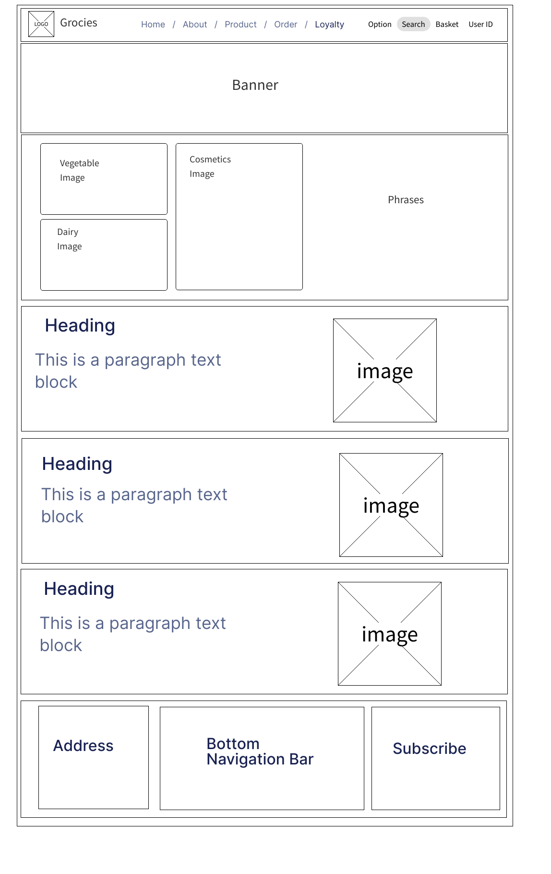

Home Page (Mobile View)

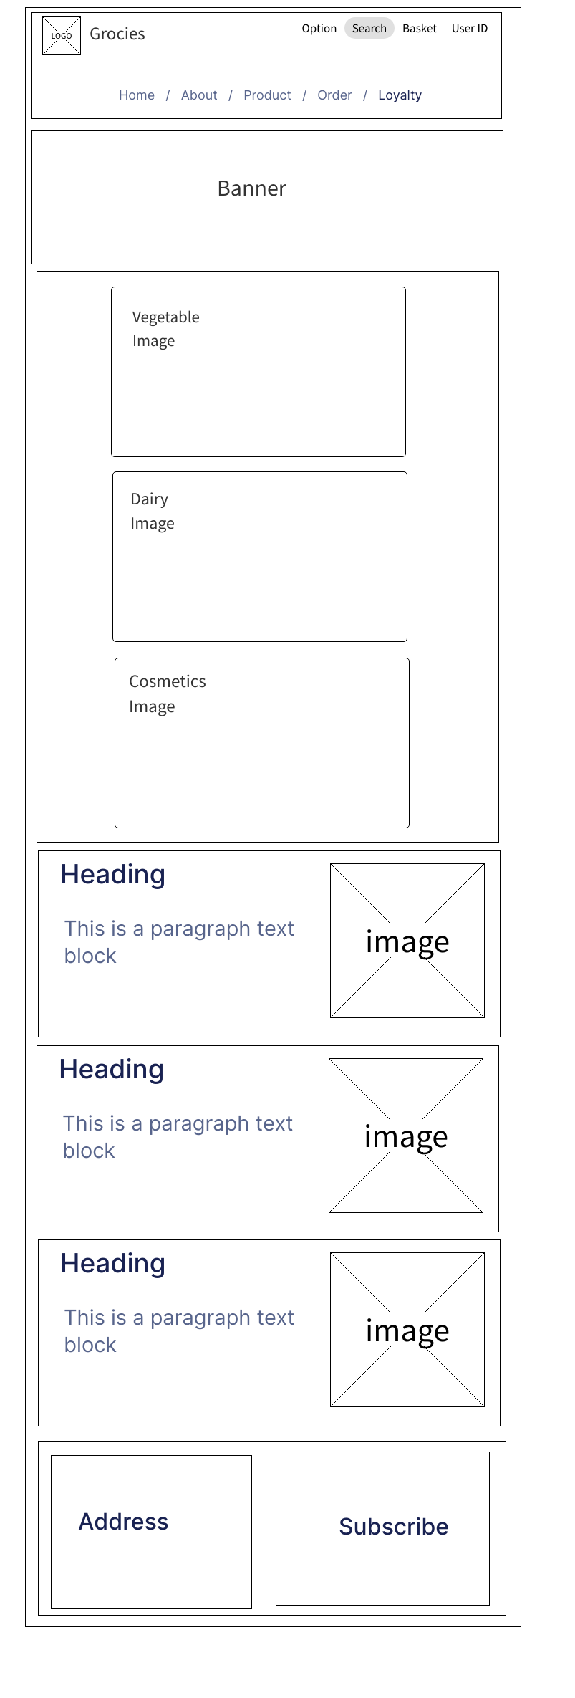

About page (Desktop view)

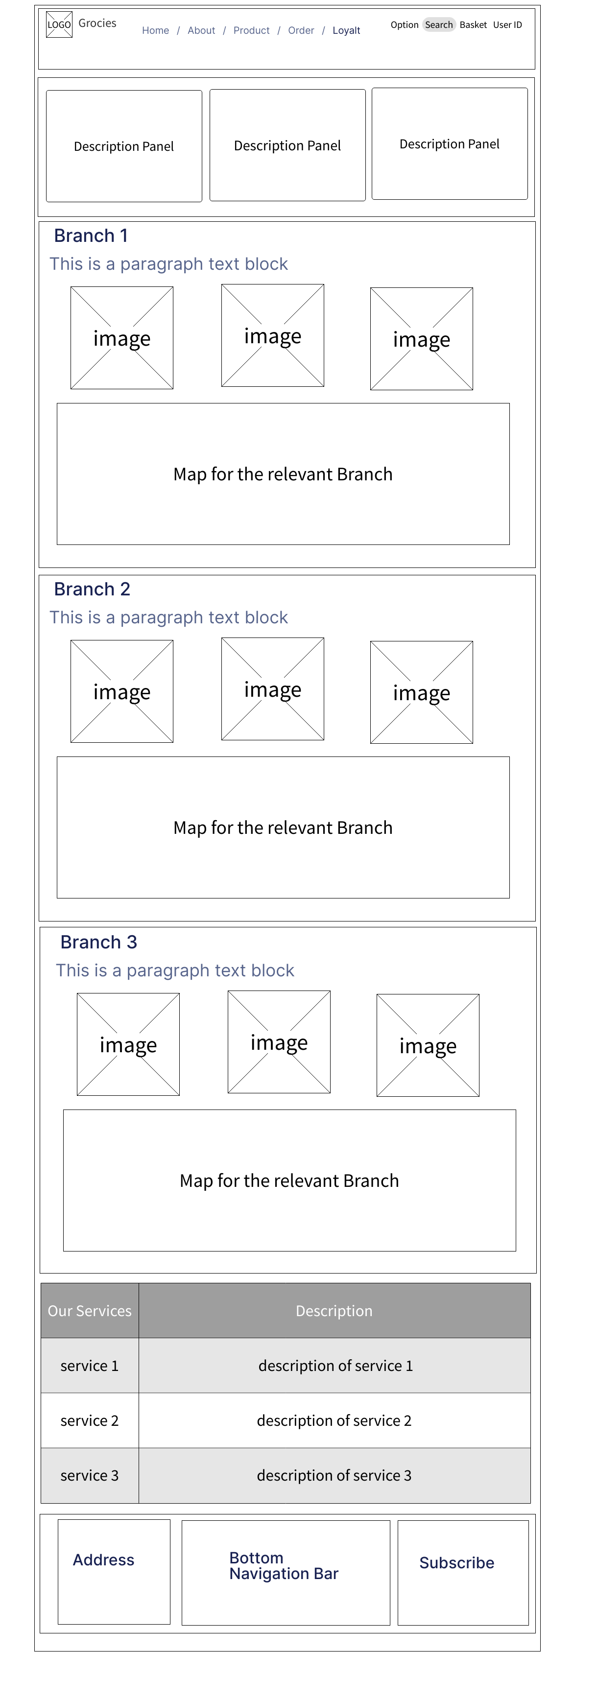
About Page (Mobile view)

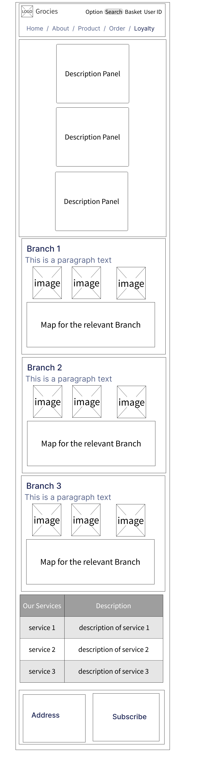
Product Page (Desktop view)
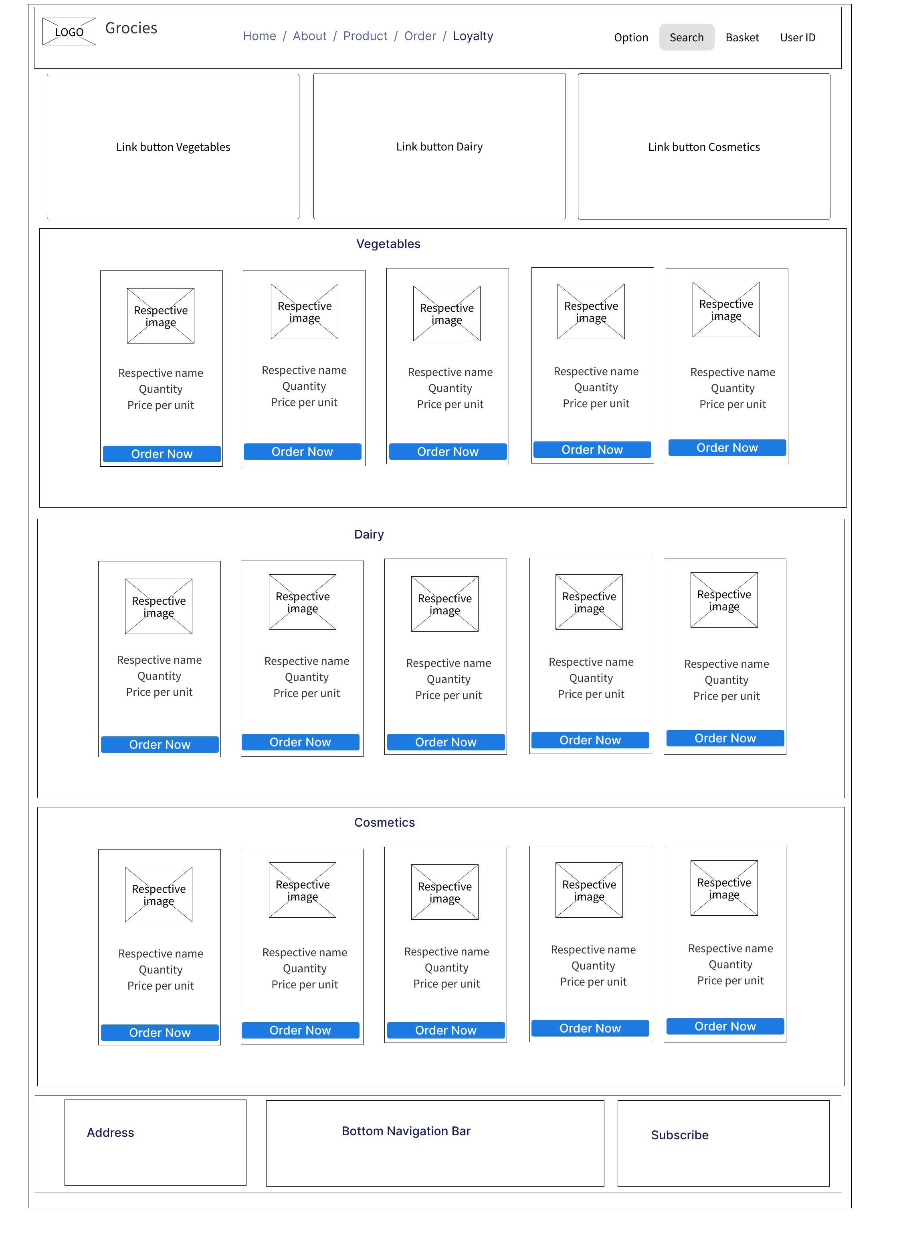

Product Page (Mobile View)

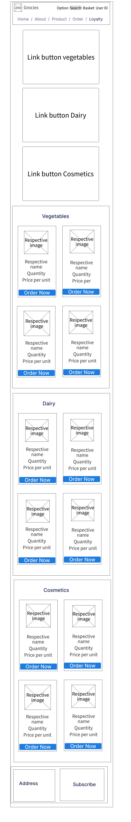

Vegetables Page (Desktop view)

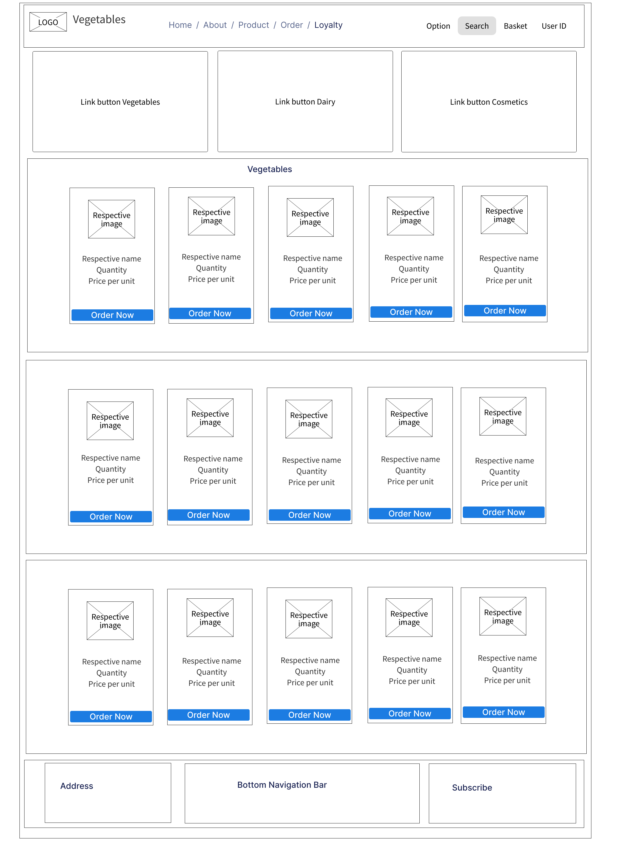

Vegetables Page (Mobile view)

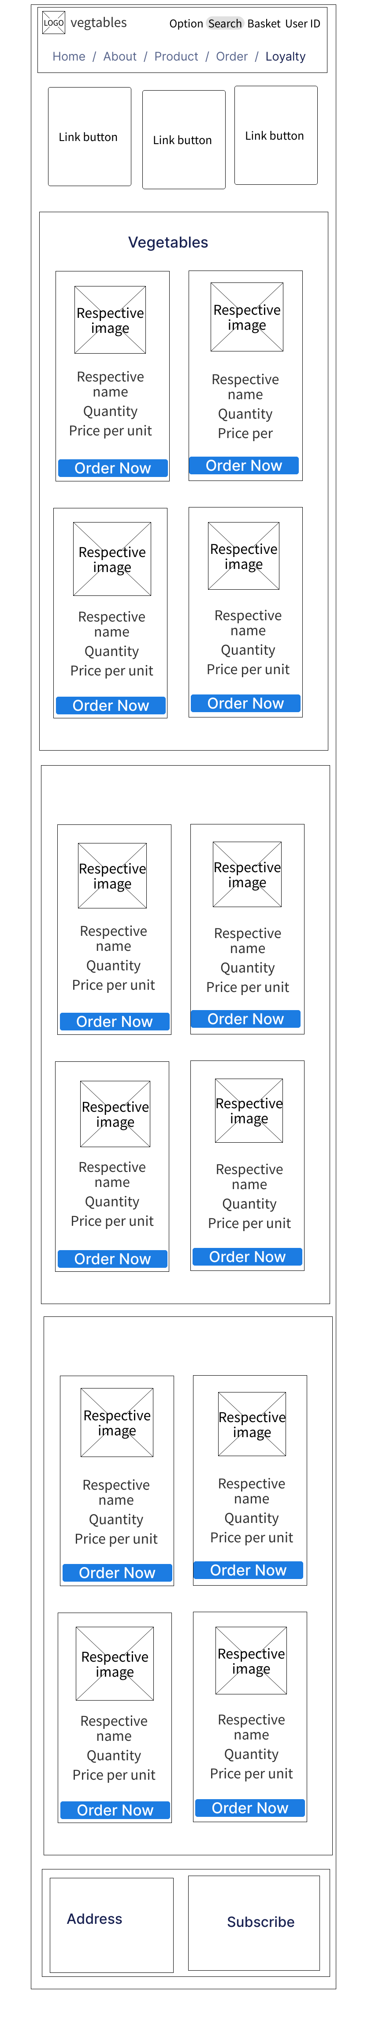

Dairy Page (Desktop view)

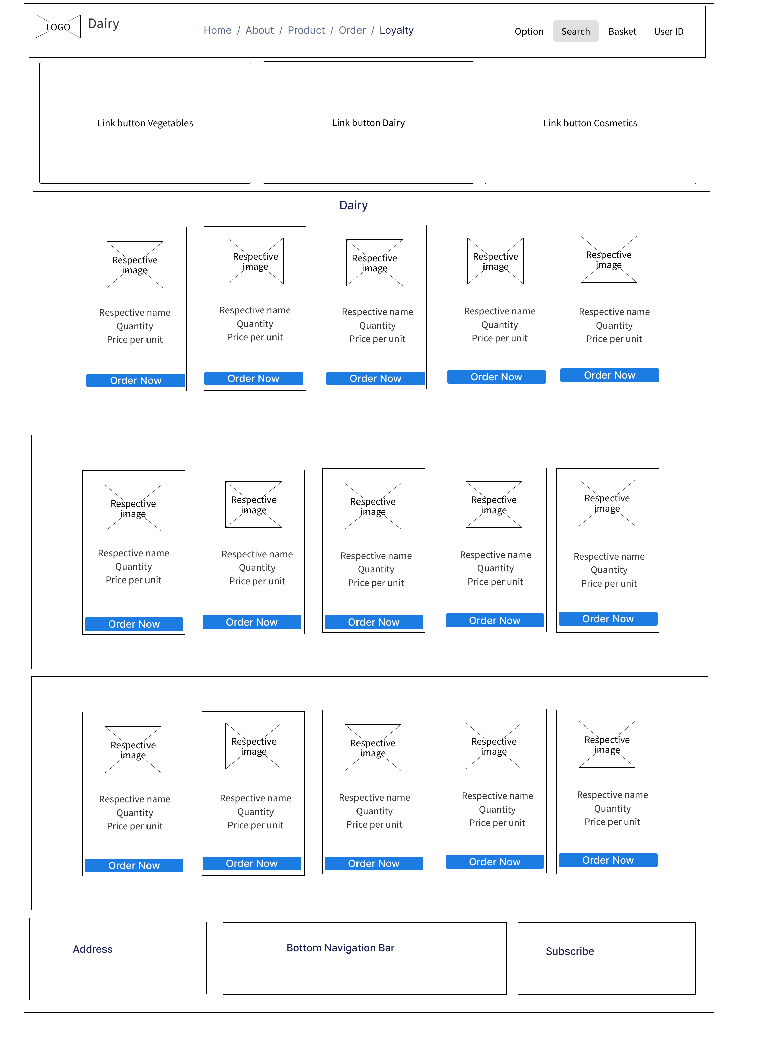

Dairy page (Mobile view)

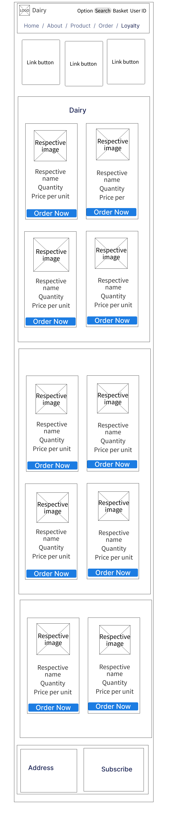
Cosmetics page (Desktop view)

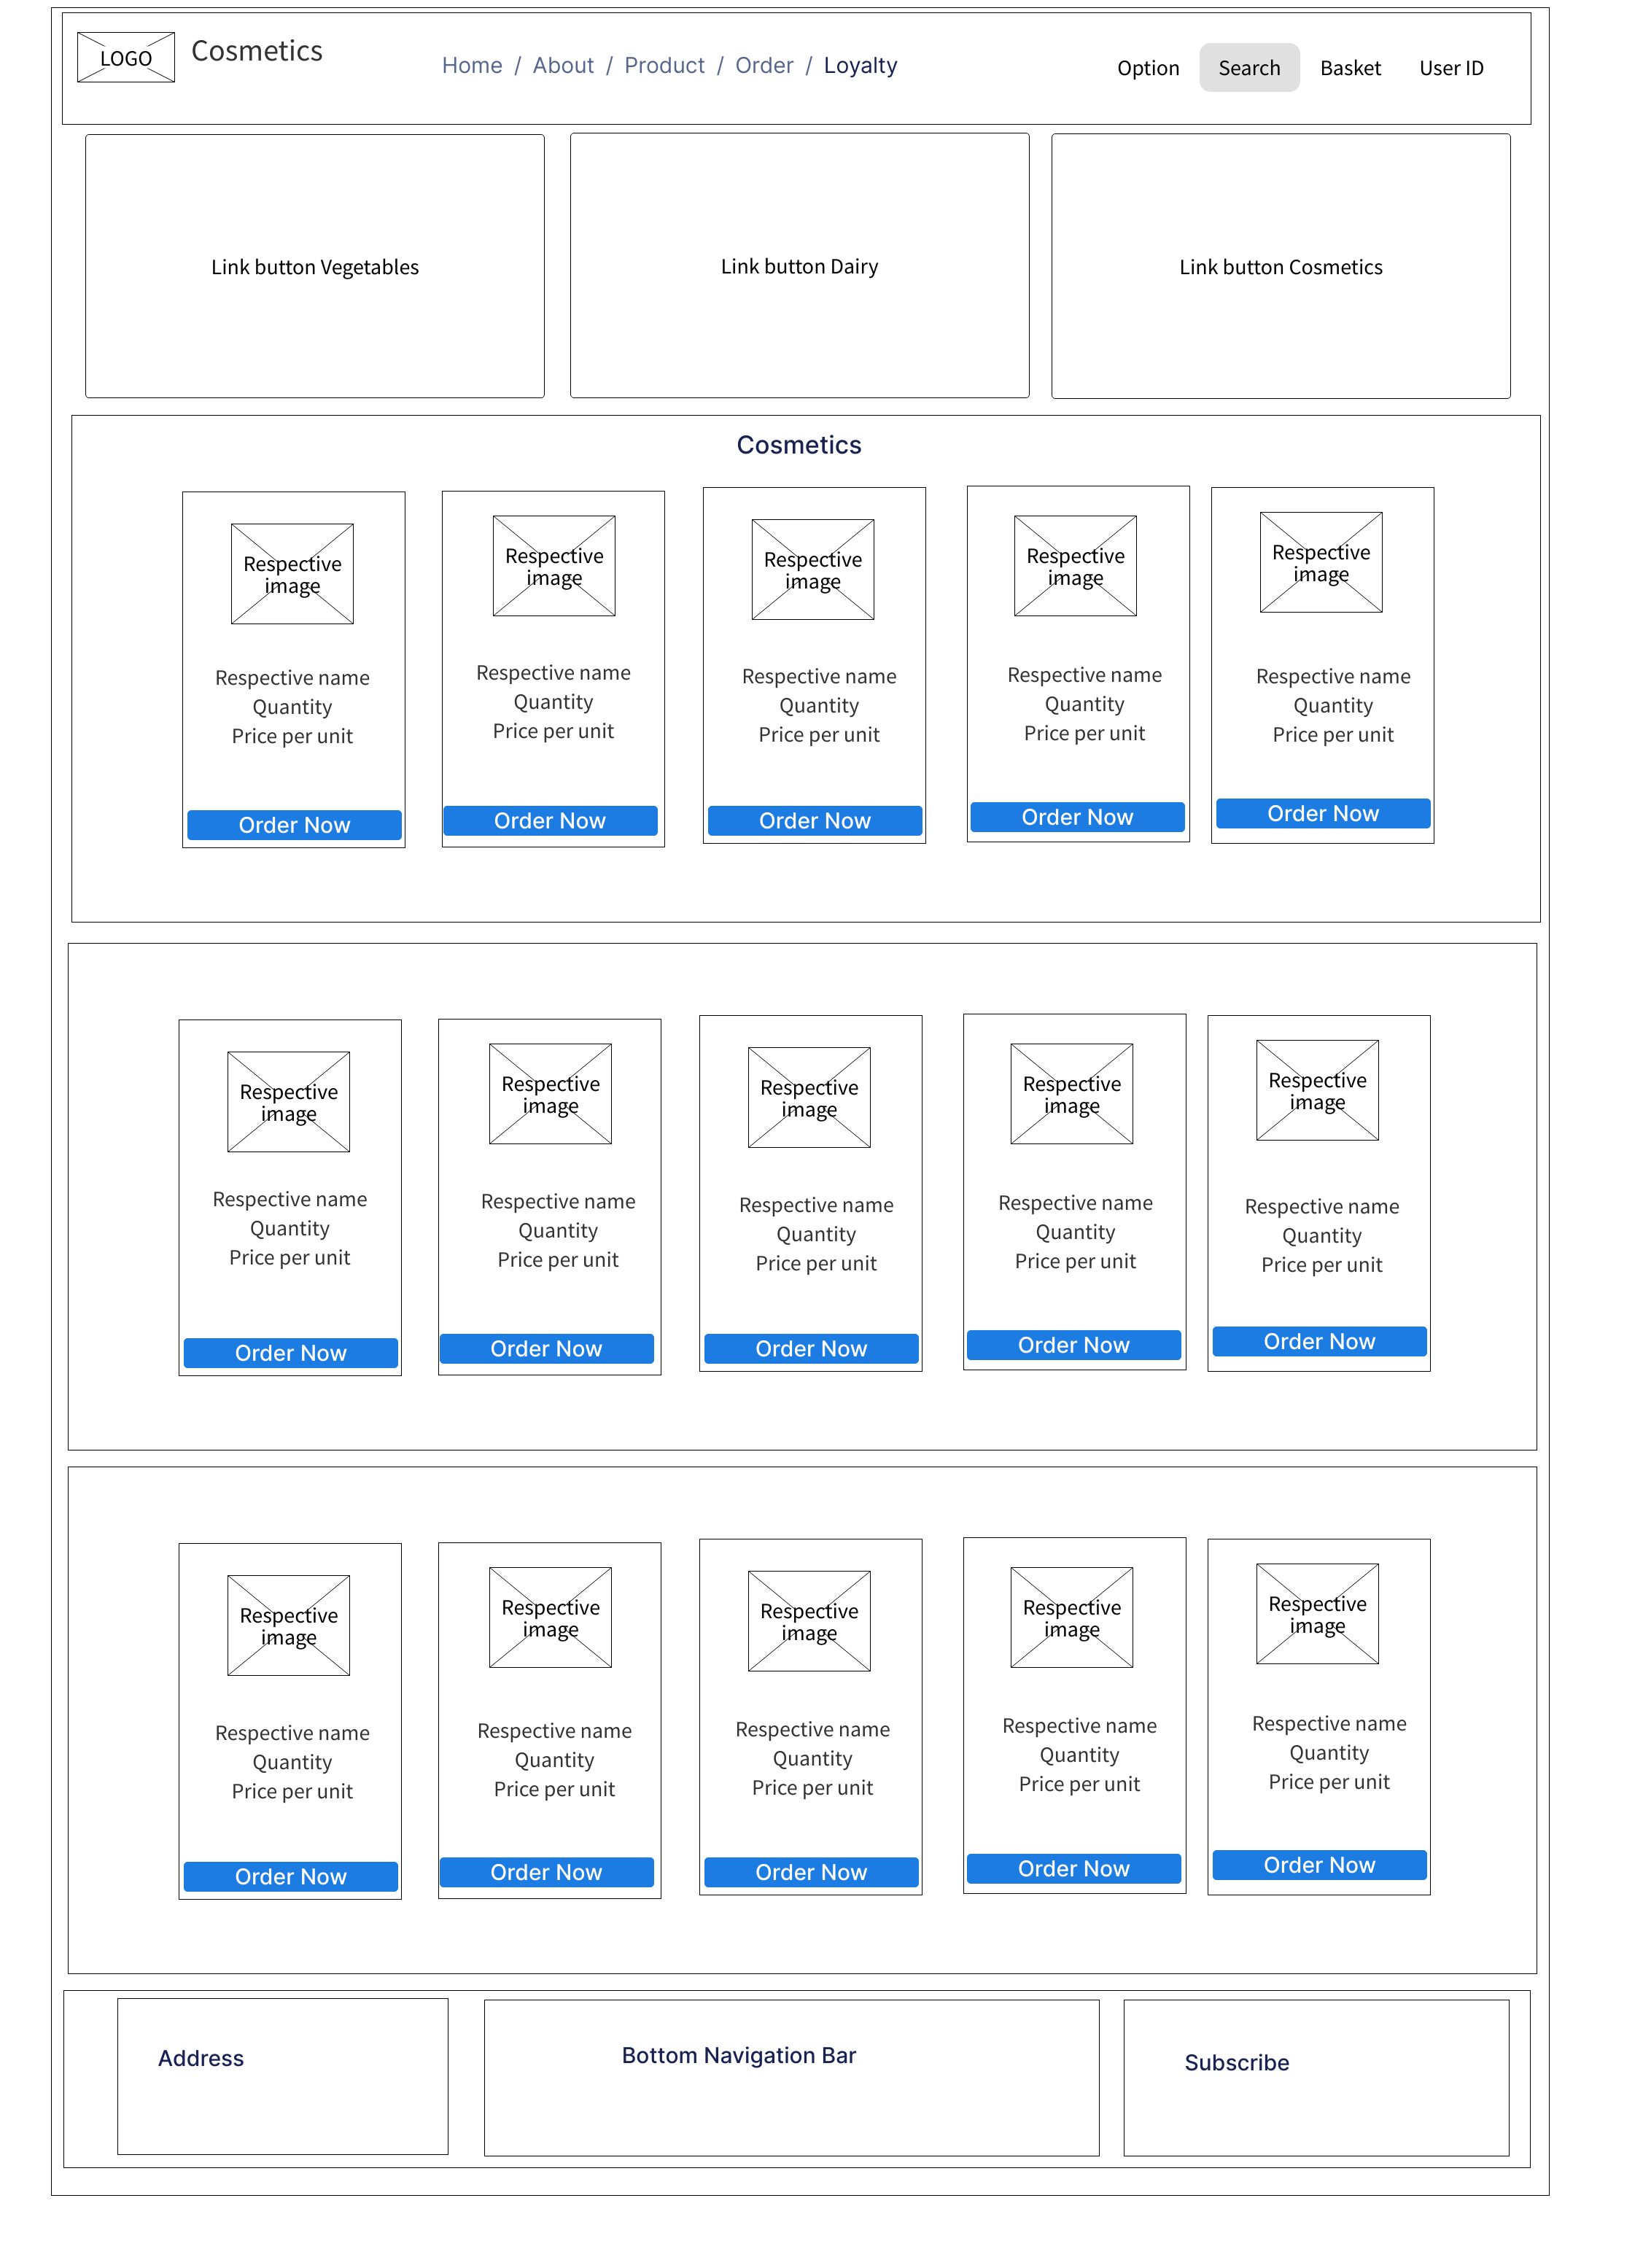

Cosmetics page (Mobile view)

Loyalty Registration (Desktop view)
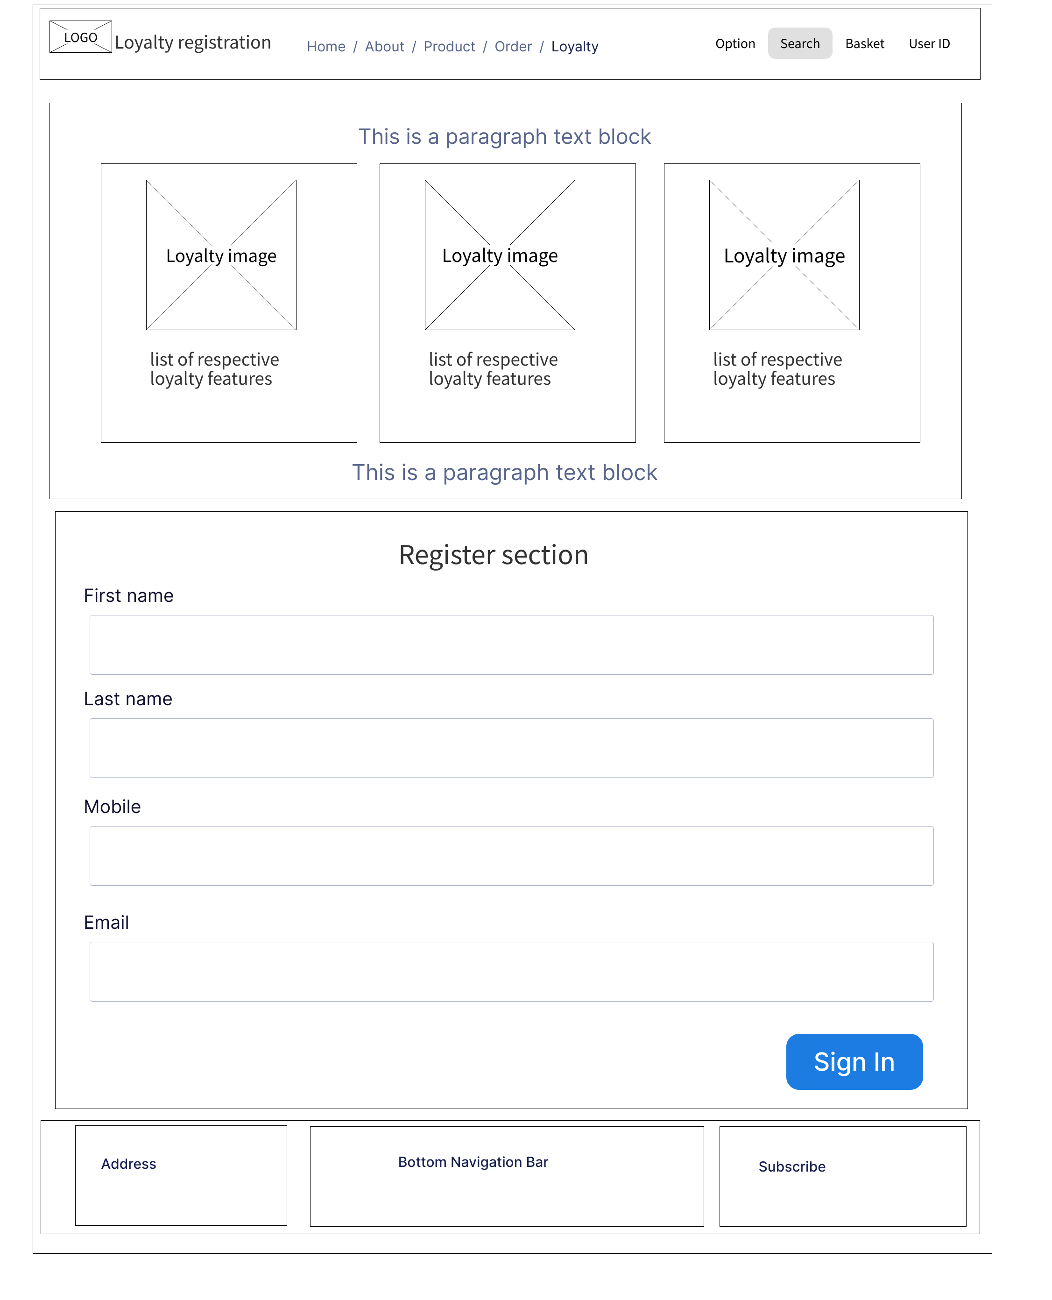

Loyalty Registration (Mobile view)

