Mobile version (Home)

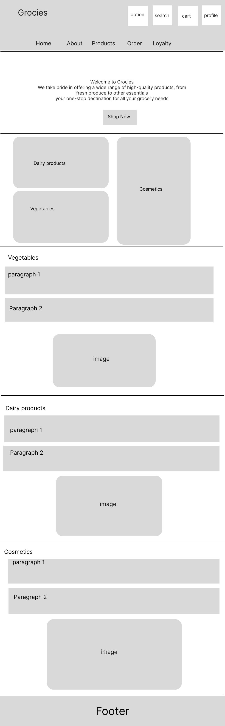

Desktop version (Home)

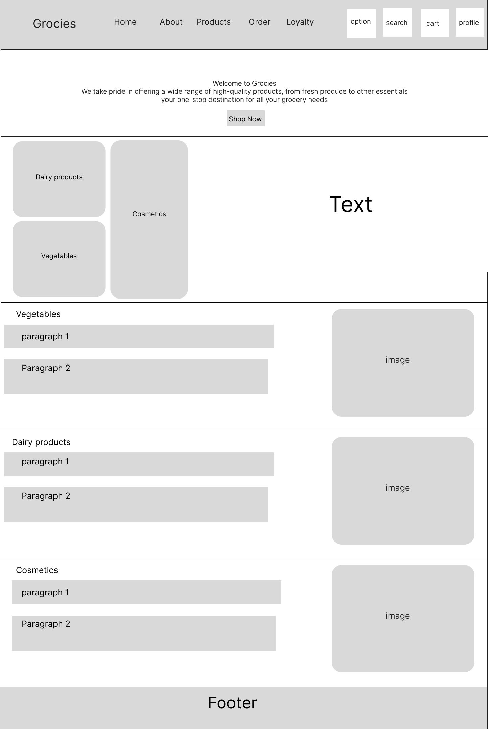

About page (Desktop view)

Loyalty registration (Desktop view)

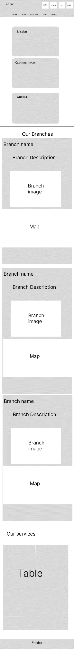 About page (mobile view)