**Computational finance Assignment 2**

**Task 1: Simulating SDE**

1.Simulating geometric brownian motion

In order to get the expectation value and variance of S(3) based on the simulation, first we need to get all the value of stock price at t=3 by using array function. Then we compute the mean and variance by using np.mean and np.var.

The expectation of S(3) is 48.9785935978.

The variance of S(3) is 177.015719826.

The theoretical expectation of GBM is given by the formula E[S(t)]= S0eµt, which will gives us value of 52.6444935.

The theoretical variance of GBM is given by the formula Var[S(t)]= S02e2µt (eơ²t – 1), which will give us the value of 623.0964723.

To calculate the probability of S(3)>39, initially we find the number of value which is greater than 39 by using S(3)>39. Then, we sum up the value and divided by the total number of S3 by using sum()/len().

P[S(3)>39]= 0.771

To get the expectation of S(3) given S(3)>39], we find the value of S(3) by summing up the values that are greater than 39. Then we divide it by the summation of the value which is greater than 39.

E[S(3)|S(3)>39]= 53.6409644125

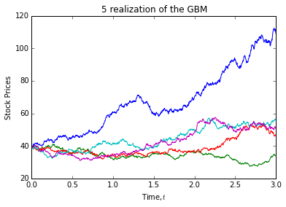

2.Simulating mean reversal process

Similar with the question above, we first get the last column value by array function and then compute the mean using np.mean.

The expectation of R(1) is 1.14393720702

The probability of R(1)>2 is calculating by getting the number of value which is greater than 2 then sum it up and divide by the total number of path.

P[R(1)>2]= 0.019

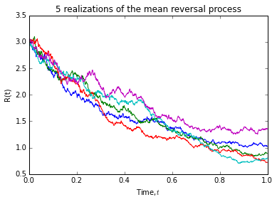

**Task 2: Downloading and manipulating stock data**

1. How many components stocks are there?

Answer: 30

The correlation of FTSEKLCI and Genting from may 2012 until may 2015 is 0.814252.

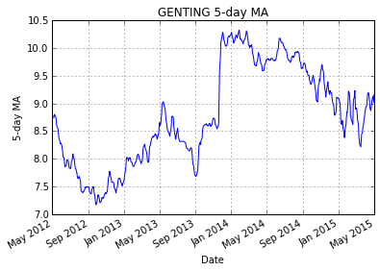

|  |  |  |  |  |  |  |
| --- | --- | --- | --- | --- | --- | --- |
| No. | Stock Name | Stock Code | Stock Sector | Weightage (%) | PE ratio | Net Market Capital(RM in million) |
| 1 | AMMB HOLDINGS BHD | 1015 | Banks | 2.38 | 9.47 | 18176 |
| 2 | ASTRO MALAYSIA HOLDINGS BERHAD | 6399 | Broadcasting & Entertainment | 1.22 | 28.64 | 16021 |
| 3 | AXIATA GROUP BERHAD | 6888 | Mobile Telecommunications | 5.62 | 24.58 | 55155 |
| 4 | BRITISH AMERICAN TOBACCO (M) | 4162 | Tobacco | 1.7 | 19.32 | 17703 |
| 5 | CIMB GROUP HOLDINGS BERHAD | 1023 | Banks | 5.76 | 17.27 | 45251 |
| 6 | DIGI.COM BHD | 6947 | Mobile Telecommunication | 4.16 | 21.5 | 43540 |
| 7 | GENTING BHD | 3182 | Hotel | 3.68 | 18.51 | 29967 |
| 8 | GENTING MALAYSIA BERHAD | 4715 | Hotel | 2.5 | 18.72 | 30302 |
| 9 | HONG LEONG BANK BHD | 5819 | Banks | 1.67 | 11.18 | 24104 |
| 10 | HONG LEONG FINANCIAL GROUP BHD | 1082 | Banks | 0.64 | 9.79 | 15960 |
| 11 | IHH HEALTHCARE BERHAD | 5225 | Health Care Providers | 3.28 | 60.65 | 46503 |
| 12 | IOI CORPORATION BHD | 1961 | Farming & Fishing | 2.99 | 61.91 | 25741 |
| 13 | KLCC PROP&REITS-STAPLED SEC | 5235SS | Real Estate Holding & Development | 0.63 | 13.59 | 12673 |
| 14 | KUALA LUMPUR KEPONG BHD | 2445 | Farming & Fishing | 2.28 | 27.75 | 22790 |
| 15 | MALAYAN BANKING BHD | 1155 | Banks | 9.32 | 12.87 | 87712 |
| 16 | MAXIS BERHAD | 6012 | Mobile Telecommunication | 3.45 | 29.09 | 47831 |
| 17 | MISC BHD | 3816 | Marine Transportation | 2.45 | 16.22 | 35755 |
| 18 | PETRONAS CHEMICALS GROUP BHD | 5183 | Commodity Chemicals | 3.55 | 21.78 | 50560 |
| 19 | PETRONAS DAGANGAN BHD | 5681 | Integrated Oil & Gas | 1.21 | 37.02 | 20445 |
| 20 | PETRONAS GAS BHD | 6033 | Exploration &Production | 3.4 | 22.43 | 42068 |
| 21 | PPB GROUP BHD | 4065 | Food Products | 1.8 | 17.88 | 17972 |
| 22 | PUBLIC BANK BHD | 1295 | Banks | 11.6 | 15.47 | 72287 |
| 23 | RHB CAPITAL BHD | 1066 | Banks | 1.06 | 9.24 | 19077 |
| 24 | SAPURAKENCANA PETROLEUM BHD | 5218 | Oil Equipment & Services | 1.98 | 12.35 | 14621 |
| 25 | SIME DARBY BHD | 4197 | Diversified Industrials | 5.51 | 21.02 | 52919 |
| 26 | TELEKOM MALAYSIA BHD | 4863 | Fixed Line Telecommunication | 2.96 | 32.43 | 24325 |
| 27 | TENAGA NASIONAL BHD | 5347 | Alternative Electricity | 9.28 | 9.42 | 7.545 |
| 28 | UMW HOLDINGS BHD | 4588 | Automobiles | 1.37 | 20.17 | 11846 |
| 29 | WESTPORTS HOLDINGS BERHAD | 5246 | Transportation Services | 0.93 | 27.69 | 14493 |
| 30 | YTL CORPORATION BHD | 4677 | Multiutilities | 1.63 | 14.55 | 16149 |