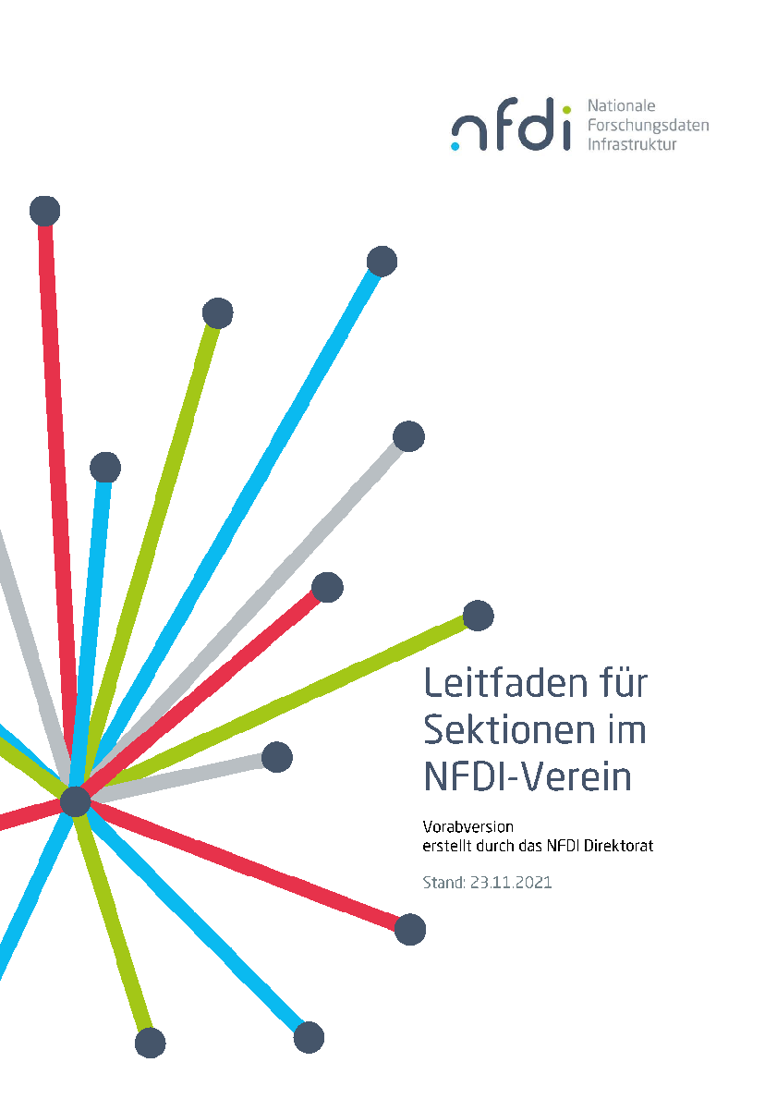



Working Group Charter  
< **WG name** >

Version 0.x, 6.12.2021

# **1. Motivation**

*(Motivation must derive from at least one of the section’s topic area)*

# **2. Objectives**

*(Concrete description of expected results)*

# **3. Work Plan**

*(Work plan with milestone descriptions)*

# **4. Initial Membership List**

*(At least 6 members from different institutions and at least 6 consortia)*

|  | **Name** | **Institution** | **NFDI consortia** |
| --- | --- | --- | --- |
| *1* | *Jane Doe (co-spoke)* | *Universität Pellworm* | *NFDI4...* |
| *2* |  |  |  |
| *3* |  |  |  |
| *4* |  |  |  |
| *5* |  |  |  |
| *6* |  |  |  |
| *...* |  |  |  |

# **5. Adoption Plan**

*(Descriptions how the participating consortia plan to apply the expected results)*