EMD v1.12 — Feedback to UAT
Below is a per-issue response: what changed, how you can verify it in the app, and the few open questions where I need a decision or a screenshot.
Legend: ✅ Closed · 🔧 Fixed this round (please re-test) · ❓ Open — needs your input

Closed — please verify

✅ #1 — Multi-select centers (QUAL-024)
Changed: the single-center dropdown is now a multi-select chip filter, shared by Datenqualität and Analyse. It narrows what you see on the client; the server still restricts to your authorized centers. How to verify:
- Datenqualität → center filter: click two center chips → only those centers' cases show; deselect all → all your centers show.
- Repeat on Analyse.
- (Security) You should never see a center you aren't assigned to, regardless of selection.

Test results: works in „Analyse“ but there is no multi-center select in Dokumentationsqualität (Do we need that though? -> Discussion).

✅ #4 — Approve/flag control placement (QUAL-025)
Changed: the flag-status (approve) control now also appears near the top of the case-detail panel, above the full patient values — no more scrolling past everything. How to verify: open a flagged case in Datenqualität → the status dropdown is reachable at the top; changing it there updates the flag (same as the bottom control).
Test results: Update correct; However, interaction concept is questionable: we now have two options to do that. Any argument agains having to confirm results directly in the „Messwerte“ list?
In general, overloaded page; Auffällige WErte / Fehlende Daten highlighted in its own card but not in the „zu prüfende Messwerte“ list.
There is the option „Behoben“, but no option to edit data. -> not self explanatory, is that just the opposite of confirming the result?

✅ #5 — Drill-down from chart to case (FALL-010) — was a real bug
Changed: you were right that this didn't work — the trajectory scatter points were rendered at zero size (a Recharts v3 issue), so they were invisible and unclickable. Fixed: points now have a visible, clickable size. How to verify: Analyse → Verläufe → the per-visit scatter points are visible; single-click a point → it opens that patient's case detail. (Drill-down is intentionally disabled in cohort-compare mode.)
Test results: The scatter points are not clickable -> I do see the pseudonym of the patient, but I cannot open the case by that.
General Remark: The „Verläufe“ Tab is very slow.

✅ #7 — Chart label clarity (FALL-012)
Changed: case-detail chart labels are now explicit: CRT legend "CRT (µm)", Visus Y-axis "Visus (Dezimal, bestkorrigiert)", and the interpolation note reads "Offener Kreis = interpolierter Wert (keine Messung)". How to verify: open any case detail with Visus/CRT data → confirm the legend/axis/interpolation wording reads clearly.
Test result: The labels are fixed now (except for the „Visus vs CRT“ plot). Visus (Dezimal, bestkorrigiert) is cut off and placed on the y axis in addition to the legend under the x axis where we would have the space.
I still do not see any open circle and thereby, I am not sure what "Offener Kreis = interpolierter Wert (keine Messung)" refers to in the figure.

✅ #9 / AUDIT-02 — Audit log login actor — your "unauthenticated" question
Changed: you asked why login rows showed unauthenticated. Those were successful logins (status 200); the username was in the row body but the actor column fell back to unauthenticated because a login request has no token yet. Now login rows show the attempted username as the actor — so you can see who logged in and, on a failed attempt, which account was targeted. (Password stays redacted; control characters stripped; truly token-less non-login requests still show unauthenticated.) How to verify:
- Log in as admin → Protokoll: your login row now shows actor admin (not unauthenticated).
- Try a login with a wrong password for some username → the failed row shows that attempted username.
- PROT-001: deleted users keep their real historical name; they cannot appear as anonymous (sessions are revoked on deletion).
Test results: There are still a lot of actions marked as unauthenticated -> see picture below:
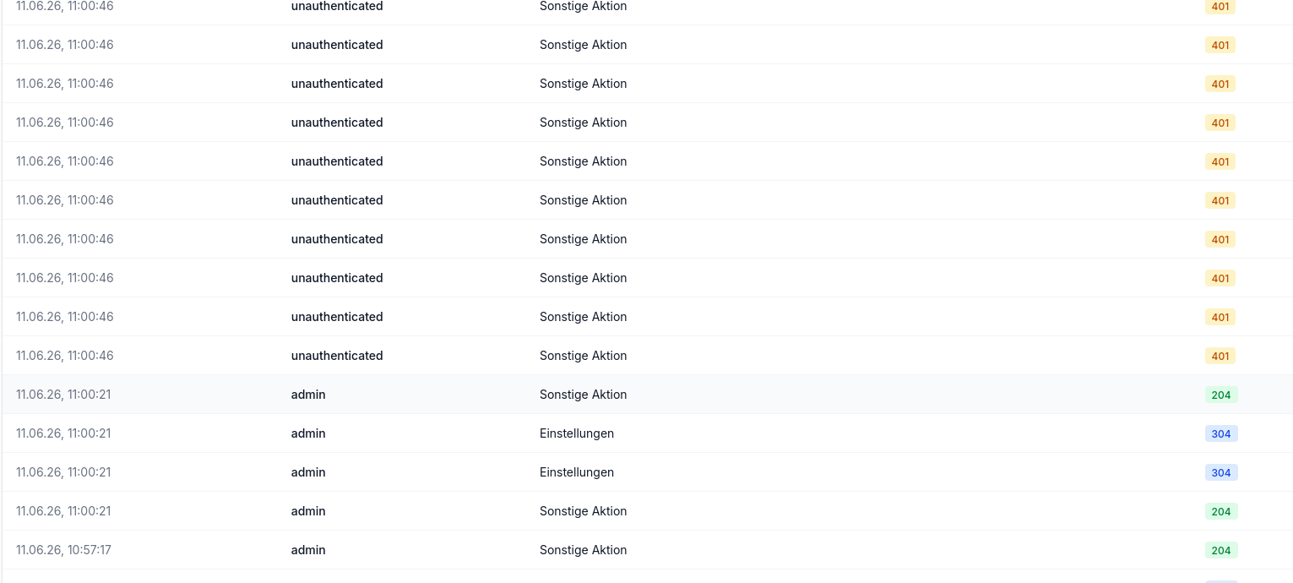
2. works.
3. Works as well.

Fixed this round (found via an adversarial self-review) — please re-test

🔧 #3 — Absolute counts on the quality overview (QUAL-023)
Root cause: you "couldn't find the absolute values" — they were prominent on Datenqualität but only the percentage showed on Dokumentationsqualität (the count was a tiny footnote). Also, the population total was summing per-center counts, which double-counted patients seen at multiple centers. Changed: both quality pages now show a prominent "Grundgesamtheit: N" label, and the count is the number of distinct patients (no double-counting), with count/total on each summary card. How to verify: open Dokumentationsqualität → a "Grundgesamtheit: N" line is visible above the metric cards, and each card shows an absolute count, not just %.
Test results: absolute numbers are shown now. These values are not adapted when I change the time range. Vollzähligkeit is computed different to the landing page. Vollzähligkeit does not adapt the Grundgesamtheit in its computation when changing the time range (the smaller the range, the less patients, the lower the Vollzähligkeit metric, which is not providing any information to the user).

🔧 #6 — Cohort reference overlay in case detail (FALL-011)
Root cause: the overlay (a) compared the patient against a cohort band that included that same patient, and (b) matched cohort data by exact calendar date — so on real data, where cohort patients rarely have a visit on the patient's exact dates, it often rendered nothing (would have looked broken to you). Changed: the index patient is now excluded from its own reference, and cohort statistics are aggregated by month so the band/median actually render across the trajectory. How to verify: open a case detail, enable the cohort-reference toggle → a median line + shaded IQR band appear along the Visus/CRT trajectory.
Test results: Cohort overlay only changes one plot. The plot becomes hardly readable, since the X-Range change (but not to relative since start, as I would expect as a user).

🔧 #8 — Missing axis ticks (A-06) — partially; see open question
Changed: explicit tick configuration added across all case/analysis charts so tick labels no longer drop on tight layouts. Re-test + see open question below (I still need your screenshot to confirm the exact chart you flagged).
Test results: all axes seem to be annotated by now.

❓ Open — I need a decision or a screenshot from you

❓ Q1 — A-06: which chart had the missing ticks?
I applied tick fixes broadly, but the original note just said "Screenshot benötigt." Please attach the screenshot of the chart where ticks were missing so I can confirm it's covered (or fix that specific one).
Answer: not relevant anymore.

❓ Q2 — QUAL-022: what should the time filter scope?
Right now the time-range filter on Datenqualität controls which cases count toward the Grundgesamtheit (a case is included if it has activity in the window). However, each included case's quality assessment / anomaly detection still uses its full visit history, not only the windowed visits. Question: is that the intended semantic ("population = cases active in the window, assessed over their full history"), or should the anomaly checks themselves be restricted to the selected window? I left the assessment over full history (it's the safer clinical default), but it's your call.
Answer: Right now, the Grundgesamtheit does not change when filtering (on the cards). The intention of the view is to generate insights on documentation quality – thus, if i as a user want to check, whether my quality increased / decreased for the last 6 month as opposed to another time range, I should probably only see metrics that are based on values from that time range. Further, we should discuss whether we can include more time range options.

❓ Q3 — (minor) Center filter with a stale selection
If a center you've selected later disappears from the available list (e.g. data reload), the chip stays selected but matches nothing. Low priority — do you want it auto-pruned, or is it fine as-is?
Irrelevant to our mock-up system.

Not changed (by design / confirmed earlier)
- FALL-010 interaction, FALL-012 wording, FALL-011 reference statistic (median+IQR), threshold scope (global), Analyse center filter (kept) — all confirmed with you on 2026-05-26; no change.

Backlog (logged for the next version, v1.13)
Per-site/per-cohort thresholds; QUAL-004 missing-value imputation; Keycloak OIDC + dead-path cleanup (blocked on infra); and a rare intermittent test flake to hunt. These are tracked as seeds (.planning/seeds/SEED-001..004).

Once you've answered Q1–Q3 and re-tested the 🔧 items, this milestone is ready to finalize.

Additional Points (NF)
- We can filter for cohorts in the Datenqualität tab now
  - However: I do not think it is self-explanatory, why quality measures are not in the Kohortenbildung tab, and what they do. This should probably move to the Dantenqualität tab.
- Sub-Cohort functionality does work now:
  - Proposal for less effort in creating sub-cohort:
    - When i want to create a sub-cohort, the intention probably is to compare two or more groups in my cohort (otherwise I could just create a new cohort using the saved queries). Thus, it might be easier to have different options here for the user: Split by gender, diagnosis, centers; split by a list of ranges for age, visus, retinal thickness; etc.

