**INVESTIGATING POLLUTION PATTERNS USING SPACE-TIME ANALYSIS**

**Introduction**

Air pollution stands out as the leading cause of premature deaths in the United States accounting for over 200,000 early deaths each year (Caiazzo et al., 2013). “Elevated levels of fine particulate matter pollution are associated with premature death and increased risk of cardiovascular and pulmonary disease, and they cost the global economy over 225 billion U.S. dollars in lost labor annually. The patterns of pollution are not uniform globally, and the pollution levels may be overreported in some locations but underreported in others” (ESRI, 2022). Human health impacts from air pollution disproportionately affect populations in countries undergoing rapid industrialization, population growth, urbanization, and motorization.

This proposal outlines a research project aimed at investigating pollution patterns using space-time analysis. The goal is to find regions where pollution is extremely high or unusual. This research will ArcGIS project package from ESRI’s pollution studies to analyze patterns of PM2.5 concentrations across regions on the globe. The aim is to identify the regional differences in pollution and their spatiotemporal dynamics.

**Objective**

This project aims to develop a user-friendly and efficient tool using ArcGIS API for Python that can automate batch processing of multiple datasets for investigating pollution patterns using space-time analysis.

**Data/Methodology**

The Methodology will include:

1. Data Collection: Data will be collated from ESRI’s learn ArcGIS portal (<https://learn.arcgis.com/en/projects/investigate-pollution-patterns-with-space-time-analysis/>). The data contains ArcGIS Pro project package and PM2.5 raster datasets.
2. Preparing Multidimensional pollution data: This involves the necessary steps in making the data usable for spatiotemporal analysis. Some of the steps here include creating a multidimensional raster layer (in CRF format) and creating a space-time cube.
3. Spatial Analysis and Visualization: The next step is to conduct spatial analysis to identify spatial patterns in pollution levels. This involves using tools in ArcGIS Pro such as interpolation, kernel density estimation, and hotspot analysis to identify areas with high pollution levels.
4. Temporal Analysis: Once spatial patterns have been identified, temporal analysis can be conducted to identify temporal patterns in pollution levels. This will involve creating a temporal profile chart to visualize pollution time series for countries.
5. Space-Time Analysis: The final step is to conduct a space-time analysis to identify spatiotemporal patterns in pollution levels. This involves the use of a space-time cube to find statistically significant hot and cold spots of pollution in space and time as well as, explore how patterns vary across the globe and through time.

**Programming Design**

The major portions of the investigation which involve the use of ArcGIS geoprocessing tools will be done using python scripting for ArcGIS. This will include everything possible on the model builder feature on ArcGIS Pro.

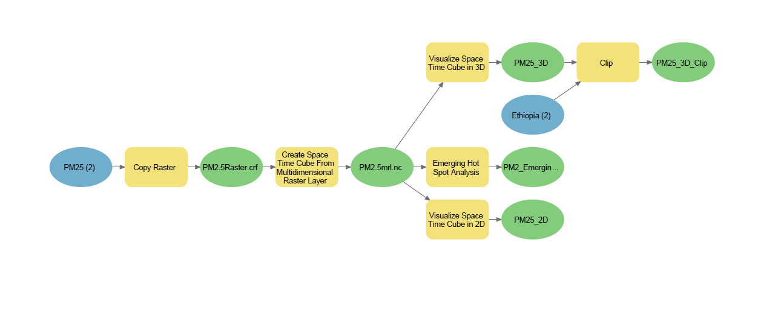

**Expected Results**

1. A user-friendly and efficient ArcGIS API for Python tool for automating batch processing tasks in investigating pollution patterns.
2. The tool will reduce the time and effort required to perform common GIS tasks, especially when dealing with raster datasets.
3. Improved data accuracy and consistency by minimizing the risk of human error.

**Conclusion**

The proposed Python tool for batch processing will provide a valuable resource for automating batch processing of multiple datasets for investigating pollution patterns using space-time analysis. The tool will automate repetitive tasks, reduce the risk of human error, and improve productivity and efficiency.