|  |  |
| --- | --- |
| To: | Professor Ilan Mitchell-Smith |
| From: | Joseph Okonoboh |
| Subject: | Knowledge Hound Memo |
| Date: | June 16, 2015 |

# Summary

In this memo we shall evaluate the quality of the instruction that the website [www.knowledgehound.com](http://www.knowledgehound.com) provides its users in ordering its products.

# Rhetorical Situation

We shall analyze the rhetorical situation in terms of purpose, audience, and constraints.

* **Purpose**

Knowledge Hound claims that it can help organizations better organize, store, evaluate, and interpret their data.

* **Audience**

The audience will typically be sales representatives and market researchers of a particular company.

The most important information that the audience of Knowledge Hound would want is how to request services and how much these services will cost. At the top of every page is REQUEST A DEMO link



that is contrasted from the rest of the text by its yellow color. Upon clicking this link, the user will be taken to the bottom of the page wherein he or she has to fill information about his or her first name, last name, and email.

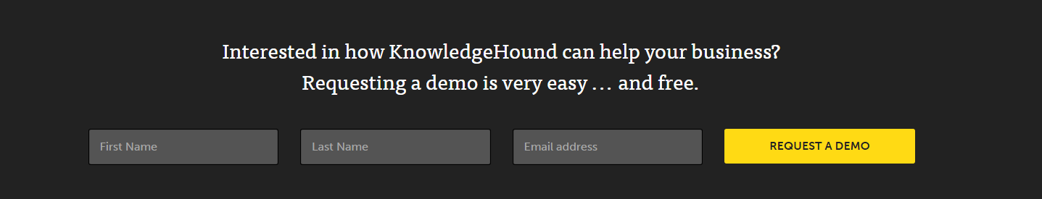

As evidenced from above, the instructions are self-explanatory and all the user need do is to enter his or her information and click on the REQUEST A DEMO button. This set of instructions is concise and makes good use of images instead of relying on words; thus they are more effective.