To verify that the server can communicate with another computer or network, I used ping command. Result showed that communication is possible. Screenshot below.

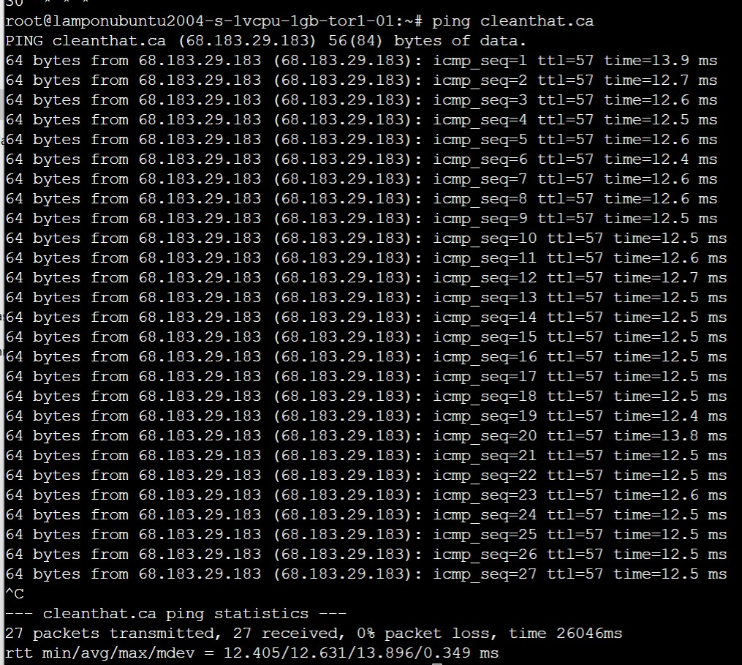

Upon ping’ing the IP address 54.205.240.192

