Skedel Tower Defense

Kai Friese
and
Jasmin Knott

Games: User Experience and Analysis
Game Development Diary

21.06.2024
Table of Contents
0.1 Work distribution 1
0.2 Game description 1
1.1.1 LoL – Jasmin Knott 2
1.1.2 Witcher – Kai Friese 2
1.2 Team up 3
1.3 Create Conflict 4
Set#1 – Jasmin Knott 4
Players: 4
Objectives/Goals: 4
Procedures/Actions: 4
Set#4 – Kai Friese 4
Procedures/Actions: 4
Rules: 4
Boundaries: 4
1.4 Create Team Conflicts 5
Players: 5
Objectives/Goals: 5
Procedures/Actions: 5
Rules: 5
Resources: 6
Conflict: 6
Boundaries: 6
Outcome/Feedback: 6
Requirements: 6
2.1 Interactive Experiences 7
2.2 Game Feel Steps 7
2.3 Unique kinetic gameplay 7
3.1 Decisions and predictability 8
3.2 Beta optimization 9

0.1 Work distribution
The project was created by a two-person team, Kai Friese and Jasmin Knott. Together, we brainstormed ideas, made crucial design decisions, and crafted the Game Development Diary.
Jasmin Knott took on the important role of visual artist, creating all the graphics and sprites entirely by hand. Her art shaped the aesthetics of the game and provided a coherent and visually captivating experience for the players. In addition, Jasmin developed the menu and user interface and implemented the underlying code. She also selected and integrated the music and sound effects to enhance the audio experience and immerse players deeper into the game world. Jasmin also came up with the setting and the story of the game.
Since Kai Friese has more experience with Unity, he took on the primary responsibility for the technical aspects and implemented the core game mechanics. He designed the code structure and patterns, ensuring a robust and scalable foundation for the game. He developed the mechanics for turrets and their placement, programmed the behavior of enemies, and implemented the kinematic abilitiy. Additionally, Kai handled the player input, added particle effects and took care of balancing.

0.2 Game description
Our game is a tower defense in which the player has the task of defending the passage between hell and the human world. More and more undead, represented by burning skulls, break out of the gate to hell and try to get through the opposite gate to the human world.
To stop these waves of enemies, the player has several towers to choose from, which he can build with gold. There are different ways to get gold. On the one hand, the player receives one gold passively every second and another 10% of his current gold as income every 30 seconds. In addition, each enemy is worth a certain bounty, which the player receives when he kills the enemy.
The turret selection is the arrow turret, which is the cheapest turret and good against weak opponents, as it attacks quickly but does little damage. The next cheapest tower is the cannon tower, which has a very long range and high damage, but has a low attack rate. There are also two elemental towers, ice and fire. The ice tower radiates an aura around itself, which slowly drains a small amount of life from all enemies within range. More importantly, it also slows down all enemies within range, giving the player more time to deal damage. The fire tower shoots flames at its target and sets it on fire. The enemy receives a number of burning stacks, which are reduced every second and cause armor-ignoring damage. Finally, there is a gold tower, which does not attack but increases the passive gold income.
There are different types of skull enemies. The standard enemies which have no special characteristics. Fast enemies, which are easier to kill but run across the map much faster. Flying skulls, which can move over towers and move in a straight line to the gate. There are also slow and particularly resistant enemies and those that split into standard enemies when they die. In addition, there is a scaling opponent who gets stronger with every round. Another special type of enemy is the golden skull. This enemy is very resistant and gives a particularly high bounty, but the life and bounty of golden enemies are doubled each time one of them is defeated, and they do not drain the player's life when they reach the exit. But golden skulls only appear by luck with a low probability.
As additional actions, the player can upgrade his towers for gold or sell them for half the total cost. He also has an ability at his disposal with which he can defeat all opponents on the map. However, this ability also costs gold and the price doubles with each use.
You can also click on towers and opponents to see information about them.
As the game is intended as a side activity and therefore the player has more control, he can interrupt the game at any time or increase the speed of the game.
Press "Escape" to call up the menu and end the game.

1.1.1 LoL – Jasmin Knott
My favorite game is the MOBA League of Legends in which two teams of five players fight against each other online. The goal of the game is to destroy the opponent's Nexus (the main building). To do this, all towers and an inhibitor must be destroyed on at least one of the three lanes. To achieve this, each player controls a character which they can choose each round. The players are divided into different positions and roles on the map. Four players divide themselves between the three lanes and try to gain gold and experience in the early game until the first towers have been destroyed. The fifth player in the team defeats neutral monsters in the jungle and helps the other players on the lanes. In the middle game, the lanes are swapped, team battles take place and objects are fought over. In the late game, there are usually more team fights and attempts are made to destroy the opponent's base and also the Nexus.
The rules of how the game is normally played are determined by the so-called meta. The meta describes the currently strong characters, equipment, strategies and more, which have a particularly high winrate.
Gold can be earned by killing NPCs, enemy characters and objects such as towers or strong neutral enemies, which can be used to buy equipment. In the same way, experience is also gained in order to level up and obtain new abilities and increase basestats. Each character has a life bar and some have mana or similar resources such as energy and rage to cast abilities.
The conflicts in the game are mainly the other players. Of course the opponents who are trying to win the game themselves, but being on the same page with random team members is not always easy. On the non-player side, there are the towers, which are strong, shooting buildings that have to be destroyed, as well as the minions that regularly spawn and run across the lanes.
The game is limited to a few maps where the player's movement is restricted by buildings and walls (especially in the jungle). Each round the player starts with a new character at level one and should not leave the round until one team has won, otherwise the teams will be unbalanced and the leaving player will receive a penalty.
The game can also be played in different ranked modes where you can earn league points at the end of each round to rank up.

1.1.2 Witcher – Kai Friese
My favorite game is the singleplayer RPG The Witcher 3 Wild Hunt. You find yourself in the role of Geralt of Riva. The player is a witcher, a magically mutated monster hunter. The player travels and explores the fantasy world, interacts with NPCs, investigates tracks and fights monsters and humans.
The main objective of the game is to follow the main quest line, which is to find the foster daughter Ciri. To level up faster and earn gold, you can also take on side quests, such as the so-called witcher quests or treasure hunts. The quests usually consist of interactions, battles, searching for and following tracks or objects.
There is also a built-in collectible card game called Gwint, which can be played against numerous NPCs throughout the world.
The player earns gold to buy armor and weapons, with a distinction being made between steel swords and silver swords, which are more effective against humans or monsters. There are also potions, bombs and weapon oils which can be produced from herbs, monster parts and other ingredients. Through experience, the player increases in level and receives skill points. In battle, there is life and stamina and poisoning as a resource.
Conflicts in the game are some difficult decisions in dialogs, fights with enemies and the limitation of potions and bombs.
Borders in the game are various areas which the player can only enter and leave by fast travel. These areas must be unlocked by progressing through the main quest. In addition, there are many rivers, rocks, trees, buildings and other obstacles in the world that restrict free movement. Outside of battles, you can save and end the game at any time.
The game has different storylines and endings depending on the decisions the player has made. However, even after completing the main quest line, the player can continue playing at will.

1.2 Team up
Our team consists of only two members, Jasmin Knott and Kai Friese, who both have basic experience in Unity and game development. We have already worked on various game projects together during our studies. In the course of the team building we were assigned additional members, but none of them participated in the course or responded.

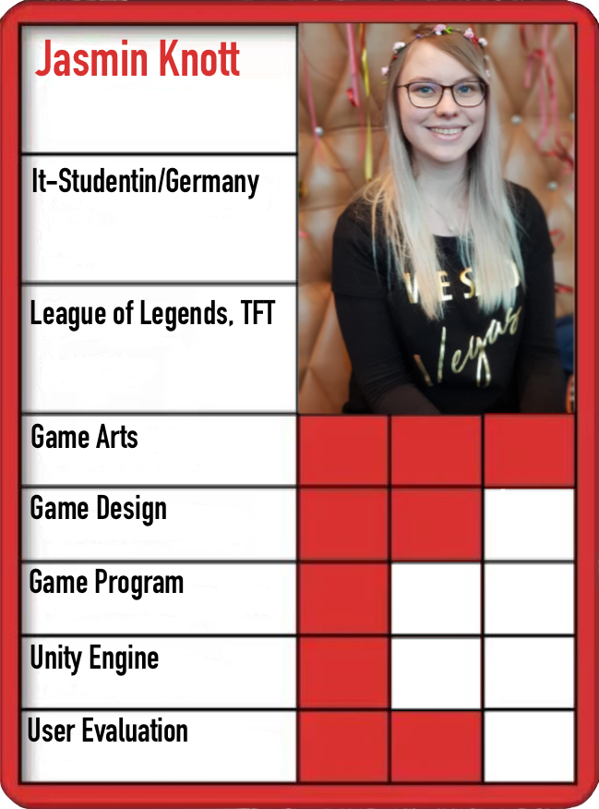Figure 2 Presentation board Jasmin Knott
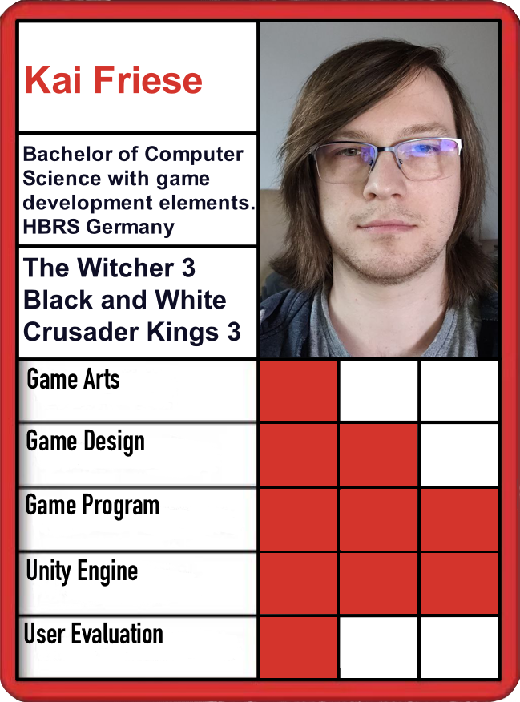Figure 1 Presentation board Kai Friese

1.3 Create Conflict

Set#1 – Jasmin Knott
Random Words: Tower, Distraction, Wave

Players:
The player takes part in the game by placing and managing towers. The game can be played as a side activity, creating a feeling of distraction. The game is supposed to be a single player game in which the player fights waves of enemies. The player takes on the role of a strategist and is effectively the commander of the towers.

Objectives/Goals:
The goal of the game is to survive as many waves of enemies as you can. Possible objectives are the destruction of enemy waves and the construction of defenses such as towers. As part of the story, it can be an objective to rescue the world from waves of enemies through towers.

Procedures/Actions:
The player's starting action is to use the gold available to him at the beginning to place towers. The progression is to get more gold through time and defeating enemies to build or upgrade more towers. A special action can be to use an ability, such as a shockwave, a buff for towers or a debuff for enemies. The game can have resolving actions such as losing all lives or defeating enough waves of enemies.

Set#4 – Kai Friese
Random Words: Skull, Wall, Fire

Procedures/Actions:
As a starting action, the player begins by building a wall. As a progression action, the player expands the wall into a kind of maze, through which enemies pass in the form of burning skulls. Meanwhile, the walls fire at the enemies. A special action could be to tear down walls again or to upgrade them to elemental variants such as ice and fire in order to burn or slow down opponents.
Resolving actions could be to defeat all enemies (skulls) or to build a complete maze.

Rules:
Some rules could be that skulls disappear when they have 0 lives. That enemies cannot pass or destroy walls. The path to the exit must not be completely blocked. That the player loses life when an opponent comes through the maze to the exit. The player earns money by defeating enemies.

Boundaries:
The limits of the game could be that it becomes a single player game. This makes it possible that the player can theoretically pause or stop playing at any time. In addition, the player only has a limited building area where each wall placed means less space is available and is also blocked by opponents.

1.4 Create Team Conflicts
Due to our small group, we only have two sets that can be put together. From the existing conflicts we have decided to create a simple tower defense game and adapt the missing conflicts.

Players:
The player takes part in the game by placing and managing towers to create a mazelike path. The goal is to create a game that can be played as a side activity, providing a feeling of distraction and occupation. The game is supposed to be a single player where the player fights the game. The story of the game is that undeads (flying, burning skulls) are trying to break out of hell and get through the gate to the world. The player's role as commander of the towers is to protect the world.

Objectives/Goals:
The goal of the game is to survive as many waves of enemies as possible. Objectives are the destruction of waves of enemies and the construction of towers as maze-like defenses. The story objective is to rescue the world, which turns out to be an endless battle for the player.

Procedures/Actions:
The player's starting action is to use the gold available to him at the beginning to build towers. Over time and by defeating enemies, he will receive more gold to build or upgrade more towers and thus create a maze-like structure. The enemies pass through this maze in the form of burning skulls in order to reach the gate. Meanwhile, the towers shoot at the enemies on their own. The player can choose different tower types to combine their advantages and disadvantages.
As a special action, an ability can be used, which is implemented as a shockwave to defeat all current opponents at once. There is also a special action with which the player can sell towers at half price. The game resolving action is to lose all lives.

Rules:
Some rules for our game are:
- The path to the exit must not be completely blocked.
- The player loses life when an enemy passes through the gate.
- Enemies have life and armor.
- Armor reduces the incoming damage by a fixed value.
- Enemies disappear when they have 0 lives.
- Enemies cannot pass through or destroy towers.
- The player receives bounty gold by defeating enemies.
- The player receives one gold every second.
- The player receives 10% of his gold every 30 seconds.
- Towers have a limited range, attack speed and damage.
- Towers cannot be placed on enemies or other towers.
- Towers can only be built or upgraded if enough gold is available.

Resources:
The resources available to the player are gold and life. While gold is actively used and increases and decreases over the course of the game, lives can only decrease and cannot be actively used. However, the game ends when there are no more lives left.
There was also the idea of using mana as a resource for the special ability. The game can also be expanded later to a rougelite, in which additional resources can be used to enable progress across rounds.

Conflict:
Conflicts arise from opponents, as they can get in the way of the player building towers. Furthermore, it is very difficult and requires several attempts to build the best possible labyrinth.
In addition, the current gold supply also limits the player's options. Of course, the loss of life is also a conflict.

Boundaries:
The limitations of the game are that it is a single-player game. The player can pause or end the game at any time. In addition, the player only has a limited building area, on which less space is available with each tower placed and which is also blocked by opponents. In addition, there is a natural limit to the number of towers that can be placed, so once they have all been placed and upgraded, the player can do nothing more than use the special ability.

Outcome/Feedback:
Outcome/feedback occurs in different variants in our game. On the one hand, the player receives a bounty for every enemy defeated. There is also the chance to spawn a golden enemy in every wave, which is difficult to defeat, but cannot drain any lives and gives an extra large bounty.
As a more personal outcome, the player will meet decisions with direct consequences and it's fun to try out new strategies.
There are also plans to include a high score and statistics on, for example, enemies killed and bounties received.

Requirements:
- 3 procedures (build tower, upgrade tower, sell tower, cast ability, select enemy or tower)
- 1 dynamic object (tower, enemies)
- 2 resources (gold, life)
- 3 forms of feedback/outcome (highscore (still in development), statistics (still in development), bountygold, luck to spawn golden enemy, decision making, learning strategys)
- 1 static or dynamic camera (static camera)

2.1 Interactive Experiences
The primary experience players have with the game revolves around making decisions and experimenting with various strategies. The thrill and joy stem from the process of learning, trying out new approaches, and mastering the intricacies of maze building. This aspect of the game offers a continuous sense of achievement and discovery, as players refine their techniques and uncover the most effective ways to construct mazes.
Moreover, playing the game provides a relaxing experience. It is an activity that can be enjoyed leisurely, allowing players to unwind and de-stress. The gameplay's calm and methodical nature makes it an ideal companion for unwinding after a long day or while multitasking with other activities.

2.2 Game Feel Steps
In order to improve the experience of our game, we give the player control over the pace of the game. In other words, pause the game and increase time speed. Looking at the three main components of Swink, the game is already in real-time control and will be further enhanced by the control over the game speed.
Our simulated space is only 2D so physical interactions, collision and cinematic effects are not used as much. However, we still have collision detection when looking for turret targets and projectiles hitting enemies. In addition, the special ability is a shockwave which has kinematic effects. It applies force to enemies in waves and pushes them away.
The visual design of the simulated space of the level is adapted to the setting to create a suitable atmosphere.
As a polish, we have added particle effects for the ice towers so that the player can see where enemies are being slowed down. We have also added projectiles to the remaining towers to give the player visual feedback. The tower levels are also represented by small symbols so that the player can see at a glance which upgrade level a tower is at.

2.3 Unique kinetic gameplay
Since our game is a simple 2D tower defense, there are only a few options for kinetic elements. One option would be a special trajectory for the projectiles, but this is difficult to visualize in the 2D top-down perspective. An alternative could have been for the cannon turret's projectiles to trigger an explosion and push enemies a little bit away. However, this would have added even more visual effects to the screen and possibly overloaded the player, and this variant would also have involved more polishing and effort. Due to our small team size and the limited time available to us, we decided to add an ability instead. This triggers a shockwave consisting of five small thrusts that exert force on the opponents and thus gradually pushes all opponents off the map and thus defeats them. Each of the five waves has a separate collision check with the opponents and only exerts a small amount of force on the opponent. This creates a unique effect in which the opponents are not all eliminated at once, but gradually.

3.1 Decisions and predictability
In our game, the player has to make various immediate decisions in real time. The obvious ones are which tower to place and where. This is made even more profound by the fact that the player can also upgrade towers and must consciously save up gold to do so. In dangerous situations, the use of the ability comes into consideration as a dramatic decision that involves a trade-off between the loss of gold or life. Saving up gold is also a conscious decision, as more gold in the bank means a higher income on a regular basis and the player has a gold reserve to use the ability in an emergency. However, the defense is weaker as less is invested here.
Some of these decisions are informed decisions. For example, the player always knows how much gold to spend on an action and knows the stats of the opponents and towers. In contrast, there are also uninformed decisions where the player lacks information. The player does not know how many and which enemies are coming in a wave and therefore does not know exactly whether he can save up gold or place gold towers to make more profit, or whether he needs more towers and upgrades for defense.
The use of gold towers and the decision of which tower to place where are long-term decisions. The gold tower is a trade off between less defense and getting more gold in the long run. The position of the towers can be corrected by selling them, but this also means a loss of gold and it will be difficult to reconstruct the labyrinth afterwards. The position of the towers is also important in order to be able to use the available building area effectively and to use towers such as the ice tower with its slowing aura and the canon towers with their long range as effectively as possible. Placement is therefore a long-term decision that requires careful consideration.
The player's wide scope for decision-making has a different influence on the game depending on the phase. The placement of a single tower only has a small influence on the current wave and at most determines whether the player loses one more or one less life. However, every decision made beforehand becomes more and more influential as the game progresses, because with stronger waves, the longest possible path for the enemies and a well thought-out distribution of the towers (especially the ice towers) is a critical function that determines whether the player survives or not.
In terms of predictability, the player has the opportunity to foresee the behavior of the opponents and the influence of his towers to a certain extent. As long as the path is not blocked, the opponents always follow the same route and always look for the shortest way to the goal. This means that the range of towers can be exploited and strategically important points can be considered in advance.
The information starvation and glut is represented in our game primarily by the information about towers, enemies and wave patterns. As far as starvation is concerned, we have deliberately omitted some information about the enemy waves, such as spawn count, spawn speed, spawn patterns and enemy types, in order to keep the player in the unknown and not provide too much information. However, there are still some places where unwanted information starvation takes place. Especially information about towers before you buy them and what an upgrade improves as well as the explanation of the income system are still missing. Until the final version, we want to add these by adding tooltips or a tutorial. There may currently be a small amount of information overload in terms of how detailed information is given about selected enemies and towers.
In terms of decision pacing, the player has to make quick decisions, especially in the early stages of the game. As the game progresses, the pace slows down and develops into a calmer game in which the player has more time to think about their decisions. The player also has the option of adjusting the pace to suit their needs by increasing or pausing the game speed.
With regard to the question of what future possibilities exist, we have two different points of view. First, from the player's point of view, which decisions he plans ahead or which decisions are foreseeable for him. The main decision for the future progress of the game is the layout of the labyrinth, the planning of expensive upgrades and the anticipation of having enough gold to use the ability. From the developer's point of view, we can expand the game and add more decision-making options. Our idea was to expand the game into a rougelike. The player would always receive another resource such as experience or gems after finishing a game (reaching 0 life points), with which he can buy improvements, new towers or abilities for all future games. With this approach, it could also be implemented that the player has to put together a set from his collection of towers and abilities at the start of a new game.

3.2 Beta optimization
To enhance the overall experience of the game, we have introduced several new features and improvements. We have added music and sound effects to enrich the auditory experience, making the gameplay more engaging and enjoyable. Alongside this, we have incorporated more visual feedback to provide players with clearer and more satisfying responses to their actions. We have also updated the user interface with a slightly more interactive menu. Players now have control over the game speed, allowing them to adjust the pace according to their preference, whether they want a more relaxed playthrough or a quicker, more intense challenge. In terms of gameplay, we have implemented numerous balancing changes to ensure a fair and challenging experience. While these adjustments have significantly improved the game, we acknowledge that further refinement is necessary to perfect the balance.
Looking ahead to the final release, we plan to implement tooltips and a simple tutorial to reduce information starvation and help new players familiarize themselves with the game mechanics. Balancing improvements will continue to be a focus, along with the addition of preprocessing to beautify the game.
If time permits, we aim to implement a highscore table and detailed statistics. These features will provide players with better feedback on their performance and encourage them to strive for higher achievements, adding an extra layer of outcome, motivation and competition to the game.

