MOBILE MONEY RWANDA

Christopher okoth

7/18/2019

## CODING CLUB ASSIGNMENT

#load the data   
library(readr)  
  
data<-read_csv("mobilemoney_data.csv",col_names=TRUE,cols(district=col_factor(),urban=col_factor(),gender=col_factor()))

## Introduction

The data was collected on the use of mobile money services and the experiences of mobile money customers in three districts of Rwanda. The dataset has been provided and you have been asked to write a short summary outlining key findings from the project. You should perform all the statistical analysis required and write up the key findings. You should remember that the target audiences do not have a statistical background

## Distribution of gender

demographics<-read_csv("demographics.csv",col_names = TRUE)

## Parsed with column specification:  
## cols(  
## age = col_double(),  
## gender = col_character(),  
## highest_grade_completed = col_character(),  
## hh_members = col_double()  
## )

head(demographics)

## # A tibble: 6 x 4  
## age gender highest_grade_completed hh_members  
## <dbl> <chr> <chr> <dbl>  
## 1 32 male primary 6 1  
## 2 32 male primary 6 1  
## 3 32 male primary 3 4  
## 4 32 male primary 3 4  
## 5 32 male primary 3 4  
## 6 30 male secondary 6 8

table(demographics$gender)

##   
## female male   
## 1458 1051

ggplot(demographics,aes(x=gender))+geom_bar(aes(x=gender))+theme_economist()+geom_bar(fill="red")

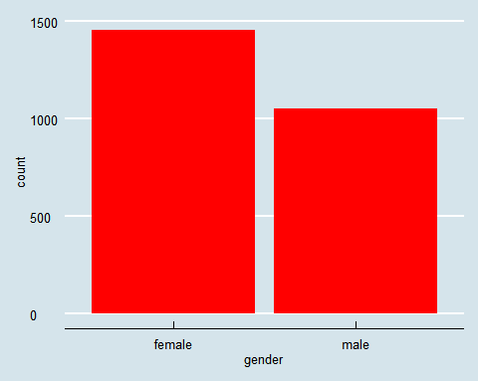 The bar chart above show that 1458 female and 1051 male were involved in the study.

## scatter plot for age against household

ggplot(data,aes(x=age,y=hh_members))+geom_point()+facet_wrap(.~gender+highest_grade_completed)+theme_economist()

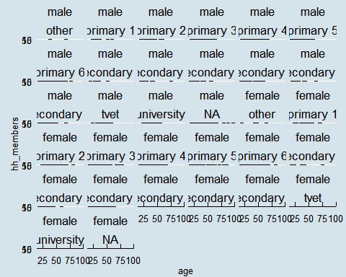 ## The distribution of types of accounts

data%>%group_by(account_type)%>%summarise(number=n())%>%mutate(percentage=number/sum(number)*100)%>%arrange(desc(percentage))

## # A tibble: 7 x 3  
## account_type number percentage  
## <chr> <int> <dbl>  
## 1 Mobile Money 825 32.9   
## 2 VSLA Account 669 26.7   
## 3 SACCO Account 467 18.6   
## 4 Bank Account 323 12.9   
## 5 None 131 5.22   
## 6 MFI Account 82 3.27   
## 7 Online Bank Account 12 0.478

The table above shows that mobile money and VSLA account are the most used with 32.88 and 26.66 percent of people usin it. The lowest bank account used is online bank account.