# CHAPTER ONE

## 1.1 Introduction

This chapter contains the introductory part of the Online Student Project Management System, the background of the study, its problem statement, the aim and objectives, scope and limitation of the scope.

Think about major projects that occur in people’s lives, such as throwing a big party, like a wedding or graduation celebration. Months are spent in advance identifying and performing all the tasks that need to get done, such as sending out invitations and selecting a menu, and time and money are carefully allocated among them. Along the way, decisions are recorded, problems are addressed, and changes are made. System development projects can be much more complicated than the projects we encounter in our personal lives-usually, more people are involved (e.g., the organization), the costs are higher, and more tasks need to be completed. Project management is the process of planning and controlling the development of a system within a specified time frame at a minimum cost with the right functionality. A project manager has the primary responsibility for managing the hundreds of tasks and roles that need to be carefully coordinated. Today, project management is an actual profession, and analysts spend years working on projects prior to tackling the management of them. There also is a variety of project management software available, such as Microsoft Project, PlanView, and PMOffice, which support project management activities. Once the project is approved, it enters project management. During project management, the project manager creates a work plan, staffs the project, and puts techniques in place to help the project team control and direct the project through the entire SDLC. (Soyemi & Isinkaye, 2017a)

A Project is an investigative undertaking, a structured, organized experiential learning including design work, field work or other placement learning. A ‘Project’ leads to a ‘dissertation’ that is assessed. (M. Thorn, 2015)

The project/dissertation is a module that provides the students with the opportunity to design, undertake or conduct an independent piece of research or study related to their Program of studies under the guidance of a supervisor, who is normally a member of the academic staff (full-time or part-time). Other qualified supervisors may also be appointed subject to approval by the Head of Department and Dean of Faculty/ Director of Centre. (David J. A, 2007).

In most tertiary institutes in the country, students seek a project in a given field of specialty as part of the upper level of their degree program. Usually, a project can be filled by at most one student, though in some cases a project is suitable for more than one student to work on simultaneously. To give students something of a choice, there should be as wide a range of available projects as possible, and in any case the total number of project places should not be less than the total number of students. Typically a lecturer will also offer a range of projects, but does not inevitably expect that all will be taken up.

Often, senior students struggle with their graduation projects throughout their university years, trying to manage their deliverables and their progress to meet deadlines. To ensure that they complete their projects, supervisors must become more involved, and what is needed to make this possible is an online application that would facilitate the whole process of creating and managing the project, which includes tasks, documentation, correspondence, and other related activities.  
Over time, it has been discovered that students are becoming very lazy and are no more originality in the project carried out to qualify them for the degree awarded. From the little findings carried out, it was discovered that since students are allocated to different supervisors, a project carried out by a student in a particular year with certain supervisor could be picked up by another student in another year and replicate to another supervisor within the same department without the supervisor’s knowledge(Soyemi & Isinkaye, 2017b)

Today in the information age that we live in, rapid changes in information and communication technologies (ICT) have become common in every field of our lives. The tools and materials that we use in our daily lives are renewed almost daily. In paralleled with these changes, ICT applications have inevitably entered into learning and teaching activities.(Yorulmaz, 2012)

The case study is Faculty of Computer Science and Information Technology, is a faculty in Bayero University kano and as a matter of fact there are close to seventeen (17) faculties in the institute, but we have chosen to focus on a particular one, Faculty of Computer Science and Information Technology.

At Faculty of Computer Science and Information Technology, all activities related to students project are carried out either manually or through electronic mails, as desired by the project supervisor.

The daily use of ICT devices has driven so deep that there cannot be an effective management without the availability of computers. The problem is that there has been number of projects mismanagement, lack of communication between students and their supervisors, loss of files which in case lead to project breakdown. It is for this reason that this work is proposed.

## 1.2 Problem Statement

The traditional way of managing project to students in the faculty of computer science and information technology need to be reevaluated since project/research writing is sensitive aspect of student education in the all higher institute. Before now, lecturers ask students to go out and get project topics for themselves for approval. This system made project writing look less like a class assignment which does not require an extra effort to complete rather an issue of copying. Most students are fond of getting their project write-up/documentation destroyed either to loss of computer system, misplacing files, fire out break and lots more. One of the most annoying and frustrating activity in conducting a research work is submitting your initial project chapters to a busy supervisor, one that is engaged both at undergraduate and postgraduate level, the entire manual process is not effective. It has become widely recognized that manual storage of student projects has inherent problems. At faculty of computer science and information technology, students submit hard copies of projects’ write-up to their various individual supervisors within the department and faculty.

Difficulty in reviewing documentations of student work, as a result of supervisors been busy most times, they find it most times very challenges to sit back in their offices in other to review students’ works. It will be very difficult for supervisors to figure out all projects topics been student been carried out by various students and possibility of repeating project topics without detection by project supervisors and project coordinator. Records of project topics carried out by a student are stored in the departmental library for a long time which occupies valuable office space. Backing up projects becomes a problem since more space will be employed. Projects are prone to loss due to natural disasters such as fire outbreak, flooding etc. Difficulty in searching for project topics already done, that needs to be reviewed. Projects cannot be accessed outside the University, that is, it has the problem of geographical barrier.

Faced with the need to organize projects, the proposed system for management of student projects is unique and totally inventive in its incorporated approach. The system to be developed makes use of rich internet technology to replace the traditional method currently in use.

## 1.3 Aim and Objectives

The aim of this research study is to develop an online student project management system for Bayero University Kano to effectively manage undergraduate students’ final year projects, which will replace the manual method. The system is aimed at reducing if not to eliminate the problems associated with the current system in use.

To achieve this aim, the following objectives are set out:

1. To study the current system in use.
2. To design and develop the proposed system putting into consideration the features present in the manual system and the new features that needs to be added in the new system.
3. To implement the new proposed system and to develop the design into fully working system.
4. To test the new system develop using FCSIT as a case study.

## 1.4 Scope and Limitation of the study

### 1.4.1 Scope of the study

The scope of this project covers Students’ Project Management in Bayero University Kano. This scope will be achieved in the following areas:

1. Keeping track of research projects both approved and completed
2. Coupling the energy of staff at a faster pace.
3. Managing complex changes in an organized way
4. Retrieving data as at when required.

The proposed system will affect three types of actors, which are the project coordinators, project supervisors and students. The system will allow eligible final year students within FCSIT to automatically generate supervisor, submit project proposal, upon approval he/she will be able to upload project initial documents. Project Supervisor also will have to approve proposed topics, download and review document and give recommendations. The project coordinator manages the entire activity for the project management, supervisors’ allocations, etc. All stakeholders must log into the system to interact with the system.

The different modules present in this project based on the three actors are as follows:

Proposed system

1. Project Coordinator’ interface
2. Login
3. Manage users
4. Manage projects
5. Manage project category and sub category
6. Manage Notifications
7. Project Supervisor’ interface
8. User Authentication (login)
9. Manage project proposals
10. Manage project chapters
11. Manage feedback
12. Suggest Topic
13. Grade students
14. Students interface
15. User Authentication (login)
16. View feedback
17. Generate project supervisor
18. Upload project proposal
19. Upload project chapters

### 1.4.2 Limitation of the study

Generally, every work has some limitations and this study is not exempted. For this study, limitations from the above could be:

1. The system will not support document word to word checking.
2. The system will not support collaboration between students.
3. The system will not support tasks assignment by project supervisors.
4. The study is limited to faculty of computer science and information technology of this institute.
5. Student cannot view their grade in their own model.
6. The system must authenticate users (students and project supervisors) before they can use it.

## 1.5 Significance of the study

The manual method as we said earlier is associated with too much set-backs and as such the reason of the new proposed system is to eliminate or reduce these problems hence the importance of the new proposed system.

The new system is time saving, non-tedious, data safe, non-data redundant and accessible from any part of the world, scalable online database system of storage and user friendly interface. Also in this study we will be moving from manual management of projects to computerized management of projects for easy retrieval, storage, accuracy, security of documents. This research work will offer the following benefits to the most faculties (FCSIT) in Bayero University Kano:

Through this system, the students will be able to use the Online Project Portal effectively for their online project activities and process especially for submitting their project proposal, uploading their project chapter. Example: It will also promote students easy access to project resources, materials etc.

1. Aid project supervisors’ allocation.
2. Avoid losing files to natural disaster.
3. Enable easy and reliable project topic selection.

# CHAPTER TWO

## LITERATURE REVIEW

## 2.1 Introduction

This chapter contains the literature review of this project. It contains some of the efforts that have been made so far in computerizing the student project management system. The project management system consist of all the processes required for a complete student project process.

A student project is a work that a student creates as part of a tertiary/high school, undergraduate, or graduate school program. Student project are long academic documents that students write after they research a particular subject in depth. Therefore, student project are usually assigned once per course, per semester, or only once as part of an academic program. (David J. A , 2007)

A graduate student project has its own definition and set of requirements. In most cases, a graduate project is “One paper that a student works on for a large portion of the graduate program, especially in his or her final months of the program. This project requires a huge amount of research and may even be ground-breaking for a particular industry”. Students will then have to defend their student project in front of a panel of judges that are familiar with the subject matter in the project. These panel members may ask the student questions related to his or her research or to the project itself. This sort of graduate project is also often called a graduate school dissertation. (Valter de Senna May 2005)

Turner (1998) defined a project as ‘an endeavor in which human (or machine), material and financial resources are organized in a novel way, to undertake a unique scope of work, or given specification, within constraints of cost and time, so as to deliver beneficial change by quantitative and qualitative objectives’. According to Turner (1998), project-based management includes five functions: organization, scope, time, quality and cost. Kerzner argues that ‘a project is any series of activities and tasks that have a specific objective to be completed within certain specifications; have a defined start and end date; have funding limits; consume money, people and equipment; and are multifunctional.’ Andersen understands projects from an organizational perspective as ‘A project is a temporary organization, established by its base organization to carry out an assignment on its behalf.’

ClockingIT (Clocking.com 2008) is a general project management system with licensing free of charge. It provides basic management function like task management with priority assignment to tasks, so that project manager can better arrange manpower and plan the schedule of project. Moreover, it has chat function and forum for ease of communication, while at the same time, it provides share folders for user to access documents and source code simultaneously. This system also included some advanced functions like Gantt chart generator which is a standard tool for project scheduling.

Clement and Bounds (2013) facilitates the management of FYP. While, their focus was to better connect students with potential supervisors before the project allocation starts. Their system also included tools for assessment submission and collection which are normal functions in a CMS. Bakar et. al. (2011) had reported their experience in developing and using an FYP management system at Universiti Kebangsaan Malaysia. Their system consists of three major modules including user profile, project monitoring and appointment setting modules. The system also contains similar functional modules as Barkar’s, while we have additional modules like project allocation, file repository and online communication.

The HKU CS Project Management System (2014) is a project management system that was developed in the University of Hong Kong, Department of Computer Science. The system can show project information, news, schedules and project allocation. In the main page of this system, it includes functions like blogs, calendar and forms downloading. Also, there is a list of projects and related information, as well as some advanced function like providing a virtual machine for students as servers for their FYP

### 2.1.1 Project management

Project management is the process of planning, scheduling, resource management, requirement analysis, designing and testing to achieve project goals and objectives. Without project management it is difficult to complete projects in given time. Therefore, project management is required to remove such barriers in project development and to achieve specific goals.(Kale et al., 2017)

Project management is about knowing exactly what your goals are, how you’re going to achieve them, what resources you’ll need, and how long it will take you to reach that specific goal. In fact, project management’s goal is to make sure that everyone involved in a project knows these and is aware of the purpose of the project.

### 2.1.2 Project Management Software

Project management software is a software that helps project managers and teams collaborate and meet goals on time while managing resources and cost. Functions may include task distribution, time tracking, budgeting, resource planning, team collaboration, and many more. Example, Microsoft Project, PlanView, and PMOffice etc.

### 2.1.3 Importance of Project Management. Without project management, a project’s development would be chaotic. The discipline’s main goal is to ensure that everyone involved in a project knows exactly what needs to be done, for how long they have to complete an activity, what resources are available, and whom they should talk to in case they encounter a problem.

If everybody clearly knows what they have to do, there will be much higher chances of meeting the project’s requirements. Also, mistakes that otherwise would require additional time to fix are eliminated from the start. These could lead you to lose important data and resources in the process.   
But, what makes project management successful? Its main goal is to ensure the final success of a project. A project is successful once all objectives have been followed on time and on budget and the client is pleased with the quality of the project.

### 2.1.4 Application of Project Management System

Project management software are applicable at various sector in the labor field. Some of which include:

1. Information technology firms
2. Engineering Firms
3. Banking Sectors
4. Education Sector
5. Software Engineering Firms and lots more.

### 2.1.5 TYPES OF PROJECT MANAGEMENT

Many types of project management have been developed to meet the specific needs of certain industries or types of projects. Some of which include:

#### 2.1.5.1 Waterfall Project Management

This is similar to traditional project management but includes the caveat that each task needs to be completed before the next one starts. Steps are linear and progress flows in one direction—like a waterfall. Because of this, attention to task sequences and timelines are very important in this type of project management.

#### 2.1.5.2 Agile Project Management

The computer software industry was one of the first to use this methodology. With the basis originating in the 12 core principles of the [Agile Manifesto](http://agilemanifesto.org/), agile project management is an iterative process focused on the continuous monitoring and improvement of deliverables.

#### 2.1.5.3 Lean Project Management

This methodology is all about [avoiding waste](https://www.investopedia.com/slide-show/top-ten-green-industries/waste-reduction.aspx&showad=1)—both waste of time and resources. The principles of this methodology were gleaned from Japanese manufacturing practices. The main idea behind them is to create more value for customers with fewer resources. There are many more methodologies and types of project management than listed here, but these are some of the most common.

## 2.2 REVIEW OF RELATED WORK

### 2.2.1 LITERATURE REVIEW

A literature review surveys books, intellectual articles, and any other sources relevant to a particular issue, area of research, or theory, and by so doing, provides a description, summary and critical evaluation of these works in relation to the overview of sources you have explored while researching a particular topic and to demonstrate to your readers how your research fits within a larger field of study.

Rahul Bhatt, Darpan Bhorade, Advait Kinare, Dev Patel (2018) developed a collaborative online supervision system for projects in Thakur polytechnic, Mumbai. They adopted questionnaire and interview to gather the requirement for this project. They developed a collaborative online system that will enable group of students and a mentor to work on a particular project, some modules are under constructions. The system does not have live chat platform where students and mentors can communicate effective, since it’s a collaborative supervision. (Bhatt, Bhorade, Kinare, & Patel, 2018)

Sanket Kale, Aniket Shewale, Premsagar J. Sarang, Prasad S.Pawar, Safia Sadruddin(2017) they developed an application which enables the managing, controlling, monitoring the final year projects of students. A methodology used is the Hash map data structure to implement automatic assigning of project guide with the domain to student groups. Some of it strength are Centralized data, up-to-date status reporting, E-mail notification, ease of use, backups etc. The application also reduces the extra time and efforts required to manage and monitor the final year projects in colleges and also this work monitors students in groups. The weakness of this work is that the appliication is a stand-alone system.

Jumoke Soyemi, Folasade O. Isinkaye (2017) developed a web- based student project duplication / detection application software to monitor projects that had been implemented before to enable supervisors detect repetitive projects and guide the student right to conduct original and unique projects that will advance the technological skill of the student as well as improve technological advancement of our great nation, Nigeria. The system finally contributed to the development of a departmental project repository. The system was developed using HTML, JavaScript, Cascading Style Sheet (CSS) and PHP as the front-end while MySQL Structured Query Language was used as the back end. It was observed that the software can only be accessed over the internet.(Soyemi & Isinkaye, 2017b)

Animesh Tayal, Ruchi Pahire, Sneha Suryawanshi, Shreyash Chawhan Assistant Professor (2017) developed an online collaborative system to manage project; that is documentation review, uploading and downloading of work. This system solved all the traditional process of manually submitting the project abstracts, synopsis or any other documents. Also it provides a platform where guide can allot tasks to their respective group and student can choose his/her group as well as can choice his project guide. Project related tasks can be allotted by the project guide and other faculties can only give reviews over it if they wish to. Students can directly upload their proposed work and the documentation on this system for evaluation of the work. At the end of the project completion, based on the performance of the students, a report will be generated for the academics and grading of the student. This application can only be accessed with internet connection.(Tayal, Pahire, Suryawanshi, & Chawhan, 2017)

Aaron. A. Izang, Chinyere. C. Ihesiulo, Miracle Ofuru, Chukwuebuka Okafor (2016) developed a web based project manangement system that fully monitors project progress, allocates tasks, creates milestones and provides an avenue for stakeholders to track project progress during its development phase., The software development model that was used is the iterative model. This model was used because the iterative model allows for requirement changing. The system also breaches the gap between the stakeholders and the project manager by offering a platform whereby the stakeholder can monitor the progress of the system.(Aaron. A., n.d.)

Fabiyi A. Aderanti, Ramoni T. Amosa. Adetutu A. Oluwatobiloba (2016) developed a resource allocation system that will used to assigning project supervisors to students. They adopted questionnaire and interview to gather the requirement for this project. Matching algorithm methodology was used to achieve the aim of this work. The algorithm was preferred due to its efficiency in data matching and selection. The programming Languages like Php and MySql and Wamp Server was used for the implementation of the system. The System demonstrated that the Matching Algorithm is able to provide solutions to many of the problems inherent in allocation of resources. The system is an online application that will only be accessed with internet connection.(Aderanti, Amosa, & Oluwatobiloba, 2016.)

Chun-Hang L, Chung-Lun L, Tsun-Kit Y, Wai-Man P, Jeff K.T, Wai-Shng H, Tak-Lam W (

2015) developed an online platform which facilitates the final year projects (FYP) process, their system include three kinds of users; they are the FYP programme organizer (PO), project supervisors and the project group members. A preliminary user study and evaluation on the system was conducted and was found to be of a positive impact to their institute. The system does not allow users to discuss or solve challenges when the project encounters problems. It is kind of hard for students to communicate with their supervisor out of the meeting time purely by email, as the feedback time is prolonged, and progress of the project will be significantly affected. Also, students usually found it difficult for them to keep up the original planned progress after the project starts. This can due to the lack of project management knowledge and tools.(Leung et al., 2015)

Abdulkareem Ademola, Adeyinka Adewale, Dike U. Ike (2013) developed a portal-based system used for the automation of the processes associated with the management of final year projects in the department of Electrical and Information department Engineering, Covenant University, Nigeria. The processes start from the allocation of project supervisors to students down to the final clearance of the student after the project defense. ASP.NET was used to create the web server, C-sharp language (C#), Microsoft SQL server 2005 as the back-end. The aim and objectives of this project was actualized. Also the portal was able to prevent the duplication / replication of final year Projects. The application can online be accessed with internet connection. (Ademola, Adewale, & Ike, 2013)

2.2.2 Literature Review Table

|  |  |  |  |  |  |
| --- | --- | --- | --- | --- | --- |
| S/N | AUTHOR(s) AND YEARS | TITLE/TYPE OF THE PAPER | OBJECTIVES | METHODOLOGY | FINDINGS |
|  | Sanket Kale, Aniket Shewale, Premsagar J. Sarang, Prasad S.Pawar, Safia Sadruddin (2017) | Project Management System (PMS) | Developed an application which enables the managing, controlling, and monitoring the final year projects of students. | A methodology used is the Hash map data structure to implement automatic assigning of project guide with the domain to student groups. | Some of it strength are Centralized data, up-to-date status reporting, E-mail notification, ease of use, backups etc. The application also reduces the extra time and efforts required to manage and monitor the final year projects in colleges and also this work monitors students in groups.  The weakness of this work is that the application is a stand-alone system. |

|  |  |  |  |  |  |
| --- | --- | --- | --- | --- | --- |
| S/N | AUTHOR(s) AND YEARS | TITLE/TYPE OF THE PAPER | OBJECTIVES | METHODOLOGY | FINDINGS |
|  | Jumoke Soyemi, Folasade O. Isinkaye (2017) | A web-based final year Students Project Duplication Detection System | Developed a web- based system to monitor projects that had been implemented before to enable supervisors detect repetitive projects and guide the student right to conduct original and unique projects that will advance the technological skill of a student. | The system was developed using HTML, JavaScript, Cascading Style Sheet (CSS) and PHP as the front-end while MySQL Structured Query Language was used as the back end. | The system finally contributed to the development of a departmental project repository. It was observed that the software can only be accessed over the internet. |

|  |  |  |  |  |  |
| --- | --- | --- | --- | --- | --- |
| S/N | AUTHOR(s) AND YEARS | TITLE/TYPE OF THE PAPER | OBJECTIVES | METHODOLOGY | FINDINGS |
|  | Sonali Gadge, Animesh Tayal, Ruchi Pahire, Sneha Suryawanshi, Shreyash Chawhan Assistant Professor (Year 2017). | Review on Student’s Project Management System for Faculty of Engineering & Technology | Developed an online collaborative system to manage project; that is documentation review, uploading and downloading of work | They Interviewed students and lecturers when gathering their data. | This system solved all the traditional process of manually submitting the project abstracts, synopsis or any other documents. Also it provides a platform where guide can allot tasks to their respective group and student can choose his/her group as well as can choice his project guide. Project related tasks can be allotted by the project guide and other faculties can only give reviews over it if they wish to. |

|  |  |  |  |  |  |
| --- | --- | --- | --- | --- | --- |
| S/N | AUTHOR(s) AND YEARS | TITLE/TYPE OF THE PAPER | OBJECTIVES | METHODOLOGY | FINDINGS |
|  |  |  |  |  | Students can directly upload their proposed work and the documentation on this system for evaluation of the work. At the end of the  Project completion, based on the performance of the students, a report will be generated for the academics and grading of the student.  This application can only be accessed with internet connection. |

|  |  |  |  |  |  |
| --- | --- | --- | --- | --- | --- |
| S/N | AUTHOR(s) AND YEARS | TITLE/TYPE OF THE PAPER | OBJECTIVES | METHODOLOGY | FINDINGS |
| 4. | Aaron. A. Izang, Chinyere. C. Ihesiulo, Miracle Ofuru, Chukwuebuka Okafor (2016) | A Web- Based Project Management System | Developed web based project management system that fully monitors project progress, allocates tasks, creates milestones and provides an avenue for stakeholders to track project progress during its development phase., | The software development model that was used is the iterative model. This model was used because the iterative model allows for requirement changing. | The system also breaches the gap between the stakeholders and the project manager by offering a platform whereby the stakeholder can monitor the progress of the system.  This application can only be accessed with internet connection. |

|  |  |  |  |  |  |
| --- | --- | --- | --- | --- | --- |
| S/N | AUTHOR(s) AND YEARS | TITLE/TYPE OF THE PAPER | OBJECTIVES | METHODOLOGY | FINDINGS |
| 5. | Rahul Bhatt, Darpan Bhorade, Advait Kinare, Dev Patel (2018) | Student Project Management System (SPMS) | Developed a collaborative online supervision system for projects in Thakur polytechnic, Mumbai. | They adopted questionnaire and interview to gather the requirement for this project. | They developed a collaborative online system that will enable group of students and a mentor to work on a particular project, some modules are under constructions.  The system does not have live chat platform where students and mentors can communicate effective, since it’s a collaborative supervision. |

|  |  |  |  |  |  |
| --- | --- | --- | --- | --- | --- |
| S/N | AUTHOR(s) AND YEARS | TITLE/TYPE OF THE PAPER | OBJECTIVES | METHODOLOGY | FINDINGS |
|  | Fabiyi A. Aderanti, Ramoni T. Amosa. Adetutu A. Oluwatobiloba (2016) | Development of Student Project Allocation System Using  Matching Algorithm | Developed a resource allocation system that will used to assigning project supervisors to students. | They adopted questionnaire and interview to gather the requirement for this project. Matching algorithm methodology was used to achieve the aim of this work. The algorithm was preferred due to its efficiency in data matching and selection. The programming Languages like Php and MySql and Wamp Server was used for the implementation of the system. | The System demonstrated that the Matching Algorithm is able to provide solutions to many of the problems inherent in allocation of resources.  The system is an online application that will only be accessed with internet connection. |

|  |  |  |  |  |  |
| --- | --- | --- | --- | --- | --- |
| S/N | AUTHOR(s) AND YEARS | TITLE/TYPE OF THE PAPER | OBJECTIVES | METHODOLOGY | FINDINGS |
|  | Abdulkareem Ademola, Adeyinka Adewale, Dike U. Ike (2013) | Design and Development of a University Portal for the Management of Final Year Undergraduate Projects | Developed a portal-based system used for the automation of the processes associated with the management of final year projects in the department of Electrical and Information department Engineering, Covenant University, Nigeria. | ASP.NET was used to create the web server, C-sharp language (C#), Microsoft SQL server 2005 as the back-end. | The processes start from the allocation of project supervisors to students down to the final clearance of the student after the project defense. The aim and objectives of this project was actualized. Also the portal was able to prevent the duplication / replication of final year Projects.  The application can online be accessed with internet connection. |

|  |  |  |  |  |  |
| --- | --- | --- | --- | --- | --- |
| S/N | AUTHOR(s) AND YEARS | TITLE/TYPE OF THE PAPER | OBJECTIVES | METHODOLOGY | FINDINGS |
|  | Chun-Hang L, Chung-Lun L, Tsun-Kit Y, Wai-Man P, Jeff K.T, Wai-Shng H, Tak-Lam W (  2015) | The Development of a Final Year Project Management System for Information Technology Programmes | Developed an online platform which facilitates the final year projects (FYP) process, their system include three kinds of users; they are the FYP programme organizer (PO), project supervisors and the project group members. | They gather information via interviews from students and lecturers. | A preliminary user study and evaluation on the system was conducted and was found to be of a positive impact to their institute.  The system does not allow users to discuss or solve challenges when the project encounters problems. Significantly affected. |

|  |  |  |  |  |  |
| --- | --- | --- | --- | --- | --- |
| S/N | AUTHOR(s) AND YEARS | TITLE/TYPE OF THE PAPER | OBJECTIVES | METHODOLOGY | FINDINGS |
|  |  |  |  |  | Also It is kind of hard for students to communicate with their supervisor out of the meeting time purely by email, as the feedback time is prolonged, and progress of the project will be Students usually found it difficult for them to keep up the original planned progress after the project starts. This can due to the lack of project management knowledge and tools. |

# CHAPTER THREE

## SYSTEM AND ANALYSIS DESIGN

## 3.1 Introduction

This chapter contains the methodology, software development lifecycle, requirement elicitation, requirement definition and analysis, description and problems of the existing system, description of the proposed system, and requirement design of the online student project management system.

## 3.2 Description of the Existing System

The existing system makes use of manual method which involves paper method where project coordinators will have to get the list of all eligible students offering CSC4600 from their course registration form.

Presently student project in the university is carried out manually. When a student registers CSC4600 as his/her final year undergraduate project for the fulfillment of a bachelor degree in Bayero University Kano, he/she will be allocated a supervisor manually, will be asked to select a major project topic (either a research work or software development).

The student will have to occasionally present hard copies of his/her project documentation to their assigned project supervisor, for vetting (manually cross checking the work to avoid students committing copy) and approval (from chapter one to chapter five). Upon approval the student will be asked to proceed to next phase of the work, either project defense as applicable in most science based faculty within the University or asked to Spiral bind his/her research work as applicable in faculties that do not conduct Undergraduate project defense. There after the student will be graded according to the project guidelines. All these can be so stressful and frustrating combining this activities with attending lectures, meanwhile this can be done at the comfort of the students and project supervisors.

### 3.2.1 Problems of the existing system

The existing system used in management of student project process in Bayero University Kano, as described above in 3.2, has many problems.

Firstly, lecturers asking students to go out and get project topics for themselves for approval, of which will definitely led to multiple selection of a single project topic by eligible students. Since different supervisors are assigned to different students.

Secondly, manual storage of student projects has inherent problems. Looking at Bayero University Kano, students are to submit hard copies of projects to their various supervisors within the department and faculty, which this documents are prone to natural disaster such as fire outbreak. Records of project topics carried out by a student are stored in the departmental library for a long time which occupies valuable office space.

Thirdly, difficulty in searching for project topics already done, that needs to be reviewed. For students to gain access to past work, and related literature review.

Finally, the current system is inflexible because project Supervisors will have to be present in their office before the process can take place, students have to visit their supervisors on daily, weekly or scheduled timing.

Below are some of disadvantages of the existing system under study:

1. The existing system consumes time and human labor.
2. Fear of being paper work been forgotten by supervisors for a long time.

ADMINISTRATOR

EXAMINER/INSRTUCTOR

CANDIDATE

**VIEW REPORTS**

**REGISTRATION**

**CREATE EXAM**

**WRITE EXAM**

1. Delay in paper work processing.
2. Cost of printing project chapters, visitations and lots more.

## 3.3 Software Development Life Cycle Model

Software development life cycle is the period of time that starts when a product is conceived and ends when the software is no longer available for use. The software life cycle includes a requirement phase, operation and maintenance phase and retirement phase (IEEE)

This Proposed system will be developed using Iterative Development Model which is an agile-driven process that is iterative as it allow for “Iterating” software development activities and for potentially “reexamining” the same work products.

3.2.1 Iterative Development Model

The iterative development model is an approach of segmenting any large software development process into smaller portions.

This type of SDLC model does not target to establish a complete specification plan. As an alternative, this model is dedicatedly designed to start with minimum requirements specifying as well as implementing only a part of the software. The iterative life cycle model comprises repeating the below-mentioned four stages as a sequence. These are: Requirements Phase, Design Phase, Implementation and Test, Review Phase. At every stage and cycle of this model, the decision is taken if the system created by the iteration or cycle will be rejected or not, or needs to process further for next cycle which is technically termed as incremental prototyping. Ultimately a situation will come, in which by implementing this model, the system requirements get complete and then the software can be distributed or delivered to the client.   
Below are some of the benefit of choosing this model:

1. Produces working system rapidly and before time throughout the software development life cycle
2. Provides more and more flexible and enhance based on requirements.
3. Simple to test as well as repair as small iteration.

  
Figure3.1: iterative development model

## 3.4 Requirement Elicitation

Data collection can be defined as any collection of data either by interview method or by reference to written text which enables the software developer to have the necessary information required in the development of a particular software and also to enable him update his database. The method of data collection used for the success of this project were Interview, reference to written text, observation and self-experience.

## 3.5 Description of the Proposed System

The proposed system intends to solve all the deficiency noted in the manual system in order to improve students’ project activities in faculty of computer science and information technology

The system will comprises of three (3) modules, which is the project coordinator, project supervisor and finally the students’ module.

The project coordinator, acts as the administrator of the system, which he/she can:

1. Login with details.
2. Add students and project supervisors
3. Post notifications.
4. Manage projects
5. Manage users
6. Manage project categories and sub fields.

The project supervisors can be able to:

1. Authenticate and login
2. Send and receives message (feedbacks)
3. Manage proposals and project documentation
4. Suggest topics
5. Grade his/her assigned students.
6. Publishes completed project

The students can be able to:

1. Authenticate and login
2. Generate project supervisor
3. Submit project proposal and project documentations.
4. Send and receive messages (feedback) to his/her assigned project supervisor

### 3.5.1 Advantages of the Proposed System

The following are the advantages of using a management system over the manual paper aided method:

1. Student can participant in the project exercise not minding their location.
2. It is time saving.
3. Less anxiety as the progress and results can be known quickly
4. Corrections on submitted works can be done quickly.
5. This system can enable good communication between students and projects’ supervisors.
6. Its cost effective
7. Easy to manage, good user friendly interface.

## 3.6 Requirement Definition

A requirement is simply a statement of what the system must do or what characteristic it must have. Requirement is categorized into two; user requirement and system requirement. Unlike user requirement (which is a high-level abstract description of the services a system should provide), system requirement is a detailed and formal definition of a system’s function.

The system requirements of this system, gotten from the user requirements which was gathered through observation and interview, is translated below into functional and non-functional requirements.

### 3.6.1 Functional Requirement

Functional requirements flow directly into the next steps of analysis (functional, structural, and behavioral models) because they define the functions that the system must have (Dennis, Wixom, & Tegarden, 2012).

Functional requirement describes a function of a system or its component. A function is styled as a set of inputs, the behavior, and outputs. This deals with what the system should do or provide for users. Functional Requirements for this system includes:

1. The system shall allow the Project Coordinator to be able to login
2. The system shall allow the Project Coordinator to be able to register project Supervisors and eligible students.
3. The system shall allow the Project Coordinator to be able to post notifications.
4. The system shall allow automatically allocate project supervisors to students.
5. The system shall allow project Coordinator to be able to compare projects.
6. The system shall allow the Project Coordinator to be able to manage the entire lists for supervisor and students.
7. The system shall allow project coordinator to be able to publish completed project to the department repository.
8. The system shall allow students and supervisors to able to authenticate and then login.
9. The system shall allow the Project supervisors to be able to download all submitted work for vetting.
10. The system shall allow the Project supervisors to be able to post notifications and send feedbacks to only his/her assigned students.
11. The system shall allow the Project supervisors to be able to suggest new research ideas (topics) to students.
12. The system shall allow the students to be able to select project, either from the suggested project list or their preferred topic.
13. The system shall allow the students to be able to upload project proposal and documents.
14. The system shall allow project supervisors to be able to grade his/her students based on their performances.
15. The system shall allow project supervisors to be able to manage proposal and project documents.

### 3.6.2 Non-Functional Requirement

Nonfunctional requirements refer to behavioral properties that the system must have, such as performance and usability. Non-functional requirements may be more critical than functional requirements, so if they are not met, the system may be useless. Below are some of the non-functional requirements that this system should meet up to. The non-functional requirements are:

1. Reliability: The system should have a very minimum rate of unavailability and failure. It should be active at almost all the time so that users can access it at all time.
2. Speed: The system should be fast in processing the input given to it, and also storing it to its database.
3. Ease of use: The system should have a very friendly user interface which will make it easy for the users to become familiar with it.
4. Security: The system needs to be secured in order to prevent unauthorized users from accessing the system.

## 3.7 Requirement Analysis

System design is the process of defining the architecture, components, modules, interfaces, and data for a system to satisfy specified requirements. The design stage focuses on translating the user requirements gathered during system analysis into a computer system design. It will detail exactly how the user requirements will be satisfied when the system is fully developed. Software design models show the objects and object classes and relationships between these entities. In the object oriented analysis and design, Unified Modeling Language (UML) is used to model several components and sub modules. The UML diagrams used in the design and modeling of the system are: Use case diagram, Class diagram and Activity diagram.

### 3.7.1 Use Case Diagram

A use case represents how a system interacts with its environment by illustrating the activities that are performed by the users and the system’s responses, use cases are a means of expressing user requirements.

Below are the use case diagrams of the proposed system.

Use Case for: Actor Project Coordinator

Fig 3.2 Use Case Diagram



Project Coordinator

ONLINE STUDENT PROJECT MANAGEMENT SYSTEM

Use case for Actor: Student

ONLINE STUDENT PROJECT MANAGEMENT SYSTEM



Student

Fig 3.3 Use Case Diagram

Fig 3.8.2 Activity Diagram

Use case for Actor: Project Supervisor 3.7.2 Use Case Description

Fig 3.4 Use Case Diagram



Project Supervisor

ONLINE STUDENT PROJECT MANAGEMENT SYSTEM

1. Authentication

Introduction; The student, project supervisor shall be authenticated before they can login to the system for the first time

Actors: Student and project supervisor.

Pre-condition: None

Post-condition: If successful, the Student/project supervisor is authenticated and can log into the system.

Basic Flow:

1. The System request that the Student/project supervisor to enter his/her unique details and password.
2. The Student/project supervisor enters the ID and password.
3. The System validates the ID and password.
4. The Student/project supervisor is authenticated
5. The use case ends

Alternate Flow

1. The System request that Student/project supervisor to enter his/her unique detail and password.
2. The Student/project supervisor enters the ID and password.
3. The System validates the ID and password.
4. The username or password is invalid; an error message is displayed
5. The use case ends.
6. Login

Introduction: The project coordinator, project supervisor and Student shall be able to log into the system with their valid username and password.

Actors: project coordinator, project supervisor and Student.

Pre-condition: The project supervisor and Student must be authenticated and recognized by the system.

Post-condition: If successful, the project coordinator/project supervisor/Student is logged into the system, otherwise the system state is unchanged.

Basic Flow:

* The user clicks on the login button.
  + The system requests that the user enters his/her username and password.
  + The user enters username and password.
  + The system validates the username and password.
  + The user is logged into the system.
  + The use case ends.

Alternate Flow:

* The user clicks on the login button.
  + The system requests that the user enters his/her username and password.
  + The user enters username and password.
  + The system validates the username and password.
  + The username or password is invalid; an error message is displayed.
  + The use case ends.

1. Register User

Introduction: The project coordinator shall be able to register all Students due for CSC4600 (major project) and also all intending project supervisors.

Actors: project coordinator.

Pre-condition: the admin must be logged into the System.

Post-condition: If successful, a student is registered, otherwise the system state is unchanged.

Basic Flow:

* The project coordinator clicks on register new student button
* The system requests that the project coordinator enters the student’s name and registration.
* The project coordinator enters the user details.
* The System validates the details.
* The user is registered.
* The use case ends.

Alternate Flow:

* The project coordinator clicks on the register new user link.
* The system requests that the project coordinator enters the user details
* The project coordinator enters the user details.
* The System validates the user details.
* The information entered is invalid; an error message is displayed.
* The use case ends.

1. Generate Supervisor

* Introduction: The student shall be able to generate a provide supervisor from the database table.

Actors: student.

Pre-condition: the student must be logged into the System.

Post-condition: If successful, a supervisor is assigned to a student, otherwise the system state is unchanged.

Basic Flow:

* The student clicks on generate supervisor button
* The System validates the student details and performs modulo operation based on the last number of the students’ registration and match with a supervisor automatically.
* The supervisor is allocated to the student.
* The use case ends.

Alternate Flow:

* The student clicks on generate supervisor button
* The System validates the student action
* The information entered is invalid; an error message is displayed.
* The use case ends.

1. Upload Documentation

Introduction: The student shall be able to upload his/her project proposal/project chapter

Actors: Student.

Pre-condition: Student must be logged into the System.

Post-condition: student must have been assigned a project supervisor, otherwise system state remains unchanged.

Basic Flow:

* The student click on submit project proposal/project chapter
* The system displays the field for the upload.
* The student fills in the necessary fields and then submit.
* The system validates the entry.
* Proposal status is updated.

Alternate Flow

* The student click on submit project proposal/project chapters.
* The system displays the field for the upload.
* The student fills in the necessary fields and then submit.
* The system validates the entry.
* The information entered is invalid; an error message is displayed.
* Use case ends.

1. Manage Documentation

Introduction: The project Supervisor shall be able to approve or reject students’ project proposal/project chapter

Actors: project Supervisor.

Pre-condition: project Supervisor must be logged into the System and the document must have been upload.

Post-condition: project supervisor must have been assigned to the student that uploaded the document, otherwise system state remains unchanged.

Basic Flow:

* The project supervisor click on take action on project proposal/chapter.
* The system displays the field for approval.
* The project supervisor select in the necessary fields and then update.
* The system validates the entry.
* Proposal/project chapter status is updated.

Alternate Flow

* The project supervisor click on take action on project proposal/chapter.
* The system displays the field for approval.
* The project supervisor select in the necessary fields and then update.
* The system validates the entry.
* The information entered is invalid; an error message is displayed.
* Use case ends.

1. Manage Project

Introduction: The Project Coordinator shall be able to upload completed project approved by the project supervisors to the project repository.

Actors: Project Supervisors, Project Coordinator.

Pre-condition: Project Supervisor must approved the student completed work.

Post-condition: completed project must have been upload a by a student, otherwise system state remains unchanged.

Basic Flow:

* The Project Supervisor click on submit complete project.
* The system displays the field for the Submit.
* The project supervisor fills in the necessary fields and then submit.
* The project coordinator validates the entry.
* Project status is updated and made available in the project repository.

Alternate Flow

* The Project Supervisor click on submit complete project.
* The system displays the field for the Submit.
* The project supervisor fills in the necessary fields and then submit.
* The project coordinator validates the entry.
* The information entered is invalid; an error message is displayed.
* Use case ends.

## 3.8 Requirement Design

For this work we will be showing the structural and behavioral design (using a class diagram and activity).

### 3.8.1 Activity Diagram

Username

Authenticate

Validate Details

Login failed

Publish Topic

Manage Users

Send Feedback

Suggest Topics

Manage Upload Documents

Generate   
supervisor

Upload  
proposal

Upload  
Documentation

View Feedback/notice

LOGOUT

Password

Not yet authenticated

Figure 3.5: Activity Diagram

Students

Check Acct Type

Manage Project

Project Coordinator

Project Supervisor

No

Yes

### 3.8.2 Class Diagram

Class diagram is to describe the specific static view of a system. For the proposed system, the class diagram is presented below

Approve

**STUDENTS**

-Name

-registration number

-password

+authenticate ();

+Login ();

+update profile ();

+generate supervisor ();

+ Submit Proposal ();

+ upload Documentation ();  
+ view Feedback ();

**Project SUPERVISOR**

-Name

-User ID

-password

+authenticate ();

+login ();

+ Suggest Topics ();

+manage proposal ();

+manage chapters ();

+send feedback ();

+Grade student ();

**PROJECT DOCUMENT**

-Document number

- File Type

- File Status

+Document Status ();

+Uploads Documents ();

+view feedback ();

**Project Coordinator**

-User ID

-password

+Login ();

+add users ();

+remove users ();

+manage project ();

+post notifications ();

+ publish Topics ();

Manages

Assigned to supervisor

Assigned to supervisor

Upload Documents

Manages

**Figure 3.6:** class diagram

# CHAPTER FOUR

## SYSTEM IMPLEMENTATION, TESTING AND MAINTENANCE

## 4.1 Introduction

This chapter presents the implementation and testing part of this project. It contains implementation, choice of programing language and integrated development environment (IDE), screen capture of the implemented system, description of the coding and the system testing.

## 4.2 Implementation

This refers to the actualization of the design into a working system that fulfills the requirements arrived at during the analysis phase of the project phase. It is also said to be a realization of a technical specification or algorithm as a program, software component, or other computer system. It entails the conversion technique, the installation, testing and maintenance of the new system.

### 4.2.1 Implementation Choices

To implement this system a web based approach was followed that is; programming languages such as:

PHP as the Server-Side language: PHP was chosen because PHP code can be executed with a command line interface embedded into HTML code, also it can be used in combination with various web template systems, web content management systems and web frameworks (Wikipedia).

JAVASCRIPT as the client side scripting language: JavaScript is a high-level interpreted programming language for computers that conforms to the ECMAScript specification. It is a programming language that is characterized as dynamic, weakly typed, prototype-based and multi-paradigm (Wikipedia).

MySQL as the Structure Query Language: MySQL is an Oracle-backed open source relational database management system (RDBMS) based on Structured Query Language (SQL).

Joining together the power of PHP for server-side scripting, JavaScript for client-side scripting, HTML and CSS for interface design and MYSQL for database management, this system will be developed.

Cascading Style Sheet and Hypertext Markup Language for the content build up: HTML (Hypertext Markup Language) and CSS (Cascading Style Sheet) are commonly used together for creating the interface of web applications. CSS is a style sheet language used for describing the presentation of a document written in a markup language like HTML.

**Table 4.1: Development Tools**

|  |  |
| --- | --- |
| CATEGORY | SOFTWARE USED |
| Operating System | Windows 7, Windows 8 and Windows 10 |
| Integrated Development Environment | Bootstrap 4.0 Studio and Sublime Text |
| Programming Languages | HTML,CSS, JAVASCRIPT and PHP |
| Database | MySQL |
| Web Browser | Google Chrome, Mozilla firefox etc. |

### 4.2.2 Sample Interface

The web-based student project management system can be said to be a collection of forms, each of which performs a specific task. Below is the screenshot of each form with an explanation of their performance.

## 4.2.3 Description of the Coding

This system allows project activities management, it has three modules, the project coordinator, project supervisor and students. Starting from the student side, when a student is signing in for the first time he/she is expected to authenticate into the system, the interface in figure 4.1 will be displayed

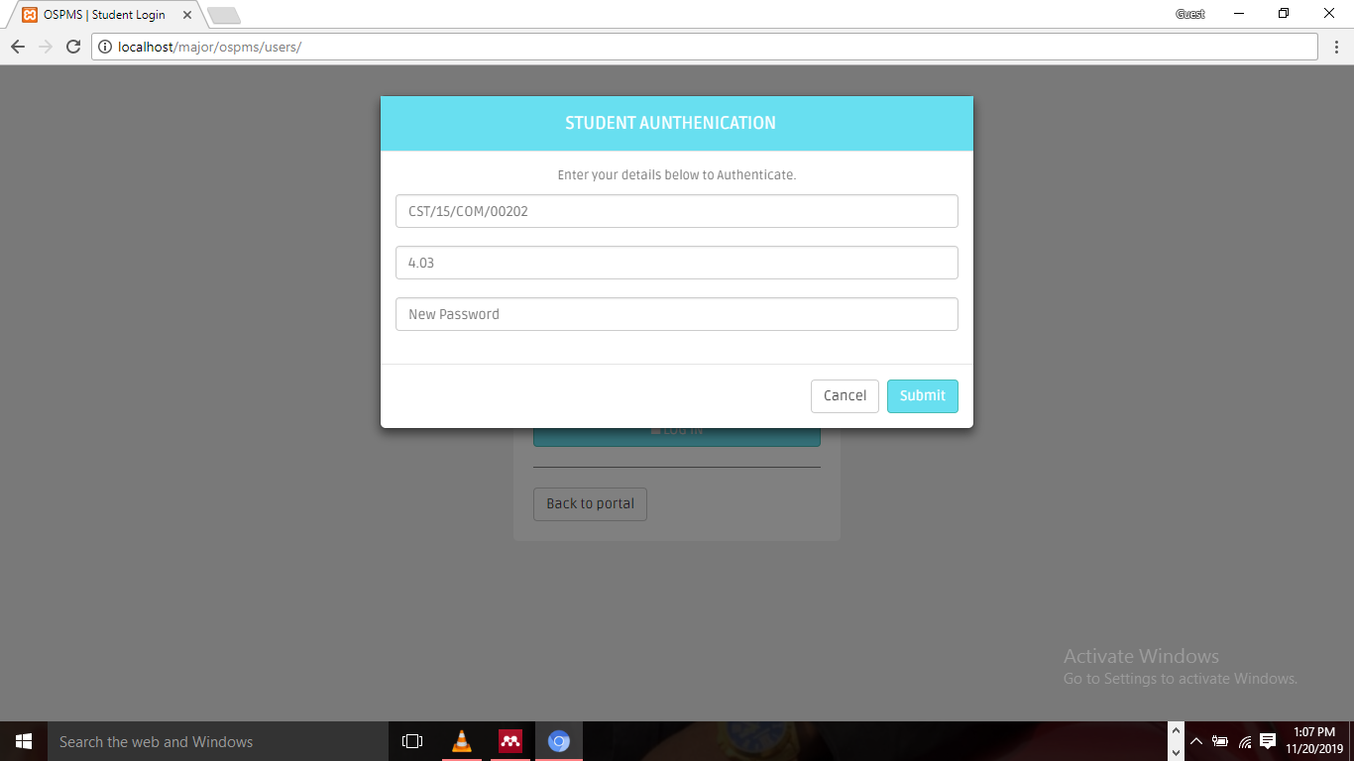

Figure 4.1: Authentication page

Before any other activity should be carried out a student is expected to generate a project supervisor, which will guide him/her

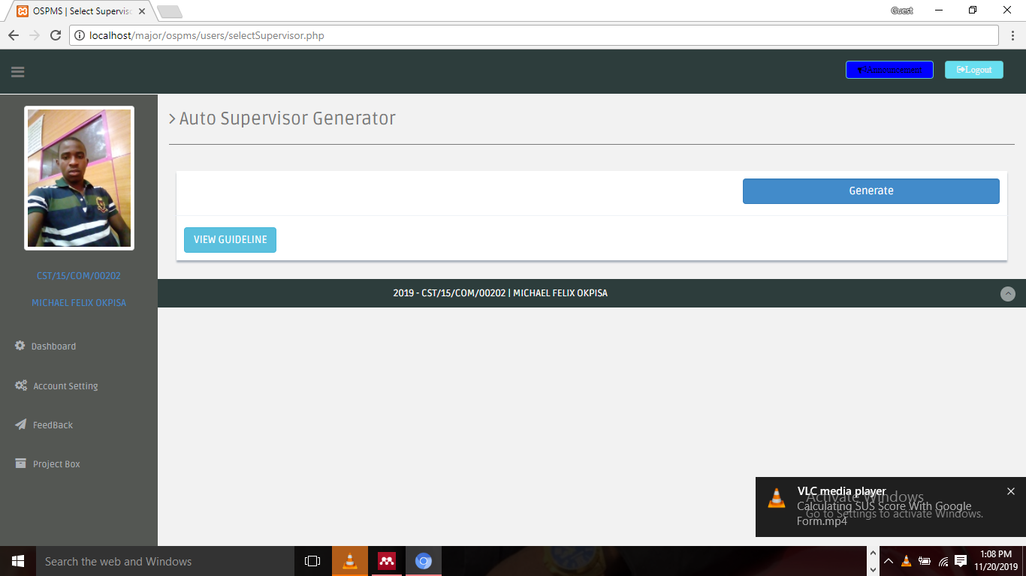

Figure 4.2: generate supervisor

Supposed a message is sent to the project supervisor from any of his/her assigned students, they will be displayed in the below figure

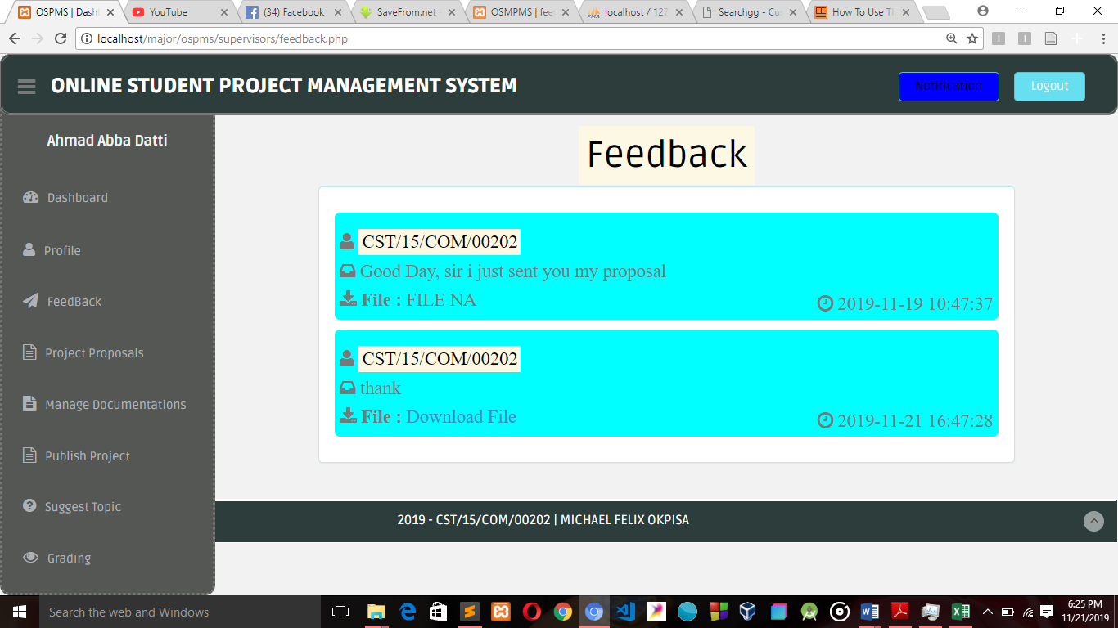

Figure 4.3: Feedback

When a student clicks on upload document in his/her dashboard, he/she will be directed to interface displayed in below figure 4.4

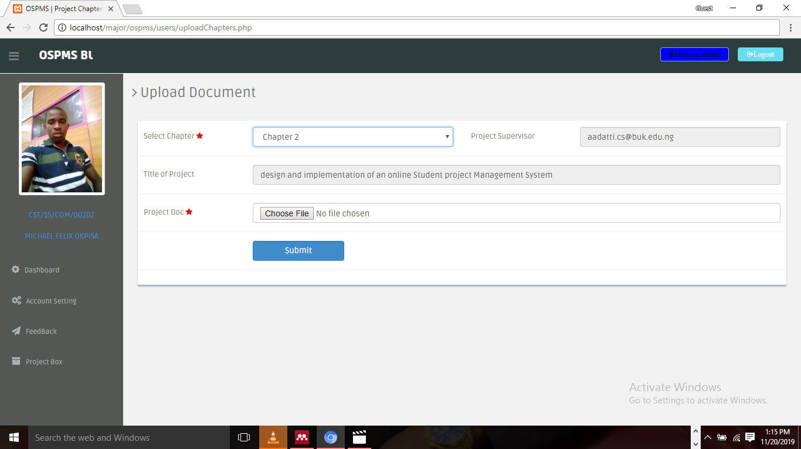

Figure 4.4: Upload Document page

Supposing a project supervisor has authenticated already and he/she clicks on the login button

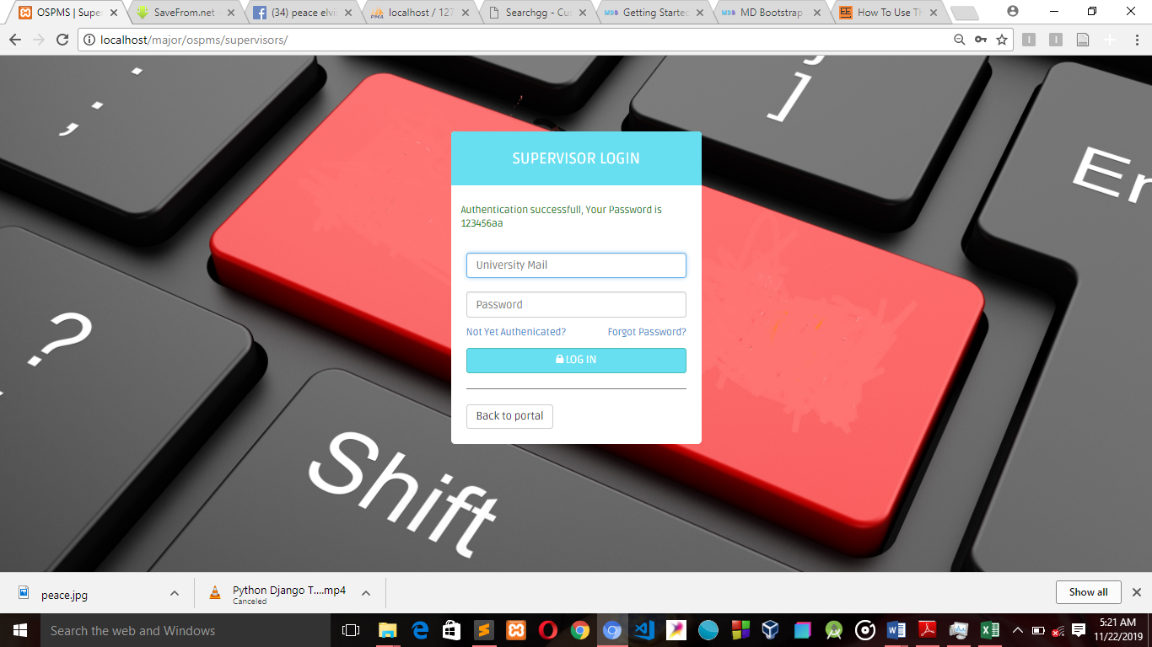

Figure 4.5: supervisor login Page

This interface in figure 4.6 is for grading students based on their performance on their work, according to CSC4600 project guidelines, this activity is carried out by the project supervisor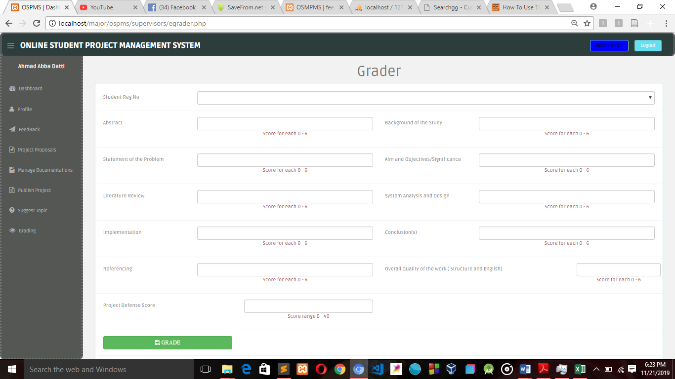

Figure 4.6: grading Page

The Interface below is figure 4.7, the project coordinator is the administrator of the system, and he/she is expected to add all other users.

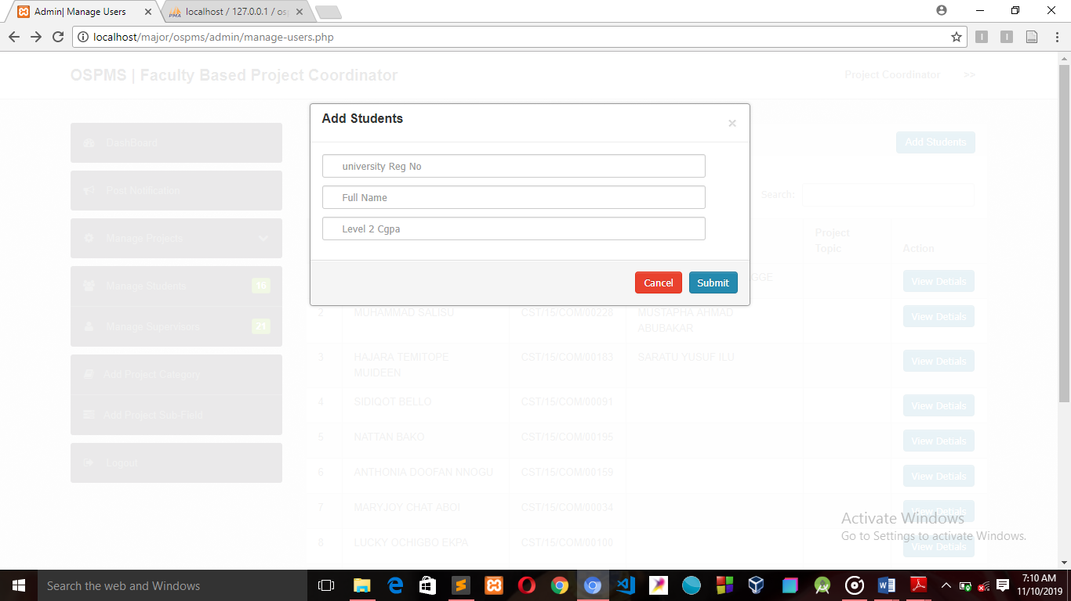

Figure 4.7: add students

In case of notifying students and project supervisors, the project coordinator will on the post notification which will display the interface below

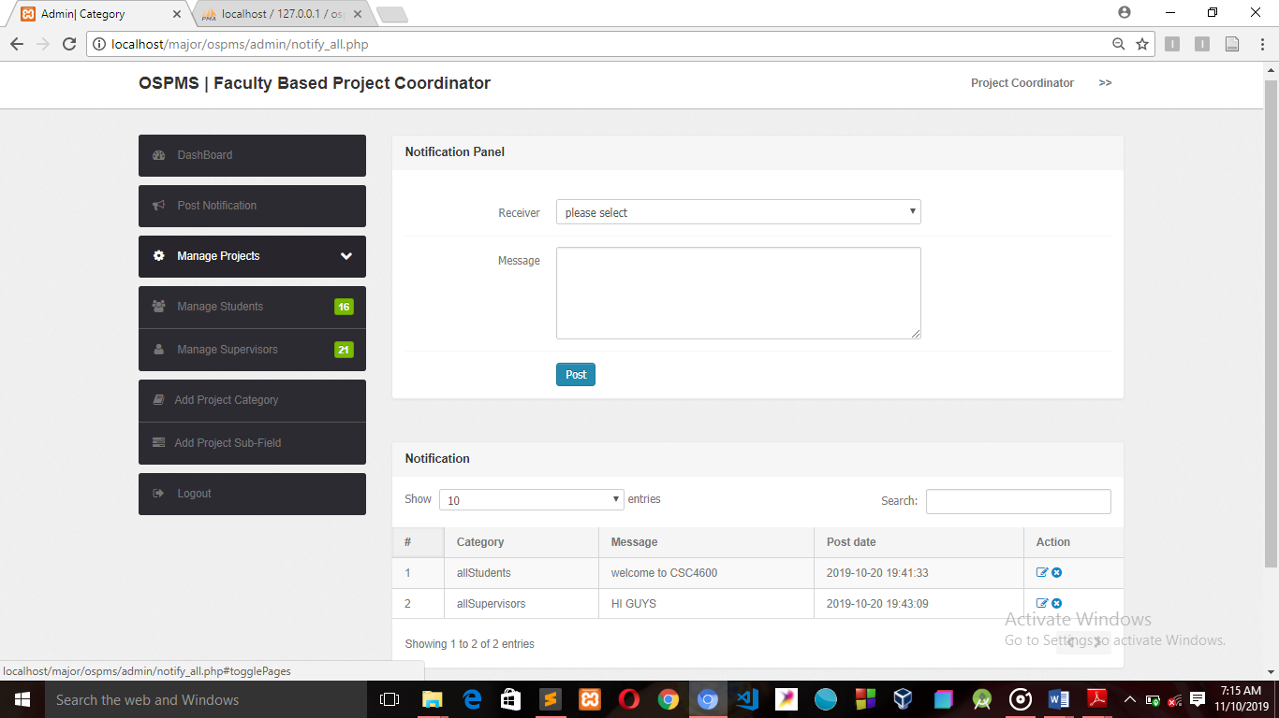

Figure 4.8: post notification

## 4.3 Testing

Testing is intended to show that a program does what it is intended to do and to discover program defects before it is put in to use. Testing can reveal the presence of errors NOT their absence. It is itself an expensive activity, yet launching of software without testing may lead to cost potentially much higher than that of testing.

### 4.3.1 Unit Testing

Unit testing is the process of testing individual units of a program and its functionalities to ensure it is working appropriately. The table below contains the unit testing of this system.

**Table 4.2** Student Authentication test case table

|  |  |  |  |  |  |  |  |
| --- | --- | --- | --- | --- | --- | --- | --- |
| **TEST CASE ID** | **TEST CASE DESCRIPTION** | **PRECONDITION** | **TEST INPUT** | **STEPS** | **EXPECTED RESULT** | **ACTUAL RESULT** | **STATUS** |
| TC-01 | Verify the fields in the authentication screen(Reg No and Cgpa) | Student authentication screen must exist | All field are blank and submit button is clicked | Click submit button | Warning message “please fill out this field” | The warning message to appear when required fields are blank | Pass |
| TC-02 | Verify the fields in the authentication screen(Reg No and Cgpa) | Student authentication screen must exist | All field are filled wrongly and submit button is clicked | Click submit button` | Warning message “Reg No not found in DB, contact Project Coordinator” | The warning message to appear when required field is entered wrongly | Pass |
| TC-03 | Verify the fields in the authentication screen(Reg No and Cgpa) | Student authentication screen must exist | The all fields are entered correctly | Click submit button | User is authenticated into the system | Student will be authenticated into the system and the desired password will be displayed on the login page to the student | Pass |

**Table 4.3** Student Upload Proposal test case table

|  |  |  |  |  |  |  |  |
| --- | --- | --- | --- | --- | --- | --- | --- |
| **TEST CASE ID** | **TEST CASE DESCRIPTION** | **PRECONDITION** | **TEST INPUT** | **STEPS** | **EXPECTED RESULT** | **ACTUAL RESULT** | **STATUS** |
| TC-01 | Verify the fields in the submit proposal screen | Student must be logged into the system | All field are blank and submit button is clicked | Click submit button | Warning message “please fill out this field” | The warning message to appear when all required fields are blank | Pass |
| TC-02 | Verify the fields in the submit proposal screen | Submit proposal screen must exist | Some fields are filled the some fields are blank | Click submit button | Warning message “please fill out this filled” | The warning message to appear when some required field is left blank | Pass |
| TC-03 | Verify the fields in the submit proposal screen | Submit proposal screen must exist | The all fields are filled | Click submit button | User project proposal is submitted into the system for approval | Student project proposal will be logged into the system and a success alert will be displayed. | Pass |

**Table 4.4** Project supervisor Login unit test case

|  |  |  |  |  |  |  |  |
| --- | --- | --- | --- | --- | --- | --- | --- |
| **TEST CASE ID** | **TEST CASE DESCRIPTION** | **PRECONDITION** | **TEST INPUT** | **STEPS** | **EXPECTED RESULT** | **ACTUAL RESULT** | **STATUS** |
| TC-01 | Verify the fields in the log-in screen(university mail and password) | Log-in screen must exist | All field are blank and login button is clicked | Click log-in button | Warning message “please fill out this fileds” | The warning message to appear when all required fields are blank | Pass |
| TC-02 | Verify the fields in the log-in screen(university mail and password) | Log-in screen must exist | The username field is filled and the password field is blank | Click log-in button | Warning message “please this fill this field” | The warning message to appear when one required field is left blank | Pass |
| TC-03 | Verify the fields in the log-in screen(university mail and password | Log-in screen must exist | The password field and the university mail field are entered correctly | Click log-in button | Warning message “please input your username and password” | The project supervisor will be logged into the system and page corresponding to the user will be displayed. | Pass |

**Table 4.5** Project supervisor send feedback unit test case

|  |  |  |  |  |  |  |  |  |
| --- | --- | --- | --- | --- | --- | --- | --- | --- |
| **TEST CASE ID** | **TEST CASE DESCRIPTION** | **PRECONDITION** | | **TEST INPUT** | **STEPS** | **EXPECTED RESULT** | **ACTUAL RESULT** | **STATUS** |
| TC-01 | To verify fields in the send feedback screen | | User must be logged into the system | All fields are left blank | Click on the send button | Warning message “please fill out all the fields” will be displayed | The warning message to appear when required fields are blank | Pass |
| TC-02 | To verify fields in the send feedback screen | | User must be logged into the system | Some of the fields are left blank | Click on the send button | message “please fill out all the fields” will be displayed | The warning message to appear when some required fields are blank | Pass |
| TC-03 | To verify fields in the send feedback screen | | User must be logged into the system | All the require fields are filled | Click on the send button | message “well done feedback sent successfully” will be displayed | The success message to appear when required fields are filled and sent | Pass |

**Table 4.6** Project Coordinator Post Notification unit test case

|  |  |  |  |  |  |  |  |
| --- | --- | --- | --- | --- | --- | --- | --- |
| **TEST CASE ID** | **TEST CASE DESCRIPTION** | **PRECONDITION** | **TEST INPUT** | **STEPS** | **EXPECTED RESULT** | **ACTUAL RESULT** | **STATUS** |
| TC-01 | To verify all the fields in the post notification screen by the admin | Project coordinator must be logged into the system | All the fields are left blank | Click on the post button | Warning message ”please fill out this field” will be displayed | The warning message to appear when required fields are blank | Pass |
| TC-02 | To verify all the fields in the post notification screen by the admin | Project coordinator must be logged into the system | One field is left blank | Click on the post button | Warning message ”please fill out this field” will be displayed | The warning message to appear when required fields are blank | Pass |
| TC-03 | To verify all the fields in the post notification screen by the admin | Project coordinator must be logged into the system | All fields are filled | Click on the post button | Success message “notification sent successfully | Message to appear when the notification is successfully sent” | Pass |

### 4.3.2 Integration Testing

Integration testing is the process of testing interface links and integration between unit components. Table 4.2 contains the integration testing of this system.

**Table 4.7: Integration test case**

|  |  |  |  |  |  |
| --- | --- | --- | --- | --- | --- |
| Test case ID | Test case objective | Test case description | Input | Expected output | Result |
| 1. | To check whether the interface links from supervisors’ dashboard to e-grader page. | Click on a button. | Button clicked. | To be directed to e-grader page. | Pass |
| Button unclicked | Remain unchanged. | Pass |
| 2. | To check whether the interface links from supervisors’ dashboard to manage documentation page. | Click on a button. | Button clicked. | To be directed to manage documentation page | Pass |
| Button unclicked | Remain unchanged. | Pass |
| 3. | To check whether the interface links from supervisors’ dashboard to send feedback page | Click on a button. | Button clicked. | To be directed to send feedback page | Pass |
| Button unclicked | Remain unchanged. | Pass |

|  |  |  |  |  |  |
| --- | --- | --- | --- | --- | --- |
| Test case ID | Test case objective | Test case description | Input | Expected output | Result |
| 4. | To check whether the interface links from project supervisor dashboard to suggest topic page. | Click on a button. | Button clicked. | To be directed to topic suggestion page. | Pass |
| Button unclicked. | Remain unchanged. | Pass |
| 5. | To check whether the interface links from student dashboard to generate supervisor page. | Click on a button. | Button clicked. | To be directed to generate supervisor page. | Pass |
| Button unclicked. | Remain unchanged. | Pass |
| 6. | To check whether the interface links from dashboard to upload project proposal page. | Click on a button. | Button clicked. | To be directed to upload project proposal page. | Pass |
| Button unclicked. | Remain unchanged. | Pass |

## 4.3.3 System Testing

System testing is a process of testing interfaces between integrated units.

### 4.3.3.1 Usability Testing

Usability testing of the online student project management system have been done to confirm that the system is working correctly. This was achieved with System Usability Scale (SUS) Questionnaire, distributed randomly to ten (10) level 400 students of computer science in the faculty of science and information technology.

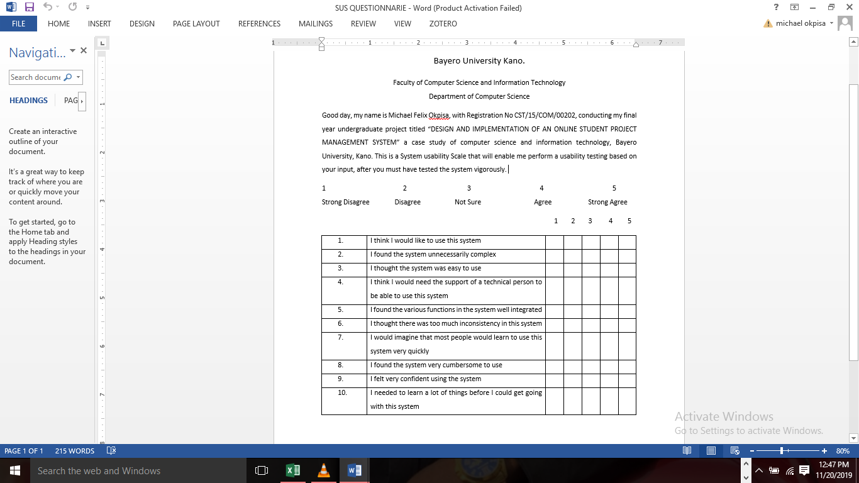

Figure 4.9: SUS Questionnaire sample

Below is the System Usability scale score computed into an excel sheet and a bar chart plotted (SUS score against Participants).

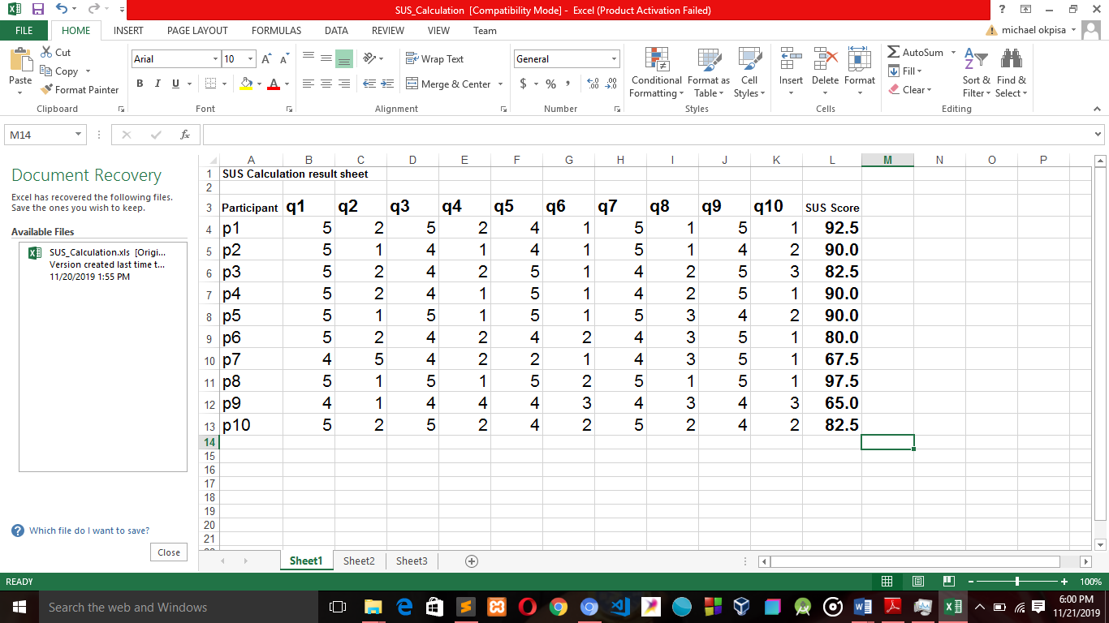

Figure 4.10 SUS Score analysis

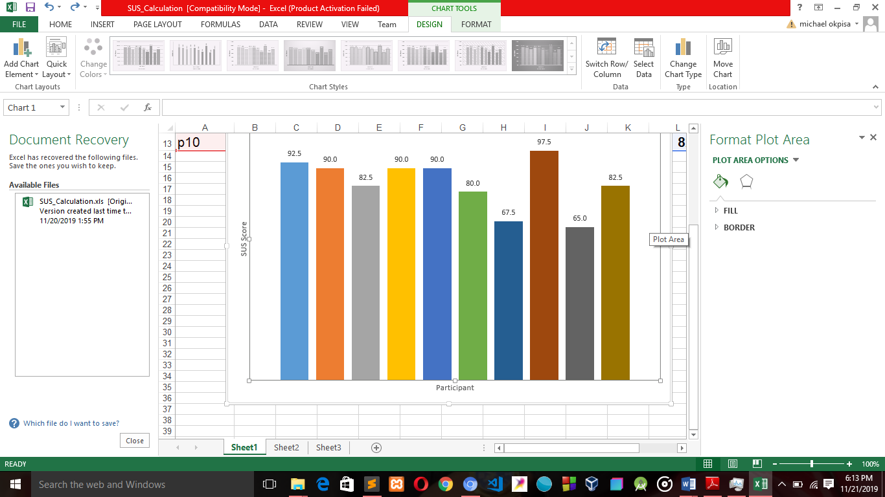  
Figure 4.11 SUS Score Bar Chart

# CHAPTER FIVE

## SUMMARY AND CONCLUSION

## 5.1 Introduction

This chapter contains summary, conclusion and recommendation of this project.

## 5.2 Summary

The online student project management system was designed and implemented for FCSIT students and its administration to carry out the student UG project process in a more flexible and efficient manner. With this new system, project supervisors can supervise student project wherever they maybe, so also project supervisors can approve student project anywhere and anytime.

The analysis and design of the system was done using appropriate modelling tools and was implemented into a single system. An unregistered student cannot access this portal. Students use the system to apply for student project, upload documents, also send and receive messages, to and from their individual project supervisor and view student project repository (if any). Project supervisor use this system to manage proposals, chapters documentation, publish completed projects for project coordinator’s approval. He/she can also send and receive message to and from students under his/her supervision, suggest project topics for all students, and finally the system enables student grading based on his/her performances. Project coordinator can use the system to manage users, post notifications to all students and all supervisors, publish suggested topics, publish completed project to the faculty repository. He/she can view student project grades computed by their respective project supervisors.

Chapter one emphasized the general overview of the background of the study, the problem statement, the aim of the project which was to automate the manual method of management final year student project in the Faculty of Computer Science and Information Technology, and objectives of the project besides its scope and limitations.

Chapter two is the literature review which describe comprehensible and conversant review of some relevant works completed in the student project management System and related System review, eight selected literature work was reviewed in this part, to find out about the work and effort that had been put together to achieve good and quality result.

Chapter three system analysis and design gave a comprehensive justification of the SDLC model used in the development of the system which is iterative development model, requirement elicitation-where the requirement of the proposed system were collected through assessment of related works, interviews and observation. The description of the working of the existing manual system as well as the proposed automated system was also conversed. The functional and non-functional requirement of the current system were also conversed, Use case diagram was used in the analysis part, class and activity diagrams was used for the system design.

Chapter four covers system implementations, review of developmental tools used and system testing. Which converts the design in chapter three to an executable system. Features of the system were shown in this chapter in form of screenshots. System testing describes how the system works by undertaking three (3) different stages of testing namely; Unit Testing, Integration Testing, and System Testing. System Usability scale questionnaire was distributed to ten (10) computer science final year students, after they have tested the newly proposed, which they gave their responses in the SUS Questionnaire and the score of all participants was calculated and a bar chart was plotted. The result of this tests were stated in the chapter.

## 5.3 Conclusion

The case study is Faculty of Computer Science and Information Technology, is a faculty in Bayero University kano and as a matter of fact there are close to seventeen (17) faculties in the institute, but we have chosen to focus on a particular one, Faculty of Computer Science and Information Technology. Whereas all activities related to students project are carried out either manually or through electronic mails, as desired by the project supervisor.

The daily use of ICT devices has driven so deep that there cannot be an effective management without the availability of computers. The problem is that there has been number of projects mismanagement, lack of communication between students and their supervisors, loss of files which in case lead to project breakdown. Faced with the need to organize projects, Difficulty in reviewing documentations of student work, Records of project topics carried out by a student are stored in the departmental library for a long time which occupies valuable office space. Backing up projects becomes a problem since more space will be employed. Projects are prone to loss due to natural disasters such as fire outbreak, flooding etc.

Through this system, the project coordinators and project supervisors can provide all the necessary information and resource material to their students and also be able to get the students’ feedback from the website. Also this will help to:

1. Enable a better storage since the system with be a web based system.
2. Improved, faster and more flexible search document.
3. Help Reduce project topic repetition and enhance project topic detection.
4. Improved Security on uploaded document.
5. Avoid losing files to natural disaster.

The future researchers could gain knowledge from the study on the benefits, advantages and disadvantages, impact of developing web Solutions for enhancing project management which they may apply to their research in the future. By improving on the platform in such a way that departmental project coordinators and supervisors can perform a plagiarism check with the current stored documents.

The development of the online student project management system was found to be successful. The aim of the system is to automate the student project activity process in order to enhance its flexibility and the project supervisors’ ability to make decisions. The web-based system is cost effective, efficient and flexible in carrying out what is expected from it.

## 5.4 Recommendation

For further enhancement of the online student project management system, the following are some recommendations.

1. Integration of Grant Chart to enable students see his/her progress in a graphical form
2. Student project account could be made to be restricted after complete approval of project and graduation.
3. Validation of number of days each type of student project process can take could be included.
4. With the advent of new technologies, the system could be updated, so as to make it more efficient and prevent it from becoming outdated.
5. Integration of in-built document editor for documentation preview and correction by the supervisor

# References

1. Aaron. A., I. (2016). A Web- Based Project Management System. *International Journal of Advanced Research in Computer Science and Software Engineering*.
2. Ademola, A., Adewale, A., & Ike, D. U. (2013). *Design and Development of a University Portal for the Management of Final Year Undergraduate Projects*. *2*, 10.
3. Aderanti, F. A., Amosa, R. T., & Oluwatobiloba, A. A. (2016). *Development of Student Project Allocation System Using Matching Algorithm*. 8.
4. Bhatt, R., Bhorade, D., Kinare, A., & Patel, D. (2018). *Student Project Management System ( SPMS )*. 1410–1411.
5. Dennis, Alan., Wixom, B. H., & Tegarden, D. Paul. (2012). *Systems analysis design, UML version 2.0 : an object oriented approach*.
6. Kale, S., Shewale, A., Sarang, P. J., Pawar, P. S., Sadruddin, S., & Scholar, U. (2017). *Project Management System (PMS)*. *5*(2), 5.
7. Leung, C.-H., Lai, C.-L., Yuan, T.-K., Pang, W.-M., Tang, J. K. T., Ho, W.-S., & Wong, T.-L. (2015). The Development of a Final Year Project Management System for Information Technology Programmes. In K. C. Li, T.-L. Wong, S. K. S. Cheung, J. Lam, & K. K. Ng (Eds.), *Technology in Education. Transforming Educational Practices with Technology* (Vol. 494, pp. 86–97). https://doi.org/10.1007/978-3-662-46158-7_9
8. Soyemi, J., & Isinkaye, F. O. (2017a). A WEB-BASED FINAL YEAR STUDENT PROJECT DUPLICATION DETECTION SYSTEM. *International Journal of Computer Application*, *7*, 8.
9. Tayal, A., Pahire, R., Suryawanshi, S., & Chawhan, S. (2017). *Implementation of Student Project Analysis and Management*. 5.
10. Yorulmaz, M. (2012). *A WEB-BASED MANAGEMENT SYSTEM AND ITS APPLICATION FOR STUDENT DESIGN PROJECTS*. *2*(2), 13.
11. Thorn M. (2015): A constraint programming approach to the student-project allocation problem, BSc Honours project report, University of York,Department of Computer Science, 2015
12. David J.A (2007): Two algorithms for the student- project allocation problem. Journal of Discrete Algorithms 5(1):pp. 73-90, 2007.
13. http://www.clockingit.com/
14. Clement, R. and Bounds, P. (2013) Making connections between final year students and potential project supervisors. Proceedings of the HEA STEM annual learning and teaching conference 2013
15. Bakar, M. A., Jailani, N., Shukur, Z., & Mohd Yatim, N. F. (2011). ‘Final Year Supervision Management System as a Tool for Monitoring Computer Science Projects’. In Procedia - Social and Behavioral Sciences, vol (18), 273- 281.
16. HKU CS: Hong Kong University Project Management System (2014), https://community.cs.hku.hk/web/cs