**BAYERO UNIVERSITY KANO**

**FACULTY OF COMPUTER SCIENCE AND INFORMATION TECHNOLOGY**

**DEPARTMENT OF COMPUTER SCIENCE**

**SUBMITTED TO**

**CENTRE FOR ENTREPRENEURIAL STUDIES**

**COURSE TITLE: VENTURE CREATION AND GROWTH**

**COURSE CODE: EEP 4201**

**ASSIGNMENT**

**BY**

**GROUP 7 MEMBERS**

|  |  |
| --- | --- |
| **NAME OF SME** | WHITE LIGHT BAKERY |
| **NAME OF INTERVIEWEE** | **ANNUR MAHMUD ASSISTANT MANAGER** |
| **CONTACT NUMBER** | **08067976935** |
| **OFFICIAL ADDRESS** | DAN BARE OPPOSITE BUK, NEW SITE KANO |

**OCTOBER, 2019**

Contents

**GROUP SEVEN (7) MEMBERS** 2

**GROUP PHOTO** 3

**WHITE LIGHT BAKERY LOGO** 4

**INTRODUCTION** 5

**NATURE OF THE SME** 7

**COMPOSITION OF WHITE LIGHT BAKERY** AND **NATURE AND INTERVENTIONS OF THE ORGANIZATION** 9

**HOW THE IDEA OF THE BUSINESS CAME INTO EXISTENCE** 9

**TARGETED CUSTOMERS AND WHY DO WHITE LIGHT BAKERY TARGET THEM** 9

**HOW DO WHITE LIGHT BAKERY SOLVE PROBLEMS/COMPLAINS FOR THEIR ESTEEM CUSTOMERS WITH THEIR PRODUCTS / SERVICES** 9

**THE DIFFERENCES BETWEEN WHITE LIGHT BAKERY AND OTHER COMPETITORS IN TERMS OF THEIR SELLING PROPOSITION** 10

**REFERENCE** 11

# **GROUP PHOTO**

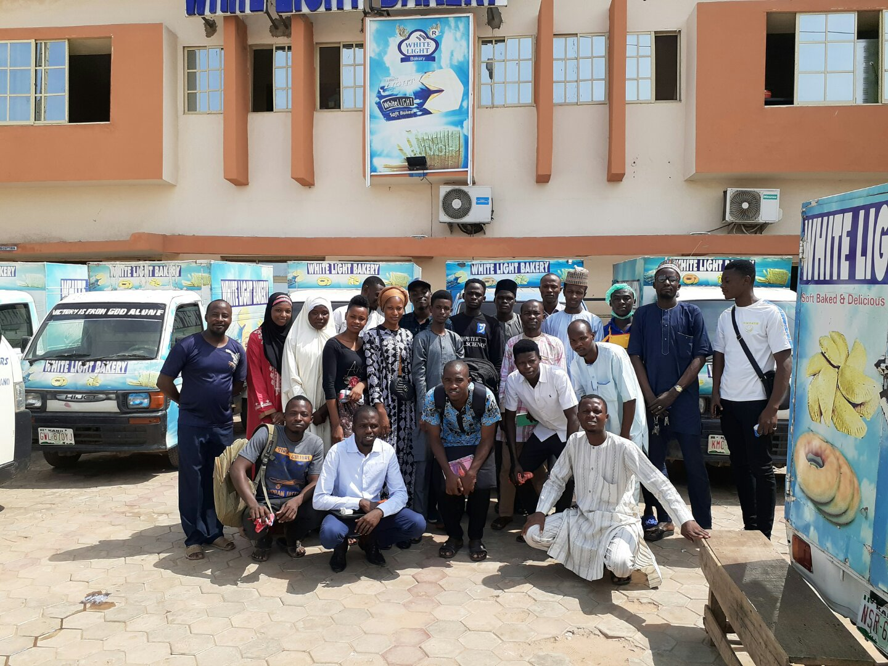

**CROSS SECTION OF MEMBERS WITH TWO (2) STAFF OF WHITE LIGHT BAKERY, KANO OFFICE: THE FIFTH PERSON FROM THE LEFT TO THE RIGHT IS ANNUR MAHMUD (ASSISTANT MANAGER) AND THE EIGHT PERSON FROM THE LEFT TO THE RIGHT IS A PACKAGING STAFF**

# **INTRODUCTION**

Most organizations are faced with the challenge of knowing where their customers are, what they desire and how they will love to be served. Furthermore, since these teeming customers have several options to choose from, each organization has to try and get the attention of the customer in order to have him/her develop preference for its product over that of the competition.

**Marketing**

Marketing is a professional activity that influences the attainment of any organization whether small or large. Also marketing can be theorized as a process that enables people obtain their needs or wants from organizations that have industrialized products or services that will help satisfy these needs or wants of people.

**Small Business Marketing:**

Marketing forms the cornerstone for the initiation, growth and subsequent profitability of a small business. Without marketing and a marketing strategy, a business cannot survive and prosper. For the entrepreneur or small business owner, marketing is a matter of determining demand, matching a product or service with customer needs, and promoting those attributes in the marketplace to produce sales and make profit in the process. Every marketing plan has to adopt the same marketing procedure, but the similarities between small business and large business marketing stop right there. Budget constraints, staffing, creative methods and strategy vary considerably between Airtel Networks Limited and a relatively micro-budget marketer and business owner like the small corner shop in our neighborhood.

Marketing is a process that encompasses a number of activities that are interrelated and interdependent.

**MARKETING MIX IN NEW VENTURES**

Marketing mix is the unique blend of the elements of marketing that will apply to the business. These elements are: product or service itself; the location of the business; the distribution methods adopted by the business; the price at which the products will be sold; the advertising and promotion alternatives available to the business; and how the product will be sold as well as the level of customer service to be provided. These elements are often summarized and commonly referred to as the 4Ps - product, price, promotion and place.

The understanding of these elements and flair with which they are mixed is fundamental. In essence, creativity and imagination must be brought to bear. If this is done well, it will put the organization ahead of the competition.

**Product:**

This is anything offered that is capable of satisfying a particular need or want. Products in the context of marketing discourse are tangible and when you pay for them you hold onto something that you can see, touch and feel. It is important for entrepreneurs to understand people never buy products but buy benefits.

**Place:**

In marketing, a business must have the right product, at the appropriate time and price, and in the right place.

**Promotion:**

This encompasses everything to do with the way an organization communicates persuasively with people to influence them towards making a purchase. Marketers use many different tools to promote their products and services.

**Price:** The phrase that goes mostly with cheap is poor quality, yet everyone wants a bargain. But as a bargain is essentially something worth more than it costs (and therefore rare) what they really want is value for money.

”I am not upset with someone who charges more for a product but I am concerned with someone who might offer a better experience” – *Jeff Bezos, CEO, Amazon.*

On the 2th of October 2019, a group of twenty (20) students visited WHITE LIGHT BAKERY located at Gwarzo Road, along Kabuga Kano

# **NATURE OF THE SME**

|  |  |  |
| --- | --- | --- |
| Name of the organization | WHITE LIGHT BAKERY | |
| Contact details of the organization | **Head office:** No. 26,27 Gwarzo Road, Kano State.  Yola Office  Abuja Office  Gombe Office  Email: [whiteLightBakery@gmail.com](mailto:whiteLightBakery@gmail.com) | |
| Contact person | Annur Mahmud  Assistant Manager  Phone number: 08067976935 | |
| Organizational Strength (Staff Strength, Position & Distribution – Full time & Part time, other facilities) | Full Time Staff | 15 |
| Part Time | 20 |
| *Details of infrastructures facilitates* | |
| Office building | 4 and 1 uncompleted bakery/office |
| Vehicles | 20 |
| NAFDAC | NAFDAC REG NO: | |
| Date of incorporation/registration | 2013, Ministry of health | |

WHITE LIGHT BAKERY is one of the leading bakery that is headquartered in Kano State with branches in three (3) other northern states, committed to nourishing the quality of life for People Living with the product and services they bake. WHITE LIGHT BAKERY was established in 2013 in Gombe state.

**Our Mission:**

* To be the leading bakery in africa
* Create demand for improved quality service and product delivery
* Empowering local women and men

**Our Vision:**

Promote satisfaction within the community and increase access to Health living with the services they offer.

**Our Core Values**

* Integrity
* Truthfulness
* Quality
* Hygiene
* Excellence in production

**Program and Project Activities**

WHITE LIGHT BAKERY is committed to improving the quality of life bread and snacks production in northern nigeria, with the availability of advanced baking models and equipments.

WHITE LIGHT BAKERY technical staffs have sound knowledge on public health and safetly. Also it marketing Staffs are fluent in English and Hausa and possess the ability to work in a short time frame and in multiple locations at the same time.

**Nutrition**

Good nutrition is essential for children’s physical growth and development, including full development of their immune systems. Certain groups of children are particularly vulnerable to malnutrition, including young children, with their products containing all proper nutritional ingredients.

# **COMPOSITION OF WHITE LIGHT BAKERY** AND **NATURE AND INTERVENTIONS OF THE ORGANIZATION** WHITE LIGHT BAKERY operates in four north western states of Kano, Gombe, Yola and Abuja of the federal republic of Nigeria. WHITE LIGHT BAKERY have about 30 staffs working under the organization.

WHITE LIGHT BAKERY has four (4) departments / sections namely

1. Administration
2. Production
3. Packaging and
4. Security

WHITE LIGHT BAKERY bakes bread and snacks of various types.

# **HOW THE IDEA OF THE BUSINESS CAME INTO EXISTENCE**

White Light Bakery was first established in Gombe state and it’s operate locally, not until the executive manager decided to implore foreign machines and advanced baking models to help rebrand their product. The introduction of foreign machines into the Bakery, was the beginning of the name WHITE LIGHT.

# **TARGETED CUSTOMERS AND WHY DO WHITE LIGHT BAKERY TARGET THEM**

Everybody is a potential customer, regarding the facts that you can patronize their products. This bakery targets the general population of Kano City (urban) and also injecting into rural areas.

Currently our major target is kano urban residents because they around the urban is a huge competition for bakers and we are not relenting. We will deliver good, quality, nourish able and healthy product to our esteem customer.

# **HOW DO WHITE LIGHT BAKERY SOLVE PROBLEMS/COMPLAINS FOR THEIR ESTEEM CUSTOMERS WITH THEIR PRODUCTS / SERVICES**

The phase “Customer is always right cannot be overlooked”, all queries and complains are treated with almost concern.

From the packaging, neat and hygiene production, delivery timing to retailers earlier so customers can purchase this products and be rest assured that we are reliable, to the size and quality improvements of the services we render and offer. The smallest complain is our major concerns.

Some customers comes into the bakery to buy a day old baked bread and he/she expected to get that they want.

If need arise for a change in service we quickly do, without hesitations. We inspects all products before they are been carefully placed in our delivery vans.

We insert our customer care contact number so as to receive complains and bookings.

# **THE DIFFERENCES BETWEEN WHITE LIGHT BAKERY AND OTHER COMPETITORS IN TERMS OF THEIR SELLING PROPOSITION**

According the module 4, which explained that With the increasing level of competition and the presence of so many products and brands that all appear to look alike, it has become necessary more than ever before for organizations to find ways to make their products distinct from those of the competition.

White Light Bakery started initially with production of seven (7) bags per days, as time grows and more customers began to find interest in the service render now we are proud to be producing 70 -80 bags in a day, with much expectation to expand our productions.

Other competitors selling proposition is not a threat to us but the fact that we sell more and more each day means we are one of the leading bakeries in Kano.

We don’t advertise on radio, billboards, newspaper, facebook, and any other means of advertisement but our delivery speaks for itself.

In so far our customers are not tried of our service, we will not be tried of purchasing more delivery vans, so that we will reach the four axes of Kano in two (2) Hours. One customer refers our service to another, just like the popular saying “Tell One to Tell Ten”.

But not withstanding we are open to new marketing models and strategizes. We are visionaries in all we do, we are innovative, we are zealous people, and we are White Light.

# **REFERENCE**

1. DRAFT TRAINING MANUAL FOR GENERAL ENTREPRENEURSHIP COURSES IN UNIVERSITIES COURSE 2: **VENTURE CREATION AND GROWTH**, MODULE 4: **ENTREPRENEURIAL MARKETING**
2. WHITE LIGHT BAKERY PROFILE