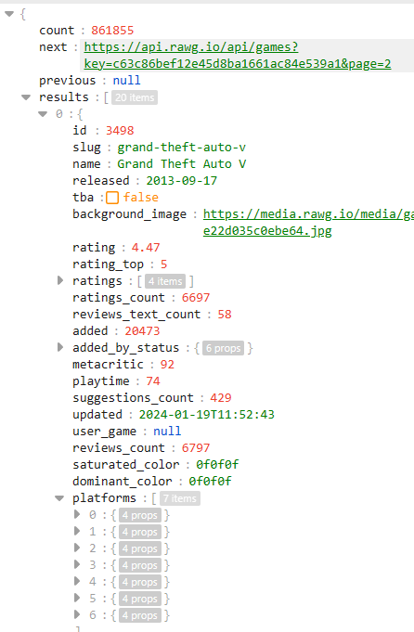

@GET("game?key=")

suspend fun getSuperheroes(@Query("search") superheroName:String): Response<SuperHeroDataResponse>

api rawg key c63c86bef12e45d8ba1661ac84e539a1