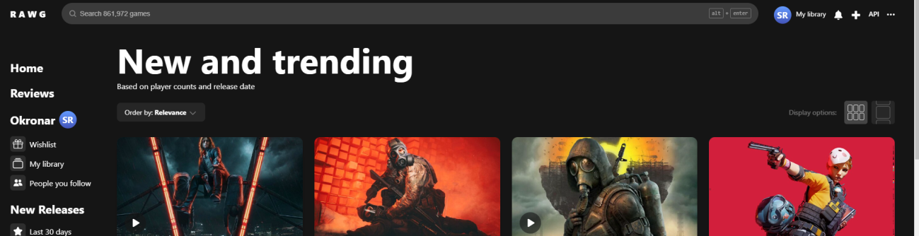

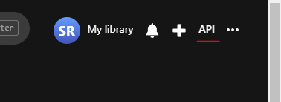

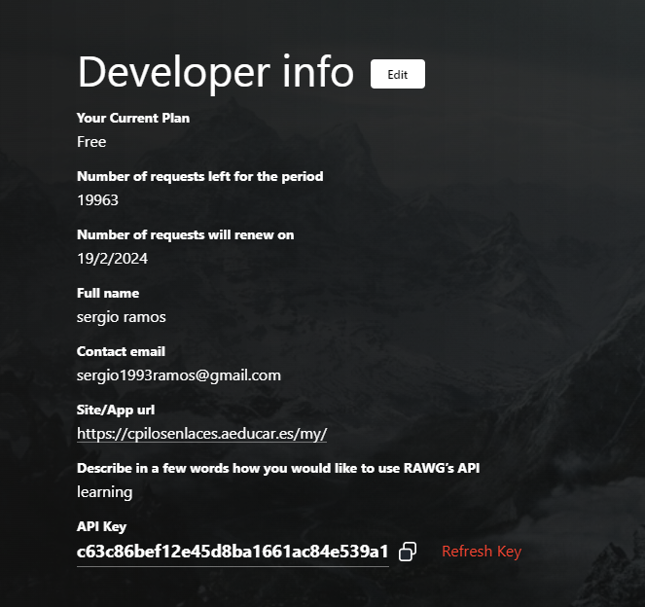

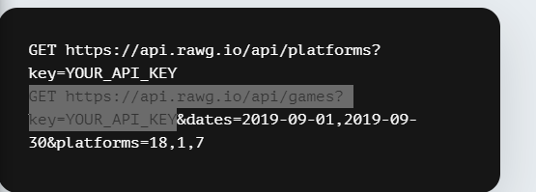

[api.rawg.io/api/games?key=c63c86bef12e45d8ba1661ac84e539a1](https://api.rawg.io/api/games?key=c63c86bef12e45d8ba1661ac84e539a1)

