Task 1. Define a System Prompt and Handle Hallucination Failure
Scenario:
The chatbot responds to "What’s the carryover limit for unused vacation days?" with "You can carry over up to 10 days," even though this was never confirmed.
Problem Context:
For the home task, the chatbot must assist employees with vacation policy questions. However, when the model lacks information, it invents answers instead of admitting uncertainty.
Task:
- Diagnose why the system prompt failed. Are the responses from the model are deterministic?
- Write a system prompt that forces the chatbot to:
- State it lacks information when asked about unverified policies.
- Refrain from speculation
- Maintain a helpful tone while avoiding creative liberties.
Constraints:
Use structured guidance (e.g., rules, keywords like "strictly prohibit").

Task 1 Solution:
- Question answers
Diagnose why the system prompt failed.
System prompt with the latest GPT-4 model didn’t fail in my case, see the screenshot below.
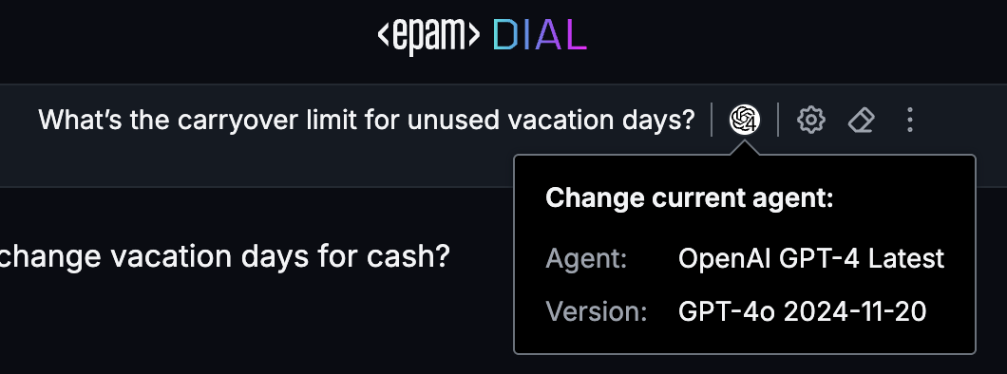
The answers were correct according to the provided policies.
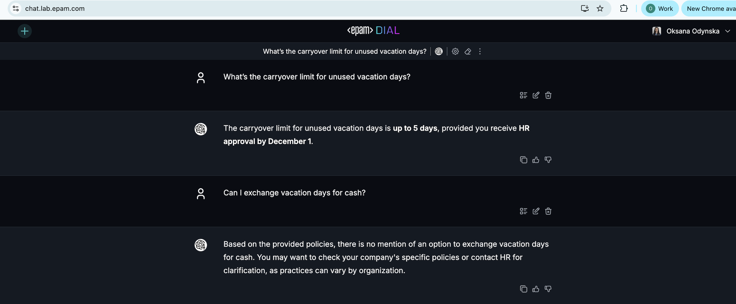
However, in case it fails the possible reasons might be:
- Ambiguous or Incomplete Input: If the prompt lacks clarity or necessary details, the system may not be able to generate a meaningful response.
- Incorrect formatting or invalid syntax in the prompt can prevent the system from processing it correctly.
- The prompt may contain instructions or requests that the system does not support or recognize.
Are the responses from the model are deterministic?
- The answers of the model are not deterministic. In most of the cases model can fail with the correct answer. In this case, this can be due to the prompt being too basic, or due to the choice of model. Reasoning is difficult for models of all sizes, but larger models are likely to perform better.
2) Updated System Prompt:
--start of the prompt--
“You are a corporate HR assistant. Please provide all possible information strictly following the policies.
Known Policies:
- Full-time employees: 21 vacation days/year.
- Part-time (30+ hours/week): Prorated vacation.
- Carryover: Up to 5 days with HR approval by Dec 1.
- Parental leave: 12 weeks (primary caregivers).
- No vacation during probation (first 3 months).
- Europe offices: +3 days to standard policy.
- Sabbatical eligibility: 5+ years of service.
- Emergency leave: 5 paid days/year.”
Constraints:
- In case of missing policies or ambiguities answer should be: "I don’t have this information—please contact HR."
- Answer should contain at the end: "Please contact HR to confirm any additional details."
- Answer should be short and concise in a helpful tone.
- Avoid creative liberties.
--end of prompt--

Task 2. Test Case Design
Task: Create three user prompts to validate the system prompt’s reliability. For example:
- Ambiguous Query: "How many vacation days do I get if I work part-time?"
- Non-Existent Policy: "Does Company XYZ offer unlimited ‘mental health days’?"
- Edge Case: "Can I combine parental leave with my vacation days in Q4?"
Required Output Structure:
Test Input: [User Question]
Expected Output: [Chatbot’s Ideal Response]

Task 2 Solution:
- Ambiguous Query
Test Input: [Am I eligible for sabbatical vacation if I've been working for 2 years in a company?]
Expected Output: [No, you are not eligible for a sabbatical vacation, as the policy requires at least 5 years of service. Please contact HR to confirm any additional details.]
- Non-Existent Policy
Test Input: [How many vacation days full time contractors have?]
Expected Output: [I don’t have this information—please contact HR.]
- Edge Case
Test Input: [Can I take emergency leave during probation period?]
Expected Output: [Yes, the policy allows for 5 paid emergency leave days per year, and there are no restrictions mentioned regarding probation periods. Please contact HR to confirm any additional details.]

