**Requirements**

This document guides through the steps needed to execute to implement the Execution POD Plugin example and templates for synchronous and asynchronous type Execution POD Plugins. Plugins to be deployed to SAP BTP Cloud Foundry to extend standard POD functionality with custom POD Plugins.

SAP Business Application Studio is used as a development environment for implementing Execution POD Plugins.

For setting up SAP Business Application Studio in an Enterprise Account refer to [Getting Started](https://help.sap.com/viewer/9d1db9835307451daa8c930fbd9ab264/Cloud/en-US/19611ddbe82f4bf2b493283e0ed602e5.html) topic of the SAP Business Application Studio Administrator Guide.

Project details:

* The “Example for Execution Plugin” (podplugins/webapp/exampleExecutionPlugin) demonstrates how to implement an "Execution" type plugin. The Property Editor provides a value help button to allow selecting an Action Button for Start and Complete which is to be executed by this plugin. A switch describes whether this plugin will run synchronously or asynchronously. When running in asynchronous mode, the plugin must tell the POD framework when it is done running. In synchronous mode, the plugin is done upon return from the execute() function. Operation filter controls if SFC should be processed at a specific operation. If SFC in new or active status then SFC will be started, if SFC is in queue – then will be completed. Plugin’s business logic assumes that only one SFC is selected.
* The “Execution Plugin Template” (podplugins/webapp/executionPluginTemplate) demonstrates how to have an execution type plugin run synchronously. It is a template that can be copy-pasted and adjusted as needed.
* The “Asynch Execution Plugin Template” (podplugins/webapp/asynchExecutionPluginTemplate) demonstrates how to have an execution type plugin run asynchronously. It is a template that can be copy-pasted and adjusted as needed.

See the Production Operator Dashboard (POD) Plugin Developer's Guide at link <https://help.sap.com/docs/SAP_DIGITAL_MANUFACTURING_CLOUD?task=develop_task> for more information related to development technical details.

**Prerequisites**

If you plan to follow the installation and configuration steps and deploy the project by yourself, you have to do some preparations:

1. Get a free account on SAP BTP Trial

Follow the steps from this tutorial: <https://developers.sap.com/tutorials/hcp-create-trial-account.html>

1. Set up SAP Business Application Studio for development

Follow steps from this tutorial: <https://developers.sap.com/tutorials/appstudio-onboarding.html>

1. Request access to DME and applications, such as:

* Manage Service Registry
* POD Designer
* Work Center POD

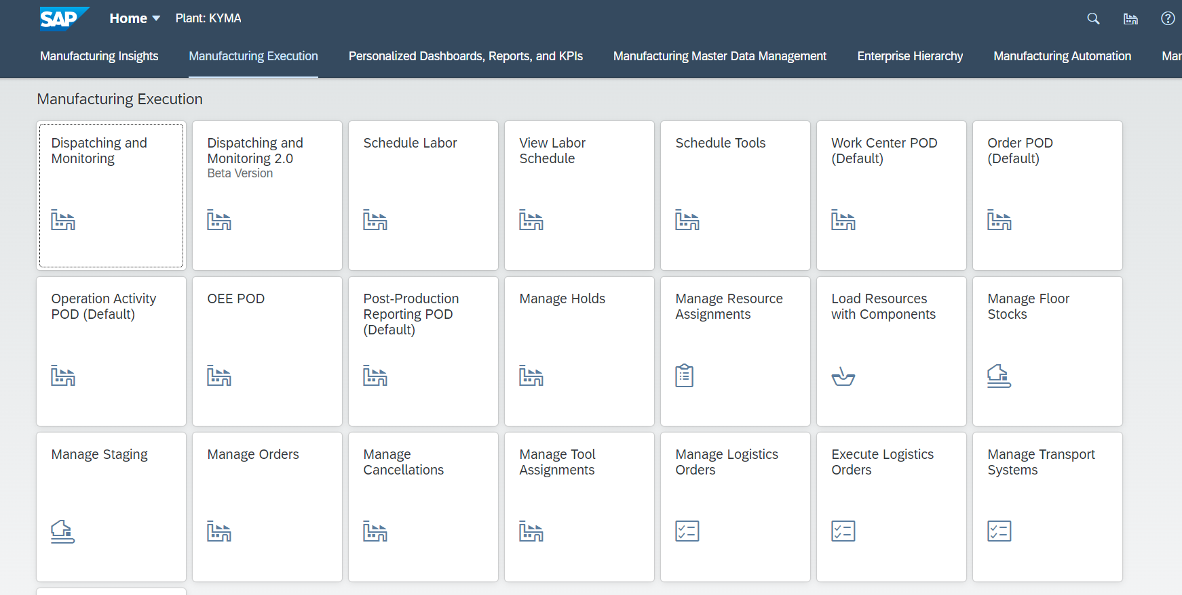

1. Clone the Git repository

In your browser, go to <https://github.com/SAP-samples/digital-manufacturing-extension-samples>

Choose the **Code** button and choose one of the options to download the code locally or simply run the following command within your CLI at your desired folder location:

git clone <https://github.com/SAP-samples/digital-manufacturing-extension-samples>

1. Open the **DMC_UIExtensions/ExecutionPodPluginTemplate_and_Example** directory in your desired editor, it contains two folders:

* **documentation** for installation and configuration guide
* **project** for the implementation part

**Installation Steps**

1. Open **SAP Business Application Studio**.

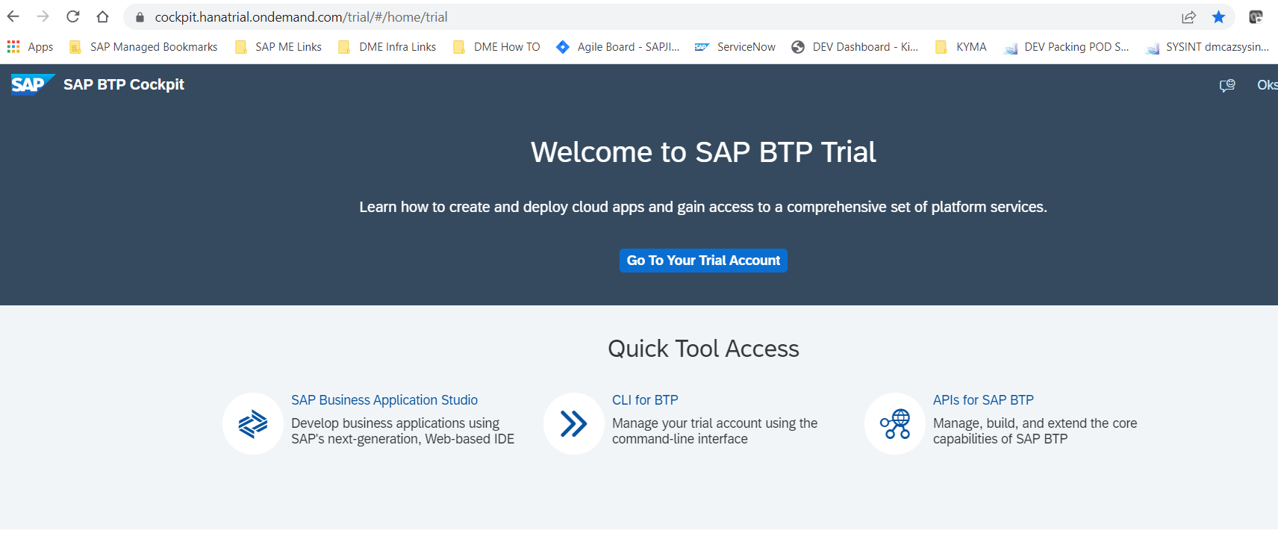

1. Choose **Create Dev Space**.

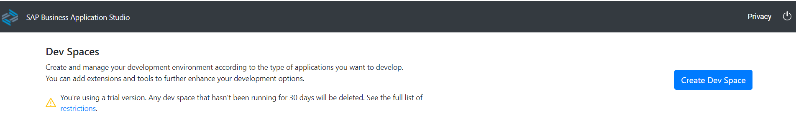

1. At the “Create New Dev Space” screen execute the following steps:

* Enter the **POD_Plugins** name for your dev space.
* Choose **Full Stack Cloud Application** as the application type.

By selecting **Full Stack Cloud Application** your dev space comes with several extensions out-of-the-box that you need to develop applications.

* Choose **Create Dev Space**.

The Dev Space will then begin starting and the process will take a minute or so as your cloud environment is being created. You see that the status for your dev space will change from **STARTING** to **RUNNING**.

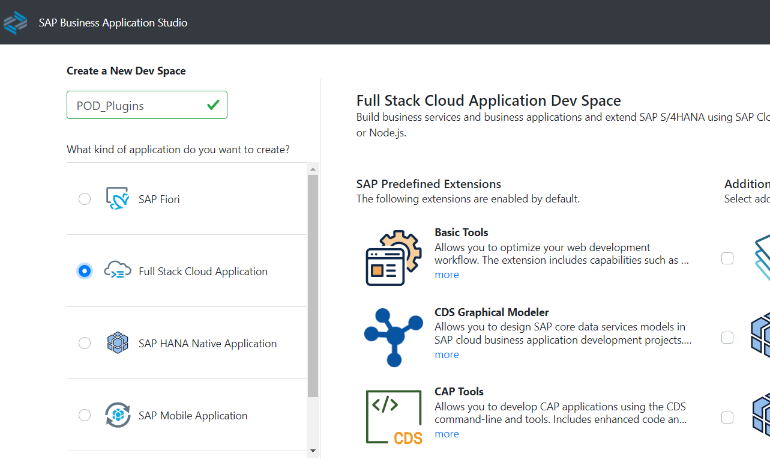

Please **NOTE**: In the SAP BTP trial you are limited to only two Dev Spaces and only one can be active at a time.

1. Once the Dev Space reaches the green status of **RUNNING**, you can click on the name of the Dev Space and it will load into the editor within your browser.

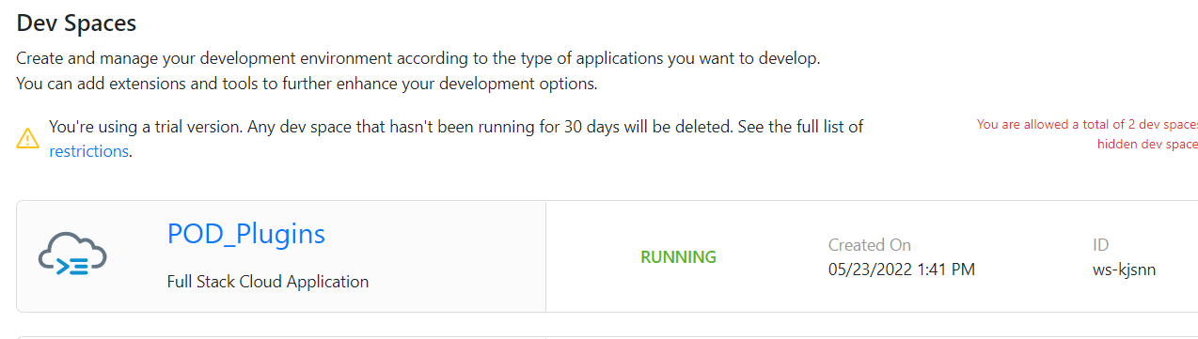

1. You’ll be redirected to your newly created SAP Business Application Studio Dev Space. Recommend you bookmark this URL so it’s easier for you to access this dev space of your SAP Business Application Studio in the future.

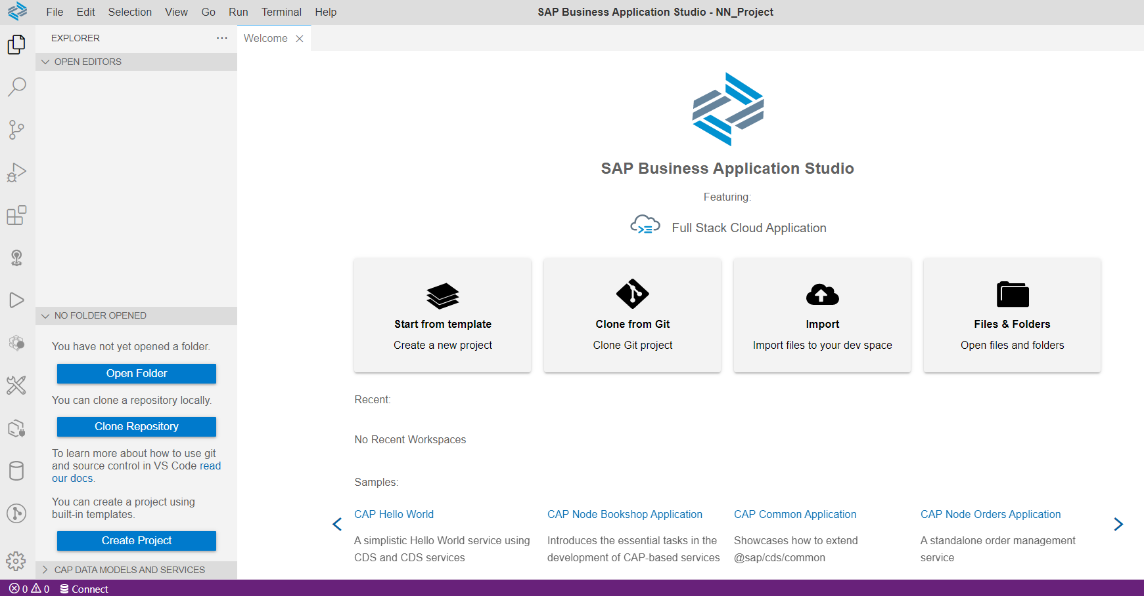

1. On the left side of the Business Application Studio click on the Cloud Foundry targets icon

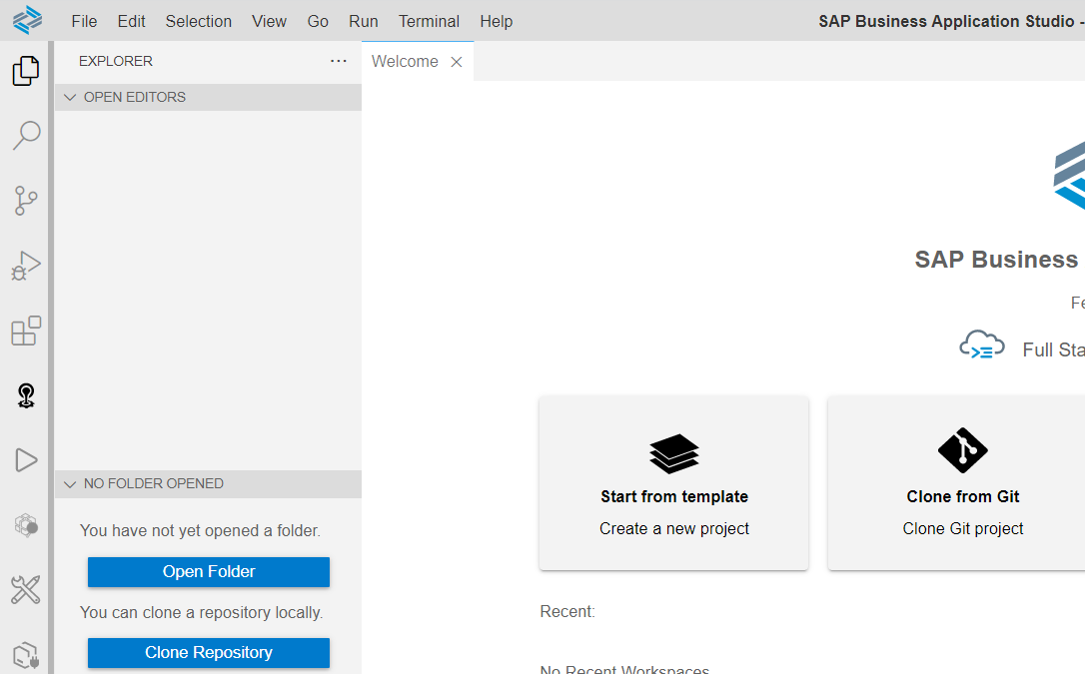

1. In the Cloud Foundry Targets window, you can expand either Service or Applications and then click on the Logon icon to continue the configuration process

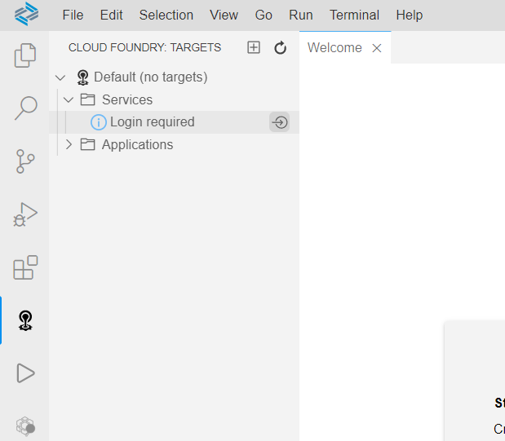

1. The command window will then open at the top of the SAP Business Application Studio. The first input will prompt you for the Cloud Foundry endpoint

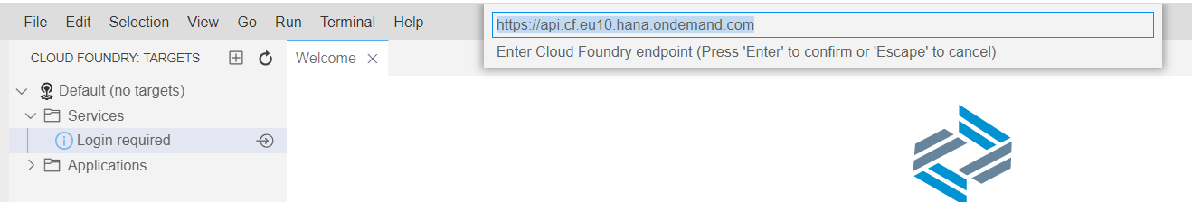

The default value proposed is likely the correct value, but if you need to confirm; the value can be found in the SAP BTP cockpit at the Subaccount level.

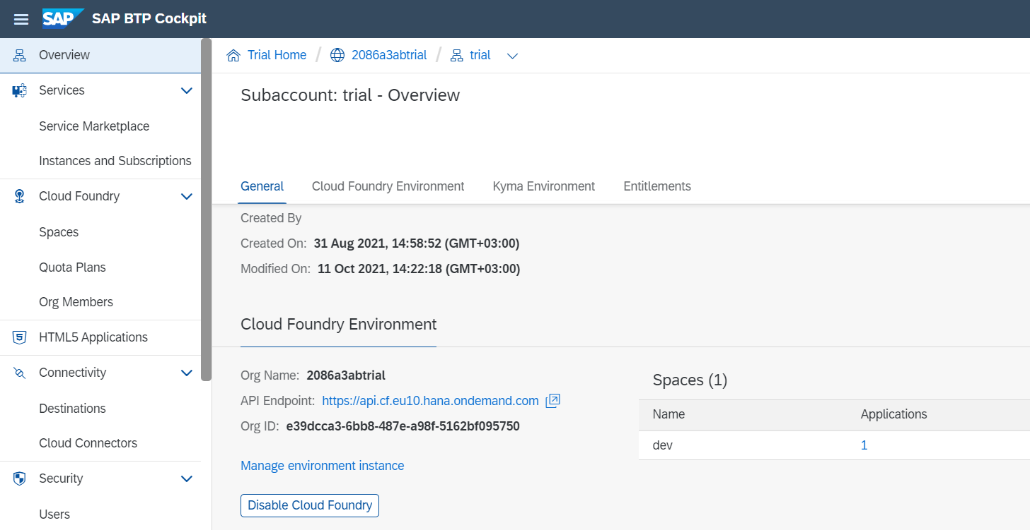

Press **Enter** to confirm your input of the Cloud Foundry endpoint.

1. The next input field will ask you for the email address you used to create your SAP BTP trial account

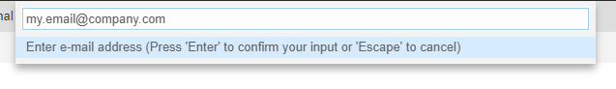

1. The next input will ask you for your SAP BTP trial account password

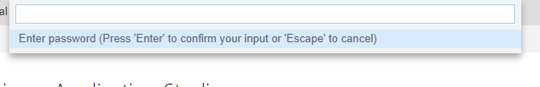

1. The next input will ask you for your Organization. In most situations, you will have a single choice. But like the API endpoint earlier, if you need to confirm the correct value it will be displayed in the top navigation of the SAP BTP cockpit

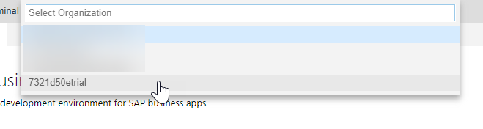

1. The final input will ask you for your Space. If you choose the endpoint API and Organization correctly, then you should have a single option of **dev**

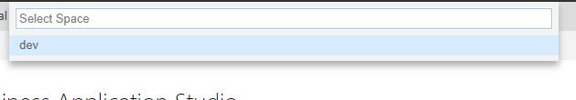

1. Upon completion of all the inputs, you should see that the Organization and Space have been set.

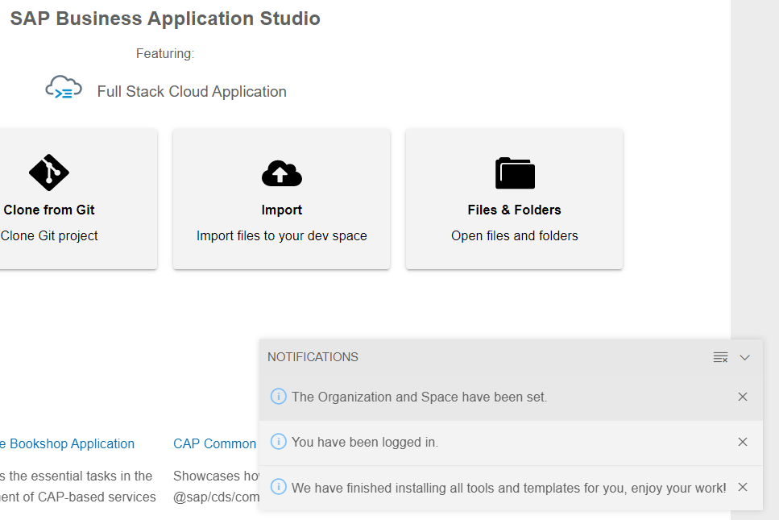

1. Choose **ExecutionPodPluginTemplateAndExample** folderfrom **DMC_UIExtensions/ExecutionPodPluginTemplate_and_Example/project** directory
2. Archive this folder to zip archive, expected result that you get archive with name: **ExecutionPodPluginTemplateAndExample.zip**
3. The next step is to add project with a POD Execution Plugin example and POD Execution Plugin Templates to workspace. From the SAP Business Application Studio Welcome page, click **Import**

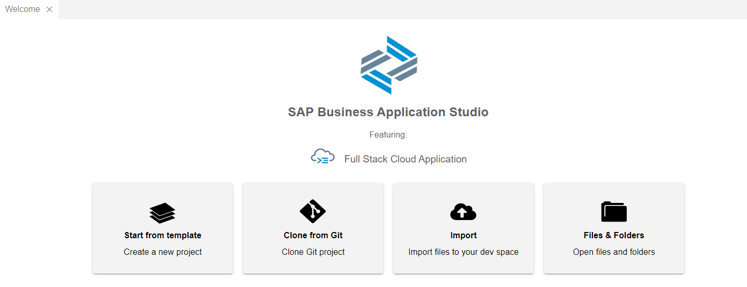

1. Choose **ExecutionPodPluginTemplateAndExample.zip** archive from step 15.

Expected result that project is imported successfully and you should choose **Open in New Worksp…**

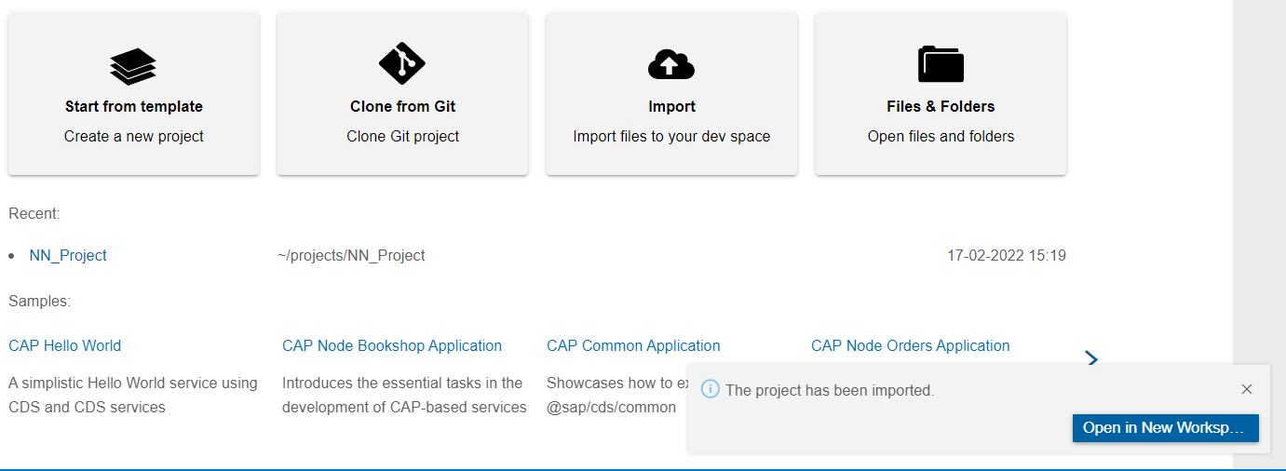

Explorer view shows **ExecutionPodPluginTemplateAndExample** with content as below

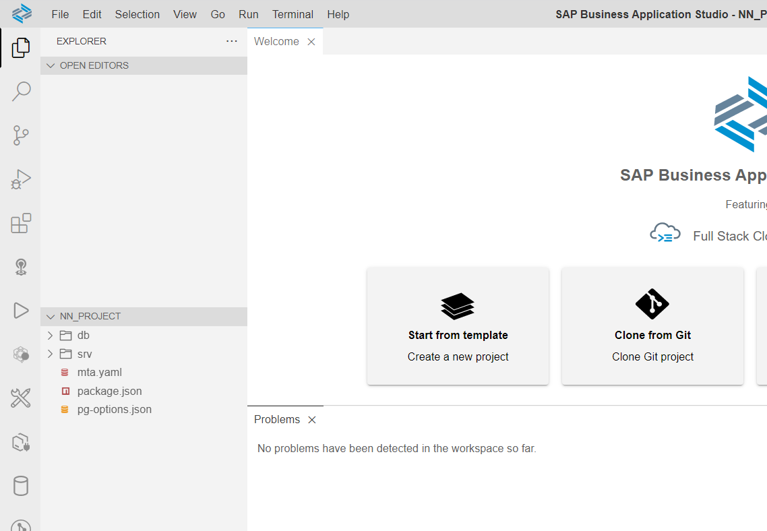

1. Find and replace all vendor
2. Replace DMC_URL in mta.yaml file
3. Right-click the mta.yaml file and choose **Build MTA Project**.

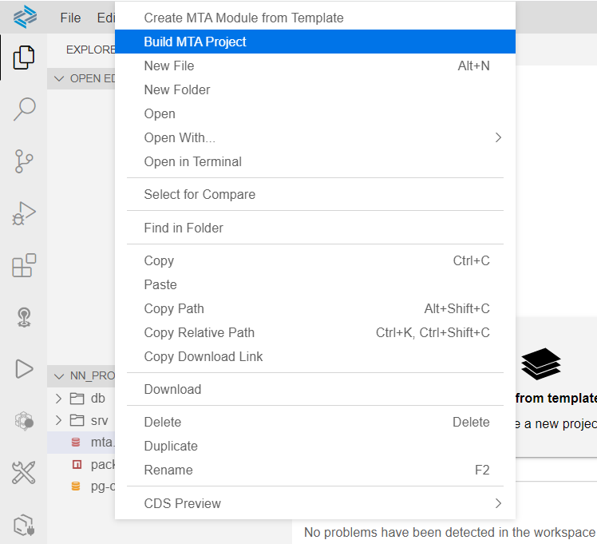

As a result of this step two new folders are created:

* **mta_archives** folder is created containing the new generated **NN_Project_1.0.0.0.mtar** file
* **node_modules** folder is created with all required dependencies defined in **package.json** file.

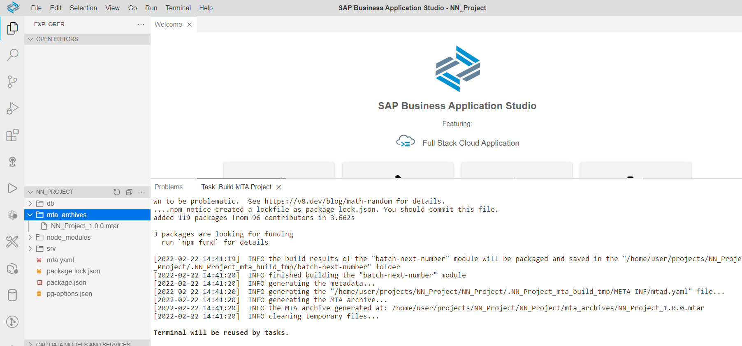

1. Right-click on the generated **NN_Project_1.0.0.0.mtar** file and choose **Deploy MTA Archive**.

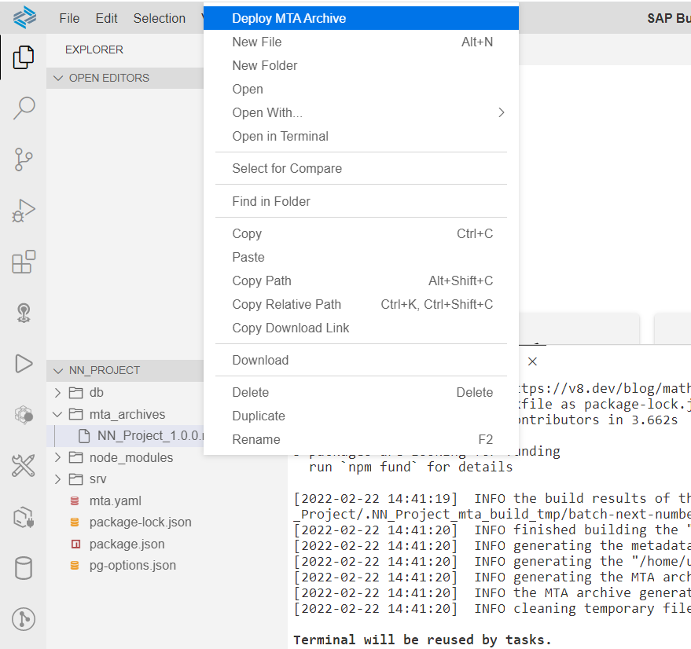

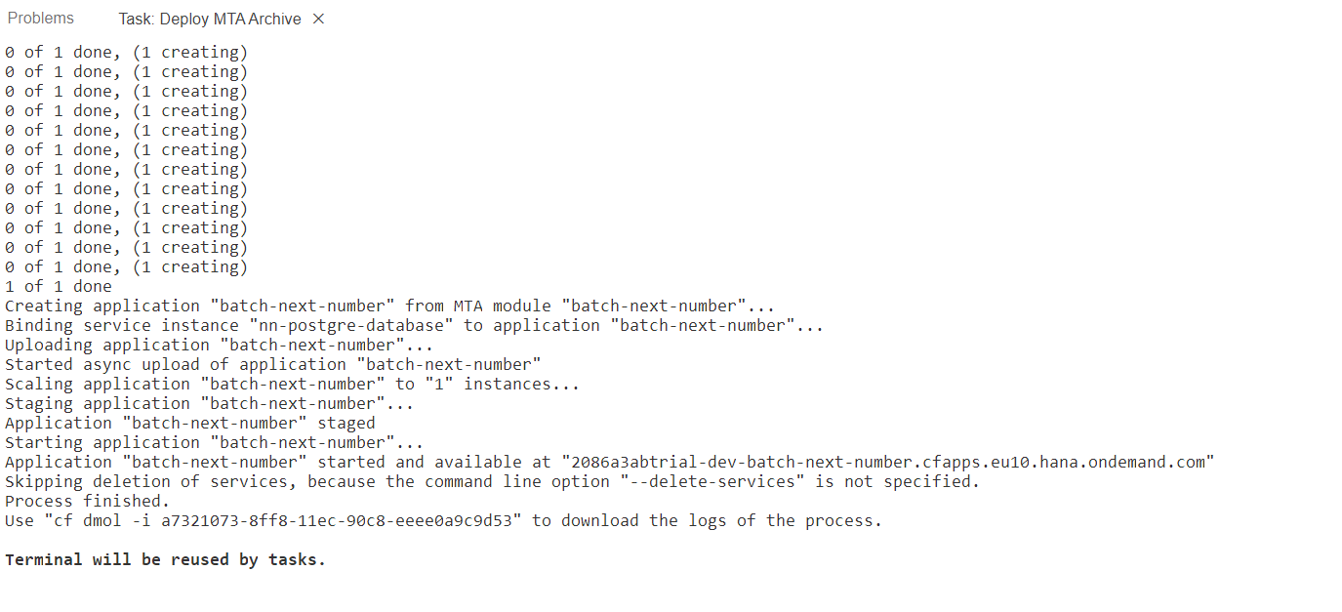

After deployment is done, your application should be available in your Cloud Foundry space. To access your application, go to your space in the SAP Cloud Platform cockpit and select **Applications** from the side menu.

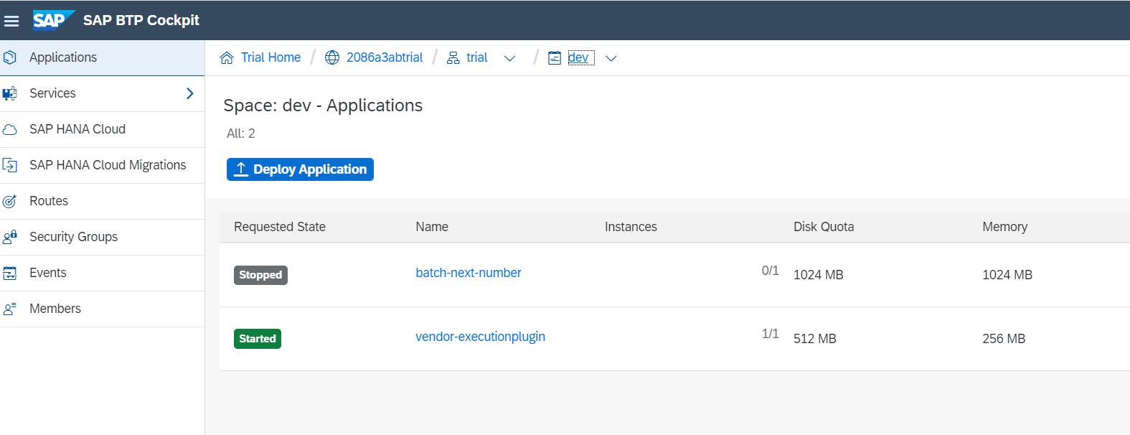

1. Choose a **vendor-executionplugin** application to see details and status.

The application should have **Started** status.

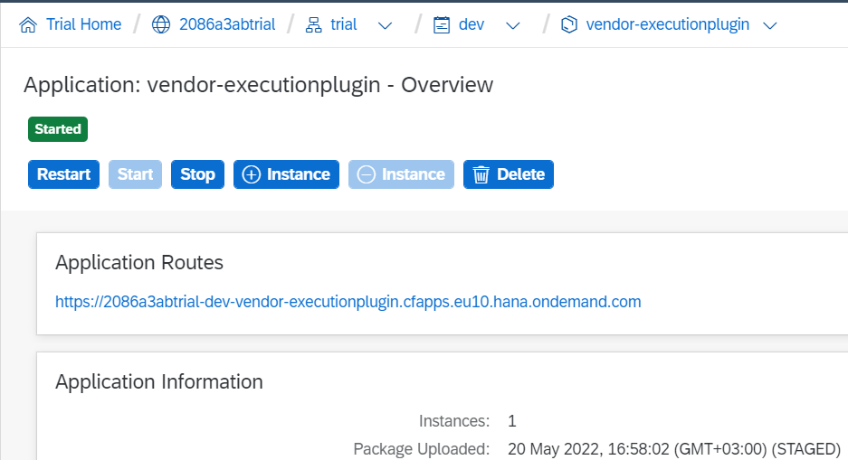

Installation steps are completed! Go to the Configuration Steps section!

**Configuration Steps**

1. Go to your space in the SAP Cloud Platform cockpit and select **Applications** from the side menu
2. Choose the **vendor-executionplugin** application



1. Click on Application Routes URL to verify that the application was deployed



Here is the result of successful deployment to Cloud Foundry.

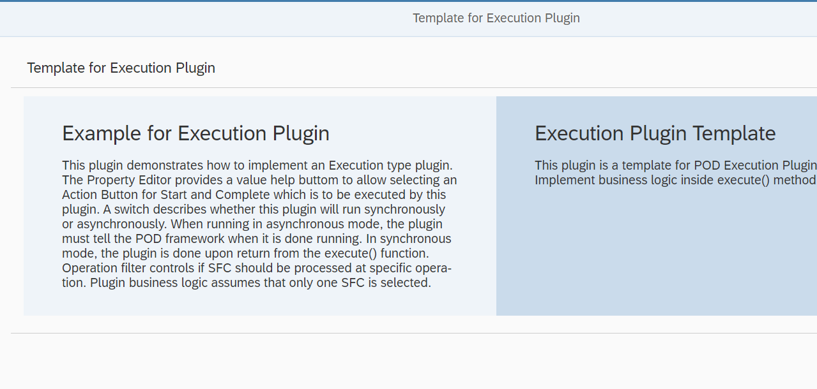

1. Copy application route URL as it will be used in Manage Service Registry application in next steps
2. Login to DMC

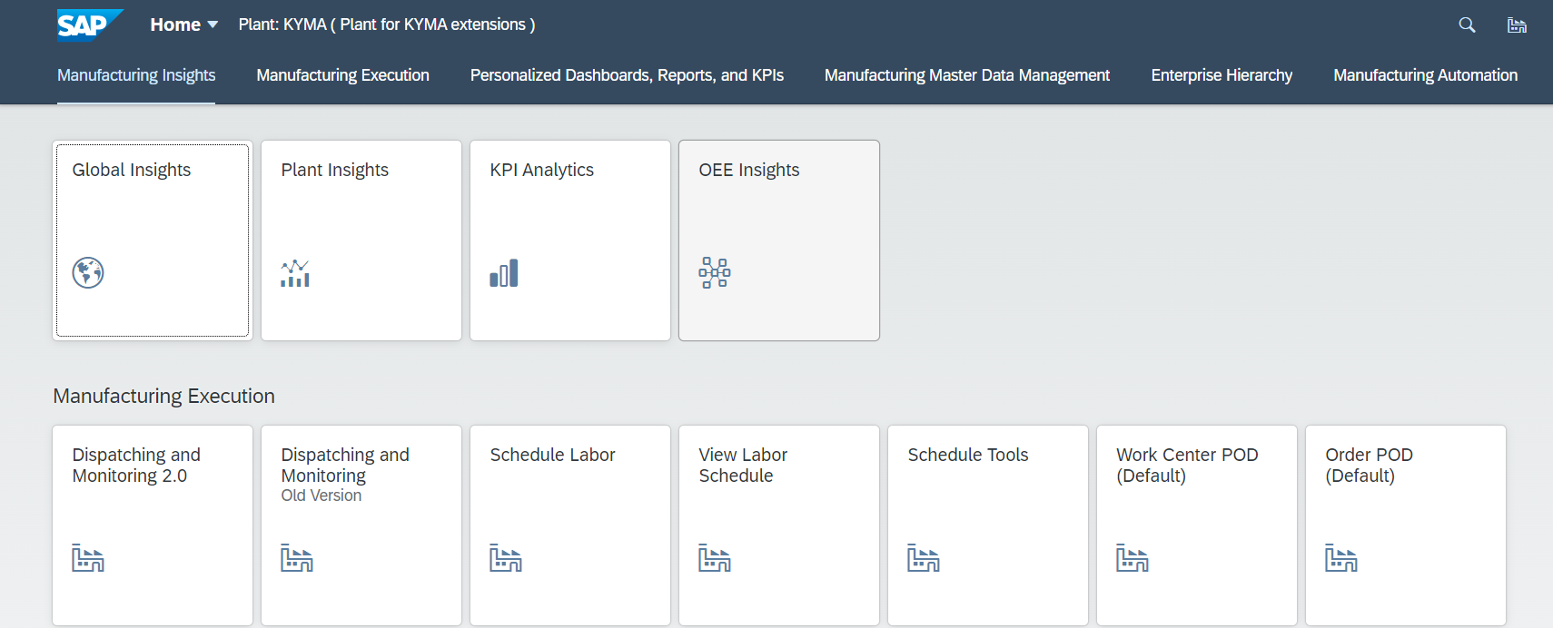

1. Open the Manage Service Registry application
2. Select UI Extensions tab and choose Create button

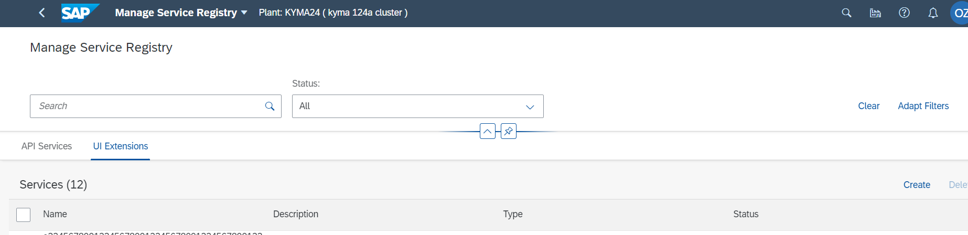

1. Define new UI Extension with the following settings below

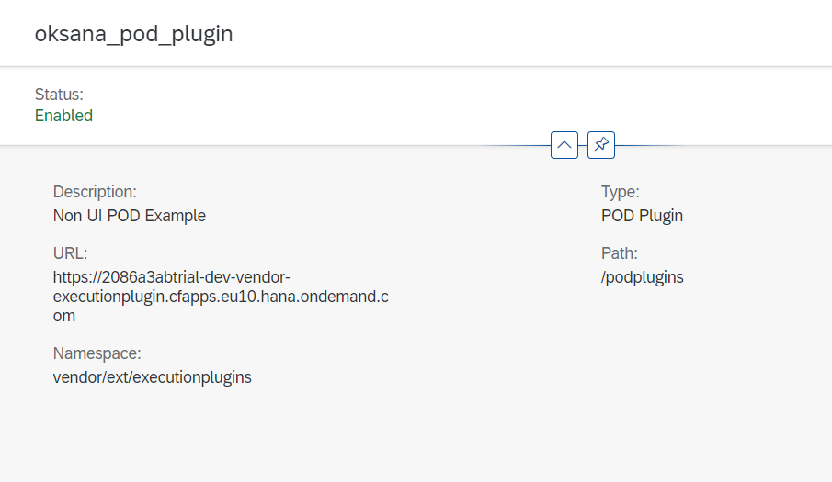

For URL field: use application route URL from “Application Routes” in BTP Cockpit

For Path field: /podplugins

For Namespace: **vendor**/ext/executionplugins

Note: replace “vendor” for Namespace with vendor value you used to find and replace in SAP Business Application Studio

1. Choose Create button and verify that the service was created with correct settings
2. Open POD Designer application and choose DEFAULT_WC_POD POD name
3. Create a copy of the POD

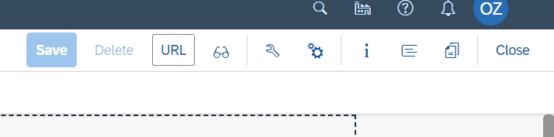

1. Drag and drop Action Button to Activities panel. Click right-mouse button on new Action button and choose “Configuration” option

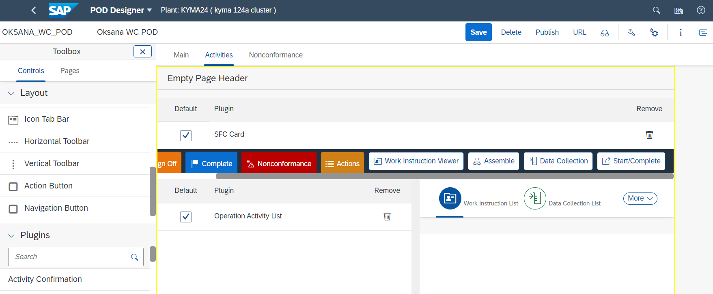

1. Define Text, icon and click on **Assign Actions** button

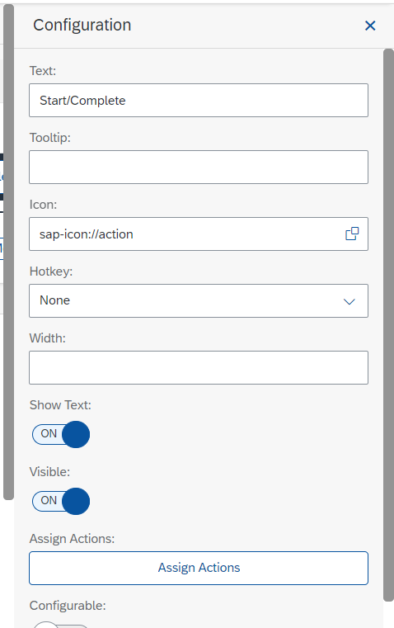

1. Click on Add button to add action for “Execution Plugin for vendor” and choose Create button

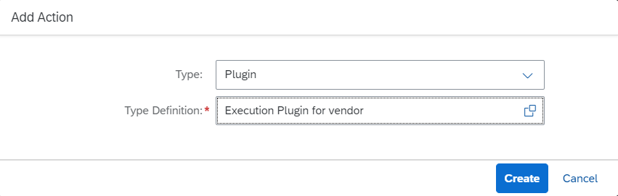

1. Click on Configuration icon and define setting for plugin execution.

The current configuration means that SFC will be started by Start action button and Completed by Complete action button at Operations: OPER1 and OPER2.

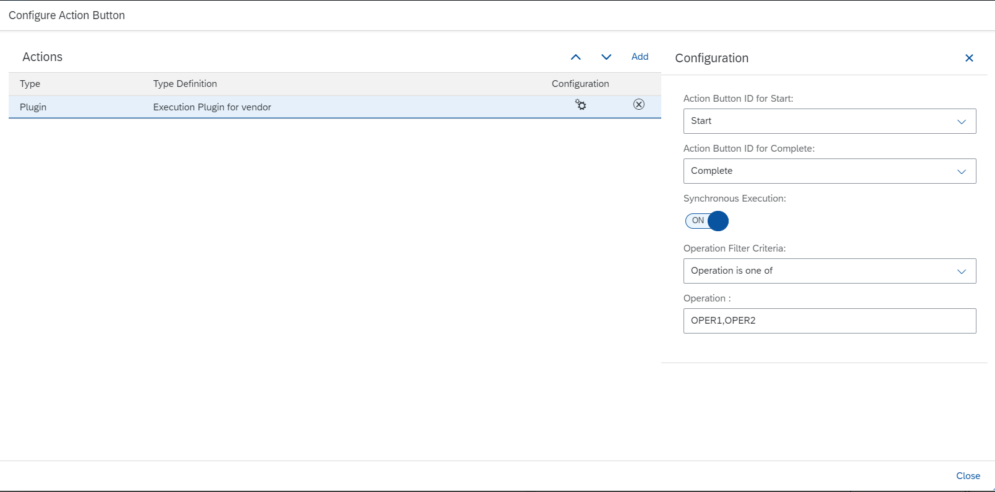

1. Save new POD configuration
2. Open POD with URL that you just configured
3. Choose new SFC and process to activities screen. There you should see Start/Complete button
4. Click button – SFC is started at OPER1. Toast messages should show appropriate messages about progress.
5. Click button again – SFC is completed at OPER1 and processed to the next operation. Toast messages should show appropriate messages about progress.

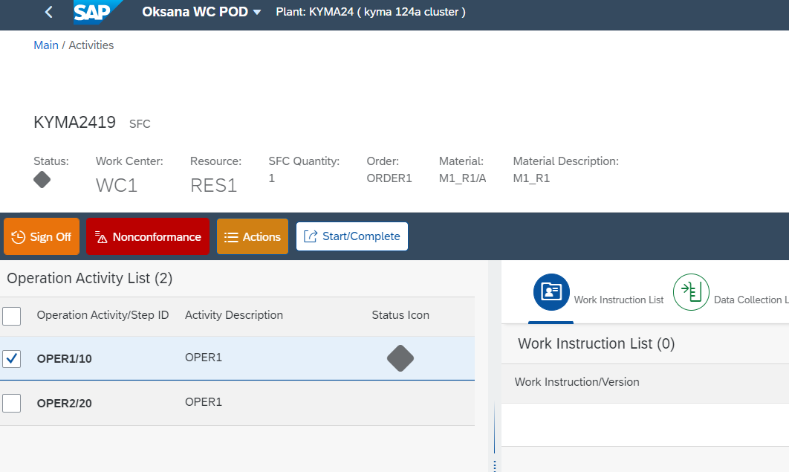

Configuration Steps are completed!