Making Connections to a Local Oracle Database
This document provides instructions about connecting to a local Oracle database after installing the Oracle server 12c standard edition. Installation videos do not seem to cover these details. Learners sometimes can get stuck after installing Oracle, not knowing how to connect and use a local Oracle database. This document demonstrates creating a connection to a local database using the SQL Developer and then using the connection to execute SQL statements.

Database Configuration after Oracle Installation
At the end of the installation process, Oracle creates a default database on the host machine using the Database Configuration Assistant. The most important information that you provide is the administrative password. You must remember the administrative password to connect to the default database using the Oracle SQL Developer.
The Database Configuration Assistant generates a message similar to Figure 1 after completing the Database Configuration Assistant. The message indicates that the default database has ORCL as the Global Database Name and System Identifier (SID). The message also indicates that you can use two predefined accounts to connect to the standard database, SYS and SYSTEM. Oracle has no default passwords for the SYSTEM and SYS accounts. You must use the administrative password that you specified during the configuration process.
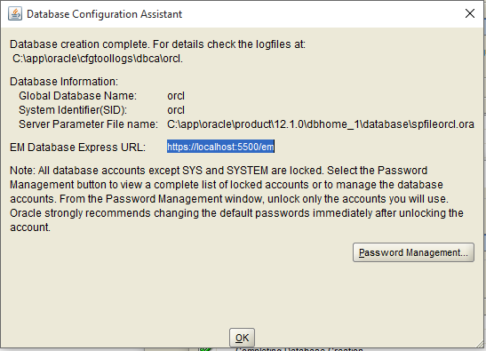
Figure 1: Summary Window for the Database Configuration Assistant

Oracle SQL Developer
You need to download the Oracle SQL Developer from the Oracle Technology Network site (http://www.oracle.com/technetwork/developer-tools/sql-developer/downloads/index.html). There is no cost to use the Oracle SQL Developer although you must have a TechNet account.

Creating the Initial Connection
Creating the initial connection to the default database is crucial. After starting the SQL Developer, you will see the New Gallery window in Figure 2 if you have not previously created connections. You should select Connections and click the Ok button. An empty window will appear for creating a connection as shown in Figure 3.
If you have already created connections, you will see the Connections tab as shown in Figure 3 instead of the New Gallery window. You will only see the connections that you have already created, not the connections shown in Figure 4. After clicking the + button, the New/Select Database Connection window opens (Figure 3).
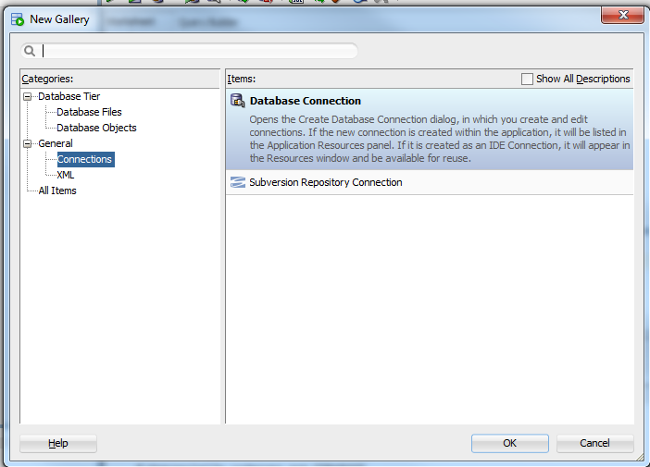
Figure 2: New Gallery Window showing Connections Item

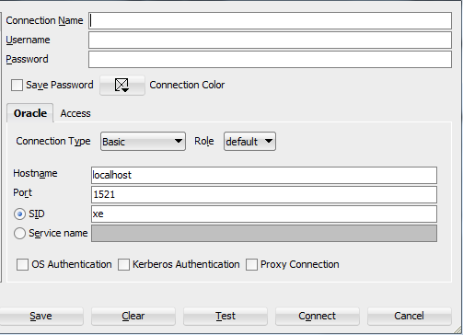
Figure 3: Empty Connection Window

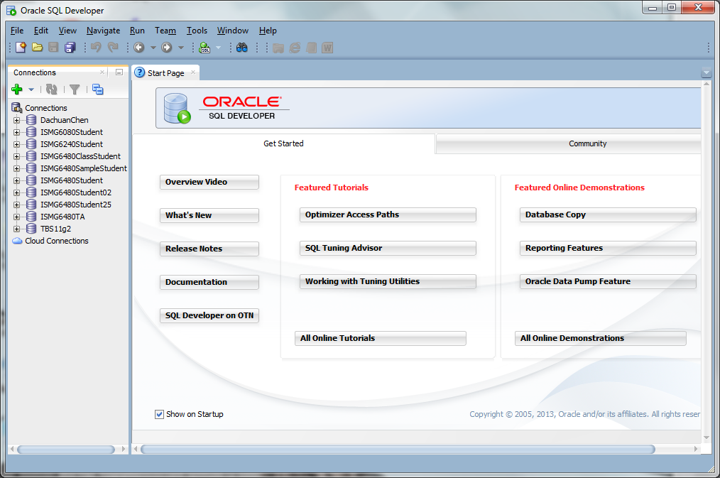
Figure 4: The Connections Tab in the SQL Developer
(Note: You will not see these connections.)

For your initial connection, you should use the SYS account and the administrative password that you gave in the configuration process. Complete the properties as described in the following list. Figure 5 shows the completed connection. After you have specified the properties, you should use the Test button to try the connection. You should see a successful connection. Click the Save button to save your connection.
- You can choose any name for the connection.
- For the user name, you should type “SYS AS SYSDBA”
- You should use the administrative password that you specified in the configuration process. Check the Save Password check box.
- The host name is “localhost” because you are connecting to a database on your own machine.
- The port is 1521.
- The SID is “ORCL”, the database name specified in the configuration process.

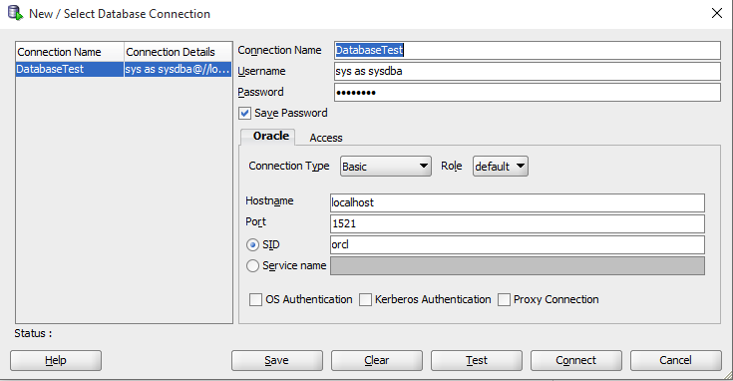
Figure 5: Completed Database Connection Window

After completing the connection properties, you can use the connection. To open a connection, you should right click the connection name in the Connection tab and select the Connect item. If you are still inside the Connection window, you can click the Connect button. You will be prompted for the user name and password if you did not enter the password in the connection properties. After the connection is made, you will see a list of object types in your connection as shown in Figure 6. After you create objects, you will see them when you select the object type.

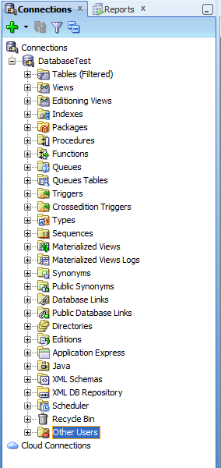
Figure 6: List of Object Types for an Open Connection

Creating another User
Because connecting with SYS AS SYSDBA is highly privileged, I recommend that you create another user for your work in this course and other courses in the specialization.
Before creating a user, you need to create a trigger that will open the physical database that the user object will reside in. You do not need to understand the details of the trigger. You only need to create and execute the trigger before other parts in this section. The trigger will execute the next time that you reboot your computer. In the SQL Worksheet, you should enter the following CREATE TRIGGER statement. After entering the statement, you should execute it using the Run Script button () as shown in Figure 7. In the Script Output pane, you should see a message that the trigger compiled successfully.
CREATE OR REPLACE TRIGGER open_pdbs
AFTER STARTUP ON DATABASE
BEGIN
EXECUTE IMMEDIATE 'ALTER PLUGGABLE DATABASE ALL OPEN';
END open_pdbs;
/

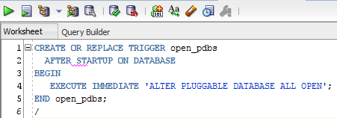
Figure 7: CREATE TRIGGER Statement in the SQL Worksheet
As a first step to creating a user account, you should enter the ALTER SESSION command as shown in Figure 8. You should execute the command using the Run Script button (). In the Script Output pane, you should see a message that the ALTER SESSION executed. If the ALTER SESSION command executes with an error, you should skip to the last section in this tutorial. Make sure that you typed the statement correctly before giving up.

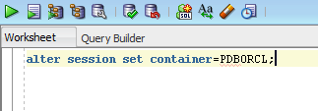
Figure 8: ALTER SESSION Command in the SQL Worksheet
You will then create a new user and grant the DBA role to the new user. You should right click on the Other Users icon at the bottom of the object list (Figure 6) and select Create User … You should enter a user name such as LocalUser1 as shown in Figure 9. You also need to create a password for the new user and select the default tablespace (USERS) and temporary tablespace (TEMP). In the Roles tab (Figure 10), you should select DBA. The generated SQL code should appear as shown in Figure 11 if you select the SQL tab. Click the Apply button and close the window.

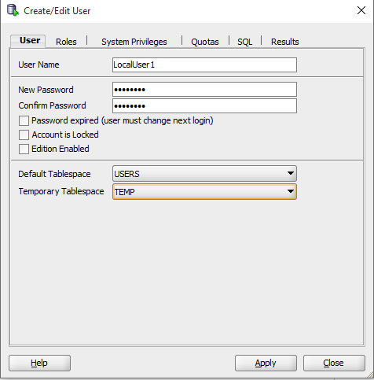
Figure 9: Create/Edit User Window

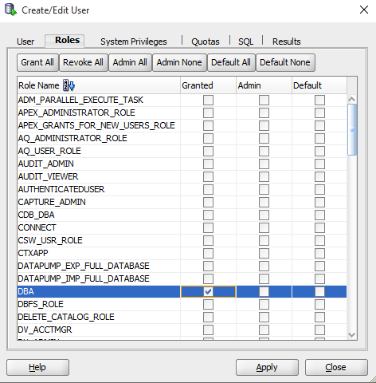
Figure 10: Selecting DBA Role for the New User

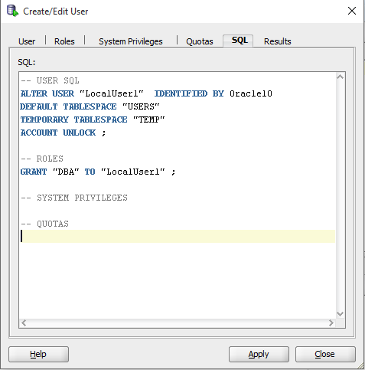
Figure 11: Generated SQL Code for the New User
Close the current connection by right clicking on the connection name (Figure 6) and selecting Disconnect. You should the click the + button to create a new connection for the user that you previously created. You should enter property values as shown in Figure 12. You can enter a different value for the Connection Name if you want. You need to enter the password that you gave in Figure 9. Note that you need to use a service name (pdborcl) instead of the ORCL SID used for your SYS AS SYSDBA connection. You should test and save the connection. You should use this connection to create and populate tables and write SELECT statements using your tables as indicated in ungraded exercises and graded assignments.

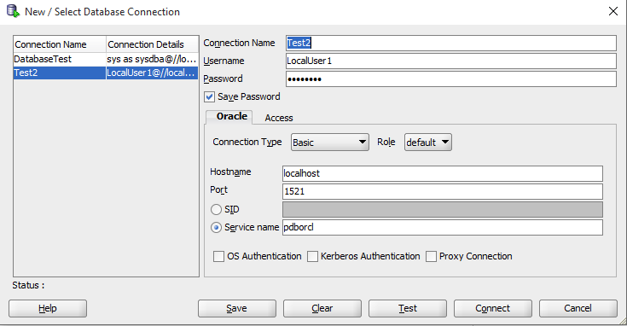
Figure 12: Database Connection for the New User

Alternative for Failed ALTER SESSION Statement
If the ALTER SESSION statement does not work (Figure 7), you should create another connection using SYSTEM as the user name. You should use SYSTEM as the user name, not SYSTEM as SYSDBA. You should use the same administrative password that you provided in the configuration process. You should use the other connection properties as shown in Figure 5. You can use this connection to create and populate tables and write SELECT statements using your tables as indicated in ungraded exercises and graded assignments in the course.

Opening and Using a Connection
After creating and testing a connection, you are ready to use it to execute SQL statements. To open a connection, you should the connection name in the Connections pane expand by clicking on the plus symbol by the connection name. You will see a list of object types for the open connection as depicted in Figure 13. After you create tables, you can see them by expanding the Tables icon in the object list.

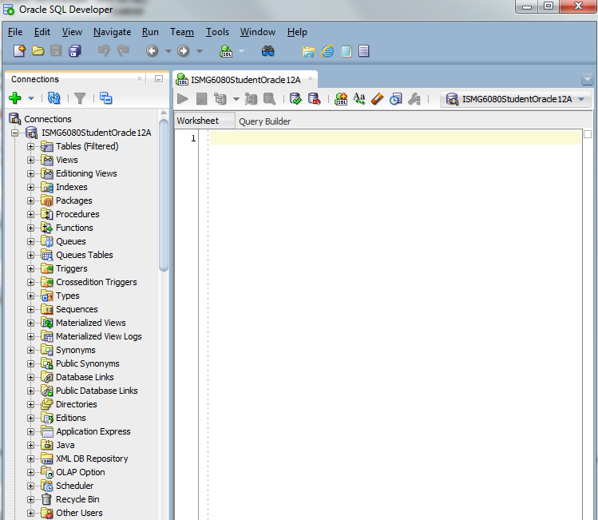
Figure 13: List of Object Types for an Open Connection
You can create and execute SQL statements using the Worksheet. Type a statement and click on the Run Script button () as depicted in Figure 14. If you previously created and populated the Employee table, the results will be displayed in the Script Output tab below the Worksheet. You can execute any SQL statement such as CREATE TABLE and INSERT statements required in Module 3 and SELECT statements required in Modules 4 and 5.

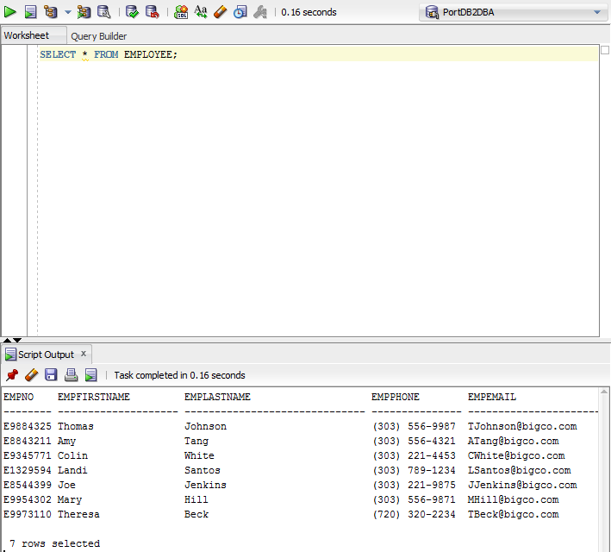
Figure 14: SQL SELECT Statement Executed in the Worksheet

