REPORT PROJECT 1 SKJ

**Oktaviani Szamocka s17874**

1. **A general solution description**

For playing, the user need to execute Main class and fill information by console

* 1. The name of agent
  2. The port of the agent
  3. The IP of introduction peer (localhost)
  4. The port of introduction agent

After connecting to introduction agent (IA), user can send any message for server but to there is some KEY to go to further process :

* join : by typing join to IA, agent can get information about the list of port number of all member in tournament
* update = to update the list (listpeers) before playing to anticipate there are new players on the IA
* play = to play with all player by giving the number to bet, the result will appear after opponent give number also
* exit = able to quit only if has play with others.

1. **Precise solution description**

The project consisted of 6 classes:

* Server = where ServerSocket created, then creating new thread to handle each client
* Clienthandler = where socket from server socket handled by thread and received and send message to each client.
* Peer = where socket (client) created and send message to server and interact with all player
* Message = the object as message that consist string and map
* Game = where agent can exchange number to play
* Main = where peer class created

Further explanation :

* To start the game, the first player need to fill the introducing port number by its own port and will wait agent to connect with him

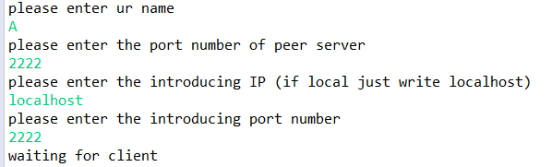

* After that, 2nd player can enter the tournament with A as an introduction agent

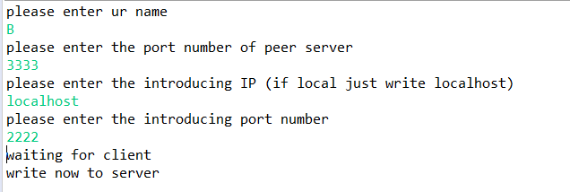

* Agent B can write to agent A now
* To share both of list of peer, agent B can send “join”

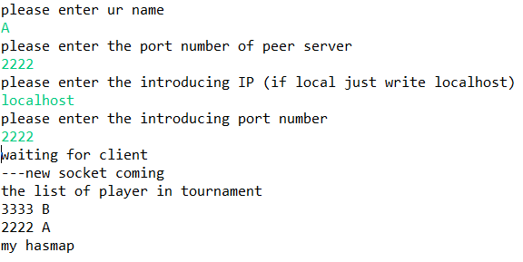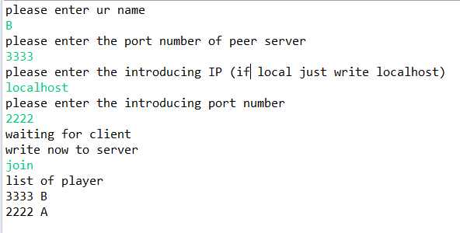

* In this case they already can play together. New Agent can come and can both connect to agent A or B, but we r going to take Agent B as IA

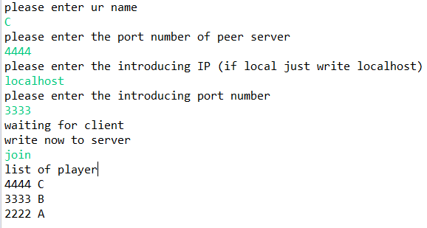

* Agent C connect to B and ask to join and get the list of player and its port and ask all the player to update their list because of his incoming by typing “update”. Now all player has same list of player!

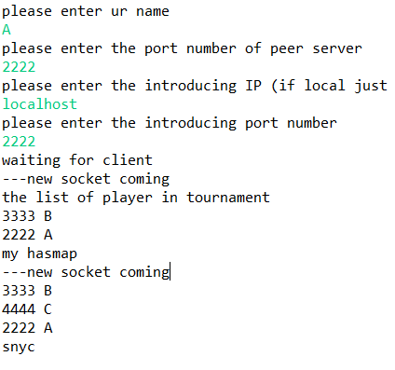 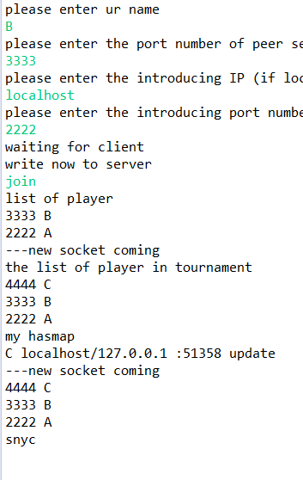 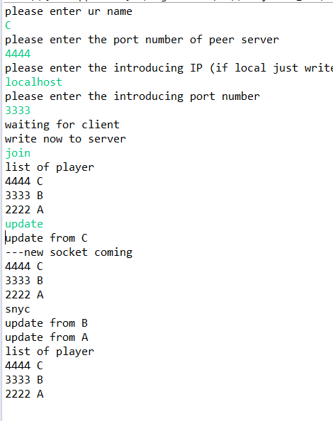

* Now player C want to start playing with all player by typing “play”

Agent C: Agent B:

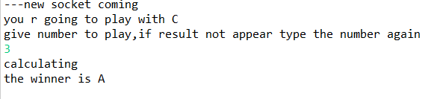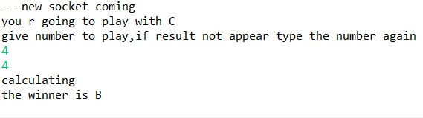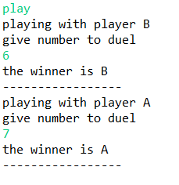

Agent A

* The agent only able to quit after playing with other. It by comparison size between list<result> and the map of all the tournament member (except himself). If the size same, the agent can exit

1. description of how the data about the network are kept;

data about the network are kept inside the map listpeers which consist of each agent port number and also name. when

1. how duels after joining a tournament by a new player were implemented

every player that wish to play need to type ‘play’ then can play with each player

1. how fairness was granted

the game is quite fair because the opponent don’t see the number of other opponent. So it doesn’t really matter which one start the counting