BB Review -- Design Overview
Overview 2
High-Level Architecture 2
CLI Surface 3
Top-Level Commands 3
Command Groups 4
Review Processing Flow 4
Three Review Modes 4
Interactive Mode 4
TUI Tabs 4
Modal Screens 5
Comment Picker Behavior - TBD 5
Triage Workflow - TBD 5
Review Rules Auto-Build Logic 5
Goal 5
CLI 5
Fetch Step 6
Draft Step 6
Signal Weighting in the Prompt 6
Databases 7
Overview 7
reviews.db 7
state.db 7
rules_mining.db 8
Configuration & Per-Repo Guides 8
Summary 8

Overview
BB Review is a Python CLI tool that adds AI code review to Review Board (RB). When a designated bot user is added as a reviewer on a review request, BB Review fetches the diff, analyzes it with an LLM or coding agent, and posts inline comments back to RB.
Key capabilities:
- Four review backends: direct LLM, OpenCode agent, Claude Code CLI, Codex CLI.
- Interactive Textual TUI with queue management, review editing, and triage.
- Comment triage workflow: classify human reviewer comments and auto-reply or fix.
- Daemon polling mode with persistent state.
- Optional semantic code search via CocoIndex (PostgreSQL + pgvector).
- Rules-mining: turn past human reviewer comments into draft repo guides.

High-Level Architecture
The CLI sits between Review Board and the chosen LLM or agent, with local SQLite stores for state, local Git checkouts for patch application, and optional CocoIndex or something like that for semantic search.

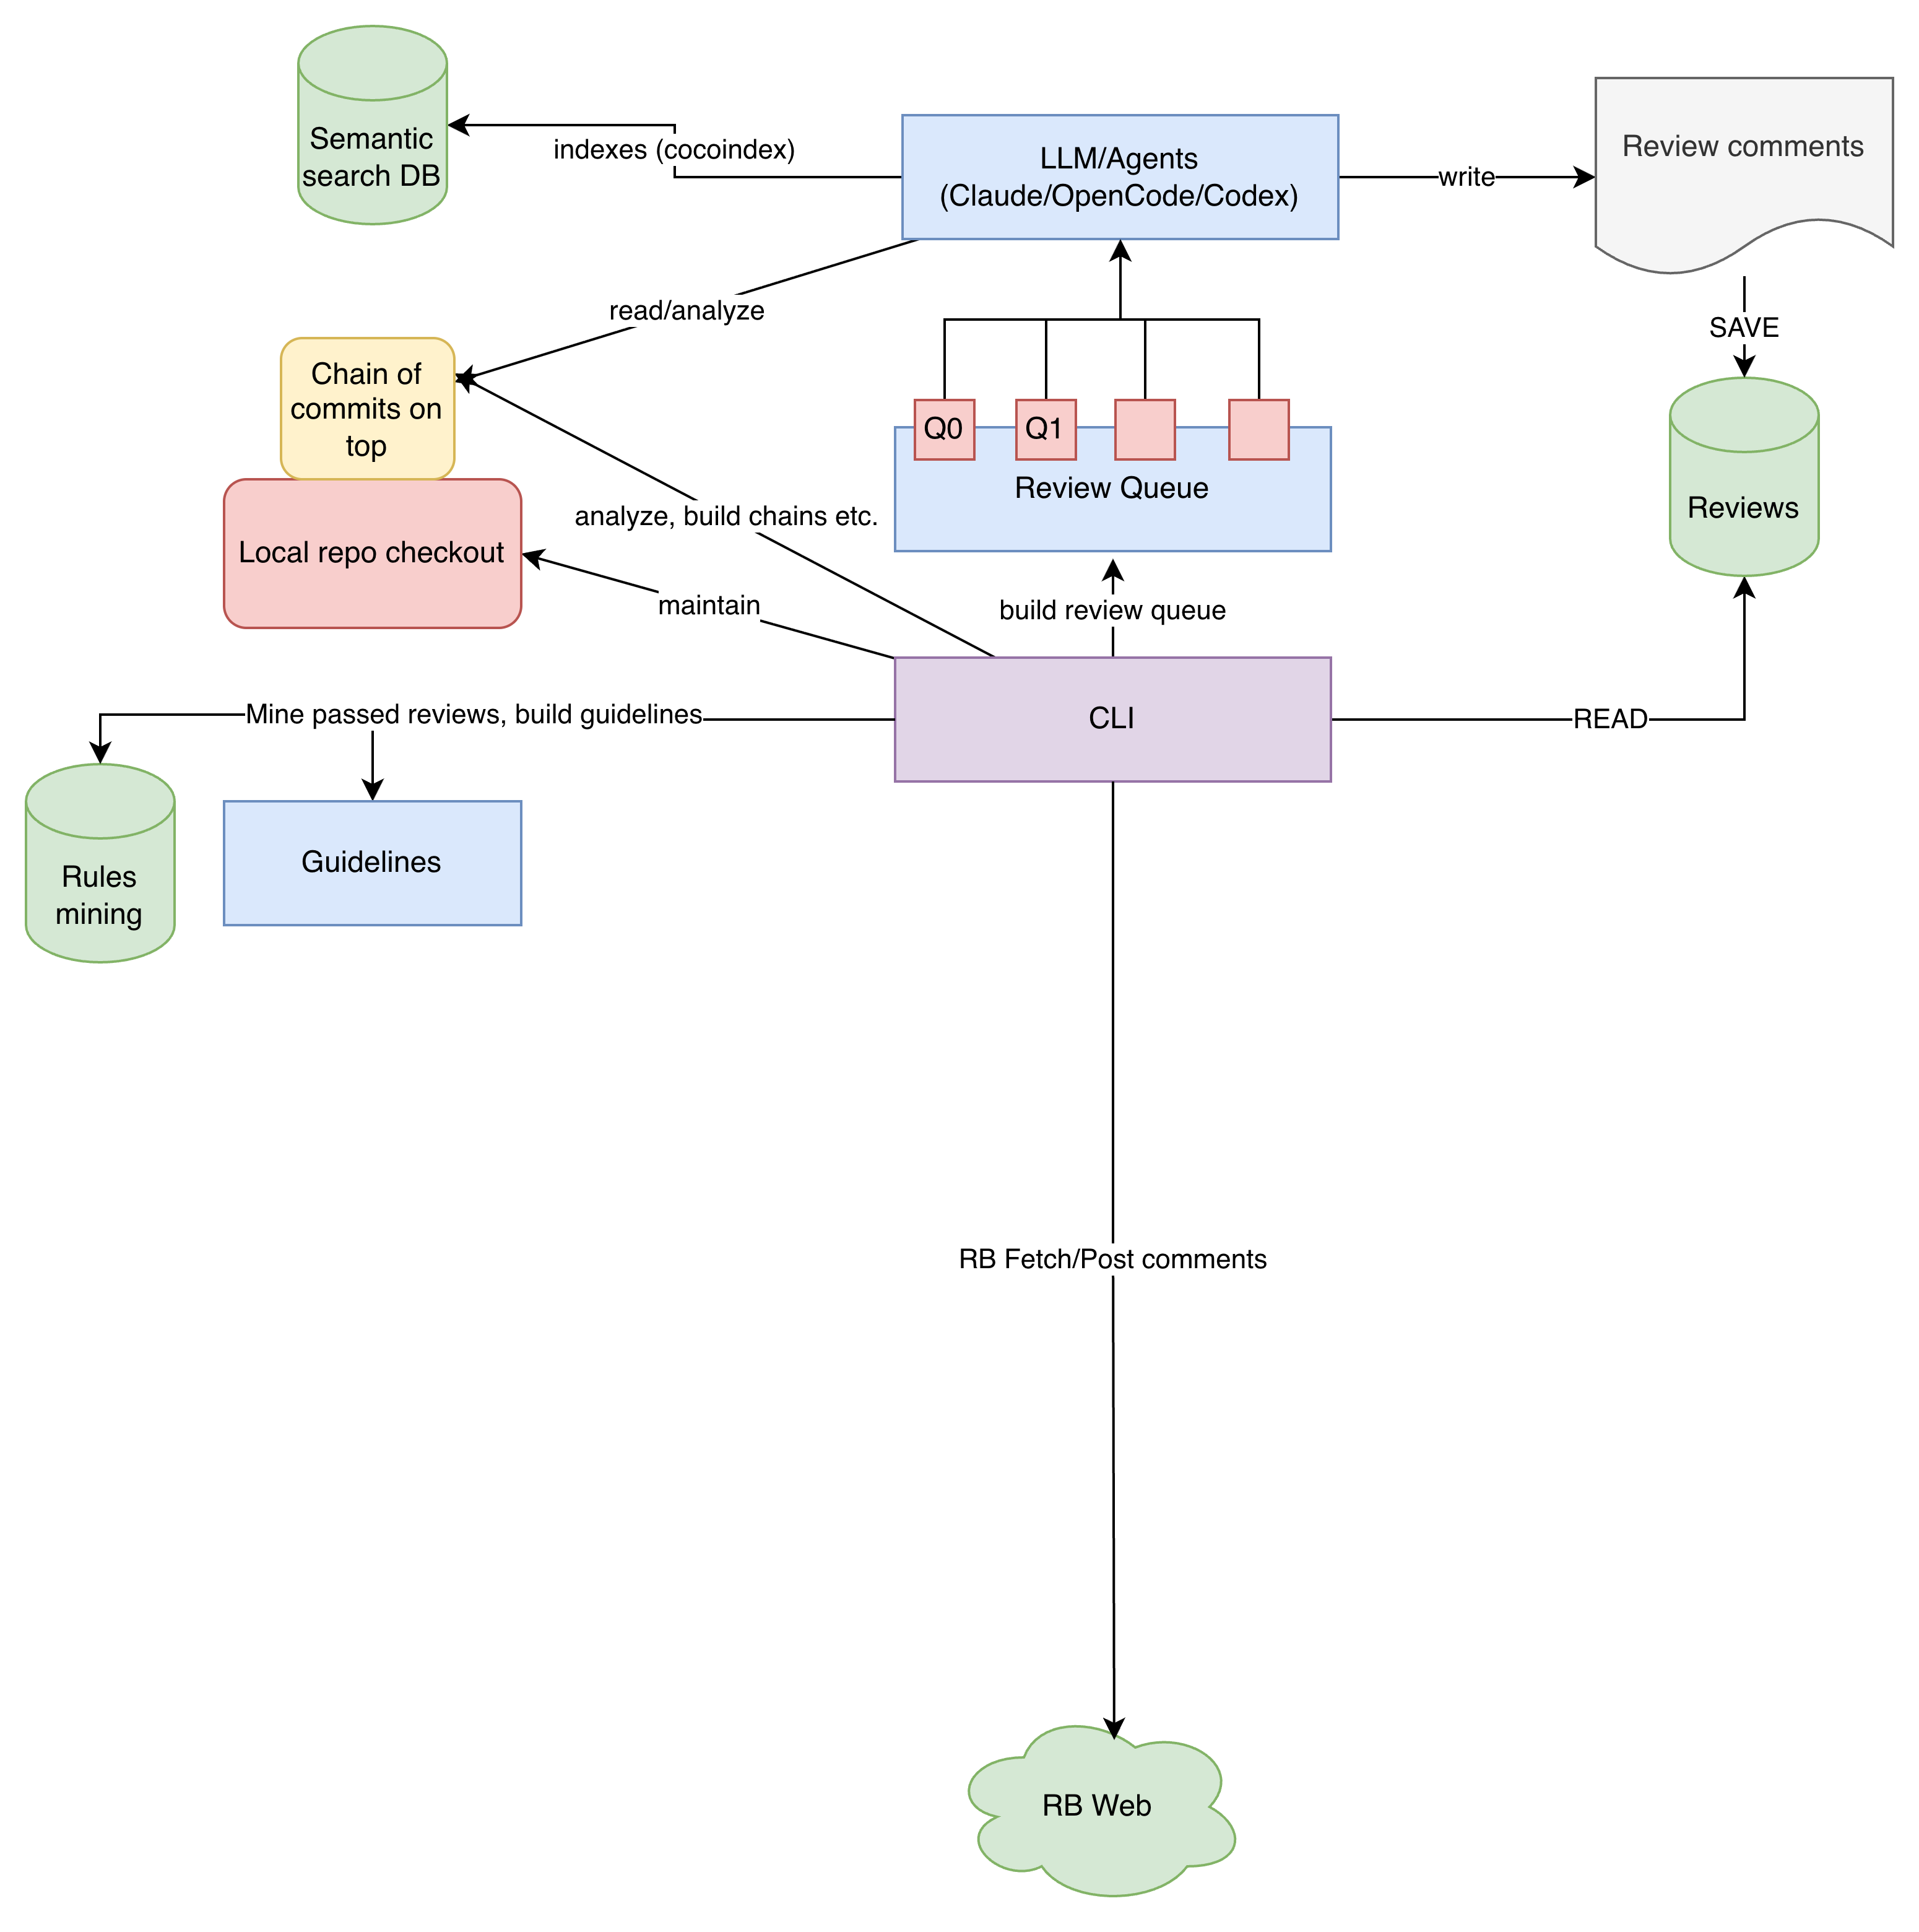
RB authentication: API token, Kerberos, username+password, or layered Kerberos+password. The RB client uses curl as a subprocess because Apache+Kerberos negotiate headers don't play well with requests-kerberos.

CLI Surface

Top-Level Commands
Four review backends share the same prompt and output shape but use different runners:
- analyze -- direct LLM analysis (Anthropic / OpenRouter / OpenAI).
- opencode -- OpenCode agent subprocess.
- claude -- Claude Code CLI in headless -p mode (agentic).
- codex -- Codex CLI in exec mode with sandbox isolation (agentic).
Workflow / output commands:
- submit -- post a saved review JSON back to RB.
- interactive -- launch the Textual TUI.
- comments -- dump human reviewer comments with source context.
- triage -- classify human comments, plan fix / reply / skip / disagree.
- resolve -- mark comments fixed or dropped on RB.
- transcript -- pretty-print a saved agent transcript.

Command Groups
- poll -- once / daemon / status (daemon polling loop).
- queue -- sync / list / set / process / stats / show (the RR queue).
- repos -- list / sync / init-guidelines / mcp-setup / clean (local repo cache).
- db -- list / show / export / stats / mark / chain / cleanup / search / import.
- rules -- fetch / draft / show (rules-mining; see dedicated section).
- cocoindex -- index / status-db / setup / clean (semantic search, optional).
Each group is a thin Click registration on the top-level main group in bb_review/cli/__init__.py.

Review Processing Flow
Every backend executes the same eight-step pipeline:
- Fetch diff and RR metadata from Review Board.
- Resolve dependency chain (walks the depends_on link).
- Check out the base commit in the local repo cache, apply patches in order.
- Load per-repo guidelines from .ai-review.yaml and guides/{repo}/.
- Analyze via the chosen backend (direct LLM / OpenCode / Claude Code / Codex).
- Deduplicate against previously-dropped comments (fuzzy match, 60% threshold).
- Optionally edit in the TUI (CommentPicker three-state toggles).
- Save to reviews.db, then post comments back to RB.

Three Review Modes
- Single -- one RR analyzed in isolation.
- Chain -- dependent RRs reviewed sequentially, each with cumulative patch context.
- Series (--series) -- entire patch set analyzed as one unit; issues partitioned across RRs.
Chain resolution walks depends_on links and stops at submitted RRs (used as base commits). RepoManager.checkout_context and chain_context provide atomic per-RR / per-chain checkouts.

Interactive Mode

TUI Tabs
bb-review interactive opens a Textual application with four tabs in a ContentSwitcher:
- Queue -- pending RRs (todo / next / in_progress / done / failed / ignore).
- Reviews -- analyses produced by the tool (draft / submitted / obsolete / invalid).
- My Reviews -- analyses the current user is working on.
- Work -- open triage sessions (scans triage_*.yaml files in the work directory).

Modal Screens
- ActionPicker -- pick a per-row action (open, export, submit, delete, etc.).
- CommentPicker -- 3-state toggle (Submit / Skip / Edit) with diff view.
- FilterPicker -- filter list by status / repo / submitter.
- IssuesScreen -- per-analysis issue list with severity filtering.
- TriageScreen + TriageViewScreen -- triage editor (FIX / REPLY / SKIP / DISAGREE).
- Export screens for JSON and Markdown.

Comment Picker Behavior - TBD
- Per-comment status: Submit / Skip / Edit.
- Edit opens an inline editor for the message.
- Skip persists into the dropped set, which feeds the dedup filter on next analysis.
- Backed by SelectableComment in bb_review/ui/models.py.
- Diff view shows the original code lines for context.

Triage Workflow - TBD
- bb-review triage <RR> fetches every human reviewer comment via RBCommentFetcher.
- LLM classifies each: valid / confused / nitpick / outdated / already_fixed / duplicate.
- Per-comment action recorded: FIX / REPLY / SKIP / DISAGREE.
- Auto-replier groups by review_id and publishes replies atomically.
- bb-review resolve marks comments fixed or dropped on RB.
- Persisted to triage_sessions and triage_comments in reviews.db.

Review Rules Auto-Build Logic

Goal
Bootstrap or augment guides/{repo}/ content from the actual comments human reviewers have left on past review requests. Useful for seeding a new repo guide or growing technical-patterns.md from real signal instead of hand-authoring it from scratch.

CLI
- bb-review rules fetch <repo> -- mine recent submitted+discarded RRs into a cache DB.
- bb-review rules show <repo> -- inspect cached RR / comment counts for a repo.
- bb-review rules draft <repo> -- run an agent to synthesize guides/<repo>/draft-rules.md.
The two-step split is intentional: the slow RB fetch is decoupled from the iterable synthesis prompt, so re-drafting is free and the prompt can be tuned without paying the RB cost again.

Fetch Step
- Discover the N most recent submitted + discarded RRs for the repo.
- RB's /api/review-requests/?repository= filter accepts the numeric ID; the config field repositories[].rb_repo_name is resolved name -> id automatically.
- Per RR: RBCommentFetcher pulls all human reviewer comments (bot's own excluded).
- Upsert into rules_mining.db (mined_review_requests + mined_comments).
- Already-cached RRs are skipped unless --refresh is passed.
- Optional --with-diff-hunks (opt-in):
- For each diff comment, fetch the RR's raw diff and slice the hunk via extract_diff_hunk() (the existing helper in bb_review/reviewers/diff_utils.py).
- Memoized per (rr_id, diff_revision) -- one extra RB call per RR's diff.
- On already-cached RRs the same flag backfills missing hunks without re-fetching the comments themselves (counter: hunks_backfilled).

Draft Step
- Load cached comments (plus hunks if present) for the repo.
- RepoManager.ensure_clone + checkout default_branch -- the agent runs with cwd = checkout so it can open referenced source files.
- Write .bb_review_mined_comments.md into the checkout (cleaned up after).
- Run the agent (Claude Code or Codex) via the shared agent_runner; capture text output.
- If guides/<repo>/technical-patterns.md exists, it is passed in the prompt so suggestions are new rather than duplicates.
The agent produces guides/<repo>/draft-rules.md with three sections:
- Recurring Mistakes -- concrete patterns reviewers repeatedly flag, ordered by recurrence.
- Conventions & Patterns -- coding conventions and expected patterns revealed by comments.
- False-Positive Candidates -- patterns the reviewers explicitly disagreed with (dropped issues).
The output is non-destructive -- it lives next to (not replacing) any curated technical-patterns.md. You review it and fold what you keep into the curated guides.

Signal Weighting in the Prompt
- issue_status = resolved -> submitter agreed and fixed -> CONFIRMED MISTAKE (strong rule).
- issue_status = dropped -> submitter pushed back / disagreed -> FALSE-POSITIVE CANDIDATE.
- Plain body comments -> softer guidance.
- Patterns recurring across multiple distinct RRs outrank one-off remarks.
- When --with-diff-hunks was used, the artifact renders a fenced ```diff block under each diff comment. The synthesis prompt instructs the agent to treat that block as ground-truth code for verifying the rule.

Databases

Overview
Three SQLite files under ~/.bb_review/ (paths configurable):
- reviews.db -- analyses, queue, triage (the main store).
- state.db -- polling daemon's deduplication state.
- rules_mining.db -- cache of human reviewer comments and (optional) diff hunks.
Plus, optionally, a PostgreSQL+pgvector database used by CocoIndex for semantic code search.
All SQLite schemas use CREATE TABLE IF NOT EXISTS plus lightweight ALTER TABLE migrations on open. Everything is inspectable with sqlite3 <path>.

reviews.db
The main store. Two managers share the file: ReviewDatabase (analyses + triage) and QueueDatabase (the queue table). Six tables, with cascade deletes from comments to their parent analysis and from triage_comments to their triage_sessions.
- analyses -- one row per AI review run. Carries RR metadata, the chosen backend / model, the resulting status (draft / submitted / obsolete / invalid), and the body text posted back to RB.
- comments -- inline review comments produced by the AI; FK -> analyses.
- chains -- one row per chain-mode run, tracking whether the chain completed.
- triage_sessions -- one row per `bb-review triage` run with the tally of fix / reply / skip / disagree actions.
- triage_comments -- per-comment classification and the action the user chose; FK -> triage_sessions.
- review_queue -- the RR triage queue with state (todo / next / in_progress / done / failed / ignore); managed by QueueDatabase but lives in the same file.

state.db
Polling daemon's local memory. Two small tables:
- processed_reviews -- one row per (RR, diff_revision) the daemon has already handled. Stops the daemon from re-analyzing unchanged diffs.
- poll_state -- single-row table holding the last poll timestamp and the count of pending RRs seen, used for status reporting.

rules_mining.db
Cache for the rules-mining feature. Lives in its own file on purpose: you can delete it and re-fetch freely while iterating on the synthesis prompt without touching reviews.db.
- mined_review_requests -- one row per RR that has been mined; carries the RR's status, summary, submitter, branch, and the fetch timestamp.
- mined_comments -- the human reviewer comments themselves (FK -> mined_review_requests, cascade delete). Each comment also carries its diff revision and, when --with-diff-hunks was used, the unified diff hunk it was made on.
The diff_revision and diff_hunk columns are added via in-place ALTER TABLE migrations, so existing caches keep working and the new fields populate only when the flag is used.

Configuration & Per-Repo Guides
- Main config: ./config.yaml or ~/.bb_review/config.yaml (git-ignored, holds secrets).
- Pydantic models in bb_review/config.py; supports ${ENV_VAR} expansion in string values.
- Per-repo override: review_method: llm | opencode | claude | codex in the repo block.
- Per-repo simple config: .ai-review.yaml in the repo root (focus areas, severity).
- Per-repo rich guides at guides/{repo}/:
- skills/{repo}.md -- project skill auto-loaded by agents.
- slash-commands/{repo}-review.md -- review protocol / workflow command.
- technical-patterns.md -- correct patterns + anti-patterns + checklist.
- false-positive-guide.md -- patterns NOT to flag.
- subsystem/{name}.md -- per-subsystem rules, loaded on trigger match.
- subsystem/subsystem.md -- trigger table: path / symbol -> guide file.
guidelines_deploy.py copies skills/commands into the repo checkout's agent config directory (.claude/commands/, .codex/, .opencode/) before the agent launches.

Summary
- Single Python CLI; four reviewer backends share one pipeline and one storage layer.
- Cleanly separated layers: bb_review/{rr, reviewers, db, rules, triage, ui, cli, git, indexing}.
- Three SQLite stores keep state outside the source tree; rules_mining.db is a regenerable cache.
- Rules-mining turns past human reviews into a draft repo guide -- no hand-authoring start.
- Agent-friendly throughout: every long-running CLI optionally saves a transcript.
- All state is inspectable with sqlite3 and ordinary text editors -- no hidden state.

