
Document Template OKTL-HLD-0000020-TE_RFC
Traffic Application Domain: TCP/IP CSAP Router Functionality High Level Design

Abstract
Description of the Router Filter CSAP is provided. API for is described. The description of filtering and routing algorithms is given.
Copyright Notice
Copyright © 2004 OKTET Labs., St.-Petersburg, Russia
Audience
The main audience of this document is TE development team.
The reader should be familiar with OKTET Labs process.
This document should be accessible to OKTET Labs employees only.
Document Status
Draft
Contact Information
Unit 3H, Universitetsky pr., 2/18, Petrodvorets, St.-Petersburg, 198504 Russia
Questions regarding this document may be forwarded to support@oktetlabs.ru.
Revision History
Date | Rev | Author | Changes
Dec, 06 2004 | A | Konstantin Ushakov | Initial Revision
Issues
Table of Contents

1 Abbreviations 5
2 Terminology 5
3 References 5
4 Introduction 6
5 Requirements 6
6 Environment 6
7 Decomposition 6
8 Subsystem services 7
9 Utilized services 7
10 Interfaces 7
10.1 Internal interfaces 7
10.2 External interfaces 8
11 Data model definition 9
12 Events processing 10
13 Initialisation and shutdown 11
14 Source organization 12

- Abbreviations
Term | Definition
CSAP | Communication Service Access Point
ASN.1 | Abstract Syntax Notation
BER | Basic Encoding Rules
TE | Test Environment
TA | Test Agent
AD | Application Domain
RCF | Remote Control Facility
EL | External Library
NDN | Network Data Notation
NDS | Network Data Specification
- Terminology
Term | Definition
Communication Service Access Point | Virtual object on TA providing receive and transmit data services. A set of primitives to create, destroy CSAP, receive and send data as well as packet templates and patterns are associated with each type of CSAP.
Network Data Notation | Formatting rules for textual representation of packets, patterns and templates. Currently these rules are specified as set of ASN.1 types.
Network Data Specification | Some data representing packet, pattern, template or CSAP init parameters. May be presented in textual format – in this case it should be formatted according to NDN, may be encoded to some binary format. In current implementation approach NDS is ASN.1 value.
Packet | Portion of data received by the CSAP, including Ethernet, IP and TCP headers.
Pattern | Portion of data specifying rules for filtering incoming data by the CSAP.
RCF application domain | Semantically independent set of services provided by RCF. Set of API functions, protocol commands and routines of Command Handler EL correspond to particular application domain.
Test | A complete sequence of actions required to achive a specific purpose (check that tested system provides a required functionality, complies a standard, etc.) and producing a verdict pass/fail. Tests are executed by the Test Engine.
Test Agent | An application performing some actions (configuring platform, interacting with the tested system, sending/receiving of packets, etc.) according to instructions provided by the Test Engine. All interactions between Test and tested system should be performed via Test Agent only.
Test Engine | Set of applications performing testing of tested subsystem according to the Test instructions.
- References
Ref | Document Title | Document Identifier
 | Proteos: Traffic RCF application domain framework | OKT-UG-0000121-TE_NDN
[2] | Information technology – Abstract Syntax Notation One (ASN.1): Specification of basic notation | ITU-T Recommendation X.680
- Introduction
This CSAP is required for testing TCP layer of the TCP/IP stack. It helps the tester to emulate the router using TA executed on some host. The main action of the CSAP is to forward packets received on one port via another. Some operations with filtered packets should be provided (see below).
- Requirements
The TCP/IP CSAP should be able to:
- Receive and parse packets from the packet socket created on some ethernet device.
- Filter received packets by the user specified patterns by the following criteria:
- MAC header
- IP header
- TCP header
- Provide possibility of processing of filtering packets.

The TCP/IP CSAP implementation should support simulation of the router behaviour with some additional parameters.

The Router functionality of the TCP/IP CSAP should:
- Forward incoming packets from source Ethernet port to destination Ethernet port
- The following operations should be supported with the filtered packets:
  - Delay filtered packets. (This function emulates the packet delay. The easiest situation emulated by this function is when the packets are transmitted through two channels with different transmit time. That means that some packets are delayed.)
  - Drop filtered packets. (The packet could be dropped if the receive queue is full or we can randomly drop the packet. That emulates packet loss.)
  - Reorder filtered packets. (That means that the router should send the packets to their destination address in the wrong order)
  - Emulate some specified throughput of router. (We need this option if we want an 1GBit adapter to operate like 56K modem)
- Environment
The TCP/IP CSAP is a multilayered CSAP. It is based on the top of Ethernet, IP and TCP or UDP CSAPs. More about CSAP and Application Domain Framework could be found in [1].
- Decomposition
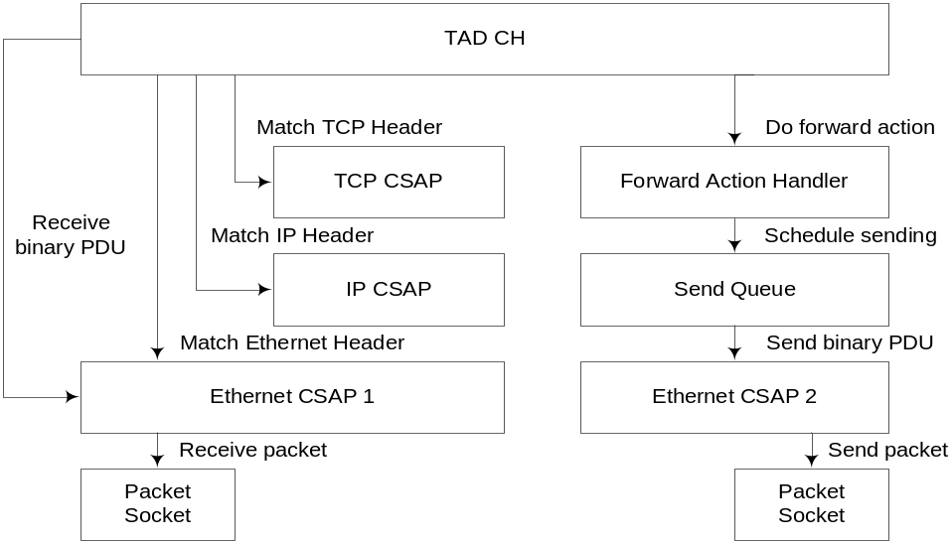
Figure 1
- TAD CH creates Rx Thread on the user ta_start_recv user request. This thread uses read_cb() callback of the Ethernet CSAP to receive binary packets.
- Then received packets headers are to be matched by the Ethernet, IP and TCP layers of TCP/IP CSAP. Matching of the packet headers may be performed using API of libpcap library. If the packet matches some of the filter patterns then action callback corresponding to the filter pattern is called. If there is no match the packet is simply dropped.
- If the action defined for the filter pattern is “forward” the packet is passed to the Router Packet Handler specified by “action-id” parameter of the “forward” action. The Forward Action Handler makes some operations with the packets due to the filter action.
- After processing in the packet handler the packet is inserted to the Send Queue with corresponding timestamp.
- When it is time to send the packet in the Send Queue, this packet is sent using another Ethernet CSAP.
- Subsystem services
The TCP/IP CSAP provide one main service: it retransmits packets from one Ethernet port to another. As it is created for testing the TCP layer of the TCP/IP stack it also provides the emulation of usual and unusual situations that could take place with normal router. The TCP/IP CSAP provides several callbacks for the TAD command handler:
- init_cb: initializes the TCP/IP CSAP and related structures;
- match_cb: applies filters of the CSAP to the packet until the packet matches some (if there is no match we are not interested in the packet);
- forward_cb: makes necessary operations due to the result of match_cb function;
- read_cb: uses libpcap library to create a packet socket and then it receives all incoming packet from defined interface and parses their Ethernet, IP and TCP headers;
- destroy_cb: simply destroys the TCP/IP CSAP and all related structures;
- setparams/getparams: sets/gets the filter parameters. When the parameters are changed during the trrecv_start still working there in no any guaranty of the work correctness.
- Utilized services
The TCP/IP CSAP uses libpcap external library. It is the same library as tcpdump uses for filtering packets received on a packet socket. The libpcap helps the CSAP to provide filtering capabilities.
- Interfaces
  - Internal interfaces
Packet forwarding includes two main processes:
- Receiving packets and filtering them. Than putting packets in the Send Queue.
- Sending packets to their destination.
For sending packets from the send queue there exists a separate thread.
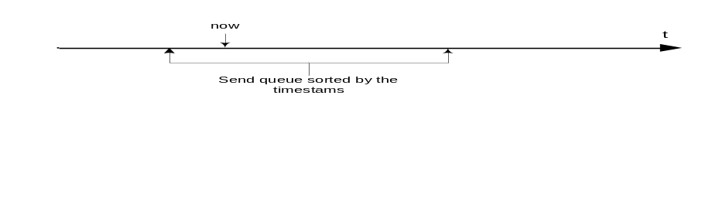
Figure 2
The send thread should send all packets from the oldest one till now. Than it sleeps until somebody wakes him.
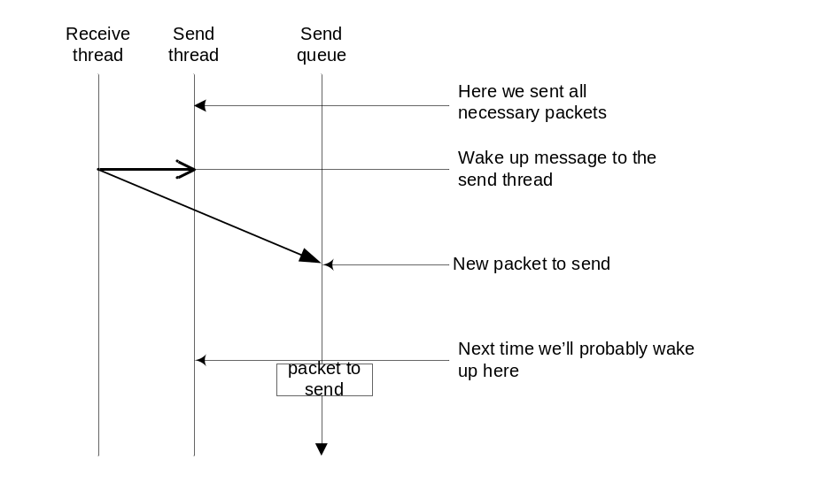
Figure 3
If during that time (Figure 3) somebody puts a new packet to be send, he should wake up the send thread.
  - External interfaces
To understand what external interfaces does the Forwarder CSAP provide let’s take a look on Figure2.
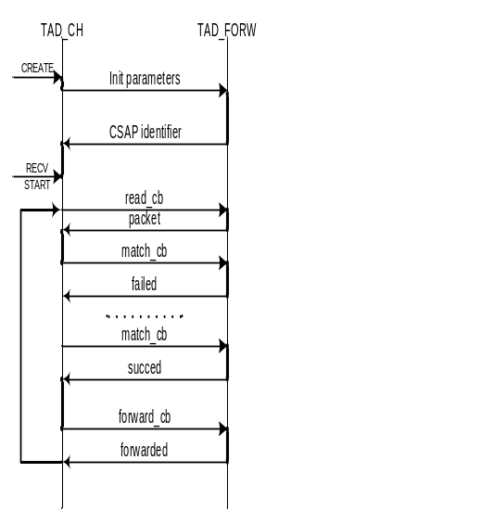
Figure 4
So Forwarder CSAP from outside looks similar to any other CSAP, with only exception that it can’t generate traffic.
- Data model definition
Definition of the CSAP structure (in ASN.1 format):

TE-NDN-Forw
DEFINITIONS ::=
BEGIN

IMPORTS DATA-UNIT FROM TE-NDN-General;

EXPORTS FORW-CSAP;

Forward-Action-Delay-Params ::= SEQUENCE {
type [0] INTEGER {disabled(0), random(1)},
delay_min [1] DATA-UNIT {INTEGER},
delay_max [2] DATA-UNIT {INTEGER}
}

Forward-Action-Reorder-Params ::= SEQUENCE {
type [0] INTEGER {disabled(0), random(1), reversed(2)},
timeout [1] DATA-UNIT {INTEGER},
reorder_size [2] DATA-UNIT {INTEGER}
}

Forward-Action-Drop-Params ::= SEQUENCE {
type [0] INTEGER {disabled(0), random(1), pattern(2)},
rate [1] DATA-UNIT {INTEGER},
}

Forward-Action ::= SEQUENCE {
aAction-id [0] DATA-UNIT {UniversalString},
delay [1] Router-Action-Delay-Params OPTIONAL,
reorder [3] Router-Action-Reorder-Params OPTIONAL,
drop [4] Router-Action-Drop-Params OPTIONAL
}

Forward-Action-List ::= SEQUENCE OF Router-Action

Forward-Bandwidth-Params ::= SEQUENCE {
type [0] INTEGER{unlimited(0), limited(1)},
bps [1] DATA-UNIT{INTEGER } OPTIONAL,
buf_size [2] DATA-UNIT{INTEGER } OPTIONAL
}

Forward-Params ::= SEQUENCE {
actions [2] Router-Action-List
bandwidth [3] Router-Bandwidth-Params OPTIONAL,
...
}

END
- Packet processing.
  - Receiving packets.
- The TAD command handler executes the trrecv_start, specifying source and destination interfaces.
- Ethernet CSAP uses packet socket receive all packets on the Ethernet device we are interested in.
- Filtering functionality of TCP/IP CSAP layers is based on libpcap library that uses BSD Packet Filtering library. libpcap library allows filtering packets by Ethernet, IP and TCP headers.
- If the packet matches one of the filtering patterns we make necessary operations with the packet by calling forward_cb with the action parameter equal to the Router Action of the filter.
- The forward_cb function puts the packet to the send queue.
  - Sending packets.
In case the TCP/IP CSAP operates as a router it has a separate thread to forward packets. This sending thread takes packets from the Send Queue and send them in the moments specified by packet transmit timestamps. Scheduling of these timestamps is performed by the packet handling functionality.
  - Operations with packets.
When the TCP/IP CSAP operates as a router, it provides several operations on the packets.
- drop: randomly drops the packets with rate specified as a parameter to drop operation.
- delay: the timestamp of the packet is increased by the delay interval. In the action parameters we should specify the max and min delay interval value for the packet. If they are equal that is a constant delay.
- reorder: reordering is the most interesting operation.
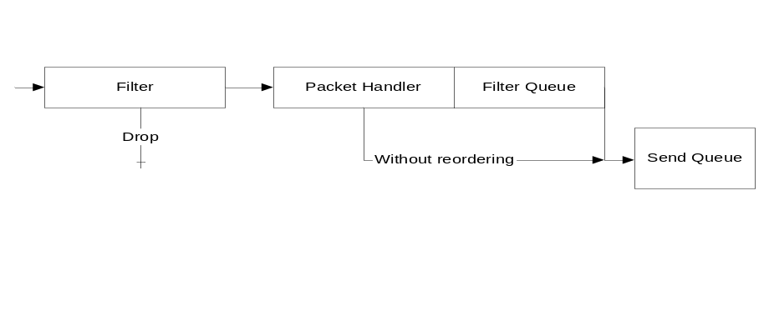
Figure 5
As it’s shown in the Figure 2, packets without reorder action enabled go straight to the Send Queue from the Packet Handler.
If reordering is enabled it is required to accumulate some sequence of packets then change their order and put them to the Send Queue. If
When a packet is to be reordered with other packets, it is put in the Filter Queue. Reordering may start if any of the following conditions is true:
- number of packets accumulated in the Filter Queue is equal to reorder_size (specified as a parameter to reorder operation);
- there are not enough packets in the Filter Queue, but the timeout (also specified as a parameter to reorder operation) is expired.
In this case the packets in the Filter Queue will be reordered and put into the Send Queue.
There are at least two types of reordering that should be implemented:
- random reordering, when all packets in the Filter Queue are shuffled;
- reversed reordering, when all packets are put into the Send Queue in the reversed order they are in the Filter Queue.

One of the router parameter is the limited bandwidth. In case this parameter is specified, the packets will not be sent more frequently than it is allowed for that bandwidth.

There may be also specified the limited buffer size parameter of the router. This parameter represents the size of the router’s receive buffer in packets (or bytes).
In case the receive buffer is overflowed all packets that are to be added to the Send Queue will be discarded.
- Initialisation and shutdown
On initialisation step if the TCP/IP CSAP determines that the Router parameter is specified then all structures required for router functionality should be created.
On trecv_start step of the CSAP life, TCP/IP CSAP should make libpcap library to start listening the ethernet device and create Sender Thread.
On trecv_stop step of the CSAP life, TCP/IP CSAP should make libpcap receiving the packets and to terminate Sender Thread after the Send Queue is flushed.
On shutdown step all resources allocated by the TCP/IP CSAP should be released.

