EMBED Word.Picture.8 

OKT-HLD-0000041-TE_LS_IF
Specify the type (High Level Design) and InfoLib identifier (OKT-HLD-…) of your document here.
Proteos: Logger interfaces
Specify the title of your document here.
Don’t forget to change document properties (click File→Properties).
If the document is not confidential change footer “... CONFIDENTIAL...” to an empty string on this page and on the third page.
Don’t forget to delete examples from your document!

Abstract
Specify here the purpose of the document.
This document describes Logger functionality within the limits of Test Environment project.
Copyright Notice
Add copyright notice of the project customer.
Copyright (C) 2003 Test Environment authors (see file AUTHORS in the root directory of the distribution).
Test Environment is free software; you can redistribute it and/or modify it under the terms of the GNU General Public License as published by the Free Software Foundation; either version 2 of the License, or (at your option) any later version.
Test Environment is distributed in the hope that it will be useful, but WITHOUT ANY WARRANTY; without even the implied warranty of MERCHANTABILITY or FITNESS FOR A PARTICULAR PURPOSE. See the GNU General Public License for more details.
You should have received a copy of the GNU General Public License along with this program; if not, write to the Free Software Foundation, Inc., 59 Temple Place, Suite 330, Boston, MA 02111-1307 USA

Audience
Specify the audience of the document and confidentiality restrictions, if exist. Specify assumed skills of the reader as well.
This document is intended for engineers who deal with creation another subsystems in the Tests Environment project context.
Document Status
Type “Draft”, “Approved” or “Obsolete” here.
Draft
Contact Information
Ulianovskaya 1, Peterhoff, 198504, St.-Petersburg, Russia
Phone: +7(812) 428-4384
Fax: +7(812) 428-4389
Questions regarding this document may be forwarded to support@oktet.ru.
For more information, call the above office or visit our web site at http://www.oktet.ru.
Revision History
The first draft should have revision ‘A’, the second – ‘B’ and so on. The first release (approved or issued) should have revision ‘1’, the second – ‘2’ and so on. If further changes are made to revision ‘1’, the revision becomes ‘1A’.
Date | Rev | Author | Changes
Jan, 09 2003 | A | Igor B. Vasiliev | Initial Revision
Issues
Type here all unclear questions as well as issues, which are not described at the moment but should appear in the document.
- The document should be submitted to the Infolib.
Table of Contents
1 Abbreviations 5
2 Terminology 5
3 References 5
4 Organisation 5
5 Introduction 5
6 Standards 6
7 Requirements 6
8 Position in the product 6
9 Internal organization 7
10 Product services 8
11 Utilized services 8
12 Interfaces 8
12.1 External interfaces 8
12.2 Internal interfaces 8
13 Data organization 9
14 Processes 9
15 Events processing 9
16 Configuration parameters 9
17 Initialisation and shutdown 9
18 Algorithms 9

- Abbreviations
List here all abbreviations used in the text.
Term | Definition
NUT | Node Under Test
TA | Test Agent
TE | Test Environment
- Terminology
Provide definitions for all specific terms (including terms listed in the section 1).
Term | Definition
Interface | Strictly defined set of means (hardware, software, network) used by one entity to interact with another entity for any purpose (inform about an event, request a service, provide a service, etc.).
Service | Activity performed by one entity on behalf of another entity.
- References
Provide here references to documents, which would be helpful for document readers or referred from this document.
Ref | Document Title | Document Identifier
 | Test Environment Architecture | TS-OKT-0000021-TEARCH
 | Test Environment Requirements | REQ-OKT-0000021-TE
- Organisation
This section is optional.
Describe here how the document is organized. Specify: contents of main parts of the document and dependencies between them; which parts are optional.

- Introduction
This document describes a logging functionality to be provided by Logger to other entities in the TE project context. Logger provides separate API to different entities involved in the all phases of the Test Environment system processing from configuring and building process across test executing to shutdown phase. Moreover, C, C++, PERL and TCL interfaces are supported.
Logger collects log messages in raw log according to as they arriving or periodically requests Test Agents by means "get log" command. So raw log is not ordered in time. Events can arise on different Test Agents in the same time. Time synchronization between TEN subsystem and Tests Agents plays the main role. Logger is not responsible for time synchronization. Each of log messages must have own timestamp to restore the order of events arising in the all parts of TE in the future.
Test Environment Architecture supports running more than one test thread at the same time. Logger will collect logging data in common raw log. Alone collection of utilities is responsible for raw log filtering, parsing and report generating.
This document does not describe raw log format and means to generate user reports in any form. Logger facilities can be tuned by means of either configuring files or command line parameters or both.
This section should provide basic knowledge about a subsystem - its purpose, functionality and complexity. It is mandatory for all profiles.
Specify here (very briefly):
- product(s) which a subsystem is part of;
- service provided by a subsystem to other subsystem or end users;
- family of standards applied to a subsystem (for example: MPLS);
- why a subsystem should be designed as a separate entity.
For example, following reasons may be provided to explain why a subsystem was separated:
- this subsystem provides optional functionality, which may be excluded
- from the product for particular customers;
- this subsystem provides the close functionality with strict interface;
- implementation of this subsystem will be re-used;
- this subsystem is designed to process some close set of data;
- this subsystem is a security bottleneck.
- Standards
No standards are taken into account for this subsystem.
This section is mandatory for core profile.
List here standards, which a subsystem should comply to and provide conformance details.
- Requirements
Requirements formulated for this subsystem are described in [2].
List here identifiers of product requirements applicable to a subsystem.
If it is not obvious, how exactly the requirement is applied or refined for a subsystem, then short explanations should be provided.
It is allowed to define new requirements here (in this case they should be identified and placed under configuration management – see [1]). These requirements are formulated for a subsystem implementer and should be taken in account during the code review.
- Position in the product
Logger is a distributed entity. The main part of it is placed on Test Engine side and others ones on Test Agents side.
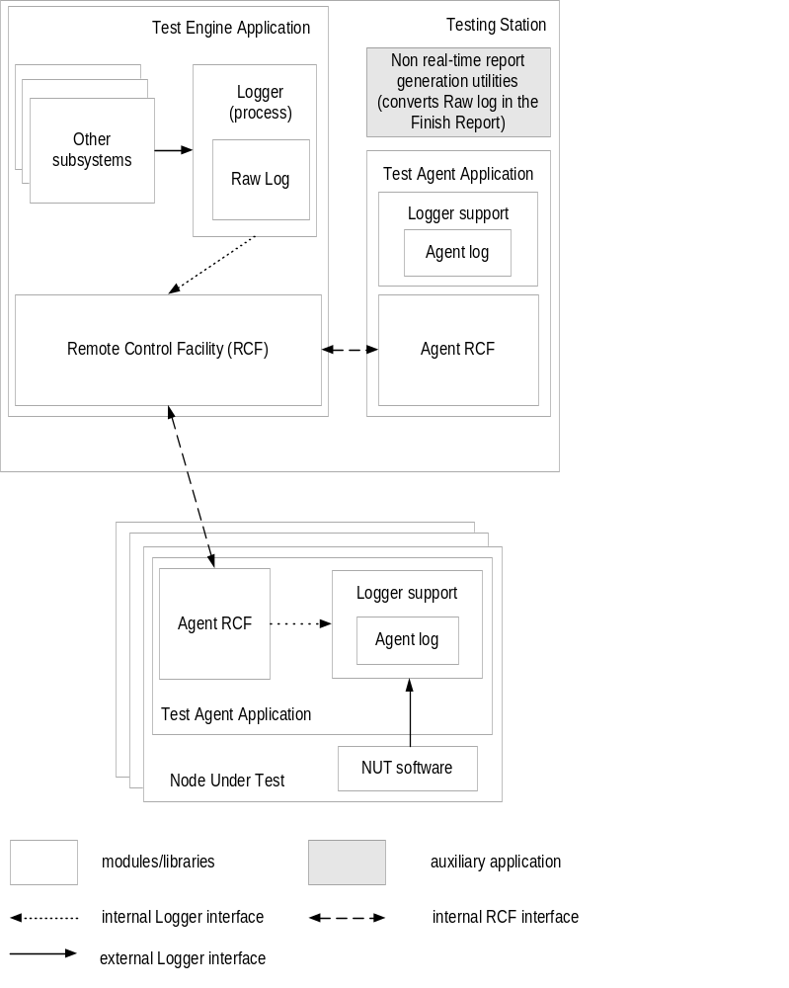
Figure 1 Place of the Logger in the Test Environment project

This section is mandatory for core and interfaces profiles.
Provide here a diagram showing the place of a subsystem in the product.
The diagram should contain all subsystems, which utilize or are used by a described subsystem.
Interactions between subsystems should be marked with arrows. All arrows should be accompanied with a clarifying text.
If some data are shared between several subsystems, show these data on the diagram. Graphical objects describing data should differ from objects describing subsystems.
If the product or a subsystem itself is distributed between several applications or stations, provide a diagram(s) showing this distribution.
Draw stations, applications and subsystems using different graphical objects.
This diagram may be omitted if you are sure that it is not essential.
- Internal organization
Logger components are distributed between Testing Station and Test Agent stations and projected as shared libraries. The main raw log and local agent logs are shared data. These should be protected by mutexes if needed. Agent Logger support provides C/C++ API only. Logger support for Test Engine subsystem provides both script based (Perl/Tcl) and C/C++ APIs.
This section describes components of the subsystem, interactions between them as well as between subsystem components and external world (note, that for the subsystem component term "external world" includes other subsystems of the product). This section is not applicable if the subsystem is indivisible.
This section, if applicable, is mandatory for core and interfaces profiles.
Provide here diagrams similar to diagrams described in the previous section (but with all subsystem components showed as separate objects)
Provide short description of the each component.
If some component of the subsystem is re-used (for example, free or acquired software is ported), provide references to available documentation and discuss license issues.
- Product services
Logger subsystem API is common for both the Test Agent module and tested software on NUT.
This section is mandatory for all profiles, but may be omitted if a subsystem does not provide service to end users directly.
List here product services provided by a subsystem to end users only.
For example, module for "IP" of the network support product may provide IP packets sending/receiving service to end user, "UDP" module and "TCP" module and function for checksum calculation to "UDP" and "TCP" modules. Mention here about IP packets sending/receiving service only.
This section is mandatory for all profiles, but may be omitted if a subsystem does not provide service to other product subsystems (for example, CLI commands interpreter).
List here all services provided by a subsystem to other product subsystems.
For core and interfaces profiles describe how these services are utilized by other subsystems (for each subsystem utilizing a service).
- Utilized services
On the Test Engine side Logger uses services provided by Remote Control Facilities subsystem.
Besides on the Test Agent side Logger can use services provided by appropriate NUT Operating System. These services should be defined at the Test Agent creation time.
This section is mandatory for core and interfaces profiles, but may be omitted if a subsystem does not use other subsystems.
List here all services utilized by a subsystem and describe how exactly the service is utilized.
Services provided by hardware and operating system may be mentioned here as well.
- Interfaces
Logger provides a single portable library to be used by all Test Agents for logging. Facilities provided by Logger are designed so to impact on tested application code as small as possible. Log message parameters are parsed according to format string. Format string details can be found in the comments to appropriate macro. It’s recommended to user to provide Name of User on Test Agent as a part of format string for more flexible and convenient report generating.
This section is mandatory for interfaces profile.
Descriptions of all interfaces in subsections of this section should include:
- specification of the type of the interface (API, messages, network protocol, RPC, register, memory);
- list of actions supported by the interface (including initiator, parameters and semantics description);
- data sharing, passing and protection issues.
It is not required to specify functions prototypes or particular type definitions.
  - External interfaces
Logger exports to the outer users different facilities:
- Logger API for software under test provides the possibilities to collect log messages with parameters of simple data types (char, integer and so on) and as memory dump up to 256 bytes;
- Logger API for TE subsystems on Test Engine side enables to collect log messages as previous one but besides it provides some possibility to log text files (ASN packet notion, configuration files and so on);
- Logger API for Test Agent side provides the same facilities as first.
Describe here interfaces exported by a subsystem to other entities, for example to
- other subsystems of the product;
- other hardware of software products;
- testing and debugging applications;
- human users.
Last kind of interfaces is called “user interfaces”. It is recommended to describe them in details in a separate document, which is intended to end-users.
It may happen that a single interface is used by humans, external applications and internal product subsystems, but it would be a rare case.
In any case it is desired to specify all external interfaces very strictly (especially interfaces used by another subsystems) to simplify further product integration. For example, for C interface type definitions and functions prototypes should be provided. However such details may be omitted is development of detailed design document is planned.
Don't forget to mention about statistics gathering describing management interface and diagnostic support (e.g. hardware diagnostic).
  - Internal interfaces
Internal logger interface provides some means to “get log” from Test Agents to the Logger process on Test Engine side.
Because internal Logger interface is very simple one there is no reason to describe it here.
Describe here interfaces between components of a subsystem. Avoid specifying of function prototypes here because they may change significantly during implementation and the probability exists that finally you'll forget synchronize your implementation with the HLD document.
- Data organization
On the Test Engine side the raw log messages are written in the file. On Test Agent side local log organization depends of local possibilities. Some file or memory buffer may be used to keep Test Agent log. User should be very careful when Logger is tuned on NUT. Some logging data on Test Agent side may be lost if Test Engine does not “get log” in time. No signalling it’s intended from Test Agent about local log buffer overflow.
This section is mandatory for data organization profile.
Describe here the following issues:
- data application domains;
- data meaning;
- data validation;
- data sharing and protection issues;
- storage (files, RAM, flash, etc.);
- access performance;
- search keys and search performance;
- primary and secondary format;
- initialization;
- backup and consistency support.
- Processes
Logger runs on the Test Engine side as alone process.
Logger process is responsible for Test Agent polling to get their log.
Logger subsystem (on Test Engine side or on Test Agent side) provides shared library for log accessing. These library functions are carried out in the user context. So mutex semaphore facilities are used for data protection.
This section is mandatory for core profile.
List here all processes (threads, tasks) involved into a subsystem functionality provisioning. Specify how they are spawned, killed and interact with each other. Data sharing, synchronization and mutual exclusion issues may be discussed here as well.
- Events processing
No events exist for Logger subsystem processing.
This section is mandatory for core profile.
List here all external events processed by a subsystem. These events may include for example:
- interface event (i.e. call or message from other subsystem);
- hardware event;
- network packet receiving;
- signal;
- timer expiration.
For each event describe how it is processed by a subsystem.
- Configuration parameters
At initialisation time Test Engine finds out about active Test Agent to be processed. Each alone log message has to be provisioned with unique Test Agent Identifier (it’s assigned by Logger process when it gets log from Test Agent). Logger subsystem facilities on Test Agent side are enabled/disabled at the building time.
This section is mandatory for core profile.
Describe here parameters of the subsystem configuration including:
- kind of the parameter (compile-time, boot-time, initialization, dynamic);
- possible values and their meaning;
- default values.
It is useful to describe how value of the particular parameter may be obtained or changed via specific management interfaces (like SNMP or CLI).
- Initialisation and shutdown
Dispatcher as the main subsystem of TE is responsible for initialisation and shutdown of executable parts of Logger subsystem. In some cases on the NUT side these processes can be carried out by means of NUT facilities only. Logger provides script-based facilities to register log messages during initialisation phase.
This section is mandatory for core profile.
Describe here:
- What entity is responsible for initialisation and shutdown of a subsystem.
- Which actions are performed by a subsystem during initialisation and shutdown, including state saving and resource releasing.
- Is dynamic re-initialisation is allowed, how it may be initiated and how it is performed by a subsystem (if a difference between re-initialisation and shutdown-initialisation sequence exists).
- Algorithms
Logger subsystem provides some means to protect log if one can be shared between different users at the same time. Also Logger subsystem provides to Test Agent and NUT users some macros to form log messages. These carry out preliminary processing before calling Logging subsystem mechanisms to provide maximal performance.
This section is applicable for algorithms profile.
Describe here state machines, algorithms, technical approaches and hints to be used during subsystem implementation. This section may contain description of several alternative approaches (with benefits and drawbacks analysis), however, after implementation it should be specified, which approach was finally used.
This section is optional.
You can specify here which means are used for logging and tracing as well for profiling and performance measurements.
This section is optional. It is intended to help a person porting a subsystem to other platform. List here all issues, which may arise during porting and possible work-arounds.

