OKTL-ARCH-0000044-TE
Specify Infolib identifier of your document here.

Test Environment Architecture
Specify title of your document here.
Don’t forget to change document properties (click File→Properties).
Change footer “CONFIDENTIAL” to the empty string on this page and on the next page if the document is not confidential.

Abstract
This document describes architecture of the Test Environment. It may be helpful during splitting of the work to subtasks as well as during the product design.
Copyright Notice
Copyright (C) 2003 Test Environment authors (see file AUTHORS in the root directory of the distribution).
Test Environment is free software; you can redistribute it and/or modify it under the terms of the GNU General Public License as published by the Free Software Foundation; either version 2 of the License, or (at your option) any later version.
Test Environment is distributed in the hope that it will be useful, but WITHOUT ANY WARRANTY; without even the implied warranty of MERCHANTABILITY or FITNESS FOR A PARTICULAR PURPOSE. See the GNU General Public License for more details.
You should have received a copy of the GNU General Public License along with this program; if not, write to the Free Software Foundation, Inc., 59 Temple Place, Suite 330, Boston, MA 02111-1307 USA
Audience
Specify the audience of the document and confidentiality restrictions, if exist. Specify assumed skills of the reader as well.
This document is intended for engineers and managers participating in Test Environment project.
The reader should be familiar with Test Environment requirements.
Document Status
Type “Draft”, “Approved”, “Issued” or “Obsolete” here.
Approved
Contact Information
Questions regarding this document may be forwarded to support@oktetlabs.ru.
Revision History
Date | Revision | Author | Changes
Dec, 1 2002 | A | Elena A. Vengerova | Initial Revision
Dec, 11 2002 | B | Elena A. Vengerova | Diagrams are added, document is re-structures, Dispatcher subsystem is added, Test Protocol command list is refined; terminology is refined.
Dec, 17 2002 | C | Elena A. Vengerova | Minor changes after review
Jan, 29 2003 | D | Elena A. Vengerova | Some changes after research and meetings (at most in terminology).
May, 5 2003 | 1 | Elena A. Vengerova | Updated after implementation of Builder and RCF and design of traffic-related framework
Issues
Type here all unclear questions as well as issue, which are not described at the moment but should appear in the document.

Table of Contents

1 Abbreviations 6
2 Terminology 6
3 References 8
4 Document Structure 8
5 Introduction 8
6 Tester 12
7 Builder 13
7.1 Building of external libraries 13
7.2 Building of Test Engine 14
7.3 Building of Test Agent and NUT bootable image 14
7.4 Builder configuration file 14
8 Configurator 14
8.1 Configuration databases 15
8.2 Configuring of environment 16
9 Logger 17
9.1 Logger configuration file 17
9.2 Logging on Test Agents 17
10 Remote Control Facility 17
10.1 Commands 19
10.1.1 reboot 20
10.1.2 shutdown 20
10.1.3 configure 20
10.1.4 start process 20
10.1.5 kill process 20
10.1.6 execute routine 20
10.1.7 read variable 20
10.1.8 write variable 20
10.1.9 read file 21
10.1.10 write file 21
10.1.11 get log 21
10.1.12 create csap 21
10.1.13 get csap parameter 22
10.1.14 destroy csap 22
10.1.15 start generate traffic 22
10.1.16 stop generate traffic 22
10.1.17 start receive traffic 23
10.1.18 stop receive traffic 23
10.1.19 get traffic 23
10.1.20 send a packet and receive an answer 23
10.2 RCF configuration file 24
11 Test Agent Creation Framework 24
12 External Library Creation Framework 24
13 Test Package Creation Framework 24

Abbreviations
List here all abbreviations used in the text.
Term | Definition
ASN.1 | Abstract Syntax Notation One
BER | Basic Encoding Rules
CSAP | Communication Service Access Point
CLI | Command Line Interface
EL | External Library
NUT | Node Under Test
RCF | Remote Control Facility
TA | Test Agent
TE | Test Environment
TEN | Test Engine
TP | Test Package

Terminology
Provide definitions for all specific terms (including terms listed in the section ).
Term | Definition
Communication Service Access Point | An object, which could be created on the Test Agent to send/receive some data (packets, frames, cells, CLI commands, etc.) A set of primitives to create, destroy CSAP, receive and send data as well as packet templates and patterns are associated with each type of the CSAP.
External Library | Optional package of the TE implemented to support a specific feature, protocol or platform. It may be used by several TE Subsystems or several Test Packages. Moreover, it may provide several API for different programming languages.
Node Under Test (NUT) | Station with tested software running.
Test | A complete sequence of actions required to achieve a specific purpose (check that tested system provides a required functionality, complies a standard, etc.) and producing a verdict pass/fail (possibly accompanied by additional data).
Test Package | Group of tightly related tests or test packages, which may share internal libraries and usually run together (one-by-one or simultaneously). Test Package may consist of one test. It may have a prolog (performing some initialization) and epilog (releasing resources and restoring TE configuration).
Test Agent | An application running on the NUT or other station and performing some actions (configuring NUT or itself, interacting with the tested system, sending/receiving of packets, etc.) according to instructions provided by the Test Engine. All interactions with the tested system should be performed via Test Agent only.
Test Engine | Set of applications performing testing of tested subsystem according to Test Package(s) and configuration specified by user.  It is responsible for:  - preparing of executables for Test Packages, Test Agents and TE Subsystems as well as bootable NUT images;  - starting of Test Agents and configuring of environment and NUT via Test Protocol as well as providing configuration information to tests;  - executing of tests in mode and order specified by user;  - interacting with Test Agents on behalf of tests;  - logging and generation of reports.
Test Protocol | Protocol used for Test Engine and Test Agent interaction.
Test Environment (TE) | Software product, which includes:  - software applications (Test Agent, Test Engine, etc.) allowing to perform the sequence of actions specified by the test scenario and obtain results in convenient form;  - set of external libraries supporting specific protocols, platforms and features;  - set of documents describing test creation framework and software tools simplifying this task;  - set of documents describing TE enhancement framework (creation of new libraries, support of new platforms, etc.) and software tools simplifying this task;  - user guides describing TE usage (how to run tests, possible log formats, external libraries API, etc.).  Note, that tests are not considered as part of the TE.
Test Environment Subsystem | A mandatory and logically separate module (which may include software, data, documents) of the Test Environment responsible for one of main services provided by TE.  The TE Subsystem can provide service to:  - TE user (for example, TA Creation Framework);  - tests or  - other TE subsystems.  TE Subsystem may run on or several threads (processes) on one or several stations (including NUT).
Storage | Location for some permanent date (like sources) and data, which should be saved to allow further analysis (like logs or NUT bootable image). Storage may be usual file system directory tree, CVS repository, archives, etc. Storage library interface only should be used by all subsystems to read/save non-temporary data.

References
Provide here references to documents, which would be helpful for document readers or referred from this document.
Ref | Document Title | Document Identifier
 | Test Environment Requirements | OKTL-REQ-0000043-TE

Document Structure
Section 5 provides a short overview of the Test Environment.
Other sections describe all subsystems of the Test Environment in details.

Introduction
This document provides overview for all subsystems of Test Environment and relations between them.
Main functionality, service provided to users, tests or other subsystems, documents to be created as well as open issues are described for the each subsystem.
Test Environment consists of following subsystems (see Figure 1 Test Environment Subsystems):
- Dispatcher, which is responsible for configuring and starting of another subsystems;
- Builder, which is responsible for preparing libraries and executables for Test Agents and TE Subsystems as well as NUT bootable images;
- Configurator, which is responsible for configuring of environment, providing of configuration information to tests and for recovering of configuration after failures; moreover it supports some TEN-local database used by Test Packages to stored shared data;
- Remote Control Facility (RCF), which is responsible for starting of Test Agents and all interactions between Test Engine and Test Agents on behalf of other subsystems and tests;
- Tester, which is responsible for running of set of Test Packages specified by user in the mode specified by user (one-by-one, simultaneous, debugging);
- Logger, which provides logging facilities for Test Environment (Test Engine and Test Agents) and tests and log processing tools to users;
- Test Agent Creation Framework, which provides documentation and tools for creation of new Test Agents;
- External Library Creation Framework, which provides documentation and tools for creation of new external libraries, including adopting of some existing tools to Test Environment;
- Test Package Creation Framework, which provides documentation and tools for creation of new test packages.
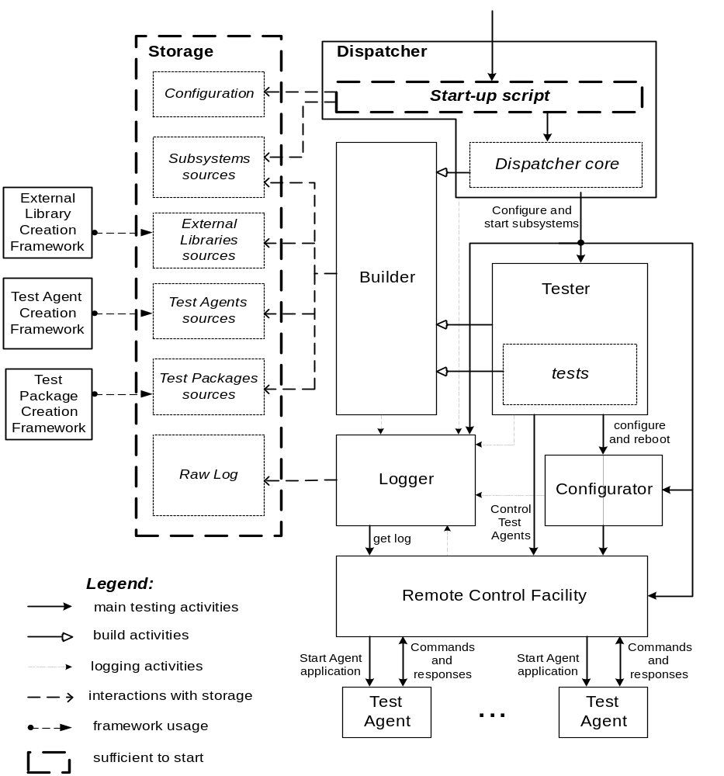
Figure 1 Test Environment Subsystems

Creation Framework subsystems are not involved to online testing itself, but are used independently, for example, for stub generation. Therefore Dispatcher does not control them.
Other subsystems as well as TE Agents may be distributed between several applications (Test Engine and Test Agents) running on different stations (see Figure 2 Stations and applications involved to testing process). Particularly, RCF is distributed between Test Engine and Test Agent.
Test Agent itself may live in several modes:
- run on the auxiliary (UNIX) station and control this station
in this case Test Protocol is used over network and all commands are applied to station, on which Test Agent runs;
- on the same station as Test Engine
the same as previous – Test Agent is not built in Test Engine and interacts with it via network using loopback; the only difference is that “reboot” command should never be issued to this Test Agent;
- run on the auxiliary (UNIX) station and control the NUT
Test Protocol is used over network and all commands are applied to the NUT (Test Agent interacts with the NUT via NUT-specific interface);
- run on the NUT and control the NUT
Test Protocol is used over network or over some other transport (for example, over serial port) and all commands are applied to the NUT.
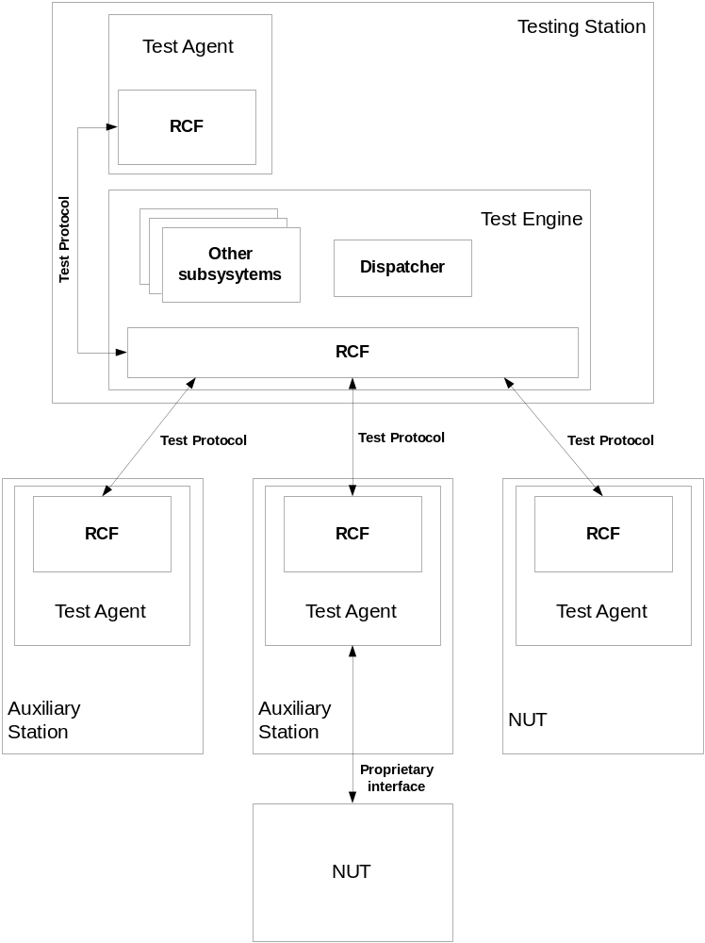
Figure 2 Stations and applications involved to testing process
The testing process is performed in following way:
- Executable Dispatcher script is started with some command line options.
- Dispatcher initializes Storage library according to command line options and obtains configuration files.
- Executable part of the Logger is initialized. Some parts of Logger (for example, logging facilities provided to tests or entity gathering log from Test Agents) may be compiled from sources, however logging facilities provided to Dispatcher and Builder should be script-based to support logging during initialization.
- The Builder is started to prepare libraries and executables for all TE Subsystem (possibly including Dispatcher), Test Packages, Test Agents and bootable NUT image(s). It accepts the configuration file describing which executables with which options should be compiled. Some executables may be saved in Storage, if it is specified.
- Logger is started. This means that thread (process) responsible for gathering of log from Test Agents via Test Protocol and listening log requests from users of the Test Engine is spawned.
- Remote Control Facility is started. It uses configuration file describing Test Agents features and possibly executables generated by Builder to load NUTs and start all Test Agents. After that it establishes sessions with Test Agents (using Test Agent specific low level connectivity support) and performs time synchronization.
- Configurator is started. It initializes dynamic databases and (possibly) performs some initial configuring of Test Agents.
- Tester is started. It accepts description of set of tests to be run and mode in which it should be run. During its work Tester may issue requests for test executables building to Builder.
- Tester runs all specified tests in specified mode with specified parameters (parameters may be generated automatically).
- Dispatcher stops Configurator and Builder.
- Dispatcher stops RCF. During its shutdown RCF should perform shutdown of all Test Agents and reboot all NUTs.
- Logger is stopped. Log the in raw format is saved in the Storage. Moreover, reports in specified formats are prepared and passed to specified destinations (for example, via E-mail).
- Dispatcher script finishes its work.
Next sections describe all TE Subsystems except Dispatcher.

Tester
Tester allows user to run set of tests. It may be specified that some tests of the set should be run one-by-one (the test is started after finishing of previous test), simultaneously (separate threads (processes) should be started for all tests). Moreover, the test may be started in debugging mode (meaning of this term depends on the test nature and TE configuration).
It is possible to run one test scenario with different parameters (specified by user or enumerated automatically according to user specification).
Some tests may be marked as checking the particular requirement(s) of the product. Tester should allow user to specify: “run all tests checking requirements R1, R2, … R3 should be run”.
Tester should be able to deal with and provide services to tests written in C, C++, PERL and TCL.
For each test Tester should provide statistics information, for example start and finish time.
Tester is responsible for error recovery. It utilizes service provided by Configurator to make backup configuration for Test Packages and restore backups in the case of test failure.
Tester utilizes service provided by Builder to build Test Packages. However all libraries necessary for these Test Packages should be specified in Builder configuration file and built/installed before starting of Tester.
Tester utilizes logging facilities provided by Logger.

Builder
This subsystem is responsible for preparing of libraries and executables for Test Engine, Test Agents as well as NUT bootable image.
C, C++, PERL and TCL may be used for TE and tests. If a library of subsystem provides service to tests then API should be implemented to be used from programs written in any of these languages.
It is possible to specify, that some parts should not be built, but taken as binaries (for example, some libraries, NUT bootable image, etc.). This mechanism may be used to prevent rebuild of some parts, which definitely are not changed during test debugging (dependencies mechanism may be too dummy).
GNU building framework (autoconf/automake) is used for the Builder implementation.
Except preparing of executables on behalf of the Dispatcher Builder may provide dynamic building service to
- Tester (test executables)
- tests (NUT bootable image only).
Moreover Builder is responsible for preparing of tested software sources to test coverage estimation.
Builder utilizes logging facilities provided by Logger.

Building of external libraries
External libraries may be used by both Test Engine and Test Agent. Therefore it may be necessary to build them for several different platforms. Builder is informed which libraries are necessary for which Test Agents and for the Test Engine applications and builds all necessary object modules (providing appropriate options to configure script).
Headers provided by external libraries should be made accessible to compiler during building of TEN and TA applications. They are installed simultaneously with installing of libraries.
Some external libraries may utilize external tools. Builder should care about checking of presence of these tools on stations where applications using these libraries run.

Building of Test Engine
Test Engine should be portable to most of UNIX systems. When it is built the configure script may be run without specifying of the platform. Builder allows to specify additional configuration- compile- and linking-time parameters for all applications and libraries.

Building of Test Agent and NUT bootable image
Test Agent may work on exotic platforms as well as on UNIX. Builder should care about:
- compiling of all specified Test Agents;
- linking them with external libraries;
- linking of NUT Test Agents with NUT bootable image.

Builder configuration file
Configuration file for the Builder should contain:
- list of libraries and applications to be built and additional options for them;
- for each Test Agent: additional options and list of external libraries;
- for each NUT: source and building script location (building script specifies how to build NUT bootable image and how to link Test Agent with it);
- list of binaries to be saved in the Storage.
Level of logging is specified as compiler option and may be included to list of building options for any object.

Configurator
This subsystem:
- supports static, dynamic and backup configuration databases (for overall system and particular Test Agents) as well as private databases of Test Packages;
- provides API to tests for dynamic environment configuring and NUT rebooting;
- provides API to tests for dynamic configuration database reading;
- provides API to tests for dynamic configuration database updating (this API is used when test configures NUT using some side mechanism – for example, for CLI testing – and should actualize Configurator data);
- provides API to tests for creating, deleting, reading and updating of Test Package databases;
- provides API to Tester for backuping of configuration databases and restoring of backup configurations (this is used for recovery after test failures);
- provide API to Tester for comparing of backup and dynamic configuration databases (it is used for Test Package verification).
Configurator utilizes logging facilities provided by Logger and service provided by RCF for interacting with Test Agents.
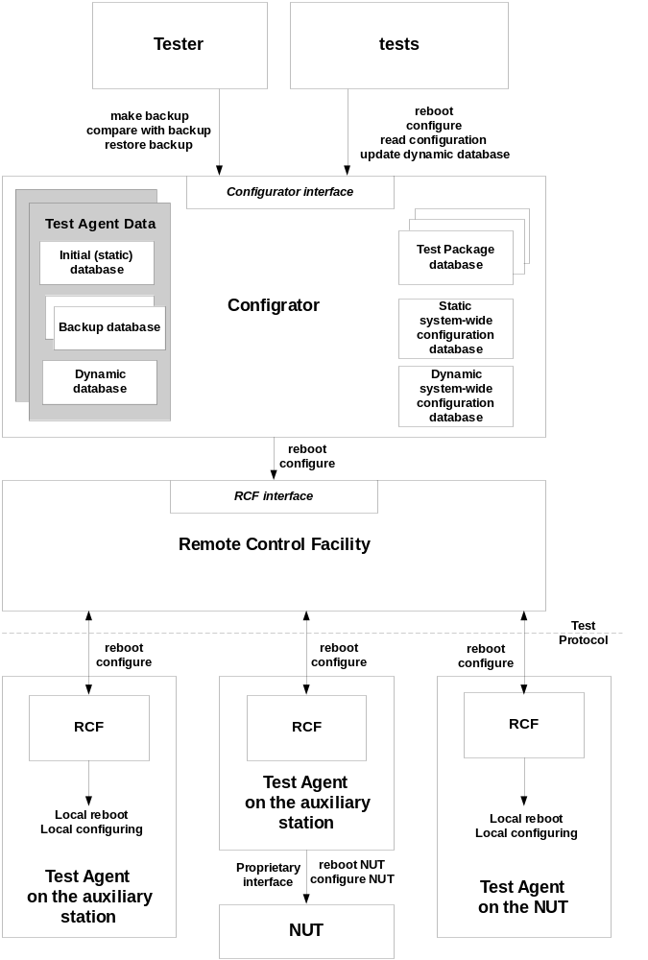
Figure 3 Configuration mechanism

Configuration databases
Configuration database consists of list of parameters identified by sequence of symbolic labels. For example: interfaces.eth1.netmask. I.e. database content may be considered as a tree.
Separate set of configuration databases are supported for each Test Agent. These databases mirrors some parameters of real configuration of Test Agent (if the Test Agent controls the station on which it runs) or NUT (if the Test Agent controls the NUT).
Following access primitives are provided to tests:
- get;
- get parent;
- get list of children;
- set;
- add;
- delete;
- synchronize.
Some parameters, which never should be installed to the Test Agent may appear in the database. Synchronize primitive is used by tests to synchronize database variable with value on the Test Agent, if it is possible.
It is assumed that history of operations is supported by the Configurator. Such approach allows simple restoring of backup configuration in the case of fatal failures: it’s just necessary to issue “reboot” command and set of “configure” commands for all objects in backup configuration database. However, it is not recommended to use “reboot” for backup restoring in non-fatal cases (for example if Test Package did not care about configuration restoring or was halted and we need to care about error recovery), because “reboot” couldn’t be applied to Test Agent running on the same station as Test Engine. Set of “set”, “delete” and “add” command should be issued instead. Note that parameters at the end of the configuration database should be processed first during configuration restoring.
Following primitives are provided by Configurator to Tester to support error recovery and Test Package verification:
- make backup;
- restore backup;
- verify backup.
Last primitive compares dynamic database with last backup database and returns error, if they are not equal or removes backup database and returns OK, if they are equal.
“Make backup” primitive may be used before starting of the Test Package followed by “verify backup” after finishing of the Test Package. This may be repeated several times for Test Packages on different levels (i.e. the chain of backup databases may be stored in the Configurator). Note, that this feature is optional and is off by default.
When test asks Configurator to reboot the station, it should specify, if it’s necessary to reboot and restore last backup configuration after reboot.

Configuring of environment
Parameters of configuration database are opaque for the Configurator. It just stores them as strings and passes them to RCF.
RCF in advance passes them to the Test Agent in command “configure”. Then it is interpreted in the agent using some internal library (this library is TA specific, but in theory, it may be used in other agent; in this case should be implemented as external library). Note, that if Test Agent runs on the auxiliary station, but is used to manage the NUT, all commands are applied to NUT.
RCF is responsible for restarting of Test Agents after reboot.

Logger
Logger:
- provides API for event logging to TE Subsystems, Test Agents and tests (if Test Agent runs on the operating system with shared address space, logging facilities may be provided to tested software as well);
- stores log in the raw format;
- generates reports in specified form with specified filtering (it should be possible to use this tool separately in packet mode as well as during automatic testing for report generation);
- sends reports to specified destinations.
Logger should provide script-based mechanism for using by Dispatcher and Builder. It is necessary to support logging during initialization.
Logger utilizes service provided by RCF to obtain list of active Test Agents and gather log from Test Agents.

Logger configuration file
Configuration file(s) of the Logger contains Information related to default log handling (list of E-mail destinations with desired filters and format) as well as dynamic log filtering parameters.
Static logging is configured using compiler options, specified in the Builder configuration file.

Logging on Test Agents
Logger should provide a single portable library to be used on all Test Agents for logging. The log is stored locally. The “get_log” command of RCF is used to obtain the list of log messages happened since the last “get log” reception. The library should care about data protection because Test Agent may run in several threads and the library may be used by software under test (if TA runs on operating system with shared address space).

Remote Control Facility
Remote Control Facility is distributed entity allowing interaction between Test Engine and Test Agents. Some parts of the software related to RCF are mandatory; others are optional or Test Agent specific. It is very desirable to use external libraries to re-use the code.
RCF is responsible for:
- starting of Test Agents during initialization or after reloading of the NUT;
- time synchronization after starting of test Agents;
- low-level interactions between Test Agents and Test Engine (serial port, telnet, ssh, etc.);
- building and passing of commands from Test Engine to Test Agents and processing of answers;
- providing of API, which may be used by different subsystems on the Test Engine as well as by tests;
- interpreting of commands on the Test Agents (Test Agents specific part) calling appropriate handles;
- logging of commands (including packet descriptions).
RCF utilizes service provided by Logger.
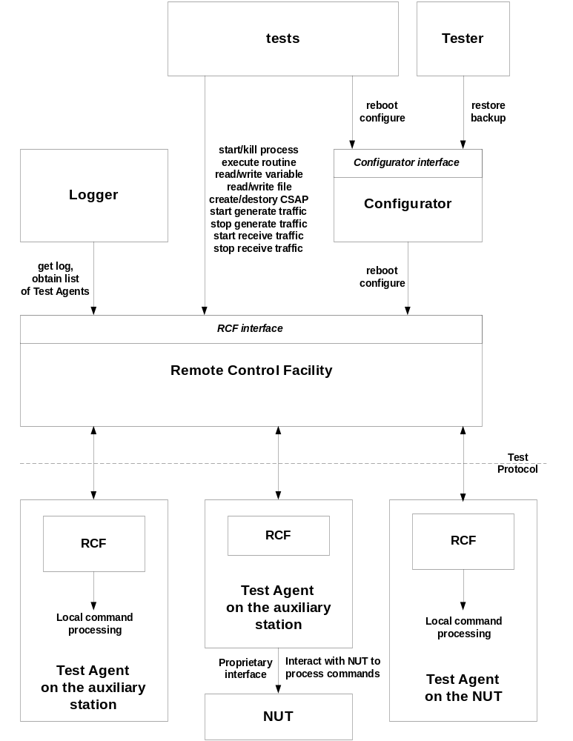
Figure 4 Remote Control Facility

Commands
Subsections of this chapter describe shortly commands, which may be issued by the Test Engine using RCF.
Note, that all commands may be interpreted by the different way on different agents.
All commands assume some immediate or postponed answers, but detailed description of them as well as detailed description of command parameters are out of scope of this document.

reboot
This command should be used to reboot the station, on which the Test Agent runs, or the NUT controlled by the Test Agent. It never should be passed to Test Agent running on the same station as the Test Engine.
The RCF is responsible for starting of Test Agent(s) and time synchronization after reboot.
The command is typically used by Configurator during backup configuration restoring or processing of test request.
The caller should provide already prepared NUT image to RCF.

shutdown
It is internal RCF command used to shut down the Test Agent.

configure
This command should be used by Configurator only to obtain or change configuration of the Test Agent or NUT controlled by the Test Agent.

start process
This command is usually used to start a process or task by an entry point.
The Test Agent should return a number (handle), which may be used to kill the process. Test Protocol does not assume any interaction with spawned process (except killing) and does not inform the test about process death.

kill process
This command is used to kill the process or task started by command described above.

execute routine
This command may be used to execute a routine in the context of Test Agent.
To support this command corresponding Test Agent should have a symbol table mapping string names of entry point routines to their addresses.

read variable
This command may be used to read environment variable (for UNIX Test Agents) or variable in the RAM (the variable should be visible for the Test Agent). For the last case the Test Agent should use symbol table.

write variable
This command may be used to change environment variable (for UNIX Test Agents) or variable in the RAM (the variable should be visible for the Test Agent). For the last case the Test Agent should use symbol table.

read file
This command should be used to obtain content of the file. Processing of this command is usually the same for all Test Agents and use libc routines.
The command may be used to read memory is corresponding facility is supported by the Test Agent.

write file
This command should be used to change the file. Processing of this command is usually the same for all Test Agents and use libc routines.
The command may be used to write memory is corresponding facility is supported by the Test Agent.

get log
This command is used to get bulk of log messages starting from the first message logged after execution of the previous command. It does not have parameters and returns multi-line string. Format of this string is opaque for RCF and should be interpreted by the Logger only.

create csap
The command allows create Communication Service Access Point (CSAP).
CSAP should be created before any traffic sending or receiving. It has the same meaning as a socket in Berkeley Socket API, but may provide an access to CLI or other communication facilities as well.
The rules for creating particular CSAP as well as parameters may differ for different protocols. Therefore this command accepts a protocol stack identifier and variable number of opaque parameters.
Protocol stack identifier has the following structure:
PID1.PID2...PIDN
where PIDi is a protocol name (IP, TCP, etc.).
For example:
snmp.udp.ipv6.ppp.aal5.atm
udp.ipv4
means “SNMP over UDP over IPv6 over PPP over AAL5 over ATM”.
The similar concepts are used in Remote Network Monitoring (see RFC2896 for details).
Some stacks may be used in “raw” mode, i.e. allowing to specify headers and trailers for upper layer protocol or in “user” mode, when PDU only is specified for upper layer protocol. In the last case stack identifier should be started from “data” sub-identifier. For example:
data.tcp.ipv4.eth
If no handlers are implemented for particular protocol stack identifier on the Test Agent, the command is rejected. Otherwise the stack-specific routine is called to process parameters.
The routine from the protocol stack support library should return a CSAP handle to be used for traffic sending/receiving and CSAP destruction.

get csap parameter
This command is used to obtain CSAP parameter, which cannot be specified during CSAP creation but generated automatically by the operating system.

destroy csap
This command should be used to destroy a CSAP created by “create CSAP” command and accepts only one parameter: CSAP handle. If CSAP is destroyed, traffic receiving/sending is stopped.

start generate traffic
This command is used to start generation of traffic using a created CSAP.
Following information is passed to the Test Agent:
- CSAP handle;
- postponed answer flag;
- packet template.
Packet template is protocol stack specific. However it should follow some common rules specified in ASN.1 for the stack. Packet template itself should be in ASN.1 as well and may be encoded using BER for transmission to the Test Agent.
Packet templates may contain formulas and regular expressions. Regular expressions may be used, for example, when values of particular fields are not important and should be filled automatically (wildcards) or packet payload should be filled by a pattern repeated several times.
Number of packets and interval between them should be delivered from the packet template.
Packet templates and patterns (used for traffic receiving) are provided by tests in the files. A library for packet templates and patterns constructing is implemented.
Postponed answer flag is used to specify to TA when the answer should be sent: after sending of packets or immediately. In the second case the separate thread (process) for traffic generating may be created.

stop generate traffic
This command is used to stop generation of traffic started using command “start generate traffic” with postponed answer flag equal to FALSE.
Only CSAP handle should be passed to the Test Agent in this command.

start receive traffic
This command should be used to initiate listening of packets using created CSAP.
Following information is passed to the Test Agent:
- CSAP handle;
- number of packets to be received;
- postponed answer flag;
- results notification policy;
- packet pattern.
Results notification policy may be:
- send description of the received packets to TEN;
- silently destroy received packets just counting them.
Packet pattern is protocol stack specific. It is specified in ASN.1 and should comply syntax defined for packet patterns for this stack.
Packet pattern describes features of packets to be received. If a packet does not match to pattern it is ignored.
Postponed answer flag is used to specify to TA when the answer should be sent: after receiving of all packets or immediately.

stop receive traffic
This command is used to stop receiving of traffic started using command “start receive traffic” with postponed answer flag equal to FALSE.
Only CSAP handle should be passed to the Test Agent in this command.
The number of packets received should be returned.
In the case of the first result notification policy packet descriptions are returned as well. Before passing of packet descriptions to TEN they are converted to ASN.1 representation.

get traffic
This command is used to retrieve received traffic started using command “start receive traffic” with postponed answer flag equal to FALSE when the first notification policy is specified (TA continues receiving of traffic on the CSAP).
Only CSAP handle should be passed to the Test Agent in this command.
Number of retrieved packets and their descriptions are returned.

send a packet and receive an answer
This command is used to generate exactly one packet and wait a response matching to sent request. Usually it is applied to CLI, SNMP, ICMP (ping) and other CSAP kinds based on client-server protocols.
User should specify CSAP handle and may specify timeout for answer waiting.

RCF configuration file
The configuration file should contain the list of Test Agents, their types and configuration parameters.

Test Agent Creation Framework
Test Agent is from one hand the most specific part of the Test Environment, however from the other hand it should follow some conventions.
The set of documents and tools should be created to simplify implementation of new Test Agents.
Particularly a tool for generation of stub source tree for Test Agent (Test Agent compiler) should be implemented.

External Library Creation Framework
External library is a code, which may be re-used by Test Engine, Test Agents and tests.
Implementer of the external library should follow some rules to make the library portable and usable. This includes providing of several API for every external library, which allow to use the library from C, C++, TCL and PERL tests.
Moreover, it’s necessary to specify advanced format for comments to be used in library sources and implement a tool for External Library Reference Manual generation from sources. It is assumed that Doxygen tool will be used for this purpose.
All these issues as well as algorithm for adaptation of side library to TE should be described in user documentation.

Test Package Creation Framework
Tests and Test Packages are not part of the Test Environment, however Test Environment should provide set of documents and tools, which may help testers to create new tests.
Particularly a tool for generation of stub source tree for test package should be implemented. Automatic generation of test specifications from stubs with user comments should be provided as well.
C, C++, PERL and TCL programming languages for test creation should be supported.

