
User Guide OKT-UG-0000043-TE_LS_DATA
Proteos: primary log format specification
Specify the title of your document here.
Don’t forget to change document properties (click File→Properties).
If the document is not confidential change footer “... CONFIDENTIAL...” to an empty string on this page and on the third page.
Don’t forget to delete examples from your document!

Abstract
Specify here the purpose of the document.
This document describes strict specification of raw log format used within the limits of Test Environment project. Described format is used for passing local log messages accumulated on Test Agents and to gather raw log in file.
Copyright Notice
Copyright (C) 2003 Test Environment authors (see file AUTHORS in the root directory of the distribution).
Test Environment is free software; you can redistribute it and/or modify it under the terms of the GNU General Public License as published by the Free Software Foundation; either version 2 of the License, or (at your option) any later version.
Test Environment is distributed in the hope that it will be useful, but WITHOUT ANY WARRANTY; without even the implied warranty of MERCHANTABILITY or FITNESS FOR A PARTICULAR PURPOSE. See the GNU General Public License for more details.
You should have received a copy of the GNU General Public License along with this program; if not, write to the Free Software Foundation, Inc., 59 Temple Place, Suite 330, Boston, MA 02111-1307 USA
Audience
Specify the audience of the document and confidentiality restrictions, if exist. Specify assumed skills of the reader as well.
This document is intended for engineers who deal with creation another subsystems in the Test Environment project context.
Document Status
Type “Draft”, “Approved”, “Issued” or “Obsolete” here.
Approved
Contact Information
Ulianovskaya 1, Peterhoff, 198504, St.-Petersburg, Russia
Phone: +7(812) 428-4384
Fax: +7(812) 428-4389
Questions regarding this document may be forwarded to support@oktet.ru.
For more information, call the above office or visit our web site at http://www.oktet.ru.
Revision History
The first draft should have revision ‘A’, the second – ‘B’ and so on. The first release (approved or issued) should have revision ‘1’, the second – ‘2’ and so on. If further changes are made to revision ‘1’, the revision becomes ‘1A’.
Date | Rev | Author | Changes
Jan, 28 2003 | A | Igor B. Vasiliev | Initial Revision
Feb, 4 2003 | B | Igor B. Vasiliev | Changes after review (according to minutes-03-02-03)
Issues
Type here all unclear questions as well as issues, which are not described at the moment but should appear in the document.
- The document should be submitted to the Infolib.
Table of Contents
1 Abbreviations 5
2 References 5
3 Conventions 5
4 Introduction 5
5 Raw log 5
5.1 File format 6
5.2 Log data format string 7

- Abbreviations
List here all abbreviations used in the text.
Term | Definition
ASN.1 | Abstract Syntax Notation One
GCC | GNU Compiler Collection
TE | Test Environment
- References
Provide here references to documents, which would be helpful for document readers or referred from this document.
Ref | Document Title | Document Identifier
 | Test Environment Architecture | OKT-ARCH-0000011-TE
 | Test Environment Requirements | OKT-REQ-0000010-TE
 | Logger interfaces | OKT-HLD-0000041-TE_LS_IF

This section is optional.
Describe here how the document is organized. Specify: contents of main parts of the document and dependencies between them; which parts are optional.
- Conventions
This section is optional.
Describe here all typing conventions (fonts, styles, etc.) used in this document.
Use “OKT a Term” character style to mark terms.
For convenience the names of format fields are appeared in bold (e.g. Next field length [mandatory] – the length of the Entity name field).
Use “OKT a Command” character style to mark commands and names of files.
- Introduction
This document describes a raw log format. Raw log format is used by Logger subsystem to store log messages in raw log file. Besides auxiliary utilities (report generators and so on) have to follow to the raw log format to understand collected log messages.
Both internal data structures and details of internal database organisation used by Logger subsystem components are not subject of this document.
Describe shortly the document content.
- Raw log
Logger subsystem is responsible for gathering log messages from different entities involved in testing process. All of these messages are collected in file and accessible to other entities (for example, report generator utilities processing log file) understanding raw log file format.
Both the raw log file format and the log data format string are described further. Log data format string has the same sense as C printf() one. Some from % directives are interpreted as C printf() ones and others are special for raw data format string.
Current Logger functionality implementation uses both some GCC built-in possibility and special macro to register the user messages in the raw log as quickly as possible and does not parse log data format string to interpret logged data rightly. Such implementation is not portable but decreases an impact on the tested software running speed.
So correctness of log data format string is not checked by Logger subsystem components.
Nevertheless utilities processing the raw log file should check correctness of the log data format string and notify users on error.
Log message format provides messages up to 64Kbytes.
Separate memory dump specifier limits the length of dumped memory by 256 bytes. User can log much more memory bytes if the several of memory dump specifiers and corresponding args will be written one after another with appropriate offset in the memory.
No trailing \0 are in the end of ASCII strings of raw file format.
In all cases where byte order of the field of raw file format (little/big endian) has some sense it corresponds to the Test Engine host byte order.
  - File format
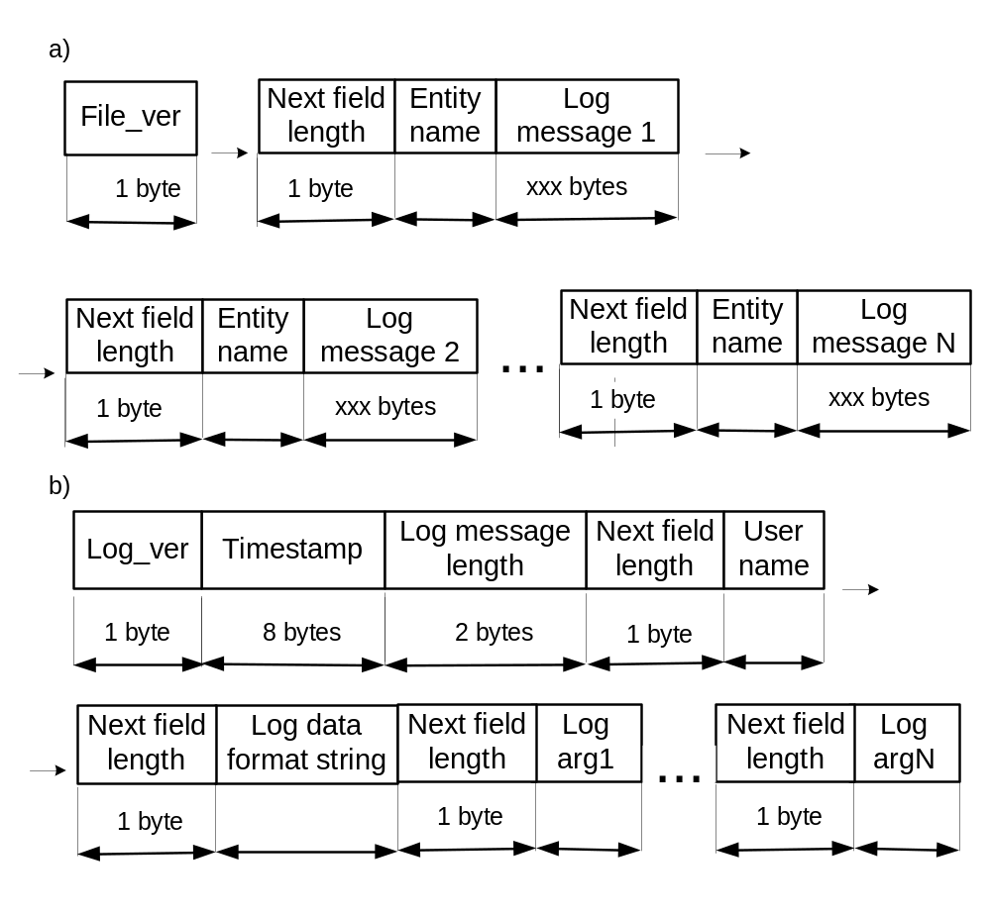
Figure 1: Raw log file format (a), separate log message format (b)

Raw log file format is showed on Figure 1(a) and contains following fields:
- File_ver [mandatory] – this field has a fixed length and appears only one time to specify the raw log file version;
- Next field length [mandatory] – the length of the Entity name field;
- Entity name [mandatory] – this field holds some ASCII name (e.g. arbitrary Agent name, “Engine” or “Test”);
- Log message [mandatory] – this is a set of fields containing separate log message (format is described below).

Separate log message has the fields (showed on Figure 1(b)) destined for:
- Log_ver [mandatory] – this field has a fixed length and accompanies each of generated log messages. It’s used for passing of log data format version;
- Log message length [mandatory] – this field contains the full message length including the Log_ver field length;
- Timestamp [mandatory] – this field has a fixed length and holds timeval obtained by means of gettimeofday();
The rest of log message consists of pairs of fields. First field of pair is Next field length that holds the length of following field. So further will be described the informational fields only:
- User name [mandatory] – this field holds some ASCII string. This string can be used for filtering of logged messages to be generated by separate entities;
- Log data format string [mandatory] – this field is the first informational string. Besides it can contain % directives to interpret Log arg parts. No Log arg parts can follow Log data format string. In this case the format string is ASCII string without any conversion directives;
- Log arg [optional] – these fields contain the arguments defined in Log data format string.

This format also can be used for gathering local log in the file on the Test Agent side if such means is possible.
  - Log data format string
Raw log file is a collection of log messages gathered from separate Test Agents and entities involved in Test Environment system processing.
More intensive operations for logging are copying of the long arrays. Logger ignores log data format string in its processing for now so the auxiliary utilities should check this on one’s own.
Current Logger subsystem implementation provides macro to optimise logging of messages. This macro based on the type of appropriate argument can make a resolve about time of copying. If data can be lost they will be coped at once or suspended until log will be requested.
Raw log file can be parsed by other entities understanding both the format of it and the log data format directives as follow:
- No elements are expected between % symbol and the conversion specifier listed further;
- No special flag characters, precision and length modifiers are defined in the current implementation;
- The character constants (\n, \t, \xHH and so on) processing is not defined here.

The C-like conversion specifiers set is defined for current release:
- %c – unsigned char;
- %d – signed decimal;
- %u – unsigned decimal;
- %o – unsigned octal;
- %x[X] – unsigned hexadecimal;
- %s – string;
- %% – symbol %.

Special conversion specifier set defined in TE context:
- %tm[[n].[w]] – memory dump, n - the number of elements after which "\n" is to be inserted , w - width (in bytes - 1, 2 or 4) of the element (argument type is unsigned char*);
- %tb – specifier denoting start of test (argument type is char*) ;
- %te – specifier denoting end of test and test result (argument type is signed int);
- %tf – specifier denoting the string arg containing a text file path relative to TE_BASE (e.g. configuration file or packet in ASN.1 that should be logged).

Additional conversion specifiers can be included for special TE processing in the future.

