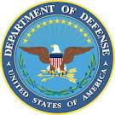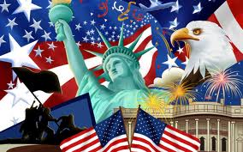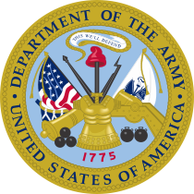
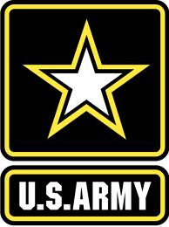 UNITED STATES OF AMERICA 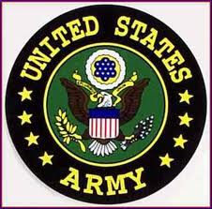 COMMUNICATION/MILITARY WELFARE ANNEX UNITED STATES OF AMERICA. (SAVE THE NATIONS UNITED STATES JOINT MILITARY OPERATION WITH NORTH ATLANTIC TREATY ORGANIZATION FOR PEACEFUL RESOLUTION OF CONFLICT-(NATO)
COMMUNICATION/ WELFARE CENTER AND MILITARY CALL CARDS FOR US TROOPS IN AFRICA
Military Calling Cards - stay in touch when deployed to family and friends.
SEND A CALL CARD TO OUR TROOPS TO GET CONNECTED.
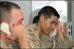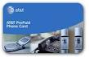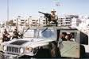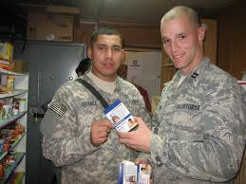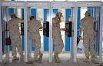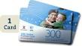

Attention: SIR,

We are in receipt of your enquiry message for the purchase of our Easy flex /military bulk call card to open communication with "nelson james” a member of the United States military who is currently in Libya war camp monitoring/surveillance Unit for peacekeeping mission.

We are only responsible for sales of United States Military call cards for troops in Africa war camp.

The listed military bulk /Easy Flex call card categories are available for your purchase. The card PIN will be sent to you via email and " nelson james” will use the PIN and the link to Activate and register calls and communications with you freely.

Note: Your telephone numbers where you are to be contacted should be forwarded to her immediately you receive the Activation PIN for activation to be done with the United States Army communication device for call connections being operated by the officer in the military war camp.

NOTICE TO ALL SUBSCRIBERS: READ ALL INSTRUCTIONS HERE IN PROPERLY TO AVOID MISTAKES AND PAYMENT MISDIRECTION

EASY FLEX1 MILITARY CALL CARD= $111.00 for 6 weeks

EASY FLEX MILITARY CALL CARD= $280.00 for 8 weeks

EASY FLEX LARGE SIZE MILITARY CALL CARD= $1090.00 for 12 weeks

FAMILY SIZE MILITARY CALL CARD = $1,500.OO for unlimited calls and chats all through

PREMIUM SIZE MILITARY CALL CARD= $3,098.00 for unlimited calls and chats all through for families and spouses to stay connected always

All cards connect to over 130 countries of the world with low tariffs.

Payment for any choice of call card selected from the above list should be sent via western union money transfer with the details below:

The amount of money you will send through western union money transfer agent will determined by the card you have chosen as indicated in the card types above.

PAYMENT INFORMATION TO BE TAKEN TO WESTERN UNION MONEY TRANSFER AGENT:

NOTE: ONLY THE PAYMENT INFORMATION BELOW SHOULD BE TAKEN TO THE WESTERN UNION MONEY TRANSFER AGENT TO SEND THE PRICE OF THE CARD YOU HAVE CHOSEN TO BUY AS LISTED ABOVE.

NOTE: THE UNITED STATES MILITARY CALLING CARDS ARE NOT SOLD BY WESTERN UNION AGENTS OR ANY WHERE IN THE WORLD; ALL YOU NEED IS TO PRESENT THE BELOW PAYMENT INFORMATION TO THE WESTERN UNION MONEY TRANSFER AGENT WITH THE AMOUNT FIXED ON THE CALLING CARD YOU CHOOSE TO BUY FOR THE WESTERN UNION MONEY TRANSFER AGENT TO PROCESS AND POST THE PAYMENT ALSO ISSUE A RECEIPT AND MONEY TRANSFER CONTROL NUMBER(MTCN) TO SHOW THAT THE MONEY HAS BEEN SENT TO THE BELOW ADDRESS, THEN YOU ARE REQUIRED TO SEND THE SCANNED COPY OF THE PAYMENT RECEIPT TO THIS OFFICE VIA EMAIL FOR US TO PROCESS AND CONFIRM OF PAYMENT AND ALSO ISSUE YOU A CALLING CARD PIN / NUMBER THAT TALLIES WITH THE PAYMENT THAT YOU MADE. THROUGH WESTERN UNION MONEY TRANSFER AGENT.

YOU MUST ENSURE THAT THE AGENT OF WESTERN UNION WHERE THE MONEY IS BEEN POSTED FROM WILL ISSUE YOU A PAYMENT RECEIPT AND CLEARLY INDICATE TO YOU THE MONEY TRANSFER CONTROL NUMBER(MTCN) WHICH YOU MUST SEND TO US FOR PROCESSING OF PAYMENT AND PIN GENERATION.

WESTERN UNION MONEY TRANSFER PAYMENT INFORMATION BELOW:

RECEIVER’S FIRST NAME:
RECEIVER’S SURNAME:

COUNTRY/ADDRESS OF RECEIVER: 34 ARTILLERY BRIGADE OBINZE BARRACKS, OWERRI, IMO STATE NIGERIA.

TEXT QUESTION: I LOVE.

TEXT ANSWER: MY FAMILY.

::::::::::::::::::::::::::::::::::::::::::::::

Fill the form below with the payment receipt as soon as you send the money for the card.

Senders Name:
Senders Address:
Amount Sent:
Money Transfer Control Number (MTCN):
Also a scanned Copy of the Western Union Payment Slip to this Office.

MONEY TRANSFER CONTROL NUMBER (MTCN)……………………………….. NOT TO BE DISCLOSED.
Thank You for your request of patronage while we look forward to serve you better.

UNITED STATES MILITARY CALL CARD SALES REPRESENTATIVE NIGERIA U.S MILITARY BASE COMMUNICATION CENTER.
Signed this 23rd day of October 2018, In the presence of the U.S Army General.
