Conceptual model for ICP 2023/2024
Here is a class diagram containing all the implemented classes.
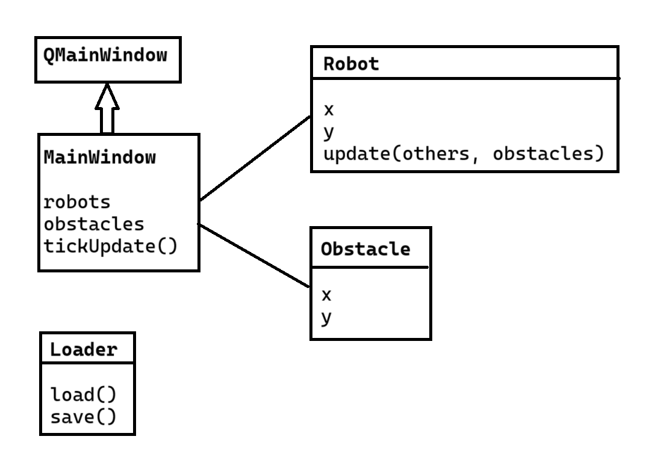
Note that class MainWindow also contains a lot of methods for processing the keyboard and mouse input and drawing robots + obstacles on the screen, but, for simplicity, they are ommited from the diagram.
On every tick, which is by default 70 times per second, MainWindow::tickUpdate is called, so every robot updates itself (this is done via Robot::update()) and everything is redrawn.

