Adding the collaborators to git project

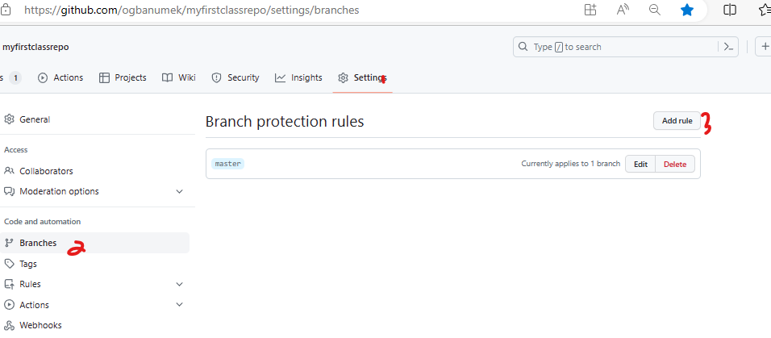

Adding protection on git branch