**Integrating gitbash or Integrated Development Environment IDE with Github.**

Step 1: Run a command to create a key-pair on your gitbash terminal

*ssh-keygen*

At every prompt, click ‘enter’ until private and public keys are created in your .ssh folder ~/.ssh

Step 2: Run a command to go the directory and open the content of the public key id_rsa.pub

*cd ~/.ssh*

*cat id_rsa.pub*

Step 3: Copy the content of the public key

Step 4: Click on your profile icon on github as shown below



Step 5: click on the settings on the drop down as shown below

**Step 6: click on ssh and GPG keys**

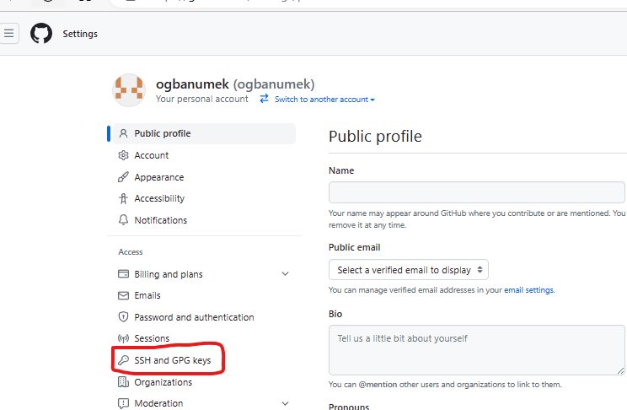

**Step 7: click on New SSH key**

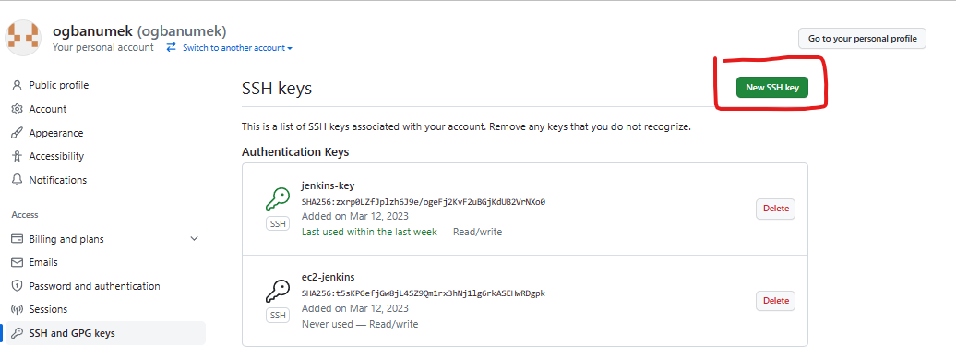

**Step 8: On Title, give any name, On Key type, leave the default value, On Key section, paste the public key that you copied from your gitbash. Then click Add SSH key**

**Step 9: Run the git clone using ssh URL to validate the handshake.**