AYUSH (Ministry of Ayush)
In terms of implementing a Bounded Browser Pool -> enhances CPU/Memory utilization -> provides zero-crash scraping of Angular SPAs.

Architecture Diagram - Scraping Details
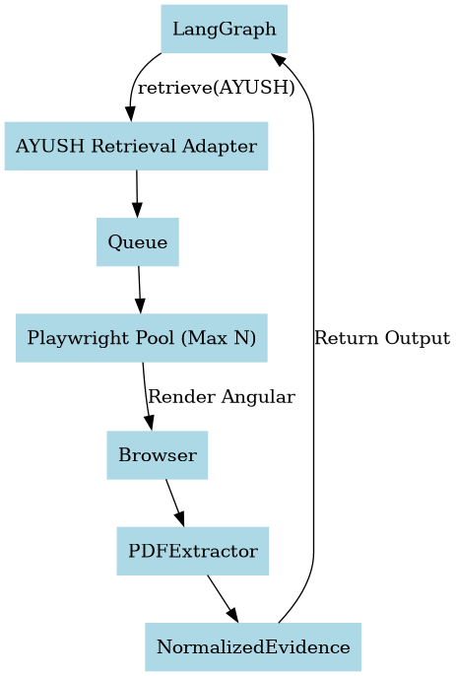

Introduction
The Ministry of Ayush portal acts as the centralized digital repository for Ayurveda, Yoga, Unani, Siddha, and Homoeopathy. It utilizes a dynamic Angular frontend which necessitates browser rendering for scraping.

What website provides
Official notifications, Ayurveda Aahara regulations, schemes, guidelines, and PDF publications.

How retrieval works
LangGraph queries the AYUSH Retrieval Adapter, which queues the request to a bounded Playwright browser pool. The browser fully renders the Angular SPA, extracts the dynamic PDF links, downloads them asynchronously, and returns normalized evidence.

Conclusion (Efficiency & Optimization)
This architecture is highly efficient because it hides the complex, memory-heavy headless browser execution behind an Adapter. By restricting concurrent browser instances, our LangGraph orchestrator remains extremely stable (avoiding OOM errors) and is fully decoupled from frontend layout changes.

