FSSAI (Food Safety and Standards Authority)
In terms of implementing a Split Rendering/HTTP Pipeline -> enhances legacy server stability -> provides uninterrupted retrieval of food safety rules.

Architecture Diagram - Scraping Details
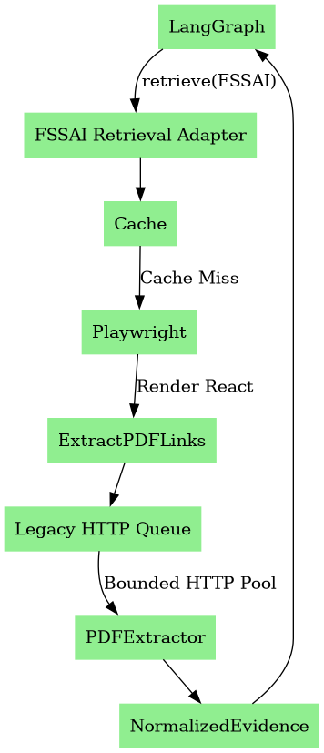

Introduction
The FSSAI portal provides mandatory food safety regulations for India. It operates via a modern React frontend paired with highly fragile legacy backend servers hosting the documents.

What website provides
Food Safety and Standards Act (2006), Ayurveda Aahara rules, gazette notifications, hygiene ratings, and licensing directives.

How retrieval works
The FSSAI Retrieval Adapter intercepts the query, checking a cache first. On a miss, it uses a lightweight Playwright instance to map the React routing and extract legacy PDF URLs. These URLs are then downloaded using a strictly rate-limited HTTP pool to avoid server bans.

Conclusion (Efficiency & Optimization)
This approach optimizes the current architecture by isolating the fragile government legacy servers from the rapid execution of the LLM. It prevents catastrophic IP bans (bot-blocking) while ensuring fast retrieval via caching, significantly improving overall system reliability.

