India Code
In terms of implementing direct REST API mapping -> enhances metadata preservation -> provides flawlessly cited legal statutes.

Architecture Diagram - Scraping Details
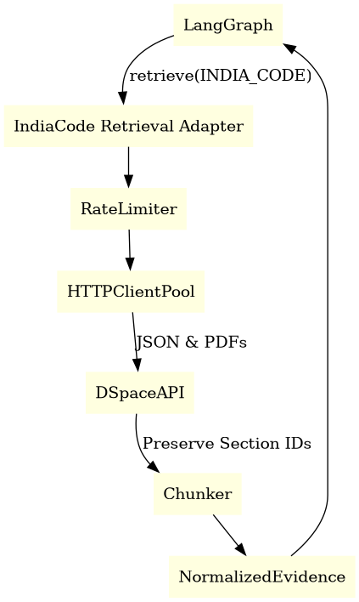

Introduction
India Code is the digital repository of all Central and State Acts. It exposes a mature DSpace REST API, allowing structured JSON access without HTML scraping.

What website provides
Central/State Acts, subordinate legislations (rules, regulations, notifications), and enactment metadata.

How retrieval works
The IndiaCode Retrieval Adapter receives the LangGraph query and uses a distributed rate limiter to make pure asynchronous HTTP requests to the DSpace API. It retrieves JSON metadata and PDF bitstreams, chunking the data while preserving exact Section IDs.

Conclusion (Efficiency & Optimization)
By completely skipping headless browsers, this is the most efficient and scalable node in the harness. The Adapter pattern ensures perfect metadata mapping from DSpace into the Vector DB, completely eliminating LLM citation hallucinations.

