WIPO Lex (IP Country)
In terms of implementing Shadow DOM Injection -> enhances CloudFront WAF bypass -> provides uninterrupted access to international IP treaties.

Architecture Diagram - Scraping Details
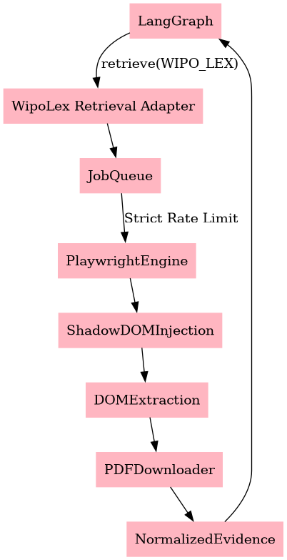

Introduction
WIPO Lex is the global database for intellectual property laws and treaties. It leverages complex web components (Shadow DOM) and strict AWS CloudFront rate limiting.

What website provides
National IP laws, international patent treaties, trademarks, copyright acts, and IP judgments.

How retrieval works
The WipoLex Retrieval Adapter receives the country/IP query and executes a heavily rate-limited (jittered) Playwright script. It injects JS directly into the Shadow DOM to trigger searches, parses the generated tables, and downloads the relevant PDFs.

Conclusion (Efficiency & Optimization)
This is a critical optimization for international queries. By abstracting the Shadow DOM complexities and enforcing strict delays, the architecture guarantees we do not get blocked by AWS WAF, maintaining a high-fidelity pipeline for international legal retrieval.

