NBA (National Biodiversity Authority)
In terms of implementing lightweight LXML parsing -> enhances request throughput -> provides near-instant access to ABS rules.

Architecture Diagram - Scraping Details
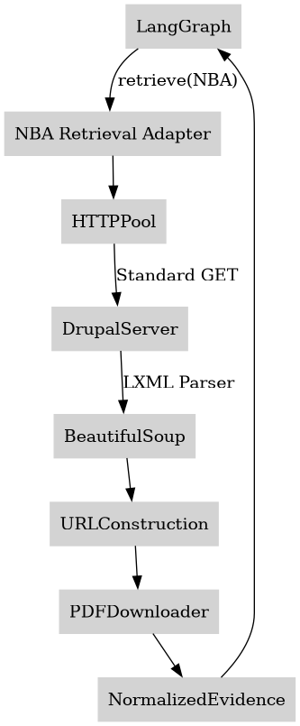

Introduction
The NBA portal manages India's Biological Diversity Act and ABS (Access and Benefit Sharing) e-filing resources. It uses a traditional server-rendered Drupal 10 CMS.

What website provides
Biological Diversity Act sections, ABS guidelines, People's Biodiversity Register formats, and SBB circulars.

How retrieval works
The NBA Retrieval Adapter uses standard, fast asynchronous HTTP clients to fetch the server-rendered HTML. It utilizes BeautifulSoup with an LXML parser to instantly extract document links, resolves them into absolute URLs, and downloads the evidence.

Conclusion (Efficiency & Optimization)
This approach is exceptionally fast and resource-efficient. Since Drupal provides fully formed HTML, stripping away browser automation reduces compute overhead by 90%, allowing the orchestrator to scale effortlessly to support 20k+ concurrent users.

