Power System Report
- Top Level System overview
- Solar Arrays
  - Specs
- Batteries
  - http://www.batteryspace.com/prod-specs/4315.pdf
- Beta Angle
  - Critical Beta Angle
- Eclipse Times
  - durations
- power Generation
  - Orbit average @ min and max Beta angle
  - Average over mission
- power budget
- Simulation Details

Simulation Details
STK Scenario, 6 Aug 2019 16:00:00 - 6 Aug 2020 16:00:00

3d model – Lassat_V1_stk_Aug12.dae
Orbit – 400 km circular, I = 51.6446 deg (assume ISS orbit), step size 60 s
J2 Perturbation

Attitude: Aligned and constrained,
Aligned ref vector Selfie-Sat Nadir (centric) (0,0,-1)
Constrained ref vector Selfie-Sat velocity (1,0,0)

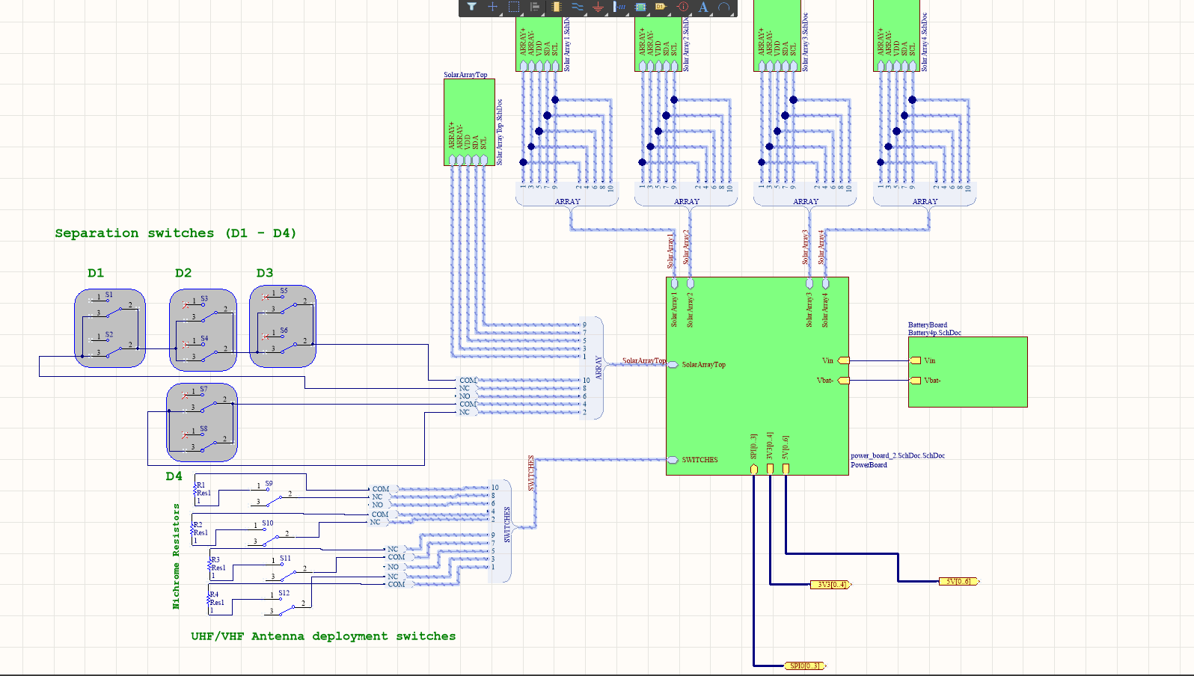
Top Level
which systems are on which voltage bus??

EPS – 3.3 V
OBC – 5 V
Payload – 5V
ACS – Sensors on 3.3V
-Magnetorquers on 5 V
Transciever- 3.3 V

Beta Angle and Eclipse Times:

Default Time period, step size (60 s) for plot

Minimum Beta: 0 deg
Maximum Beta: 75.032 deg
Average Beta: 31.2066

Table of values in Appendix
(1) critical beta angle, Space Thermal Control Handbook, Volume 1 – Gilmore, David G. - 2002. Page 41 equation 2.8

Eclipse-free intervals are:
Start: 9644820 epoch sec, Finish: 9968580 epoch sec, duration = 3.747 days
Start: 14828400 epoch sec, Finish: 14953140 epoch sec, duration = 1.444 days
Start: 27718620 epoch sec, Finish: 28152000 epoch sec, duration = 5.016 days

Calculated eclipse fraction with:

found that lighting conditions are favourable

worst case: 39% of orbit in eclipse
best case: 0% of orbit in eclipse (intervals are above)
average: 34.3% of orbit in eclipse

orbital period is 92 minutes

worst case: 35.88 minutes of eclipse, 56.12 minutes of light
average: 31.556 minutes of eclipse, 60.444 minutes of light
Above graph demonstrates the fraction of orbit in eclipse, during one year of mission. (i.e fraction at 40% indicates that 40% of orbit, about 36 minutes, is in eclipse. Fraction of 0% indicates that there is no eclipse at all in this time period)

Beta angle versus eclipse fraction for the ISS orbit
Above graph is superposition of beta angle and eclipse fraction plots

lighting interval sim in STK to verify:

Max B - “Lighting Times” Report/Graph for 22 Jun 00:00:00 to 28 Jun 00:00:00 shows approximately 5 days of lighting (matches calculation for lighting intervals above beta angle)

Min B - Report/Graph for 11 Aug 2019 00:00:00 to 12 Aug 2019 00:00:00 (one of several minimum beta angle time periods) shows a total of 33815.572 seconds in umbra. 33815.572/86400 = 0.3913 which verifies the calculation for worst case 39% in eclipse.

Above graph shows the eclipse/lighting intervals during the max beta angle.

Above graph indicates the eclipse and lighting intervals during minimum beta angle (which is for most of the mission)

Solar Array Specs

Power Generation

Looking at the two power generation cases. Minimum beta angle (the absolute worst case scenario for power generation) and maximum beta angle. Conditions throughout the mission are most often similar to minimum beta angle.

Used STK to generate CSV files of power generation

Max B 23 Jun 2020 00:00:00 to 24 Jun 2020 00:00:00 step size = 5 s

Min B for 11 Aug 2019 00:00:00 to 12 Aug 2019 00:00:00 step size = 5 s

Average B for 19 August 2019 00:00:00 to 21st August 2019 00:00:00

Matlab to produce plots and average values:

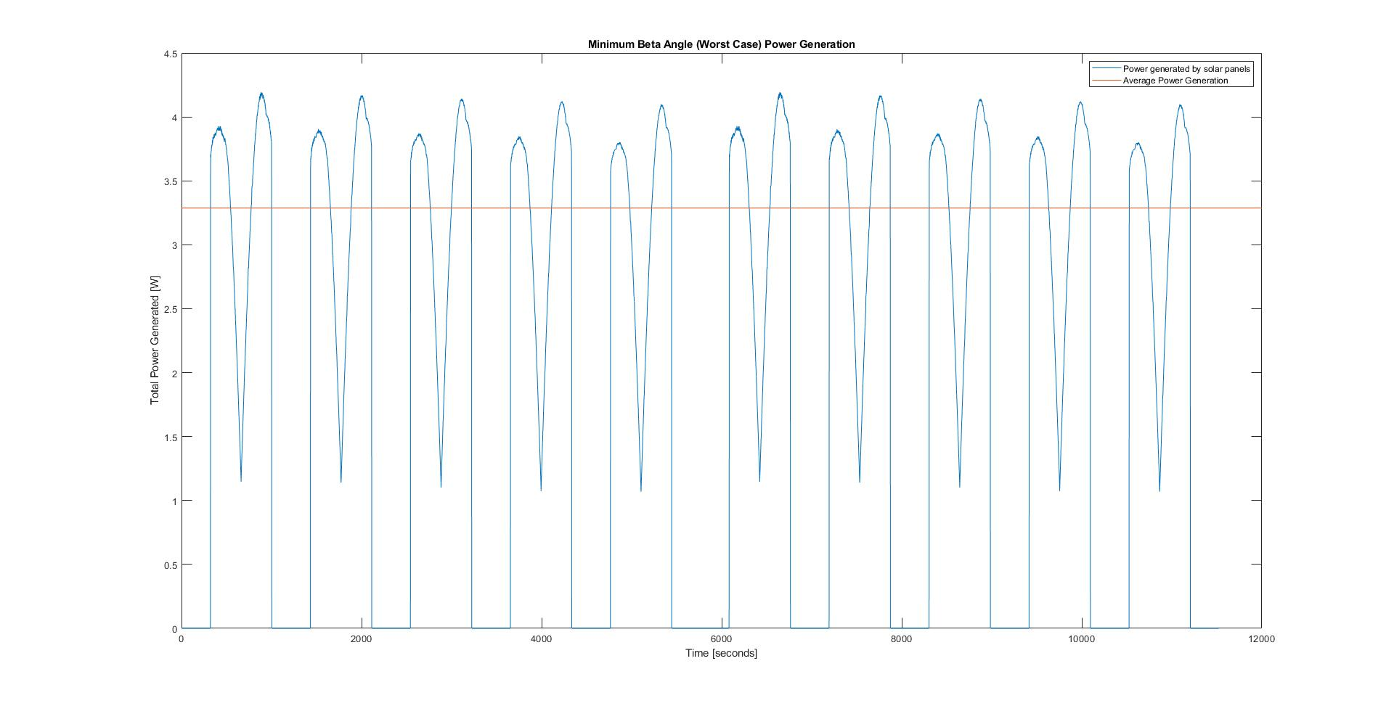

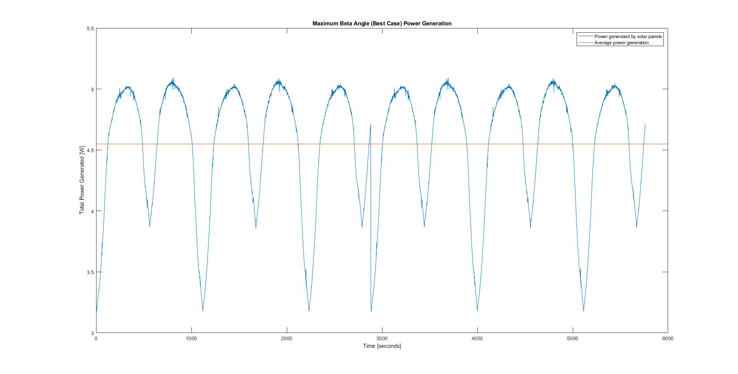

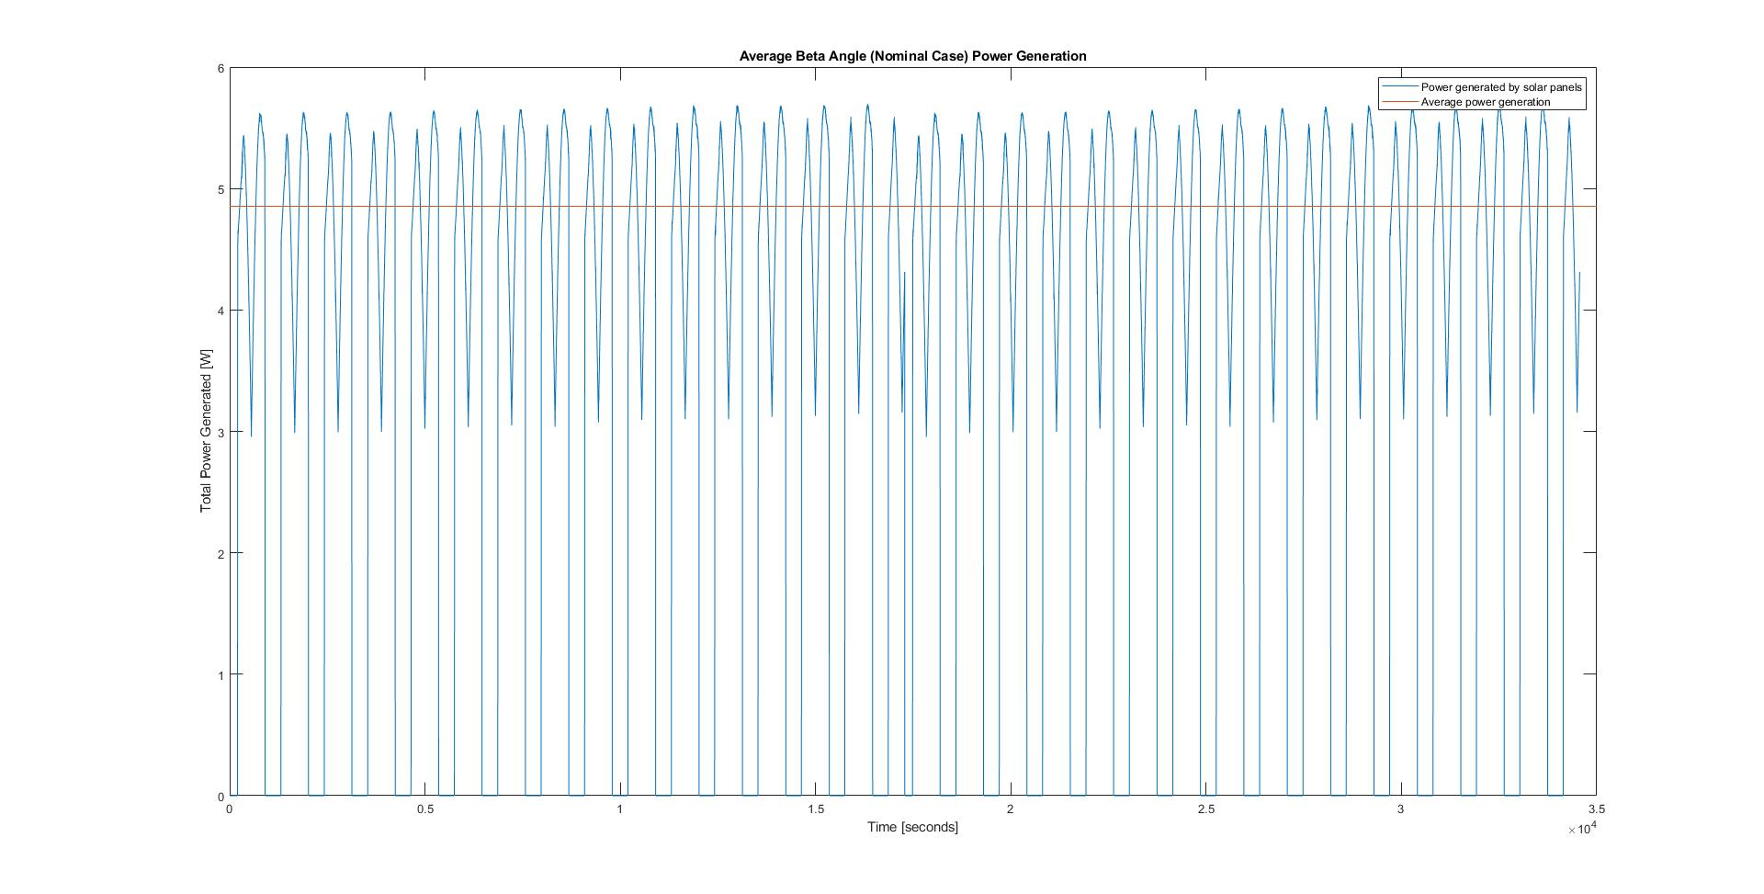

Beta Angle | Average Power Generation | Least Power Generation | Max Power Generation | Power Requirement
0 deg | 3.2870 W | 0 W | 4.1940 W
75.032 deg | 4.5493 W | 3.173 W | 5.092 W
31.2066 | 4.8536 W | 0 W | 5.6950 W

orbital period is 92 minutes

worst case: 35.88 minutes of eclipse, 56.12 minutes of light
average: 31.556 minutes of eclipse, 60.444 minutes of light
best case: no eclipse, 5.016 days of sun

Battery capacity: 1400 mAh * 4 batteries = 5.6 Ah = 18.648 kJ

Low Beta Angles mode

Daytime Operation: 56.12 minutes of sun, 1.609084935 Watt demand, 3.346 W power generation

energy generated:
energy consumed:
net energy:

Night Operation: 35.88 minutes of eclipse with 1.609084935 Watt demand

energy generated:
energy consumed:
net energy:
Net Orbit Energy:

Nominal Case

Daytime Operation: 60.444 minutes of sunlight, 2.783300935 Watt demand, 4.9163 W power generation

energy generated:
energy consumed:
net energy:

Night Operation: Average of 31.556 minutes of eclipse with 2.765800935 Watt demand

energy generated:
energy consumed:
net energy:

Net Orbit Energy:

Best Case

Daytime Operation: 5.016 days of sun, 2.783300935 Watt demand, 4.5493 W power generation

energy generated:
energy consumed:
net energy:

