Poster content

## Abstract

The objective of the project is to develop a biomedical device that can noninvasively monitor a dog’s heart rate using a conductive fabric. Nowadays more and more people are keeping dogs as their loyal companions. According to statista.com, the number of pet dogs has increased from 68 million in 2000 to 89.7 million by 2017. As such the need for simple reliable and cheap heart rate sensor for dogs will also be increasingly demanded. Our device can really simplify the dog heart rate sensing technology making them more affordable and reliable for a dog or even other pet owners.

## Introduction

The approach towards this project is to measure the breath rate of a dog which is related to its heart rate by detecting the movement of the dog’s chest. The resistance of the fabric will vary as the dog’s chest stretches the fabric. Using a resistance to voltage convert circuitry, we generate a voltage signal that is correlated with the movement of the dog’s chest. This signal is captured using a microcontroller and then together with the temperature readings from a temperature sensor they will be sent over to a computer wirelessly for further process and analysis. This custom-made sensor-microcontroller device is attached to a dog harness. Finally, in our computer, we would filter out all the noises and measure the number of pulses which represents the breath rate and ultimately heart rate from the signal. The recorded data can be used in analyzing, diagnosing and improving the dog’s health conditions.

## References

## Ada, L. and Nosonowitz, D. (2017). *Adafruit HUZZAH32 - ESP32 Feather*. [online] Adafruit. Available at: https://learn.adafruit.com/adafruit-huzzah32-esp32-feather/ove [Accessed 14 Aug. 2018].

## Design

In general, the microcontroller will collect data from sensors and send them through Wi-fi. The PC will collect data and further process and analyze them.

#### Hardware

The hardware mainly consists of an Adafruit HUZZAH32 board, a 350mah lithium polymer battery, and a power switch.

The Adafruit HUZZAH32 board carries an ESP32 microcontroller, which has got an Xtensa dual-core 32-bit LX6 microprocessor which runs at 240MHz, 520kB SRAM, 2 onboard ADC with 12 channels and a variety of wireless communication method including Wi-Fi, Regular Bluetooth, and BLE, which perfectly fit our needs.

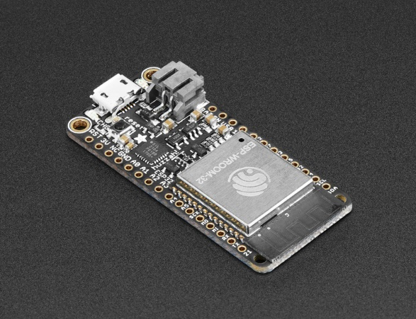

In addition, the board has got a miniature shape that is perfect for a wearable device.

#### Software

The software design uses a server-client model. The microcontroller which is generating all the data will be assigned as the server, and the PC which is receiving all the data will be considered as the client.

The server program was developed using Arduino IDE. Details of how to set up and develop in Arduino IDE can be found on Adafruit website (Ada, 2017).

The server program would initialize the Wi-fi and connect to the designated hotspot “Dog_temp” which is broadcasted by the PC, and then wait for a client connection. After the connection is established the server will start the corresponding measurement according to the command sent over by the client. After that, the data will be sent through Wi-fi. This process will repeat until the client disconnect.

On the PC side, before starting the client, we need to first enable the Wi-fi hot spot in our laptop. The hot spot needs to have the same name and password as specified in the server program.

The client program was developed with MATLAB Instrument Control Tool Box and GUIDE.

After the program is finished the MATLAB application compiler will package it into a standalone application. There are four steps after the user pressed the start measurement key: take breath rate measurement (i.e. the fabric resistance data), signal process and calculate breath rate, take temperature data, record data.

At each measurement phase, the client will send out command first and then continuously read the measurement till the specified time was reached.

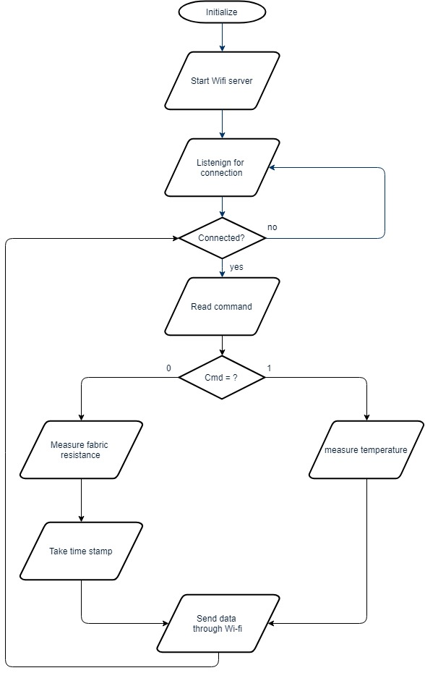

Server flow chart

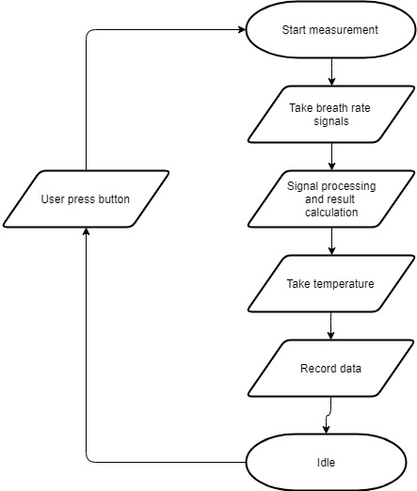

Client flowchart.

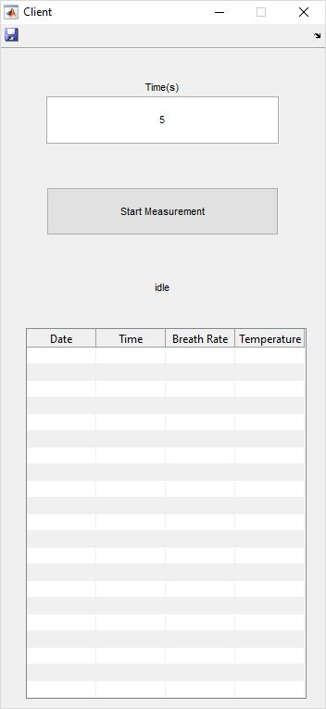

Client interface

#### Sensors

The fabric sensor we selected was the Adafruit Conductive Rubber Cord Stretch Sensor. It has got a 7-8kOhms resistance at rest. When we do the measurement the rubber cord will be wrapped around the dog’s chest and sense its chest movement.

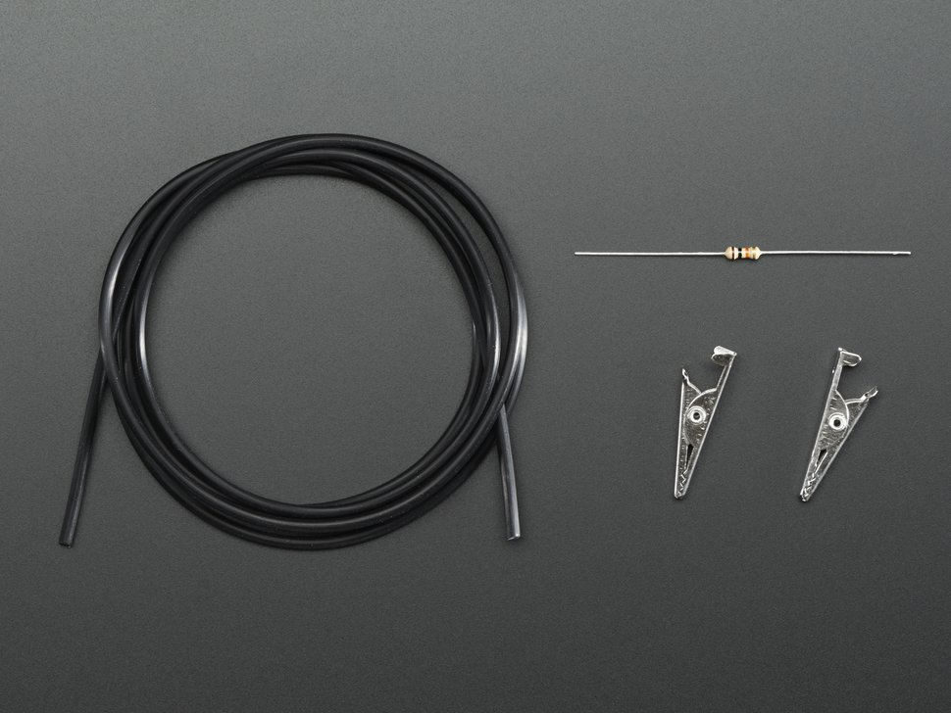

The temperature sensor is a DS18B20 Digital Temperature Sensor. It is connected to our microcontroller pin A0 through one wire interface.

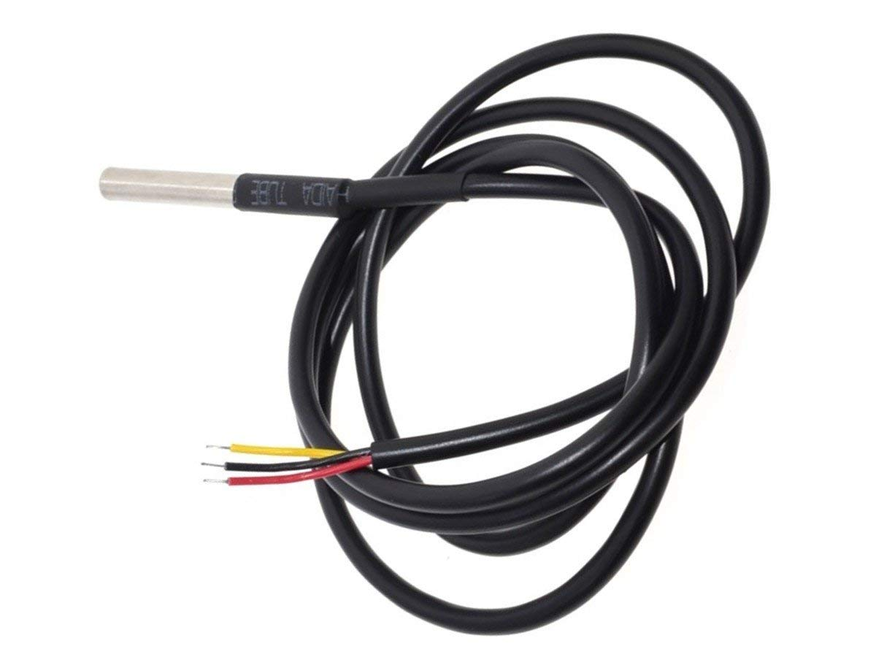

#### Signal Processing

The breath rate signal is expected to be around 1-2Hz with a triangular shape. As such a low pass filter with 7Hz of the cutoff frequency. To preserve the triangular shape additional harmonics were added. The filter can be described by the equation:

$$\sum_{i}^{n}{\frac{4}{π^{2}}\frac{1-{(-1)}^{n}}{n^{2}}} (f∈[(n-1) ,n]×7(Hz))$$

The following plot shows the shape of the filter in the frequency domain.

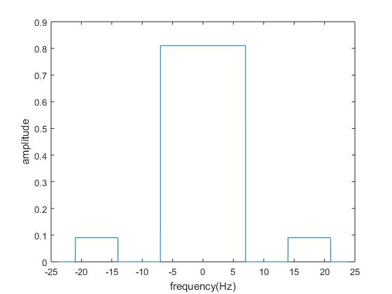

The effect of filtering is shown as follows.

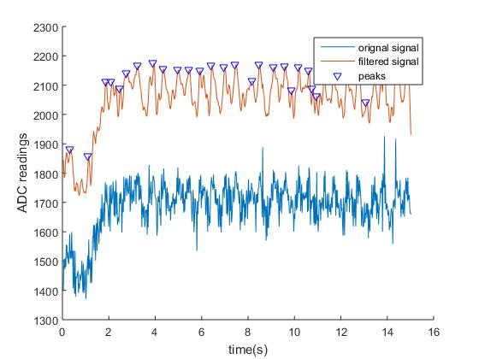

## Results

We experimented the device on a dog and compared the result with signal collected from a stethoscope.

## Conclusion

## Acknowledgment