**Project Name:**

**Registration Solution System (RSS)**

**Client Name:**

**Oueslati Sportschule**

**Group Name: Streamliners**

**Members:**

Olasunkanmi Bakare

Peter Vo

Rudyahly Tossel

Bahija Oueslati

Table of Contents

1. Executive Summary & Recommendation3

1.1 Organizational Benefits3

1.2 Cost and Risk3

1.3 Implementation Strategies3

1. Introduction4

2.1 Organizational Background4

2.2 Known Business Issues and Problems4

2.3 Project Phase-1 Report – Initial System Request4

Feasibility Analysis5

Systems Request6

Feasibility Analysis Snapshot Excel7

1. Requirement Gathering Schule, Procedure and Result8

3.1 Project Phase II Report -Requirement Determination and System Analysis8

Use Case Diagram9

Class Diagram9

Use Case Description ID 110

Use Case Description ID 211

Use Case Description ID 312

Use Case Description ID 413

Use Case Description ID 514

Activity Diagram15

Sequence Diagram for Use Case ID 216

Sequence Diagram for Use Case ID 517

Behavioral State Machine Diagram 118

Behavioral State Machine Diagram 218

Use Case Point Estimation19

3.2 Interview Gathering Information20

Appendix 120

Appendix 221

Appendix 322

1. Mock Prototype of the System23

4.1 Screenshots23

1. **Executive Summary**

Our group started with the initial investigation and selection of the group project that we could tackle, and each one of us had to write down some aspects of the business: issues in the current system and ideas on how we can improve the current system. We targeted a relatively small system and a real-world business process. After evaluating which project fits us more and which one is feasible for us, we finalized our proposal. We created an *Initial System Request* in which we identified business needs, the users, project success factors, detailed feasibility analysis (including technical, economic, & organizational), the scope of the project, and potential constraints and issues. Projected development cost is $6,000, with about 30% return on investment and break-even in the second year of operation.

Oueslati Sportschule expected an increase in registrations, which could lead to an overload on the current system. It makes a crucial business decision for a new (scalable) system to be created. The new system will have a modified enrollment/registration system to sign up for sessions on specific dates/times. Clients of Oueslati Sportschule will derive the following benefits from the new system:

1. Allow them to sign up for sessions (min. Time spent to call registrar etcetera.)
2. A more convenient way for the client (sign up any day/time) from any web browser
3. Transparent overview of the dashboard (see the payment history, profile, storage of file ex. online waivers)

We had to take into consideration possible risks and constraints of the systems that could lead to security issues due to online payment and transactions. Also, the system must comply with privacy laws.

Per our analysis, we detected that the business would cut some costs and be able to generate more revenues. Projected cost reduction of $2325 per annum and 2.25% yearly increase in revenue.Intangible benefits include customer loyalty and a 98% improvement in customer satisfaction. Oueslati Sportschule processes 80% of total session enrolment through the web application and securely process payment without disruptions to regular business operations.

The next steps were to write the *Requirement Determination and System Analysis.* We conducted our interviews with multiple prospects. We analyzed and summarized the functional requirements and nonfunctional requirements. We created several *System Models* and use case descriptions to visualize and have a vivid presentation of our established system.

At the end of our efforts, we finalized a detailed process reports and carefully implemented all requirements. Finally, we delivered a Mock Prototype of the system that should satisfy project champions, senior management, users, and other stakeholders.

1. **Introduction**

**2.1 Organizational Background**

The team is working on a project from Oueslati Sportschule, a small business located at 6050 Peachtree Parkway Suite 240-323 Atlanta, Georgia. The business offers professional athletic development programs for individuals who want to excel in sports. Although the business offerings have focused on soccer, it is expanding to cover all sporting activities and general healthy living.

* 1. **Known Business Issues and Problems**

The company’s current system, which is a web application, does not allow online payment. As a result, clients and prospects would have to walk into the office, send an email, or place a call through to administrative staff to complete their registration for sessions. The business recently made a sizable investment in marketing activities, which is expected to increase sales of forms and registration for sessions. The business expects an increase in registrations, which could lead to an overload on the current system and slow the process. Therefore, the business needs a system that can scale to accommodate increases in sales, process payments, and securely manage the client's information.

* 1. **Project Phase-1 Report – Initial System Request**

**Users:**

1. Clients and prospects who are interested in increasing their involvement in sports and want to receive lessons that will increase their overall athletic abilities or professional development.
2. The client care representative is responsible for registering and scheduling clients for available sessions.
3. The coaches and instructors check schedules for time and list of participants in their sessions.
4. The vice president of marking uses the client information to bolster marketing activities like sending promotional offers and email marketing.
5. The vice president of operations, who is also the project sponsor, manages schedules, and use the system to improve client experience.

**Success Factors:**

This project is a success when:

1. Oueslati Sportschule effectively manages client’s activities through the web application and securely process payment without disruptions to regular business operation.
2. Oueslati Sportschule processes 80% of total session enrolment through the web application.
3. 98% of users report a satisfactory experience.

**Feasibility Analysis for RSS**

**Technical Feasibility: Can We Build It?**

* Familiarity with Application

The users are familiar with the application, which is simply an expansion of the existing system.

* Familiarity with Technology

Users are familiar with the existing technology. We will keep underlying hardware but add some extended cloud functions to the system for improved functionality and user-friendliness.

* Project Size

Medium size; adding some components for data management.

**Economic Feasibility: Should We Build It?**

* Development Costs

Projected development cost is $6,000 with about 30% return on investment and break-even in the second year of operation.

* Annual Operating Costs

$7196 per annum

* Annual Benefits (Cost Savings and Revenues)

Projected cost reduction of $2325 per annum and 2.25% yearly increase in revenue.

Intangible benefits include customer loyalty and an improvement in customer satisfaction.

**Organizational Feasibility: If We Build It, Will They Come?**

* Project Champion(s)

1. VP of operation.
2. VP of marketing.
3. President.

* Senior Management

1. VP of operations
2. VP of marketing

* Users

Clients who use the website and in-house users

* Other Stakeholders

Coaches, Sponsors, Partnerships

[9/24/19]

**System Request**

**Project Name:** **Registration Systems for clients (RSS)**

**Project Sponsor:** VP of operations

Name: Jessin Oueslati

Department:

Organization: Oueslati Sportschule

Phone: 4042792032 E-mail: info@oueslatisportschule.com

**Business Need:**

Following a sizable investment in marketing activities, Oueslati Sportschule needs an integrated digital system to manage an expected increase in registration and client data.

**Functionality:**

1. Maintain records for clients enrolled in sessions
2. Automated update of session offered day/time/location
3. Search available sessions
4. Maintain client’s records
5. Allow clients to create profile and register for sessions
6. Payments (set automated payment and view payment history)
7. Sign and submit electronic waiver forms
8. Send notifications for upcoming sessions

**Expected Value:**

*Tangible*:

1. Increase in sales at a rate of 2.25% on the current sale of $8,345.
2. A total of $2,325 reduction in the cost of operation per year.
   1. 20% cost reduction, which amounts to $1,000, in registration time per annum

(400 hours - $4,000 @ $10/hr.; instead of 500 hours - $5,000 @ $10/hr.).

* 1. 10% increase in staff productivity (Saving $600 per annum)
  2. Reduce the cost of printing (decrease expenses by an average of $725 per annum)

*Intangible:*

* Customer loyalty
* Improve valuable customer experiences: accessibility and usability (expected to increase positive reviews and testimonies by 80%)

**Special Issues or Constraints:**

Take into consideration security issues due to online payment and transactions.

The system must comply with privacy laws.



1. Requirement Gathering, Procedure and Result

**3.1 Project Phase-II Report – Requirement Determination and System Analysis**

**Interview Reports:**

The team is using an interview as a technique for gathering information on this project. The requirement analysis strategy is to understand the as-is system, identify improvements, and develop requirements for the to-be system. In the process, the team selected three interviewees: an active member, vice president of operations, and vice president of marketing at Oueslati Sportschule**.** Appendices 1, 2, and 3 contain detailed interview reports and information for problem analysis.

**Functional Requirements:**

1. Prospects create an account to apply for membership and make payment.

2. Oueslati representative reviews application and schedules interviews with the prospect.

3. Prospect view application status and accept the interview request.

1. Oueslati representative interviews prospect through video chat.
2. Members update account information.
3. Members search for sessions, register, and make payments.
4. Authorized Oueslati representatives can send promotional messages to clients and prospects.
5. Authorized Oueslati representative update schedule and time slots
6. Members provide feedback.
7. Members sign and submit electronic forms.

**Nonfunctional Requirements:**

1. Operational Requirements:
   1. A friendly user interface that is compatible with both desktop and mobile devices.
   2. It should operate on all web browsers.
2. Performance Requirements:
   1. The system should be able to perform high definition video and audio chat.
   2. The load time for information should be less than 2 seconds.
   3. Creates, updates, and retrieves member information from databases in less than 2 seconds.
3. Security Requirements:
   1. Clients' records should be secured and inaccessible by an unauthorized person.
   2. Implement and enforce a different level of access and authority among Oueslati representatives.
   3. Employ the use of multi-layer security for login.
4. Cultural and Political Requirements
   1. The system must comply with government policies on a secure payment process.
   2. The system should include terms of use and privacy statement.

**Use Case Diagram:**

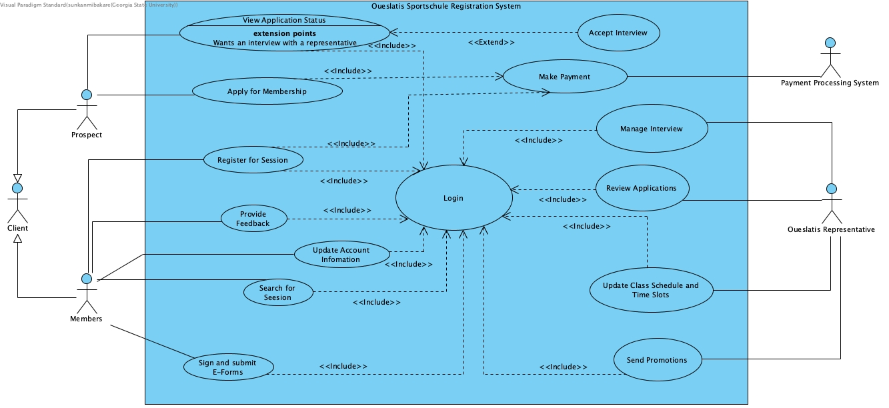

**Class Diagram:**

**Activity Diagram for Overall Business Process:**

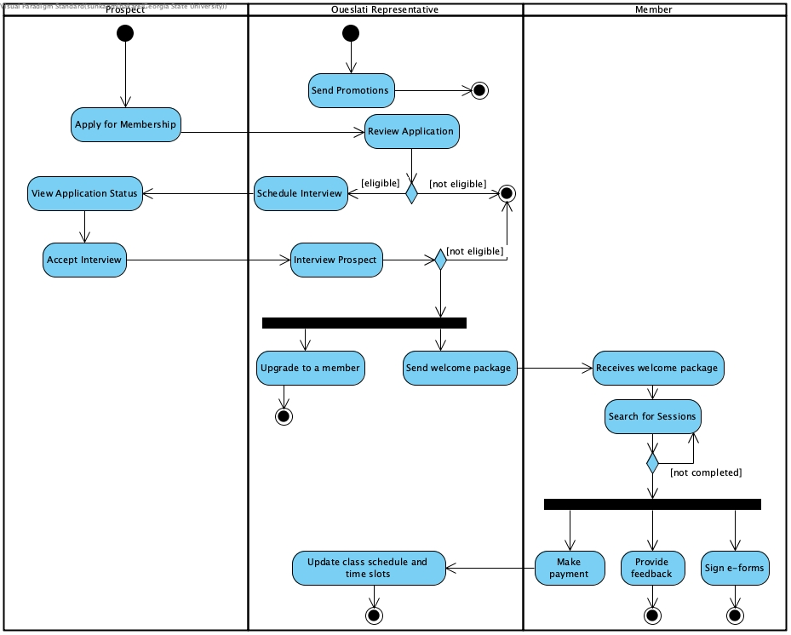

**Activity Diagram for Manage Interview Use Case:**

**Sequence Diagrams: Use Case Name: Apply for Membership - ID:2**

**Use Case Name: Manage Interview - ID:5**

**Behavioral State Machine Diagram 1.**

State of Prospect Class from application to membership:

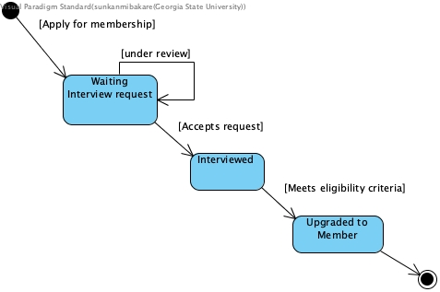

**Behavioral State Machine Diagram 2.**

State changes of “Member” class:

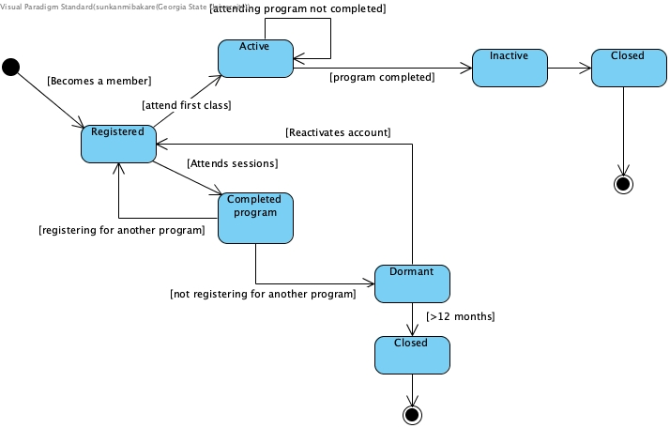



**3.2 Interview Gathering Information**

**Appendix 1.**

|  |
| --- |
| Interview Notes Approved by: Jessin Oueslati |
| **Person Interviewed: Jessin Oueslati**  **Vice President, Operations**  **Interviewer: Olasunkanmi Bakare**  **Purpose of Interview:**   * Understand how the current system processes an application for session * Understand the current operation capacity vis-à-vis enrollment * Identify problems with the current system and processes   **Summary of Interview:**   * The current system serves as a starting point in the application process. It is underutilized because prospective members need to take further steps by physically visiting the office to make payments and attend interviews. Consequently, prospects that are not discouraged by the many stages of the application prefer to visit the office for both form and payment * Oueslati Sportschule have a little above **320** active members but have a capacity for **1,000** * The office processes about **50** applications per day during the peak period of enrollment * There are three significant problems with the current system and process   + The system does not accept payment and interview cannot be conducted online, which makes it impossible for the application process to commence and end online   + The current application process puts pressure on office resources as more prospects choose to visit the office during peak period   + The system does not have members portal, which makes it challenging for members to keep up with their schedule and other personal information   **Open Items:**   * Schedule interview with an active member * Schedule interviews with one of the coaches**.** |

**Appendix 2.**

|  |
| --- |
| Interview Notes Approved by: Thekia Jones |
| **Person Interviewed: Thekia Jones**  **Vice President, Marketing**  **Interviewer: Olasunkanmi Bakare**  **Purpose of Interview:**   * Understand how the current system enables marketing * Determine information requirements for future system   **Summary of Interview:**   * The current system uses a membership application form to generate contact information, which the marketing department copies and upload to another service for email and SMS marketing * The future system must not only capture clients and prospects' information; it must be able to send direct messages to the target audience * There are two problems with the current system and process   + The marketing department manually collects data, which are often lost or prone to error during transfer, from the system   + The system does not support digital marketing efforts such as google review and email marketing   **Open Items:**   * Schedule interview with an active member, Ramon Anthony * Schedule interview with one of the coaches |

**Appendix 3.**

|  |
| --- |
| Interview Notes Approved by: Ramon Anthony |
| **Person Interviewed: Ramon Anthony**  **Active Member**  **Interviewer: Rudyahly Tossel**  **Purpose of Interview:**   * Understand user interaction with the current system * Determine what the user needs to achieve with to-be system   **Summary of Interview:**   * The user has not visited the website since the beginning of membership but used it as a source of information before becoming a member * As a client, the current system does not provide information such as the schedule of sessions and membership information * As an active member, I want to be able to make payments online and view data that are critical to my membership     **Open Items:**   * Schedule interview with one of the coaches |

**4. Mock Prototype of the System**

**Registration page**

**Login Page**

**Payment Page**

**Send Promotional Message**

**View Application**

**Search Session**

**Update class schedule and time slots**

**Sign and submit e-forms**

**Provide feedback**

