Design Justifications

- Strong Entities:
- Clients
- Markets
- Stocks
- Orders
- Invoices
- Client Account Profile
- Weak Entities:
- Client Account Market
- Executions

My reasons to choose Weak entities:
- The Client Account Markets entity is designed as a weak entity because it exists solely to represent the relationship between Client Account Profiles and Markets. Since an account cannot trade in a market unless explicitly authorized, this entity depends on both Client Account Profiles and Markets for its existence. If either the client account or the market is removed, the corresponding record in Client Account Markets becomes invalid. This ensures data consistency while efficiently managing the many-to-many relationship between accounts and markets.

- The Executions entity is a weak entity because it depends entirely on the existence of an Order. An execution represents the actual fulfillment of an order, meaning it cannot exist without a corresponding order. Since an order may be executed in multiple parts, each execution record stores details like quantity and price. If an order is never executed, there will be no execution records linked to it. This dependency ensures data integrity and prevents orphaned execution records.

Some of solution challenges:
- One of the initial challenges was determining whether Client Account Profile should be a weak entity. At first, it seemed like a weak entity since it belongs to a specific Client, but there was no natural identification dependency that required it to rely on the client's primary key for uniqueness. To ensure clarity and proper database design, I treated Client Account Profile as a strong entity by assigning it a unique identifier, allowing it to exist independently while maintaining its relationship with the Client entity.

- Another challenge was determining whether the Invoice entity should be a weak entity since it is generated only when an Order has at least one execution. However, after researching the best practices, I found that invoices are generally treated as strong entities. To align with standard database design principles, I assigned Invoice a unique identifier, allowing it to exist independently while still maintaining a relationship with Orders and Executions for reference and integrity.

Handling Orders and Invoices with Triggers:
To ensure the system correctly manages Orders and Invoices, I implemented database triggers to handle the following cases automatically:
- Orders with no executions: If an order is placed but never executed, the system ensures that no invoice is generated for it.
- Partial or full execution of an order: Since an order can be executed in multiple parts, triggers updating the order status, accordingly, reflecting whether it is partially or fully executed.
- Invoices generated only for executed orders: An invoice is automatically created once at least one execution is recorded for an order, ensuring invoices are only generated for complete transactions.
Handling Trading for authorized accounts only:
- A stored procedure is a great solution to enforce the authorization rule before placing an order. It ensures that an account can only buy or sell stocks if it's authorized in the corresponding market.

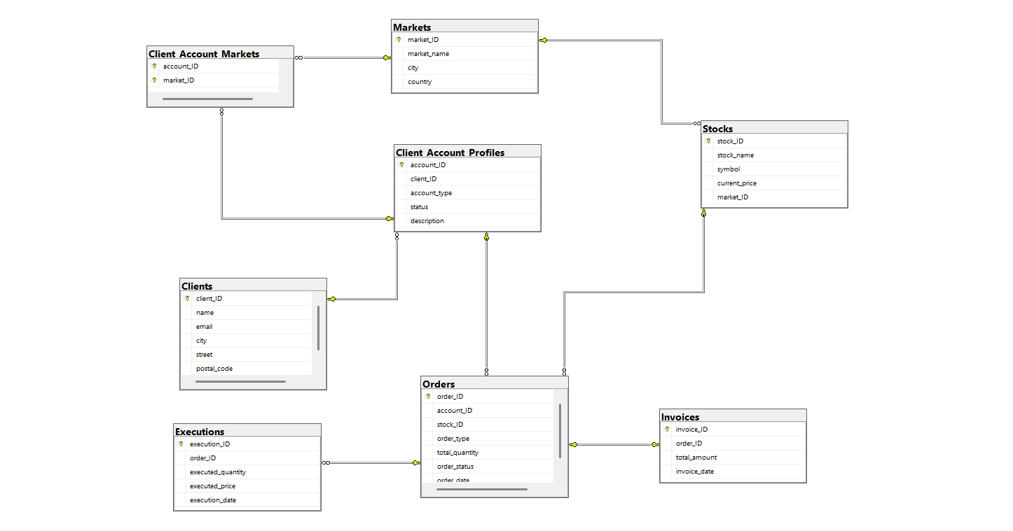
My DB Schema Design:
- My ERD Design exist on my Repository.
- Queries for Trigger and SP to handle Invoices, Executions Case and only authorized Accounts can Trade (Sell or Buy) Link for All in GitHub:
https://github.com/olaNazmy/EFG_TaskCompletion

