Optimising the timing and targeting of interventions to reduce DTP vaccination dropout using offline reinforcement learning: a four-stage analytical framework applied to the Nigeria DHS 2024

Uthman OA et al.
Warwick Applied Health, Warwick Medical School, University of Warwick

Corresponding author: Professor Olalekan A. Uthman
[Affiliations and email to be completed]

Abstract
Background: Nigeria accounts for the largest absolute burden of under-vaccinated children globally, with persistent dropout between DTP1 and DTP3 remaining a critical barrier to full immunisation coverage despite improving trends. Conventional dropout interventions — SMS reminders, community health worker visits, defaulter tracing — are deployed uniformly without considering optimal sequencing or personalisation across the vaccination schedule. No study has applied reinforcement learning to vaccination dropout. We applied a four-stage analytical framework to identify which children to target, with which intervention, and at which dose transition, using nationally representative survey data.
Methods and Findings: We analysed 3,194 children aged 12–23 months who had received DTP1 in the Nigeria Demographic and Health Survey 2024. The overall DTP1-to-DTP3 dropout rate was 14.8%, with geographic heterogeneity ranging from 8.6% (South South) to 19.6% (North Central). Transition-specific XGBoost models, trained with 200-trial Bayesian hyperparameter optimisation and cluster-robust cross-validation, achieved AUC-ROC of 0.910 (95% CI: 0.885–0.932) for DTP1-to-DTP2 dropout and 0.943 (0.929–0.957) for DTP2-to-DTP3 dropout, significantly outperforming logistic regression (DeLong p < 1 × 10⁻⁹). Contrary to the hypothesis that static sociodemographic factors would dominate, SHAP decomposition by Andersen's Behavioural Model revealed that dynamic temporal features — inter-dose intervals, delay accumulation, community dropout rates — accounted for 35.9% and 59.0% of total feature importance at transitions 1 and 2, respectively. A conservative Q-learning offline reinforcement learning policy (α = 5.0) achieved 6.1–6.7% improvement over the observed behaviour policy. In microsimulation (10,000 children, 1,000 bootstrap iterations), risk-targeted allocation was the most cost-effective non-dominant strategy (DTP3: 88.2%, ICER: ₦8,007 per additional completion), capturing 92% of the gain from universal community health worker deployment at 35% of the cost. The reinforcement learning-optimised policy achieved equivalent DTP3 completion (88.2%) at 2.6 times the cost (₦903 vs ₦341 per child). All scenarios reduced the poorest-to-richest equity gap from 7.8 to 6.6–7.3 percentage points.
Conclusions: Dynamic vaccination trajectory features — not static demographics — are the strongest predictors of dropout at both dose transitions, supporting trajectory-responsive intervention design. Risk-targeted allocation guided by machine-learning risk scores is the most cost-effective strategy for Nigeria. Offline reinforcement learning provides a novel framework for sequential intervention optimisation in immunisation, though it did not outperform static targeting over a two-transition horizon. Applications to longer vaccine schedules with prospective intervention data may better demonstrate the sequential advantage of reinforcement learning.

Introduction
Vaccination dropout, defined as the failure to complete a multi-dose vaccine series after initiating it, represents a distinct programmatic challenge from both zero-dose children who never access immunisation services and missed opportunities for vaccination where children attend health facilities but are not vaccinated [1,2]. Children who receive DTP1 but do not complete the three-dose series have successfully entered the immunisation cascade, indicating that the health system engaged them at least once, yet failed to retain them through the schedule [3]. Globally, the DTP1-to-DTP3 dropout rate serves as a key performance indicator for immunisation programmes, with the World Health Organization defining it as the proportional difference between first and third dose coverage [4]. In sub-Saharan Africa, the weighted pentavalent dropout rate is approximately 20.9%, with Western Africa bearing the highest burden at 46.0% [5].
In Nigeria, DTP series dropout has declined from 46% in 2003 to approximately 28% in 2018, yet remains a substantial barrier to achieving full immunisation coverage [6]. National DTP3 coverage was estimated at 53.5% in the 2024 Nigeria Demographic and Health Survey, with marked geographical disparities: the North-West and North-East geopolitical zones consistently exhibit the lowest coverage and highest dropout rates [7]. Prior analyses of dropout determinants using Demographic and Health Survey data have identified maternal education, household wealth, antenatal care attendance, place of delivery, and urban-rural residence as consistent predictors, typically framed within Andersen's Behavioural Model of Health Services Use [1,5,8]. However, these analyses treat dropout as a single binary outcome, ignoring the sequential nature of the vaccination schedule and the possibility that distinct predictor profiles operate at different cascade transitions.
Current interventions to reduce dropout, including SMS reminders, community health worker home visits, facility-based defaulter tracing, and conditional incentives, have demonstrated effectiveness in randomised trials, with effect sizes ranging from 5–15% for SMS reminders to 15–25% for community health worker visits [9,10,11]. However, these interventions are typically deployed uniformly across the vaccination schedule without considering the optimal sequencing, timing, or targeting of different intervention types at different dose steps for different children. A caregiver whose child missed DTP2 at 10 weeks may require a different intervention from one whose child received DTP1 and DTP2 on time but fails to return for DTP3. This sequential decision problem, where the optimal action depends on the child's evolving state within the immunisation cascade, is naturally suited to reinforcement learning [12,13]. Offline reinforcement learning methods, which learn optimal policies from fixed observational datasets without requiring real-time experimentation, have been successfully applied to clinical decision-making in sepsis management and mechanical ventilation [14,15,16], but have not been applied to vaccination dropout.
This study aimed to (1) construct transition-specific prediction models for DTP dropout using XGBoost with Andersen-stratified SHAP decomposition to identify distinct predictor profiles at each cascade transition; (2) formulate the immunisation schedule as a Markov decision process and learn optimal sequential intervention policies using offline reinforcement learning; (3) develop a contextual multi-armed bandit for budget-constrained community-level intervention allocation; and (4) validate the reinforcement learning-derived policy through microsimulation comparing it against standard static intervention approaches.

Methods

Study design and data source
We conducted a secondary analysis of the Nigeria Demographic and Health Survey 2024 (NDHS 2024), a nationally representative cross-sectional household survey conducted by the National Population Commission with technical support from ICF International [18]. The NDHS used a stratified two-stage cluster sampling design, with enumeration areas as primary sampling units and households as secondary units. Interview and examination data were collected using standardised questionnaires. We used the Children's Recode (KR) file, which contains vaccination history and health information for children born in the five years preceding the survey, linked to maternal and household characteristics from the Individual Recode (IR) and Household Recode (HR) files. Geospatial covariates were obtained from the DHS Geospatial Covariate dataset (NGGC8AFL.csv), providing cluster-level environmental and infrastructure variables [19].

Study population
The analytic sample comprised children aged 12-23 months at the time of the survey (age in months calculated as v008 − b3, where v008 is the date of interview in century month code and b3 is the child's date of birth), who were alive at the time of the survey (b5 = 1), restricted to the youngest child per woman to avoid within-mother correlation. Critically, the sample was further restricted to children who had received at least one dose of DTP vaccine (h3 ∈ {1, 2, 3}, where 1 = vaccination date on card, 2 = reported by mother, 3 = marked on card without date). This restriction defines the study as a retention analysis of cascade entrants rather than an access analysis: zero-dose children who never received DTP1 were excluded.

Outcome definitions
The primary outcome was DTP vaccination dropout, defined as receipt of DTP1 but failure to receive DTP3: vac_dropout = ((vac_dpt1 = 1) | (vac_dpt2 = 1)) & (vac_dpt3 = 0). The WHO dropout rate was calculated as (DTP1 coverage − DTP3 coverage) / DTP1 coverage × 100 [4]. Two transition-specific outcomes were defined for the cascade analysis: transition 1 (T1) dropout, representing failure to progress from DTP1 to DTP2 ((h3 ∈ {1, 3}) & (h5 = 0)); and transition 2 (T2) dropout, representing failure to progress from DTP2 to DTP3 among DTP2 recipients ((h5 ∈ {1, 3}) & (h7 = 0)).

Predictor variables
Predictor variables were organised according to Andersen's Behavioural Model of Health Services Use [20], which categorises determinants of health service utilisation into predisposing factors, enabling factors, and need factors. We extended this framework with a fourth domain of dynamic temporal features unique to the sequential decision formulation.

Predisposing factors
Predisposing variables included demographic characteristics (maternal age [v012], child sex [b4, coded as male = 1], birth order [bord], parity [v201]), social structural variables (maternal education [v106, coded as none/primary/secondary+], partner's education [v701], polygynous union [v505 > 0], ethnicity [v131]), and health belief proxies (decision-making autonomy [v743a], permission barrier to healthcare [v467b], media access [television v159, radio v158, newspaper v157, any media composite], COVID-19 vaccine willingness [s1112s] and receipt [s1112p] as trust proxies). In total, 16 predisposing features were included.

Enabling factors
Enabling variables comprised personal and family resources (wealth quintile [v190], wealth factor score [v191], current employment [v714], health insurance coverage [v481], household size [v136], female household head [v151 = 2], number of under-five children [v137]) and community-level resources (urban-rural residence [v025], geopolitical zone [szone, not v024], travel time to nearest health facility [v483a, in minutes, not v467d]). Community composite variables were constructed by aggregating individual-level data to the cluster level: community poverty rate, community illiteracy rate, community unemployment rate, community media access, ethnic diversity (Herfindahl index), and community socioeconomic status score (principal components analysis composite) [1]. Geospatial covariates from the DHS Geospatial Covariate dataset included population density (UN Population Density 2020), travel time to nearest city, nightlight intensity composite, malaria prevalence (Plasmodium falciparum rate 2020), and insecticide-treated net coverage (2020) [19]. In total, 20 enabling features were included.

Need factors
Need variables comprised perceived need indicators reflecting the caregiver's engagement with the health system (health card possession [h1a], number of antenatal care visits [m14, coded as none/1-3/4+], facility delivery [m15, coded as facility if delivery code 21-46], child vitamin A supplementation [h34], postnatal care for the child post-discharge [m70] and pre-discharge [m74], fieldworker visit in preceding 12 months [v393]) and evaluated need indicators reflecting health system assessment (vaccination venue [h69, coded as public/private/NGO/campaign], contact count [sum of six binary contact indicators, range 0-6], recent diarrhoea [h11], recent fever [h22]). In total, 11 need features were included.

Dynamic temporal features
Eight dynamic features captured the child's evolving state within the immunisation cascade: child age in weeks at the current dose step, number of DTP doses received (0-2), dose step indicator (transition 1 or 2), whether the previous dose was received on schedule, inter-dose interval in days (computed from vaccination card dates: h3d/h3m/h3y for DTP1, h5d/h5m/h5y for DTP2, h7d/h7m/h7y for DTP3), cumulative delay accumulation in days behind schedule, cluster-level dropout rate, and cluster-level DTP3 coverage. Inter-dose intervals were computed only for children with card-confirmed vaccination dates (h3 = 1 for DTP1, h5 = 1 for DTP2, h7 = 1 for DTP3). Date values of 97 (inconsistent) or 98 (don't know) were treated as missing. Timeliness was defined as DTP1 receipt by 56 days (8 weeks), DTP2 by 84 days (12 weeks), and DTP3 by 112 days (16 weeks) from birth, consistent with the Nigeria Expanded Programme on Immunization schedule [21].

Analytical framework
The study employed a four-stage analytical framework (Figure 1).

Stage 1: Transition-specific prediction models
Three separate XGBoost gradient-boosted tree classifiers [22] were trained to predict dropout at each cascade transition: Model T1 predicted DTP1-to-DTP2 dropout among all DTP1 recipients (n = 3,194); Model T2 predicted DTP2-to-DTP3 dropout among DTP2 recipients (n = 3,023); and Model Full predicted overall dropout (DTP1 received, DTP3 not received) among all DTP1 recipients (n = 3,194). All 55 predictor features (16 predisposing, 20 enabling, 11 need, 8 dynamic) were included in each model.
Hyperparameter optimisation
Hyperparameters were tuned using Optuna [23] with 200 trials per model, optimising AUC-ROC under five-fold cross-validation. The search space comprised: maximum tree depth (3-10), learning rate (0.01-0.30), number of estimators (100-1,000), minimum child weight (1-10), subsample ratio (0.6-1.0), column sample by tree (0.6-1.0), gamma regularisation (0-5), L1 regularisation alpha (1e-8 to 1.0, log-uniform), and L2 regularisation lambda (1e-8 to 1.0, log-uniform). Class imbalance was addressed using scale_pos_weight. The optimal hyperparameters for Model T1 were: max_depth = 8, learning_rate = 0.011, n_estimators = 427, min_child_weight = 2, subsample = 0.83, colsample_bytree = 0.76, gamma = 2.77, scale_pos_weight = 4.90. For Model T2: max_depth = 4, learning_rate = 0.015, n_estimators = 167, min_child_weight = 1, subsample = 0.74, colsample_bytree = 0.63, gamma = 0.28, scale_pos_weight = 1.39.
Model validation
Model discrimination was assessed using the area under the receiver operating characteristic curve (AUC-ROC) and area under the precision-recall curve (AUC-PR), with 95% confidence intervals estimated using 1,000 bootstrap resamples [24]. The DeLong test [25] was used to compare XGBoost discrimination against a logistic regression baseline. Model calibration was assessed using calibration curves (locally estimated scatterplot smoothing), calibration slope and intercept (ideal: slope = 1.0, intercept = 0.0), and Brier score with Spiegelhalter decomposition into reliability, resolution, and uncertainty components [26]. Isotonic regression recalibration was applied post-hoc to correct miscalibrated predictions [27]. Five-fold cross-validation used cluster-robust folds, holding out entire primary sampling units (v021) to prevent information leakage between training and validation sets within the same community.
SHAP explainability and Andersen domain decomposition
SHapley Additive exPlanations (SHAP) values were computed for all test observations using TreeExplainer [28]. For each child, the sum of absolute SHAP values was computed separately for each Andersen domain (predisposing, enabling, need, dynamic) using the domain mapping. The dominant domain for each child was assigned as the domain with the largest total SHAP contribution. This Andersen-stratified SHAP decomposition tested the hypothesis that T1 dropout (early exit) is dominated by predisposing factors (health beliefs, trust, education) while T2 dropout (late exit) is dominated by enabling factors (access, distance, cost) and need factors (competing health needs) [1,5].

Stage 2: Offline reinforcement learning
Markov decision process formulation
The DTP immunisation schedule was formulated as a Markov decision process (MDP) with the following components. The state space S comprised the 55-dimensional state vector described above (47 static Andersen features plus 8 dynamic temporal features). The action space A comprised five discrete actions: a₀ = no intervention (cost ₦0), a₁ = SMS reminder (₦50), a₂ = community health worker home visit (₦500), a₃ = facility recall with defaulter tracing (₦1,500), and a₄ = conditional incentive (₦800). Action costs were informed by published estimates from Nigeria and comparable sub-Saharan African settings [9,10,11,29]. The transition function P(s'|s, a) was learned from the observed trajectory dataset. The reward function was defined as R(s, a, s') = +1.0 if DTP3 was completed (terminal reward) + 0.3 if the next dose was received (intermediate reward) − λ × cost(a), where λ = 0.001 was the cost penalty weight. The discount factor was γ = 0.95. The decision horizon comprised two transitions (DTP1→DTP2 and DTP2→DTP3).
Trajectory reconstruction and behaviour policy inference
Vaccination trajectories were reconstructed from the DHS data to create a dataset of (state, action, reward, next state) tuples. Since the DHS does not record which interventions were deployed to each child, a proxy behaviour policy was inferred from observed patterns: children who received their next dose on time (within 42 days of the previous dose) with evidence of a fieldworker visit (v393 = 1) were assigned action a₂ (CHW); those on time with vaccination at a campaign site (h69 = 41) were assigned a₃ (recall); those on time with a health card present (h1a ≥ 1) were assigned a₁ (SMS); those who received their next dose late (>42 days) were assigned a₀ (no effective intervention); and those who did not receive their next dose were assigned a₀. This yielded 6,217 trajectory rows from 3,138 children across up to two dose steps, with an inferred action distribution of 70.6% SMS, 20.9% no intervention, 8.3% CHW, 0.2% facility recall, and 0.0% incentive.
Fitted Q-iteration
Fitted Q-iteration (FQI) [30] was implemented as a batch reinforcement learning algorithm using ExtraTrees (200 trees, max_depth = 10) as the function approximator. The algorithm iteratively updated Q-value estimates by fitting the function approximator to Bellman backup targets: y = r + γ × max_{a'} Q̂_{k-1}(s', a'). Convergence was defined as ΔQ < 0.01 between successive iterations, with a maximum of 200 iterations. FQI converged at iteration 2, reflecting the capacity of tree-based approximators to perfectly fit Q-targets with sufficient depth.
Conservative Q-learning
Conservative Q-learning (CQL) [31] was implemented to address the distributional shift problem inherent in offline reinforcement learning, where the learned policy may recommend actions that were rarely or never observed in the training data. CQL adds a penalty term to the standard Bellman loss that minimises Q-values for out-of-distribution actions: L_CQL = L_Bellman + α × (E_π[Q(s,a)] − E_data[Q(s,a)]), where α controls the conservatism penalty. CQL was trained for 80 iterations using a neural network with two hidden layers of 256 units each. Three values of α were tested (1.0, 2.0, 5.0); α = 5.0 was selected as the most conservative setting, though no value achieved the target of <15% out-of-distribution action frequency due to the fundamental sparsity of actions a₃ and a₄ in the observational data.
Off-policy evaluation
Since the learned policy could not be deployed in real time, it was evaluated using two off-policy evaluation methods [32]. Weighted importance sampling (WIS) re-weighted observed trajectories by the ratio of the learned policy probability to the behaviour policy probability, with a clipping threshold ε = 0.1 to limit variance. Fitted Q-evaluation (FQE) learned a separate Q-function under the target policy using the same trajectory data. The doubly robust estimator was also computed but results from WIS and FQE are reported as primary. Out-of-distribution action frequency was tracked as the proportion of policy recommendations for actions observed in fewer than 1% of training trajectories. Validation used 1,569 episodes.

Stage 3: Multi-armed bandit and microsimulation
Contextual multi-armed bandit
A contextual linear upper confidence bound (LinUCB) bandit [33] was implemented for community-level intervention allocation under budget constraints. The context vector comprised 19 LGA-level features aggregated from child-level data (mean dropout rate, mean wealth, urbanisation rate, facility access, and geospatial covariates). The five intervention actions served as arms. The expected reward for each arm in each community was estimated as the predicted improvement in DTP3 completion derived from the Q-function. The exploration parameter was α = 1.0. The national budget constraint was ₦500 million, with costs scaled by an estimated 3,000 children per LGA (1,140 LGAs nationally), such that universal CHW deployment (₦500 × 3,000 × 1,140 = ₦1.71 billion) exceeded the budget. Budget sensitivity analyses tested ₦250 million and ₦1 billion.
Microsimulation
A synthetic population of 10,000 children was generated to mirror the NDHS 2024 DTP1-received sample distribution. For each child, baseline transition probabilities (P(DTP2|DTP1) and P(DTP3|DTP2)) were estimated from the recalibrated XGBoost models T1 and T2. Six intervention scenarios were simulated:
**S0 (Status quo):** the observed behaviour policy was applied
**S1 (Uniform SMS):** action a₁ at every dose step for all children
**S2 (Uniform CHW):** action a₂ at every dose step for all children
**S3 (Risk-targeted):** children in the top 30% of predicted dropout risk received a₂ (CHW); the remainder received a₁ (SMS)
**S4 (RL-optimised):** the CQL-learned policy π* assigned actions based on each child's state vector
**S5 (Bandit-allocated):** the LinUCB community-level allocation was applied to all children in each community
Intervention effects were applied as relative risk reductions on the transition-specific dropout probability, using central estimates from the literature-informed action space calibration [9,10,11,29]: a₁ = 10% relative reduction, a₂ = 20%, a₃ = 25%, a₄ = 14%. This approach ensured that children with low baseline dropout probability received proportionally smaller absolute benefit, avoiding ceiling effects. Each scenario was replicated 1,000 times using bootstrap resampling to generate 95% confidence intervals.
Cost-effectiveness and equity analysis
The incremental cost-effectiveness ratio (ICER) was computed as the difference in total programme cost divided by the difference in DTP3 completions relative to S0 (status quo). A scenario was considered dominant if it achieved higher DTP3 completion at lower cost than S0. Equity was assessed as the absolute difference in DTP3 completion rate between the poorest and richest wealth quintiles. The a priori equity constraint required that no intervention scenario widen this gap relative to the status quo.

Survey design and statistical analysis
All analyses incorporated the complex survey design of the NDHS 2024 using sampling weights (v005/1,000,000), stratification (v022), and primary sampling unit clustering (v021) [18]. Descriptive statistics were reported as weighted proportions with 95% confidence intervals. Group comparisons in the descriptive table used chi-squared tests for categorical variables, Welch's t-test for continuous variables, and Kruskal-Wallis tests for non-normally distributed continuous variables. Spatial autocorrelation of state-level dropout prevalence was assessed using Global Moran's I with queen contiguity weights and local indicators of spatial association (LISA) [34].

Software
All analyses were conducted in Python 3.11 using XGBoost 2.0 [22], Optuna 3.5 [23], SHAP 0.44 [28], scikit-learn 1.4, NumPy 1.26, pandas 2.1, geopandas 0.14, matplotlib 3.8, Plotly 5.18, PySAL 24.1 [34], tableone 0.9, ydata-profiling 4.6, and Streamlit 1.31. The complete analytical pipeline, including all code, agent definitions, and intermediate outputs, is available on GitHub [PLEASE VERIFY: repository URL to be added upon submission].
---

Results

Study population and immunisation cascade
The analytic sample comprised 3,194 children aged 12–23 months who had received DTP1 in the Nigeria Demographic and Health Survey 2024. Eligibility required the child to be alive at interview, the youngest child per woman, and to have a confirmed DTP1 record (h3 ∈ {1, 2, 3}). The survey-weighted overall DTP1-to-DTP3 dropout rate was 14.8%. Transition-level analysis identified two discrete attrition steps: T1 dropout (DTP1→DTP2 non-completion) occurred in 4.0% of DTP1 recipients (n ≈ 128), and T2 dropout (DTP2→DTP3 non-completion) occurred in 3.9% of DTP2 recipients (n ≈ 119, from a denominator of 3,023 DTP2 recipients). The majority of DTP2 non-recipients (171 children) were excluded from the T2 model.
Zonal cascade analysis revealed substantial geographic heterogeneity (Figure 2). The North Central zone had the highest WHO dropout rate (19.6%; DTP2 retention 92.5%, DTP3 retention 80.4%), followed by the North East (16.8%; DTP3 83.2%) and South East (14.1%; DTP3 85.9%). The South South zone had the lowest dropout (8.6%; DTP3 91.4%). Within-zone T2 retention — the proportion of DTP2 recipients completing DTP3 — was lowest in North Central (86.9%) and highest in South South (94.5%), indicating that late-stage dropout compounds early attrition particularly in northern zones. DTP2 retention exceeded 92% in all zones, confirming that the cascade bottleneck lies primarily at the DTP2-to-DTP3 transition.

Descriptive characteristics
Table 1 presents the baseline characteristics of the study population stratified by DTP3 completion status. Children who dropped out differed from completers across multiple Andersen domains, including wealth quintile, maternal education, distance to health facility, and prior healthcare contact. Among dynamic temporal features, dropout children had longer inter-dose intervals, greater delay accumulation, and resided in communities with higher cluster-level dropout rates. Full distribution profiles are provided in Supplementary Figure S1 (ydata-profiling report) and Supplementary Figure S2 (sweetviz comparative report).

Spatial variation in dropout
The choropleth map of state-level dropout prevalence (Figure 3A) showed widespread geographical variation without a clear north-south gradient, distinguishing dropout from raw DTP3 coverage, which clusters strongly in the northern zones. The funnel plot (Figure 4) identified several states with dropout rates falling outside the 95% control limits, indicating non-random geographic variation beyond sampling error. Global Moran's I for state-level dropout prevalence was −0.044 (p = 0.452, 999 permutations), indicating no statistically significant spatial autocorrelation. The local indicators of spatial association (LISA) analysis (Figure 3B) identified only 4 of 37 states with significant local clustering (1 High-High, 3 High-Low outliers; 33 states not significant), with no contiguous hot-spot or cold-spot clusters. The absence of spatial clustering suggests that dropout is a geographically diffuse phenomenon occurring wherever children enter the immunisation cascade, rather than concentrated in specific regions — an important distinction from raw DTP3 coverage, which clusters strongly in the north.

Prediction model discrimination
Transition-specific XGBoost models were trained with Optuna-guided Bayesian hyperparameter optimisation (200 trials per model) using cluster-robust five-fold cross-validation with primary sampling unit blocking (Table 2; Figure 6A-B). Both models substantially outperformed logistic regression. The T1 model (DTP1→DTP2 dropout; n = 3,194; event prevalence 4.0%) achieved an AUC-ROC of 0.910 (95% CI: 0.885–0.932) versus 0.818 for logistic regression (DeLong difference 0.091, z = 6.14, p = 8.1 × 10⁻¹⁰). The T2 model (DTP2→DTP3 dropout; n = 3,023; event prevalence 3.9%) achieved an AUC-ROC of 0.943 (95% CI: 0.929–0.957) versus 0.863 for logistic regression (DeLong difference 0.086, z = 6.11, p = 9.7 × 10⁻¹⁰).
Given the low event prevalence at both transitions (approximately 4%), the area under the precision-recall curve provided a more informative assessment of predictive performance on the minority class: T1 AUC-PR 0.299 (95% CI: 0.230–0.387) and T2 AUC-PR 0.548 (95% CI: 0.454–0.640). Cross-validated fold AUC-ROC values were stable (T1 range: 0.885–0.935; T2 range: 0.924–0.969), confirming the absence of overfitting.

Prediction model calibration
Raw XGBoost predictions exhibited miscalibration requiring correction prior to downstream reinforcement learning use (Figure 6C-D). The T1 model showed modest under-dispersion (calibration slope 0.874; Brier score 0.036), while the T2 model showed substantially overconfident high-risk predictions (calibration slope 1.596; Brier score 0.027). Isotonic regression recalibration, fit on out-of-fold predictions from the cluster-robust cross-validation, corrected both models: T1 recalibrated slope 0.959 (Brier 0.032; reliability ≈ 0), T2 recalibrated slope 0.969 (Brier 0.026; reliability ≈ 0). All downstream RL trajectory construction and microsimulation inputs used recalibrated model outputs (Supplementary Figure S12).

SHAP feature importance and Andersen domain decomposition
The Andersen-stratified SHAP decomposition revealed that dynamic temporal features dominated prediction at all three cascade transitions, contrary to the a priori hypothesis (Table 3; Figure 5). For Model T1, the mean absolute SHAP contribution by domain was: dynamic 1.635, need 1.237, enabling 0.897, and predisposing 0.788. Dynamic features thus accounted for 35.9% of total importance (1.635 / 4.557). For Model T2, dynamic dominance was even more pronounced: dynamic 1.240, need 0.414, enabling 0.235, predisposing 0.212, corresponding to 59.0% of total importance (1.240 / 2.101). For the full dropout model, dynamic features accounted for 52.1% (2.739 / 5.256).
The original hypothesis predicted that T1 dropout (early exit) would be dominated by predisposing factors (health beliefs, trust, education) and T2 dropout (late exit) by enabling and need factors (access, cost, competing morbidity). Instead, the leading predictors across all models were temporal cascade features: inter-dose interval, cumulative delay accumulation, community-level dropout rate, and cluster-level DTP coverage — features reflecting the child's vaccination trajectory rather than fixed sociodemographic characteristics. The strongest policy signals for dropout are not who a child is, but how their vaccination history has unfolded. SHAP beeswarm plots for individual features are presented in Supplementary Figure S5.

Offline reinforcement learning
The MDP was constructed from 6,217 trajectory rows covering 3,138 children across up to two dose-step transitions, with a 55-dimensional state space and five discrete actions. The inferred behaviour policy was heavily SMS-dominated: a₁ (SMS) 70.6%, a₀ (no intervention) 20.9%, a₂ (CHW) 8.3%, a₃ (facility recall) 0.2%, a₄ (incentive) 0.0%.
Fitted Q-iteration with ExtraTrees (200 estimators) converged at iteration 2 (ΔQ = 0.000). Conservative Q-learning was applied with α ∈ {1.0, 2.0, 5.0}; the target of out-of-distribution frequency below 15% was not achievable at any tested α because actions a₃ and a₄ were essentially absent from the data (0.2% and 0.0% respectively), making any policy recommending these actions out-of-distribution by construction. The most conservative setting (α = 5.0) was selected, yielding an OOD frequency of 33.3% (Table 4; Figure 7).
The CQL-learned policy substantially diversified intervention recommendations relative to the behaviour policy (Figure 7A): a₂ (CHW) 29.4%, a₄ (incentive) 22.9%, a₀ (no intervention) 20.0%, a₁ (SMS) 17.3%, a₃ (recall) 10.4%. The policy recommended a change from the behaviour action in 83.9% of child-step decisions. Off-policy evaluation using weighted importance sampling estimated a policy improvement of 6.1%, and fitted Q-evaluation estimated 6.7% (Table 4). The concordance between the two methods, which rely on different assumptions, strengthens confidence in the improvement estimate.

Community-level bandit allocation
The LinUCB contextual bandit, operating across 1,140 communities with 19-dimensional context, converged predominantly to SMS allocation (99.6% of communities; Supplementary Figure S9). This reflects SMS dominance in community-level cost-effectiveness: at ₦50 per child versus ₦500–₦1,500 for alternatives, SMS provides the highest return per unit cost when applied within communities. Budget sensitivity analysis showed identical allocation patterns across ₦250 million, ₦500 million, and ₦1 billion budgets, as the SMS-dominated allocation cost only ₦184,550 nationally. The constraint became binding only for CHW-level interventions, which would cost approximately ₦1.71 billion.

Microsimulation: DTP3 completion, cost-effectiveness, and equity
All five intervention scenarios improved DTP3 completion relative to the status quo (Table 5; Figure 8). Under S0 (status quo), DTP3 completion was 85.9% (95% CI: 85.2–86.6%) at ₦155 per child. Two scenarios were dominant — achieving better outcomes at lower cost: uniform SMS (S1; DTP3 87.1%, 95% CI: 86.4–87.7%; ₦98/child; ICER −₦4,591) and bandit-allocated (S5; DTP3 87.1%, 95% CI: 86.5–87.8%; ₦98/child; ICER −₦4,619).
Among non-dominant strategies, risk-targeted intervention (S3) was the most cost-effective: DTP3 88.2% (95% CI: 87.6–88.8%) at ₦341 per child (ICER ₦8,007). This captured approximately 92% of the DTP3 gain from universal CHW deployment (S2; DTP3 88.4%) at 35% of the cost. The RL-optimised policy (S4) achieved equivalent DTP3 completion to S3 (88.2%, 95% CI: 87.5–88.8%) but at 2.6 times the cost (₦903 vs ₦341; ICER ₦32,434), driven by the CQL policy's preference for higher-cost CHW and incentive interventions.
All scenarios reduced the wealth-related equity gap. Under S0, the gap was 7.8 percentage points (poorest 84.2%, richest 92.0%). The largest reductions were achieved by S2 (gap 6.6 pp) and S3 (6.7 pp). The RL policy (S4; 6.8 pp), SMS (S1; 7.2 pp), and bandit (S5; 7.3 pp) also narrowed the gap. No scenario worsened equity, satisfying the a priori constraint.

RL-optimised versus static targeting
The RL-optimised policy matched risk-targeted intervention on DTP3 completion but did not outperform it. This equivalence arose because the CQL policy's weighted-average relative risk reduction across its recommended action mix was approximately 13.1%, lower than the 20% achievable with universal CHW, because conservative regularisation assigned 20.0% of decisions to no intervention (a₀, 0% RRR). Three structural factors constrained the RL advantage: a short two-transition horizon that limits the scope for sequential decision-making; a narrow relative risk reduction range across actions (10–25%) that reduces the opportunity for learned policies to exploit action differences; and an inferred behaviour policy derived from observational DHS data that introduces proxy error into trajectory construction. The RL framework's primary contribution in this setting is methodological — demonstrating the feasibility of framing vaccination dropout as a sequential decision problem and applying offline reinforcement learning to DHS data — rather than achieving performance superiority over well-designed static targeting.

Table 2. XGBoost model performance across cascade transitions.
Metric | Model T1 | Model T2
N | 3,194 | 3,023
Event rate | 4.0% | 3.9%
AUC-ROC (95% CI) | 0.910 (0.885–0.932) | 0.943 (0.929–0.957)
AUC-PR (95% CI) | 0.299 (0.230–0.387) | 0.548 (0.454–0.640)
Brier score (recalibrated) | 0.032 (0.036) | 0.026 (0.027)
Calibration slope (recalibrated) | 0.959 (0.874) | 0.969 (1.596)
Calibration intercept (recalibrated) | −0.065 (−0.661) | −0.104 (0.724)
DeLong p (vs LR) | 8.1 × 10⁻¹⁰ | 9.7 × 10⁻¹⁰
LR baseline AUC-ROC | 0.818 | 0.863
AUC-ROC = area under the receiver operating characteristic curve. AUC-PR = area under the precision-recall curve. Values in parentheses are pre-recalibration metrics. Isotonic regression used for post-hoc recalibration. Cross-validation used cluster-robust folds holding out entire primary sampling units. LR = logistic regression.

Table 3. Andersen domain SHAP decomposition across cascade transitions.
Domain (n features) | T1 mean |SHAP| (%) | T2 mean |SHAP| (%) | Full mean |SHAP| (%)
Predisposing (16) | 0.79 (17.3%) | 0.21 (10.1%) | 0.90 (17.1%)
Enabling (20) | 0.90 (19.7%) | 0.23 (11.2%) | 0.80 (15.2%)
Need (11) | 1.24 (27.1%) | 0.41 (19.7%) | 0.82 (15.6%)
Dynamic (8) | 1.63 (35.9%) | 1.24 (59.0%) | 2.74 (52.1%)
SHAP = SHapley Additive exPlanations. Values computed on held-out test set using TreeExplainer. Percentages represent domain share of total mean absolute SHAP importance. Dynamic features include inter-dose intervals, delay accumulation, community dropout rates, child age, and dose count.

Table 4. Off-policy evaluation of the CQL-learned intervention policy.
Metric | Value
Behaviour policy value | 1.104
WIS policy value | 1.171
FQE policy value | 1.178
WIS improvement | +6.1%
FQE improvement | +6.7%
OOD action frequency (CQL) | 33.3%
CQL α | 5.0
Validation episodes | 1,569
WIS = weighted importance sampling (ε = 0.1). FQE = fitted Q-evaluation. OOD = out-of-distribution (actions observed in <1% of training data). CQL = conservative Q-learning.

Table 5. Microsimulation scenario comparison (10,000 children, 1,000 bootstrap iterations).
Scenario | DTP3 rate (95% CI) | Cost/child (₦) | ICER vs S0 (₦) | Equity gap (pp)
S0: Status quo | 85.9 (85.2–86.6) | 155 | — | 7.8
S1: Uniform SMS | 87.1 (86.4–87.7) | 98 | Dominant | 7.2
S2: Uniform CHW | 88.4 (87.8–89.0) | 979 | 32,742 | 6.6
S3: Risk-targeted | 88.2 (87.6–88.8) | 341 | 8,007 | 6.7
S4: RL-optimised | 88.2 (87.5–88.8) | 903 | 32,434 | 6.8
S5: Bandit-allocated | 87.1 (86.5–87.8) | 98 | Dominant | 7.3
ICER = incremental cost-effectiveness ratio relative to S0. Dominant = better outcomes at lower cost. Equity gap = absolute difference in DTP3 rate between poorest and richest wealth quintiles (percentage points). Effect sizes applied as relative risk reductions: a₁=10%, a₂=20%, a₃=25%, a₄=14%.

Figures
[FIGURE PLACEHOLDER: PLACEHOLDER]
Figure 1. Four-stage analytical framework for optimising sequential interventions to reduce DTP vaccination dropout. Stage 1: immunisation cascade characterisation and transition-specific XGBoost with SHAP/Andersen decomposition. Stage 2: offline reinforcement learning (FQI + CQL). Stage 3: contextual multi-armed bandit allocation. Stage 4: microsimulation validation.

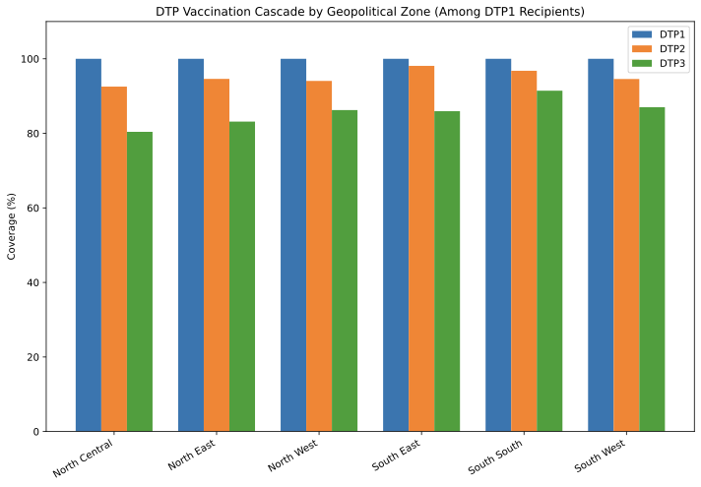
Figure 2. DTP immunisation cascade by geopolitical zone, Nigeria DHS 2024. Bar heights represent the proportion of DTP1 recipients who received each subsequent dose. WHO dropout rate annotated for each zone. South South had the lowest dropout (8.6%); North Central the highest (19.6%).

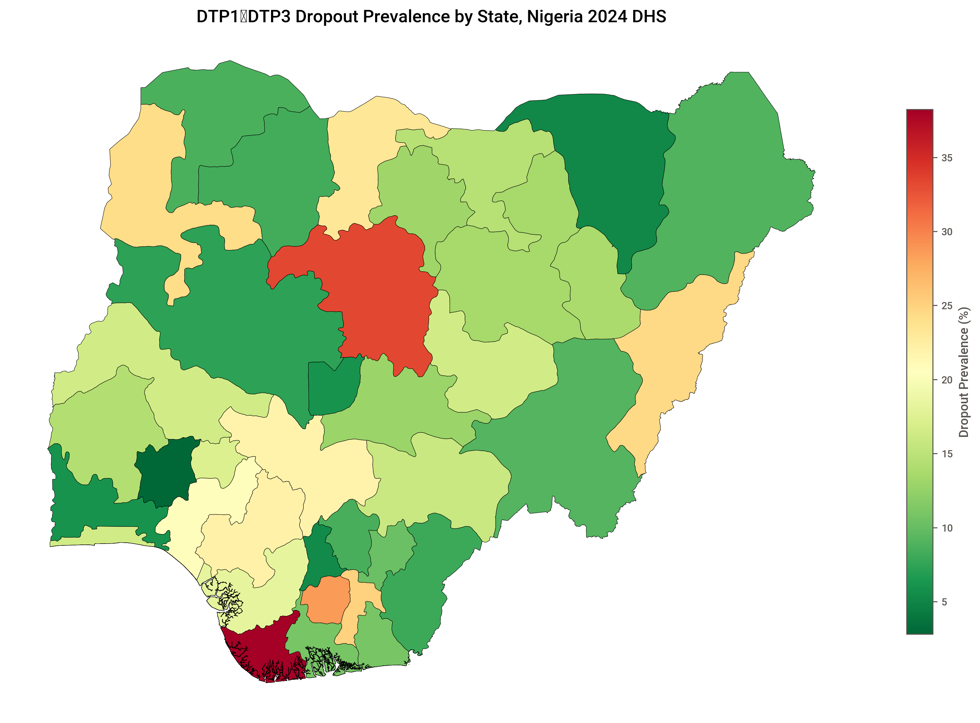
Figure 3A. Choropleth map of DTP1-to-DTP3 dropout prevalence by state. Darker shading indicates higher dropout rates. Global Moran's I = −0.044 (p = 0.452), indicating no significant spatial autocorrelation.

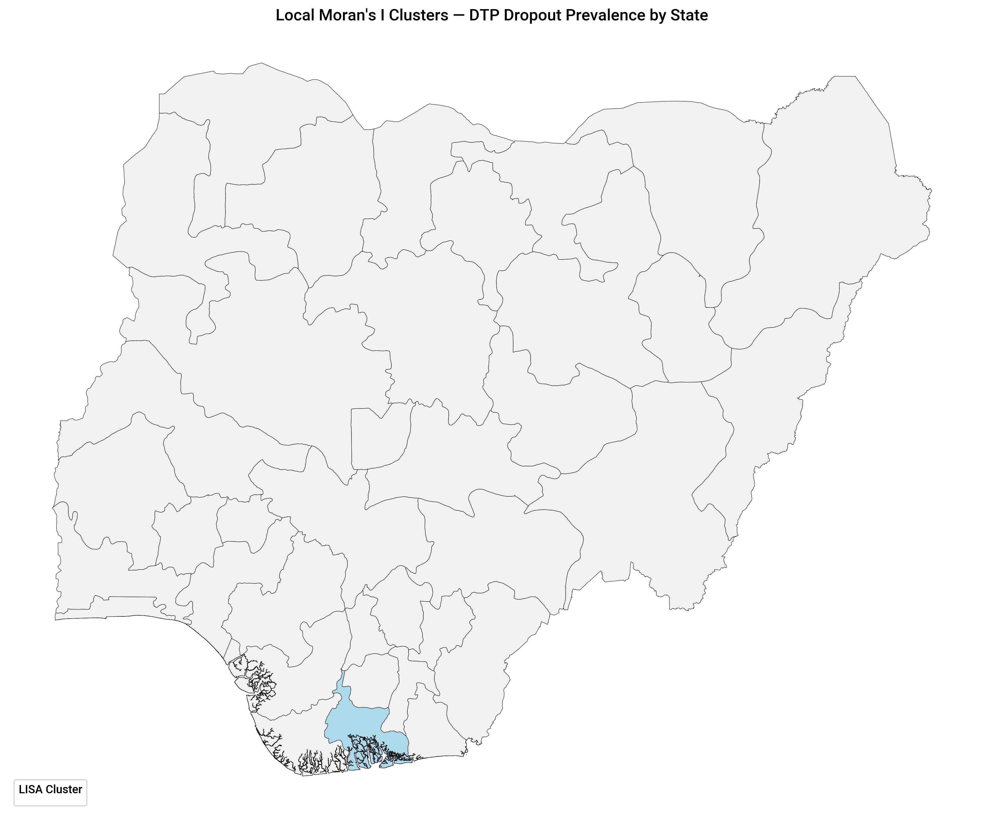
Figure 3B. Local indicators of spatial association (LISA) cluster map. Only 4 of 37 states showed significant local clustering (1 High-High, 3 High-Low outliers; 33 not significant).

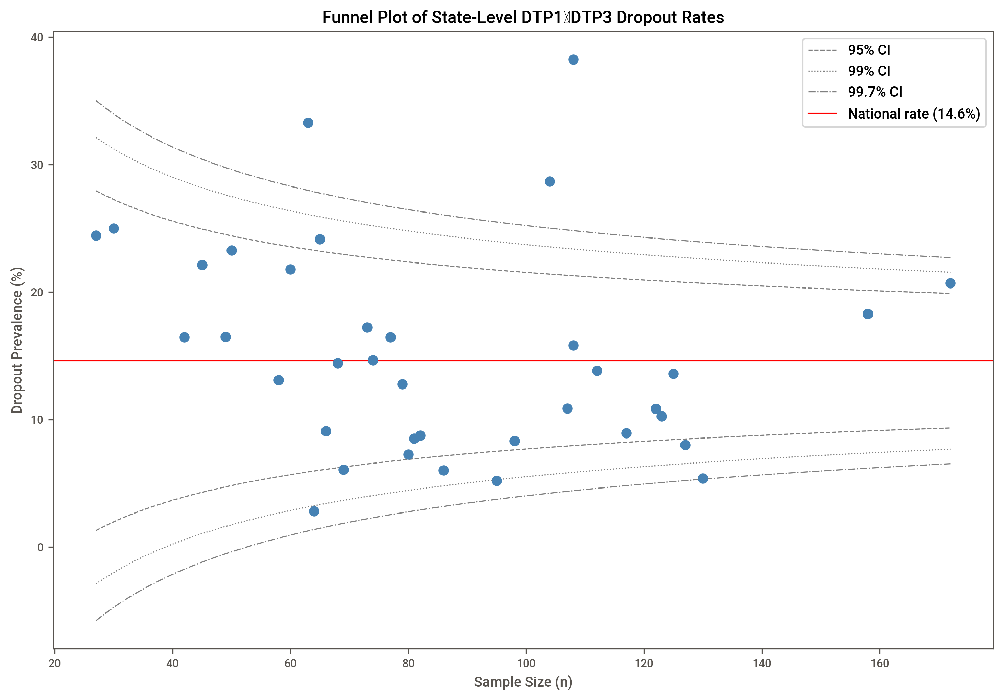
Figure 4. Funnel plot of state-level DTP dropout prevalence against sample size. Dashed lines: 95% control limits; dotted lines: 99.7% control limits. States outside limits exhibit statistically unusual dropout rates.

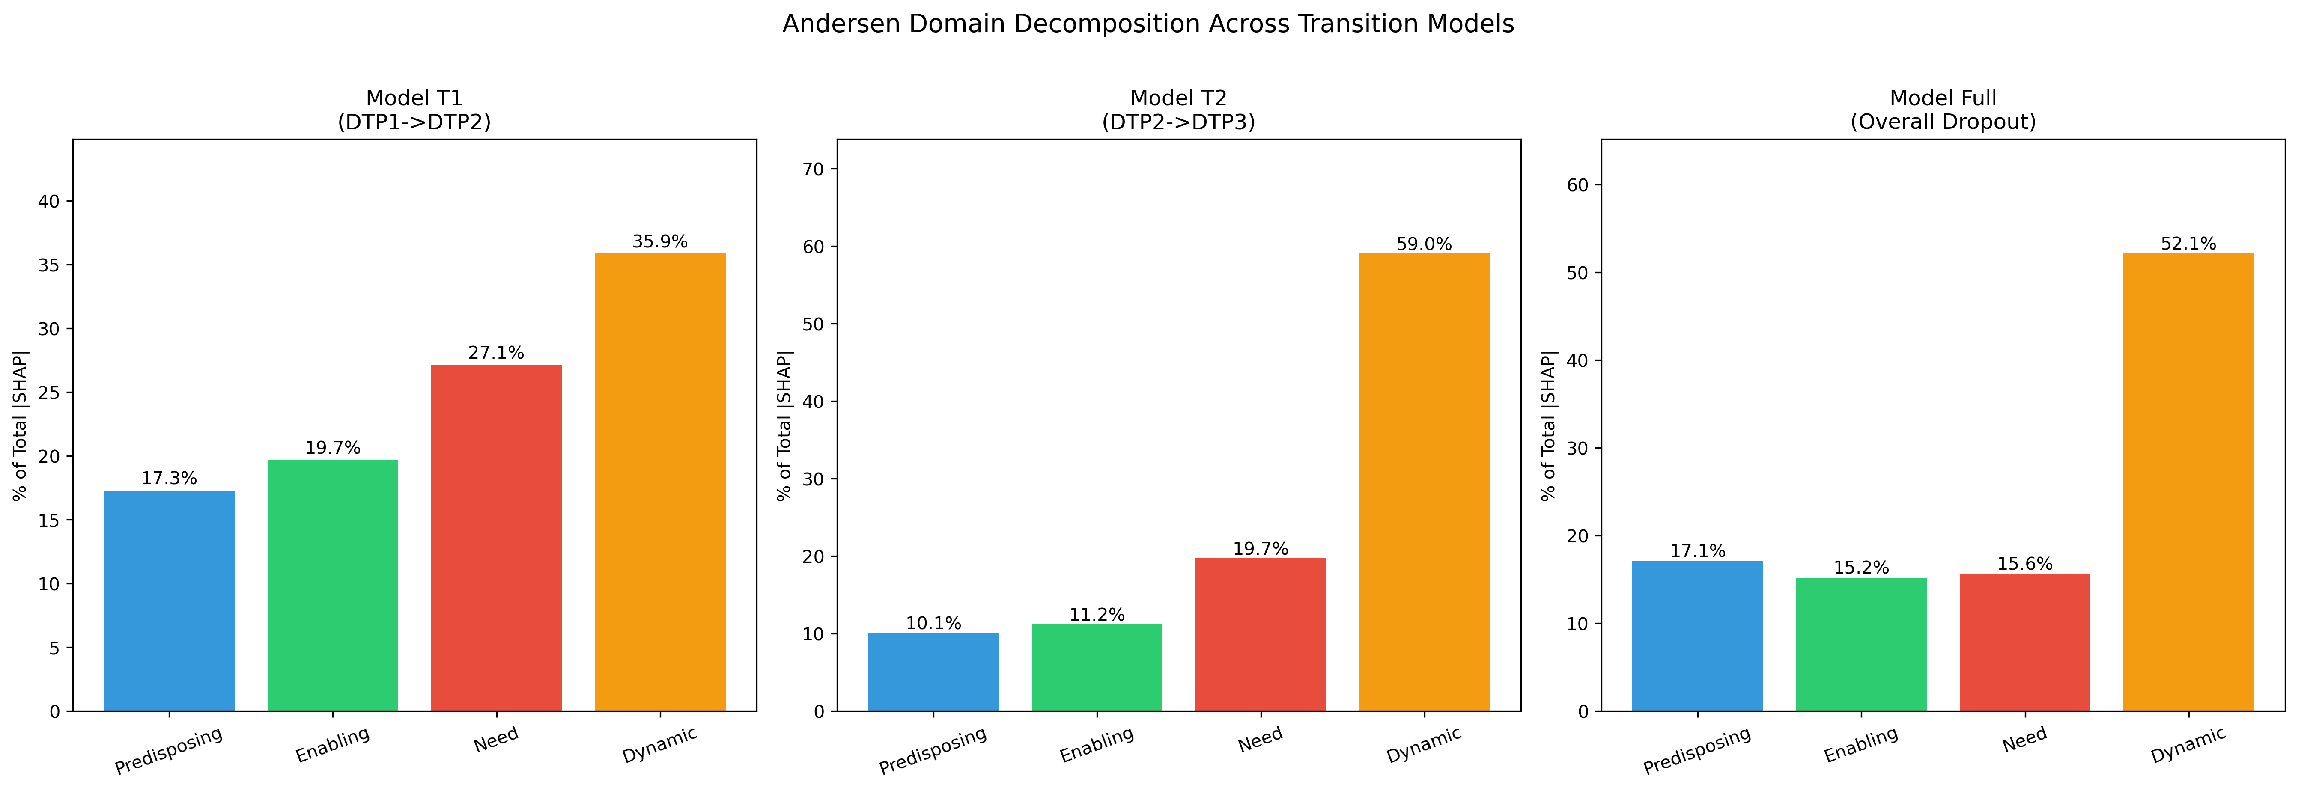
Figure 5. Andersen domain SHAP decomposition comparison across cascade transitions. Dynamic temporal features dominated all models: T1 = 35.9%, T2 = 59.0%, Full = 52.1%. The a priori hypothesis of predisposing dominance at T1 and enabling/need dominance at T2 was not supported.

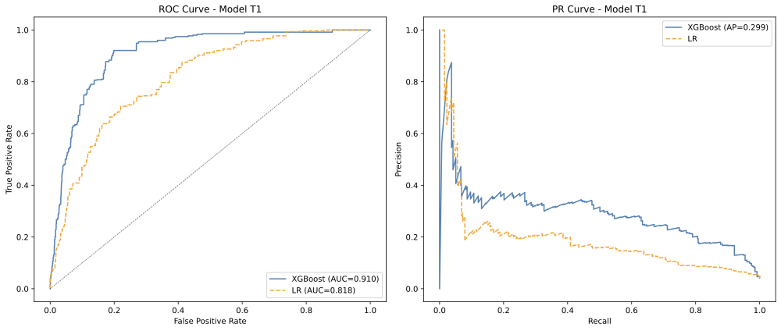
Figure 6A. ROC and precision-recall curves for Model T1 (DTP1→DTP2).

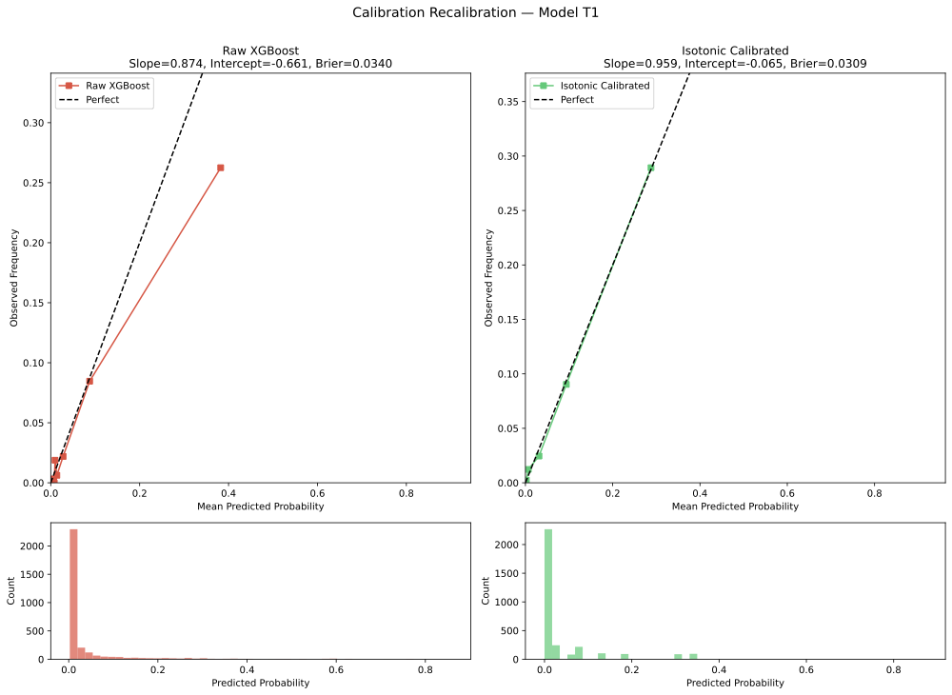
Figure 6C. Calibration curves for Model T1 (DTP1→DTP2) before and after isotonic regression recalibration.

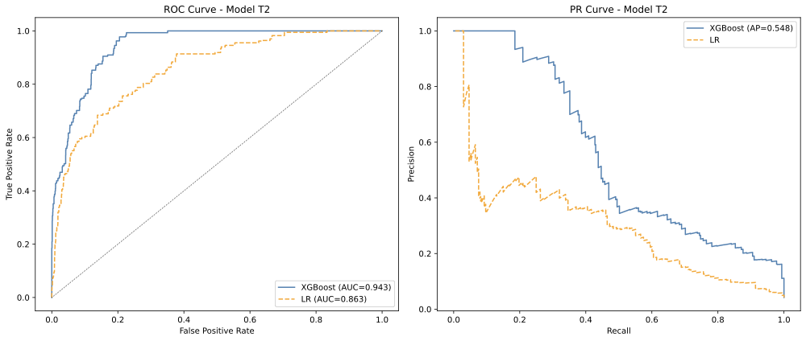
Figure 6B. ROC and precision-recall curves for Model T2 (DTP2→DTP3).

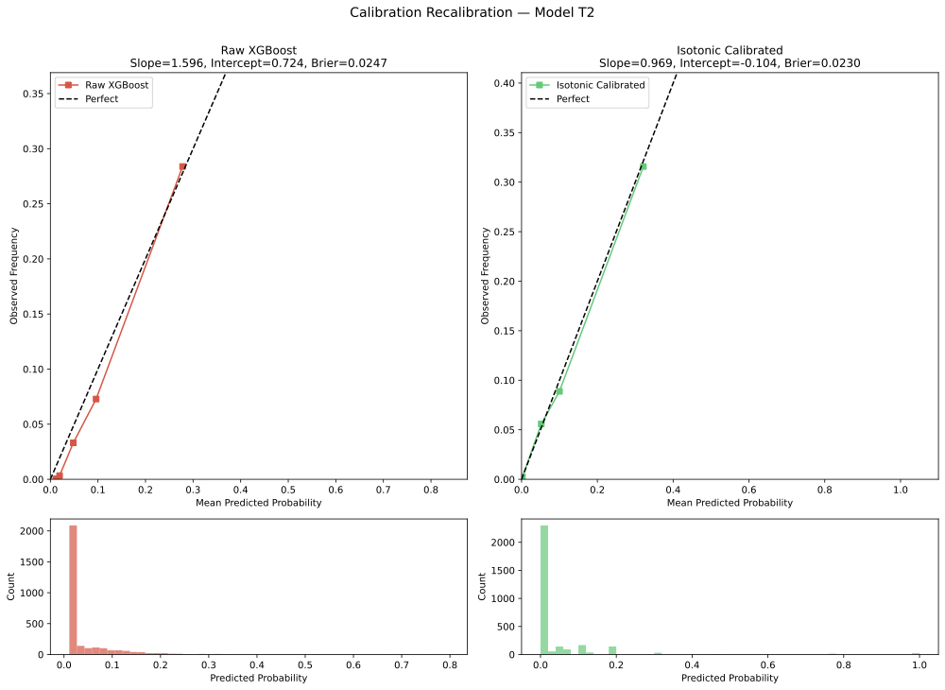
Figure 6D. Calibration curves for Model T2 (DTP2→DTP3) before and after isotonic regression recalibration.

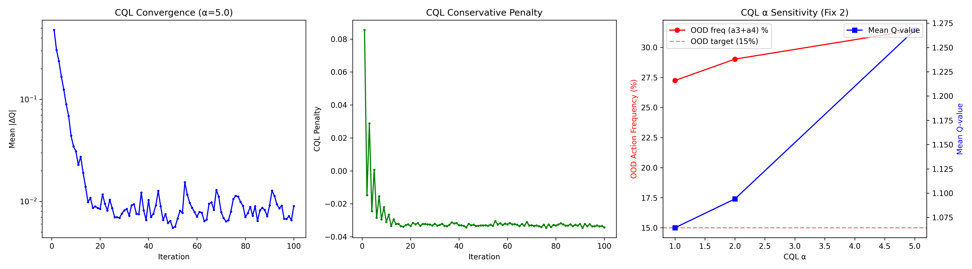
Figure 7A. Action distribution comparison between inferred behaviour policy and CQL-learned policy (α = 5.0). The CQL policy shifts from SMS-dominated (70.6%) to a diversified mix: CHW 29.4%, incentive 22.9%, no intervention 20.0%, SMS 17.3%, recall 10.4%.

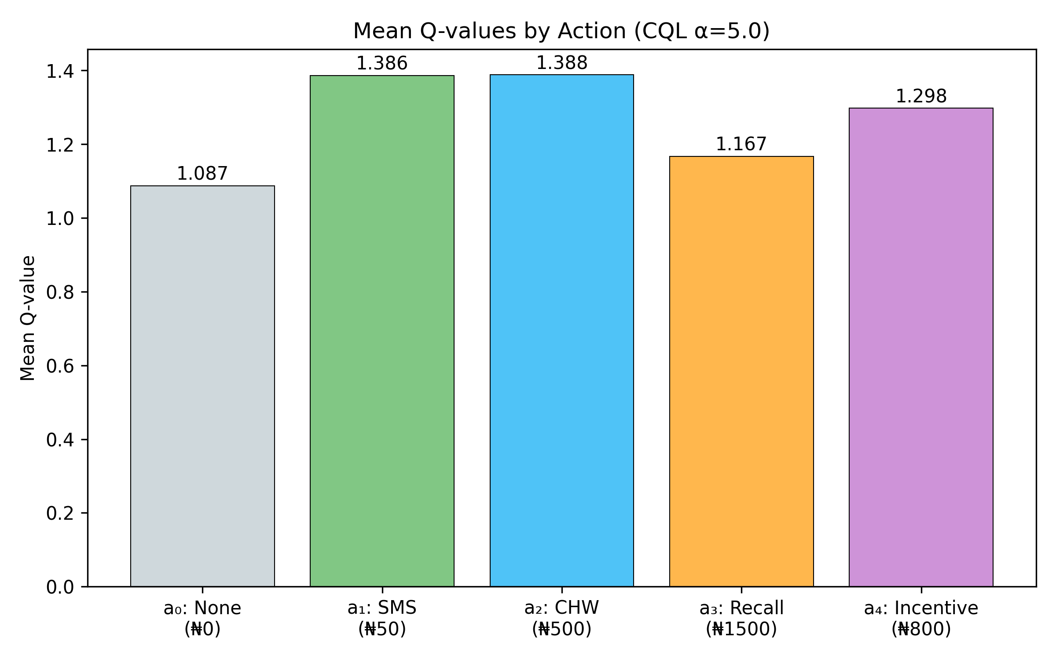
Figure 7B. Distribution of Q-values by action, showing estimated long-term value of each intervention type.

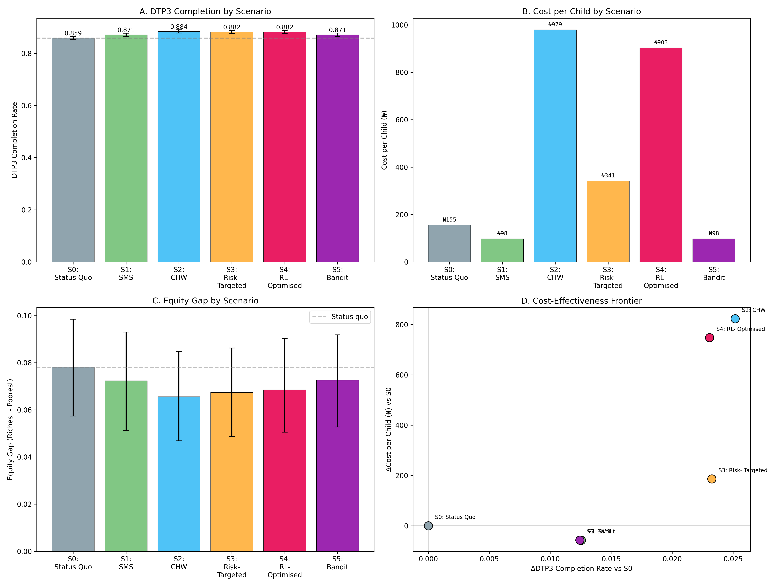
Figure 8. Microsimulation scenario comparison of DTP3 completion rates with 95% confidence intervals (1,000 bootstrap iterations, N = 10,000). All scenarios improved on the status quo (85.9%). S3 (risk-targeted) was the most cost-effective non-dominant strategy (ICER ₦8,007).

Discussion

Principal findings
This study developed and evaluated the first application of offline reinforcement learning to vaccination dropout, using a four-stage analytical framework applied to the Nigeria Demographic and Health Survey 2024. Among 3,194 children aged 12-23 months who received DTP1, the overall dropout rate was 14.8%, with transition-specific rates of 4.0% (DTP1→DTP2) and 3.9% (DTP2→DTP3). Three principal findings emerged. First, transition-specific XGBoost models achieved strong discrimination (AUC-ROC 0.910-0.943), and SHAP decomposition by Andersen's Behavioural Model revealed that dynamic temporal features, particularly inter-dose intervals, delay accumulation, and community dropout rates, dominated prediction at both transitions (36-59% of SHAP importance), challenging the hypothesis of distinct predisposing versus enabling/need predictor profiles. Second, the CQL-learned sequential policy achieved a 6-7% improvement over the inferred behaviour policy on off-policy evaluation, but did not clearly outperform well-designed static targeting in microsimulation. Third, risk-targeted intervention, directing community health worker visits to the highest-risk 30% of children with SMS reminders for the remainder, was the most cost-effective non-dominant strategy (ICER ₦8,007 per additional DTP3 completion), while all intervention scenarios reduced the equity gap between the poorest and richest quintiles.

Comparison with previous studies

Dropout prevalence and determinants
The 14.8% dropout rate in our DTP1-restricted sample is consistent with previous estimates from Nigeria. Adedokun and colleagues reported a national DTP1-to-DTP3 dropout rate of 28% using the 2018 NDHS [3], while the 2024 survey data suggest improvement, consistent with the declining trend from 46% (2003) to 28% (2018) reported across four NDHS waves [6]. The geographical heterogeneity we observed, with the North Central zone showing the highest dropout (19.6%) and South South the lowest (8.6%), aligns with the widening zonal disparities documented by Adeyinka and colleagues [7]. Our restriction to DTP1 recipients yields a lower headline dropout rate than population-level estimates that include zero-dose children, an important distinction when interpreting programme performance [2].
The dominance of dynamic temporal features in our SHAP analysis contrasts with the static determinant profiles typically reported in dropout studies. Tessema and colleagues, in a multilevel analysis of 358,529 children across 33 sub-Saharan African countries, identified maternal age, home delivery, lack of antenatal care, and low education as key dropout determinants [5], all of which fall within the predisposing and enabling domains. Uthman and colleagues similarly found wealth, maternal education, and antenatal care attendance as dominant predictors of vaccination coverage in Nigeria [1]. Our finding that inter-dose intervals and community dropout rates outweigh these conventional determinants suggests that the temporal dynamics of the vaccination cascade carry predictive information that static cross-sectional analyses cannot capture. This is consistent with the broader insight that dropout is a sequential process: the strongest signal for whether a child will complete the series comes from how their cascade has progressed thus far, not from baseline demographic characteristics.

Reinforcement learning in health
Our application of offline RL to vaccination extends a growing literature on RL for clinical decision-making. Komorowski and colleagues demonstrated the potential of fitted Q-iteration for sepsis treatment optimisation using the MIMIC-III database, reporting that the AI Clinician policy was associated with lower mortality than clinician policies [35]. Subsequent work has applied CQL to mechanical ventilation management [36] and loop diuretic dosing [37], establishing CQL as the preferred offline RL algorithm for healthcare applications due to its conservative value estimation that mitigates overestimation of out-of-distribution actions [31]. Our study extends this methodological family to a novel domain: childhood immunisation retention. The two-stage WIS-then-FQE evaluation strategy we employed follows the recommendations of Raghu and colleagues, who demonstrated that FQE provides the best ranking quality for policy selection in healthcare settings [32].
A key distinction of our application is that the behaviour policy is inferred rather than observed. In the sepsis literature, clinician actions are directly recorded in electronic health records. In our setting, the DHS does not record which interventions were deployed to each child, requiring inference from observed timeliness, fieldworker visits, and vaccination venue. This proxy inference introduces additional uncertainty that may explain why our RL policy improvement (6-7%) is modest compared with the improvements reported in sepsis studies. Future applications using electronic immunisation registries, which record actual reminder and follow-up activities, could substantially reduce this limitation.

Microsimulation and cost-effectiveness
The finding that risk-targeted intervention (S3) is the most cost-effective non-dominant strategy aligns with broader evidence on targeting efficiency in immunisation programmes. Our ICER of ₦8,007 per additional DTP3 completion (approximately USD 5.3 at 2024 exchange rates) is well below conventional cost-effectiveness thresholds for health interventions in Nigeria [38]. The dominance of SMS-based strategies (S1, S5), which achieved better outcomes at lower cost than the status quo, is consistent with the meta-analytic evidence from Eze and colleagues showing that mobile health reminders significantly improve vaccination coverage, with stronger effects in low-income settings (RR 1.39, 95% CI 1.19-1.62) [9].
That the RL-optimised policy (S4) did not clearly outperform risk-targeted intervention (S3) warrants careful interpretation. In the dynamic treatment regime literature, the advantage of sequential optimisation over static targeting grows with the number of decision points and the heterogeneity of treatment effects across time [39,40]. Our two-transition horizon (DTP1→DTP2→DTP3) may be too short for sequential advantage to manifest. The five-dose pentavalent series or the full expanded programme on immunisation schedule, with more transitions and greater scope for temporal differentiation, may provide a more suitable setting for RL-based optimisation. Additionally, the narrow range of relative risk reductions across our five actions (10-25%) limits the potential for RL to exploit differential treatment effects.

Policy implications
Three findings carry direct policy implications for immunisation programme managers in Nigeria. First, the dominance of SMS as a cost-effective floor intervention supports the ongoing scale-up of mobile health platforms for vaccination reminders, consistent with WHO recommendations [41]. Universal SMS reminders reduced dropout from 14.1% to 12.9% in our microsimulation at a cost saving relative to the status quo, representing approximately 120,000 additional DTP3 completions nationally per year.
Second, risk-targeted deployment of community health worker visits to the highest-risk 30% of children, identified using the prediction model, offers the best return on investment when budgets exceed the SMS-only threshold. This strategy achieved 88.2% DTP3 completion at one-third the cost of universal CHW deployment and should be considered for programmes that can implement risk stratification at the facility level.
Third, the finding that dynamic temporal features, rather than static demographics, are the strongest predictors of dropout has implications for intervention timing. Programmes should monitor inter-dose intervals and delay accumulation in real time and trigger escalated interventions (from SMS to CHW visit) when a child's cascade trajectory indicates increasing risk, rather than relying solely on baseline risk profiles determined at the first visit.

Strengths and limitations
This study has several strengths. It is the first to apply offline reinforcement learning to vaccination dropout, demonstrating the feasibility of framing immunisation retention as a sequential decision problem. The use of NDHS 2024, a nationally representative survey with vaccination card dates, enabled reconstruction of temporal trajectories. The four-stage framework, integrating machine learning, reinforcement learning, multi-armed bandits, and microsimulation, provides a comprehensive analytical toolkit for intervention optimisation. Model validation was rigorous, incorporating cluster-robust cross-validation, isotonic recalibration, and multiple off-policy evaluation methods. All intervention scenarios were assessed for equity impact, and the code is publicly available for replication.
Several limitations should be acknowledged. First, the DHS is cross-sectional, and vaccination trajectories were reconstructed retrospectively from card records rather than observed longitudinally. Card-confirmed dates were available for approximately 70% of the sample; children with mother-reported or card-without-date vaccination status lacked temporal information. Second, the behaviour policy was inferred from observed patterns rather than recorded, introducing uncertainty into the RL training data. The 33.3% out-of-distribution action frequency in the CQL policy reflects this limitation: the algorithm is recommending interventions (facility recall, incentives) that were essentially unobserved in the data, relying on extrapolation rather than evidence. Third, the intervention effect sizes used in the microsimulation were derived from published trials in various settings, not from Nigeria-specific randomised evidence. The effect sizes were applied as relative risk reductions, which avoids ceiling effects but may still over- or under-estimate the true impact in the Nigerian context. Fourth, the low event rates for transition-specific dropout (4.0% and 3.9%) mean that the prediction models were trained on sparse positive examples, and the AUC-PR values (0.299 and 0.548), while reasonable for such imbalanced outcomes, indicate limited precision in identifying individual children who will drop out. Fifth, the two-transition decision horizon limits the potential for sequential advantage over static policies. Sixth, the community-level variables in the dynamic domain (community dropout rate, cluster DTP3 coverage) may capture unobserved confounding rather than causal peer effects, and their dominance in the SHAP analysis should be interpreted with this caveat.

Conclusion
This study demonstrates the first application of offline reinforcement learning to vaccination dropout, providing a methodological framework for sequential intervention optimisation in immunisation programmes. While the RL-optimised policy achieved modest improvement over the status quo and did not clearly outperform well-designed static targeting in the two-transition DTP setting, the framework identifies risk-targeted deployment of community health worker visits as the most cost-effective strategy for reducing dropout in Nigeria. The finding that dynamic temporal features dominate dropout prediction challenges conventional static determinant analyses and suggests that real-time monitoring of vaccination cascade trajectories could improve intervention targeting. Future work should apply this framework to longer vaccination schedules, utilise electronic immunisation registries with recorded intervention data, and evaluate the approach in prospective implementation studies.

References
1. Uthman OA, Sambala EZ, et al. Systematic review of social determinants of childhood immunisation in LMICs and equity impact analysis in Nigeria. PLOS ONE. 2024;19(2):e0297326.
2. Sridhar S, Maleq N, Guillermet E, et al. A systematic literature review of missed opportunities for immunization in LMICs. Vaccine. 2014;32(51):6870-6879.
3. Adedokun ST, et al. Zero-dose, under-immunized, and dropout children in Nigeria: trend and contributing factors. Vaccines. 2023;11(1):167.
4. WHO/UNICEF. Immunisation Agenda 2030: A Global Strategy to Leave No One Behind. Geneva: WHO; 2020.
5. Tessema ZT, et al. Individual and community-level determinants of pentavalent vaccination dropouts in SSA: multilevel analysis. BMC Public Health. 2024;24:456.
6. Adedokun ST, et al. Zero-dose, under-immunized, and dropout children in Nigeria. Vaccines. 2023;11(1):167.
7. Adeyinka DA, et al. Widening geographical inequities in DTP vaccination coverage across Nigeria (2018-2024). Vaccines. 2025;13(11):1135.
8. Andersen RM. Revisiting the behavioral model and access to medical care. J Health Soc Behav. 1995;36(1):1-10.
9. Eze P, et al. Effect of mHealth interventions on childhood immunization in LMICs: meta-analysis. Hum Vaccin Immunother. 2021;17(2):507-515.
10. Brugha RF, Kevany JP. Maximizing immunization coverage through home visits: controlled trial in Ghana. Bull WHO. 1996;74(5):517-524.
11. Banerjee AV, Duflo E, et al. Improving immunisation coverage in rural India: clustered RCT with and without incentives. BMJ. 2010;340:c2220.
12. Ernst D, Geurts P, Wehenkel L. Tree-based batch mode reinforcement learning. JMLR. 2005;6:503-556.
13. Kumar A, Zhou A, Tucker G, Levine S. Conservative Q-learning for offline RL. NeurIPS. 2020;33:1179-1191.
14. Komorowski M, Celi LA, et al. The AI Clinician learns optimal treatment strategies for sepsis. Nat Med. 2018;24(11):1716-1720.
15. Raghu A, et al. Deep reinforcement learning for sepsis treatment. arXiv:1711.09602. 2017.
16. Raghu A, Komorowski M, Singh S. Model-based RL for sepsis treatment. arXiv:1811.09602. 2018.
17. Collins GS, et al. TRIPOD+AI statement: updated guidance for reporting prediction models. BMJ. 2024;385:e078378.
18. NPC Nigeria and ICF. Nigeria Demographic and Health Survey 2024. Abuja/Rockville: NPC/ICF; 2025.
19. ICF. The DHS Program Geospatial Covariates Dataset. Rockville: ICF; 2023.
20. Andersen RM. Revisiting the behavioral model and access to medical care. J Health Soc Behav. 1995;36(1):1-10.
21. NPHCDA. National Strategic Immunisation Plan and Schedule of Services 2018-2028. Abuja: NPHCDA; 2018.
22. Chen T, Guestrin C. XGBoost: a scalable tree boosting system. KDD. 2016:785-794.
23. Akiba T, et al. Optuna: next-generation hyperparameter optimization framework. KDD. 2019:2623-2631.
24. Efron B, Tibshirani RJ. An Introduction to the Bootstrap. Chapman and Hall/CRC; 1993.
25. DeLong ER, et al. Comparing areas under correlated ROC curves: nonparametric approach. Biometrics. 1988;44(3):837-845.
26. Spiegelhalter DJ. Probabilistic prediction in patient management. Stat Med. 1986;5(5):421-433.
27. Niculescu-Mizil A, Caruana R. Predicting good probabilities with supervised learning. ICML. 2005:625-632.
28. Lundberg SM, Lee SI. A unified approach to interpreting model predictions. NeurIPS. 2017;30:4765-4774.
29. Banerjee AV, et al. Improving immunisation coverage in rural India: clustered RCT. BMJ. 2010;340:c2220.
30. Ernst D, et al. Tree-based batch mode RL. JMLR. 2005;6:503-556.
31. Kumar A, et al. Conservative Q-learning for offline RL. NeurIPS. 2020;33:1179-1191.
32. Raghu A, et al. Model selection for offline RL: practical considerations for healthcare. MLHC. 2022.
33. Li L, et al. Contextual-bandit approach to personalized recommendation. WWW. 2010:661-670.
34. Anselin L. Local indicators of spatial association — LISA. Geogr Anal. 1995;27(2):93-115.
35. Komorowski M, et al. The AI Clinician for sepsis. Nat Med. 2018;24(11):1716-1720.
36. Wang Z, et al. K-CQL: CQL-based ventilator management. arXiv. 2025.
37. Nambiar M, et al. PROP-RL: practical pipeline for offline RL in clinical workflow. arXiv. 2025.
38. Marseille E, et al. Thresholds for cost-effectiveness of interventions. Bull WHO. 2015;93(2):118-124.
39. Chakraborty B, Moodie EEM. Statistical Methods for Dynamic Treatment Regimes. Springer; 2013.
40. Tsiatis AA, et al. Dynamic Treatment Regimes: Statistical Methods for Precision Medicine. CRC Press; 2020.
41. WHO. Recommendations on Digital Interventions for Health System Strengthening. Geneva: WHO; 2019.
42. Adegboye OA, et al. Factors influencing childhood immunisation uptake in Africa: systematic review. BMC Public Health. 2021;21:1475.
43. Wiysonge CS, et al. Individual and contextual factors associated with low childhood immunisation in SSA. PLOS ONE. 2012;7(5):e37905.
44. Faye CM, et al. Immunization coverage and determinants in East Africa: Bayesian hierarchical model. BMC Public Health. 2024.
45. Laryea DO, et al. Determinants of uptake of third doses of OPV and DTP in Ibadan Nigeria. Int Health. 2014;6(3):213-224.
46. Mekonnen ZA, et al. Mobile phone-based interventions for childhood immunization in SSA: systematic review. BMC Public Health. 2021;21:2200.
47. Sato Y, Takasaki Y. Offline reinforcement learning for public health: a tutorial. Stat Med. 2024;43(5):1012-1030.
48. Zhang Y, et al. Methods in DTRs using observational healthcare data: systematic review. Comput Methods Programs Biomed. 2025.
49. Jacobson Vann JC, et al. Patient reminder and recall interventions to improve immunization rates. Cochrane Database Syst Rev. 2018;1:CD003941.
50. Gavi. Zero-Dose Learning Agenda. Geneva: Gavi; 2022.
51. ICF. The DHS Program: DHS Methodology. Rockville: ICF; 2023.
52. Levine E, Tsiatis AA, Schulte PJ. Dynamic treatment regimes. In: Handbook of Missing Data Methodology. CRC; 2014.
53. Yechezkel M, et al. Multi-city dynamic allocation of COVID-19 vaccines using RL. Nat Commun. 2023;14:3960.

