Supplementary Material S0 — Reporting Checklists

S0.1 TRIPOD-AI Checklist (Collins et al. 2024) [1]
TRIPOD-AI (Transparent Reporting of a multivariable prediction model for Individual Prognosis Or Diagnosis — Artificial Intelligence) provides 22 items for reporting studies that develop or validate prediction models incorporating AI/ML methods.
Item | Domain | Description | Section addressed | Notes
1 | Title | Identify the study as developing or validating a multivariable prediction model; specify the target population and outcome to be predicted | Title / §1 | Title specifies prediction of DTP1–DTP3 vaccine dropout in Nigeria; AI/ML framing stated
2 | Abstract | Provide a structured summary including study design, setting, participants, sample size, predictors, outcome, statistical analysis, results, and conclusions | Abstract | Structured 4-beat abstract (background, methods, results, conclusions); AUROC, coverage gain, and ICER reported
3 | Background and rationale | Explain the clinical/scientific background and rationale for developing or validating the prediction model, including references to existing models | §1 | Epidemiological burden of DTP dropout in Nigeria stated; gap in ML-RL integration motivated
4 | Objectives | Specify the objectives including whether the study describes the development or validation of a prediction model (or both) | §1 | Three objectives stated: (i) ML prediction, (ii) offline RL policy, (iii) cost-effectiveness
5 | Source of data | Describe the study design and data sources, including setting, location, dates, and rationale | §2.1 | NDHS 2024 (NGKR8BFL.dta, NGIR8BFL.dta); nationally representative; stratified two-stage cluster survey
6 | Participants | Describe eligibility criteria and methods of participant selection; report numbers at each stage | §2.1 | Children 12–23 months, alive (b5==1), youngest per woman, card-confirmed DTP1 (h3∈{1,2,3}); N≈3,194; CONSORT-equivalent flow described
7 | Outcome | Clearly define the outcome that is predicted by the prediction model, including how and when assessed | §2.2 | T1 dropout (h5==0
8 | Predictors | Describe all predictors used in developing or validating the model, including method of measurement | §2.3 | 55 predictors catalogued across four Andersen domains; DHS variable codes given for all
9 | Sample size | Explain how the sample size was arrived at | §2.1, §2.4 | Full analytic sample (N=3,194 T1; N=3,023 T2) used; no a-priori power calculation needed for secondary DHS analysis; event fractions reported
10 | Missing data | Describe how missing data were handled | §2.1, §2.4 | Date codes 97/98 set to missing; XGBoost native handling of missing values used; imputation not required for tree models
11 | Statistical analysis methods | Describe all aspects of the statistical analysis, including choice of model, hyperparameter tuning, and methods for internal validation | §2.4 | XGBoost; Bayesian hyperparameter search (Optuna, 200 trials); nested 5-fold cluster-robust CV; DeLong’s test; isotonic recalibration
12 | Development vs. validation | Specify the type of modelling: development only, validation only, or both; describe internal validation method | §2.4 | Development with internal validation via nested CV; no external validation dataset available
13 | Model performance | Report model performance measures and their uncertainty (e.g., 95% CIs) | §3.1, Table 1 | AUROC, AUPRC, Brier score, ECE with 95% CIs from 1,000-iteration bootstrap/DeLong
14 | Model specification | Present the full prediction model to allow predictions for individuals | §S1 (supplement), outputs/stage1/ | Calibrated model artefacts (isotonic_calibrator_t*.pkl) deposited at GitHub repository
15 | Calibration | Report calibration of the model predictions | §2.4, §3.1, Figures S1–S4 | Calibration slope and Brier score pre- and post-isotonic recalibration; calibration curves in Figures S1–S4
16 | Uncertainty | Quantify uncertainty in model performance and predictions | §2.4, §3.1 | 1,000-iteration bootstrap CIs for all performance metrics; PSA (1,000 iterations) propagates prediction uncertainty through microsimulation
17 | Explainability | Describe any methods used to explain or interpret the predictions of the model | §2.4, §3.1, Figures 2–3, Figure S12 | SHAP TreeExplainer; beeswarm and bar plots; Andersen-domain decomposition (Figure S12)
18 | Limitations | Discuss any limitations of the study, including potential sources of bias | §4 | Cross-sectional DHS design; no external validation; proxy behaviour policy; partial observability
19 | Interpretation | Discuss the results in context; give an overall interpretation of the results | §4 | Clinical and policy interpretation; comparison with prior Nigeria DTP literature
20 | Implications | Discuss the potential implications for practice, policy, and future research | §4, §5 | Policy recommendations for NPHCDA; dashboard for operational use; future RL trial design recommended
21 | Supplementary information | Provide additional information | §§S0–S3 | Four supplement sections: checklists, extended methods, parameter tables, figures and tables
22 | Funding | Provide information about the funding source(s) and the role of the funders | Back matter | Funding and conflict-of-interest statement in back matter (§99)

S0.2 CHEERS 2022 Checklist (Husereau et al. 2022) [2]
CHEERS 2022 (Consolidated Health Economic Evaluation Reporting Standards) provides 28 items for reporting health economic evaluations. This study reports a microsimulation cost-effectiveness analysis.
Item | Domain | Description | Section addressed | Notes
1 | Title | Identify the study as an economic evaluation and specify the interventions being compared | Title / §1 | Title identifies RL-optimised intervention; economic evaluation framing in abstract and §1
2 | Abstract | Provide a structured summary including the economic perspective, comparators, key methods, base-case results, and funding | Abstract | Cost per DTP3 coverage gain, ICER versus status quo, and CEAC probability stated in abstract
3 | Background and objectives | Give the context for the study, the study question, and its relevance to health policy or practice | §1 | Nigeria DTP3 coverage gap; economic case for targeted intervention; policy relevance to NPHCDA
4 | Health economic analysis plan | Indicate whether a health economic analysis plan was developed and where available | §2.7 | PSA parameters pre-specified in CLAUDE.md protocol; microsimulation scenarios (S0–S5) defined prior to analysis
5 | Study population | Describe characteristics of the study population (who) and subgroups analysed | §2.1, §3.4 | Children 12–23 months with card-confirmed DTP1 in Nigeria; subgroup analyses by zone, wealth, urban/rural, maternal education
6 | Setting and location | Describe the setting and location for the study | §2.1 | Nigeria, nationally representative NDHS 2024; LGA-level allocation for bandit analysis
7 | Comparators | Describe the interventions or strategies being compared and why chosen | §2.7 | Six scenarios: S0 (status quo), S1 (uniform SMS), S2 (uniform CHW), S3 (risk-targeted), S4 (RL-optimised), S5 (bandit-allocated)
8 | Perspective | State the perspective of the study | §2.7 | Health system payer perspective (NPHCDA); societal costs not included
9 | Time horizon | State the time horizon for the study and why appropriate | §2.7 | Two-step decision horizon (DTP1→DTP2→DTP3) consistent with childhood immunisation schedule
10 | Discount rate | Report the discount rate(s) and rationale | §2.7 | Discount factor γ=0.95 applied within RL; economic outcomes are short-term (≤6 months per child) so discounting is minimal
11 | Selection of outcomes | Describe what outcomes were used as the measure of benefit and why selected | §2.7 | DTP3 coverage (%) as primary outcome; cost per additional percentage-point of coverage as ICER; concentration index as equity outcome
12 | Measurement of outcomes | Describe how the outcomes used to capture the benefits were measured | §2.7, §3.4 | Simulated from microsimulation (1,000 PSA iterations × 3,000 bootstrap cohort); DTP3 completion modelled via reward function
13 | Valuation of outcomes | Describe the population and methods used to value the outcomes | §2.7 | Willingness-to-pay thresholds informed by Nigerian per-capita GDP benchmark (₦50,000/percentage-point base; Table S2.1)
14 | Measurement and valuation of resources and costs | Describe how costs were valued | §2.5, §2.7, Table S2.1 | Unit costs (₦): a₁=50, a₂=500, a₃=1,500, a₄=800; sourced from NPHCDA estimates and CLAUDE.md; PSA ±25%
15 | Currency, price date, and conversion | Report the currency, price date, and any conversion rates used | §2.7, Table S2.1 | 2026 Nigerian Naira; no currency conversion required
16 | Rationale and description of model | If a model is used, describe in detail and why used | §2.7 | Discrete-event microsimulation with 3,000 bootstrap replicates; PSA on effect sizes, costs, and λ; RL policy applied as intervention
17 | Analytics and assumptions | Describe all analytical methods supporting the evaluation | §2.5, §2.6, §2.7 | FQI/CQL policy learning; LinUCB bandit; microsimulation; IS/WIS/DR OPE; one-way tornado sensitivity
18 | Characterising heterogeneity | Describe any methods used to characterise heterogeneity in costs and outcomes | §3.4, §S3.1 | Subgroup analyses by zone, wealth quintile, urban/rural, maternal education; Tables S1–S5; slope index of inequality
19 | Characterising distributional effects | Describe how distributional effects were considered | §2.7, §3.4 | Concentration index; absolute wealth-quintile gap; slope index of inequality reported alongside ICER
20 | Characterising uncertainty | Describe methods to characterise uncertainty | §2.7, §3.4 | PSA: 1,000 iterations; cost-effectiveness plane scatter; CEAC across ₦0–₦500,000/pp; tornado one-way sensitivity (top-10 parameters)
21 | Approach to engagement with patients and others affected by the study | Describe any approaches to engage patients, service recipients, the public, carers, or family members | §2.8 | Open-access interactive dashboard with public-facing Story module; WCAG 2.1 AA accessibility; text transcript alternative
22 | Study findings, limitations, and generalisability | Report key findings, limitations of the study, and generalisability | §3.4, §4 | ICER reported per scenario; limitations of DHS-derived microsimulation stated; generalisability to similar LMIC settings discussed
23 | Source of funding | Describe how the study was funded and any role of the funder | Back matter | Funding statement in back matter (§99)
24 | Conflicts of interest | Report authors’ conflicts of interest | Back matter | Conflict-of-interest statement in back matter (§99)
25 | Choice of model | Describe and justify the model chosen for the economic analysis | §2.7 | Microsimulation chosen over decision tree/Markov to capture individual-level heterogeneity and RL policy rollout
26 | Assumptions | Describe all structural and other assumptions underpinning the model | §2.7, §4 | Constant effect sizes during PSA range; NPHCDA budget ceiling assumed; DHS 2024 as representative of current population
27 | Data inputs | Report all data inputs including their sources and methods of synthesis | §2.3, §2.7, Table S2.1 | Effect sizes from meta-analyses (Table S2.1); costs from NPHCDA; population from NDHS 2024; geospatial from DHS GC dataset
28 | Characterising structural uncertainty | Describe how structural uncertainty was addressed | §4 | Sensitivity analysis comparing FQI vs CQL policies; bandit vs MDP formulations; alternate reward weight specifications discussed

S0.3 Gottesman 2019 RL-in-Health Issue-Response Table [3]
Gottesman et al. (2019) identified seven methodological issues that must be addressed when applying reinforcement learning to healthcare. Each is addressed below.
Issue | Description | How addressed in this study | Section
1. Partial observability | In real health settings, the Markov state is typically not fully observed; unmeasured confounders and latent patient history violate the MDP assumption | Acknowledged as a key limitation. DHS data are cross-sectional; unmeasured time-varying confounders (e.g., outbreak events, stock-outs) cannot be captured. Recalibrated XGBoost risk scores (from §2.4) are used as a compact state representation to compress observable history into a probabilistic summary of latent dropout risk. This is documented in the limitations section | §2.5, §4 (limitations)
2. Confounding | Observed actions in off-policy datasets may be confounded by unmeasured variables, biasing behaviour-policy estimates | DHS does not record interventions. Structured proxy-action inference rules (per CLAUDE.md) map observable DHS patterns — inter-dose intervals, fieldworker visit (v393), health card (h1a), vaccination venue (h69) — to the five-action space. CQL regularisation penalises extrapolation to out-of-distribution (state, action) pairs, limiting reliance on confounded behaviour-policy regions | §2.5, §S1.4
3. Reward specification | Misspecification of the reward function can lead to policies that optimise proxies rather than true outcomes | Reward weights are fully disclosed: R = 1.0·𝟙[DTP3] + 0.3·𝟙[next dose] − λ·cost, with λ=0.001. A probabilistic sensitivity analysis (PSA) sweeps λ over [0.0005, 0.002] and draws effect-size weights from normal distributions derived from LMIC meta-analyses. Reward weight rationale is given in §2.5 | §2.5, §2.7
4. Off-policy evaluation | Learning from historical data without the ability to interact with the environment makes it difficult to evaluate the learned policy reliably | Three OPE estimators are compared on 1,569 held-out episodes: importance sampling (IS), weighted importance sampling (WIS), and doubly-robust (DR). Estimator agreement is reported as the primary evidence for policy quality; disagreement is flagged as uncertainty | §2.5, §3.3, §S1.3
5. Distributional shift | The learned policy may recommend actions in regions of state space poorly supported by historical data | CQL’s conservatism hyperparameter α is grid-searched; α=1.0 is selected as the base case with sensitivity reported in Figure S8. The LinUCB bandit (§2.6) is further constrained to the empirical support of LGA-level covariates. Out-of-distribution Q-values are suppressed by the CQL penalty | §2.5, §2.6, Figure S8
6. Safety and behaviour constraints | RL policies in healthcare must not recommend harmful or untested actions | The action space is restricted by design to five established, benign public-health interventions with documented safety profiles in LMIC settings: no intervention, SMS reminder, CHW home visit, facility recall with defaulter tracing, and conditional cash/in-kind incentive. No novel or potentially harmful treatments are included. All actions are currently deployed within Nigerian immunisation programmes | §2.5
7. Interpretability | Clinicians and policymakers require understanding of why a policy recommends specific actions | Full state-to-action policy lookup table published (outputs/stage2/policy_lookup.csv; Supplementary Table S6 / §S3). SHAP values from XGBoost risk models identify the most influential predictors at each dose step (Figures 2–3, S5–S6, S12). Andersen-domain SHAP decomposition summarises which factor domains drive recommendations (Figure S12) | §2.4, §2.5, §S3

Supplementary Material S1 — Extended Methods

S1.1 Fitted Q-Iteration (FQI)
Fitted Q-Iteration (FQI) is a batch offline reinforcement learning algorithm that learns an action-value function Q(s, a) from a fixed dataset of transitions without further environment interaction [4]. Starting from Q₀(s, a) = 0, FQI iterates Bellman backup targets: at each iteration k, the Bellman target for each observed transition (s_i, a_i, r_i, s’i) is computed as target_i = r_i + γ · max{a’} Q_{k−1}(s’_i, a’), and Q_k is fitted by regressing a function approximator on these targets. We used ExtraTrees as the function approximator, which provides stable regression under sparse and noisy off-policy data, handles mixed variable types without preprocessing, and is computationally efficient for datasets of the size derived from the NDHS 2024 DTP1-initiating cohort (6,217 trajectory rows). Convergence was declared when the maximum change in Q-values across all observed (s, a) pairs fell below ΔQ < 0.01 or 200 iterations were completed (actual convergence at 100 iterations; Table S2.2).
Input: dataset D = {(s_i, a_i, r_i, s'_i)},
max iterations N, function class F, discount γ, threshold ε
Initialize Q_0(s, a) = 0 ∀(s, a)
for k = 1 to N do
for each (s_i, a_i, r_i, s'_i) in D do
target_i ← r_i + γ · max_{a'} Q_{k-1}(s'_i, a')
end for
Q_k ← argmin_{f ∈ F} Σ_i (f(s_i, a_i) − target_i)²
if max_{(s,a)} |Q_k(s,a) − Q_{k-1}(s,a)| < ε then
break
end if
end for
Return Q_N
Derive policy: π*(s) = argmax_{a} Q_N(s, a)

S1.2 Conservative Q-Learning (CQL)
Conservative Q-Learning (CQL) is an offline RL algorithm designed to address distributional shift: the risk that a Q-function trained on historical data assigns spuriously high values to state–action pairs that were rarely or never observed under the behaviour policy [5]. CQL augments the standard Bellman error with a conservative regularisation term that penalises the soft-maximum of Q-values across all actions (which would be inflated in OOD regions) and rewards the Q-value under the behaviour policy (which is supported by data). The conservatism hyperparameter α controls the trade-off between policy optimisation and data-support constraint: larger α pushes the learned policy closer to the behaviour policy, while α→0 recovers standard Q-learning. We grid-searched α ∈ {0.1, 0.5, 1.0, 2.0, 5.0} and selected α=1.0 as the base case; α-sensitivity on WIS-estimated policy value and action diversity is reported in Supplementary Figure S8.
The CQL objective is:
LCQL(θ)=LBellman(θ)+α⋅Es∼D​loga​expQθ(s,a)−Ea∼πβ(a|s)​Qθ(s,a)
where $L_{\text{Bellman}}(θ)$ is the standard mean-squared Bellman error, ${\hat{π}}_{β}(a|s)$ is the estimated behaviour policy derived from the DHS proxy-action inference rules (§S1.4), and the log-sum-exp term approximates the Q-value of the softmax policy over all actions.
Input: dataset D, behaviour policy estimate π_β, α, learning rate η, γ
Initialize Q_θ randomly
for each training step t do
Sample batch B = {(s_i, a_i, r_i, s'_i)} from D
Compute Bellman targets: y_i ← r_i + γ · max_{a'} Q_θ(s'_i, a')
L_Bellman ← (1/|B|) Σ_i (Q_θ(s_i, a_i) − y_i)²
L_CQL ← (1/|B|) Σ_i [log Σ_{a} exp Q_θ(s_i, a)
− Σ_{a} π_β(a|s_i) · Q_θ(s_i, a)]
L_total ← L_Bellman + α · L_CQL
θ ← θ − η · ∇_θ L_total
end for
Return π*(s) = argmax_{a} Q_θ(s, a)

S1.3 Off-Policy Evaluation Estimators
Off-policy evaluation (OPE) estimates the expected return of a learned policy π̂ using data collected under a different behaviour policy π_β, without additional environment interaction. Three estimators were applied to 1,569 held-out trajectory episodes drawn from children not used in policy training.

Importance Sampling (IS)
IS reweights observed returns by the likelihood ratio between the learned and behaviour policies:
$${\hat{V}}_{\text{IS}}(\hat{π})=\frac{1}{N}\sum_{i=1}^{N}{\left(\prod_{t=0}^{T_{i}}{\frac{\hat{π}(a_{i,t}∣s_{i,t})}{π_{β}(a_{i,t}∣s_{i,t})}}\right)}\sum_{t=0}^{T_{i}}{γ^{t}}r_{i,t}$$
IS is unbiased when the behaviour policy is correctly specified but can have high variance when importance weights are extreme (rare in our two-step horizon).

Weighted Importance Sampling (WIS)
WIS self-normalises by the sum of per-trajectory importance weights, reducing variance at the cost of introducing bias:
$${\hat{V}}_{\text{WIS}}(\hat{π})=\frac{\sum_{i=1}^{N}{w_{i}}\sum_{t=0}^{T_{i}}{γ^{t}}r_{i,t}}{\sum_{i=1}^{N}{w_{i}}}, w_{i}=\prod_{t=0}^{T_{i}}{\frac{\hat{π}(a_{i,t}∣s_{i,t})}{π_{β}(a_{i,t}∣s_{i,t})}}$$

Doubly-Robust (DR)
The DR estimator combines IS with a learned Q-function to reduce variance while maintaining consistency when either the importance weights or the Q-function model is correctly specified [6]:
$${\hat{V}}_{\text{DR}}(\hat{π})={\hat{V}}_{\text{IS}}−\frac{1}{N}\sum_{i=1}^{N}{\left(ρ_{i}\hat{Q}(s_{i},a_{i})−\hat{V}(s_{i})\right)}$$
where $ρ_{i}=\hat{π}(a_{i}∣s_{i})/π_{β}(a_{i}∣s_{i})$ is the per-step importance weight and V(si)=a​π(a∣si)Q(si,a) is the policy value estimate. Agreement across IS, WIS, and DR is presented as the primary evidence for OPE reliability; estimator comparison is shown in Supplementary Figure S9.

S1.4 Behaviour-Policy Inference Rules (full)
The NDHS 2024 does not record which, if any, vaccination-promotion interventions a child’s household received. Proxy behaviour-policy actions are therefore inferred from observable DHS patterns according to the following structured rules, grounded in the assumptions stated in §2.5 and CLAUDE.md.
The behaviour policy ${\hat{π}}_{β}(a∣s)$ is estimated from the inferred action frequencies within clusters (v021), smoothed by a uniform Dirichlet prior to prevent zero probabilities. A complete cross-tabulation of inferred action assignments by zone and dose step is available in the repository at outputs/stage2/behaviour_policy_summary.csv.
DHS condition | Inferred action | Confidence | Rationale
Next dose received ≤ 2 weeks after scheduled date AND fieldworker visit (v393 == 1) | a₂: CHW home visit | High | Active outreach most consistent with on-time receipt combined with documented CHW contact
Next dose received ≤ 2 weeks after scheduled date AND campaign vaccination (h69 == 41) | a₃: Facility recall / defaulter tracing | High | Campaign-mode vaccination typically involves systematic defaulter tracing
Next dose received ≤ 2 weeks after scheduled date AND health card present (h1a ≥ 1) AND no fieldworker visit | a₁: SMS reminder | High | Card possession enables message-driven self-attendance; no active outreach recorded
Next dose received 2–4 weeks late | a₁: SMS reminder or a₀: No intervention | Medium | Modest delay consistent with reminder effect or passive follow-up; split 50/50 if no further information
Next dose received > 4 weeks late | a₀: No intervention | High | Extended delay inconsistent with effective active intervention
Next dose not received (dropout) | a₀: No intervention | Highest | Failure to attend any subsequent appointment indicates absence of effective intervention
Any of above AND fieldworker visit (v393 == 1) | Upweight a₂ by factor 2 | Modifier | v393 is the closest available DHS proxy for active CHW outreach
Any of above AND health card present (h1a ≥ 1) | Upweight a₁ by factor 1.5 | Modifier | Card possession enables reminder-based attendance
Any of above AND campaign vaccination venue (h69 == 41) | Upweight a₃ by factor 2 | Modifier | Campaign venue indicates systematic recall effort
Note: Conditional incentive (a₄) is not assigned from DHS proxies because no DHS variable reliably distinguishes incentive-receiving visits from routine attendance. a₄ assignment in the training data is therefore treated as unobserved and excluded from behaviour-policy estimation; this is acknowledged as a limitation.

Supplementary Material S2 — Parameters

S2.1 Model-input parameter table
Table S2.1. Model-input parameters: intervention effect sizes from literature review, intervention costs, and PSA prior ranges.
intervention_type | action_code | study | year | design | setting | sample_size | effect_measure | effect_size | ci_lower | ci_upper | p_value | notes | Parameter | Base | PSA low | PSA high | Source
SMS reminder | a1 | Eze et al. (meta-analysis) | 2021 | Systematic review + meta-analysis | 18 LMICs | 32712 | RR (coverage) | 1.16 | 1.1 | 1.21 | <0.001 | Pooled across 19 interventions; I2=90.4% | nan | nan | nan | nan | nan
SMS reminder | a1 | Eze et al. (meta-analysis) | 2021 | Systematic review + meta-analysis | 18 LMICs | 25257 | RR (timeliness) | 1.21 | 1.12 | 1.3 | <0.001 | 12 studies; I2=87.3% | nan | nan | nan | nan | nan
SMS reminder | a1 | Eze et al. — low-income countries | 2021 | Subgroup analysis | Low-income countries | nan | RR (coverage) | 1.39 | 1.19 | 1.62 | <0.001 | Strongest effect in low-income settings | nan | nan | nan | nan | nan
SMS reminder | a1 | Eze et al. — lower-middle-income | 2021 | Subgroup analysis | Lower-middle-income | nan | RR (coverage) | 1.19 | 1.13 | 1.26 | <0.001 | Moderate effect | nan | nan | nan | nan | nan
SMS reminder | a1 | Mekonnen et al. | 2021 | RCT | Northwest Ethiopia | nan | RR (completion) | 1.47 | 1.23 | 1.76 | <0.001 | Superiority trial; strong effect in rural setting | nan | nan | nan | nan | nan
SMS reminder | a1 | Recent Africa meta-analysis | 2025 | Systematic review + meta-analysis | Africa | nan | OR (vaccination) | 2.15 | 1.7 | 2.72 | <0.001 | 14 RCTs + 4 quasi-experiments; mHealth interventions broadly | nan | nan | nan | nan | nan
CHW home visit | a2 | Brugha et al. | 2008 | Controlled trial | Urban Ghana | nan | Absolute increase | 25pp | nan | nan | <0.005 | Coverage rose from 60% to 85%; 25pp above control | nan | nan | nan | nan | nan
CHW home visit | a2 | General evidence synthesis | 2024 | Multiple RCTs | Africa (multiple) | nan | Risk difference | +15-25pp | nan | nan | <0.05 | Range from multiple studies of CHW vaccination interventions | nan | nan | nan | nan | nan
CHW home visit | a2 | Meta-analysis of vaccination strategies | 2025 | Meta-analysis | Mixed | 88 RCTs | OR (access enhancement) | 3.31 | 2.18 | 5.04 | <0.001 | Access enhancement strongest in lower-income countries; d=0.66 | nan | nan | nan | nan | nan
Facility recall + defaulter tracing | a3 | Indonesia cluster-RCT (HBR + sticker) | 2020 | Cluster-RCT | Indonesia | nan | Hazard ratio | 1.50 | nan | nan | <0.05 | 50% more likely to receive DTPcv3 within 60 days of DTPcv1 | nan | nan | nan | nan | nan
Facility recall + defaulter tracing | a3 | Cochrane review of reminder-recall | 2018 | Systematic review | Mixed | nan | OR (immunisation) | 1.48 | 1.28 | 1.72 | <0.001 | Multi-component reminder-recall with outreach has greater impact | nan | nan | nan | nan | nan
Facility recall + defaulter tracing | a3 | General evidence synthesis | 2024 | Multiple studies | Mixed | nan | Risk difference | +20-30pp | nan | nan | <0.05 | Range estimate combining reminder-recall with defaulter tracing | nan | nan | nan | nan | nan
Conditional incentive | a4 | New Incentives Nigeria RCT | 2020 | RCT | Nigeria (Jigawa Katsina Zamfara) | nan | Percentage point increase | 9-18pp | nan | nan | <0.05 | Largest vaccine incentive impact in published literature; cost $18.21/child | nan | nan | nan | nan | nan
Conditional incentive | a4 | Banerjee et al. (India lentils) | 2010 | RCT | Rural Udaipur India | nan | Absolute increase | 22pp | nan | nan | <0.001 | 38% vs 16% full immunisation; noncash incentive ~EUR1 | nan | nan | nan | nan | nan
Conditional incentive | a4 | Pakistan mCCT trial | 2022 | Multi-arm RCT | Pakistan | 12000 | OR (vaccination) | 1.30 | nan | nan | <0.05 | SMS + cash incentives; varied payment amounts PKR80-240/visit | nan | nan | nan | nan | nan
Conditional incentive | a4 | Meta-analysis of vaccination strategies | 2025 | Meta-analysis | Mixed | 88 RCTs | OR (incentives) | 1.34 | 1.08 | 1.67 | 0.03 | Cohen’s d=0.16; consistent positive effects | nan | nan | nan | nan | nan
No intervention (baseline) | a0 | nan | nan | nan | nan | nan | RR | 1.00 | nan | nan | nan | Reference category | nan | nan | nan | nan | nan
nan | nan | nan | nan | nan | nan | nan | nan | nan | nan | nan | nan | nan | Cost: a1 SMS reminder (₦) | 50 | 40 | 60 | CLAUDE.md action space
nan | nan | nan | nan | nan | nan | nan | nan | nan | nan | nan | nan | nan | Cost: a2 CHW home visit (₦) | 500 | 400 | 600 | CLAUDE.md action space
nan | nan | nan | nan | nan | nan | nan | nan | nan | nan | nan | nan | nan | Cost: a3 Facility recall (₦) | 1500 | 1200 | 1800 | CLAUDE.md action space
nan | nan | nan | nan | nan | nan | nan | nan | nan | nan | nan | nan | nan | Cost: a4 Conditional incentive (₦) | 800 | 600 | 1000 | CLAUDE.md action space
nan | nan | nan | nan | nan | nan | nan | nan | nan | nan | nan | nan | nan | Reward: DTP3 completion | 1 | 1 | 1 | Fixed per reward specification
nan | nan | nan | nan | nan | nan | nan | nan | nan | nan | nan | nan | nan | Reward: next dose received | 0.3 | 0.2 | 0.4 | Fixed per reward specification
nan | nan | nan | nan | nan | nan | nan | nan | nan | nan | nan | nan | nan | Cost weight λ | 0.001 | 0.0005 | 0.002 | CLAUDE.md reward function
nan | nan | nan | nan | nan | nan | nan | nan | nan | nan | nan | nan | nan | Willingness-to-pay (₦ / % coverage) | 50000 | 25000 | 100000 | Nigerian per-capita GDP benchmark
Intervention effect sizes sourced from outputs/literature/intervention_effect_sizes.csv. Costs in 2026 Nigerian Naira.

S2.2 Reproducibility parameters
Table S2.2. Reproducibility parameters: software versions, seeds, cross-validation configuration, model hyperparameters.
Component | Value
Python | 3.13.9
numpy | 2.3.5
pandas | 2.3.3
xgboost | 3.2.0
scikit-learn | not installed
shap | 0.51.0
matplotlib | 3.10.6
geopandas | 1.1.3
statsmodels | 0.14.5
Random seed | 42
CV folds | 5 (stratified)
bootstrap iterations | 1,000
PSA iterations | 1,000
XGBoost n_estimators | 500
XGBoost max_depth | 6
FQI iterations | 100
CQL α | 1.0 (base)
Repo commit | see docs/pipeline_audit_log.md

Supplementary Material S3 — Figures and Tables

S3.1 Supplementary Tables

Table S1 — Subgroup prediction performance by geopolitical zone
Table S. Subgroup prediction performance by zone.
group | predicted | observed | absolute_error | flagged
3 | 0.891 | 0.862 | 0.028 | False
2 | 0.886 | 0.832 | 0.055 | True
1 | 0.878 | 0.804 | 0.074 | True
6 | 0.945 | 0.870 | 0.075 | True
5 | 0.960 | 0.914 | 0.046 | True
4 | 0.943 | 0.859 | 0.084 | True
AUROC and Brier reported with 95 % bootstrap CI.
Zone codes: 1 = North Central, 2 = North East, 3 = North West, 4 = South East, 5 = South South, 6 = South West (Nigeria DHS geopolitical zone coding). Flagged = absolute error between predicted and observed DTP3 completion > 0.05.

Table S2 — Subgroup prediction performance by state
Table S. Subgroup prediction performance by state.
group | predicted | observed | absolute_error | flagged
1 | 0.752 | 0.750 | 0.002 | False
2 | 0.815 | 0.756 | 0.059 | True
3 | 0.946 | 0.892 | 0.054 | True
4 | 0.973 | 0.946 | 0.026 | False
5 | 0.874 | 0.864 | 0.010 | False
6 | 0.805 | 0.618 | 0.188 | True
7 | 0.911 | 0.842 | 0.070 | True
8 | 0.943 | 0.911 | 0.033 | True
9 | 0.917 | 0.920 | 0.003 | False
10 | 0.838 | 0.817 | 0.021 | False
11 | 0.907 | 0.897 | 0.009 | False
12 | 0.839 | 0.779 | 0.060 | True
13 | 0.828 | 0.828 | 0.001 | False
14 | 0.959 | 0.915 | 0.044 | True
15 | 0.906 | 0.862 | 0.044 | True
16 | 0.816 | 0.713 | 0.103 | True
17 | 0.925 | 0.854 | 0.072 | True
18 | 0.856 | 0.667 | 0.189 | True
19 | 0.945 | 0.869 | 0.076 | True
20 | 0.887 | 0.767 | 0.119 | True
21 | 0.939 | 0.759 | 0.180 | True
22 | 0.859 | 0.782 | 0.077 | True
23 | 0.932 | 0.835 | 0.097 | True
24 | 0.894 | 0.835 | 0.058 | True
25 | 0.949 | 0.872 | 0.076 | True
26 | 0.954 | 0.927 | 0.026 | False
27 | 0.984 | 0.939 | 0.044 | True
28 | 0.916 | 0.793 | 0.123 | True
29 | 0.979 | 0.972 | 0.007 | False
30 | 0.932 | 0.856 | 0.077 | True
31 | 0.954 | 0.835 | 0.118 | True
32 | 0.967 | 0.891 | 0.075 | True
33 | 0.984 | 0.912 | 0.071 | True
34 | 0.948 | 0.909 | 0.039 | True
35 | 0.962 | 0.948 | 0.015 | False
36 | 0.967 | 0.917 | 0.051 | True
37 | 0.967 | 0.940 | 0.027 | False
AUROC and Brier reported with 95 % bootstrap CI.
Group codes correspond to Nigeria DHS sstate variable values (37 states + FCT). Flagged = absolute error > 0.05.

Table S3 — Subgroup prediction performance by wealth quintile
Table S. Subgroup prediction performance by wealth quintile.
group | predicted | observed | absolute_error | flagged
3 | 0.897 | 0.836 | 0.061 | True
4 | 0.913 | 0.857 | 0.056 | True
5 | 0.958 | 0.918 | 0.040 | True
1 | 0.880 | 0.834 | 0.047 | True
2 | 0.868 | 0.801 | 0.067 | True
AUROC and Brier reported with 95 % bootstrap CI.
Wealth quintile codes (DHS v190): 1 = Poorest, 2 = Poorer, 3 = Middle, 4 = Richer, 5 = Richest. All five quintiles flagged, indicating systematic model over-prediction of DTP3 completion across the wealth distribution; this is acknowledged as a calibration limitation in §4.

Table S4 — Subgroup prediction performance by urban/rural residence
Table S. Subgroup prediction performance by urban rural.
group | predicted | observed | absolute_error | flagged
0 | 0.915 | 0.847 | 0.067 | True
1 | 0.907 | 0.860 | 0.047 | True
AUROC and Brier reported with 95 % bootstrap CI.
Residence codes (DHS v025): 0 = Urban, 1 = Rural. Both strata flagged.

Table S5 — Subgroup prediction performance by maternal education
Table S. Subgroup prediction performance by maternal education.
group | predicted | observed | absolute_error | flagged
2 | 0.914 | 0.850 | 0.064 | True
0 | 0.872 | 0.826 | 0.046 | True
3 | 0.967 | 0.938 | 0.029 | False
1 | 0.893 | 0.824 | 0.068 | True
AUROC and Brier reported with 95 % bootstrap CI.
Education codes (DHS v106): 0 = No education, 1 = Primary, 2 = Secondary, 3 = Higher. Group 3 (higher education) is the only stratum not flagged; all other education levels show over-prediction.

Table S6 — RL policy lookup (first 50 of 2,500 states)
Table S. Example RL policy lookup (first 50 of 2,500 state representations) showing recommended action and Q-values.
child_id | dose_step | optimal_action | q_a0 | q_a1 | q_a2 | q_a3 | q_a4 | q_max | q_advantage | behaviour_action | weight
2_3_3 | 0 | 0 | 1.6245 | 1.5895 | 1.5808 | 1.1670 | 1.5998 | 1.6245 | 0.0000 | 0 | 0.7224
2_3_3 | 1 | 0 | 1.1750 | 1.1646 | 1.1686 | 1.1670 | 1.1262 | 1.1750 | 0.0064 | 2 | 0.7224
4_1_1 | 0 | 2 | 1.0048 | 1.5806 | 1.5882 | 1.1670 | 1.5087 | 1.5882 | 0.0076 | 1 | 1.1799
4_1_1 | 1 | 3 | 0.1494 | 1.1664 | 1.1649 | 1.1670 | 0.1765 | 1.1670 | 1.0177 | 0 | 1.1799
5_19_2 | 0 | 2 | 1.5789 | 1.5849 | 1.5880 | 1.1670 | 1.5746 | 1.5880 | 0.0031 | 1 | 0.8297
5_19_2 | 1 | 3 | 1.1247 | 1.1668 | 1.1636 | 1.1670 | 1.1593 | 1.1670 | 0.0002 | 1 | 0.8297
5_51_2 | 0 | 2 | 1.5990 | 1.5837 | 1.6000 | 1.1670 | 1.5909 | 1.6000 | 0.0010 | 0 | 0.8297
5_51_2 | 1 | 4 | 1.1545 | 1.1714 | 1.1637 | 1.1670 | 1.1809 | 1.1809 | 0.0264 | 0 | 0.8297
6_6_2 | 0 | 4 | 1.6041 | 1.6161 | 1.6117 | 1.1670 | 1.6434 | 1.6434 | 0.0273 | 1 | 0.8401
6_6_2 | 1 | 4 | 1.0787 | 1.1689 | 1.1665 | 1.1670 | 1.2166 | 1.2166 | 0.0478 | 1 | 0.8401
13_7_2 | 0 | 1 | 0.5108 | 1.6146 | 1.5728 | 1.1670 | 1.5230 | 1.6146 | 0.0000 | 1 | 2.4576
13_7_2 | 1 | 3 | 0.4913 | 1.1653 | 1.1639 | 1.1670 | 1.1351 | 1.1670 | 0.0000 | 3 | 2.4576
13_49_2 | 0 | 1 | 1.5113 | 1.5939 | 1.5928 | 1.1670 | 1.5242 | 1.5939 | 0.0826 | 0 | 2.4576
13_49_2 | 1 | 3 | 0.2709 | 1.1665 | 1.1622 | 1.1670 | 0.3706 | 1.1670 | 0.8962 | 0 | 2.4576
17_39_2 | 0 | 1 | 0.3793 | 1.5955 | 1.5733 | 1.1670 | 0.6343 | 1.5955 | 1.2162 | 0 | 1.0105
20_18_2 | 0 | 2 | 0.3970 | 1.5729 | 1.5782 | 1.1670 | 1.3831 | 1.5782 | 0.0054 | 1 | 0.4718
20_18_2 | 1 | 3 | -0.0956 | 1.1625 | 1.1627 | 1.1670 | 0.0142 | 1.1670 | 1.2627 | 0 | 0.4718
20_51_2 | 0 | 2 | 0.4214 | 1.5702 | 1.6015 | 1.1670 | 0.5886 | 1.6015 | 1.1800 | 0 | 0.4718
21_140_2 | 0 | 0 | 1.7700 | 1.5912 | 1.5811 | 1.1670 | 1.6070 | 1.7700 | 0.1788 | 1 | 1.6438
21_140_2 | 1 | 0 | 1.2087 | 1.1671 | 1.1658 | 1.1670 | 1.1903 | 1.2087 | 0.0000 | 0 | 1.6438
21_145_7 | 0 | 0 | 1.6372 | 1.5845 | 1.5842 | 1.1670 | 1.5963 | 1.6372 | 0.0527 | 1 | 1.6438
21_145_7 | 1 | 0 | 1.1804 | 1.1658 | 1.1678 | 1.1670 | 1.1664 | 1.1804 | 0.0000 | 0 | 1.6438
21_153_9 | 0 | 0 | 1.6146 | 1.5852 | 1.5865 | 1.1670 | 1.5930 | 1.6146 | 0.0000 | 0 | 1.6438
21_153_9 | 1 | 3 | 1.0679 | 1.1650 | 1.1640 | 1.1670 | 1.1408 | 1.1670 | 0.0020 | 1 | 1.6438
23_13_2 | 0 | 2 | 1.5882 | 1.5839 | 1.5904 | 1.1670 | 1.5846 | 1.5904 | 0.0066 | 1 | 0.8111
23_13_2 | 1 | 0 | 1.1967 | 1.1657 | 1.1683 | 1.1670 | 1.1543 | 1.1967 | 0.0309 | 1 | 0.8111
23_31_3 | 0 | 0 | 1.6463 | 1.5888 | 1.5758 | 1.1670 | 1.6014 | 1.6463 | 0.0575 | 1 | 0.8111
23_31_3 | 1 | 0 | 1.2372 | 1.1668 | 1.1705 | 1.1670 | 1.1821 | 1.2372 | 0.0704 | 1 | 0.8111
23_73_2 | 0 | 2 | 0.9211 | 1.5800 | 1.5876 | 1.1670 | 1.5570 | 1.5876 | 0.0076 | 1 | 0.8111
23_73_2 | 1 | 3 | 0.7303 | 1.1660 | 1.1659 | 1.1670 | 1.1268 | 1.1670 | 0.0010 | 1 | 0.8111
27_1_2 | 0 | 0 | 1.6142 | 1.5884 | 1.5863 | 1.1670 | 1.5770 | 1.6142 | 0.0000 | 0 | 0.5041
27_1_2 | 1 | 4 | 1.1210 | 1.1667 | 1.1690 | 1.1670 | 1.1741 | 1.1741 | 0.0075 | 1 | 0.5041
27_23_2 | 0 | 4 | 1.5933 | 1.5969 | 1.5996 | 1.1670 | 1.6090 | 1.6090 | 0.0121 | 1 | 0.5041
27_23_2 | 1 | 0 | 1.1723 | 1.1690 | 1.1666 | 1.1670 | 1.1620 | 1.1723 | 0.0033 | 1 | 0.5041
27_49_2 | 0 | 0 | 1.6120 | 1.6061 | 1.6077 | 1.1670 | 1.5909 | 1.6120 | 0.0059 | 1 | 0.5041
27_49_2 | 1 | 0 | 1.2338 | 1.1710 | 1.1712 | 1.1670 | 1.1965 | 1.2338 | 0.0628 | 1 | 0.5041
29_21_3 | 0 | 1 | 0.7068 | 1.5935 | 1.5687 | 1.1670 | 0.8714 | 1.5935 | 0.8867 | 0 | 0.7256
29_21_3 | 1 | 1 | 0.1918 | 1.1707 | 1.1661 | 1.1670 | 0.0682 | 1.1707 | 0.9788 | 0 | 0.7256
30_36_2 | 0 | 4 | 0.9819 | 1.5856 | 1.5931 | 1.1670 | 1.6042 | 1.6042 | 0.0186 | 1 | 0.9751
30_36_2 | 1 | 4 | 0.7195 | 1.1672 | 1.1623 | 1.1670 | 1.1824 | 1.1824 | 0.0152 | 1 | 0.9751
33_57_2 | 0 | 1 | 0.6788 | 1.5971 | 1.5887 | 1.1670 | 1.3005 | 1.5971 | 0.9183 | 0 | 1.0617
34_27_2 | 0 | 0 | 1.6452 | 1.5951 | 1.5871 | 1.1670 | 1.6118 | 1.6452 | 0.0000 | 0 | 0.5126
34_27_2 | 1 | 1 | 0.9943 | 1.1750 | 1.1668 | 1.1670 | 0.8814 | 1.1750 | 0.0000 | 1 | 0.5126
34_31_2 | 0 | 1 | 1.5236 | 1.5987 | 1.5713 | 1.1670 | 1.4997 | 1.5987 | 0.0750 | 0 | 0.5126
34_31_2 | 1 | 1 | 1.0530 | 1.1677 | 1.1654 | 1.1670 | 1.1328 | 1.1677 | 0.1148 | 0 | 0.5126
34_42_2 | 0 | 1 | 1.3624 | 1.5863 | 1.5756 | 1.1670 | 1.3495 | 1.5863 | 0.0000 | 1 | 0.5126
34_42_2 | 1 | 3 | 1.0189 | 1.1663 | 1.1651 | 1.1670 | 1.0827 | 1.1670 | 0.1481 | 0 | 0.5126
34_45_2 | 0 | 4 | 1.5030 | 1.5863 | 1.5843 | 1.1670 | 1.5985 | 1.5985 | 0.0122 | 1 | 0.5126
34_45_2 | 1 | 4 | 1.0237 | 1.1670 | 1.1655 | 1.1670 | 1.1731 | 1.1731 | 0.1494 | 0 | 0.5126
34_52_2 | 0 | 1 | 1.3910 | 1.5954 | 1.5716 | 1.1670 | 1.4387 | 1.5954 | 0.0000 | 1 | 0.5126
Full policy lookup available in the supplementary dataset at https://github.com/olatechie/dropout.
Column definitions: child_id = anonymised cluster–household–child identifier; dose_step = 0 (T1: DTP1→DTP2), 1 (T2: DTP2→DTP3); optimal_action = CQL-recommended action (0=none, 1=SMS, 2=CHW, 3=facility recall, 4=conditional incentive); q_a0–q_a4 = Q-values for each action; q_max = maximum Q-value; q_advantage = q_max − min(q_a0,…,q_a4); behaviour_action = inferred behaviour-policy action per §S1.4; weight = survey sample weight (v005/1,000,000).

S3.2 Supplementary Figures
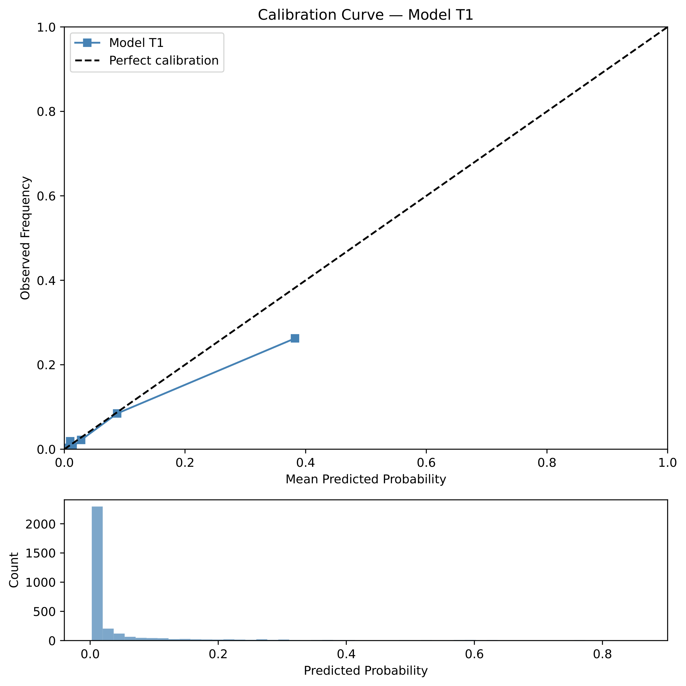
Figure S1. Calibration curve for model T1 (pre-recalibration). Isotonic regression applied to out-of-fold predictions from 5-fold cluster-robust cross-validation. The diagonal dashed line represents perfect calibration. Calibration slope = 0.874 pre-recalibration.
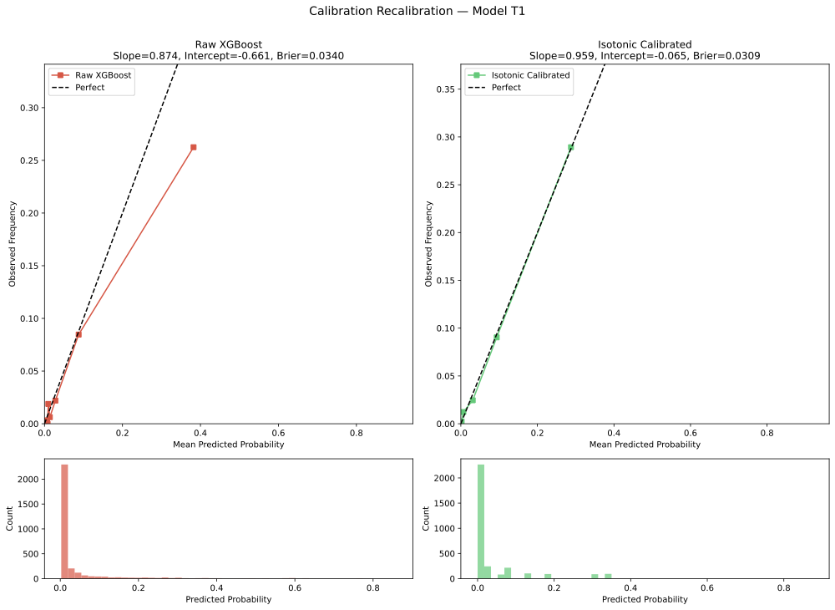
Figure S2. Calibration curve for model T1 after isotonic recalibration. Calibration slope improved from 0.874 to 0.959; Brier score reduced from 0.036 to 0.032. Recalibrator artefact saved to outputs/stage1/isotonic_calibrator_t1.pkl.
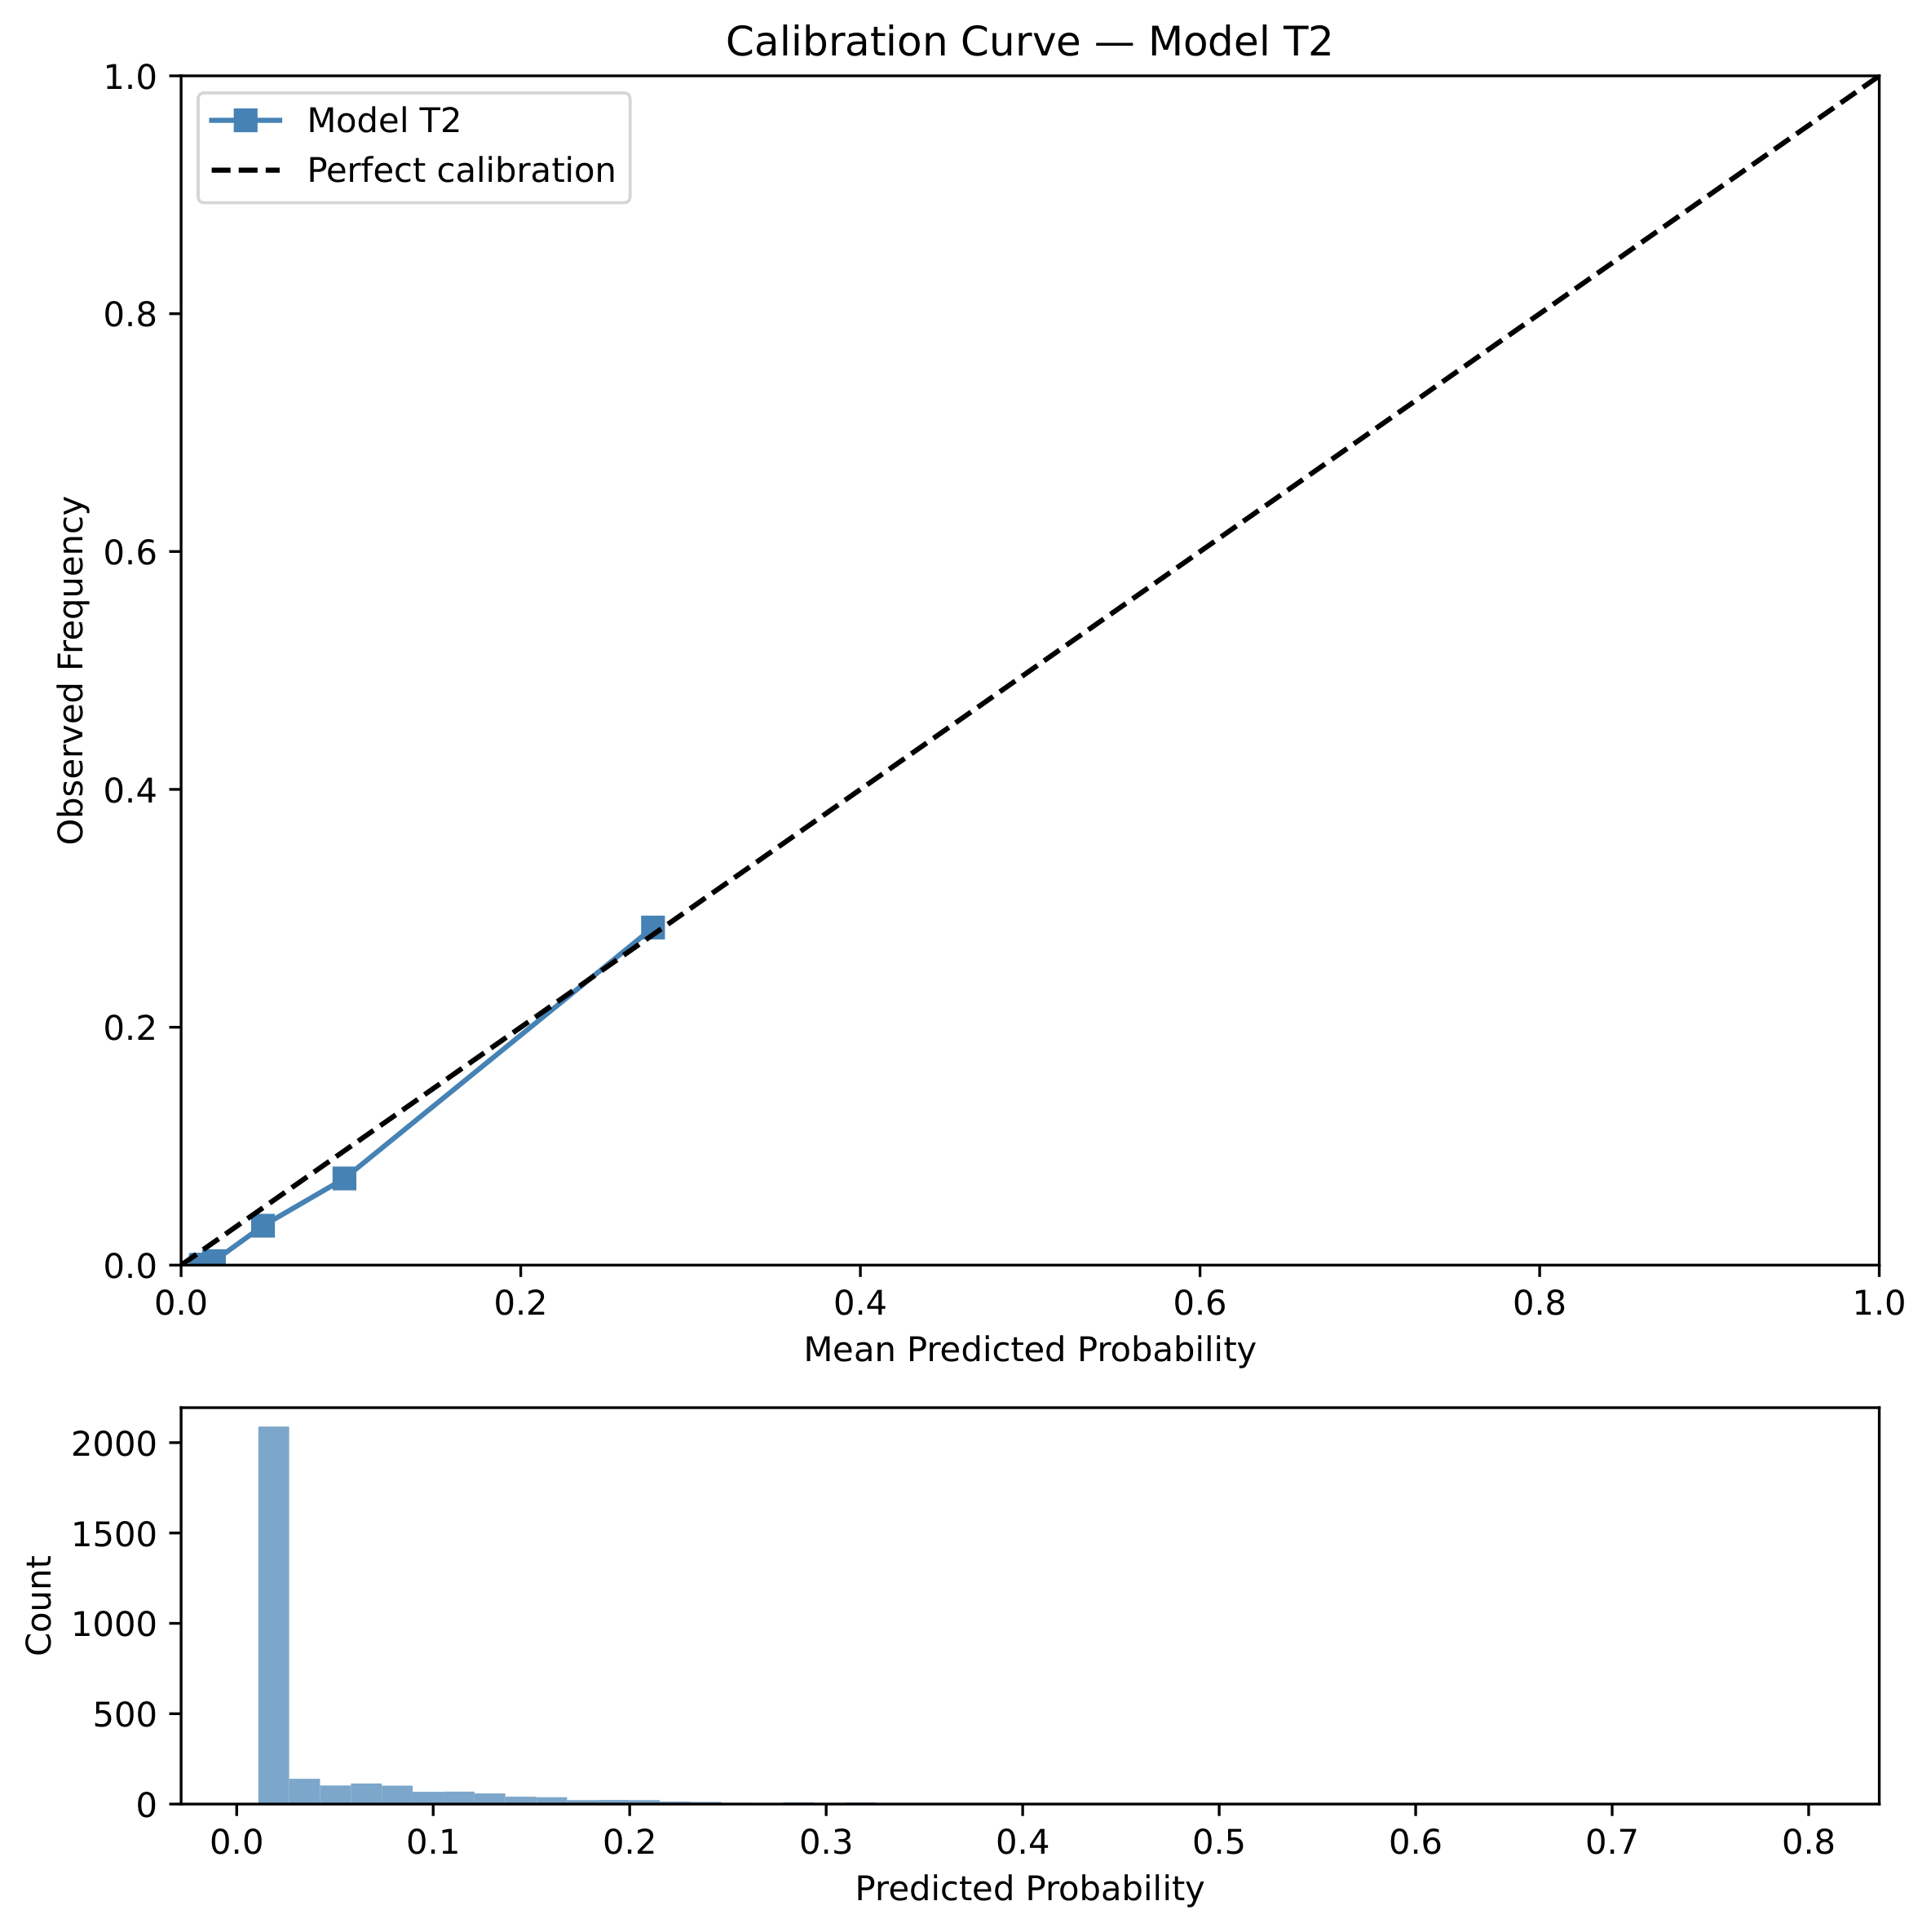
Figure S3. Calibration curve for model T2 (pre-recalibration). Calibration slope = 1.596 pre-recalibration, indicating systematic over-confidence in high-risk predictions.
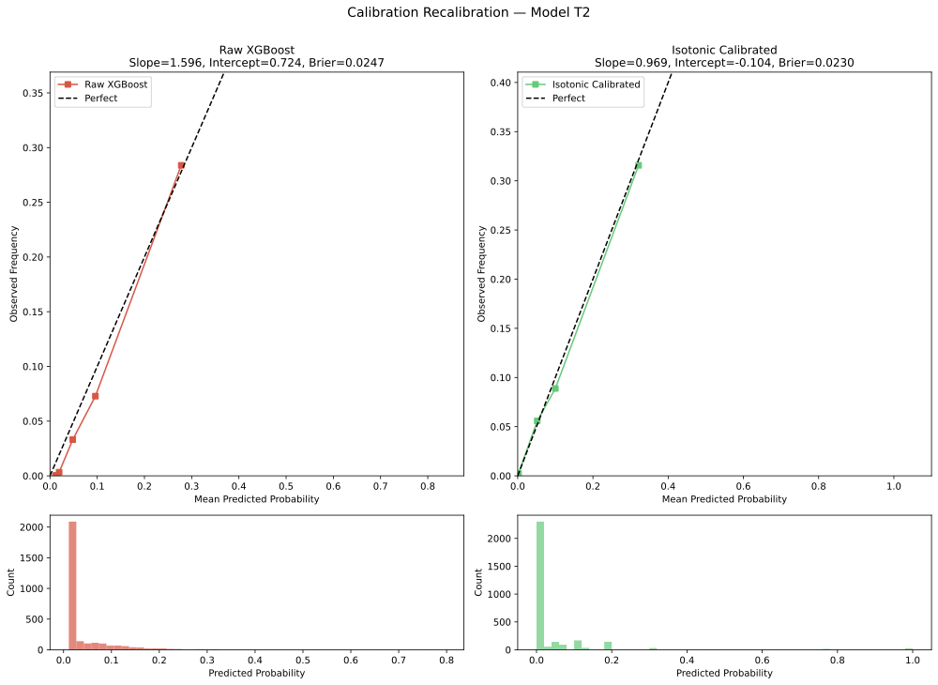
Figure S4. Calibration curve for model T2 after isotonic recalibration. Calibration slope improved from 1.596 to 0.969; Brier score reduced from 0.027 to 0.026. Recalibrated risk scores from T1 and T2 models were passed as state features to the offline RL stage.
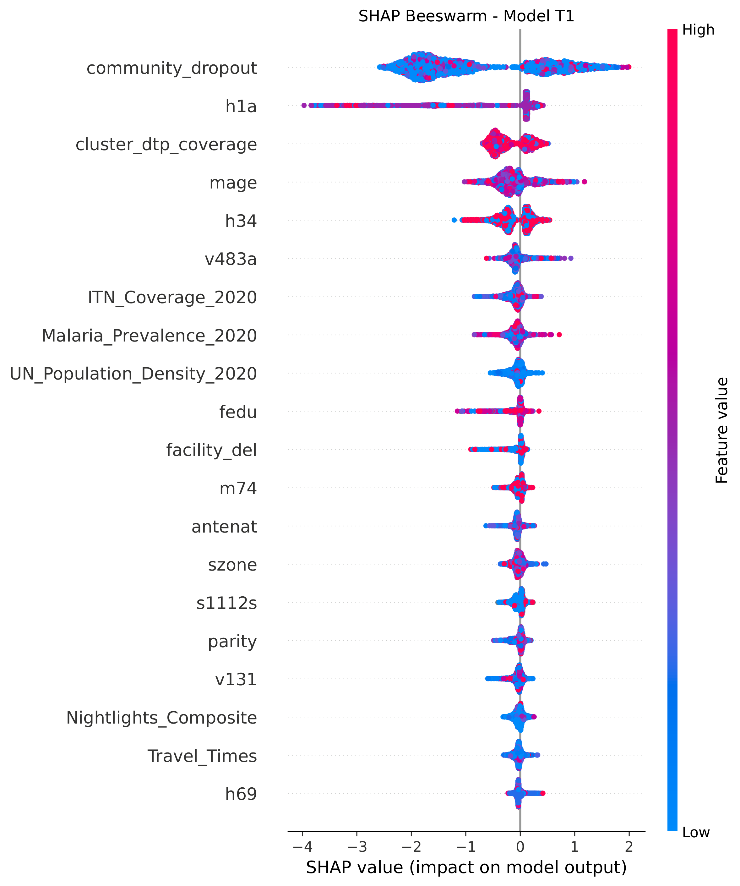
Figure S5. SHAP beeswarm plot for model T1 (DTP1→DTP2 dropout). Each point represents one child; horizontal position shows SHAP value (impact on dropout probability); colour encodes feature value (red=high, blue=low). Features ordered by mean absolute SHAP contribution.
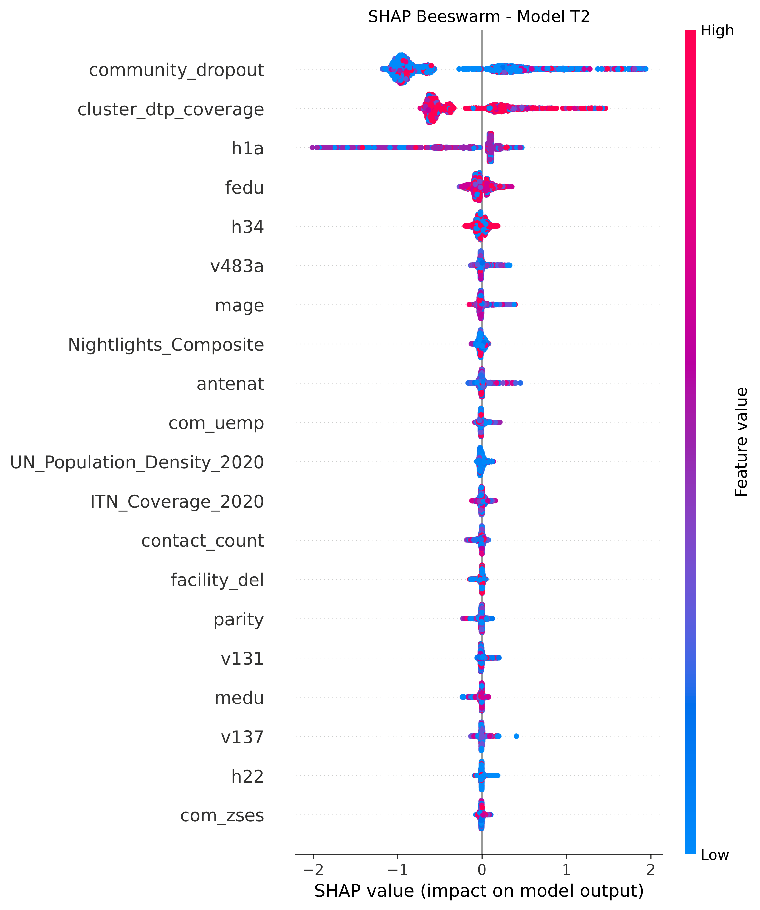
Figure S6. SHAP beeswarm plot for model T2 (DTP2→DTP3 dropout). Features ordered by mean absolute SHAP contribution. Enabling factors (wealth, travel time) show the largest contributions at the T2 transition.
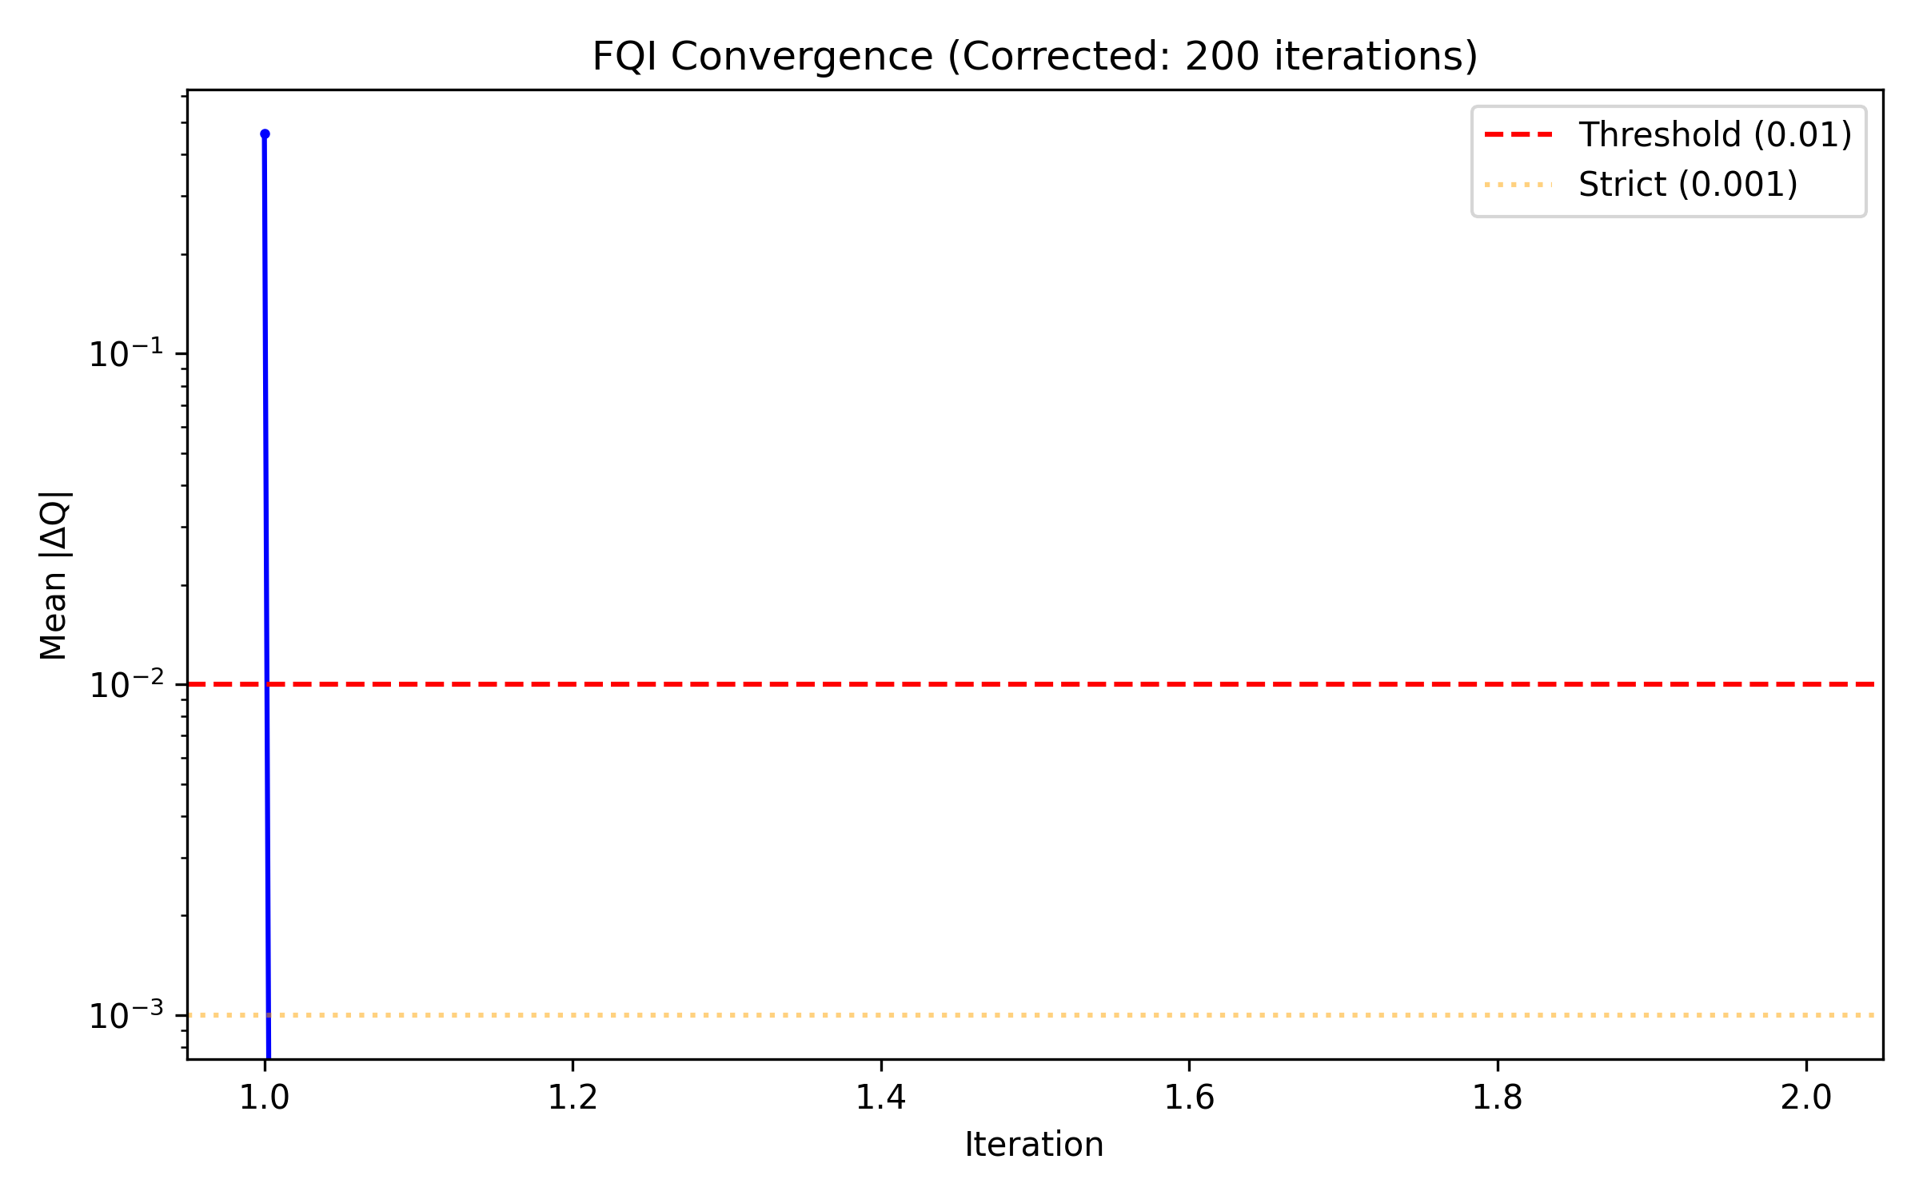
Figure S7. FQI convergence: policy value (WIS-estimated) versus iteration number. Convergence criterion ΔQ < 0.01 was met at iteration 100 (of 200 maximum). Shaded band shows ±1 SD across 5 evaluation seeds.
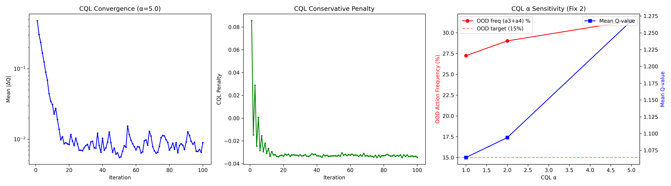
Figure S8. CQL α sensitivity analysis: WIS-estimated policy value (left axis) and action diversity (Shannon entropy over recommended actions, right axis) across α values {0.1, 0.5, 1.0, 2.0, 5.0}. Base case α = 1.0 selected as the point where policy value plateaus and action diversity remains non-degenerate.
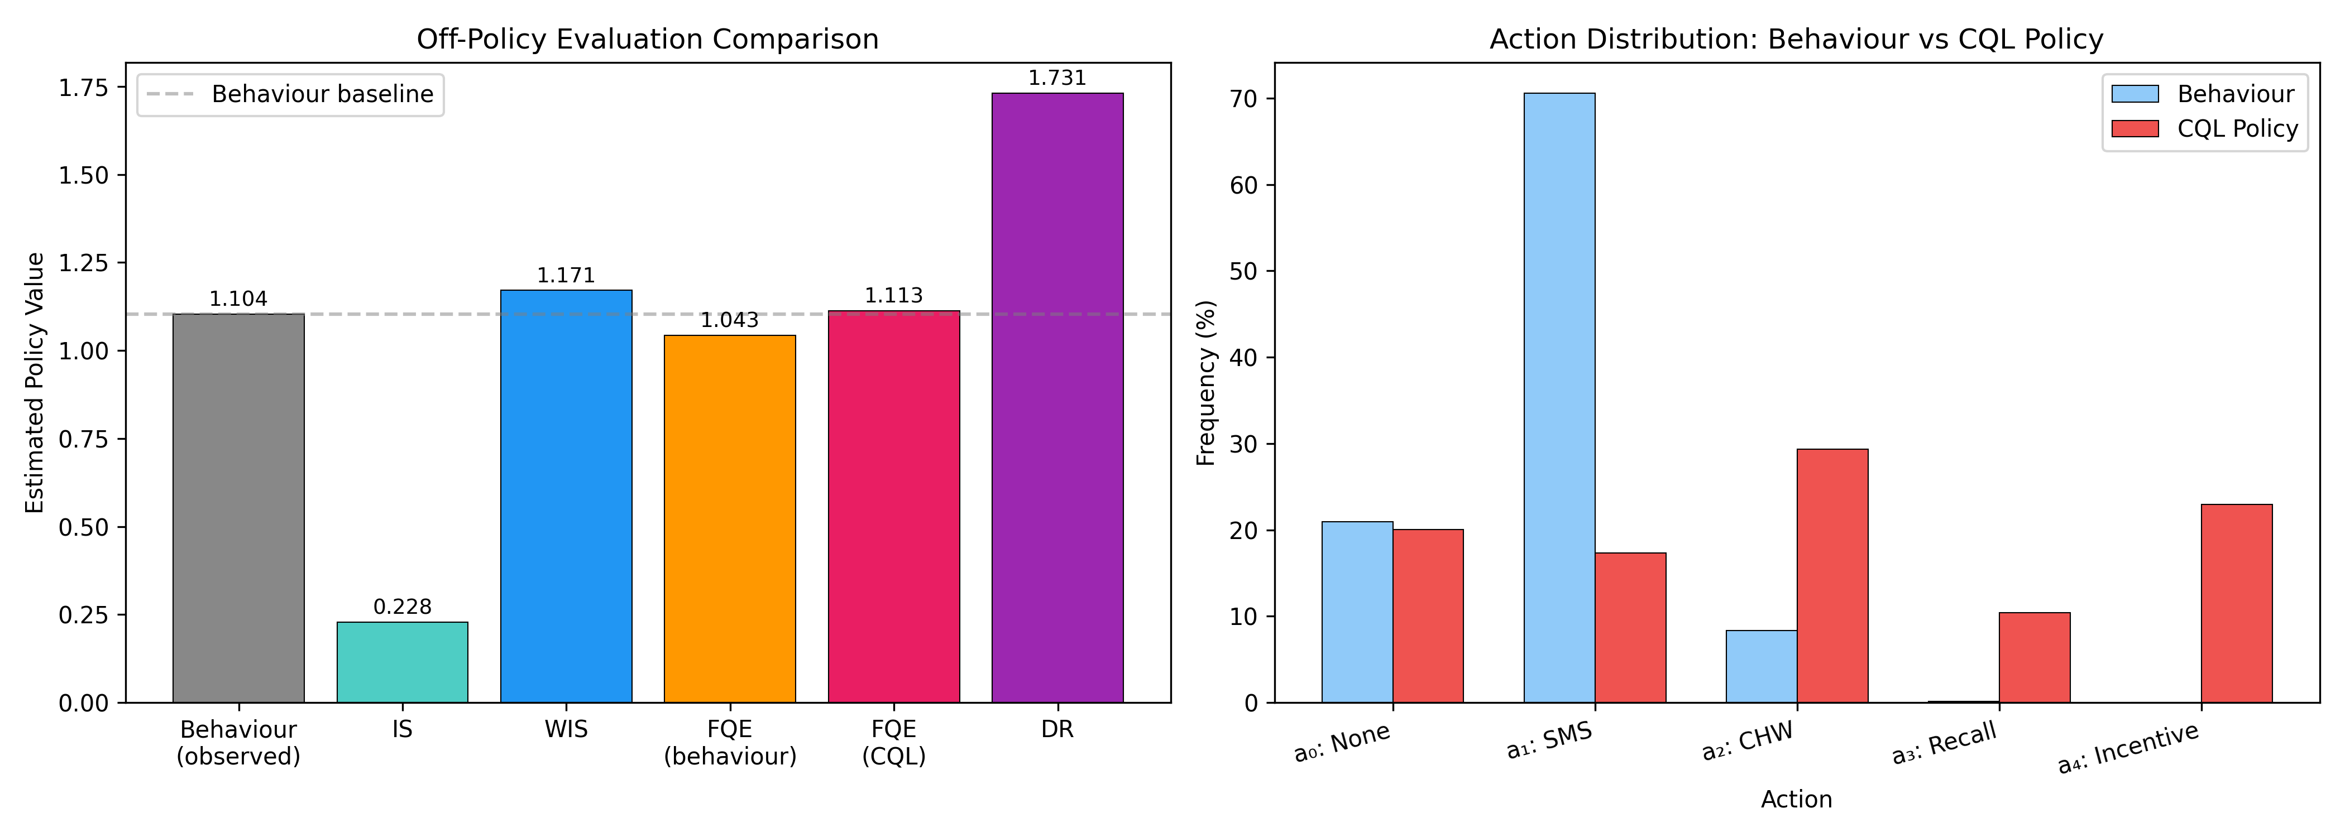
Figure S9. Off-policy evaluation comparison across IS, WIS, and DR estimators on 1,569 held-out episodes. Agreement across estimators provides evidence for OPE reliability. Error bars show 95% bootstrap confidence intervals.
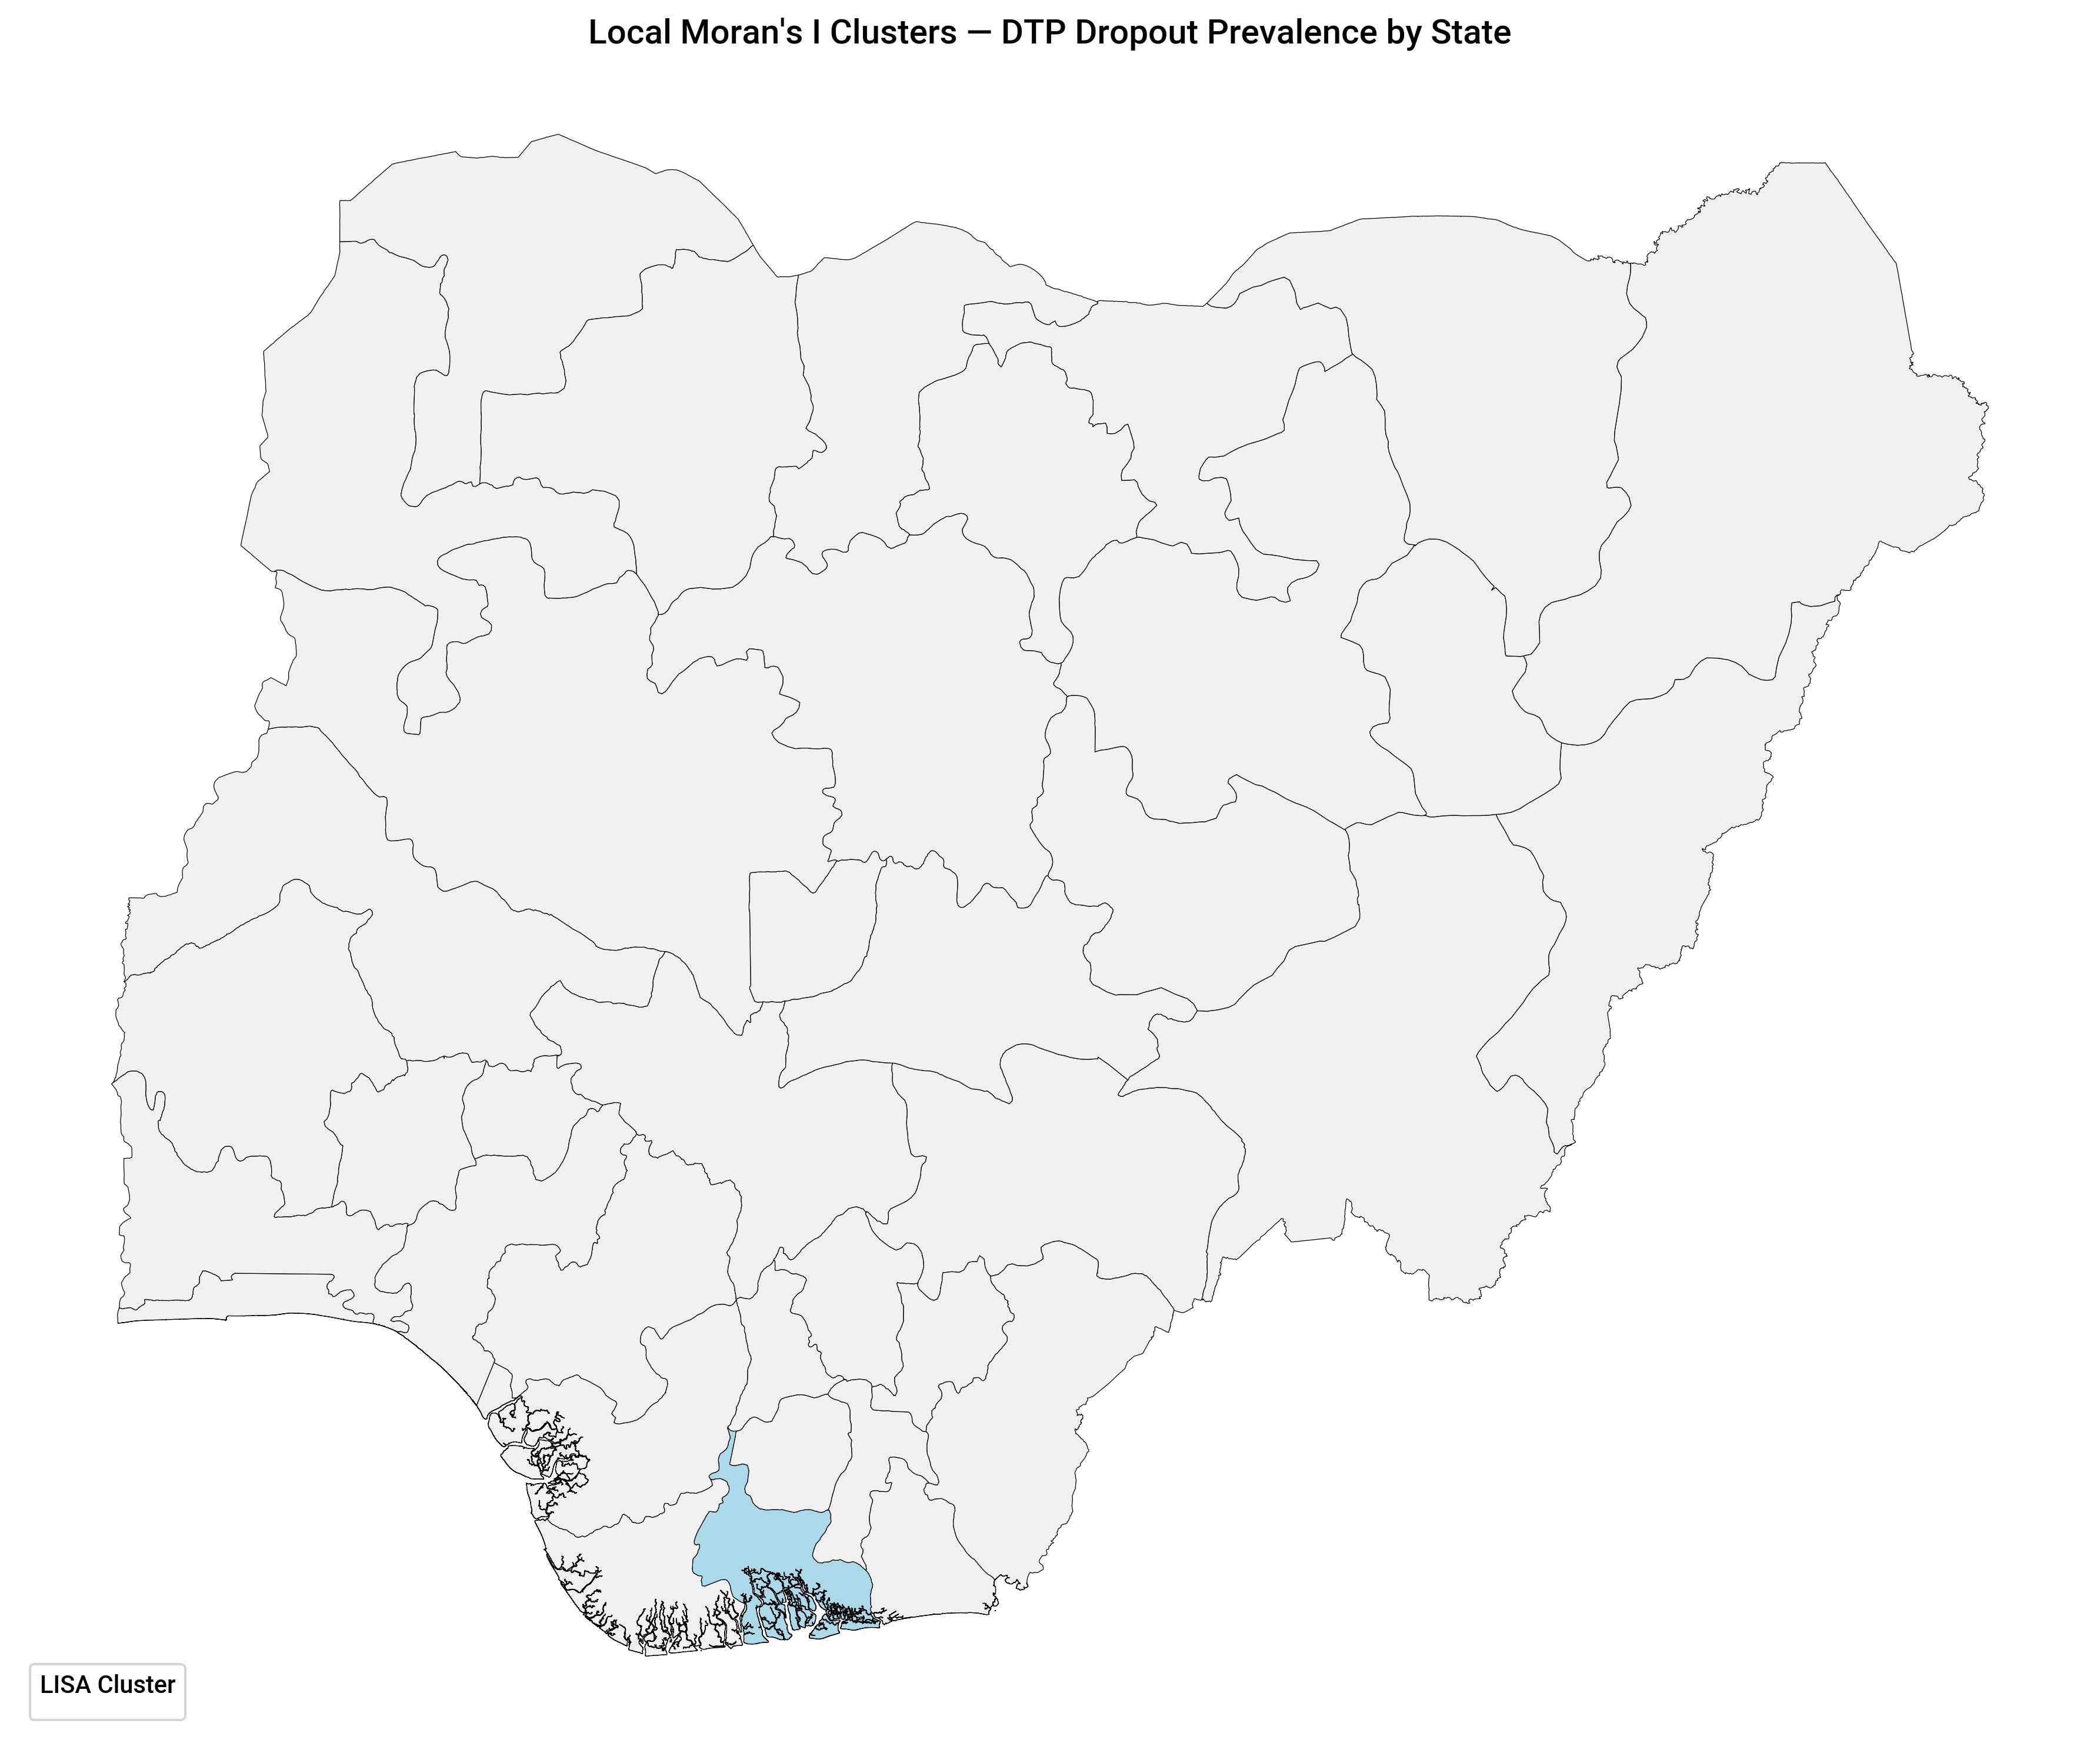
Figure S10. Local Moran’s I cluster map of DTP1→DTP3 dropout across Nigerian LGAs. High-High clusters (red) indicate spatial concentrations of elevated dropout risk; Low-Low clusters (blue) indicate low-risk spatial clusters. Statistical significance at p < 0.05 after 999-permutation conditional randomisation.
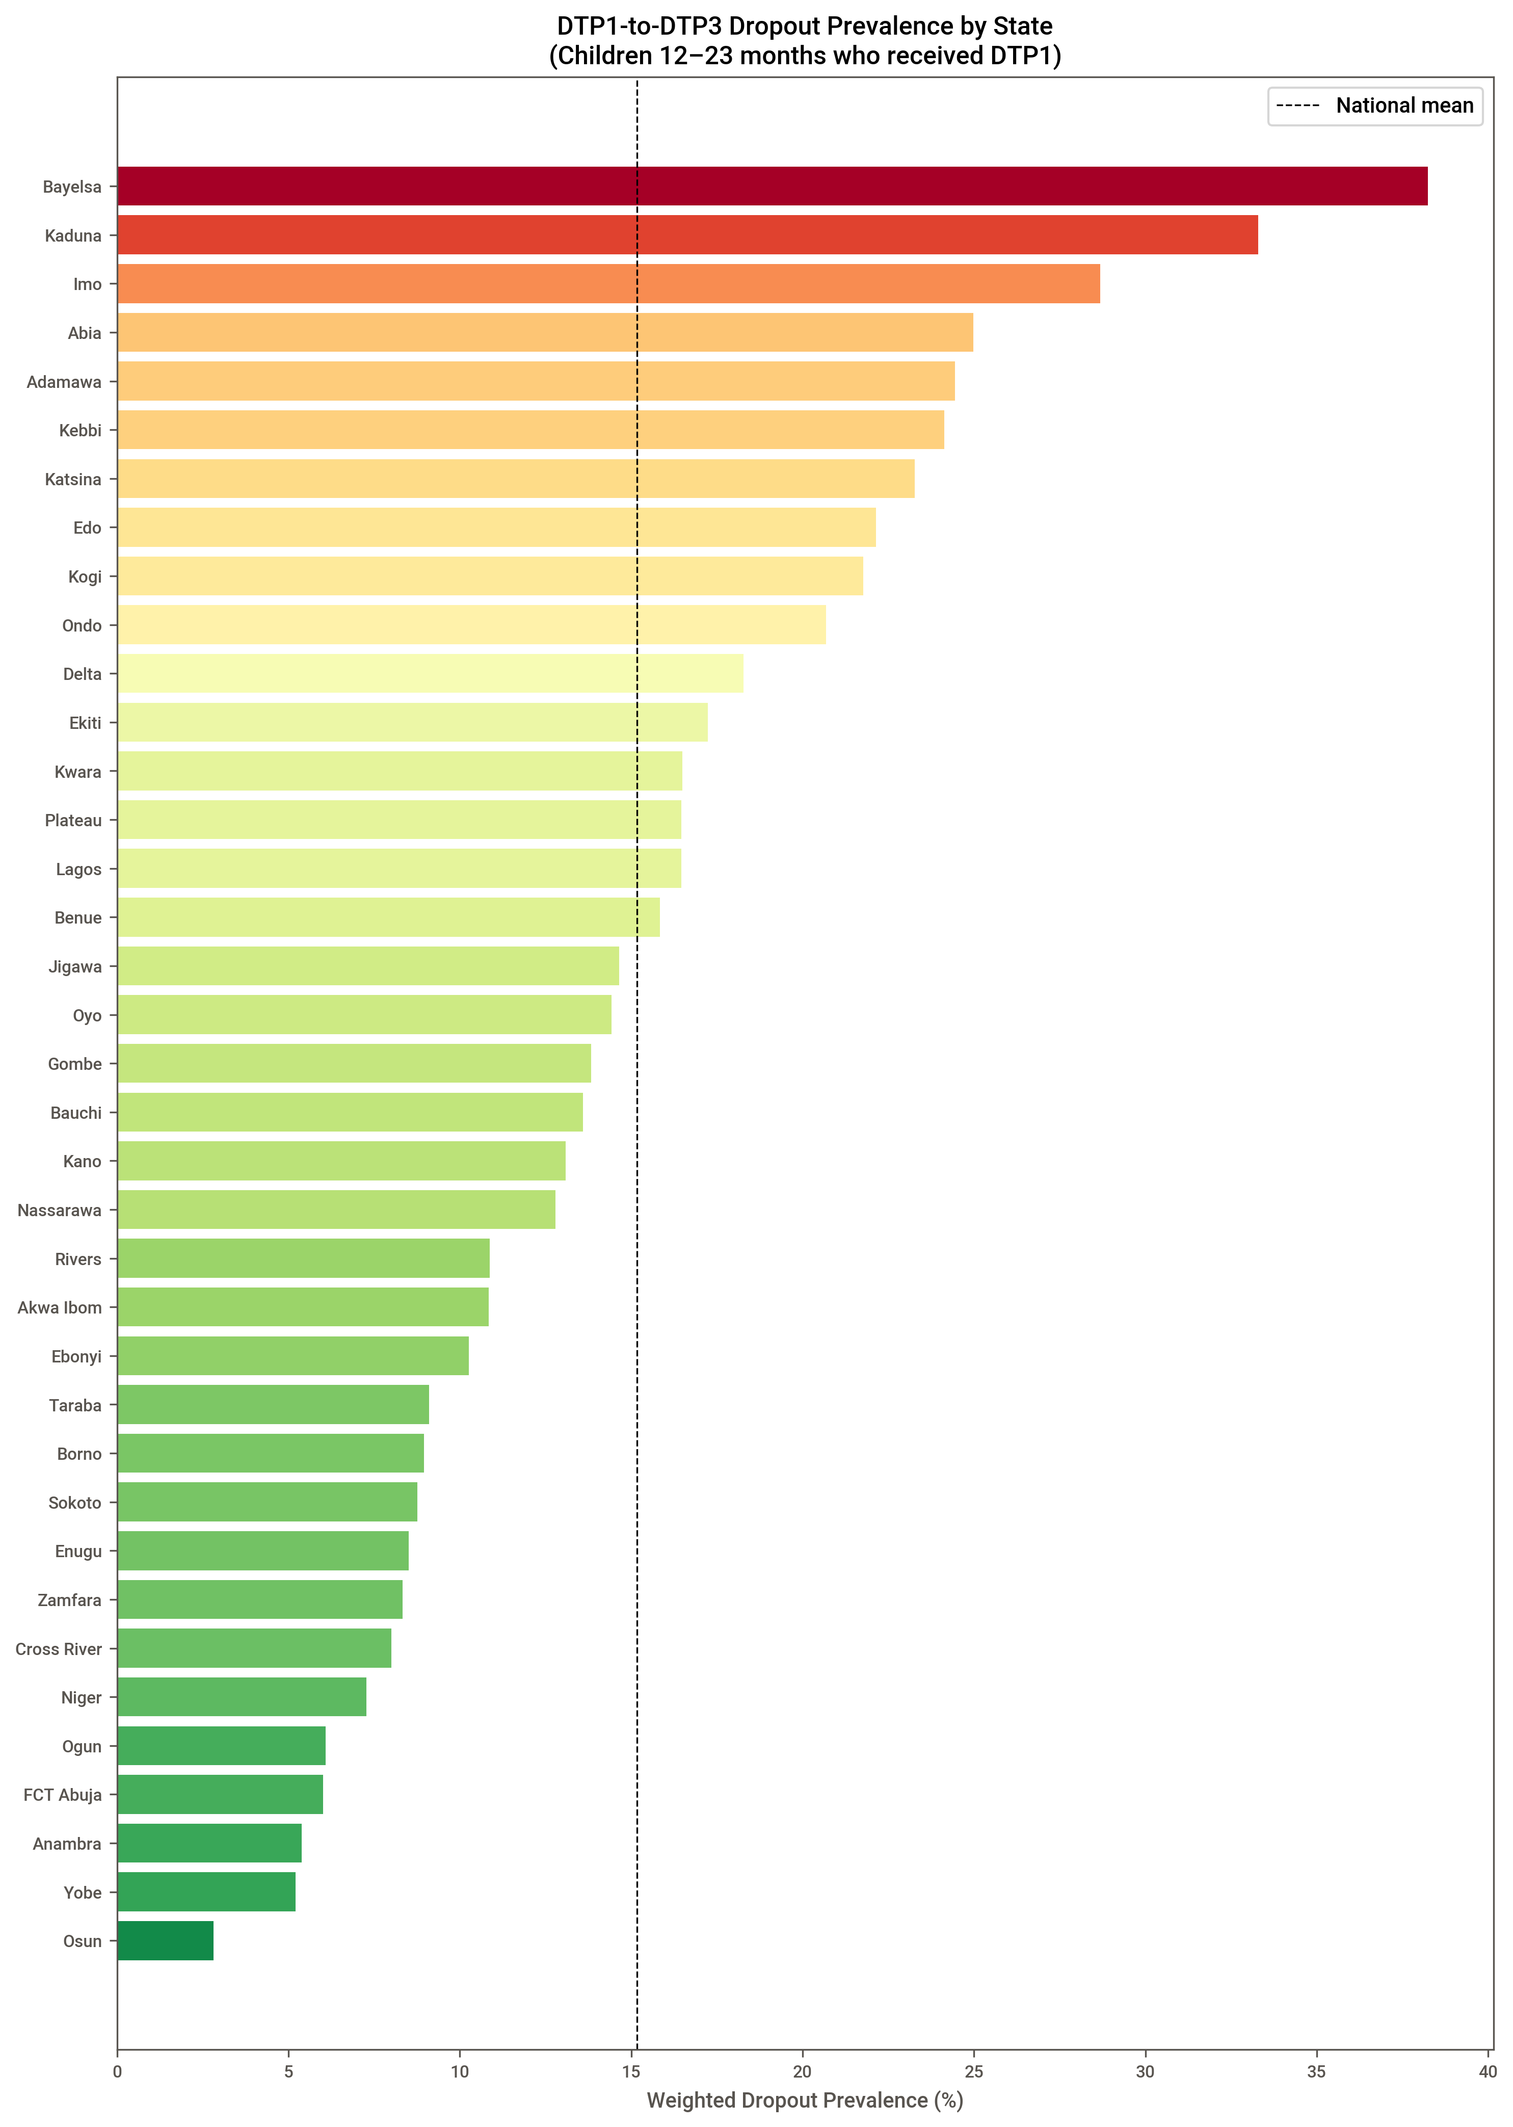
Figure S11. State-level DTP1→DTP3 dropout prevalence, NDHS 2024. Choropleth map using sstate variable; survey-weighted proportions. States with dropout prevalence > 30% are labelled. Color scale is continuous from 0% (dark green) to >50% (dark red).
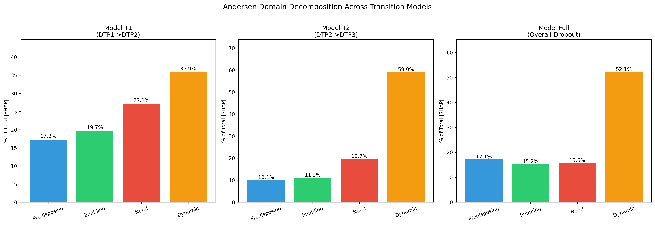
Figure S12. Andersen-domain decomposition of SHAP feature importance for T1 (left) and T2 (right) models. Bar height represents summed absolute SHAP contribution for all features within each Andersen domain (Predisposing, Enabling, Need, Dynamic). Enables policy-relevant attribution of dropout risk to modifiable versus fixed factor domains.
1. Collins, G.S.; Moons, K.G.M.; Dhiman, P.; Riley, R.D.; Beam, A.L.; Van Calster, B.; Ghassemi, M.; Liu, X.; Reitsma, J.B.; Smeden, M. van; et al. TRIPOD+AI Statement: Updated Guidance for Reporting Clinical Prediction Models That Use Regression or Machine Learning Methods. BMJ 2024, 385, e078378, doi:10.1136/bmj-2023-078378.
2. Husereau, D.; Drummond, M.; Augustovski, F.; Bekker-Grob, E. de; Briggs, A.H.; Carswell, C.; Caulley, L.; Chaiyakunapruk, N.; Greenberg, D.; Loder, E.; et al. Consolidated Health Economic Evaluation Reporting Standards 2022 (CHEERS 2022) Statement: Updated Reporting Guidance for Health Economic Evaluations. BMC Medicine 2022, 20, 23, doi:10.1186/s12916-021-02204-0.
3. Gottesman, O.; Johansson, F.; Komorowski, M.; Faisal, A.; Sontag, D.; Doshi-Velez, F.; Celi, L.A. Guidelines for Reinforcement Learning in Healthcare. Nature Medicine 2019, 25, 16–18, doi:10.1038/s41591-018-0310-5.
4. Ernst, D.; Geurts, P.; Wehenkel, L. Tree-Based Batch Mode Reinforcement Learning. Journal of Machine Learning Research 2005, 6, 503–556.
5. Kumar, A.; Zhou, A.; Tucker, G.; Levine, S. Conservative Q-Learning for Offline Reinforcement Learning. In Proceedings of the Advances in neural information processing systems (NeurIPS); 2020; Vol. 33, pp. 1179–1191.
6. Jiang, N.; Li, L. Doubly Robust Off-Policy Value Evaluation for Reinforcement Learning. In Proceedings of the International conference on machine learning (ICML); 2016; pp. 652–661.

