BIZDATA
Bank Reports Intelligence System

COMPLETE MANUAL
Every module, every sub-page, and all four decision-support phases — in one document

25 modules · 6 sub-page deep-dives · 4 phases · live screenshots · 3 July 2026

Part I — Introduction

BIZDATA is a multi-source data-intelligence platform that estimates recoverable tax revenue from underdeclaration. It ingests structured data from banks and other financial providers, matches it to taxpayers, compares observed financial flows against declared income, and turns the gaps into a prioritised, auditable enforcement worklist.
This is the single complete reference. Part II documents every module in menu order with a live screenshot. Part III drills into the key sub-pages. Part IV covers the four decision-support phases that turn the flag list into a decision-support system. All figures come from the running system (48 providers, 911 taxpayers, 7,451 records, ~700 cases, 2,076 AI signals).
How it fits together
Providers submit files (Submissions) → parse into Data Records → a Scan aggregates per taxpayer vs Declared Income → gaps become Flagged Review → promoted into Cases → Cross-State hands off out-of-jurisdiction ones. Analytics shows where the intelligence and gaps are; the Tax-Net comparative shows who is in the net and lets you bring them in; Portfolios route work to a named owner; Identity Resolution closes the identity gap. Audit Logs, Sensitive Access and Data Protection keep it accountable; Users and Settings govern access.

Part II — The Modules

Every left-menu item, in order — what it does, why it is useful, and a live screenshot.

1. Dashboard
The command centre — recoverable-revenue position and system health at a glance.
What it does
- Money-first KPIs: revenue at risk, recovered, open cases, critical-risk count.
- Operations strip: provider compliance, open alerts, audit integrity, cross-state referrals.
- Detection→recovery funnel, risk distribution, top cases, and the six AI analytics agents (Run agents).
Why it is useful
The first screen each day — answers "how much can we recover and what needs attention" with no clicks.
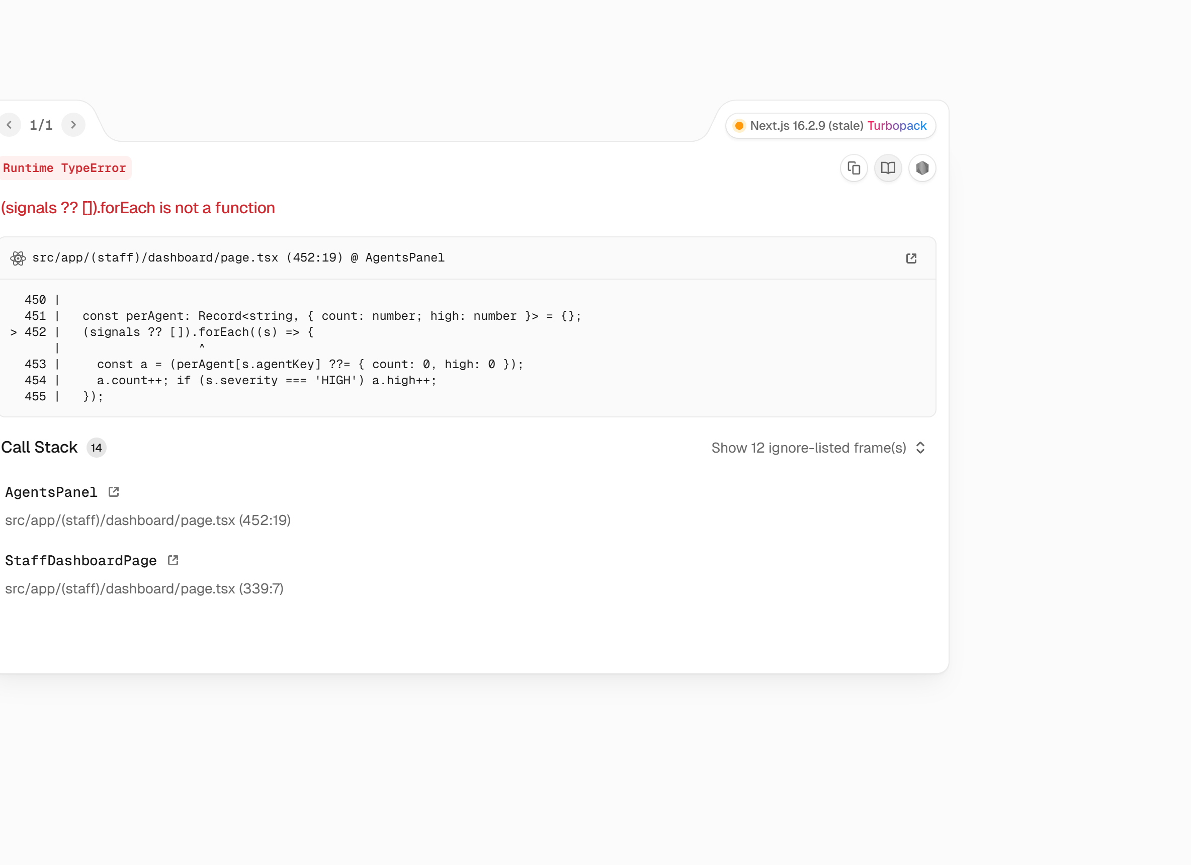

2. Data Providers
A risk-ranked compliance dashboard for the §29 data providers.
What it does
- KPI row + a quarterly compliance heatmap (provider × Q1–Q4, colour-coded).
- At-risk callout for providers with missing submissions.
- Step-up-authorised uploads viewer + CSV export.
Why it is useful
Shows who must report, who has, and who is behind. Each provider has its own detail dashboard at /providers/[id].
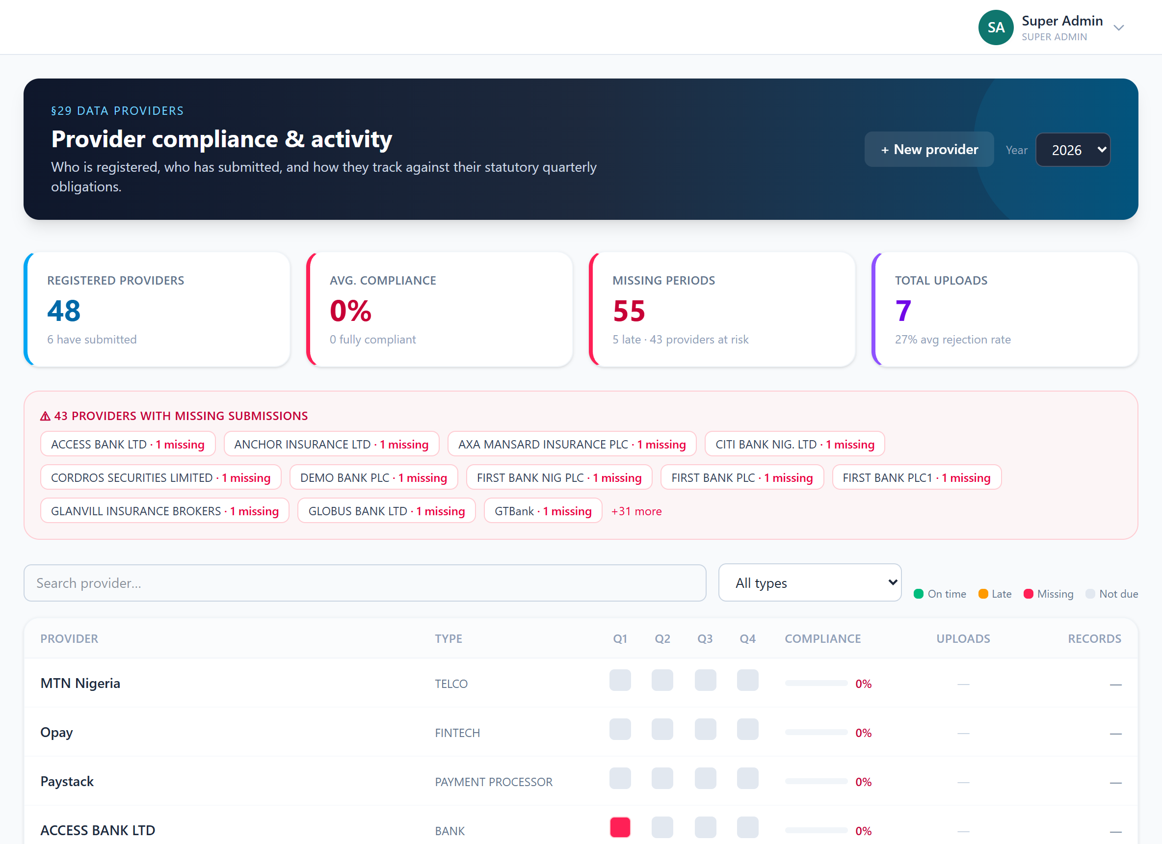

3. Tax Payer Data
The registry of every individual and corporate tracked.
What it does
- Searchable by name, NIN, RC, TIN; filterable by type and status.
- PII (NIN/BVN/TIN) stored encrypted; list shows safe identifiers only.
- CSV import and individual add.
Why it is useful
The master list — every case, record and declaration links back to a taxpayer here.
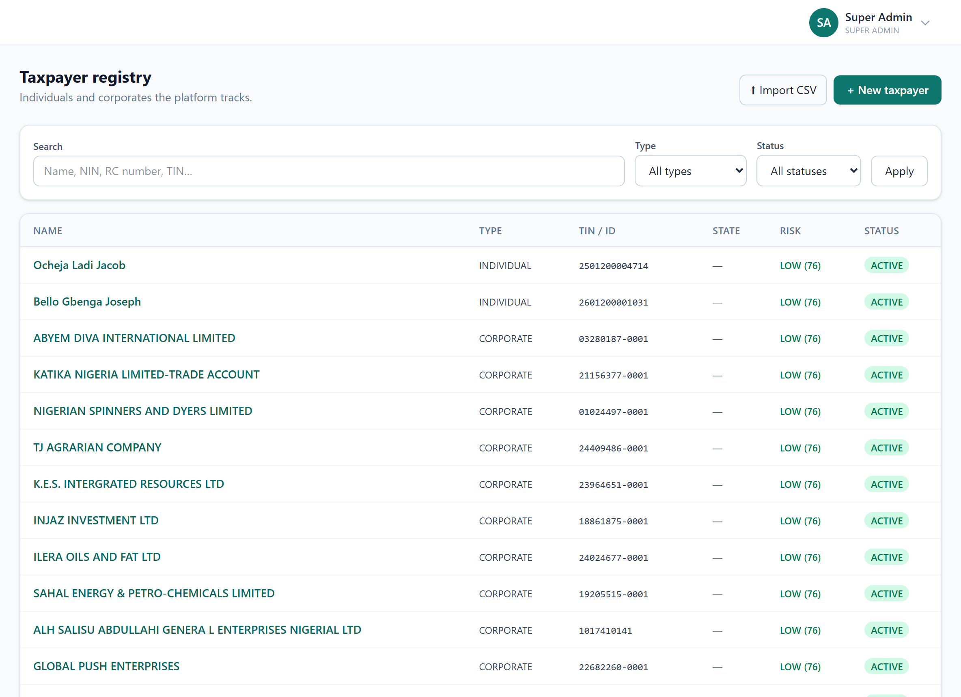

4. Taxpayer 360
One unified view of a single taxpayer across every data source.
What it does
- Search by name, TIN, NIN, BVN or CAC.
- Declared income, observed flows, cases and risk in one place.
Why it is useful
The single-pane-of-glass for investigating one entity (see the taxpayer deep-dive later).
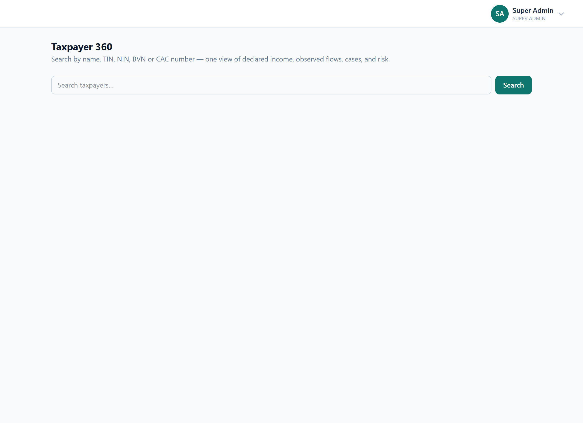

5. Tax Net
Who is in the tax net and who isn’t — with registration into the net. (Phase 2)
What it does
- Classifies every party as Captured / Unverified / Invisible against its truth-of-record ID (RC / TIN).
- Ranked by observed inflow; source-provider column; identity pips.
- Register manually per-row or auto/bulk; also hosts the Phase-4 identity-resolution strip.
Why it is useful
The board-level headline: of everyone receiving money, who is registered — and bring the rest in.
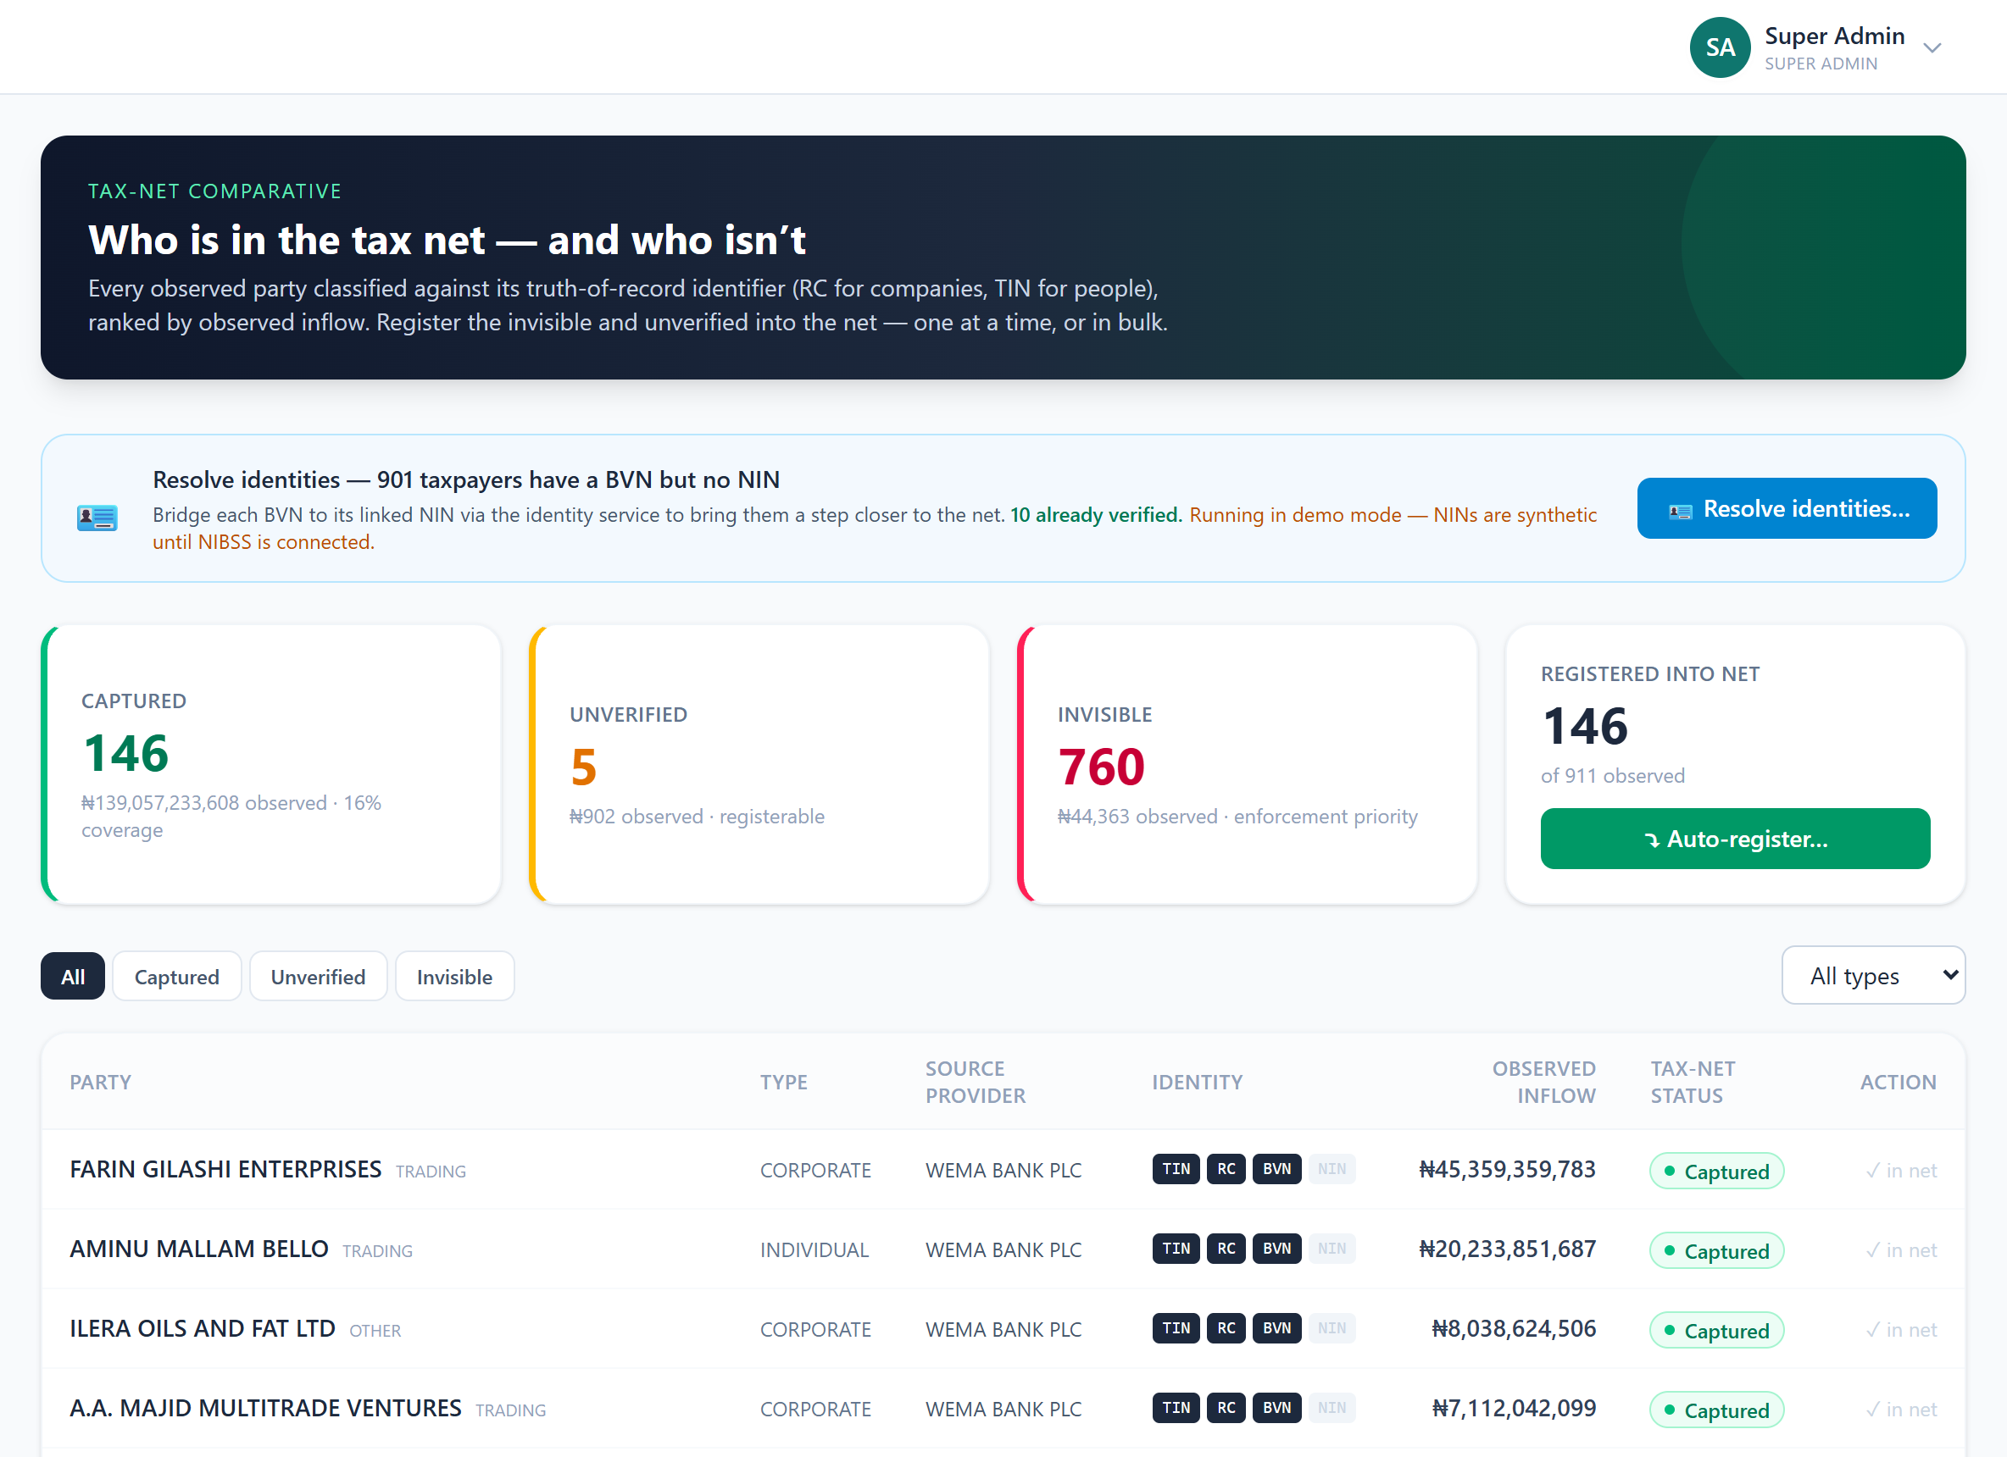

6. Analytics
Analysis by provider and by sector. (Phase 1)
What it does
- By provider: volume, value, data quality (rejection, identity completeness), yield /1k.
- By sector: underdeclaration concentration, tax-net coverage, estimated recoverable tax.
Why it is useful
Where the intelligence and the gaps are — the comparison that drives decisions.
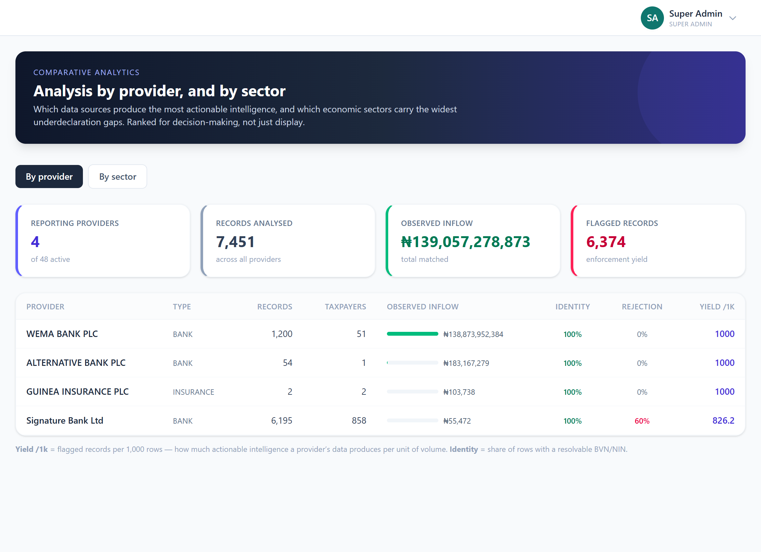

7. Declared Income
The annual income declarations the scan compares against.
What it does
- One declaration per taxpayer per year; CSV import.
- Observed flows minus declared income = the discrepancy.
Why it is useful
The "declared" side of the equation — without it the scan cannot measure true underdeclaration.
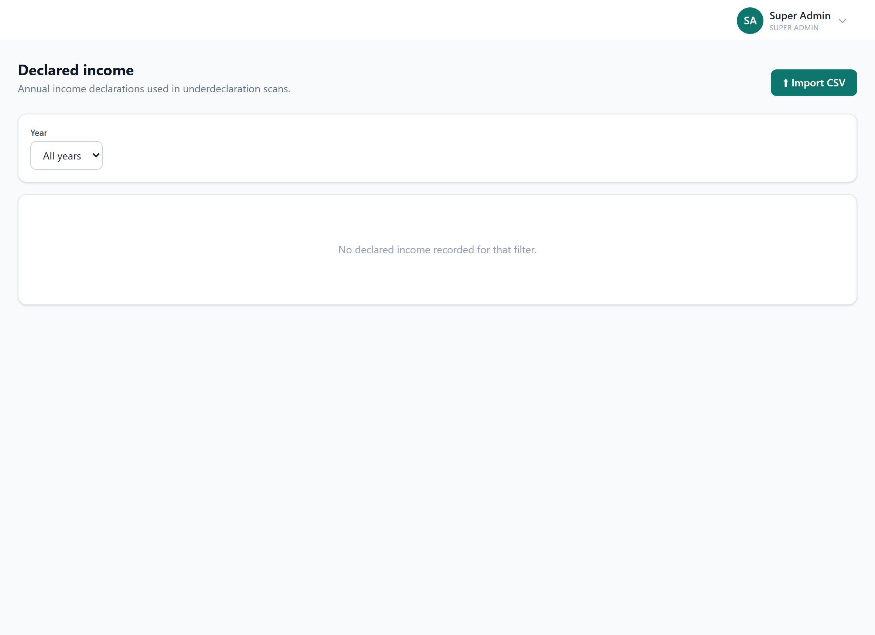

8. Submissions
Every data file uploaded by a provider (or staff on their behalf).
What it does
- Period, provider, status, and accepted/rejected counts.
- Each parsed into records and issued a §6.5 acknowledgment receipt.
Why it is useful
The audit trail of what data came in, when, from whom, and whether it passed validation.
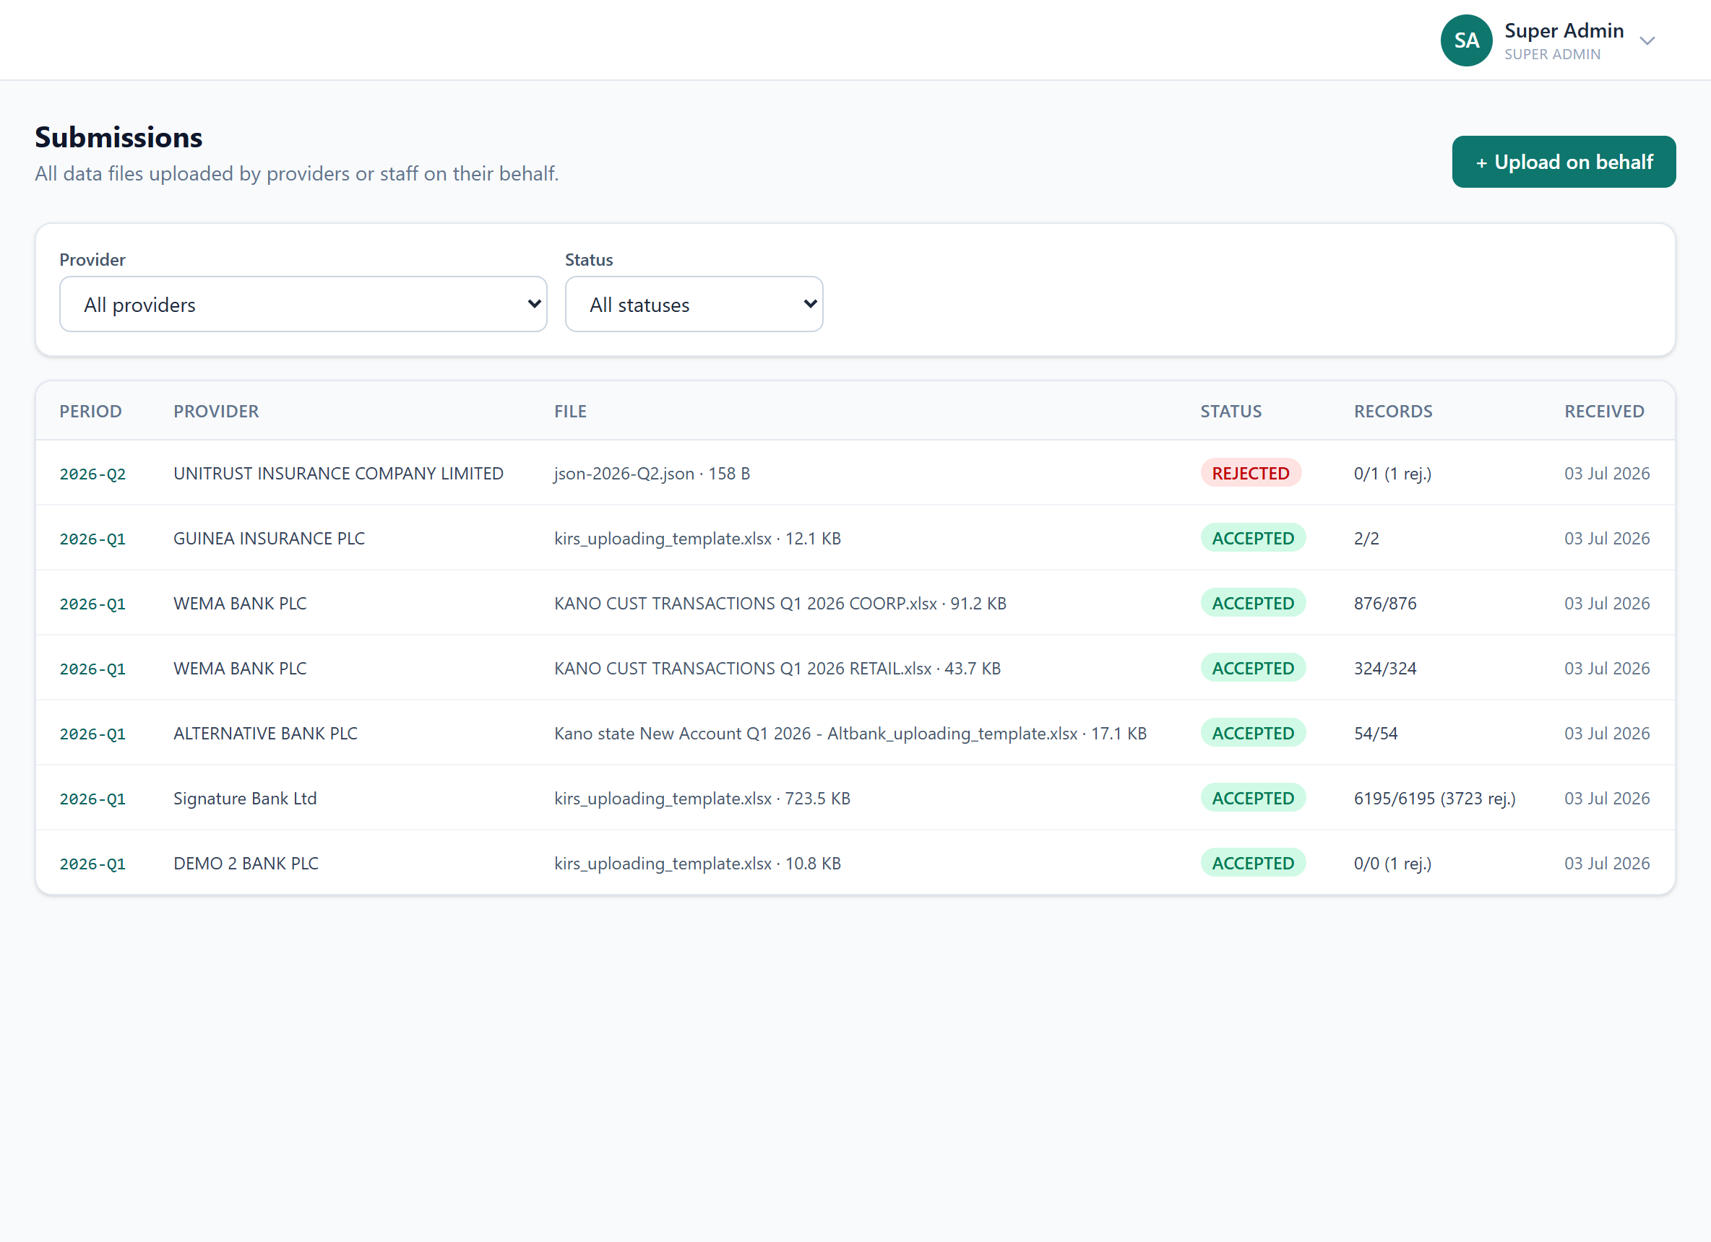

9. Compliance
NTAA §29 reporting-obligation tracking across all providers.
What it does
- Derives required periods, computes the statutory due date (15 days after period end).
- Marks each period on-time / late / missing; reports rate + data quality.
Why it is useful
The formal obligation ledger behind the provider dashboard.
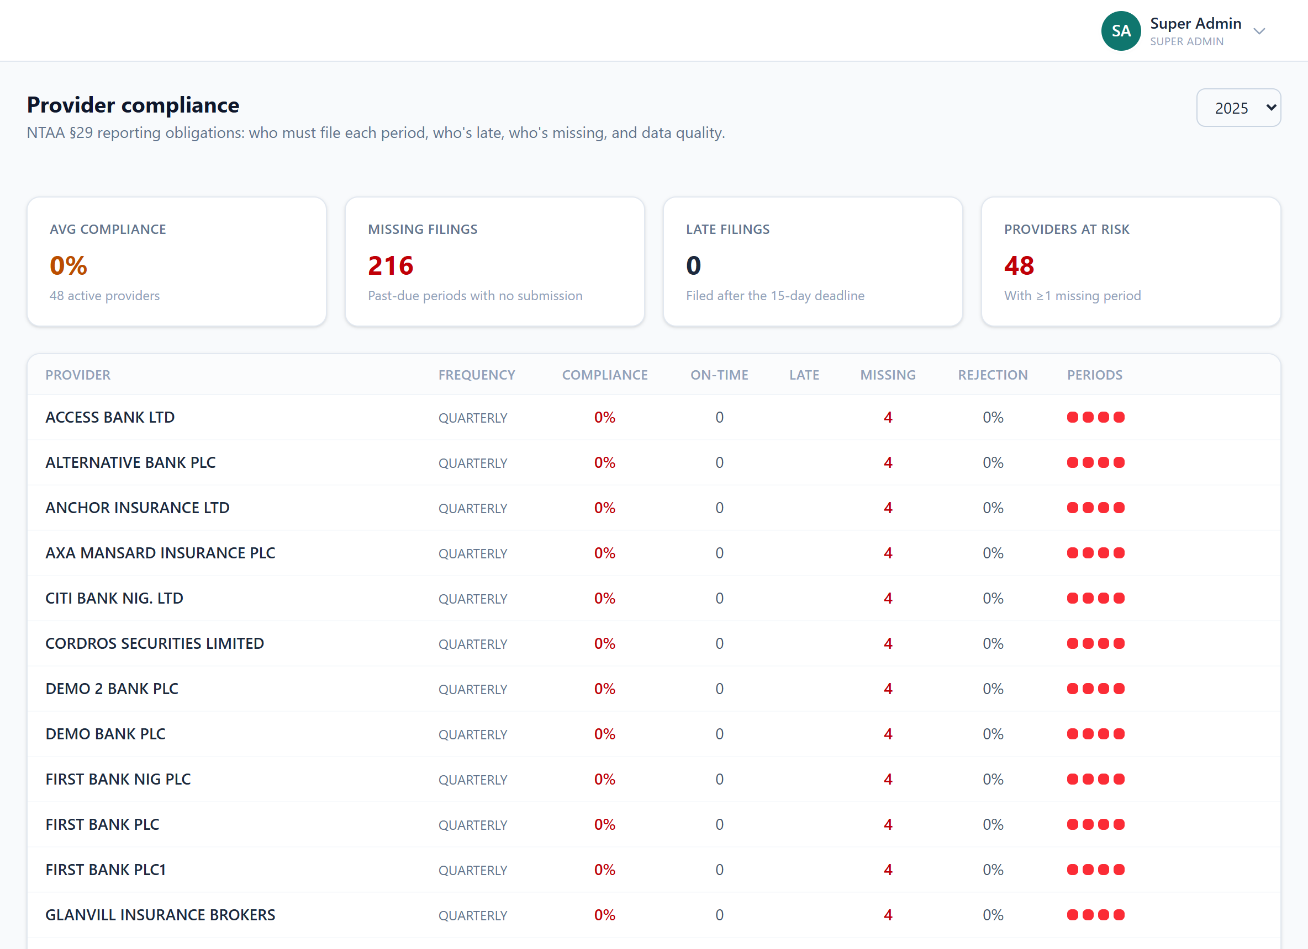

10. Cross-State
JRB Act 2025 §15 referrals of non-FCT-resident taxpayers.
What it does
- Minimised referral (TIN + amounts only); tracks outbound + inbound.
Why it is useful
Hands cases to the right jurisdiction while sharing the least data necessary.
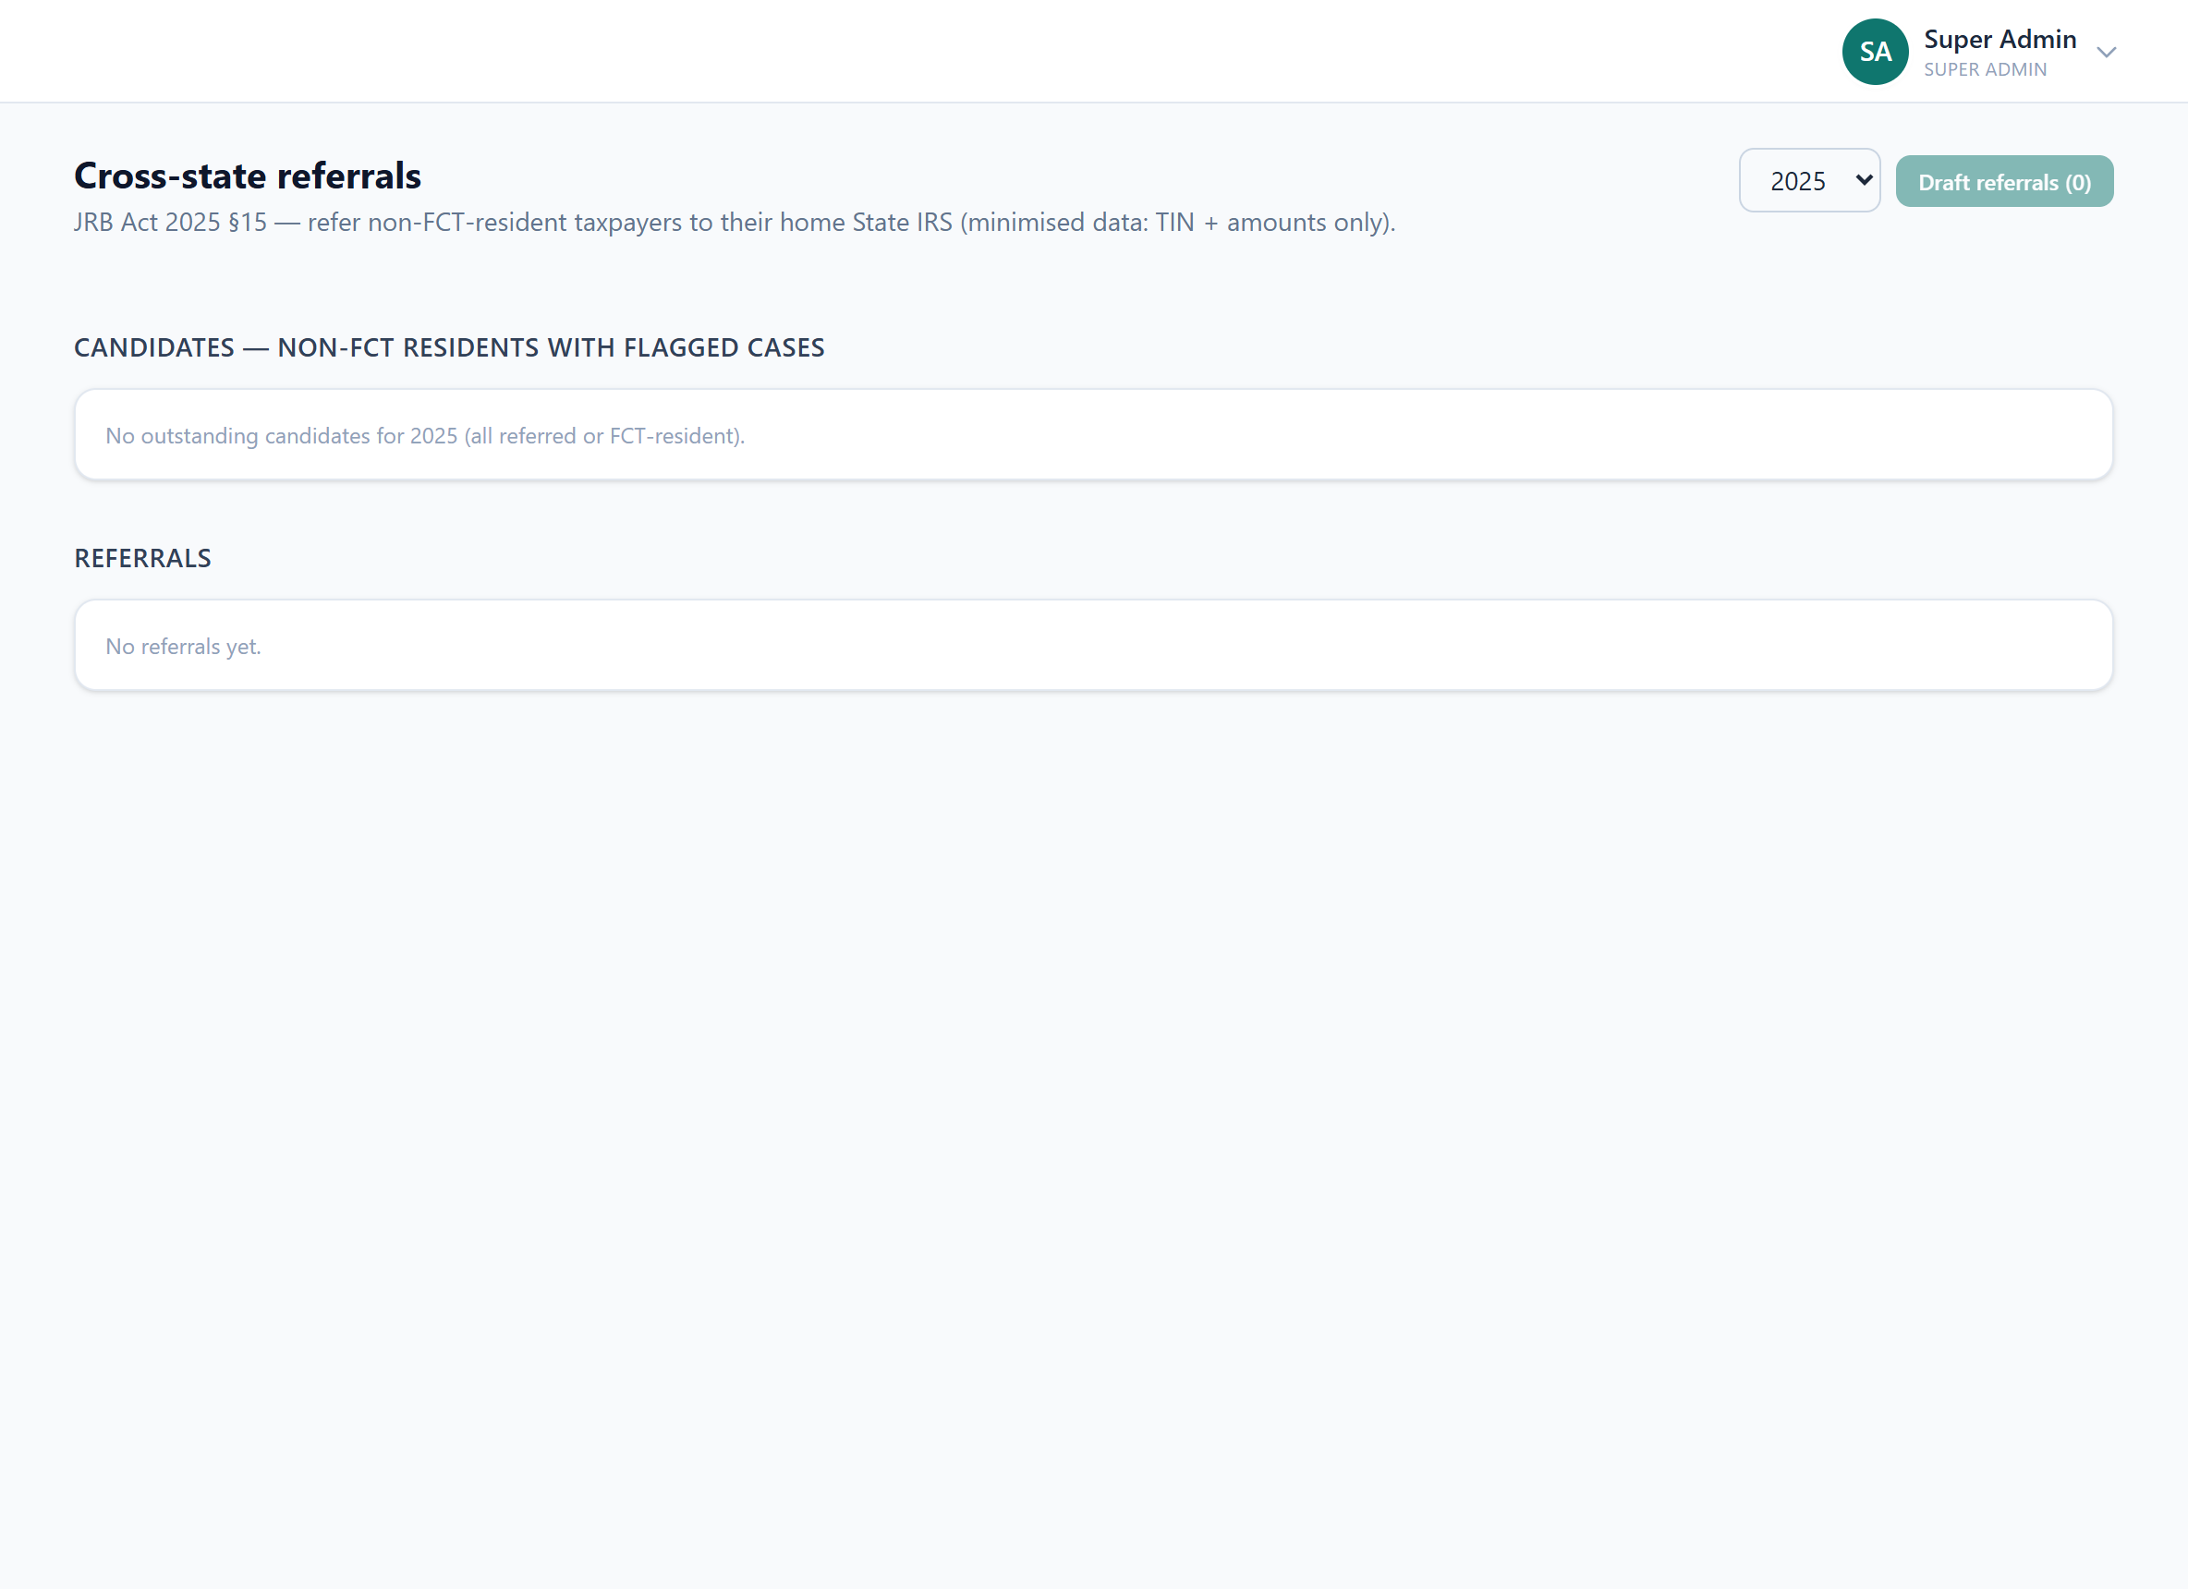

11. Data Records
Every individual ingested row across every provider type.
What it does
- Raw normalised records: account, identifiers, inflow/outflow, period.
- Filterable by flag and review status; links to taxpayer + submission.
Why it is useful
The lowest-level evidence layer behind every case and flag.
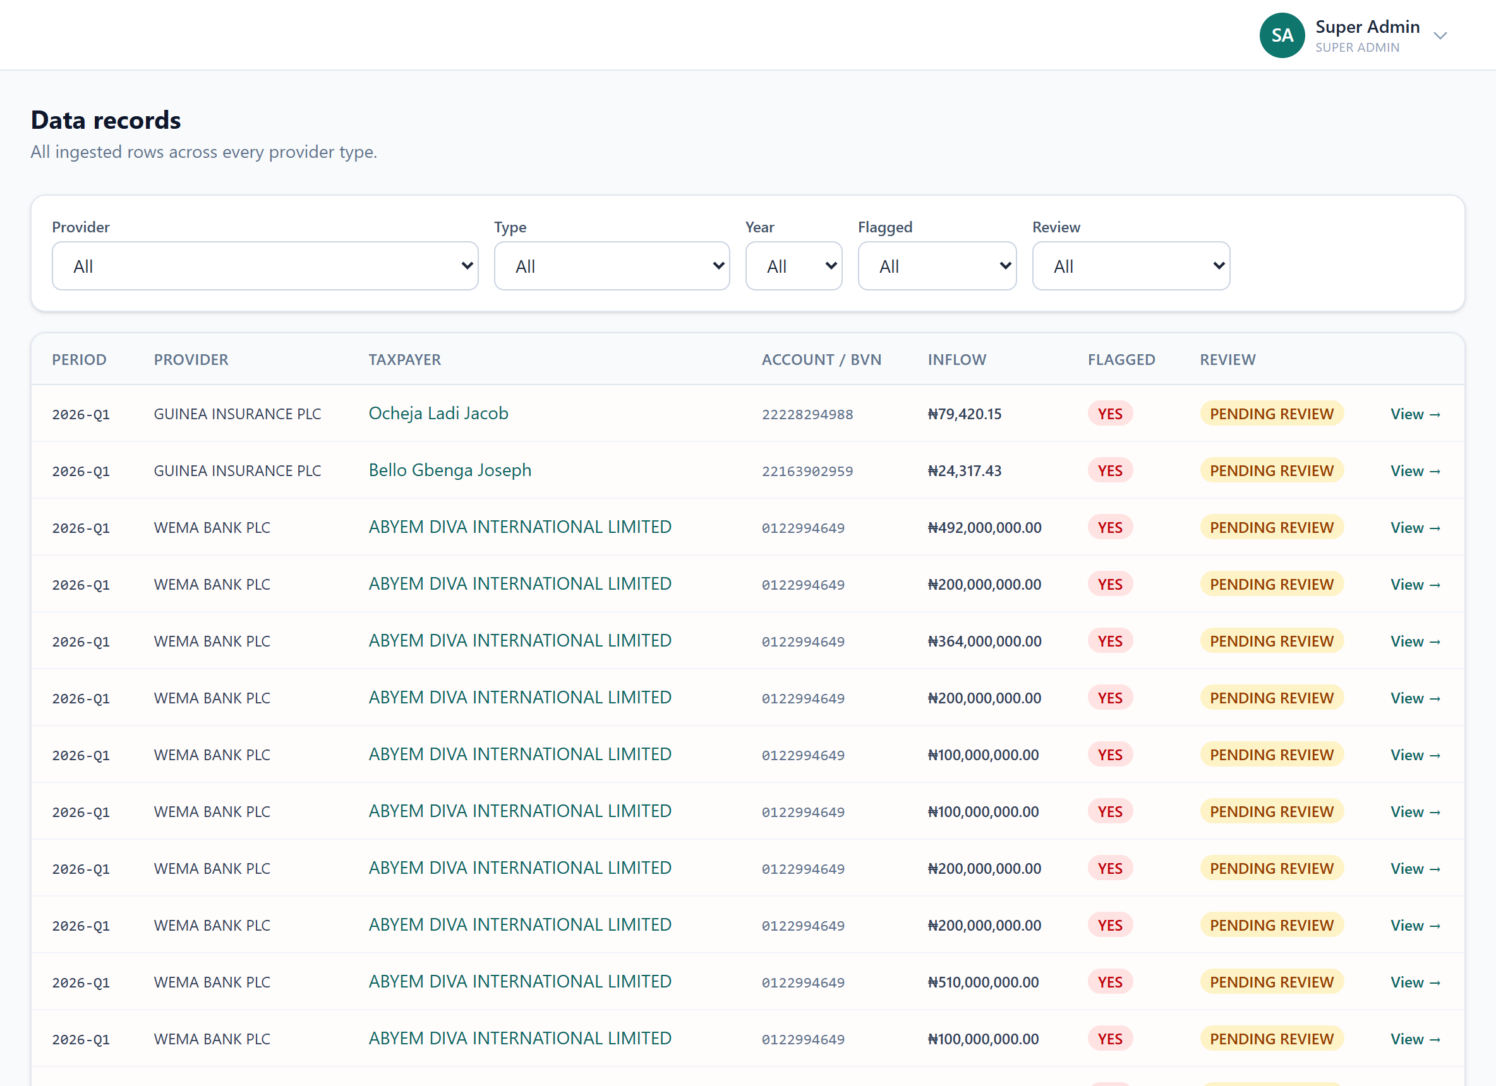

12. Cases
The prioritised worklist of taxpayers whose observed flows exceed declared income.
What it does
- Ranked by estimated recoverable tax; observed, declared, est. tax, confidence, risk.
- Lifecycle: detected → review → notice → objection → confirmed → settled → recovered.
Why it is useful
The heart of enforcement (see the case deep-dive later).
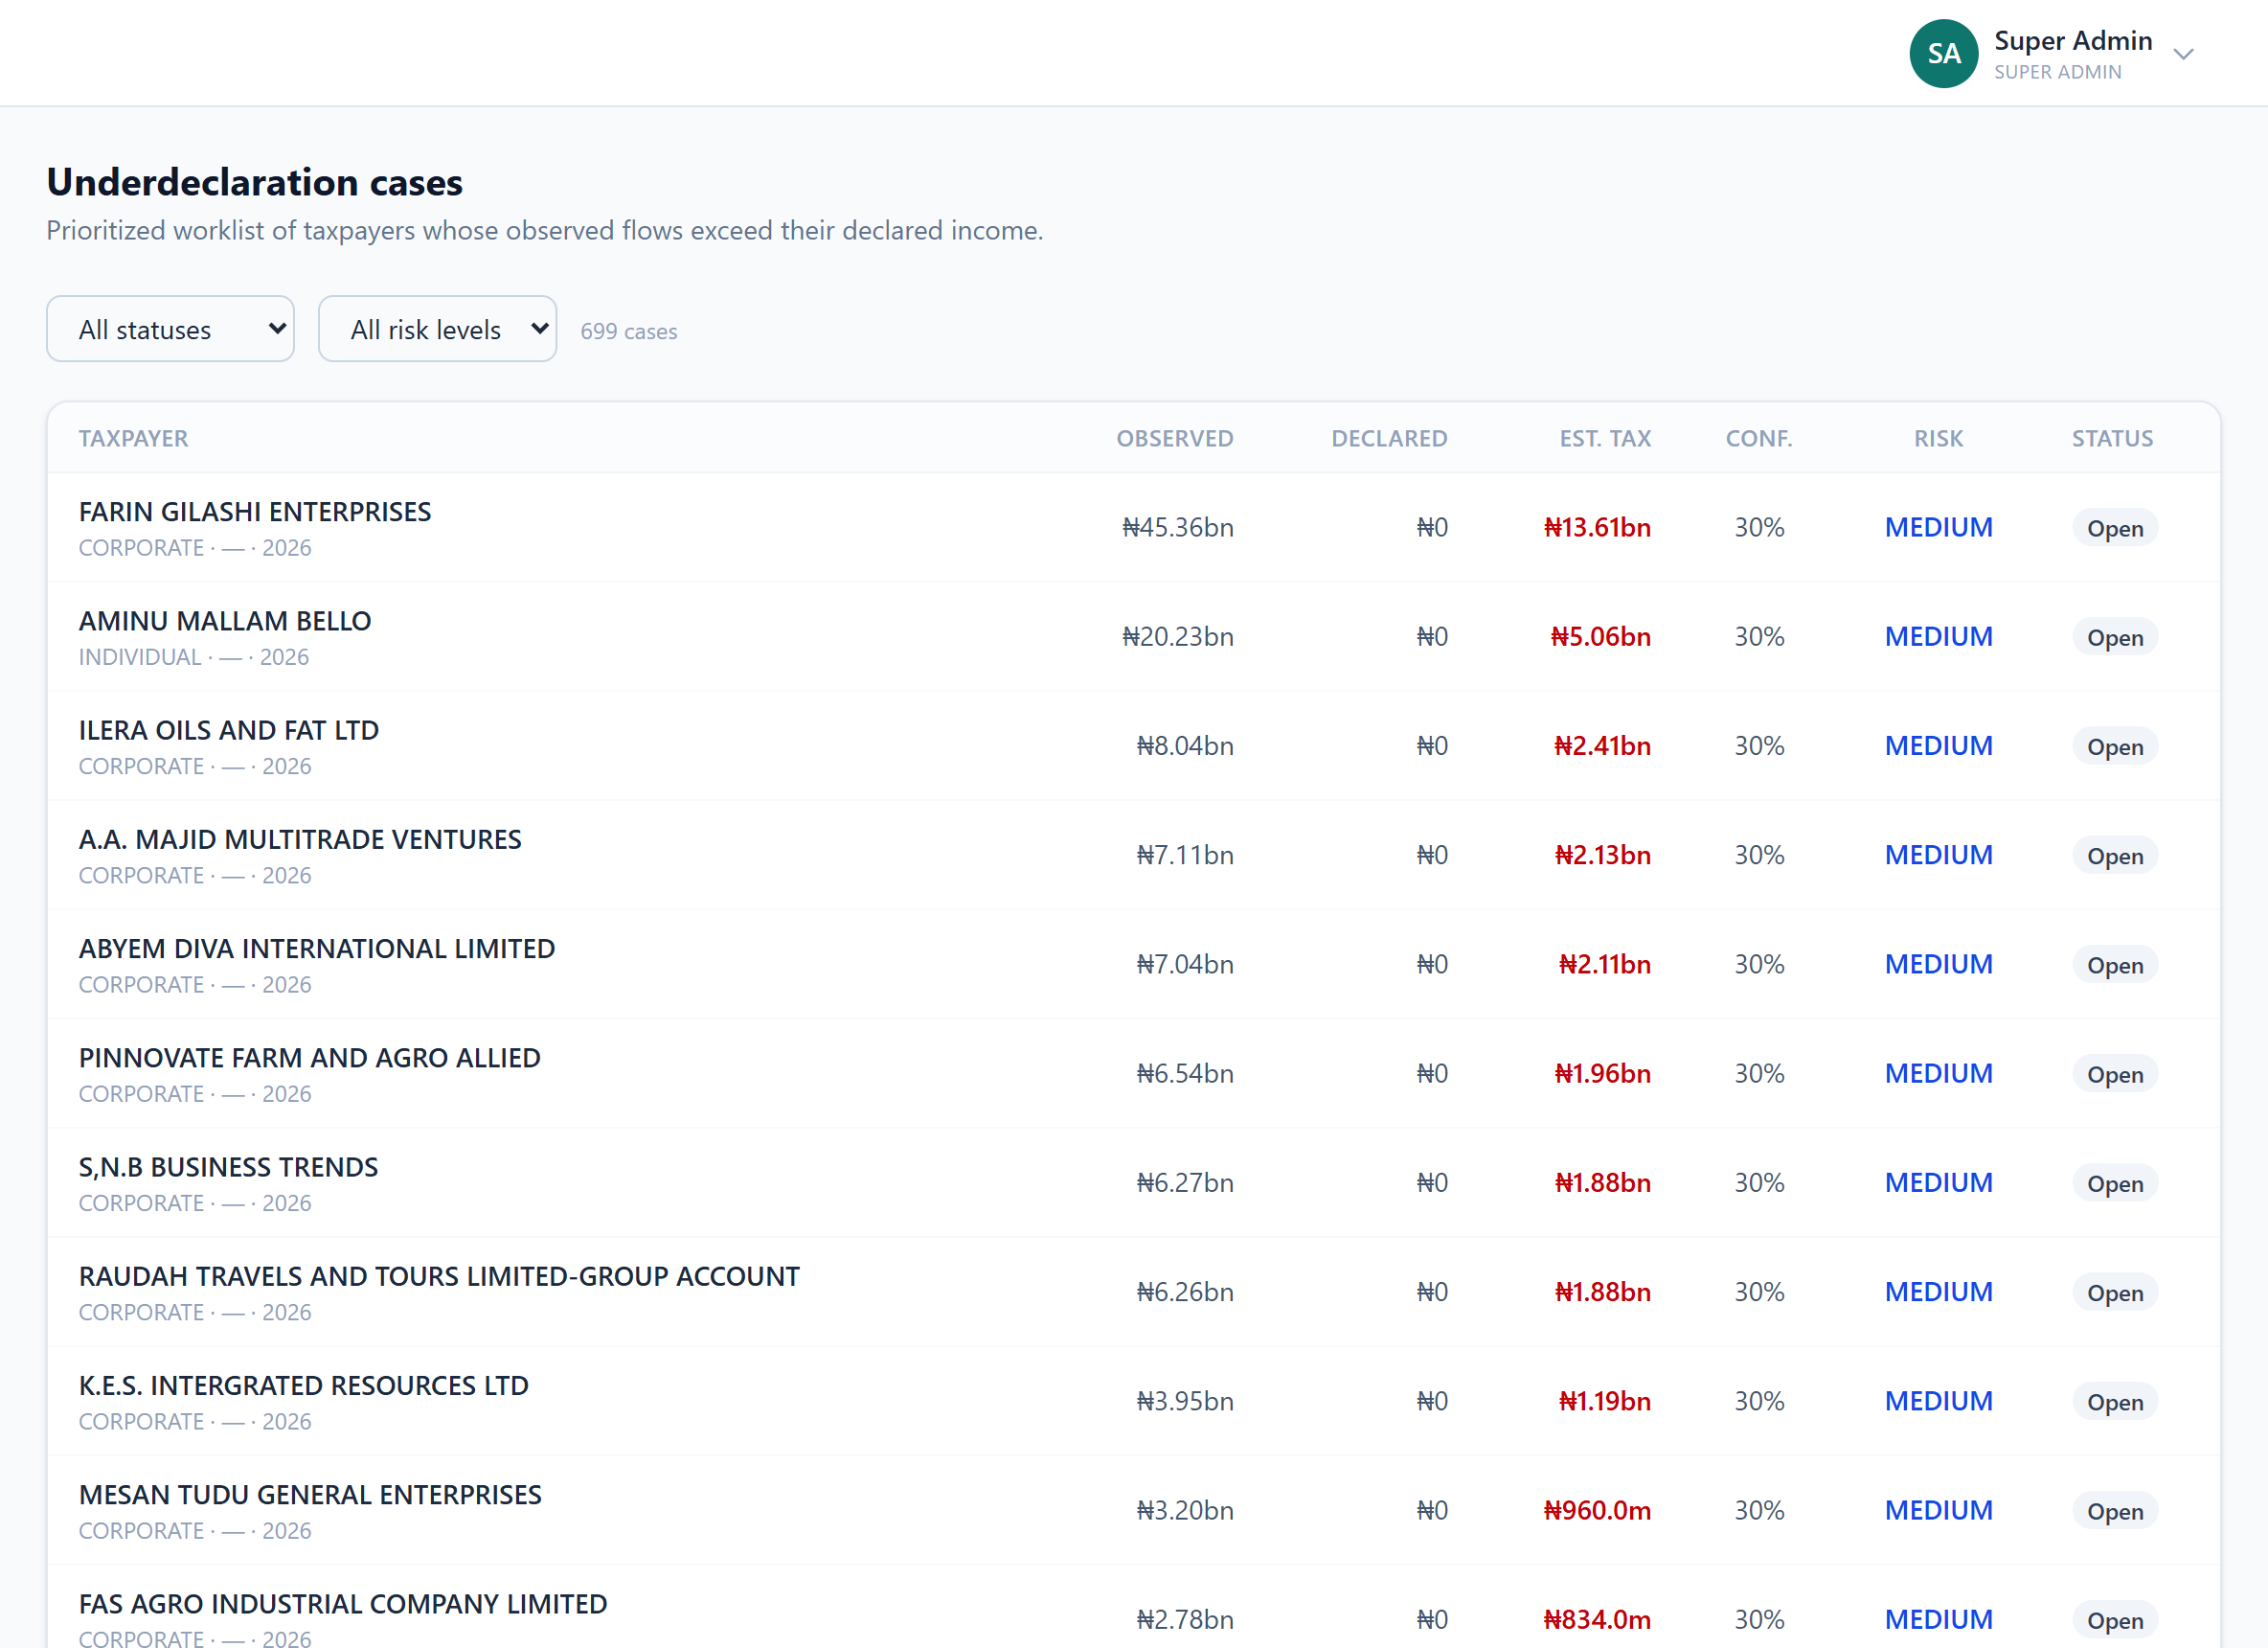

13. Flagged Review
Records flagged by a scan and still awaiting a human decision.
What it does
- Taxpayer, provider, period, observed vs declared, discrepancy.
- Clear or Confirm each; a confirmed flag feeds the case pipeline.
Why it is useful
The human-in-the-loop checkpoint — no automated flag becomes a case without review.
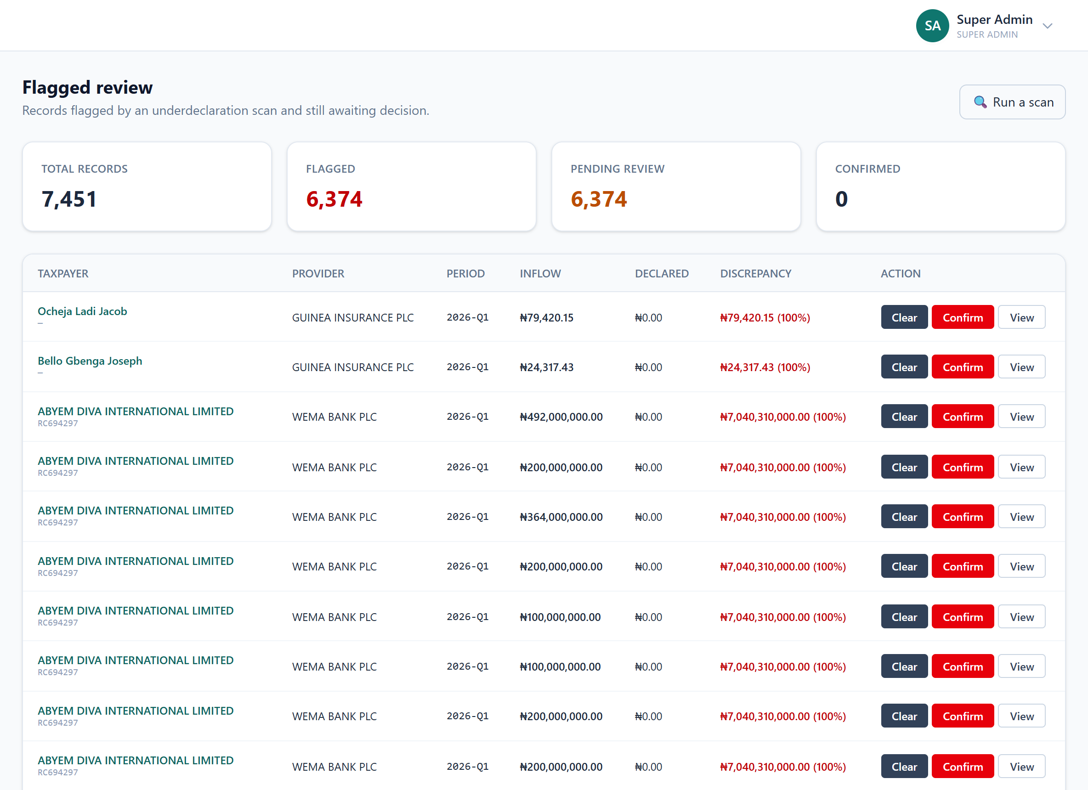

14. Scans
Runs the underdeclaration analysis: aggregate inflows per taxpayer vs declared.
What it does
- Configurable by year and threshold; aggregates across ALL providers.
- Produces flagged records, risk scores, estimated recoverable tax.
Why it is useful
The engine that turns raw provider data into leads. Re-runnable when new data lands.
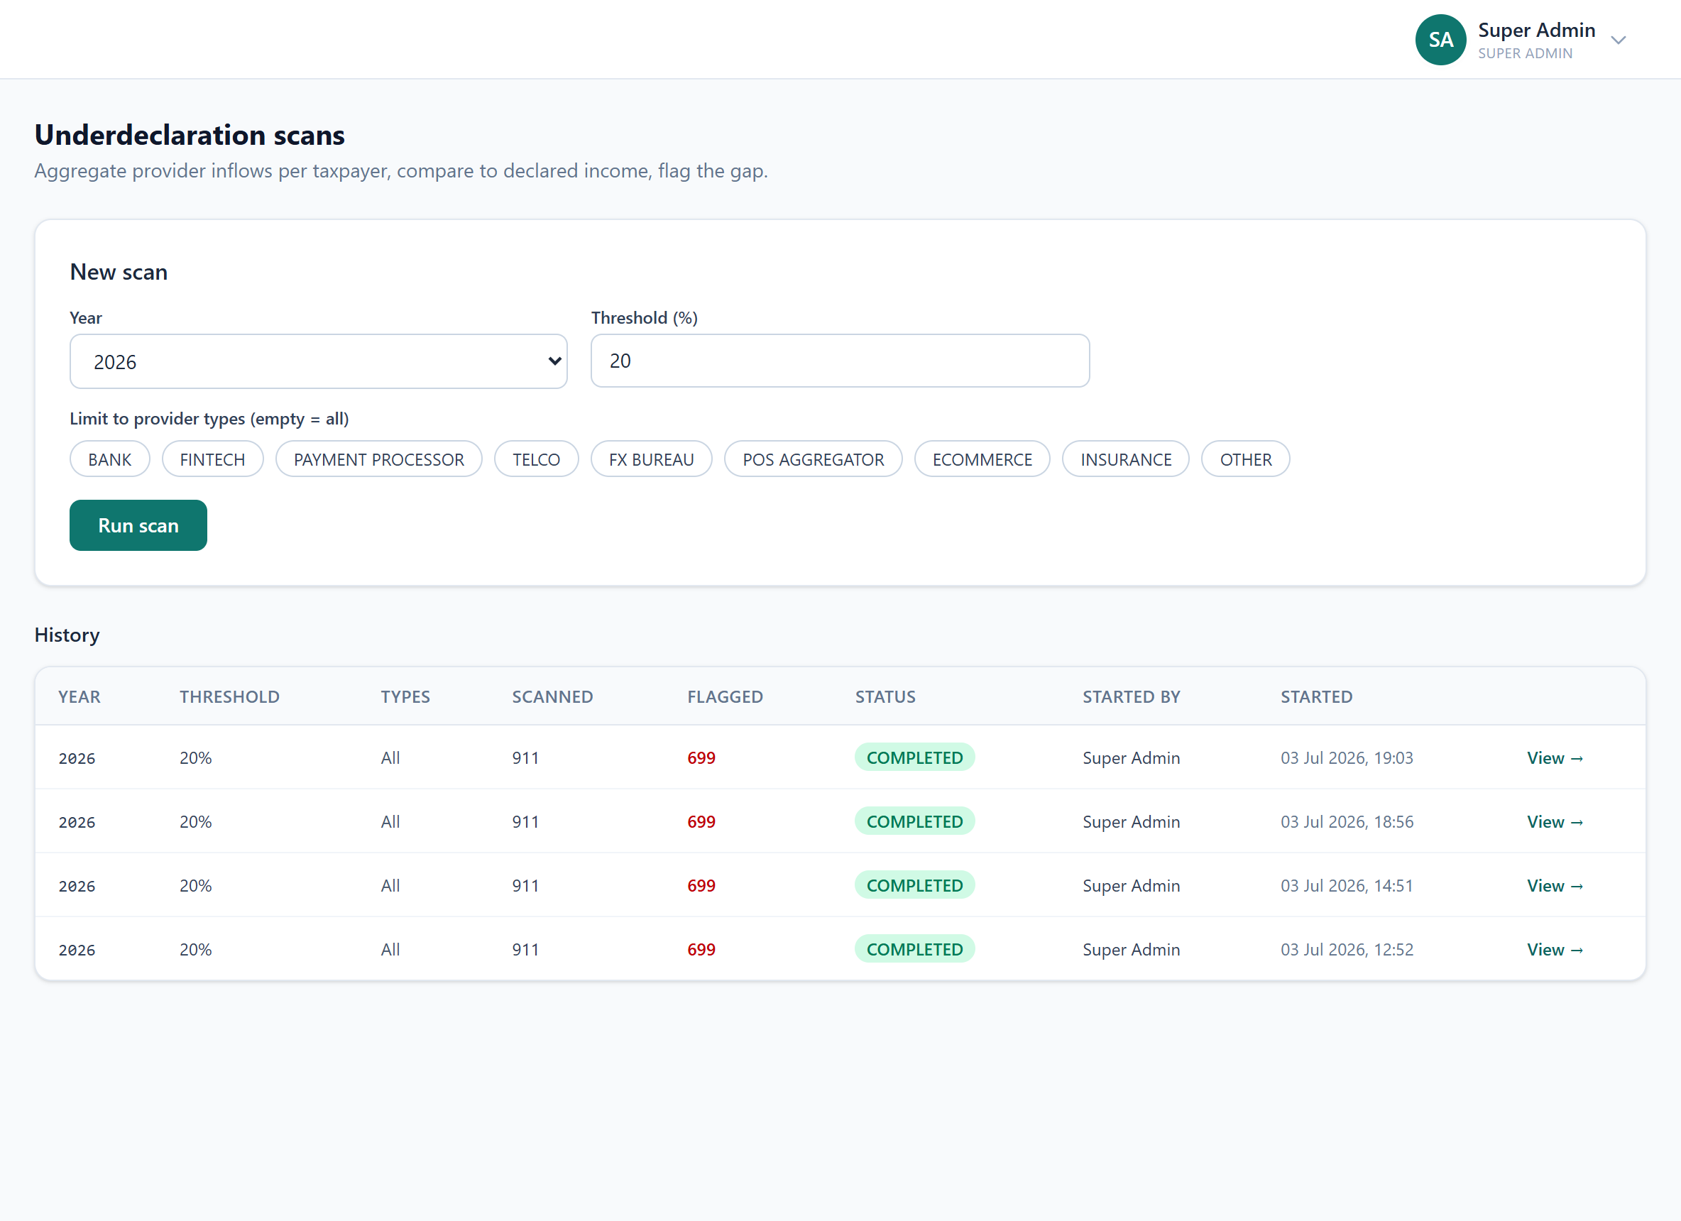

15. Agent Signals
Every AI-agent finding across all taxpayers, filterable. (New)
What it does
- Per-agent summary + severity filters (HIGH/MEDIUM/LOW).
- Each signal with its plain-language explanation and a link to the taxpayer.
Why it is useful
The AI analytics "report" in one place — no longer buried inside individual cases.
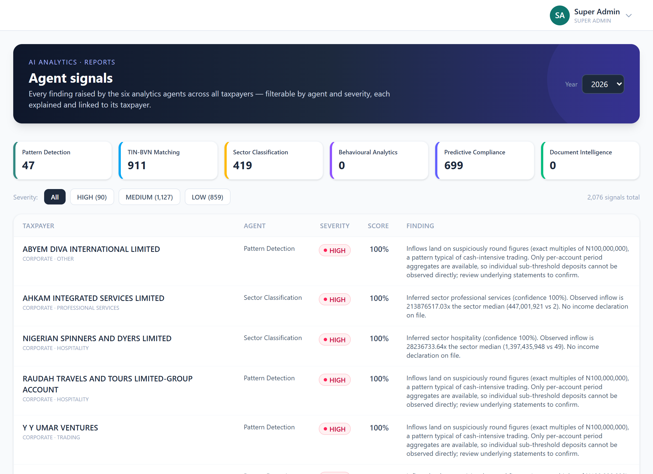

16. Schemas
The CSV column expectations applied when a submission is ingested.
What it does
- One schema per provider type (incl. Insurance).
- Every schema now also accepts common sector + businessType columns.
Why it is useful
The config that lets many provider file layouts flow into one normalised model.
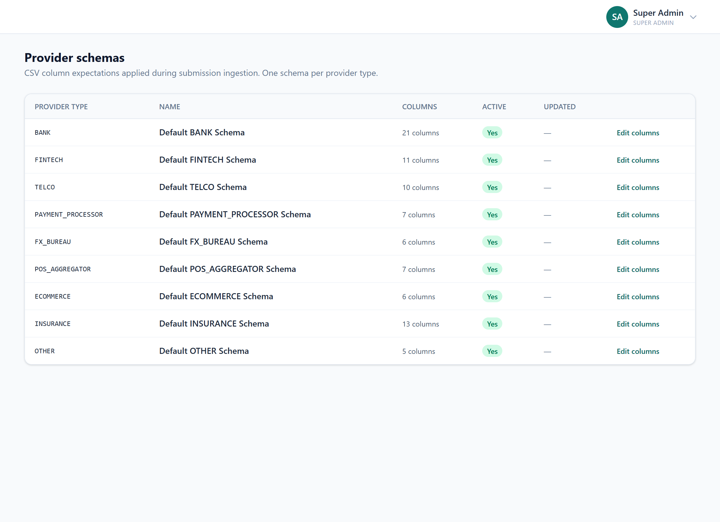

17. Audit Logs
A tamper-evident, hash-chained record of every privileged action.
What it does
- Each event SHA-256 hash-chained to the previous; re-verifiable on demand.
Why it is useful
The forensic backbone — evidence the system and its operators are accountable.
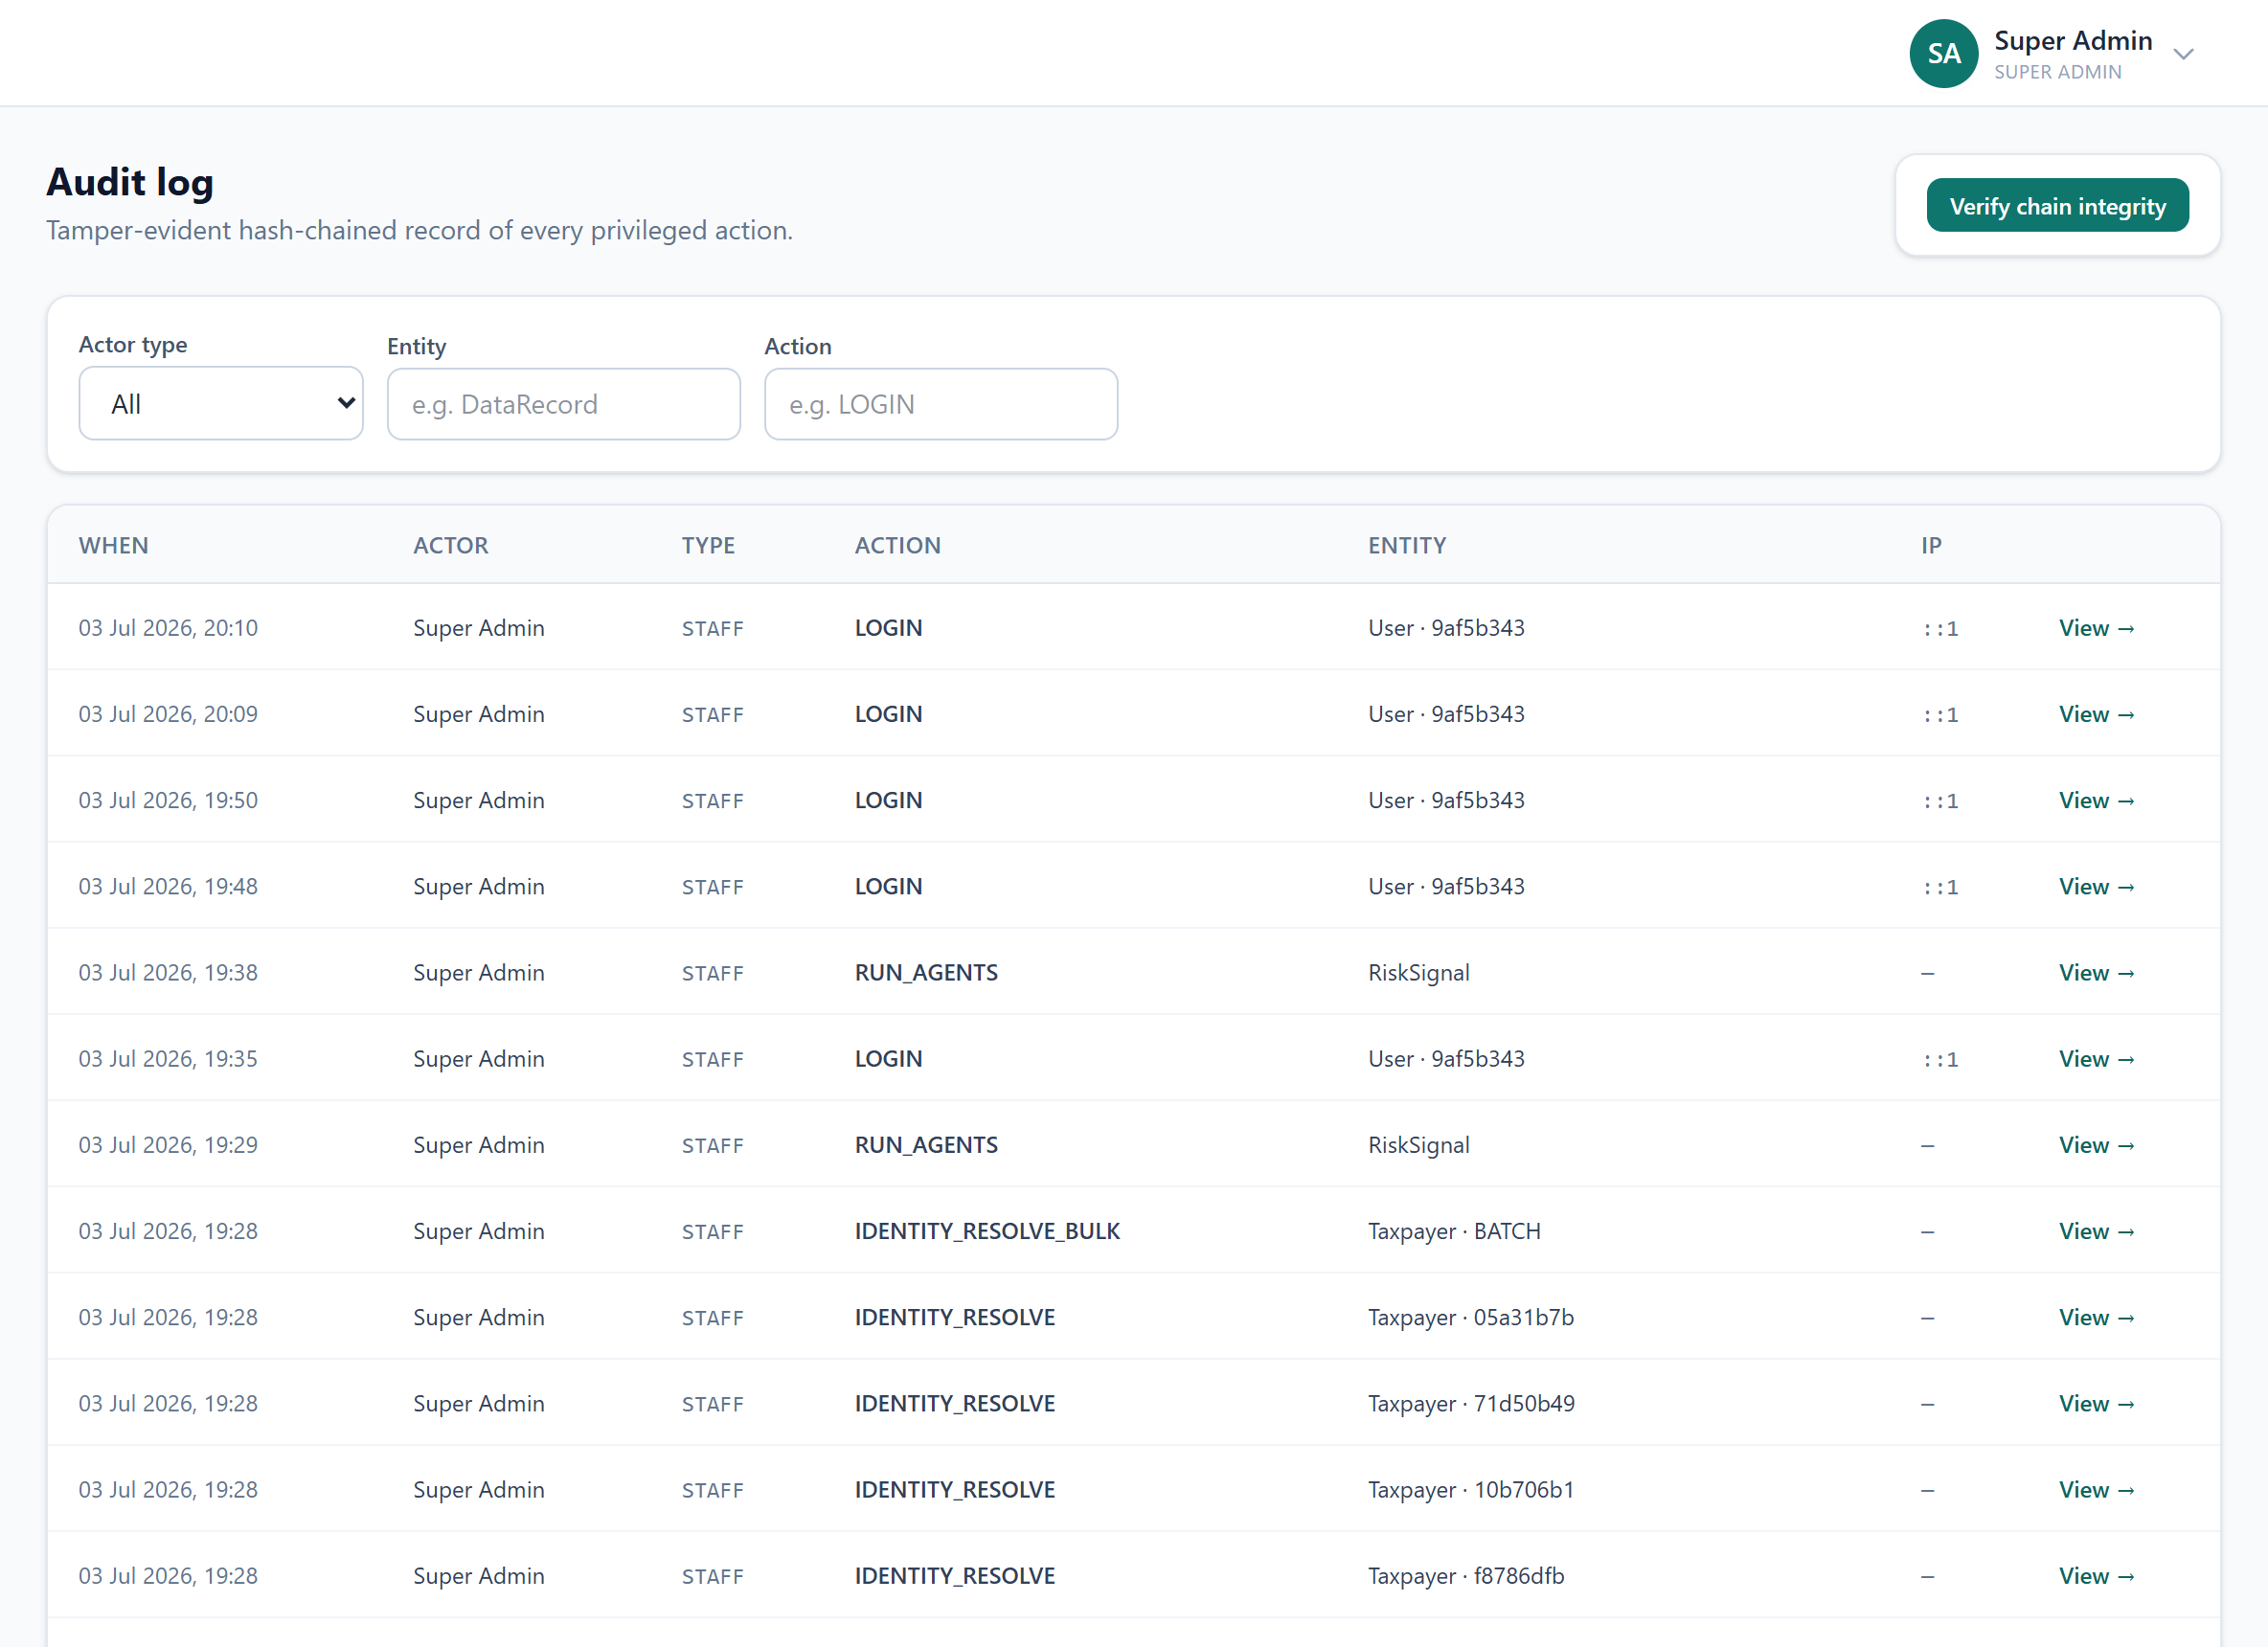

18. Alerts
High-value flags, missing submissions, deadlines — and case assignments.
What it does
- Auto-generated alerts; now also per-user CASE_ASSIGNED notifications (Phase 3).
- Marked read/unread; dashboard shows the unread count.
Why it is useful
The push channel for time-sensitive items and work routed to you.
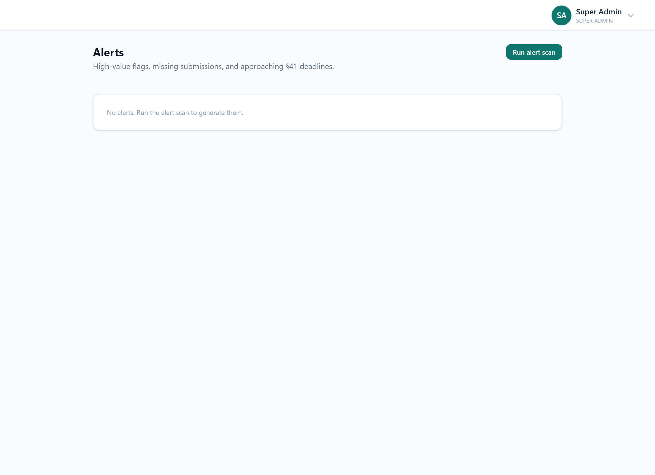

19. Model & Fairness
Detection precision and the distribution of flags, to monitor disparate impact.
What it does
- A precision proxy; flag distribution across segments.
Why it is useful
Governance over the analytics itself — accuracy and fairness of the model.
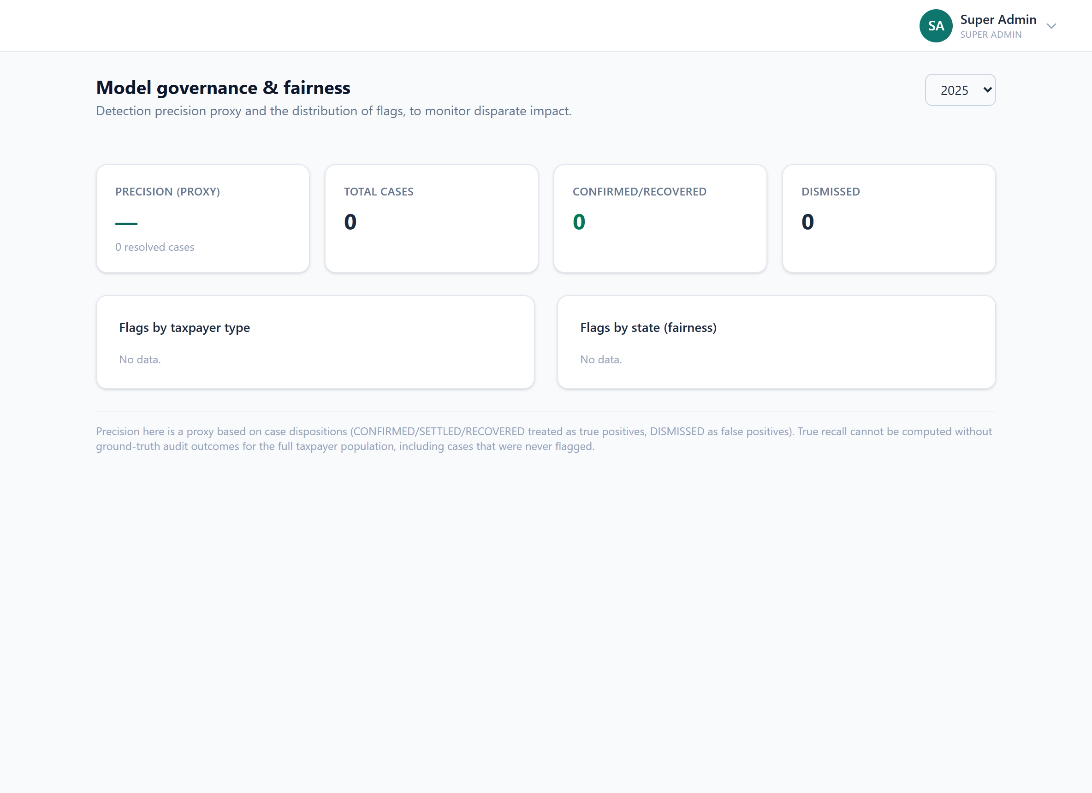

20. Governance
The steering-committee report pack and bank MoU / onboarding status.
What it does
- Generated oversight report pack; tracks MoUs and onboarding.
Why it is useful
The board-level view — programme status and the agreements underpinning data sharing.
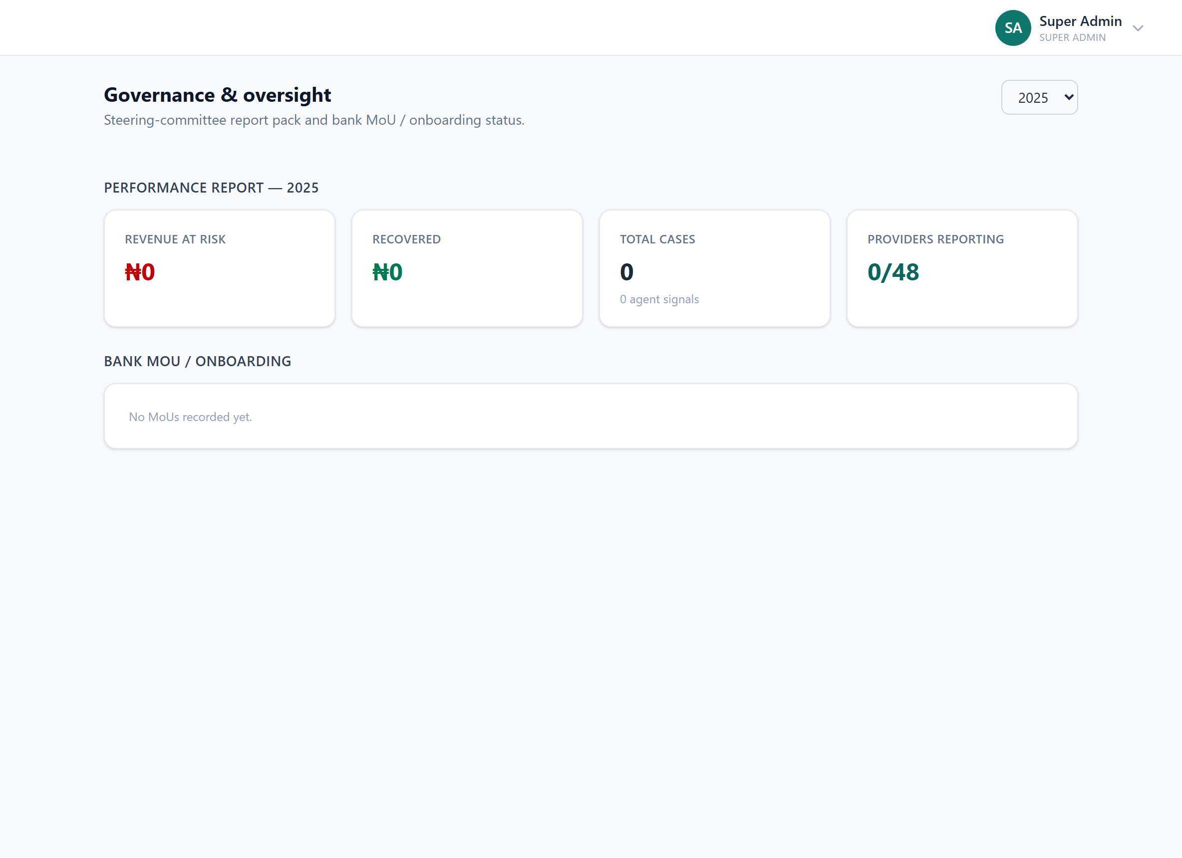

21. Sensitive Access
Just-in-time, supervisor-approved access to masked PII.
What it does
- BVN + full account numbers masked by default; time-boxed access with approval; audited.
Why it is useful
The controlled gateway to the most sensitive fields — deliberate, temporary, logged.
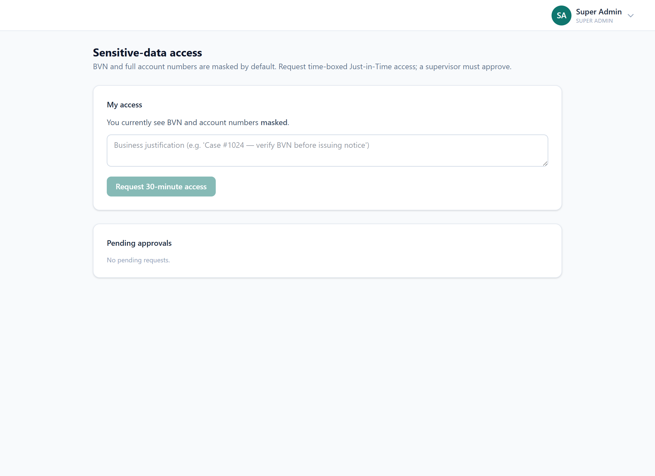

22. Data Protection
NDPA 2023 oversight: lawful basis, access events, storage-limitation.
What it does
- Records lawful basis; surfaces PII access events; retention + purge.
Why it is useful
The privacy-compliance console — demonstrates the programme meets the law.
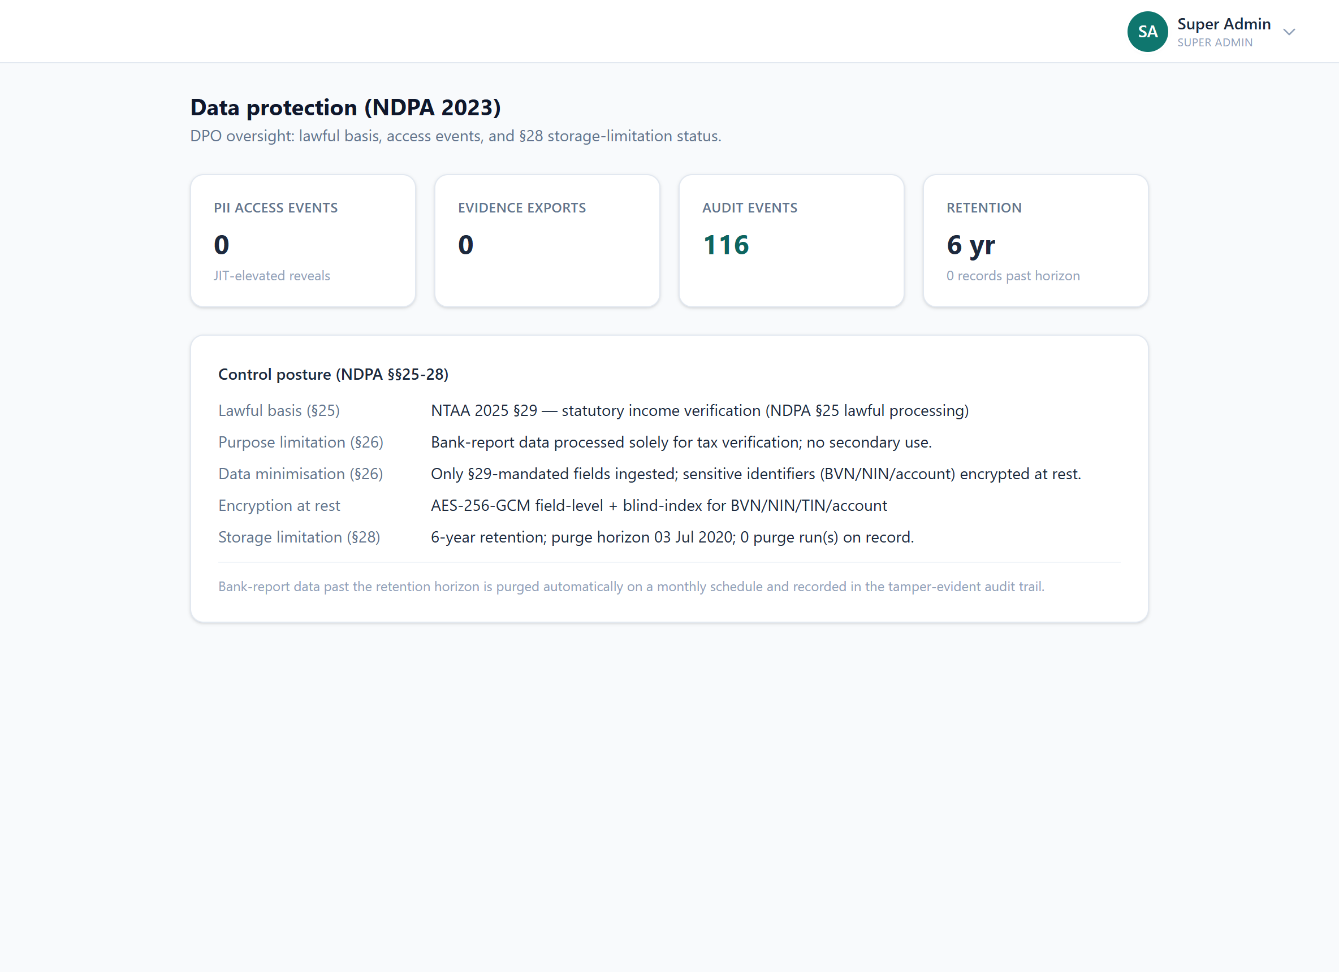

23. Portfolios
Analyst ownership of providers / types / sectors, with auto-routing. (Phase 3)
What it does
- Own an individual provider, a provider type, or a sector.
- New cases auto-route to the owner (provider beats type beats sector); the analyst is notified.
- Per-analyst workload: open cases, revenue at risk, portfolio count.
Why it is useful
Puts a named owner on every provider/type/sector so no lead falls between desks.
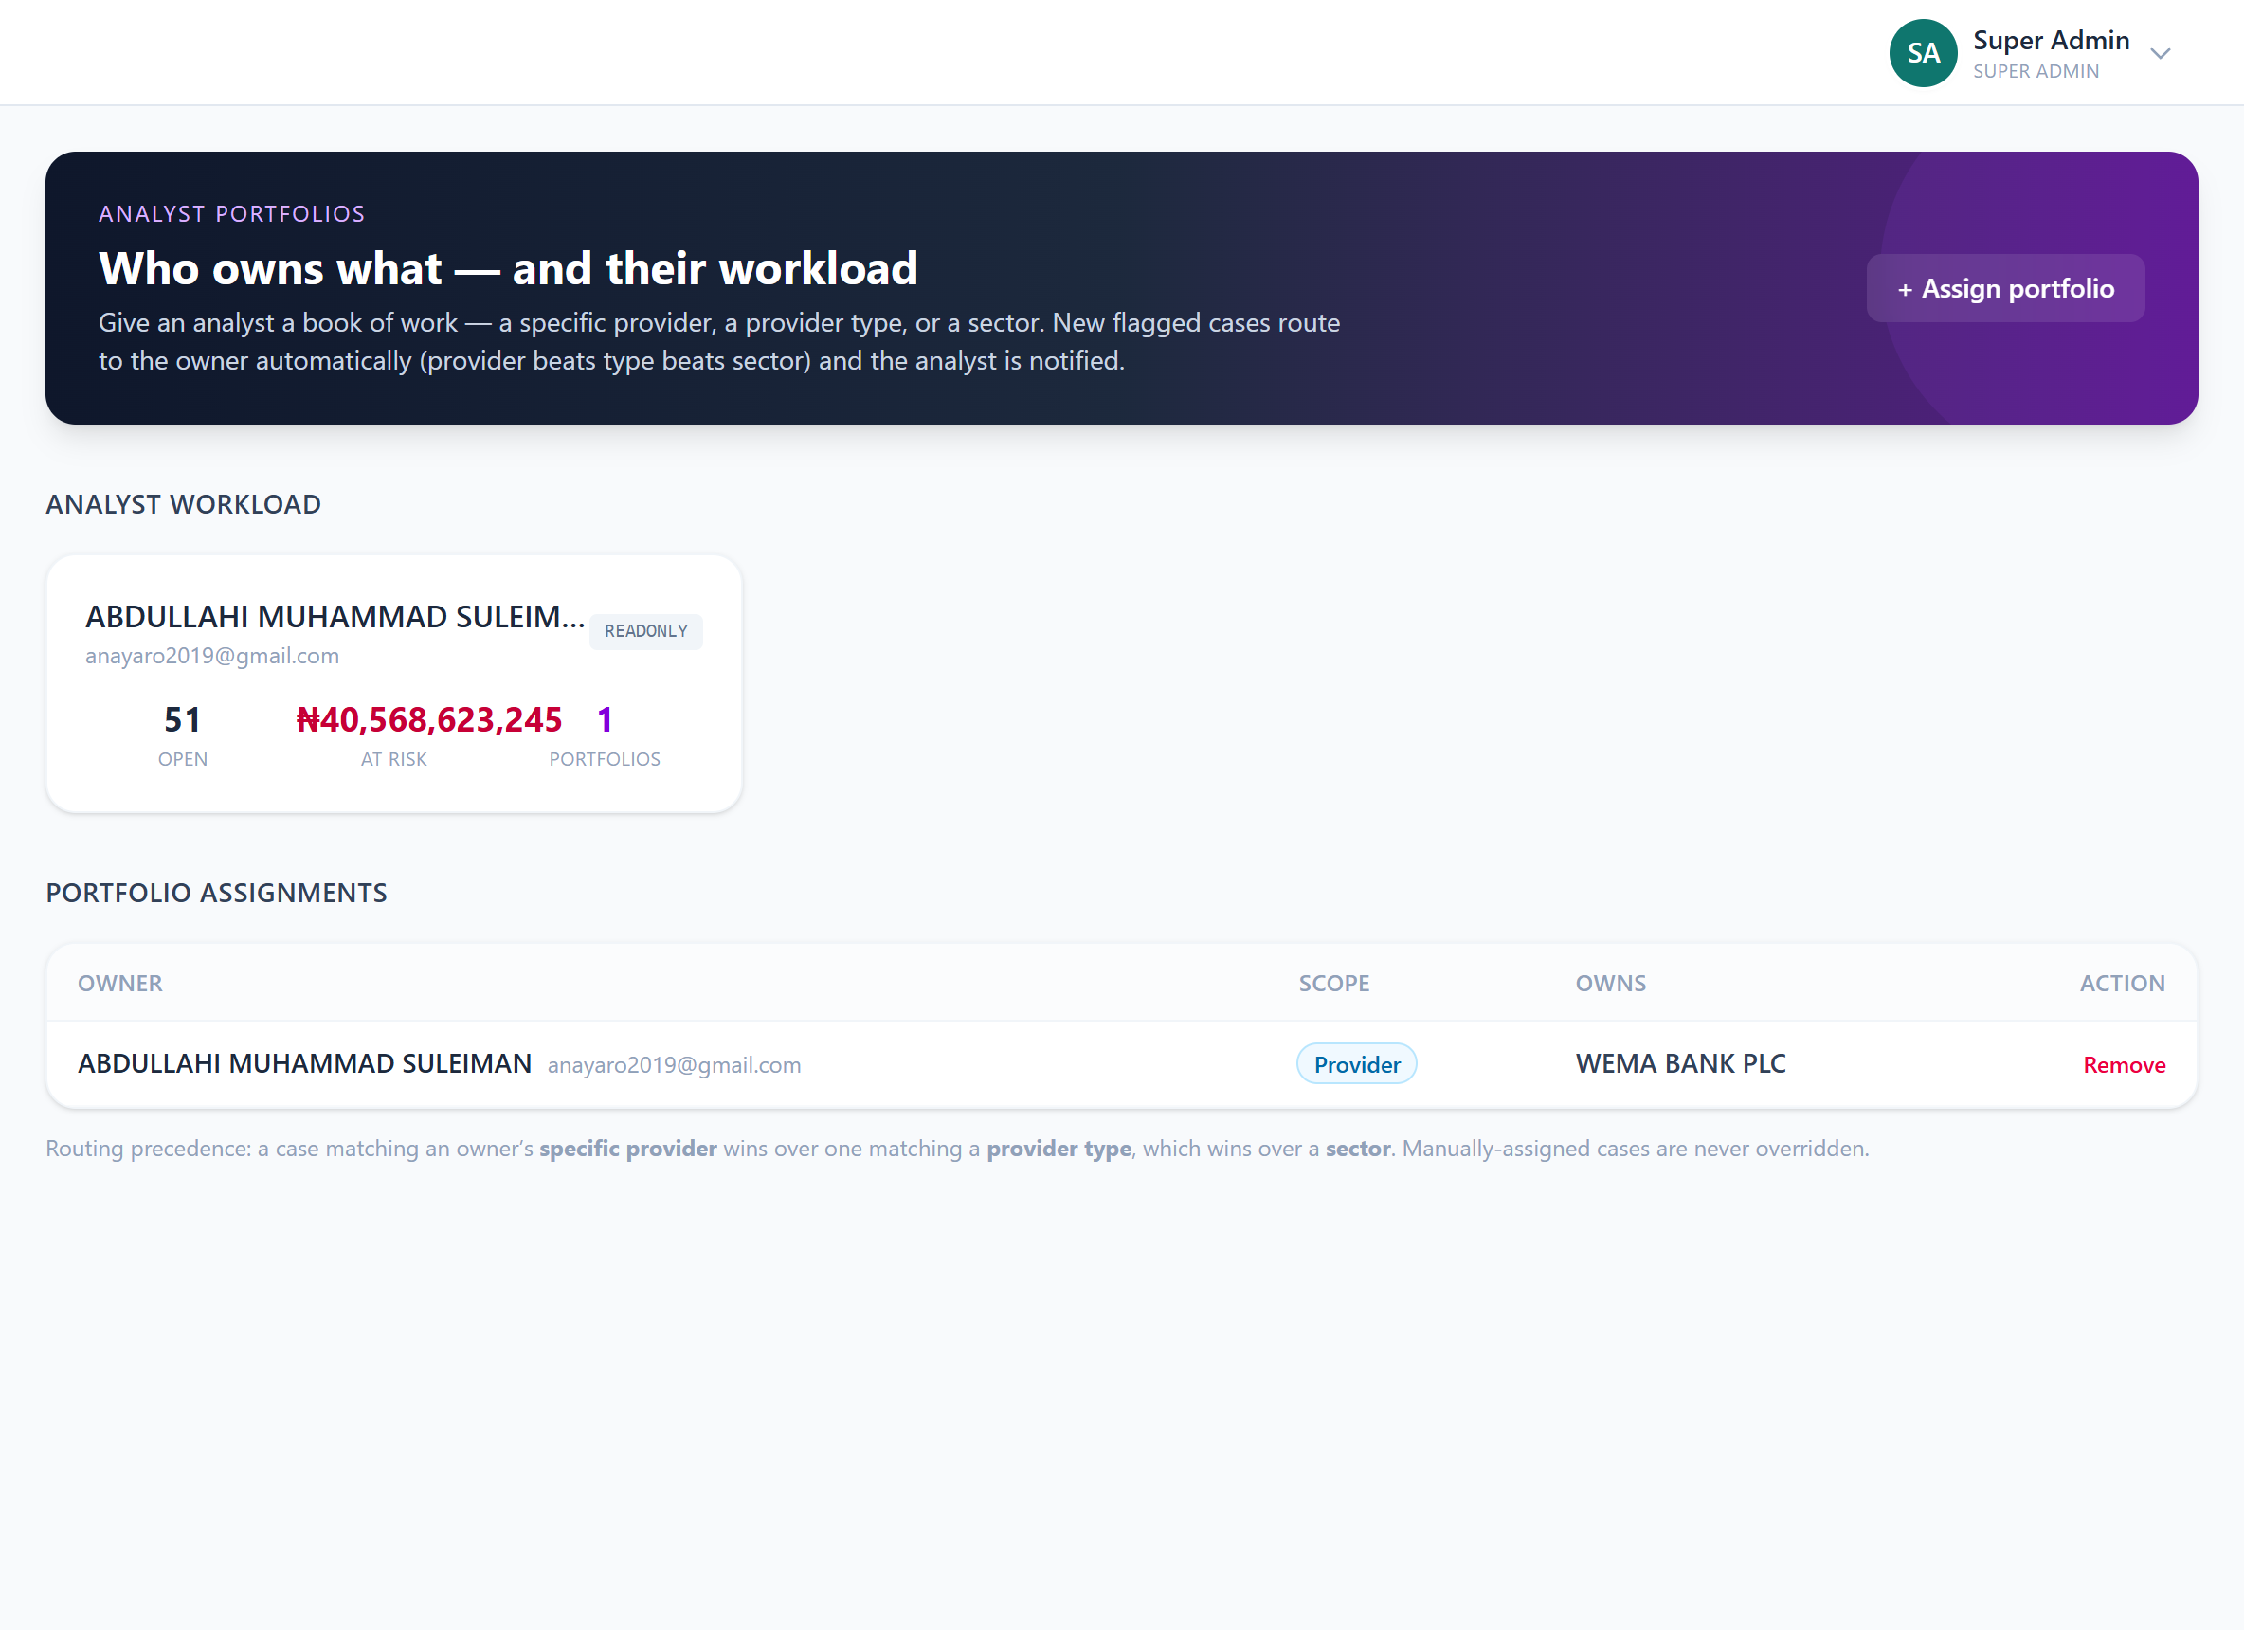

24. Users
The staff who can sign in to the back office.
What it does
- Role-driven permissions (SUPER_ADMIN … READONLY); create + manage.
Why it is useful
Access control for the back office.
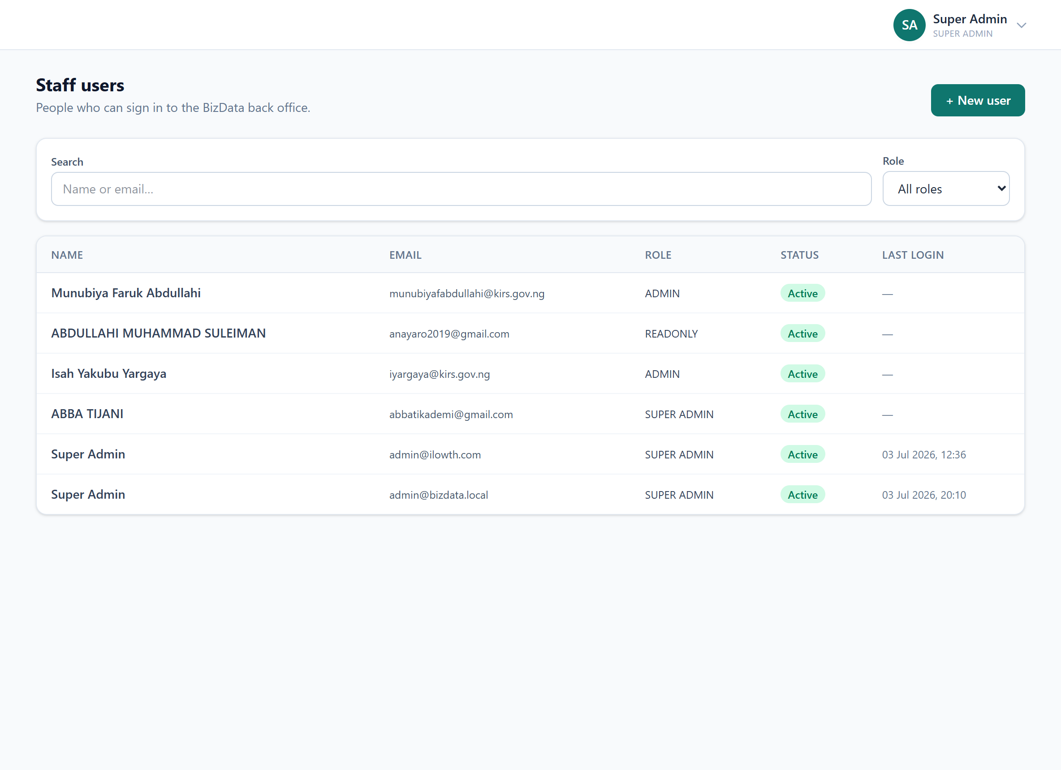

25. Settings
Tenant profile and the signed-in officer’s account preferences.
What it does
- Tenant profile; personal preferences, password change, MFA setup.
Why it is useful
Housekeeping — organisation identity and each user’s own security settings.
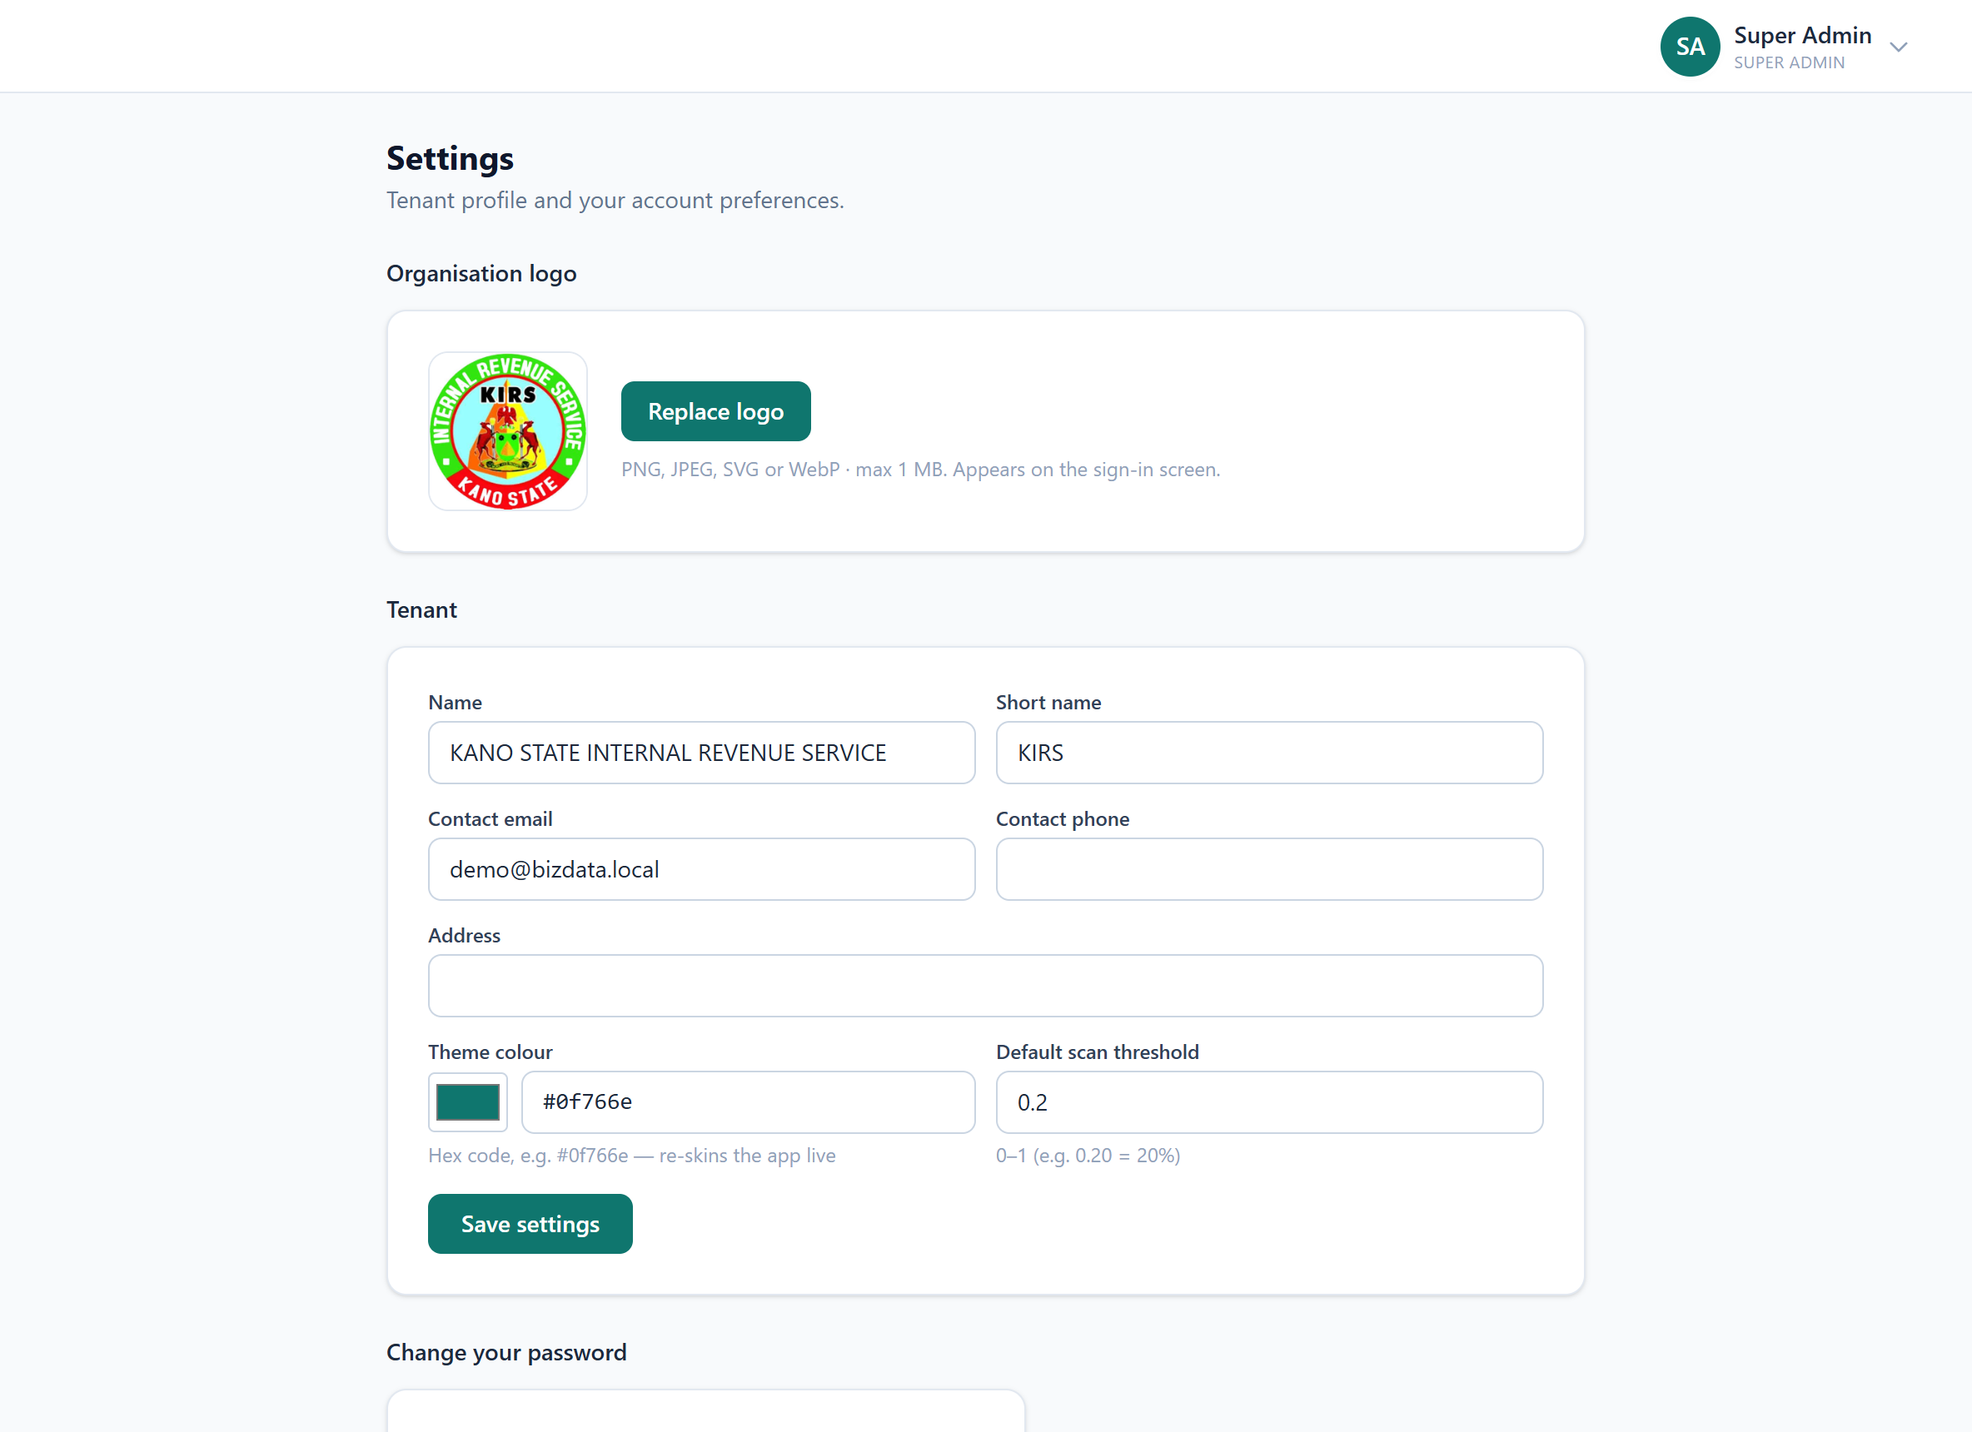

Part III — Sub-page Deep-Dives

The detail screens an officer opens most.

Case detail (Cases → a case)
The full anatomy of a case — evidence and statutory position.
What it shows
- Header: observed, declared, discrepancy, estimated tax due.
- "Why was this flagged" — weighted signals producing the confidence score.
- Observed-flows table, case actions, and AI signals with explanations.
Why it matters
Where an officer decides whether to pursue — every number traceable to its source.
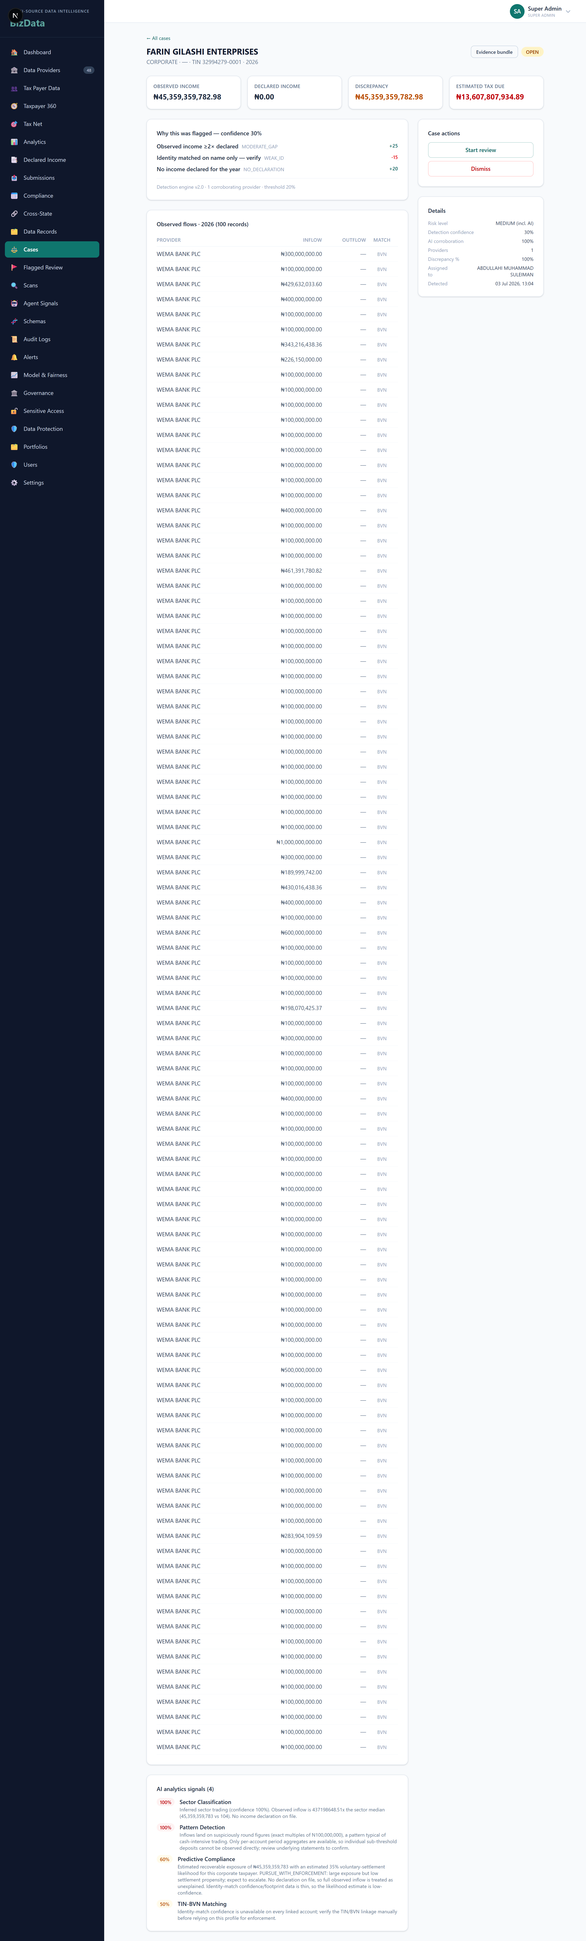

Taxpayer profile (Tax Payer Data → a taxpayer)
The single-entity view Taxpayer 360 assembles.
What it shows
- Identity cards: NIN, BVN, TIN, RC, phone, email, sector, business type.
- Declared income section; a data-records table with discrepancy + review status.
Why it matters
The anchor when investigating one person or company.
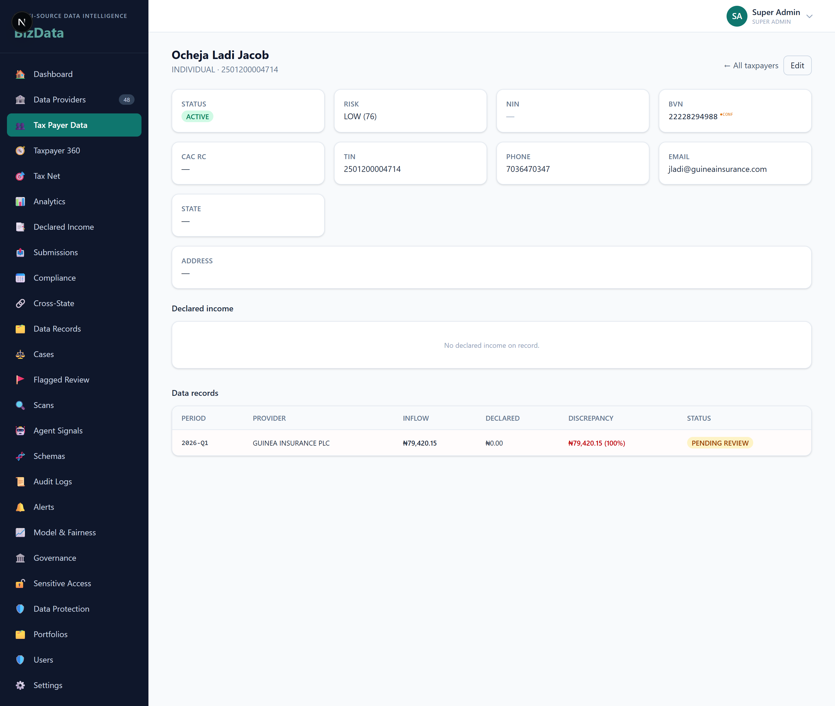

Submission detail (Submissions → a file)
One uploaded file and how it was processed.
What it shows
- File metadata, record counts, validation outcome, §6.5 receipt hash.
Why it matters
Proves exactly what a provider sent and how it validated.
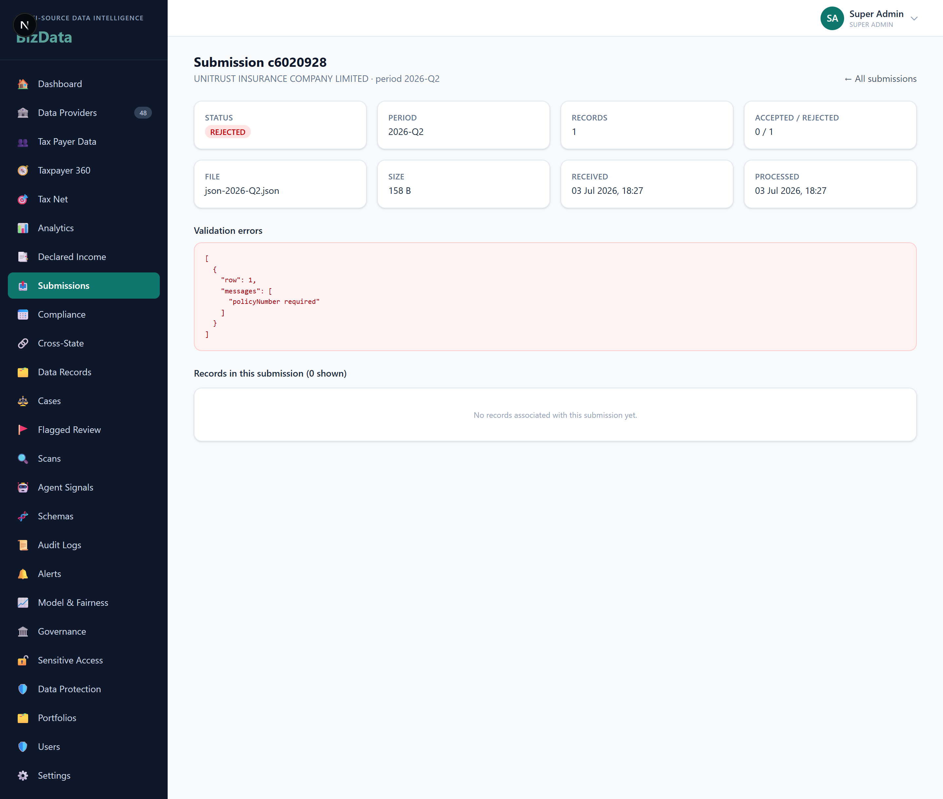

Data-record detail (Data Records → a row)
One normalised transaction row, fully expanded.
What it shows
- Account/identifier fields, inflow/outflow, period, match method.
- Links to taxpayer + submission; flag/review status.
Why it matters
The atomic unit of evidence — a single number traced to its source.
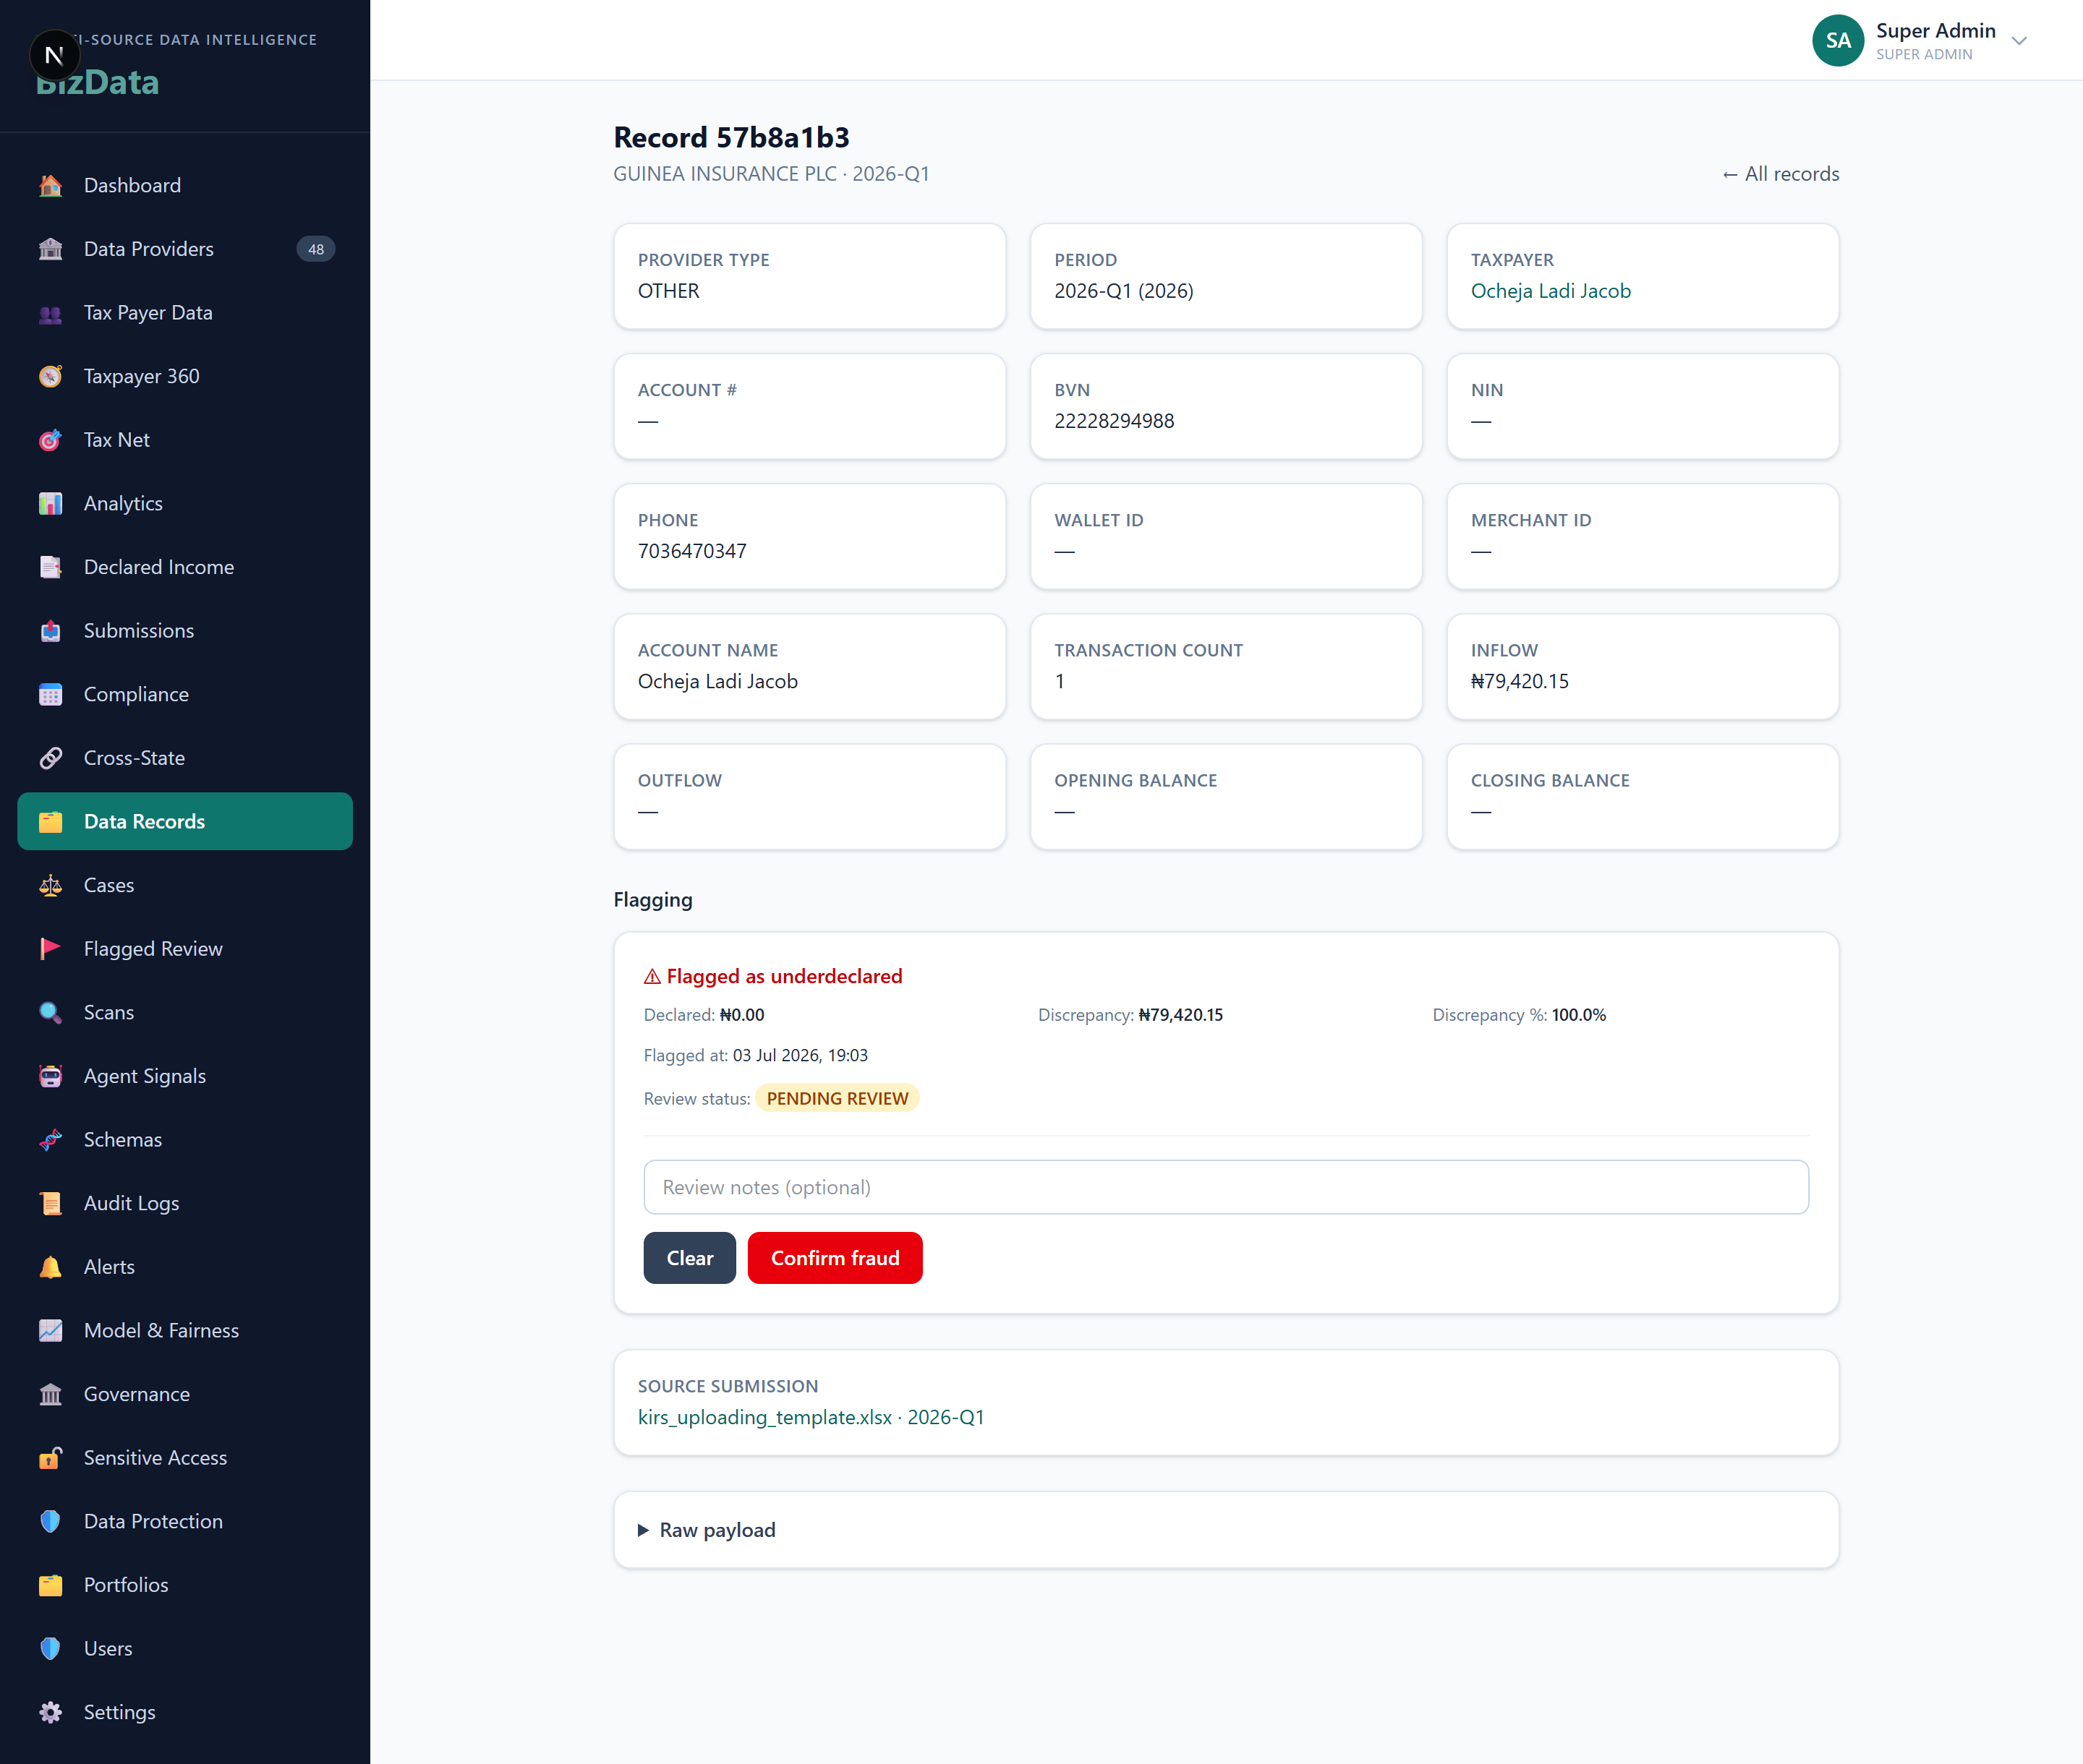

Scan detail (Scans → a run)
The result summary of one underdeclaration scan.
What it shows
- Parameters (year, threshold); outcome counts; status + timing.
Why it matters
The provenance of a batch of flags — which run produced them and how.
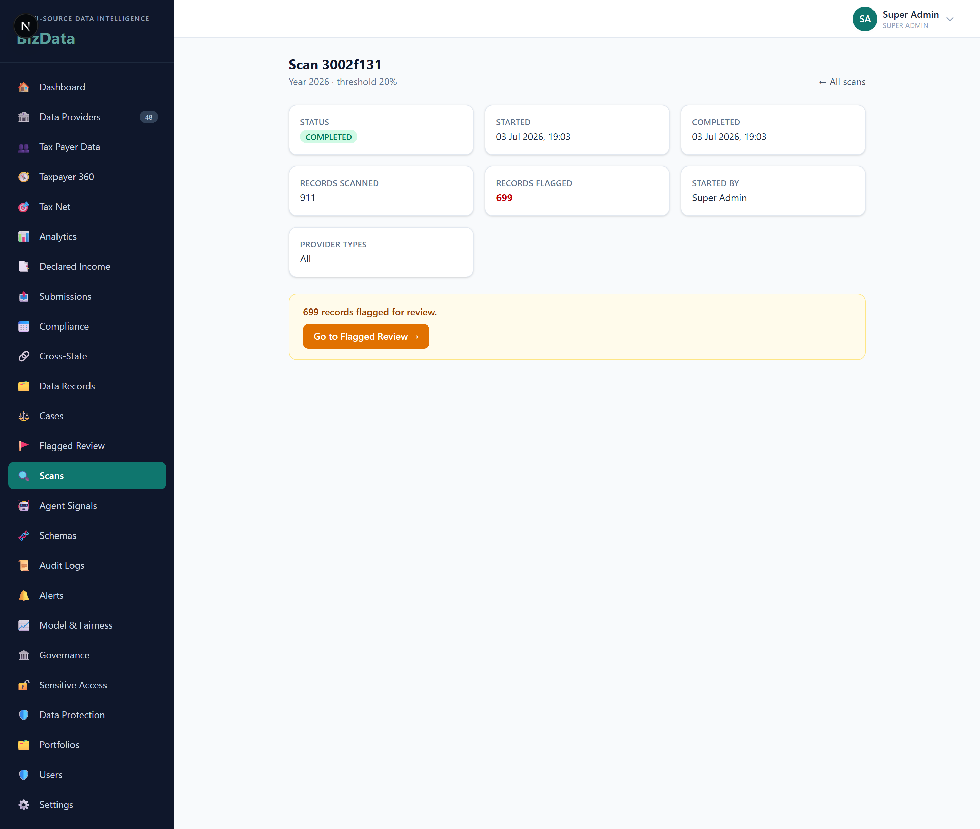

Provider detail (Data Providers → a provider)
A single provider’s compliance dashboard.
What it shows
- Compliance KPIs + a four-quarter reporting timeline (due vs received).
- Portal users, recent submissions, and the gated uploads viewer.
Why it matters
Everything about one provider’s reporting behaviour in one place.
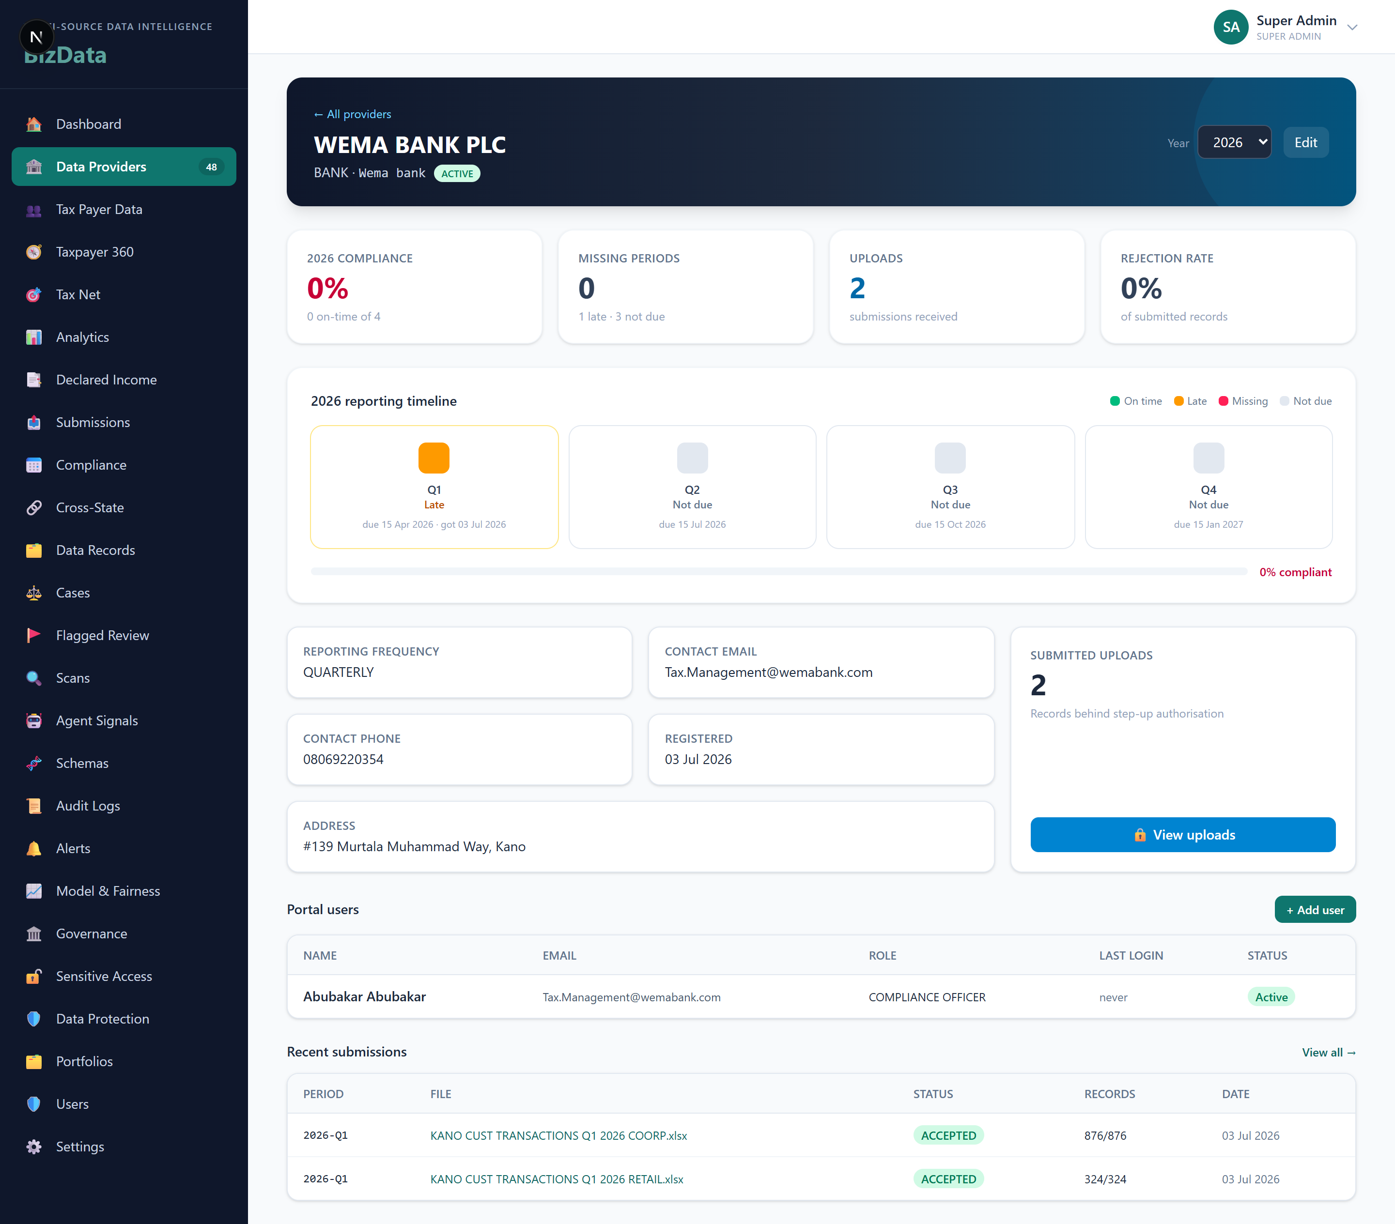

Part IV — Decision-Support Phases

Four phases that turn a flag list into a decision-support system. Each is independently valuable.

Phase 1 — Comparative Analytics
The Sector Classification agent computed a sector but never saved it — persisting it unlocked the sector dimension (0 → 911 classified). Two aggregation views turn 7,451 records into comparison: by-provider (volume, quality, yield) and by-sector (underdeclaration concentration, coverage, recoverable tax). Example: Hospitality shows 92% flagged with 31% coverage — a clear target.

/analytics

Phase 2 — Tax-Net Comparative
Classifies every observed party as Captured (has RC/TIN), Unverified (registered, ID missing), or Invisible (receiving money, no registration), ranked by inflow. Registration into the net is available per-row (manual) or auto/bulk, assigning a provisional TIN — every action audited. A source-provider column shows where each party’s data came from.

/tax-net

Phase 3 — Analyst Portfolios
An analyst owns a book of work — a specific provider, a provider type, or a sector. New flagged cases auto-route to the owner by precedence (specific provider beats type beats sector); manual assignments are never overridden. On assignment, a CASE_ASSIGNED notification is addressed to that specific analyst (per-user targeting was added to the platform). Verified: assigning WEMA to an analyst routed 51 cases and created 51 targeted notifications.

/portfolios

Phase 4 — Identity Resolution (NIMC / NIBSS)
~90% of individuals have no TIN and no NIN, but every one has a BVN. NIBSS bridges a BVN to its linked NIN, moving the individual toward the net. Built as a pluggable IdentityProvider interface with a deterministic mock for development and a NIBSS stub for production — swapping is a config change (IDENTITY_PROVIDER=nibss), not a rewrite. Single + bulk resolution, both audited; demo NINs clearly labelled synthetic. The control lives on the Tax-Net page.

/tax-net

Part V — Notes & known limitations

Provider compliance reads low — by design
Statutory quarterly due dates have passed without on-time filing (migrated submissions arrived after the Q1 due date; later quarters are not due or missing). The 15-day/quarterly rule is a configurable default (§29/§6.6) and should be confirmed against the gazetted NTAA text.
Underdeclaration figures
The scan aggregates each taxpayer’s inflow across all providers vs a single declared-income figure. Because real declared-income data is not yet loaded, most taxpayers hit the "no declaration" branch, treated as a 100% gap — so extreme percentages and huge sector ratios appear. Read flags as "has observed inflow, no filing on record" until declarations are loaded. Provisional TINs (registration) and mock NINs (identity) are clearly labelled and must be confirmed against FIRS / NIMC / NIBSS before they are authoritative.

